Proje Adı | Personel Maaş Sistemi
Proje Konusu | Personel, Rol, Kullanıcı, İzin ve Maaş Hesaplama İşlemleri
Proje Çözüm Adı | SAT242516046

Proje ‘Çözüm Gezgini (Solution Explorer)’ penceresinin (alt klasörler ve dosyalar dahil olacak şekilde) ekran görüntüsünü resim olarak ekleyiniz

Projede oluşturulan arabirimlerin (interface) C# kodlarını yazınız.
public interface IMyDbModel
{
string Message { get; set; }
IMyDbModel_Parameter Parameters { get; set; }
IDictionary<object, object> OrderByItems { get; set; }
}
public interface IMyDbModel<T> : IMyDbModel where T : class, new()
{
IEnumerable<T> Items { get; set; }
}

public interface IMyDbModel_Parameter
{
string OrderBy { get; set; }
int PageNumber { get; set; }
int PageSize { get; set; }
int TotalPageCount { get; }
int TotalRecordCount { get; set; }
IDictionary<string, object> Params { get; set; }
IDictionary<string, string> Where { get; set; }
}

public interface IMyDbModel_Result_KeyValue<TKey, TValue>
{
TKey Key { get; set; }
TValue Value { get; set; }
}
public interface IMyDbModel_Provider
{
ValueTask<IMyDbModel<TResult>> Execute<TResult>(IMyDbModel<TResult> myResultModel,
string spName = "",
bool isPagination = true) where TResult : class, new();

ValueTask<IMyDbModel<TResult>> Execute<TResult>(string spName = "",
params (string Key, object Value)[] parameters)
where TResult : class, new();

ValueTask<IEnumerable<TResult>> GetItems<TResult>(string spName = "",
params (string Key, object Value)[] parameters)
where TResult : class, new();

ValueTask<IEnumerable<TResult>> SetItems<TResult>(string spName = "",
params (string Key, object Value)[] parameters)
where TResult : class, new();
}

public interface IMyDbModel_UnitOfWork
{
Task Execute<T>(IMyDbModel<T> myDbModel, string spName = "", bool isPagination = true)
where T : class, new();
}

Projede oluşturulan sınıfların (class) C# kodlarını yazınız.
Uyarı : Sınıf içerisinde metotların sadece isim ve parametreleri yazılacak.
Örnek : public async Task MethodAsync(parameters…) { return null; }

public MyDbModel() { }
public MyDbModel(int pageNumber, int pageSize, string orderBy) { }
public static MyDbModel_Parameter Create(int pageNumber, int pageSize, string orderBy) { }
private MyDbModel_Parameter(int pageNumber, int pageSize, string orderBy) { }
public class MyDbModel_Result_KeyValue<TKey, TValue> { }
public static IDictionary<object, object> GetOrderByItems<E>(this MyDbModel<E> myDbModel) where E : class, new() { }
public MyDbModel_Provider(IMyDbModel_UnitOfWork myDbModel_UnitOfWork) { }
public async ValueTask<IMyDbModel<TResult>> Execute<TResult>(IMyDbModel<TResult> myResultModel, string spName = "", bool isPagination = true) { }
public async ValueTask<IMyDbModel<TResult>> Execute<TResult>(string spName = "", params (string Key, object Value)[] parameters) { }
public async ValueTask<IEnumerable<TResult>> GetItems<TResult>(string spName = "", params (string Key, object Value)[] parameters) { }
public async ValueTask<IEnumerable<TResult>> SetItems<TResult>(string spName = "", params (string Key, object Value)[] parameters) { }
public MyDbModel_UnitOfWork(TDbContext context) { }
public async Task Execute<T>(IMyDbModel<T> myDbModel, string spName = "", bool isPagination = true) where T : class, new() { }
public MyDbModel_DbContext(DbContextOptions<MyDbModel_DbContext> options) : base(options) { }
protected override void OnModelCreating(ModelBuilder modelBuilder) { }
public static IEnumerable<T> DataTableToList<T>(this DataTable table) where T : class { }
public static T GetObject<T>(this DataRow row, List<string> columnsName) where T : class { }
public static string Color<T>(this T value) { }
public static string Title<T>(this T value) { }
public static T JsonToItem<T>(this string jsonItem) { }
public static string ItemToJson<T>(this T item) { }
public static List<T> JsonToList<T>(this string json) { }
public static string ListToJson<T>(this List<T> list) { }
public static SqlParameter ToSqlParameter_Table_Type_Dictionary<TKey, TValue>(
this IDictionary<TKey, TValue> dictionary,
string parameterName,
string parameterTypeName = "",
int length = 0,
SqlDbType sqlDbType = SqlDbType.Structured,
ParameterDirection direction = ParameterDirection.Input) { }

public static SqlParameter ToSqlParameter_Data_Type<T>(
this T value,
string parameterName,
ParameterDirection direction = ParameterDirection.Input,
SqlDbType sqlDbType = SqlDbType.NVarChar) { }
public ColorAttribute(string color) { }
public string Color { get; set; }
public TitleAttribute(string title) { }
public string Title { get; set; }

appsettings.json dosyasında “DefaultConnection” ifadesini projenize göre yazınız
"DefaultConnection": "Server=localhost,1445; Database=SAT242516046; User Id=sa; Password=Oo_454545; TrustServerCertificate=True;"

Program.cs dosyasında, gerekli servis kayıtlarını yapan C# kodlarını yazınız.
//// DBCONTEXTS
builder.Services.AddDbContext<MyDbModel_DbContext>(options => options.UseSqlServer(connectionString));

//// UNITOFWORKS
builder.Services.AddScoped<IMyDbModel_UnitOfWork, MyDbModel_UnitOfWork<MyDbModel_DbContext>>();

//// MODELS
builder.Services.AddScoped(typeof(IMyDbModel<>), typeof(MyDbModel<>));

//// PROVIDERS
builder.Services.AddScoped<IMyDbModel_Provider, MyDbModel_Provider>();

App.razor bileşeninde, gerekli C# kodlarını yazınız
<Routes @rendermode="@RenderModeForPage" />
@code {

[CascadingParameter] private HttpContext HttpContext { get; set; } = default!;

private IComponentRenderMode? RenderModeForPage =>
HttpContext.Request.Path
.StartsWithSegments("/Account")
? null
: InteractiveServer;

}

Projenizde oluşturmuş olduğunuz bileşenlerin tasarım ve C# kodlarını yazınız (Blazor Component)
NOT: daha fazla bileşen için, aşağıdaki tabloyu çoğaltınız.
@page "/personeller"
@using SAT242516046.Data
@using SAT242516046.Models.MyDbModels
@using SAT242516046.Models.Providers
@using SAT242516046.Models.Extensions
@using System.ComponentModel.DataAnnotations

<h3 class="mb-4">Personel Yönetim Sistemi</h3>

@if (!string.IsNullOrEmpty(Model.Message))
{
<div class="alert alert-danger">SQL Hatası: @Model.Message</div>
}
@if (IsSuccess)
{
<div class="alert alert-success">İşlem Başarılı! Liste güncellendi.</div>
}

@if (OperationMode != Operation.None)
{ <div class="card p-4 mb-4"> <h4 class="text-@(GetColor(OperationMode))">
@(OperationMode == Operation.Add ? "Yeni Personel Ekle" :
OperationMode == Operation.Update ? "Personel Güncelle" : "Personel Sil")
</h4>

<EditForm Model="@CurrentPersonel" OnValidSubmit="@HandleSubmit">
<DataAnnotationsValidator />

<div class="form-group mb-3">
<label>Ad</label>
<InputText class="form-control" @bind-Value="CurrentPersonel.Ad" />
</div>

<div class="form-group mb-3">
<label>Soyad</label>
<InputText class="form-control" @bind-Value="CurrentPersonel.Soyad" />
</div>

<div class="d-flex justify-content-end">
<button type="button" class="btn btn-secondary me-2" @onclick="() => OperationMode = Operation.None">İptal</button>
<button type="submit" class="btn btn-@(GetColor(OperationMode))">
@(OperationMode == Operation.Add ? "Ekle" : OperationMode == Operation.Update ? "Güncelle" : "Sil")
</button>
</div>
</EditForm>
</div>
}

<div class="d-flex justify-content-between align-items-center mb-3">
<h4>Personel Listesi</h4>
<button class="btn btn-success" @onclick="() => StartOperation(Operation.Add, null)">Ekle</button>
</div>

@if (Model.Items != null && Model.Items.Any())
{
<table class="table table-striped table-bordered">
<thead>
<tr>
<th>ID</th>
<th>Ad Soyad</th>
<th>Maaş</th>
<th>İşlem</th>
</tr>
</thead>
<tbody>
@foreach (var personel in Model.Items)
{
<tr>
<td>@personel.PersonelID</td>
<td>@personel.Ad @personel.Soyad</td> <td>@personel.BrutMaas.ToString("C")</td> <td>
<button class="btn btn-sm btn-warning me-2" @onclick="() => StartOperation(Operation.Update, personel)">Güncelle</button> <button class="btn btn-sm btn-danger" @onclick="() => StartOperation(Operation.Remove, personel)">Sil</button>
</td>
</tr>
}
</tbody>
</table>
}
else if (OperationMode == Operation.None)
{
<p><em>Gösterilecek personel bulunamadı.</em></p>
}
@code {
public enum Operation { None, Add, Update, Remove }

public IMyDbModel<Personel> Model { get; set; } = new
MyDbModel<Personel>();
public Personel CurrentPersonel { get; set; } = new Personel();
public Operation OperationMode { get; set; } = Operation.None;
public bool IsSuccess { get; set; }

protected override async Task OnInitializedAsync()
{
await LoadPersoneller();
}

private async Task LoadPersoneller()
{
IsSuccess = false;
Model = await DbProvider.Execute(Model, "sp_Personel_Listele");

if (!string.IsNullOrEmpty(Model.Message))
{
Model.Items = new List<Personel>();
}
}

private void StartOperation(Operation mode, Personel? personel)
{
OperationMode = mode;
IsSuccess = false;

if (personel != null)
{
CurrentPersonel = new Personel
{
PersonelID = personel.PersonelID,
Ad = personel.Ad,
Soyad = personel.Soyad,
Departman = personel.Departman,
BrutMaas = personel.BrutMaas
};
}
else
{
CurrentPersonel = new Personel();
}
}

private async Task HandleSubmit()
{
string operationName = OperationMode.ToString().ToLower();
var jsonString = new List<Personel> { CurrentPersonel }.ListToJson();

var resultModel = await DbProvider.Execute<MyDbModel_Result_KeyValue<string, int>>(
"sp_Personel_EkleGuncelleSil",
("operation", operationName),
("jsonvalues", jsonString));

if (resultModel.Items != null && resultModel.Items.FirstOrDefault()?.Value == 1)
{
IsSuccess = true;
}
else
{
Model.Message = resultModel.Message ?? "İşlem başarısız oldu.";
}

OperationMode = Operation.None;
await LoadPersoneller();
}

private string GetColor(Operation mode) => mode switch
{
Operation.Add => "success",
Operation.Update => "warning",
Operation.Remove => "danger",
_ => "primary"
}; }

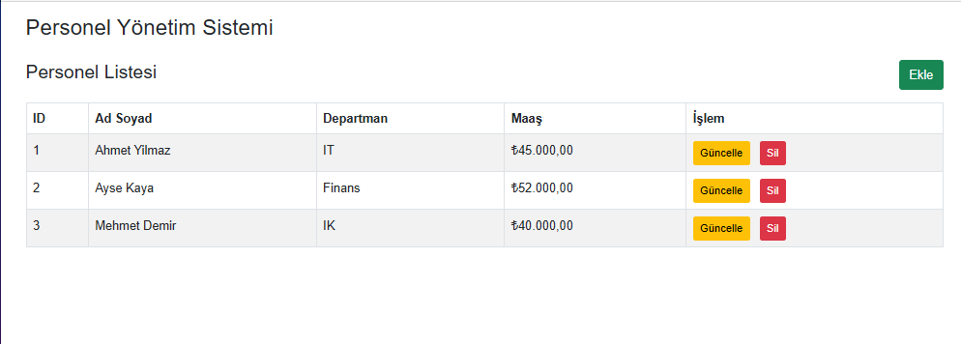
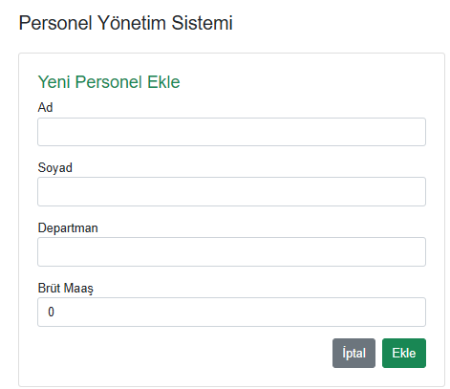 | 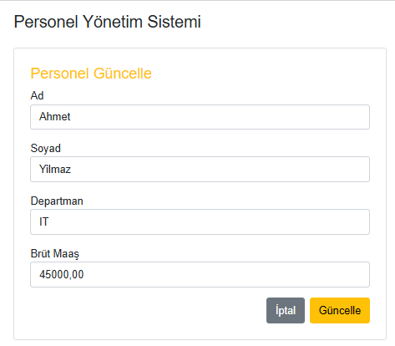 | 