Proje Adı | Ürün Sipariş ve Takip Sistemi
Proje Konusu | Müşteri, ürün, kategori, sipariş ve sipariş detaylarının yönetildiği; stok takibi ve sipariş süreçlerinin yönetildiği Blazor Server tabanlı sistem.
Proje Çözüm Adı | SAT242516033

Proje ‘Çözüm Gezgini (Solution Explorer)’ penceresinin (alt klasörler ve dosyalar dahil olacak şekilde) ekran görüntüsünü resim olarak ekleyiniz
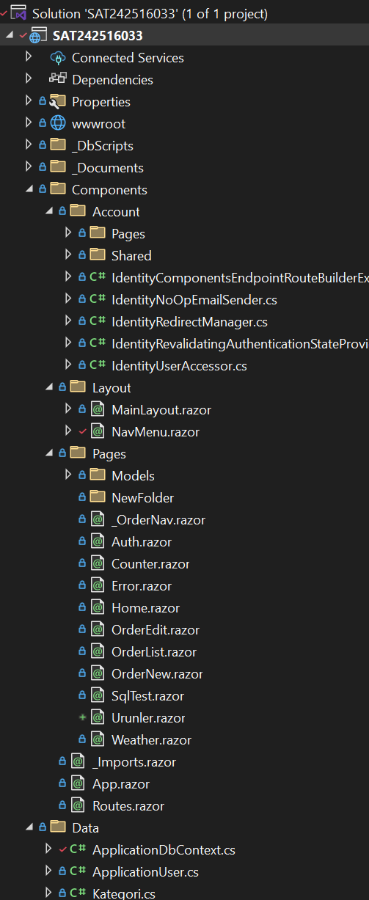 | 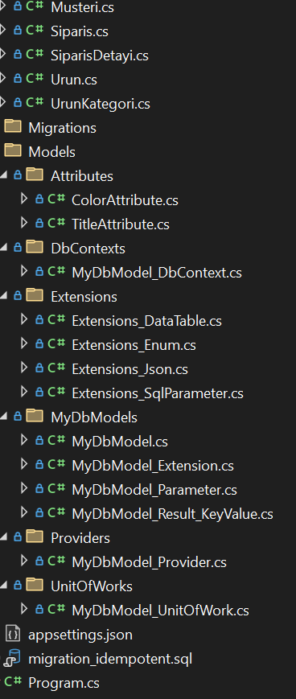

Projede oluşturulan arabirimlerin (interface) C# kodlarını yazınız.
public interface IMyDbModel
{
string Message { get; set; }
IMyDbModel_Parameter Parameters { get; set; }
IDictionary<object, object> OrderByItems { get; set; }
}
public interface IMyDbModel<T> : IMyDbModel where T : class, new()
{
IEnumerable<T> Items { get; set; }
}
public interface IMyDbModel_Parameter
{
string OrderBy { get; set; }
int PageNumber { get; set; }
int PageSize { get; set; }
int TotalPageCount { get; }
int TotalRecordCount { get; set; }
IDictionary<string, object> Params { get; set; }
IDictionary<string, string> Where { get; set; }
}
public interface IMyDbModel_Result_KeyValue<TKey, TValue>
{
TKey Key { get; set; }
TValue Value { get; set; }
}
public interface IMyDbModel_Provider
{
ValueTask<IMyDbModel<TResult>> Execute<TResult>(IMyDbModel<TResult> myResultModel,
string spName = "",
bool isPagination = true) where TResult : class, new();

ValueTask<IMyDbModel<TResult>> Execute<TResult>(string spName = "",
params (string Key, object Value)[] parameters)
where TResult : class, new();

ValueTask<IEnumerable<TResult>> GetItems<TResult>(string spName = "",
params (string Key, object Value)[] parameters)
where TResult : class, new();

ValueTask<IEnumerable<TResult>> SetItems<TResult>(string spName = "",
params (string Key, object Value)[] parameters)
where TResult : class, new();
}
public interface IMyDbModel_UnitOfWork
{
Task Execute<T>(IMyDbModel<T> myDbModel, string spName = "", bool isPagination = true)
where T : class, new();
}

Projede oluşturulan sınıfların (class) C# kodlarını yazınız.
Uyarı : Sınıf içerisinde metotların sadece isim ve parametreleri yazılacak.
Örnek : public async Task MethodAsync(parameters…) { return null; }
public MyDbModel() { }
public MyDbModel(int pageNumber, int pageSize, string orderBy) { }

public static MyDbModel_Parameter Create(int pageNumber, int pageSize, string orderBy) { }
private MyDbModel_Parameter(int pageNumber, int pageSize, string orderBy) { }

public class MyDbModel_Result_KeyValue<TKey, TValue> { }

public static IDictionary<object, object> GetOrderByItems<E>(this MyDbModel<E> myDbModel) where E : class, new() { }

public MyDbModel_Provider(IMyDbModel_UnitOfWork myDbModel_UnitOfWork) { }
public async ValueTask<IMyDbModel<TResult>> Execute<TResult>(IMyDbModel<TResult> myResultModel, string spName = "", bool isPagination = true) { }
public async ValueTask<IMyDbModel<TResult>> Execute<TResult>(string spName = "", params (string Key, object Value)[] parameters) { }
public async ValueTask<IEnumerable<TResult>> GetItems<TResult>(string spName = "", params (string Key, object Value)[] parameters) { }
public async ValueTask<IEnumerable<TResult>> SetItems<TResult>(string spName = "", params (string Key, object Value)[] parameters) { }

public MyDbModel_UnitOfWork(TDbContext context) { }
public async Task Execute<T>(IMyDbModel<T> myDbModel, string spName = "", bool isPagination = true) where T : class, new() { }

public MyDbModel_DbContext(DbContextOptions<MyDbModel_DbContext> options) : base(options) { }
protected override void OnModelCreating(ModelBuilder modelBuilder) { }

public static IEnumerable<T> DataTableToList<T>(this DataTable table) where T : class { }
public static T GetObject<T>(this DataRow row, List<string> columnsName) where T : class { }

public static string Color<T>(this T value) { }
public static string Title<T>(this T value) { }

public static T JsonToItem<T>(this string jsonItem) { }
public static string ItemToJson<T>(this T item) { }
public static List<T> JsonToList<T>(this string json) { }
public static string ListToJson<T>(this List<T> list) { }

public static SqlParameter ToSqlParameter_Table_Type_Dictionary<TKey, TValue>(
this IDictionary<TKey, TValue> dictionary,
string parameterName,
string parameterTypeName = "",
int length = 0,
SqlDbType sqlDbType = SqlDbType.Structured,
ParameterDirection direction = ParameterDirection.Input) { }

public static SqlParameter ToSqlParameter_Data_Type<T>(
this T value,
string parameterName,
ParameterDirection direction = ParameterDirection.Input,
SqlDbType sqlDbType = SqlDbType.NVarChar) { }

public ColorAttribute(string color) { }
public string Color { get; set; }

public TitleAttribute(string title) { }
public string Title { get; set; }

appsettings.json dosyasında “DefaultConnection” ifadesini projenize göre yazınız
"DefaultConnection": "Server=localhost,1445; Database=SAT242516033; User Id=sa; Password=Oo_454545; TrustServerCertificate=True;"

Program.cs dosyasında, gerekli servis kayıtlarını yapan C# kodlarını yazınız.
//// DBCONTEXTS
builder.Services.AddDbContext<MyDbModel_DbContext>(options => options.UseSqlServer(connectionString));

//// UNITOFWORKS
builder.Services.AddScoped<IMyDbModel_UnitOfWork, MyDbModel_UnitOfWork<MyDbModel_DbContext>>();

//// MODELS
builder.Services.AddScoped(typeof(IMyDbModel<>), typeof(MyDbModel<>));

//// PROVIDERS
builder.Services.AddScoped<IMyDbModel_Provider, MyDbModel_Provider>();

App.razor bileşeninde, gerekli C# kodlarını yazınız
<Routes @rendermode="@RenderModeForPage" />
@code {

[CascadingParameter] private HttpContext HttpContext { get; set; } = default!;

private IComponentRenderMode? RenderModeForPage =>
HttpContext.Request.Path
.StartsWithSegments("/Account")
? null
: InteractiveServer;

}

Projenizde oluşturmuş olduğunuz bileşenlerin tasarım ve C# kodlarını yazınız (Blazor Component)
NOT: daha fazla bileşen için, aşağıdaki tabloyu çoğaltınız.
Bileşen Adı | Urunler
Tasarım Kodları | @page "/urunler"  @using SAT242516033.Data  @using UrunSiparisTakip.Models  @using Microsoft.EntityFrameworkCore  @using Microsoft.AspNetCore.Components.Forms  @inject ApplicationDbContext Db  <h2 class="mt-3">Ürünler</h2>  <h5 class="text-primary">Liste</h5>  @if (list is null)  {  <p>Veriler yükleniyor...</p>  }  else  {  <div class="table-responsive">  <table class="table table-striped table-sm align-middle">  <thead>  <tr>  <th>Id</th>  <th>Ad</th>  <th>SKU</th>  <th>Fiyat</th>  <th>Stok</th>  </tr>  </thead>  <tbody>  @foreach (var u in list)  {  <tr>  <td>@u.UrunId</td>  <td>@u.UrunAdi</td>  <td>@u.SKU</td>  <td>@u.BirimFiyat</td>  <td>@u.StokAdet</td>  </tr>  }  </tbody>  </table>  </div>  <div class="row g-3 mt-3">  <!-- Ürün Ekle -->  <div class="col-md-4">  <div class="card border-success">  <div class="card-header fw-bold">Ürün Ekle</div>  <div class="card-body">  <EditForm Model="@newUrun" OnValidSubmit="@AddAsync">  <DataAnnotationsValidator />  <div class="mb-2">  <label class="form-label">Ürün Adı</label>  <InputText class="form-control form-control-sm" @bind-Value="newUrun.UrunAdi" />  </div>  <div class="mb-2">  <label class="form-label">SKU</label>  <InputText class="form-control form-control-sm" @bind-Value="newUrun.SKU" />  </div>  <div class="mb-2">  <label class="form-label">Fiyat</label>  <InputNumber class="form-control form-control-sm" TValue="decimal" @bind-Value="newUrun.BirimFiyat" />  </div>  <div class="mb-3">  <label class="form-label">Stok</label>  <InputNumber class="form-control form-control-sm" TValue="int" @bind-Value="newUrun.StokAdet" />  </div>  <div class="d-flex gap-2">  <button type="reset" class="btn btn-outline-secondary btn-sm">Temizle</button>  <button class="btn btn-success btn-sm" type="submit">Ekle</button>  </div>  </EditForm>  </div>  </div>  </div>  <!-- Ürün Güncelle -->  <div class="col-md-4">  <div class="card border-warning">  <div class="card-header fw-bold">Ürün Güncelle</div>  <div class="card-body">  <EditForm Model="@updateUrun" OnValidSubmit="@UpdateAsync">  <DataAnnotationsValidator />  <div class="mb-2">  <label class="form-label">Id</label>  <InputNumber class="form-control form-control-sm" TValue="int" @bind-Value="updateUrun.UrunId" />  </div>  <div class="mb-2">  <label class="form-label">Ürün Adı</label>  <InputText class="form-control form-control-sm" @bind-Value="updateUrun.UrunAdi" />  </div>  <div class="mb-2">  <label class="form-label">SKU</label>  <InputText class="form-control form-control-sm" @bind-Value="updateUrun.SKU" />  </div>  <div class="mb-2">  <label class="form-label">Fiyat</label>  <InputNumber class="form-control form-control-sm" TValue="decimal" @bind-Value="updateUrun.BirimFiyat" />  </div>  <div class="mb-3">  <label class="form-label">Stok</label>  <InputNumber class="form-control form-control-sm" TValue="int" @bind-Value="updateUrun.StokAdet" />  </div>  <div class="d-flex gap-2">  <button type="reset" class="btn btn-outline-secondary btn-sm">Temizle</button>  <button class="btn btn-warning btn-sm" type="submit">Güncelle</button>  </div>  </EditForm>  </div>  </div>  </div>  <!-- Ürün Sil -->  <div class="col-md-4">  <div class="card border-danger">  <div class="card-header fw-bold">Ürün Sil</div>  <div class="card-body">  <EditForm Model="@removeModel" OnValidSubmit="@RemoveAsync">  <div class="mb-3">  <label class="form-label">Id</label>  <InputNumber class="form-control form-control-sm" TValue="int?" @bind-Value="removeModel.Id" />  </div>  <div class="d-flex gap-2">  <button type="reset" class="btn btn-outline-secondary btn-sm">Temizle</button>  <button class="btn btn-danger btn-sm" type="submit">Sil</button>  </div>  </EditForm>  </div>  </div>  </div>  </div>  }  @code {  List<Urun>? list;  Urun newUrun = new();  Urun updateUrun = new();  class RemoveDto { public int? Id { get; set; } }  RemoveDto removeModel = new();  protected override async Task OnInitializedAsync()  {  list = await Db.Urunler.OrderBy(x => x.UrunId).ToListAsync();  }  async Task RefreshAsync()  {  list = await Db.Urunler.OrderBy(x => x.UrunId).ToListAsync();  StateHasChanged();  }  async Task AddAsync()  {  Db.Urunler.Add(newUrun);  await Db.SaveChangesAsync();  newUrun = new();  await RefreshAsync();  }  async Task UpdateAsync()  {  var ent = await Db.Urunler.FindAsync(updateUrun.UrunId);  if (ent is not null)  {  ent.UrunAdi = updateUrun.UrunAdi;  ent.SKU = updateUrun.SKU;  ent.BirimFiyat = updateUrun.BirimFiyat;  ent.StokAdet = updateUrun.StokAdet;  await Db.SaveChangesAsync();  updateUrun = new();  await RefreshAsync();  }  }  async Task RemoveAsync()  {  if (removeModel.Id is null) return;  var ent = await Db.Urunler.FindAsync(removeModel.Id.Value);  if (ent is not null)  {  Db.Urunler.Remove(ent);  await Db.SaveChangesAsync();  removeModel = new();  await RefreshAsync();  }  }  }
Ekran Görüntüleri  UYARI:  Resim boyutlarının çok büyük olmamasına dikkat ediniz | 