PROJECT NAME: NeuroMatter: Universal Local AI Hub
GROUP MEMBERS: Duru Deniz Alptekin, Şevval Acar, Kaan Efe Koygun, Ege Haktan Aykut, Ali Utku Aydın, Eren Karlı, Deren Kocabaş, Efe Berkay Soyucak.

TASK # | PROJECT TASKS WHICH REQUIRE SOFTWARE TOOL SUPPORT
1 | Mobile Application
2 | Database Management System
3 | AI Inference & Intelligence Management
4 | Control Layer
5 | Hardware Layer

SOFTWARE TOOLS FOR TASK 1: Mobile Application
Tool Cost/Training/Functionality Data

Tool | Flutter | React Native | Swift | Kotlin
Cost | $500/y | $800/y | $1500/y | $1500/y
Training Days | 10 | 15 | 25 | 25
Functionality | 95 | 85 | 90 | 90

Normalized Cost/Training/Functionality Data

Tool | Flutter | React Native | Swift | Kotlin
Cost | 33.3 | 53.3 | 100 | 100
Training Days | 40 | 60 | 100 | 100
Functionality | 100 | 89.4 | 94.7 | 94.7

Normalized Tool Graph
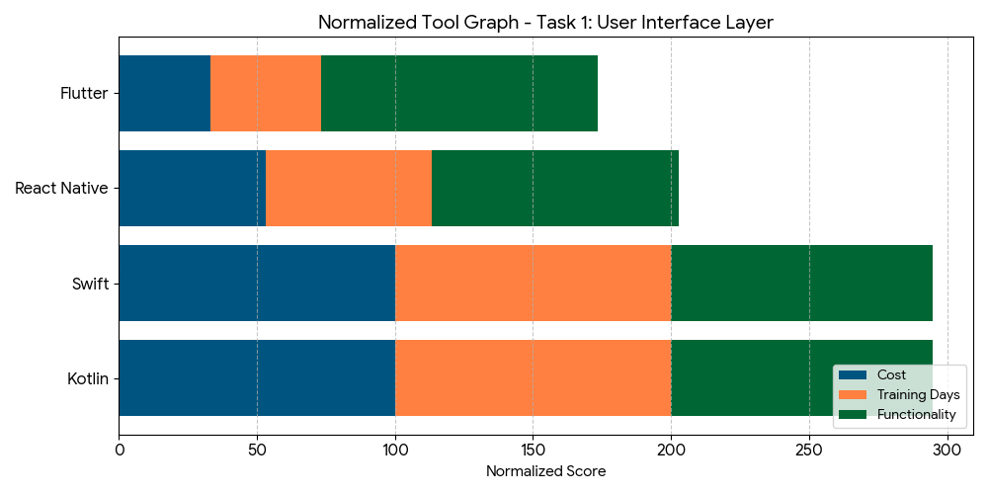

Which tool has been selected? Why?
When evaluating our options among Swift, Kotlin, and React Native, we have decided to move forward with Flutter. Our choice is rooted in a clear strategic advantage: Flutter provides the most practical and fastest solution by utilizing a single codebase for both iOS and Android. This approach allows us to deliver a high-quality experience to all users simultaneously, ensuring that our features remain consistent across different devices without the need for separate development teams or redundant effort.

By choosing Flutter over platform-specific languages or bridge-based frameworks, we significantly accelerate our development cycle and reduce operational overhead. Its high-performance rendering engine and "Hot Reload" capabilities allow us to iterate quickly and maintain a pixel-perfect UI on every screen. Ultimately, Flutter represents the most efficient path to market, offering a streamlined development process that combines the speed of cross-platform tools with the polished feel of a native application.

SOFTWARE TOOLS FOR TASK 2: Database Management System
Tool Cost/Training/Functionality Data

Tool | SQLCipher | SQLite (Standard) | PostgreSQL | MySQL
Cost | $500/y | $0 | $1200/y | $1000/y
Training Days | 5 | 2 | 10 | 10
Functionality | 100 | 40 | 90 | 85

Normalized Cost/Training/Functionality Data

Tool | SQLCipher | SQLite (Standard) | PostgreSQL | MySQL
Cost | 41.6 | 0 | 100 | 83.3
Training Days | 50 | 20 | 100 | 85
Functionality | 100 | 40 | 95 | 85

Normalized Tool Graph
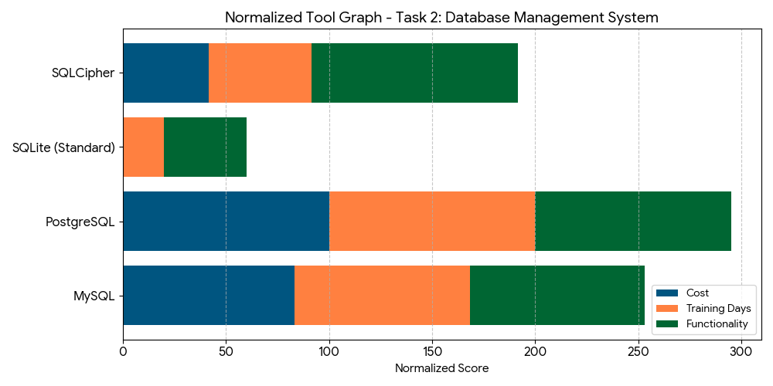

Which tool has been selected? Why?
For the data storage layer of our system, SQLCipher has been strategically selected to handle our local database needs. Given the "closed-box" nature and the strictly local operational principle of this project, ensuring that all data remains secure directly on the device is of critical importance. While standard SQLite offers advantages such as a minimal learning curve and ease of implementation, it lacks the native security features required to protect sensitive information from unauthorized access or external extraction.

To address these security requirements, SQLCipher provides a robust extension to SQLite by implementing 256-bit AES encryption. This level of industrial-grade encryption is the primary reason for our choice, as it ensures that local event logs and system data are fully encrypted at rest. By integrating SQLCipher, we maintain the lightweight efficiency of a relational database while providing a high-security environment that aligns perfectly with our project's commitment to data integrity and localized privacy.

SOFTWARE TOOLS FOR TASK 3: AI Inference & Intelligence Management
Tool Cost/Training/Functionality Data

Tool | ONNX Runtime | TF Lite | PyTorch | NVIDIA TensorRT
Cost | $400/y | $400/y | $800/y | $1500/y
Training Days | 6 | 6 | 12 | 15
Functionality | 98 | 95 | 70 | 100

Normalized Cost/Training/Functionality Data

Tool | ONNX Runtime | TF Lite | PyTorch | NVIDIA TensorRT
Cost | 26.6 | 26.6 | 53.3 | 100
Training Days | 40 | 40 | 80 | 100
Functionality | 98 | 95 | 70 | 100

Normalized Tool Graph
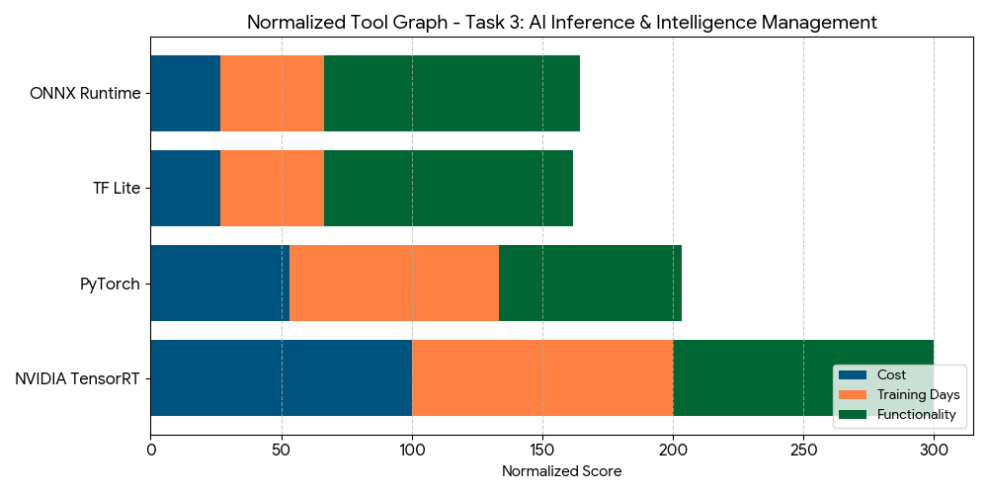
Which tool has been selected? Why?
For the AI inference layer of our system, TensorFlow Lite (TFLite) has been strategically selected as the primary deployment framework for running our machine learning models entirely within the local infrastructure. TFLite's optimized runtime is specifically engineered for on-device inference, making it the ideal choice for executing our YOLOv8n object detection model and Qwen2-VL-2B Vision Language Model without any reliance on external cloud processing. Its native support for quantization allows us to significantly reduce model size and memory consumption while preserving accuracy, which is essential for meeting our strict "2-second rule" and maintaining a seamless, responsive user experience.
By deploying our models through TFLite on the Raspberry Pi 4, we ensure that all AI processing remains fully local, in complete alignment with the project's "closed-box" principle. TFLite's tighter integration with ARM-based embedded hardware, its lightweight execution engine, and its mature mobile and edge ecosystem make it the superior choice for this project's architecture. While ONNX Runtime remains a viable alternative for cross-framework compatibility, standardizing on TFLite provides a consistent, well-supported, and highly optimized inference pipeline that delivers maximum performance on constrained local hardware, guaranteeing that end-to-end inference latency stays well below the required threshold for a reliable and efficient system.

SOFTWARE TOOLS FOR TASK 4: Control Layer
Tool Cost/Training/Functionality Data

Tool | CSA Matter SDK | Home Assistant | openHAB | Domoticz
Cost | $1000/y | $200/y | $200/y | $200/y
Training Days | 20 | 8 | 12 | 10
Functionality | 100 | 70 | 65 | 50

Normalized Cost/Training/Functionality Data

Tool | CSA Matter SDK | Home Assistant | openHAB | Domoticz
Cost | 100 | 20 | 20 | 20
Training Days | 100 | 40 | 60 | 50
Functionality | 100 | 70 | 65 | 50

Normalized Tool Graph
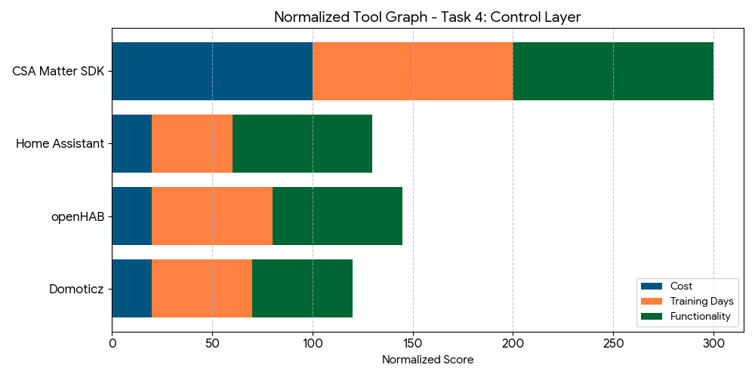

Which tool has been selected? Why?
For the automation engine, we have strategically selected the CSA Matter SDK paired with a Python (FastAPI) backend. This combination allows us to establish a high-performance architecture where the core hardware layer communicates via C++ for near-zero latency, while Python serves as the sophisticated bridge between our artificial intelligence models and the physical hardware. By offloading time-critical tasks to C++ and leveraging FastAPI’s asynchronous capabilities for high-level logic, the system achieves a professional-grade balance between raw power and modern flexibility.

Integrating the Matter protocol is a foundational decision for the project's long-term scalability and interoperability. As the industry standard for smart homes, Matter ensures that our system is not a closed ecosystem but a future-proof platform capable of seamless communication with a vast array of third-party smart devices. This standardized approach, combined with our custom automation engine, elevates the backend architecture to a level of performance and compatibility that meets the highest modern standards for smart infrastructure.

SOFTWARE TOOLS FOR TASK 5: Hardware Layer
Tool Cost/Training/Functionality Data

Tool | Raspberry Pi 4 | Arduino
Cost | $90/y | $35/y
Training Days | 3 | 2
Functionality | 85 | 55

Normalized Cost/Training/Functionality Data

Tool | Raspberry Pi 4 | Arduino
Cost | 20 | 7.8
Training Days | 60 | 40
Functionality | 94.4 | 61.1

Which tool has been selected? Why?
For the hardware layer of our system, a dual-platform architecture combining Arduino and Raspberry Pi 4 has been strategically selected, with each platform assigned a distinct and specialized role within the system pipeline. This combination allows us to establish a clean separation of responsibilities: Arduino handles all real-time sensor data acquisition and actuator management at the hardware level, while Raspberry Pi 4 serves as the central processing unit responsible for coordinating system logic, managing inter-component communication, and running the AI inference pipeline entirely on-device.
By assigning Arduino the role of dedicated low-level controller, we leverage its deterministic, interrupt-driven execution to ensure that time-sensitive hardware interactions — such as reading environmental sensors and triggering physical outputs — are handled with minimal and predictable latency. The Raspberry Pi 4, with its quad-core ARM CPU and Linux-based environment, provides the computational headroom necessary to run TensorFlow Lite implementations of YOLOv8n and Qwen2-VL-2B locally, fully aligned with the project's "closed-box" principle. This layered approach eliminates the need for cloud dependency at the hardware level, ensuring that the system remains fully autonomous, cost-effective, and maintainable while meeting the strict 2-second inference threshold required for a seamless and responsive user experience.

