Bilkent University

Computer Science Department



**Senior Design Project**

*Project Name: Hygiene Score*

Project Analysis

Project Members: Ege Karaarslan, Onatkut Dağtekin, Özge Karaaslan, Defne Demirtürk, Alper Eroğlu

Supervisor: Özgür Ulusoy

Jury Members: Mustafa Özdal and R. Gökberk Cinbiş

Nov 7, 2016

This report is submitted to the Department of Computer Engineering of Bilkent University in partial fulfillment of the requirements of the Senior Design Project course CS491/2.

Table of Contents

1. Introduction 3

2.Proposed System 4

2.1 Overview 4

2.2 Functional Requirements 4

2.2.1 Functional Requirements for the Users 4

2.2.1.1 Customers 4

2.2.1.2 Business Owners 5

2.2.1.3 Inspector 5

2.3 Non-Functional Requirements 5

2.3.1 User-friendly Interface 5

2.3.2 Maintainability 5

2.3.3 Platform Compatibility 5

2.4 Constraints 6

2.4.1 Economic Constraints 6

2.4.2 Social Constraints 6

2.4.3 Implementation Constraints 6

2.4.4 Language Constraints 6

2.4.5 Sustainability Constraints 6

2.4.6 Security Constraints 7

2.4.7 Technical Constraints 7

2.4.8 Timing Constraints 7

2.5 System Models 7

2.5.1 Scenarios 7

2.5.2 Use Case Model 16

2.5.3 Object and Class Model 17

2.5.4 Dynamic Models 19

2.5.5 User Interface Designs 26

# 1. Introduction

The recent advancements in technologies has enabled people to reach information with ease. With increasing accessibility to the web and quickness of mobile devices, information about anything is in people’s hands in no time. People search for the items that they wish to buy, the movies they want to see and where they want to eat before anything else. Mobile applications and websites are introduced to reach people’s demands for this information annually. In today’s world, people do not wish to have a go at it, but they want to know every detail beforehand.

Restaurants and other food establishments are the most searched industry on the web. A research done in 2013 indicates that 81 percent of consumers search the restaurant they wish to eat before going there. Today there are many applications and websites on the market that provide information and even other customers’ experiences about restaurants. These applications focus on the tastiness of the food, fastness of the service or the attitude of the serving personnel. However, the customers have no information about the background of these establishments. They do not have access to infrastructural features such as the hygiene of the cooking place, hygiene of the personnel or about the quality of the food used. The recent trend among the people is the priority given to hygiene and people want transparency regarding this aspect. There is currently no application in the market that can deliver information about these infrastructural features of restaurants. Moreover, customers have no visible access to the evaluations of restaurants conducted by professional food inspectors. Hygiene Score is an application that wishes to meet people’s demand for more information and transparency by providing enlightenment about unseen feature of restaurants supervised by professional inspectors.

On an owner’s point of view, they are investing grave amount of money to advertisements to attract customers to their establishments. With the recent increase of demand for transparency, being undisguised is a form of great advertisement. This application is a way for them to open their doors and show their infrastructure in a single environment and promote their restaurant in the most noble of ways.

# 2.Proposed System

## 2.1 Overview

As a group we have decided to work on a software project regarding the hygiene aspect of food establishments. In our world applications about grading and scoring quality is getting more global everyday. Thus, we decided to create an application that would show people how clean and neat an establishment is regarding some data which are proven by inspectors. In our previous report we have showed and declared our fundamental specifications without any unnecessary details. Now, in our analysis report, we have composed our more detailed models and scenarios of our system. The following sections will be presenting these subsections.

## 2.2 Functional Requirements

* Application should have relationship with external interfaces to be user-friendly

system that can be learned and used easily by users.

* Web site should show an individual home page for every food establishment.
* The shown data and statistical graph should be accurate.
* The application will be accessible via mobile markets and web.
* The application will store information about the food establishments and show them on their specific home pages.
* Hygiene Score will categorize the food establishments into different categories
* Application will have a page that recommends a weekly high rated establishment from the database according to the grades of them.

## 2.2.1 Functional Requirements for the Users

### 2.2.1.1 Customers

* Customers can search the food establishments regarding their category
* Customers shall be allowed to view all of the home pages of the food establishments.
* Customers that are interested, can get beginner’s education via virtual education videos about how to inspect the hygiene level of a place.
* Customers shall give marks to the food establishments.
* The application will provide a graphical representation of the grades of the specific food establishment that are gained through the inspections, to the customers.
* Customers shall comment to the food establishments

### 2.2.1.2 Business Owners

* Business Owners who have requested the system to provide their workers some training on hygiene shall be allowed to get the education for their workers via the virtual education videos.
* Business Owners can set up their home pages.
* Business Owners can put pictures of their establishment to their home page.
* Business Owners can set up their home pages.

### 2.2.1.3 Inspector

* Hygiene Score will provide a evaluation interface for the inspectors that afterwards will be recorded in a database.
* Inspectors would be the only users that are allowed to use the evaluation interface

## 2.3 Non-Functional Requirements

## 2.3.1 User-friendly Interface

Hygiene Score’s target audience is generally the new millennial generation, although the user’s age could increase in daily life. As younger generation is our target audience, our application should have a user friendly user friendly interface otherwise no matter how great our application is, people will not get used to using neither our application nor our web site.

## 2.3.2 Maintainability

For our application, Hygiene Score, the maintainability would have  both the back end and the application client on the market works as intended. For the mobile application of Hygiene Score maintaining the latter one will be through the updates through Android Play Store. The former one is related to the server side of the system. Maintaining server side operations will be our responsibility as long as the application is being used.

## 2.3.3 Platform Compatibility

Hygiene Score will be developed as an application that is compatible with multiple platforms. The users will be able to use it as a web-application on Windows and also as a mobile application on Android phones.

## 2.4 Constraints

### 2.4.1 Economic Constraints

* The application will be free to download from the appstore and free to use from internet browsers.
* Domain name for the website will be bought and the databases needed for the website and the app will be purchased. The database will be used to contain information about the restaurants, fast food chains etc. and the users of the application.
* The application will also contain fees for the restaurant customers to get access to hygiene control education modules, restaurant owners to earn a certification badge after following a personnel education and hygiene education module.

### 2.4.2 Social Constraints

* The users have to create their own accounts or login via Facebook to use the application and the website.
* Other than rating the restaurant in specific, the users will be able to leave comments about the restaurant and it might have a difference in impact according to their account’s history.

### 2.4.3 Implementation Constraints

* The language of the android application will be Java.
* The website will be developed with HTML5, CSS and JavaScript.

### 2.4.4 Language Constraints

* The language of the application of the website will be available both in English and Turkish.

### 2.4.5 Sustainability Constraints

* The growth of Hygiene Score will be in parallel with the size of the data it stores.
* Hygiene Score will be updated in every once in awhile.
* Hygiene Score stores both professional and unprofessional evaluation from the previous moths’ inspections on the food establishments therefore, so that the user can see the particular establishment’s improvement or descension.

### 2.4.6 Security Constraints

* The data of the restaurants and the users that has been collected for Hygiene Score will be kept in the database system and they will be backed up.
* The data that has been given by the user during the registration such as name, password and email address will be maintained safe and they will not be shared with anyone.

### 2.4.7 Technical Constraints

* Since Hygiene Score is a web based program it will work on devices that has access to the internet.
* The application will work on the mobile devices that has Android Operating System.

### 2.4.8 Timing Constraints

* The project will be completed both on the implementation and testing aspects by May 2017.

## 2.5 System Models

### 2.5.1 Scenarios

Log-In

Use Case Name: Log-In

Participating Actor: User

Entry Condition: User clicks the log-in button.

Exit Condition: User successfully logs in with his/her credentials.

Flow of Events:

1. User is asked to enter his/her email and password.

2. User enters his/her email and password registered to the system.

3. The user’s entered credentials are checked and approved.

4. User is logged in.

Alternative Flow of Events:

3.1. User is not approved to the system due to a wrong credential.

3.2. User is prompted to enter his/her credentials again or create an account.

Search by Restaurant Name

Use Case Name: Search by Restaurant Name

Participating Actor: User

Entry Condition: User clicks the search icon.

Exit Condition: User finds the desired result.

Flow of Events:

1. User types in a keyword for the name of the restaurant he/she wishes to see.

2. The restaurants that contain that keyword in their name are listed.

Search by User Name

Use Case Name: Search by User Name

Participating Actor: User

Entry Condition: User clicks the search button.

Exit Condition: User finds the user he is looking for.

Flow of Events:

1. User types in a keyword for the user he/she wishes to see.

2. The users that contain that keyword in their name are listed.

Search with Filter

Use Case Name: Search with Filter

Participating Actor: User

Entry Condition: User clicks the search icon.

Exit Condition: User finds the restaurant he/she is looking for.

Flow of Events:

1. User chooses from the parameters listed to him such as the cuisine, location and rating etc. to find a restaurant matching those parameters.

2. The restaurants that match the given criteria are listed.

Create Account

Use Case Name: Create Account

Participating Actor: User

Entry Condition: User clicks the create account button.

Exit Condition: User successfully completes the creation of account.

Flow of Events:

1. User is asked to enter personal information, such as name, email, location.

2. User enters the desired information.

3. The user’s entered information is checked and verified.

4. The user is asked to choose the type of the account which can be customer, owner or inspector.

5. User chooses the type as customer.

6. The user is asked to choose his cuisine interest.

7. User enters his cuisine interests and approves the information he entered by clicking the finish button.

8. An account for the new user is created.

Alternative Flow of Events:

1.1. User chooses the type as owner.

1.2. The user is prompted to the create restaurant page before the account creation.

2.1. User chooses type as inspector.

2.2. The user is asked to enter his company and professional details.

2.3. User enters the desired information.

2.4. The user’s entered information are verified and an account is created.

Customer Rate Restaurant

Use Case Name: Customer Rate Restaurant

Participating Actor: Customer

Entry Condition: Customer is at the restaurant’s profile page.

Exit Condition: Customer successfully rates the restaurant.

Flow of Events:

1. Customer clicks the rate restaurant button.

2. Customer gives his desired ratings about the restaurant by choosing a number from 1 to 5 about the given parameters.

Inspector Rate Restaurant

Use Case Name: Inspector Rate Restaurant

Participating Actor: Inspector

Entry Condition: Inspector is at the restaurant profile page.

Exit Condition: Inspector successfully rates the restaurant.

Flow of Events:

1. Inspector clicks the rate as inspector button.

2. The checklist for rating for the inspector is displayed.

3. Inspector gives his desired ratings by giving a number from 1 to 5 to each item in the checklist.

4. Inspector clicks the complete button.

Request Restaurant Addition

Use Case Name: Request Restaurant Addition

Participating Actor: Owner

Entry Condition: Owner clicks the add restaurant button.

Exit Condition: Owner successfully completes the application.

Flow of Events:

1. The owner is asked to fill information about the restaurant such as location, name, and cuisine etc.

2. Owner enters the desired information to the form provided.

3. Owner clicks the complete button.

Approve Restaurant Create Request

Use Case Name: Approve Restaurant Creation

Participating Actor: Inspector

Entry Condition: Inspector receives a restaurant creation request from an owner.

Exit Condition: Inspector approves the request of the owner.

Flow of Events:

1. The inspector is asked to confirm if such a restaurant exists.

2. Inspector inspects the restaurant and enters his rating to the site.

3. An approval of the restaurant message is sent to the owner.

Create Restaurant Profile

Use Case Name: Create Restaurant Profile

Participating Actor: Owner

Entry Condition: Owner receives the approval of his restaurant addition request.

Exit Condition: Owner successfully enters information about the restaurant.

Flow of Events:

1. Owner clicks the create restaurant profile option in the message.

2. Owner enters menu of the restaurant through a form.

3. Owner uploads photos of the restaurant.

4. Owner clicks the complete button to finish.

5. The restaurant profile is made visible in the system.

Manage Personal Account

Use Case Name: Manage Personal Account

Participating Actor: User

Entry Condition: User clicks edit account button.

Exit Condition: User successfully completes the editing of the account.

Flow of Events:

1. User makes the changes he desires about his account from the form provided to him.

2. User approves the changes by clicking complete.

Manage Restaurant Profile Page

Use Case Name: Manage Restaurant Profile Page

Participating Actor: Owner

Entry Condition: Owner clicks the edit restaurant profile button.

Exit Condition: Owner successfully completes his changes.

Flow of Events:

1. Owner enters his desired changes on the restaurant profile from the form provided to him.

2. Owner approves the changes by clicking the complete button.

Comment on Restaurant

Use Case Name: Comment on Restaurant

Participating Actor: Customer

Entry Condition: Customer is on the restaurant’s page.

Exit Condition: Customer publishes his comment.

Flow of Events:

1. Customer clicks the comment button.

2. A form is provided to the customer asking him to enter the comment and other details such as when he visited the restaurant.

3. Customer fills the content of the comment and selects the other details.

4. Customer completes his comment by clicking the complete button.

5. The customer’s comment is published on the restaurant’s page.

Add Restaurant to Favourites

Use Case Name: Add Restaurant to Favourites

Participating Actor: Customer

Entry Condition: Customer is on the restaurant’s profile.

Exit Condition: Customer successfully adds the restaurants to his favourites list.

Flow of Events:

1. Customer clicks the add to favourites icon on the profile of the restaurant.

2. The restaurant is added to the favourites list of the customer.

Create Education Module

Use Case Name: Create Education Module

Participating Actor: Inspector

Entry Condition: Inspector clicks the create education module button.

Exit Condition: The education module is made visible to the other users.

Flow of Events:

1. The inspector is asked to fill in the details about the module such as who it is for and the name and scope of the module.

2. Inspector uploads the content of the module as a video.

3. Inspector writes in further details about the module.

Pay for Education Module

Use Case Name: Pay for Education Module

Participating Actor: User

Entry Condition: User is in the modules page.

Exit Condition: The module is made visible to the user.

Flow of Events:

1. User clicks the pay for module next to the module in the list.

2. The user is asked to confirm his personal information.

3. User confirms his personal information.

4. The user is asked to enter his credit card info.

5. User enters his credit card details and clicks the complete button.

6. The entered card info by the user is verified and user is prompted to complete his order.

7. User completes his order by pressing the complete button.

8. A receipt/bill is sent to the user’s email.

Alternative Flow of Events:

6.1. The credit card is not verified.

6.2. The user is asked to re-enter the card information or cancel the payment.

View Education Module

Use Case Name: View Education Module

Participating Actor: User

Entry Condition: The module is visible to the user after his payment.

Exit Condition: User successfully completes module and receives a certificate.

Flow of Events:

1. User clicks the start module button.

2. The user is provided with the material put in by the inspector.

3. User opens the video and materials and views them.

4. After the completion of the video, user is asked to take a test.

5. The user is provided with questions about the scope of the module.

6. User takes the test by choosing the answers for each question.

7. The user’s answers are evaluated and determined as successful.

Alternative Flow of Events:

7.1. The user’s test is not found successful.

7.2. The user is asked to re-view the education material.

View Restaurant

Use Case Name: View Restaurant

Participating Actor: User

Entry Condition: The user is in the search results page.

Exit Condition: User clicks the return to homepage button.

Flow of Events:

1. User chooses the restaurant he wishes from the search results page.

2. The restaurant’s profile page is opened.

Get Help

Use Case Name: Get Help

Participating Actor: User

Entry Condition: User has opened the application.

Exit Condition: User clicks the return to homepage button.

Flow of Events:

1. User clicks the help button.

2. The user is shown the FAQs and other options button.

3. User choose other options button.

4. The user is displayed a form asking him to enter his personal information and the content of his problem.

5. User enters the desired information and details of his problem.

6. User clicks the complete button.

7. The message is sent to the person in charge.

2.5.2 Use Case Model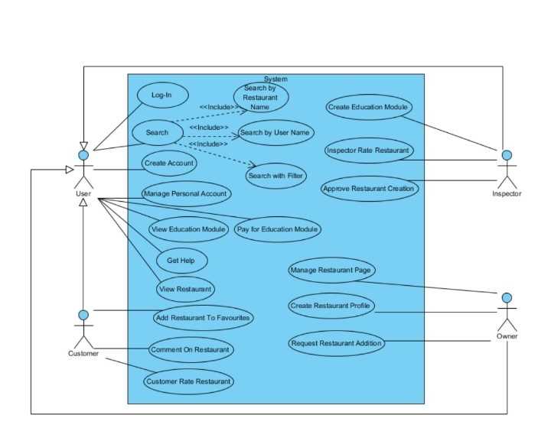

### 2.5.3 Object and Class Model

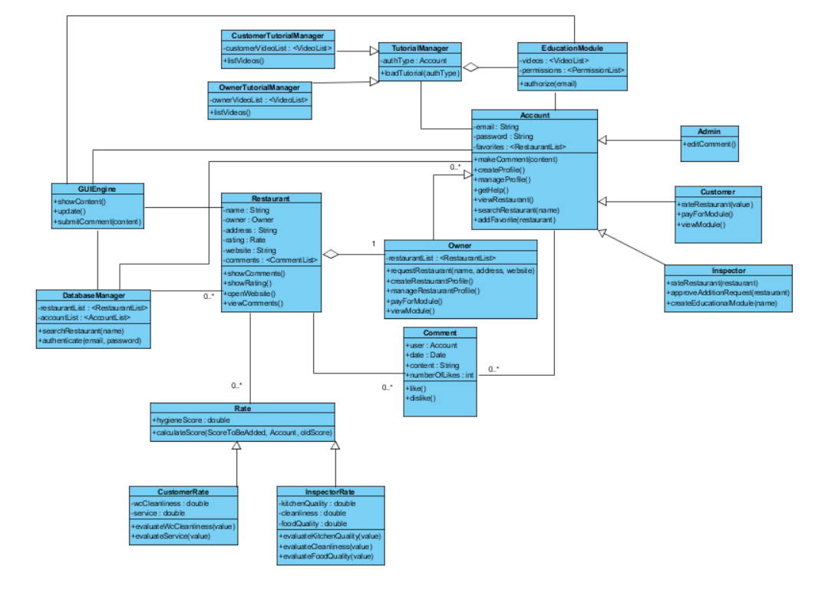

The object model of HygieneScore is illustrated above. This diagram contains 16 classes.

**Account:** This class is where the accounts and profiles of users aree araanged and organized. Account controls profile creation and management, commenting and getting help operations. Account class has 4 child classes such as Owner, Customer, Inspector and Admin.

o   **Owner:** Owner is the class here the list of restauants of the owner is kept and the capabilities assosiated with the Owner type user is managed.

o   **Customer:** Customer is the class where the operations of Customer type of user is arranged such as rating, favoriting and paying for tutorals.

o   **Inspector:** Inspector is the class where the rating rastaurants according to how hygiene they are, apporiving the addition of restaurant request and  forming the EducationModule tuttorial are arranged.

o   **Admin:** Admin is the class where the comments by the users are editted.

**Restaurant:** Restaurant is the class where the information about restaurant and the operations such as showing  comments, showing rating and opening resturant website is managed.

**Comment:**  Comment is the class where the customer comments are managed.

**GUIEngine:**  GUIEngine is the class that is responsible for communicating  with the user.  It manages the operations such as showContent(), update() and submitComment(content).

**DatabaseManager:**  DatabaseManager is responsible for communicating with the database which keeps the restaurant and account information.

**EducationModule:** This class is responsible for arranging permissions and tutorial videos.

**TutorialManager:** TutorialManager is responsible for loading tutorial videos. This class has two child classes such as CustomerTutorialManager and OwnerTutorialManager

**Rate:** This class is responsible for calculating the rate of a restaurant. Rate class has two child classes : CustomerRate and InsepctorRate.

### 2.5.4 Dynamic Models

#### 2.5.4.1 State Chart Diagram

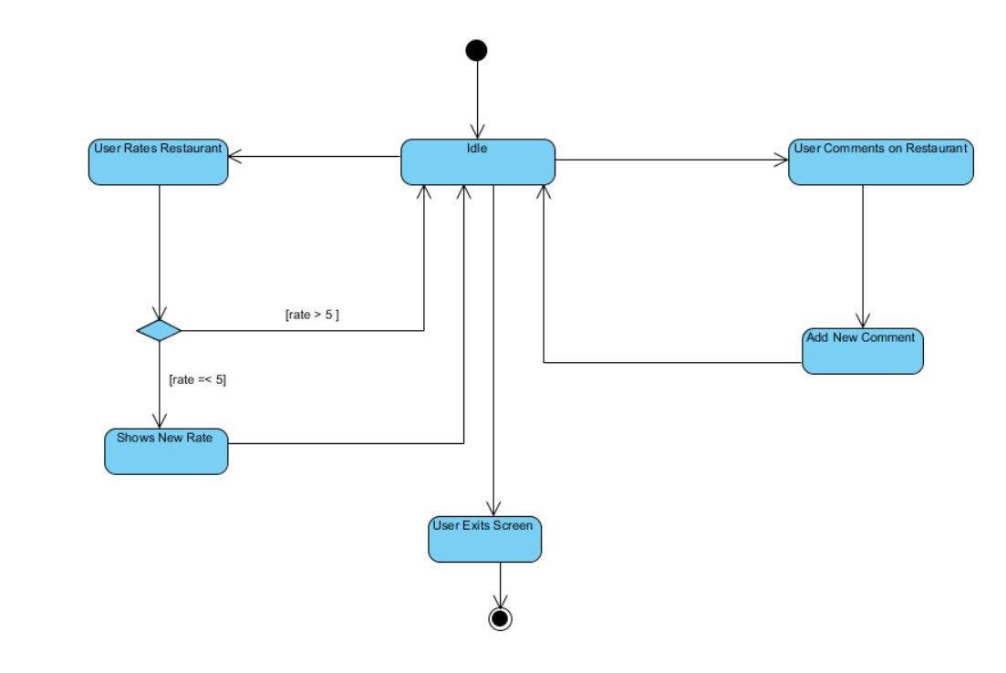

This state chart diagram explains the actions that can be done on a Restaurant objects. If the user comments on the restaurant the new comment is added to the restaurant. If the user rates the restaurant out of 5 the system checks if the rate is greater than 5 or not. If greater than 5 the restaurant object becomes idle. If the rating is smaller than 5 then the new rating of the restaurant is shown to the user. In addition to these, user may exit the screen and the process reaches to an end.

#### 2.5.4.2 Activity Diagram

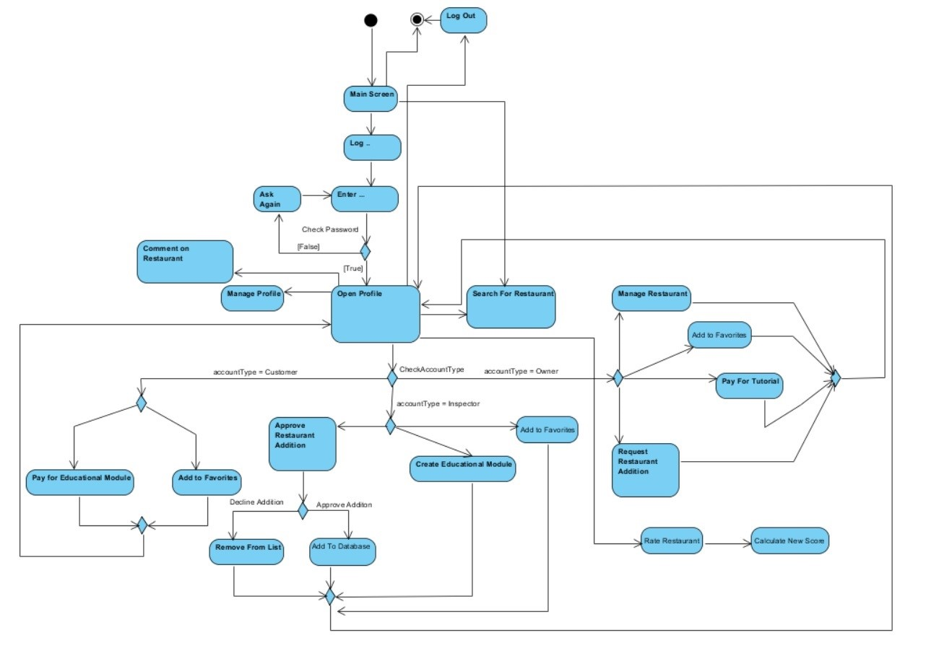

This diagram explains the overall state flow through out the system depending on the type of user. The user is greeted by a screen that asks him to enter his/her account credentials, if he/she does not have an account, the user can only search for the food establishments. If the user has an account, the system asks for the email and the password. If the information does not match the user is asked again, else the user profile is open. From the next screen, the user can have a variety of options on what to do depending on their type of account. If he/she is a customer, he/she can manage his/her profile, search for a restaurant, start an educational module, add a restaurant to their favourites comment on a restaurant and rate a restaurant. If the user is an inspector, he/she can manage his profile, add restaurants to favorites list, create new educational modules by supplying the necessary information, approve a restaurant addition requested by an owner, rate a restaurant. The inspector can decline or approve the addition of the restaurant, if approved the new restaurant will be added to the database. The owners can manage their restaurant profiles and own profiles, add other restaurants to favorite list, pay for educational modules, request new restaurant additions, comment on restaurants, search for restaurant and rate them.

#### 2.5.4.3 Sequence Diagrams

Scenario #1: Commenting on Restaurant

Customer Özge requests to log in to the system by entering her email and password with the help of GUIEngine. Then, the email address and password entered by the customer are searched through the DatabaseManager. If found in the database, the system sends massage to Account class to give authentication to Özge according to parameters she has given and sets her authentication as “Customer”. Then the GUIEngine is updated. After this step, Özge searches for a restaurant and the page is updated by displaying the restaurant that is searched for. Özge, then selects the restaurant and makes a comment on the restaurant. Through this process, the system calls Account class’s method on making a comment and after this Account creates a Comment object. In GUIEngine the comment gets submitted and the page is updates according to the changes.

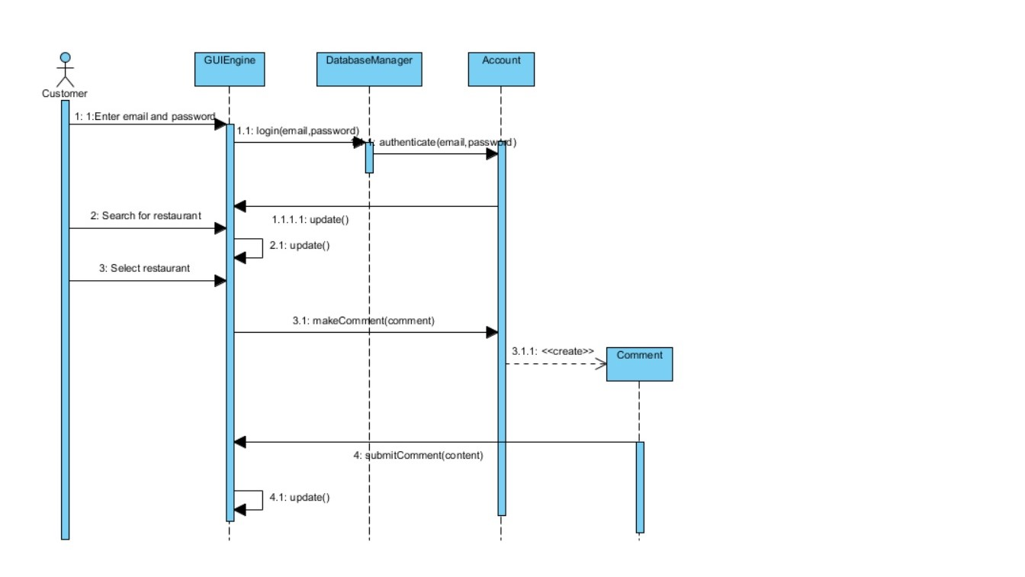

Scenario #2: Rating a Restaurant

Customer Defne requests to rate one of the restaurant HygieneScore has in its database. Assuming that the steps of the login process to the system that is explained in the previous sequence diagram are performed, Defne selects the restaurant she will rate and the GUIEngine is updated. Then, she presses on the rate restaurant button on the page. Following that, a CustomerRate object is created and the system calculates the new score of the restaurant according to the new rate Defne has given. Lastly, GUIEngine is updated.

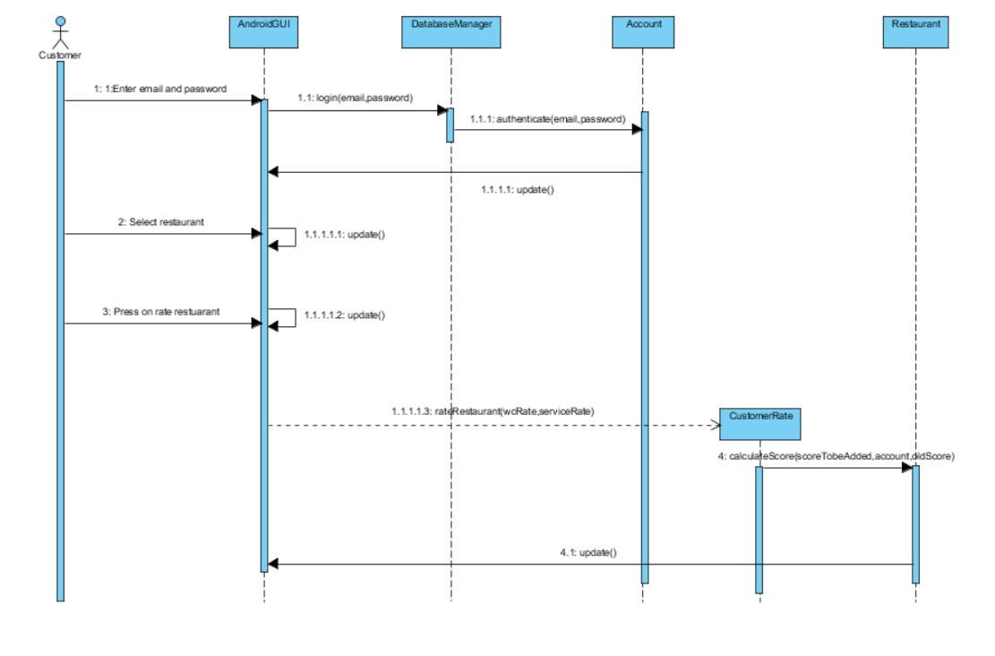

Scenario #3: Showing Tutorials

User (Customer/ Owner) Onatkut, requests to view the tutorials that are uploaded and arranged by the inspectors. Assuming that the steps of the login process to the system that is explained in the previous sequence diagram are performed, Onatkut presses on tutorials button on the page. Then, the system calls the authorize method of EducationModule in order understand if the user is a customer or an owner. An authType is returned to the system and TutorialManager loads the tutorial videos. If the authType is equal to “Customer”, CustomerTutorialManager lists the tutorial videos prepared for customers. If it is equal to “Owner”, OwnerTutorialManager lists the Owner tuttorials.

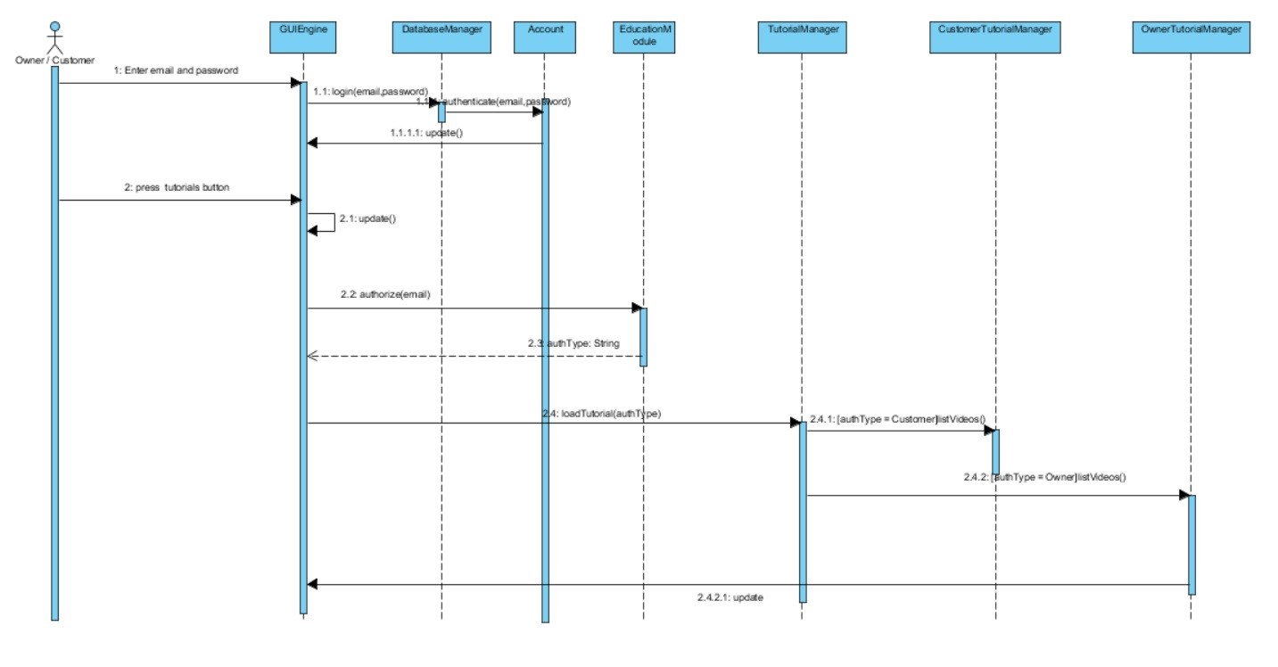

Scenario #4: Creating Restaurant

Owner Alper, requests to create a restaurant in HygieneScore system. Assuming that the steps of the login process to the system that is explained in the previous sequence diagrams are performed, Alper enter the name address and the website information of the restaurant that will be created. Then, the system calls createRestaurant method of Owner class and after this process, the new restaurant object is created.

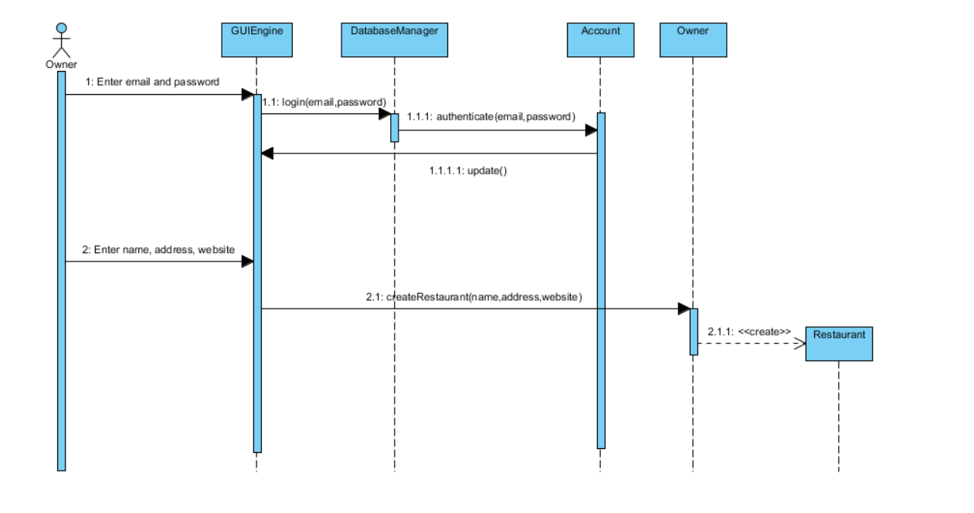

Scenario #5: Searching a Restaurant

Custemer Ege requests to search for a restaurant with the help of GUIEngine. Then, DatabaseManager searches for the restaurant according to the given restaurant name. When the system finds the restaurant in the database a Restaurant object is created and GUIEngine shows the information about the restaurant to Ege. After all is done, the Restaurant object created is deleted.

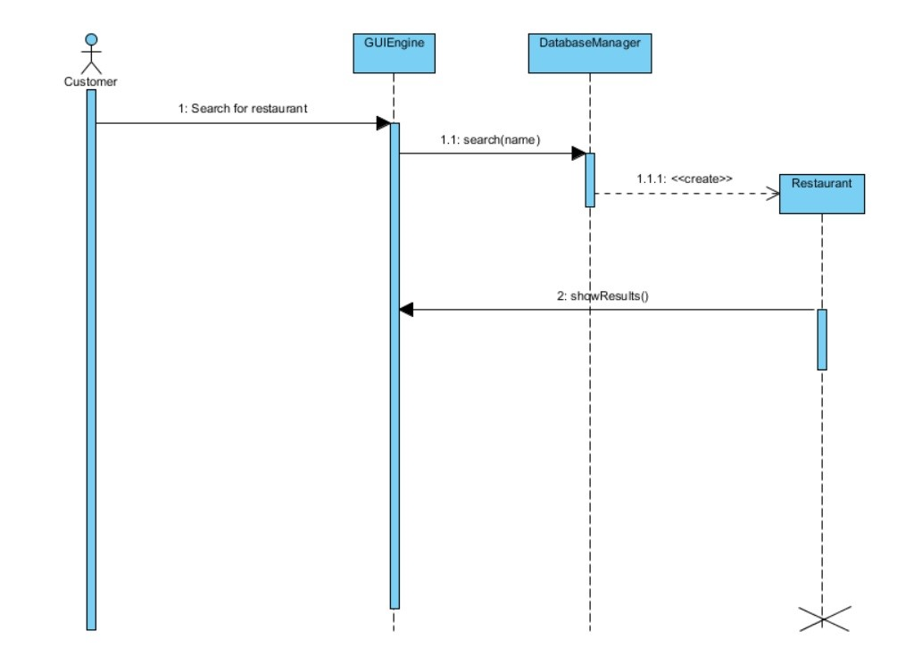

### User Interface Designs

#### 2.5.5.1 Website UI

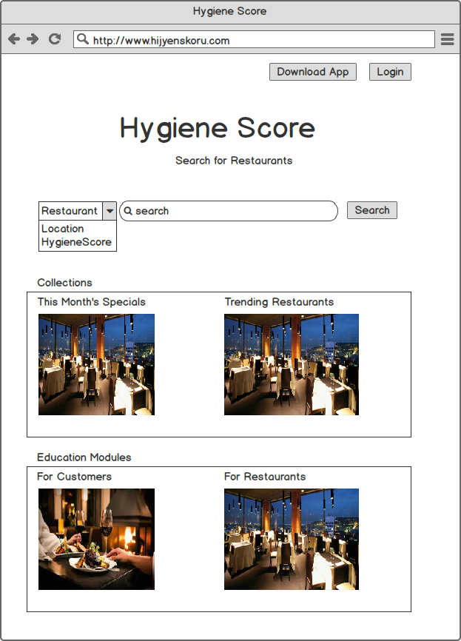

Figure 1: Homepage Window for Hygiene Score Website

Our program will have a homepage in it’s website, and in it the user will be able to search for restaurants and reach to some educating tutorials. Moreover, the user will ben able to see some other features such as trending restaurants and monthly specials as seen in Figure 1.

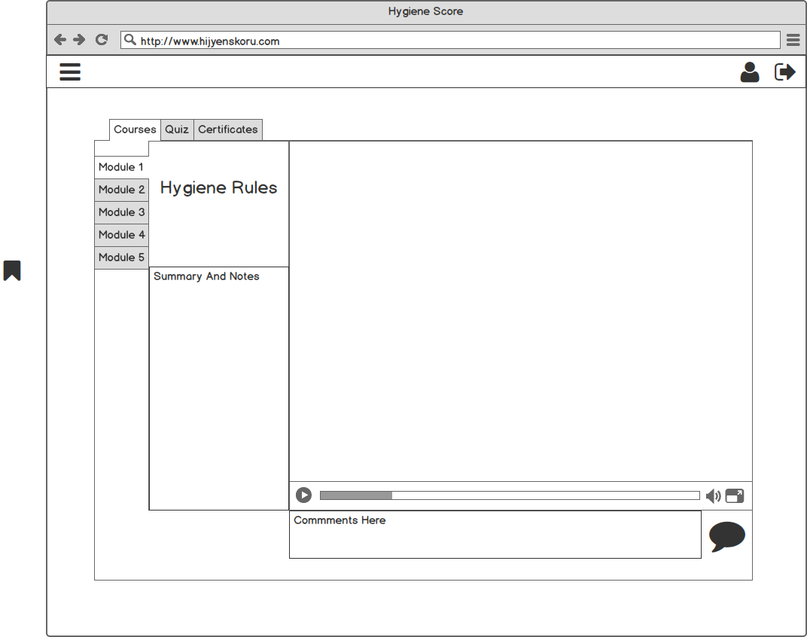

Figure 2 : Tutorials Window for Hygiene Score Website

Moreover, if the user wanted to proceed to see the tutorials, then as in Figure 2 the tutorials page will be shown. Here user will be able to watch the tutorials as a seriesof modules.

#### 2.5.5.2 Android UI

For the Android application version of our software, the user interface would be as follows.

When the user initiates the application the welcoming page displayed in Figure 3 would appear with two options. The user can either move on to login to the application or they can search any restaurant without having an account.

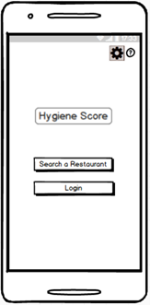

Figure 3: Home Page Window

If the user decides to search a restaurant then the search window will appear as shown in Figure 4.

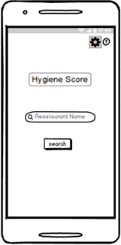

Figure 4: Search Restaurant Window

When the user proceeds to login the system then the application will ask for the email address of the user and also the password as it is shown in Figure 5.

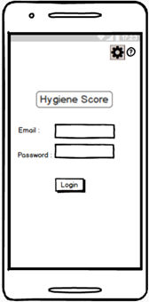

Figure 5: Login Window

A)  Customer UI

If the user has an account type of customer, then the options specific for the customer will be shown on the customer home page, as shown in Figure 6.

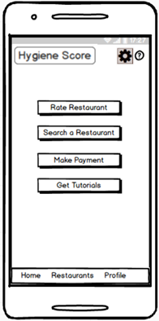

Figure 6: Customer Home Page Window

If the user selects the Search a Restaurant option, then the default Search Restaurant Window will be displayed. (Figure 4)

If the user selects the Get Tutorials option, the window that lists the related tutorials which the user has paid for will be shown. (Figure 7)

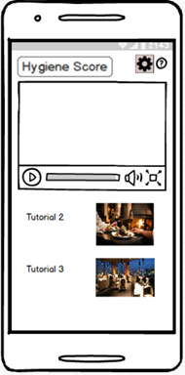

Figure 7: Customer’s Tutorials Window

If the user selects the Rate Restaurant option, then as shown in Figure 8, the application will show the window that gathers the hygiene rating of restaurant.

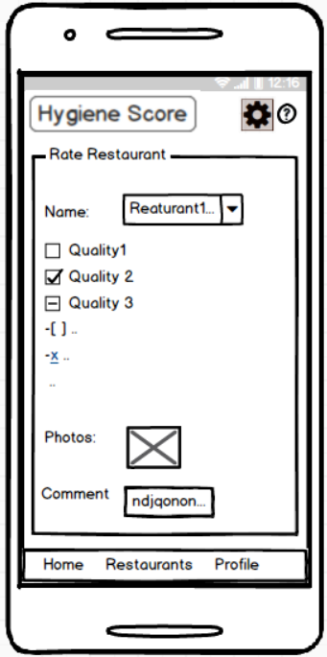

Figure 8: Rate Restaurant Window

Other than the options the owner can use the buttons in the bottom of the display, such as “Profile”. If they press the “Profile” button than their own profile page will be displayed as shown in Figure 9.

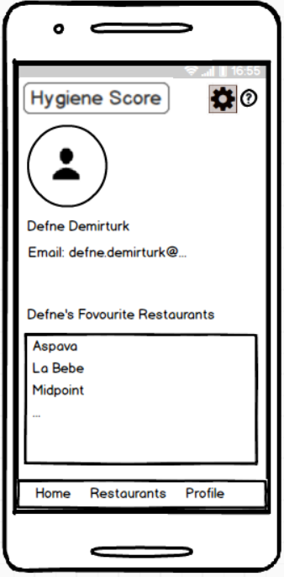

Figure 9: Customer’s Profile Window

 B)  Owner UI

If the user has an account type of owner, then the options specific for the owner will be shown on the owner home page, as shown in Figure 10.

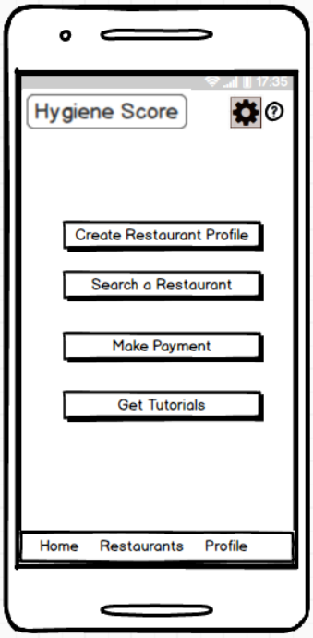

Figure 10: Owner Home Page Window

If the user selects the Create Restaurant Profile option, then the window in Figure 11 will appear.

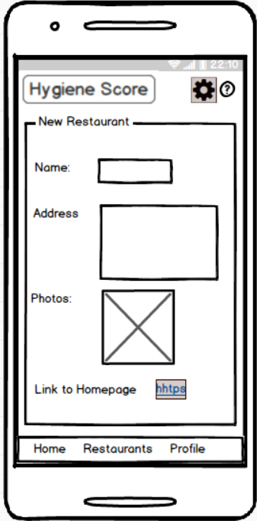

Figure 11: Create Restaurant Profile Window

If the user selects the Search a restaurant option, then the default Search Restaurant Window will be displayed. (Figure 4)

If the user selects the Get Tutorials option, the window that lists the related tutorials which the user has paid for will be shown. (Figure 12) The tutorials for owners and customers will be different than each other.



Figure 12: Owner’s Tutorials Window

Other than the options the owner can use the buttons in the bottom of the display, such as “Profile”. If they press the “Profile” button than their own profile page will be displayed as shown in Figure 13.

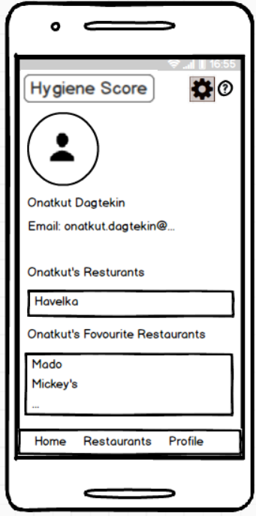

Figure 13: Owner’s Profile Window

C) Inspector UI

If the user has an account type of inspector, then the options specific for the inspector will be shown on the inspector home page, as shown in Figure 14.

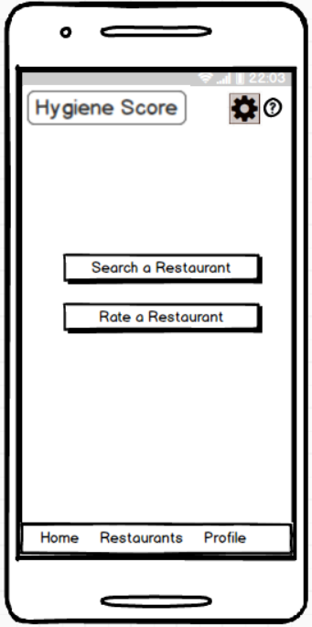

Figure 14: Inspector Home Page Window

If the user selects the Search a restaurant option, then the default Search Restaurant Window will be displayed. (Figure 4)

If the inspector selects the Rate Restaurant option, as shown in Figure 15, the hygiene rating page will be shown in the application.



Figure 15: Hygiene Rating Window

Other than the options, the inspector can use the buttons in the bottom of the display, such as “Profile”. If they press the “Profile” button than their own profile page will be displayed as shown in Figure 16.

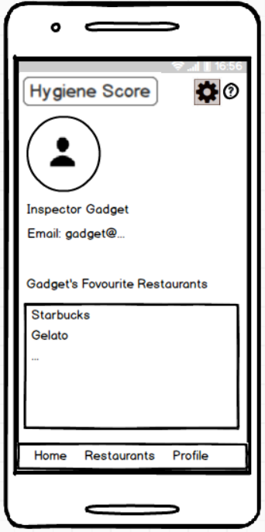

Figure 16: Inspector’s Profile Window