Bilkent University

Computer Science Department



**Senior Design Project**

*Project Name: Hygiene Score*

Final Report

Project Members: Ege Karaarslan, Alper Eroğlu, Onatkut Dağtekin, Özge Karaaslan, Defne Demirtürk

Supervisor: Özgür Ulusoy

Jury Members: Mustafa Özdal and R. Gökberk Cinbiş

May 4, 2017

This report is submitted to the Department of Computer Engineering of Bilkent University in partial fulfillment of the requirements of the Senior Design Project course CS491/2.

Contents

1. Introduction 2

1.1 Purpose of the Project 2

2. Final Architecture and Design 3

2.1 Overview 3

2.2 Subsystem Decomposition 3

2.3 Class Diagram 5

2.4 Hardware/software mapping 6

2.5 Persistent Data Management 7

2.6 Access Control and Security 8

2.7 Global software control 9

2.8 Boundary conditions 9

3. Impact of Engineering Solutions 10

3.1 Global Impact 10

3.2 Economic Impact 10

3.2 Environmental Impact 11

3.3 Social Impact 11

4. Tools, Technologies and Libraries Used 12

5. Contemporary Issues Related with the Area of the Project 13

6. Glossary 14

7.References 14

8. User Manual 15

# 1. Introduction

The increased accessibility, range and vastness of the internet, motivate people to include it to their daily lives as an essential component. One of the main reasons for this is the availability of seemingly infinite amount of information on the internet. However, most of the information on the web is not refined, not verified and due to these facts is misleading. This can be seen abundantly in the dining industry.[1] Coarse, deficient and vague advertisements of restaurants populate the internet and diminish the joy people get from dining outside. This is mainly due to the unseen and unpublished facts about the infrastructure and hygiene of the restaurants.

## 1.1 Purpose of the Project

The purpose of the Hygiene Score system is to assist people, so that they can reach refined, verified and explicit data when searching for a place to eat. This will be done by the rating system and the educational components provided by the system. The rating system will be liable due to the fact that it uses the rankings made by professional food inspectors that have access to the infrastructure of the restaurants, as well as the rankings of the users that visit the restaurant. The system will combine these rankings accordingly and generate a final rating that is easy to evaluate by the people that are searching for a place to eat. Moreover, the users will be also trained in hygiene and food quality through education modules in the system. These will be available for both the consumers and owners. Through this training, the consumers will be available to detect the flaws that are not easy to see and the owners will be more careful and considerate about their establishment.

# 2. Final Architecture and Design

## 2.1 Overview

This part of the report contains information about subsystem decomposition, class diagram, hardware/software mapping, persistent data management, access control and security, global software control and boundary conditions of the application.

## 2.2 Subsystem Decomposition

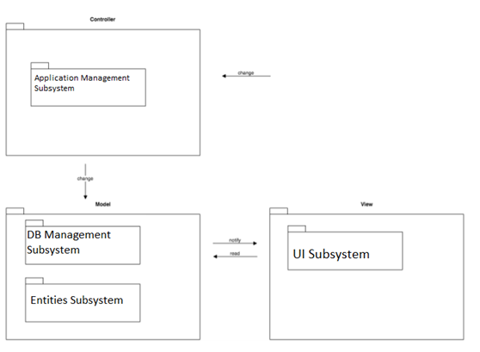

We will be managing our subsystem decomposition by acquiring two different architectures together. Namely these architectures are, the client-server architecture and the MVC architecture. We will be using the MVC architecture to compose the smaller subsystem components of client-server architecture.

We will be connecting with our users through the client side of our system. Our Android application and website will be representing the client side of the client-server architecture. Mainly this side represents the user interface of Hygiene Score. Our Android application will be getting data of restaurants and it will use these data to generate the UI content accordingly. Furthermore, the user input, that is the grading of restaurants or the profile setup, is given through the android application interface and send to the server over mobile internet.

In the server side our system will be composed of a database controller and the corresponding manager that is for communicating with the database. In the server side there will be a database, a database controller and a communication manager. In this way, with dividing the server side our system will have modularity. Database will be where we will store everything including user profiles, comments, scores, restaurant details, and photos if there are any. The users will be actually using the database through the database connection manager of our system when they are using Hygiene Score’s application and website. We are already familiar with PHP and MySQL so we will be going with these as our DB of choice. Database manager is responsible for database operations such as deleting data, updating data etc.

## 2.3 Class Diagram

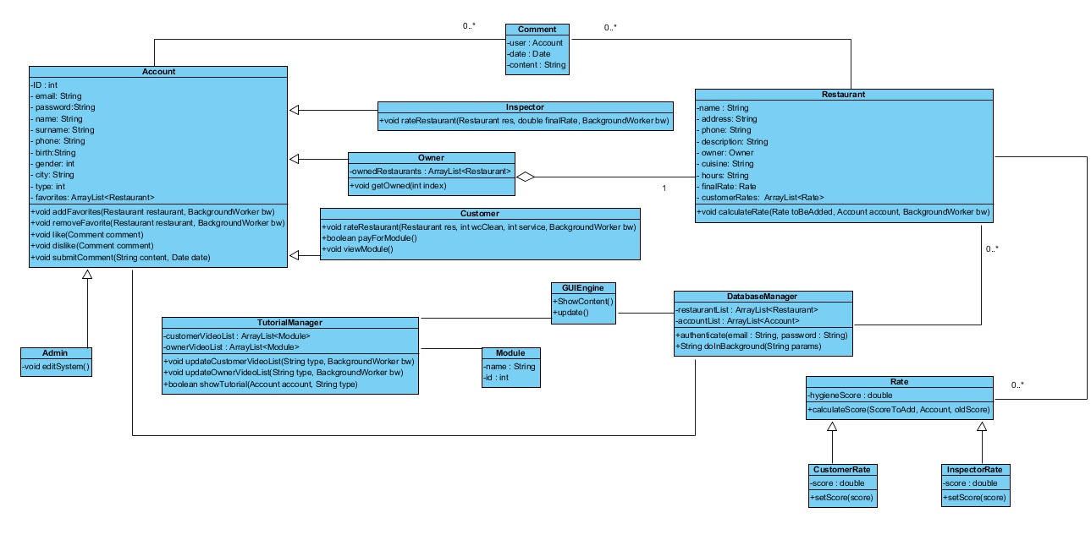

The object model of HygieneScore is illustrated above. This diagram contains 14 classes.

**Account:** This class is where the accounts and profiles of users are arranged and organized. Account controls profile creation and management, commenting and getting help operations. Account class has 4 child classes such as Owner, Customer, Inspector and Admin.

o   **Owner:** Owner is the class here the list of restauants of the owner is kept and the capabilities assosiated with the Owner type user is managed.

o   **Customer:** Customer is the class where the operations of Customer type of user is arranged such as rating, favoriting and paying for tutorals.

o   **Inspector:** Inspector is the class where the rating rastaurants according to how hygiene they are, apporiving the addition of restaurant request and  forming the EducationModule tuttorial are arranged.

o   **Admin:** Admin is the class where the comments by the users are editted.

**Restaurant:** Restaurant is the class where the information about restaurant and the operations such as showing  comments, showing rating and opening resturant website is managed.

**Comment:**  Comment is the class where the customer comments are managed.

**GUIEngine:**  GUIEngine is the class that is responsible of communicating  with the user.  It manages the operations such as showContent(), update() and submitComment(content).

**DatabaseManager:**  DatabaseManager is responsible of communicating with the database which keeps the restaurant and account information.

**TutorialManager:** This class is responsible for which videos are going to be shown to the user depending on the user type.

**Rate:** This class keeps track of information about the score given by the user to a restaurant and is indirectly related to the database manager. It has two types CustomerRate and InspectorRate

## 2.4 Hardware/software mapping

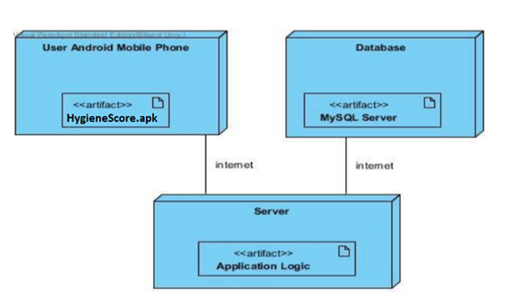

Figure : Hardware/Software Mapping

In Hygiene Score, the connection between hardware and software parts of the system will be handles with a client-server approach. Our system shall have a server which will be working continuously and also it shall have a database that will gather and track all the relevant data coming from web sites. These data will be used instantly in our Android application and website. In order to use our application, our users should install the HygieneScore.apk priorly. They should also have continuous internet connection for the system to be able to gather content from the server. The server will display the relevant data for the specific user through the internet.

## 2.5 Persistent Data Management

Since Hygiene Score can be classified as a social media application that includes education modules, persistent data of Hygiene Score can be classified as user data and education module data. User data can be classified into 2 further categories, which are customer’s and restaurant owners.

Restaurant customer data will consist of personal information, messages, comments, likes/dislikes for comments, score given to a restaurant.

Restaurant owner data will consist of restaurant information, comments, payments made for the education module designed for restaurant owners, last visited education module information, education quiz results, restaurant’s score and past restaurant scores.

Education module data will consist of different videos and it will hold last visited education module information and education quiz results of a user, along with payments made for the module by the user.

To keep all the data described above, we will use a database (MySQL). Since Hygiene Score will be a multiuser application, there will be a lot of data exchange going on and in order not to frustrate the user, Hygiene Score’s interaction with the database needs to be rapid and efficient. Additionally, the transactions of each user will be logged in order to increase fault tolerance and recoverability of data in case of a failure.

## 2.6 Access Control and Security

Hygiene Score is a multi-user system and each user will have different kinds of access levels. The table 1 below is an access matrix showing some of the actions each user type can do. Guest is any user without a login and customer is the restaurant customer who logged in and owner is the restaurant owner who logged in.

|  |  |  |  |
| --- | --- | --- | --- |
| **Action\User Type** | **Guest** | **Customer** | **Owner** |
| See Hygiene Score | + | + | + |
| See Comments | + | + | + |
| Write Comments | - | + | + |
| Pay for Education Module | - | + | + |
| See Hygiene Score Progress Graph | - | + | + |
| Like Comment | - | + | + |
| See Inspection Details | - | + | + |
| Alter Restaurant Information | - | - | + |
| View Restaurant Information | + | + | + |
| Add/Delete Restaurant | - | - | + |
| Delete Account | - | + | + |
| Give Hygiene Score To a Restaurant | - | + | - |

Table 1: Granted Permissions to certain actions of users matrix

To provide security, the HTTP authentication [1] will be used for securing login and for database protection, database auditing [2] will be used and precautions for SQL injection [3] will be taken. To provide security in payments, PCI protocol [4] will be used.

## 2.7 Global software control

For Hygiene Score we plan to use event-driven control as the type of the control flow. Another option for control flow is procedure-driven control. However, we do not prefer this approach because it needs objects with concurrency inheritance to be mapped to the flow of control. Therefore, it makes flexibility lower than event-driven control and it is harder to maintain the sequence for the large number of objects. The reason we prefer the event-driven control is that user actions such as mouse clicks and key presses determine the flow of the program.

## 2.8 Boundary conditions

Boundary conditions has three cases: Initialization,Termination and Failure.

Initialization: It indicates how the system will start.

* The user should enter to the web page of the Hygiene Score if he/she prefers to web application of the program. If they want to use the android application, they first should go to the Google Play Store and download the application to their phone.
* If the user has an account for Hygiene Score, they can login to the system by using their username and password.
* After this process, the user will be directed to the main page if they have used the correct username and password.
* Then, user can use the all the functionalities of Hygiene Score as they want.

Termination: It indicates how the system will shut down.

* Users of the Hygiene Score can log out from the system anytime they want regardless to what page they are on.
* When user presses the logout button, system will let user exit from the web and mobile application safely.
* System also enables the user to close the application (web-mobile) without logging out the system.

Failure: It indicates how the system react when faced with unusual activities.

* When there is a disconnection from the internet, Hygiene Score fails to process the user operations.
* For the mobile application, if the user does not update the application for a long time, system will not be able to keep up with the differences and show an error message regarding to the problem.

# 3. Impact of Engineering Solutions

## 3.1 Global Impact

The application will be influential in developing standards for the hygiene of food establishments. The hygiene information of the restaurants on the application will be transparent and available worldwide on the web. The score and evaluation put forward by the application can be the basis for the hygiene standards of food establishments.

## 3.2 Economic Impact

The main income of the application will be the fee that the restaurants will pay for the inspections by professional food inspectors. These will be paid every 6 months and the results of these inspections will be included in the Hygiene Score of the establishment. Advertisements will also be included in the application in the future, when the application grows over a certain limit in terms of users.

## 3.2 Environmental Impact

The inspection grades given by the inspectors also include the handling of waste and, the quality of used ingredients and whether these ingredients are organic or not. These are important environemtal apsects and they will have to be handled carefully by the owners, in order to get scores that will be beneficial for them. this will improve the environmental impact of establishements that want to get high scores.

## 3.3 Social Impact

Hygiene Score gives information about hygiene and infrastructure of an establishment through the evaluation conducted by a professional food inspector. It provides this evaluation as a grade which is understandable by the users that are looking for a place to eat. Education modules provided in the application raise overall hygiene awareness of users and owners. They are though about simple rules of an establishment that is hygienic and safe to eat. The application also helps users to find restaurants of their liking which helps them find satisfying food establishments.

# 4. Tools, Technologies and Libraries Used

In Hygiene Score, MAMP is used for creating a local server environment which has Apache Web Server which is the world’s most used web server software, MySQL for database operations and PHP as its server side programming language.

MAMP has 2 versions of PHP installed in it. In our version, it has 5.6.23 and 7.0.8 and we use 7.0.8 for development of it. MAMP, provides a GUI called PhpMyAdmin for editing the database. When a group member, creates a table or edits it we use the import/export functionality provided by MAMP and get the changes to our local environment.

For Web part of Hygiene Score, we have used Sublime Text3 as the IDE and we have used the syntax check function of SublimeLinter (PHP).

For Hygiene Score, we are getting a hosting service from a provider in Turkey and for publishing the finished modules, final structures of database tables and the project itself. To do this, we are using CPanel provided from the hosting company.

Github was used as the version control and development collaboration tool. The developers uploaded their code and project sections into Github every month and also with every update. The new and updated code and sections were also mirrored by the other developers every month to continue on working from that point. The repository we used was private as part of the Github Developer Student Edition. The repository was kept private in order not share the code and keep it secure from piracy.

Hygiene Score is an Android application so the development was made on Android Studio which is developed by Google as an IDE and available for multiple OS. It includes essential Android Tools for integration, necessary packages and testing as well as a complete virtual android machine for testing. It supports Gradle-based builds, refactoring and quick-fixes to code and includes a layout editor with drag-and-drop UI component capabilities. Android Studio supports version management tools such as Google Cloud,Github, Git etc.

Tools like draw.io and Visual Paradigm are used for creating documentation in our project. They have specific functionality for creating UML diagrams.

During the development of web application, we have used PHPMailer library, and for some client side animations ve have used JavaScript, Jquery and the FontAwesome.io which gives scalable vector icons that can be customized.

Google Maps API is used in the web application as the map provider. It allowed us to embed a map into the website, put markers on the map, get location information from the map, such as address, longtitude and latitude.

# 5. Contemporary Issues Related with the Area of the Project

Privacy of data: Privacy has become a concern for many people since the wide use of Internet as it opens their information to a wide web of strangers. Our policy for privacy is to get a minimum amount of data from users which are already in web such as name, surname and gender. The anonymity of the users that vote or comment on restaurants will be preserved against to keep them safe from forcefully changing their opinions.

Mobile application development: With the rise of smartphones in recent years , mobile applications have gained more popularity. These applications must be user-friendly and easy to use which Hygiene Score aims to do. Information is easier to distribute through mobile applications as they can be used anywhere from a mobile device. The data gathered in HygieneScore will be reachable to more people in this manner.

# 6. Glossary

**PHP** is a [server-side scripting](https://en.wikipedia.org/wiki/Server-side_scripting) language designed primarily for [web development](https://en.wikipedia.org/wiki/Web_development) but also used as a [general-purpose programming language](https://en.wikipedia.org/wiki/General-purpose_programming_language).

**Java** is a general-purpose [computer programming language](https://en.wikipedia.org/wiki/Programming_language) that is [concurrent](https://en.wikipedia.org/wiki/Concurrent_computing), [class-based](https://en.wikipedia.org/wiki/Class-based_programming), [object-oriented](https://en.wikipedia.org/wiki/Object-oriented_programming), and specifically designed to have as few implementation dependencies as possible.

**APK(Android application package**) is the [package](https://en.wikipedia.org/wiki/Package_format) [file format](https://en.wikipedia.org/wiki/File_format) used by the [Android](https://en.wikipedia.org/wiki/Android_(operating_system)) operating system for distribution and installation of [mobile apps](https://en.wikipedia.org/wiki/Mobile_app) and [middleware](https://en.wikipedia.org/wiki/Middleware).

**UML (The Unified Modeling Language)** is a general-purpose, developmental, [modeling language](https://en.wikipedia.org/wiki/Modeling_language) in the field of [software engineering](https://en.wikipedia.org/wiki/Software_engineering), that is intended to provide a standard way to visualize the design of a system.

# 7.References

[1]Special Report By Tom Rawstorne, "Disturbing proof that persuasive online reviews may be FAKE," in *Daily Mail*, Daily Mail, 2015. [Online]. Available: http://www.dailymail.co.uk/news/article-3276617/Disturbing-proof-online-review-book-holiday-FAKE-Investigation-reveals-entire-industry-dedicated-generating-bogus-appraisals-cash.html. Accessed: Feb. 20, 2017.

# 8. User Manual



When the app is started, the user is welcomed with this page and can log in by clicking the button or create an account by clicking the text.

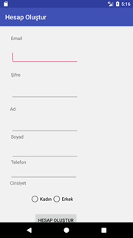

If the user wants to create an account, he/she can do it by filling the fields in the figure.

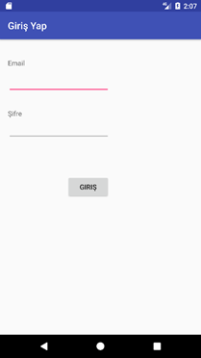

If the user wants to log in the page above shows up and after filling the credentials, the user is directed to the main page.

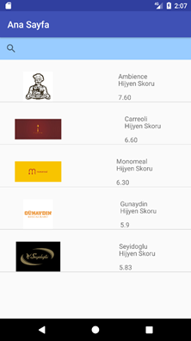

The main page contains top 5 restaurants of the app. The user can also do a search or explore more options by sliding the navigation drawer on the rightside.

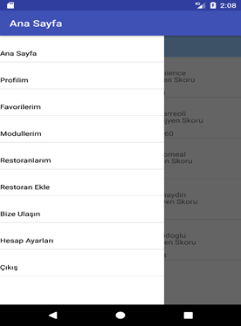

After opening the drawer panel, the user can go back to main page,see his/her profile,see his/her favorites, watch module videos, can see his/her restaurants (if the user is an owner), can contact the company by sending an email, can his/her account information.

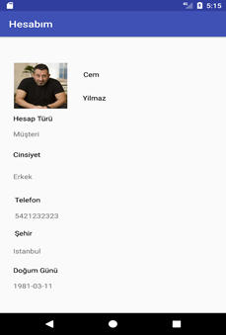

The profile page contains information about the account as seen from above.

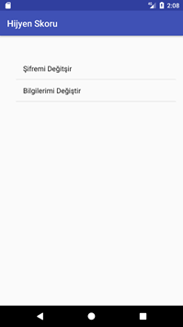

The account settings page has two options changing password and changing account information. Clicking either of them starts a new page which user enters new information.

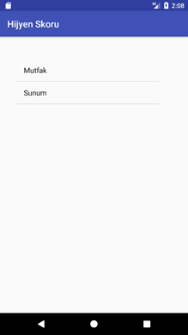

The module page contains various videos about the hygiene infrastructure of a food establishment, the user can access this page from the drawer panel and watch the videos associated with that topic.

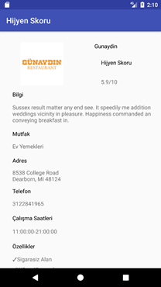

In the restaurant profile page, the user can rate a restaurant by answering multiple questions and see the information about that restaurant.