The project consists the restful spring boot application using ”mongoDB” as database with “gradle” the building tool. There are 5 operations which solve the business requirements below:

- Send message 🡪 sendMessage

- List incoming messages for a user 🡪 findIncomingMessages

- List sent messages by a user 🡪 findSentMessages

- Read message details 🡪 readMessageDetails

- Endpoint to estimate the number of total messages that will be sent probably for the rest of the day or week🡪 estimateMessageCount

You can use to build and run the application via command line in the current folder of the project

build --> ./gradlew bootJar

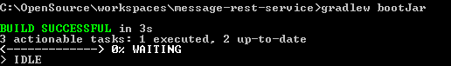

run --> ./gradlew bootRun

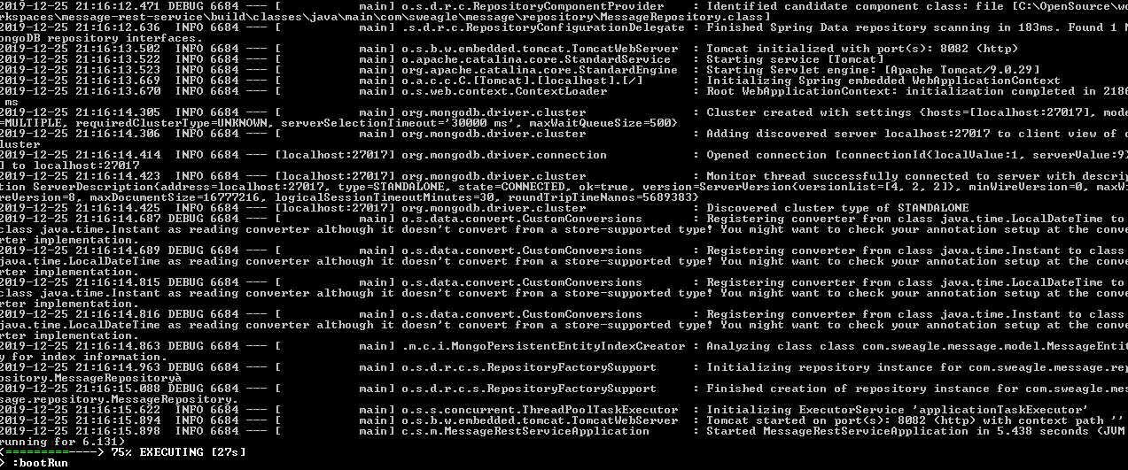

Except the source folder, you may find the postman requests for end-to-end testing the solution. Also you may find the mongoDB js file to insert the many records.

