**HAPITY FOR CUSTOM WEBSITE**

Setup is simple and only needs to be done the first time. More detailed instructions and video demonstrations are [here](http://www.hapity.com/help)

**Step 1**

Go to [www.hapity.com](http://www.hapity.com/)

Login with button on top right hand corner (Registering requires a Name, Email Address and Password)

**Choose “Settings” on top right hand corner**

Make a note of the plugin ID

**Step 2**

Now you will need to make an authentication call with following parameters

* Authentication key
  + Your plugin id from step 1
* Call back URL

The call back URL you want to receive communication from HAPITY APIs

e.g <https://www.hapity.com/api/validate_key/?auth_key=[YOUR_AUTH_KEY]>

&type=custom&url=[http://www.yourdomain.com/hapity-callback]

Once this call is successful, you will get 200 status code.

**Step 3**

When a Hapity broadcast will be created a HTTP call to your given call back URL will be made with following POST parameters

* title **–** Title of the broadcast
* stream_url **–** The URL of the broadcast file
* bid **–** The broadcast ID
* user_id **–** Id of registered user on hapity
* broadcast_image **–** The thumbnail image of broadcast
* status **–** The status of broadcast online/ondemand
* key - This is Plugin ID from your hapity account settings
* description **–** Description of broadcast video

e.g

**http://www.yourdomain.com/**- callback

& post variables

**title**=test

**stream_url**=rtsp://52.18.33.132:1935/live/1480543830184. stream_360p

**bid**=16

**user_id**=1

**broadcast_image**=link_to_your_broadcast_thumbnail_image

**status**=online

**Key**=1242342435

**description**=sample description of broadcast

You can save these POST parameters into your own website database and can generate an ember code as below

<iframe height="600" width="100%"

scrolling="no" frameborder="0"

src="[https://www.hapity.com/widget?stream=[](https://www.hapity.com/widget?stream=213772020315933.stream.mp4&title=Test&status=Online&bid=7036&broadcast_image=4c3b84e65c295ef5f3a20106a85d4ea4.jpg)**[stream_url](https://www.hapity.com/widget?stream=213772020315933.stream.mp4&title=Test&status=Online&bid=7036&broadcast_image=4c3b84e65c295ef5f3a20106a85d4ea4.jpg)**[]&title=[](https://www.hapity.com/widget?stream=213772020315933.stream.mp4&title=Test&status=Online&bid=7036&broadcast_image=4c3b84e65c295ef5f3a20106a85d4ea4.jpg)**[title](https://www.hapity.com/widget?stream=213772020315933.stream.mp4&title=Test&status=Online&bid=7036&broadcast_image=4c3b84e65c295ef5f3a20106a85d4ea4.jpg)**[]&status=[](https://www.hapity.com/widget?stream=213772020315933.stream.mp4&title=Test&status=Online&bid=7036&broadcast_image=4c3b84e65c295ef5f3a20106a85d4ea4.jpg)**[online](https://www.hapity.com/widget?stream=213772020315933.stream.mp4&title=Test&status=Online&bid=7036&broadcast_image=4c3b84e65c295ef5f3a20106a85d4ea4.jpg)**[]&bid=[](https://www.hapity.com/widget?stream=213772020315933.stream.mp4&title=Test&status=Online&bid=7036&broadcast_image=4c3b84e65c295ef5f3a20106a85d4ea4.jpg)**[220](https://www.hapity.com/widget?stream=213772020315933.stream.mp4&title=Test&status=Online&bid=7036&broadcast_image=4c3b84e65c295ef5f3a20106a85d4ea4.jpg)**[]&broadcast_image=](https://www.hapity.com/widget?stream=213772020315933.stream.mp4&title=Test&status=Online&bid=7036&broadcast_image=4c3b84e65c295ef5f3a20106a85d4ea4.jpg)[**broadcast_image**]">

</iframe>

**To Broadcast**

If your PC has a camera you can instantly broadcast by going to [Hapity](http://www.hapity.com/main/webcast) and pressing the start button

Alternatively you can download Hapity from the Android Playstore or Apple App store. Use your login from Step 1

Click the Live Stream button within the app.

On Android this is the camera button on bottom right

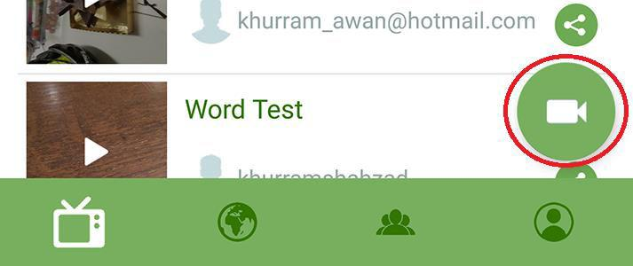

On Apple it is the green circle at the top of the broadcast menu



Enter a name for the broadcast (this is optional) and press "Start streaming"

**Tips**

You can share the broadcast on Facebook and Twitter before or after by selecting the appropriate icons.

The first time you will be asked to login to your Facebook or Twitter account.

You can also share the video on email, SMS, whatsapp and many other ways. The [video](http://www.hapity.com/help) demonstrates

A video file of all the broadcasts will be saved to your phone as well which can be found in your "Gallery" for android and "Photos" for iPhone.

You own the content you livestream

No need to update your website hardware or worry about additional web data charges as all of the broadcasting is handled in the background by Hapity servers