**NLC Innovation Ecosystems Commitment Program – 7/1/2020**

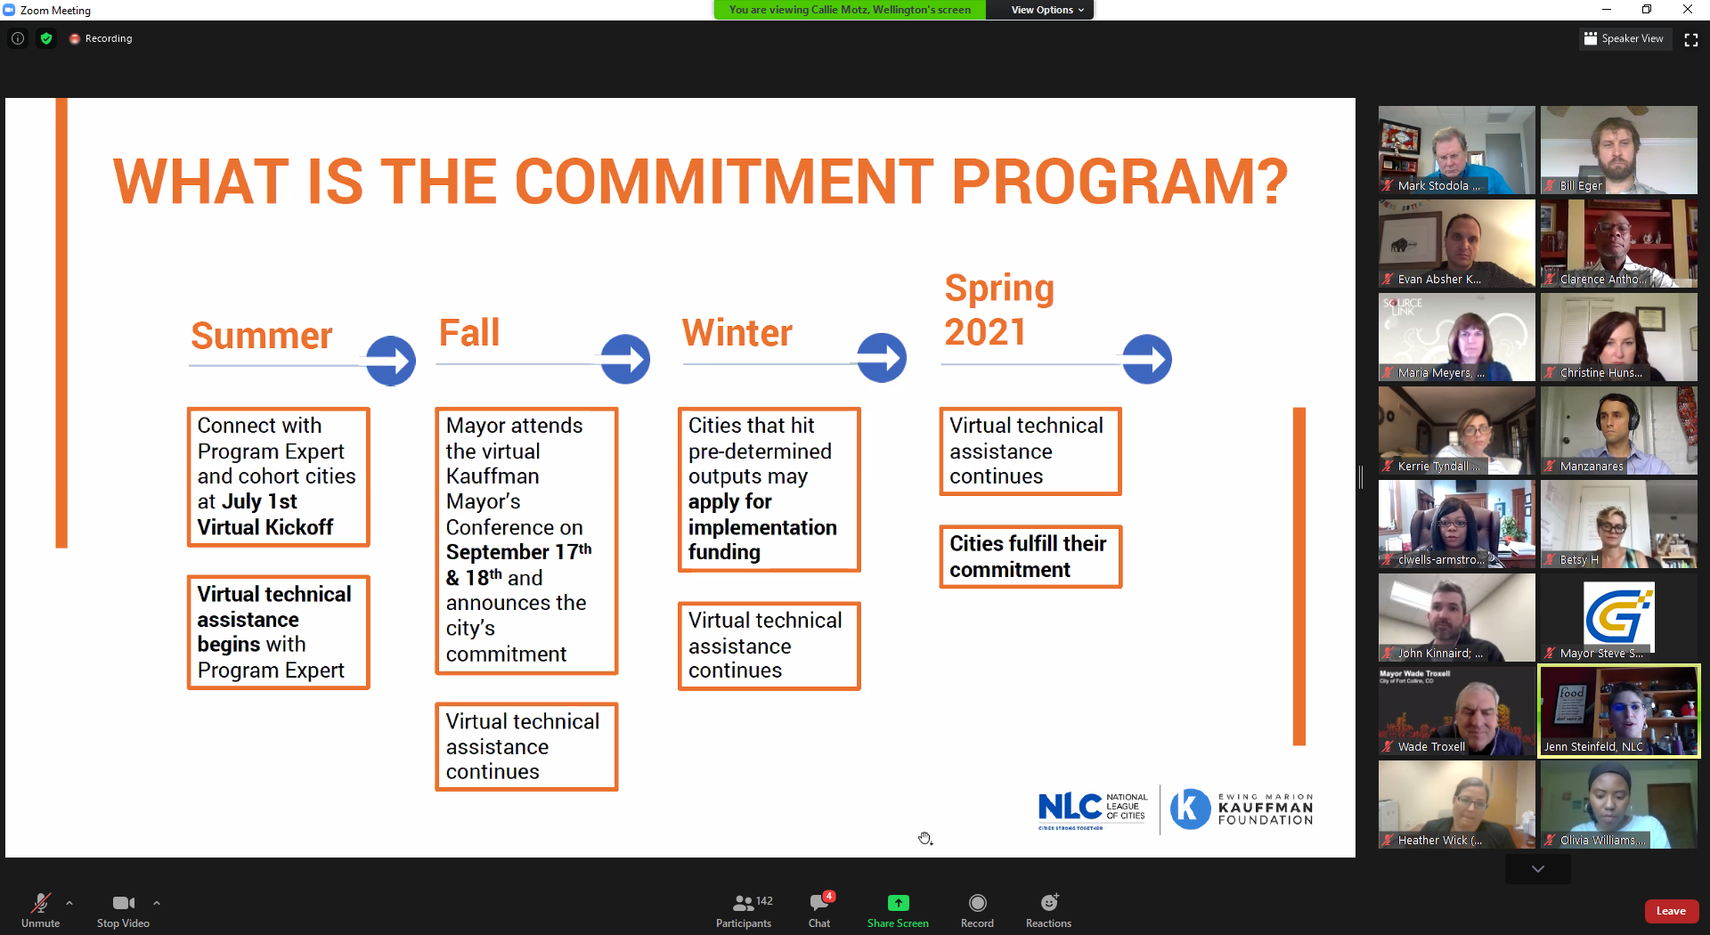

SmartCityPX

Typical means of engaging – door knocking, meetings, etc. are not available. What can digital tools help

KC Digital Divide – emerging tech opportunities inside City with opportunities outside City.

CivStart

* De-risking for governments
* Trusted
* Talking government

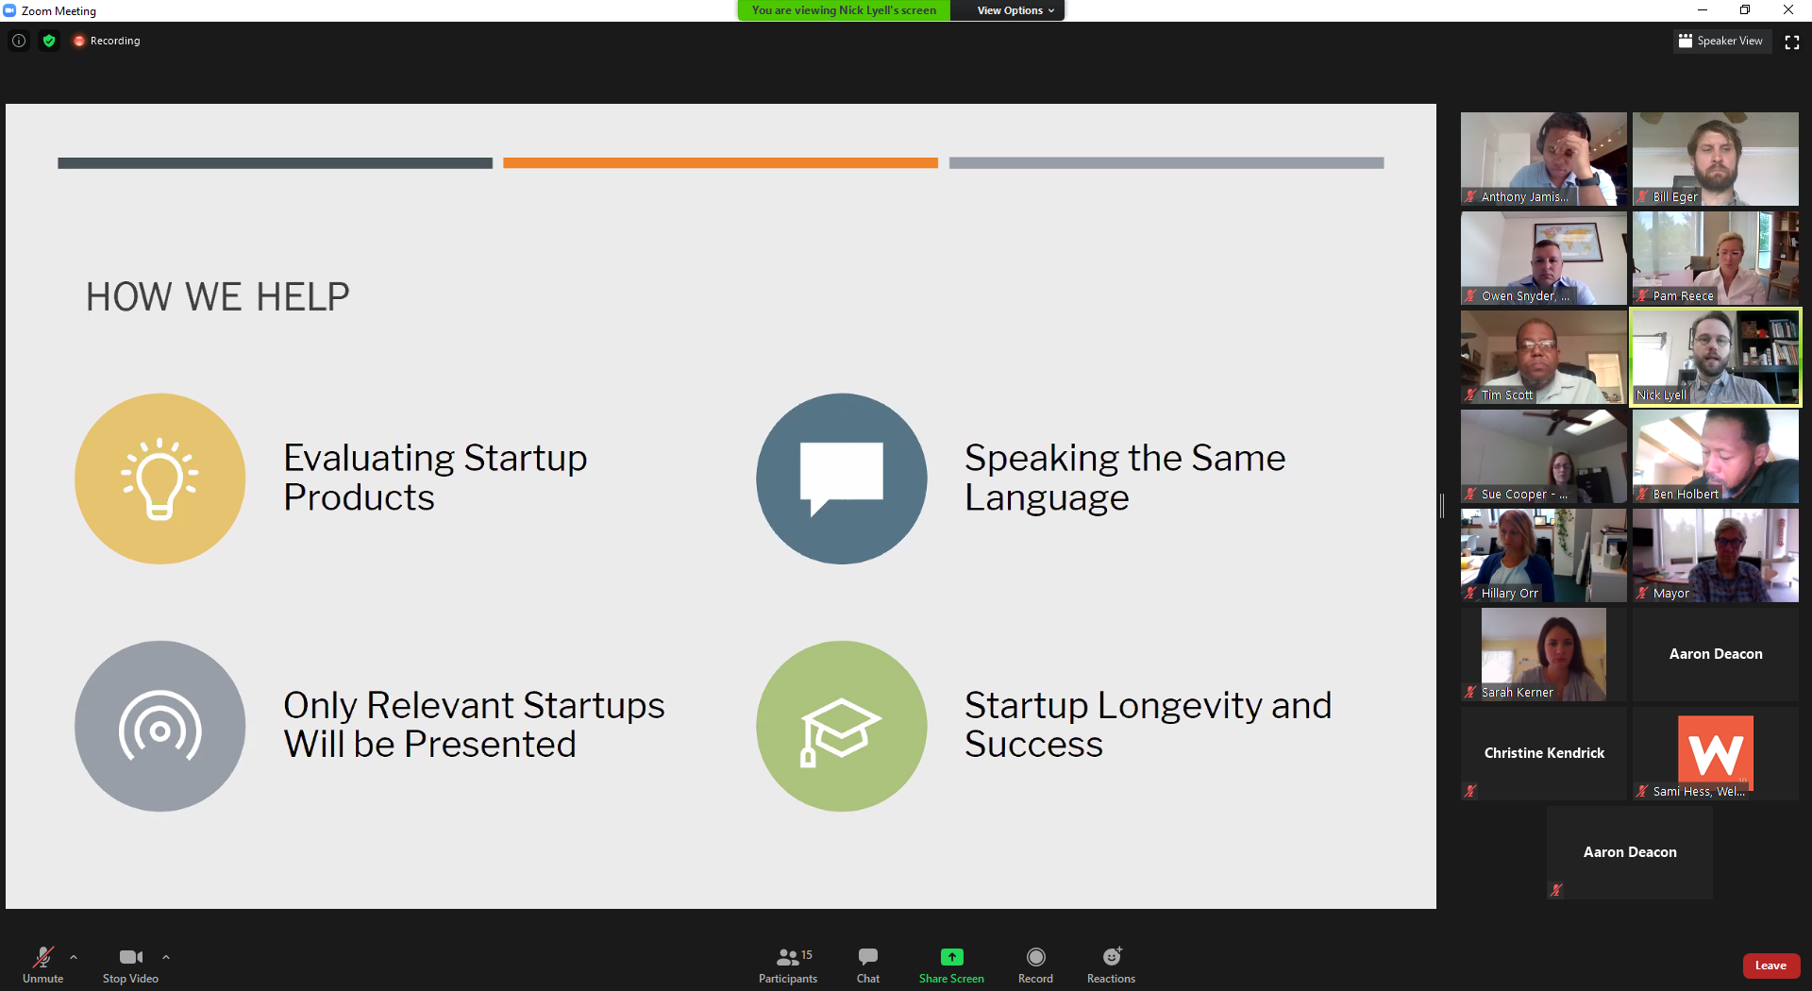

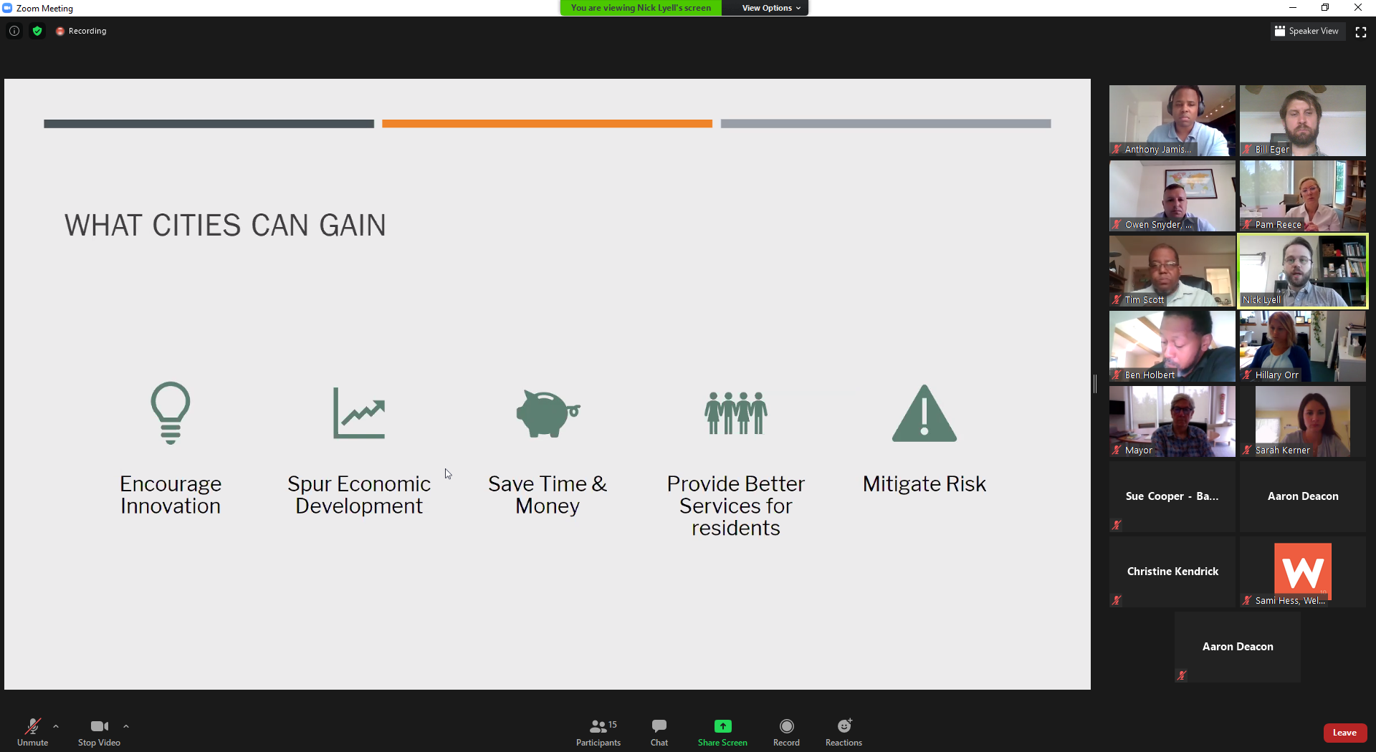

No more than 10 hours / month

IT and Procurement involved

1 point of contact