**Distributed Energy Conference – 7/1/2020 – Notes**

ReOPT Lite

Mixed-Integer Linear Programming

Behind-the-meter Capacity Expansion model

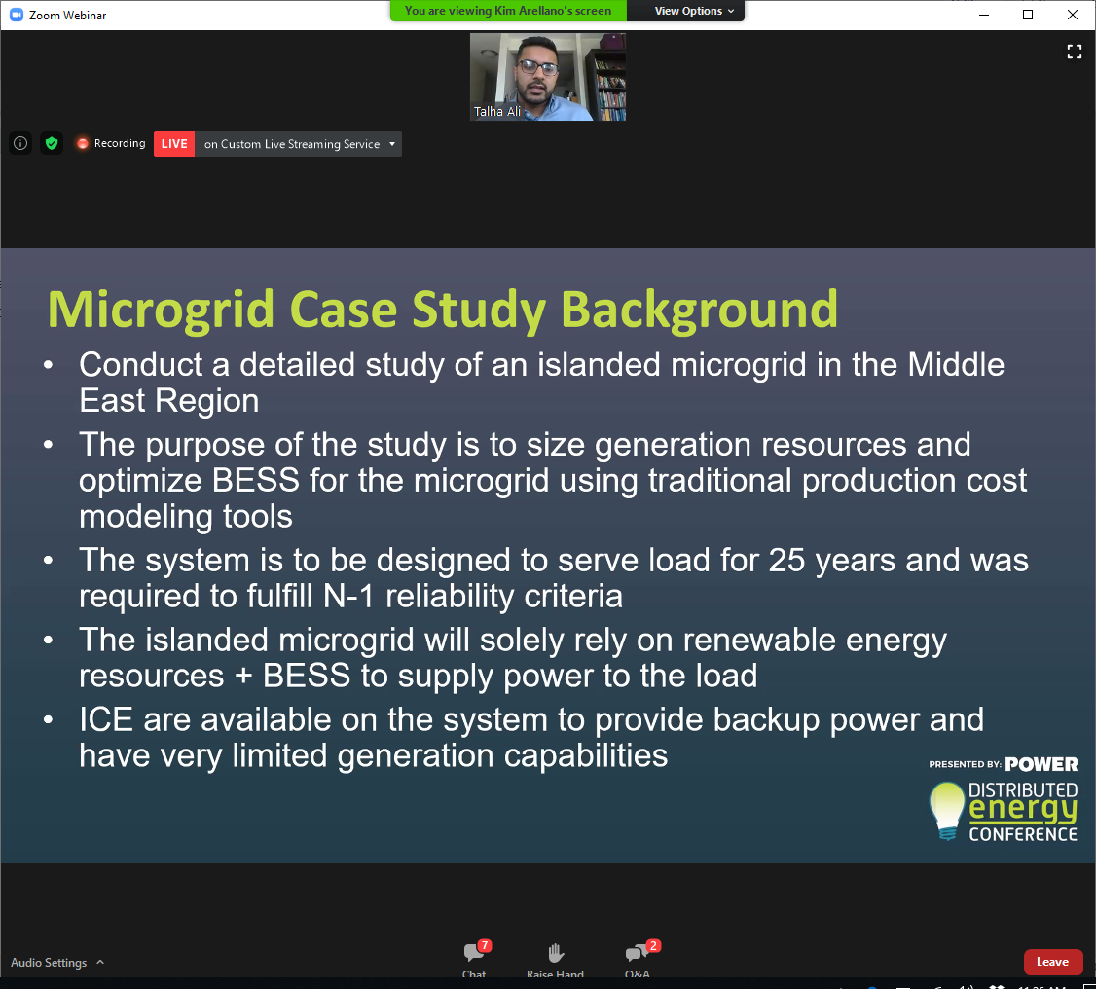

PLEXOS – made by Energy Exemplar

* Uses Production Cost Modeling methodology

Use PVSys tool to take into account Solar GIS data and then converted to 8650 hours of solar production

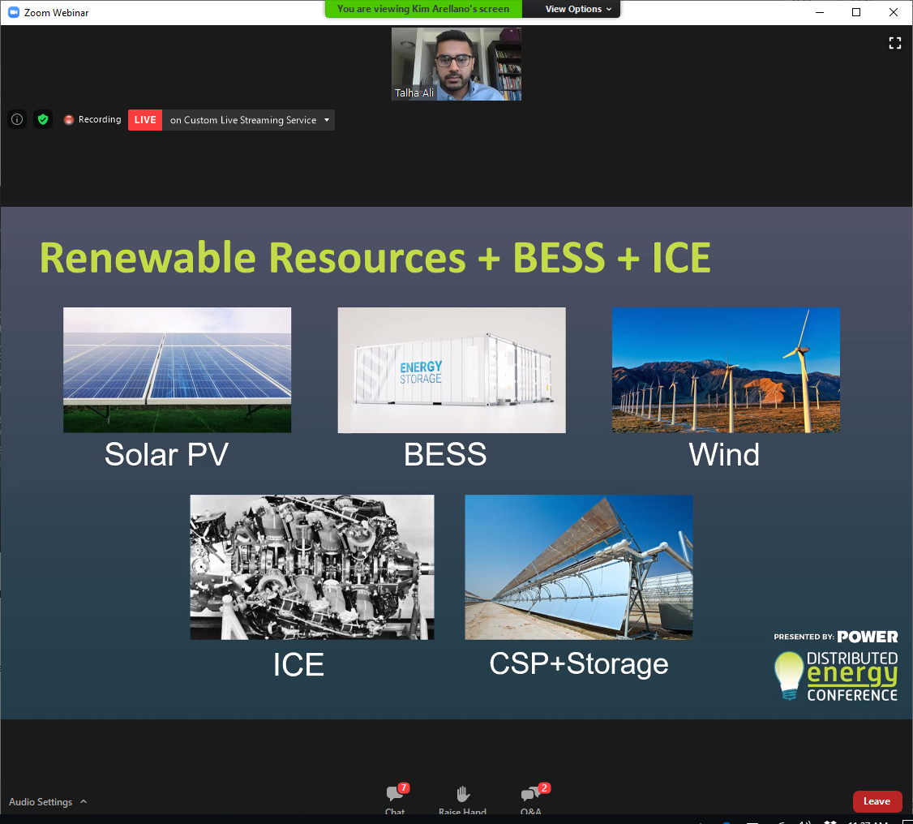

SAM Model – System Advisor Model

System typology

