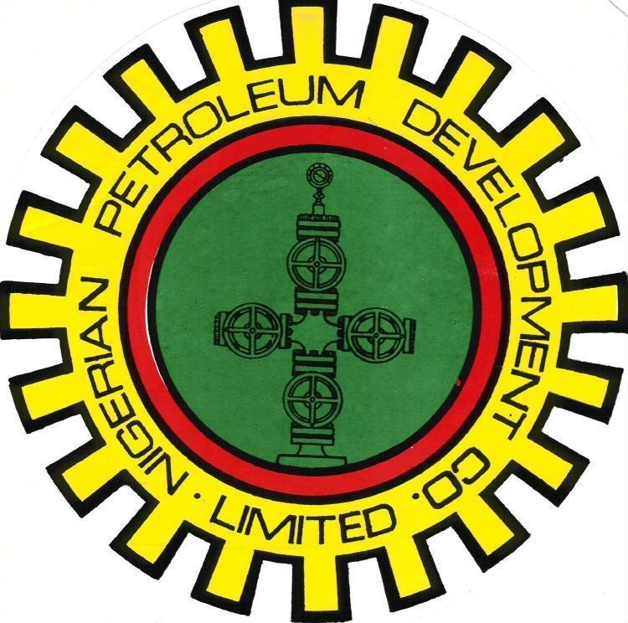
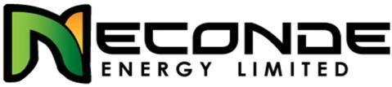

NECONDE ENERGY LIMITED

ODIDI 36S

DRAFT UNPLUGGING, ACID SOAK & NITROGEN LIFT PROGRAM

OML 42

JUNE - 2015

APPROVALS

ACTION | NAME | TITLE | SIGNATURE | DATE
Prepared by | Oludewa Awani
Reviewed by
Agreed by

Approved by

OBJECTIVES:
- Retrieve downhole DW plug
- Perform acid soak/wash
- Nitrogen lift well back to production

COST & DURATION SUMMARY:
Total Cost (MM$) | 197,000
Total Duration (Days) | 3
N.B: Cost is based on CT & WL activity daily spread.

BASIC COMPLETION DATA:
WELL | Tree  type | Tree Connection | Tubing  Size | ScSSSV  Size/type | ScSSSV  Depth | Last survey/well entry
Odidi 036S | Cooper  Cameron ‘FC’ | 2-7/8” ACME | 2-3/8" 4.7Ib/ft  Drift 1.86’’ | 2’’ ‘OB-6’  WL-ScSSSV | 133’ | Well kill operation in 2010.
NB:
- Ensure well site visit is carried out to confirm X-mas tree adaptor prior to mobilization
- Conduct a well-slot visit to ensure that the well-slot is accessible for CTU operation before mobilization of CTU to site.
- Ensure completion of FLM and SLM works on wellhead, before commencement of CTU operation.

PRODUCTION DATA & WELL STATUS:
Test Date | Gross | Net Oil | BSW | GOR | THP | Bean
 | bbl/d | bopd | % | Mscf/b | psig | /64"
05/01/2006 | 1450 | 261 | 82 | 2.2 | 180 | 64
DFE to top CHH: 36ft
SAND: E5.0
Known well Problem(s): A well kill operation was performed in 2010, when the wellhead was vandalized. The well was killed by bullheading and secured with downhole plug.
See Appendix B attached (well completion schematics).

ROLES & RESPONSIBILITIES:
Field Engineer:
The Field Engineer is in charge of the job at the location. He should hold pre-job safety briefing and job safety analysis (JSA), issue all safety permits and has overall responsibility for all safety matters during the operation. He should submit daily progress report to the line-manager/Supervisor.
Production Supervisor:
Operate (or assign an operator to operate) the wellhead control units and tree valves at the request of the Field Engineer. He should provide directives based on standard procedure at the wellhead and or flowstation.
Production Operators:
Responsible for wellhead operations, opening and closing of wellhead valves.
CT/WL Contractor
Supply certified CT/WL crew, certified CT/WL equipments, tools and perform operations in a safe and professional manner.
CT/WL Operator
Run CT unit, auxiliary equipment and perform operations as required, in a safe manner.
To submit a detailed report at end of exercise

NB: Invoice to be submitted along with the comprehensive CT/WL summary reports.

GENERAL SAFETY GUIDELINES FOR CT, WL & N2 OPERATIONS
- Prior to commencing any form of operation, a pre-job safety meeting must be held on site, primarily focused on hazard identification, observation and controls
- All personnel involved in the CT operation should be aware of the details of the operation, the related safety points and the areas of responsibility as outlined by the WI Supervisor in the pre-job meeting.
- Personnel shall wear, at all times, the appropriate Personal Protective Equipment (PPE) as suited for this operation. This include (but not limited to) safety shoes, hard hat, floating device, coverall, eye-google, hand-gloves, nose mask etc. The N2 Operator Must use cryogenic type hand gloves during the handling of N2 lines & hoses.
- Fire extinguishers will be available and located at a central access point during the CT operation.
- During the N2 Lift operation the work area will be designated as a hazardous area and barricaded from general access. All non-essential personnel would be informed to stay clear of the area.
- Safety harnesses must be worn when working on top of the reel, injector head or at any unsupported height above two metres where safety may be at risk.
- Clamps must be used at all times to hold the tubing other than when it is stabbed in the injector head and in operation.
- Prior to the N2 Lift activity, the CT well control equipment must be function tested and pressure tested in accordance with standard pressure test procedures.
- Treating lines must be secured with cable slings to fixed points at the opposing ends.
- Any treating lines must include a pressure relief valve (PRV) on the discharge side of the line. The discharge vent of the PRV should be positioned so that any discharged fluid or gas travels to an area remote of any personnel.
- When the CT is rigged up on the wellhead the CT Operator or a competent designated personnel must remain in the CT control cabin at all times.
- Other than when stabbing the coiled tubing into the injector head, personnel must NOT work on top of or around the CT injector head while the hydraulic circuits are activated or power pack is running.
- While the coiled tubing is in the well, all valves in line with the wellbore shall be secured in an open position by a fail-safe system. A responsible person to be assigned by the WI Supervisor shall supervise the control system continuously during CT operations.
- While the CT is rigged up on the well there will be no crane lifting operations above or in the vicinity of the CTU.
- Extreme caution will be used while handling and cutting coiled tubing. Due to the residual bend and stresses stored in the CT, it will have a tendency to spring when handled or cut. This situation will be amplified greatly if the tubing breaks or is cut while under pressure.
- When CT operations are suspended or completed, the well shall be left in a safe condition and the site shall also be left in a safe and tidy condition.
- The extremely low temperature of nitrogen (N2) in its liquid state can cause severe burns to the skin similar to that of a thermal burn. Cold nitrogen vapour can also have the same effect on delicate tissues such as those in the eyes. In its liquid form nitrogen can also cause structural damage to installations if spilt in sufficient quantities.
- Gaseous nitrogen is an asphyxiate and will displace air creating an oxygen deficient atmosphere within an enclosed area. Nitrogen vapour, when cold, is also heavier than air and will settle in low areas. Both of these factors can cause suffocation.
- Nitrogen is pumped under pressurized conditions and as with any other pressurized gas, its transfer must be carefully controlled and monitored due to the stored potential energy.
- General safety practices in well intervention to apply during the duration of the job.
- All pressure equipment (chicksans, xmas tree adapter, wire line lubricator etc) must have valid test certificate and/or test bands indicating test pressures/dates.
- NO SMOKING rule MUST be strictly enforced.
- Unauthorized person(s) must not be allowed on/around the location throughout the duration of the job.
- Carry out well head gas test using a portable gas tester prior to commencement of well entry
- All chemicals to the used onsite must be accompanied by a SHOC (safe Handling of Chemical) card. Personnel MUST be aware of the hazards and mitigation.
- No environmental pollution.
- Make up connector to CT and pull test to 15,000 lbs
- Only 1502 WECO Chicksans are to be used for hooking-up all pumping lines.
- All work should be carried-out during daylight. Work should not progress under poor visibility or bad weather condition.
- Ensure the use of correctly sized tools and equipment during the job.
- Leaks should be avoided by ensuring that the lubricator and stuffing box are not leaking.
- Do not allow swab tank to fill and over-flow to avoid pollution of the area.
- Ensure all line and hoses between swab tank and well head are not leaking to avoid pollution.

EQUIPMENT REQUIRED
These may include, but not limited to the following;
- W/L unit / tools and surface equipment.
- Various sizes of gauge cutters (1.86’’ for full bore drift)
- CT unit, tools and equipment for N2-lifting and acid soak

FRONT-END ACTIVITIES
- Validate premob certificate of CT/WL equipment and tools.
- Ensure all safety and environmental precautions have been observed
- Check and confirm that production operation is fully aware of the intended operation
- Ensure Nitrogen lift operation is carried out when flowstation is up and functional.
- Confirm from production operations that the flow-line is hooked up and not leaking.
- Check and record well head pressures before commencement of job.
- Check wellhead for integrity, check and confirm the position of the valves, ensure xmas tree valves are closed, read and record CITHP, bleed off CITHP.
- Ensure flowback tank has a flame arrestor installed in the vent stack and all hoses and lines between the flow-back tank and wellhead are in good conditions and correct pressure rating.
- Ensure the CT is pull-tested to 15000ibs okay.
- Ensure the CT BHA is function tested okay.
- Ensure PT-1 & PT-2 are conducted on the CT, pressure control equipment and CT BHA before commencement of job.

WIRE-LINE ACTIVITIES
    - Check and confirm that the well is closed-in.
    - Record wellhead pressures (CITHP, CHP) using the provided template (if casing head pressure is high, bleed off, if it rises again, report to the Field Engineer or Office).
    - Rig up wire line BOP and lubricator on wellhead and pressure test to the CITHP for 15 minutes.
    - Hook up wing valve flow arm to the flow-back tank (environmental barge).
    - M/U 1.86” GC on WL toolstring and RIH to tag suspected DW plug at 71ft and POOH. (If any HUD is encountered before DW plug at 71ft, run an LIB to determine nature of HUD and report to office for further instruction).
    - M/U and RIH 2’’ DW pulling prong, latch on the DW plug, equalize pressure and POOH DW plug.
    - Perform a 2nd drift run with 1.86’’ GC to XN-nipple at 8273ftah, to confirm free tubing-bore and POOH. (Record the pulling weight at every 500ft to check for drag, if drag exceeds 500lb, review job with Field engineer)

COIL TUBING/ACID SOAK ACTIVITIES
    - Review the program and the well schematic with the CT operator and crew prior to running in hole.
    - Use Data acquisition system to record CT weights, RIH and POOH.
    - Samples of pumped fluids should be taken and SG measured. The samples should be available until end of operations.
    - Flowback records such as type of fluid, choke, rates should be taken.
    - Monitor and record the tubing pressure, casing pressure, and coiled tubing/tubing annulus pressure and pump rates during the job. Note any unusual events on charts; send charts to NEL/NPDC representatives upon completion of job. RU Martin Decker chart recorder as a back-up.
    - R/U coil tubing, ensure pressure tests 1 and 2 are performed, capture tests on chart.
    - Pickle CT and surface lines with 5 bbls 15% HCl and displace into the flowback tank. Neutralize acid in flow back tank with 15% caustic soda or 30% soda ash.
    - Measure BHA, record BHA components, lengths, OD’s, ID’s e.t.c before M/U up to CT
    - Make up the Coil Connector and perform Pull Test to 15,000lbs
    - RIH 1.25’’ coil tubing, close the back-side and carry out injectivity by bullheading brine at different flowrates. (DO NOT EXCEED 3408psi +250psi downhole during injection. Reservoir pressure is ca.3408psi).
    - If injectivity is good i.e above 4.0 bpm, proceed to nitrogen-lift the well. Otherwise, perform acid soak/wash (as per acid soak recipe below).
    - Wait for 30minutes for acid to soak before washing. Displace with filtered brine. Take returns at surface and POOH.
Note: Fluids are to be foamed with Nitrogen to aid flowback and fluid diversion.
Stages | Volume | Concentration & Chemical | Purpose
Acid Soak | 150gal/ft | 10% HCL + corrosion inhibitor + Mutual Solvent | Acid soak and wash.
Displacement | 35bbls | Clean filtered inhibited brine | To displace spent acid and enable flowback via nitrogen lifting.

COIL TUBING /NITROGEN LIFTING ACTIVITIES
    - Line well to flowback tank and attempt to flow interval to production.
    - If interval is unable to flow, R/U and RIH CT at 10ft/min until clear of wellhead valves and other restrictions, thereafter increase to 20ft/min to below fluid level and commence lifting well with nitrogen at 250-300 scf/min (in stages of 500ft) to a maximum depth of 4000ft.
    - If at maximum lift depth of 4000ft below fluid level, a stable flow is not achieved, call office for advice before proceeding further down hole.
    - Nitrogen lift interval to production until FTHP stabilises. Pump Nitrogen at 250 – 300scf/min.
    - Gradually shut off nitrogen when flow stabilizes.
    - POOH CT. Monitor well performance at the flow-back tank, until flow is satisfactory.
    - POOH CT into injector head and close the XMT swab valve to isolate the injector head from the well flow. Continue to monitor the well.
    - Bleed off all pressures above the Swab valve.
    - Close the UMV and bleed off all pressures from the UMV to the Choke manifold. Close the flow line gate valve.
    - Bleed off all surface pressures and record total amount of returns received in flow back tank and effluent tank.
    - Rig down CT injector head and return line from the well
    - Pump all well effluent to the station by hooking up on the flowline at the wellhead.
    - Do not exceed a maximum pressure of 300 psi on the flow line. Inform the operations personnel of plan to pump effluent through the flow-line. Ensure the flowline is properly lined-up. Ensure the flow-line plug valve downstream the wellhead and the flow-line valve at the station are both opened.
    - Rig up wireline lubricator.
    - RIH and install ScSSSV @ 133ftah and leak test okay.
    - Open well on choke 24/64’’ to flowstation and record flowing pressures.
    - Rig down WL lubricator, clean up wellhead, hand-over well to production and demobilize

APPENDIX A: Wellhead Pressure Recording Template
Well Name: Odidi-036S
Initial Recording | On Arrival
Date: | Time:
CITHP (psig): | CHP (psig):
Final Recording | Before Departure
Date: | Time:
CITHP (psig): | CHP (psig):

APPENDIX B: ODIDI-36 COMPLETION SCHEMATIC

