3, EHORO CRESCENT ELELENWO
RIVERS
7/1/2026

OPTIMUSBANK LIMITED
YABA BRANCH

Dear Team,

TRANSFER INSTRUCTION

Kindly take this as an instruction to reverse the sum of N80,000.00 (Eighty thousand Naira only) from my account number 2000002664 - EGERUE NNAMDI JOSEPH and credit 0030371085_ ST PETERS C.A.C.N.
Bank : UNION BANK .

Please treat as urgent.

Thank you.
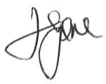

EGERUE NNAMDI JOSEPH

