Işık Express

Requirements Specification and Analysis

1.0

20.11.2020

Anzel Öztürk

Seray Şimşek

Berkan Hakseven

İrfan Ege Saray

Prepared for

SE301 Software Engineering



Table of Contents

1. Introduction 1

1.1. Purpose of the System 1

1.2. Scope of the System 1

1.3. Objectives and Success Criteria of the Project 1

1.4. Definitions, Acronyms, and Abbreviations 1

1.5. Overview 1

2. Current System 1

3. Proposed System 1

3.1. Overview 1

3.2. Functional Requirements 2

3.3. Nonfunctional Requirements 2

Usability 2

Reliability 2

Performance 2

Supportability 2

Implementation 2

Interface 2

Packaging 2

Legal 2

3.4. System Models 2

Scenarios 2

Use case model 2

Object model 2

Dynamic model 2

User interface—navigational paths and screen mock-ups 3

3.5. Project Schedule 3

4. Glossary 3

5. References 3

REQUIREMENTS ANALYSIS DOCUMENT[1]

# Introduction

## Purpose of the System

Işık Express is a website which mainly developed for people who wants to travel by flight. Anyone can register to the website, buy tickets, see the prices, flight times, flight directions and how much space a flight has.

## Scope of the System

When the project is finished, a completed purchase website model and Admin control panel will be completed. Main idea of creating Işık Express is to make possible that people who search for flights can easily book their flights and to make them reach best prices and wide range of flight times

. Different than all the website flight booking platforms, Işık Express website model will be focused on the easiness for people and also Admins who edits the website. İn Admin panel, the managers and employees will be possible to change, read or add ; Flight times, prices, maintenance times, feedbacks done by the users, add advertisements, campaigns, flight requirements and etc.

## Objectives and Success Criteria of the Project

Işık Express’s main objective is to be the first selected and searched flight booking website over a year. To make website always up to date and show the best matching flight information to the user.

For Us, Işık Express must be understandable and accessible to everyone, design of the website must always be interactive and user friendly.

## Definitions, Acronyms, and Abbreviations

RAD: Requirement Analysis Document

## Overview

Overall general explanations of system design, current system , changed system due to proposed system, functional requirements which is made for user friendly design, nonfunctional requirements which defines what our system has in the side of user and what is has to do in scope of several attribute, system models which shows how our system works and our work schedule.

Our report is designed that starting from what is our scope and ends with how we implement this project through time, that anyone can understand what we do and what will be done.

# Current System

When we look to the most searched flight booking websites ETS or FLYPGS, they were complicated to understand and there were too much information not including flights.

# Proposed System

İn our system, total change is done one the user side .Different than the other websites, we show only the flight selection in entry page then according to that we show the dates and information to block information confusion due to unnecessary information. Also we developed the interface by changing the feedback and help buttons to make user can easily contact authorized persons.

## Overview

Users can choose ticket types, flight time, destination and departure points, seat numbers and general actions done in interface. İn admin side of the system, admins can change or add any information on the website.

## Functional Requirements

1)The registered user must be able to cancel their ticket.

2)The registered user must be able to buy a ticket.

3)The registered user must be able to select the ticket time, time of the ticket, seat number, number of passengers, departure, destination and currency for payment while purchasing a ticket.

4)The registered user should be able to get information about travel updates (delay, flight cancellation)

5)The registered user must be able to get the information in how many hours she/he can reach the place she/he wants to go from.

6)When the registered user encounters any problem, he/she must be able to provide feedback to the website.

7)The visitor must be able to Access company information from the site (contact information…)

8)The registered user must be able to choose whether the ticket will be one-way or round-trip.

9)The registered user must be able to login to site.

10) The registered user must be able to register on the site

11)The registered user must be able to update her/his e-mail address.

12) The registered user must be able to update her/his password.

13)The registered user must be able to view the flights she/he has already made.

14)The registered user must be able to save credit card information in the system.

15)The registered user must choose which class they want to travel in (business class, economy class).

16)The registered user must be able to check in for baggage.

17) Admin must be able to modify flights.

18) Admin must be able to respond feedbacks.

## Nonfunctional Requirements

### Usability

1. The registered user should understand everything on the website clearly.
2. Admins should change anything on the system on the panel easily.

### Reliability

1. When the registered user searches for a flight, system should be showing the correct flight information to the user.
2. When the registered user is buying a ticket from the website, payment information should be collected safely.
3. System should be %90 reachable.

### Performance

1. While registered user changing the page in Işık Express, system must respond within 3 second.
2. When a feedback is given from the registered user, answer or correction should be done in 7 days.

### Supportability

1. As our system is controlled by admins and employees, when there is a problem according to the website, authorized person corrects or edits, so the system becomes self-repaired every time.

### Implementation

1.System is implemented based on html structure.

### Interface

1. The registered User must always easily see feedback button anytime.
2. The registered User must easily return to the homepage anytime.

### Packaging

1. Our system is a website, you do not need to download anything.

### Legal

1. The registered user’s ID should always be checked due to criminal records.
2. System should show tax amount to the registered user.
3. Website employees mustn’t share any personal information of the registered users.

## System Models

### Scenarios

**Scenario name** HowToCancelTicket

**Participating Actors** Albert: RegisteredUser

**Flow of Events** 1. Albert wants to cancel his ticket, because of his health condition.Luckly for him there is still enough time for canceling ticket.

2. Albert clicks on the My tickets section in the My Account section of the site.

3.Albert clicks the “cancel ticket” button which is at the side of the ticket informations.

4.Albert sees the message which says “Your cancellation has been completed successfully.”

5.Albert closes the tabs and waits for his return.

**Scenario name** GoingToUşak

**Participating Actors** İrfan: RegisteredUser

**Flow of Events** 1. İrfan is studying in İstanbul.In summer vacation he wants to see his homeland, therefore he decides to fly with IşıkExpress.He has already logged in and selected the ticket type, therefore it is the time for other ticket options.

2. İrfan selects departure as İstanbul airport and destination as Uşak airport.

3. İrfan sees the flights available.

4.İrfan sees that there is a flight at 20.06.2020 therefore İrfan selects that flight.After that İrfan selects number of passenger.

5. Then he clicks “continue” button.

**Scenario name** HowMuch?

**Participating Actors** Yağış: RegisteredUser

**Flow of Events** 1. Yağış wants to arrange a holiday for her parents. She promises her parents for a high class journey to another country. The day comes and her parents arranges their tickets and calls Yağış at payment page.

2. Yağış sees the price as 4500TL. She expected a much more expensive price from a brand like IşıkExpress

3.She selects from one of her registered credit cards and clicks “buy” button.

5.Yağış sees that there is not enough money in her card.Therefore she

selects another registered credit card.

6.Yağış successfully buys the ticket.

**Scenario name** WhenWasMyFlight?

**Participating Actors** Ali: RegisteredUser

**Flow of Events** 1. Ali always wanted to go Antalya, therefore he bought a ticket from IşıkExpress.But now just two days before flight he cannot remember the departure time.Therefore he logs in to his account.

2.Ali notices My tickets section in the My Account section

of the site. So he clicks it.

3. Ali sees the information about his flight.

4.He learns the departure time and now he knows that something happens like delay or flight cancellation he can learn it from here.

**Scenario name** HowMuchTime?

**Participating Actors** Ahmet: RegisteredUser

**Flow of Events** 1. Ahmet is trying to buy a ticket from IşıkExpress, after he completes the registiration actions, he is now selecting the flight.

2.After Ahmet selects and completes the buying ticket actions, he close the system.

3.After, he speaks with his friends about when he is going to land, he wants to check it from IşıkExpress. He enters the IşıkExpress with his account information, he selects “My Account” button.

4. Then Ahmet sees his ticket's information and flight time.

**Scenario name** SomethingWentWrong

**Participating Actors** Selin:RegisteredUser

**Flow of Events** 1. Selin enter the IşıkExpress website. She completes buying ticket.

2. She then wants to control her ticket information after some time. But when she clicks “My Account” button and when she wants to see her ticket information, she gets shocked. Because there seems to be no ticket.

3.Then she finds the feedback page and, a list is shown to her by system, she chooses one of the options that request, suggestion or complaint, and she writes her problem about her ticket.

4. After that Selin uses send button and completes the action.

**Scenario name** HowToReachYou?

**Participating Actors** Mehmet**:** Visitor

**Flow of Events** 1. Mehmet is a advertiser in a company. His company wants to advertise VIP car rental prices.

2.Mehmet enters the Işık Express website and he tries to find contact information about Işık Express company.He scrolls down the page and sees the contact information that includes social media accounts, e-mail adress, fax and call center number.

**Scenario name** HaveToGetBack

**Participating Actors** Sibel, Murat**:** RegisteredUser

**Flow of Events** 1. Sibel and Murat wants to go to Paris for their honeymoon. But when they speak with their manager. Manager give them only 3 days of time.

2.After that they enter the Işık Express for selecting the ticket. They chooses the place and the Işık Express displays them to options; one way trip or round trip.

3.Sibel and Murat chosses the round-trip option. Because they have to turn in 3 days. They selects first ticket information from them and second ticket information.

4.After Sibel and Ahmet sees the their tickets informations.

**Scenario name**  HowToLogin?

**Participating Actors** Ali**:** RegisteredUser

**Flow of Events** 1. Ali wants to go on a business trip for the weekend and want an airplane ticket for safety and comfortable travel.

2. Ali enters the IşıkExpress website and sees that he has to login for buy a ticket. He has an account and he enters his mail and his password to the login section.

3. After that Ali uses Login button and succefully login into web page to buy a ticket.

**Scenario name**  HowToRegister?

**Participating Actors** Büşra**:** RegisteredUser

**Flow of Events** 1. Büşra is studying at a university in another city, separate from her family and she travels a lot between two cities. She wants a register a site that buy or cancel ticket easily and see her old flight. She found out Işık express and opens site.

2.She sees that if she want an account she has to register.

3.Büşra clicks register button and fills the information about her, like email, password and credit card info.

4.Büşra sees a message about successfully saving her account.

**Scenario name**  HowToChangeE-mail

**Participating Actors** Ayşe:RegisteredUser

**Flow of Events** 1. Ayşe didn’t want to use her e-mail account and opened new one. She realizes that she has to change it in Işık Express to buy a ticket. She enters to Işık express and login with her old e-mail. Goes to my accounts section and selects change email button.

2.She fills the sections about her old email and new one that she wants replace with.

3.Ayşe wrote her old and new email addresses.

4.She sees that site successfully replace it with new one

**Scenario name**  HowToChangePassword

**Participating Actors** Melis**:**RegisteredUser

**Flow of Events** 1. Melis said her IşıkExpress password to a stranger by mistake and want to change her password immediately. She enters to Işık express and login with her e-mail and old password. Goes to my accounts section and selects change password button.

2. In the change password page, she writes old password and new one that she wants replace with.

3. She sees that site successfully replace it with new one.

**Scenario name** HowToSeePrevious

**Participating Actors** Beyza: RegisteredUser

**Flow of Events** 1. Beyza forgets the time she landed on the weekend and logins the Işık ekspress website to check it.

2. She enters the “My Flights” page because the list of her flights is on that page.

3. After that she want to see oldest flight she made. That’s why she clicks the “details” button to see oldest flight.

**Scenario name** HowToAddCreditCart

**Participating Actors** Selen:RegisteredUser

**Flow of Events** 1. Selen logins the Işık ekspress website to buy Antalya flight ticket. She will go with her friends for holiday

2. She wants to use his father's credit card because her credit card limit is over. She enters the account information section and adds credit card information then clicks the “Save” button.

3. After adding, she goes to the ticket purchasing section and gets her ticket.

**Scenario name** HowToChooseClass

**Participating Actors** Berkan**:** RegisteredUser

**Flow of Events** 1. Berkan logins the Işık ekspress website to buy a ticket for his honeymoon with his wife.

2. He clicks the purchase section which is at the purchase page of the Işık Express.

3. While buying tickets, he chooses the first-class ticket option to make a more comfortable flight with his wife.

4. Then he clicks the “buy” button and sees their ticket information.

**Scenario name** HowToCheck-in

**Participating Actors** Fatih**:** RegisteredUser

**Flow of Events** 1. Fatih will go to Ankara for a business trip, but he was late due to traffic. So, he decides to check-in. He logins the Işık ekspress website.

2. He enters the check-in section then sees the list of seats and option of baggage.

3. After the selection, he clicks the “select” button and sees message which is says “Succesfully check-in”.

**Scenario name** ThereİsAMissingFlight

**Participating Actors** Zeynep:Admin

**Flow of Events** 1. Zeynep enters the Işık Express to get up in the morning and reply to the feedbacks.

2. One of the registered users says there is a flight to NewYork in other websites, but I couldn’t find that flight in your website.

3. And Zeynep check if it is correct then modify the flight.

**Scenario name** AlotOfFeedbacks

**Participating Actors** Zeynep:Admin

**Flow of Events** 1. When Zeynep enters the Işık Express, she sees that there are many messages in the feedback box.

2. Since the replying will take a long time, Zeynep takes a coffee and begins to respond.

### Use case model

**Use case name** DisplayPreviousFlights

**Participating Actors** Initiated by RegisteredUser

**Flow of Events** 1. RegisteredUser enters the “My Flights” page in the Işık Express.

2. Işık Express shows the flights of the RegisteredUser by listing the newest flight at the top. Previous flights are showed in detail, so there is no another button to show them in more detail. If there is no previous flight, then Işık Express displays a message which says “Sorry, you haven’t go to your flight yet.”.

**Entry condition -** RegisteredUser is logged in to the Işık Express with his/her email and password.

**Exit condition** - RegisteredUser notices a list his/her flights in the Işık Express or if he/she did not flight yet, RegisteredUser notices a message which says “Sorry, you haven’t go to your flight yet.”.

**Quality reqirements** Registered User should understand every information about a flight clearly.

**Use case name** ChangePassword

**Participating Actors** Initiated by RegisteredUser

**Flow of Events** 1. RegisteredUser enters the “Change Password” page of the Işık Express which is only allowed for the RegisteredUser.

2. Işık Express responds to the RegisteredUser by

displaying a empty form.

3. RegisteredUser, enters old password 1 time, new password 2 times and then clicks the “Save” button.

4. Işık Express responds to the RegisteredUser by displaying message which says “Saved Succesfully”.

**Entry condition -** RegisteredUser is logged in to the Işık Express with his/her email and password.

**Exit condition -** RegisteredUser notices a message of the Işık Express as a respond which says “Saved Succesfully”.

**Quality reqirements** Işık Express must encrypt passwords for security.

**Use case name** ChangeE-Mail

**Participating Actors** Initiated by RegisteredUser

**Flow of Events** 1. RegisteredUser enters the “My Account” page and then the enters the “Change E-mail” page of the Işık Express which is only allowed for the RegisteredUser.

2. Işık Express responds to the RegisteredUser by

displaying a empty form.

3. RegisteredUser, enters new e-mail address then clicks the “Save” button.

4. Işık Express responds to the RegisteredUser by displaying message which says “Saved Succesfully”.

**Entry condition -** RegisteredUser is logged in to the Işık Express with his/her email and password.

**Exit condition -** RegisteredUser notices a message of the Işık Express as a respond which says “Saved Succesfully”.

**Quality reqirements** User should understand the interface of the page.

**Use case name** Login

**Participating Actors** Initiated by RegisteredUser

**Flow of Events** 1. RegisteredUser fills out the blank email adress and password fields with his/her credentials. After that, he/she clicks the “Log in”button

2. Işık Express responds to the Customer by displaying the homepage of the Işık Express and also his/her name on the right corner of the page.

**Entry condition -** RegisteredUser enters the login page of the Işık Express

**Exit condition** - RegisteredUser recevies the home page of the Işık Express and also notices his/her name on the right corner of the page.

**Quality reqirements** Işık Express must not show given password on screen.

**Use case name** AddCreditCart

**Participating Actors** Initiated by RegisteredUser

**Flow of Events** 1. RegisteredUser adds their credit card information to the account information section and then clicks the “Save” button.

2. Işık Express responds to the RegisteredUser by displaying message which says “Saved Succesfully”.

**Entry condition -** RegisteredUser is logged in to the Işık Express with his/her email and password.

**Exit condition** - RegisteredUser notices a message of the Işık Express as a respond which says “Saved Succesfully”.

**Quality requirements** Işık Express should encrypt the credit card informations for safety.

**Use case name** Register

**Participating Actors** Initiated by Visitor

**Flow of Events**

1. Işık Express shows login page and register button.

2. Visitor clicks to register button in the page.

3. Işık Express shows displays a blank form for registration which includes the fields of full name, email adress and password.

4. Visitor fills out the form and then clicks the “Register” button.

5. Işık Express responds to the Customer by displaying a pop-up message which says “You are registered to the system succesfully.” and then directs the Customer to the login page of the Işık Express.

**Entry condition -** Visitor enters the register page of the Işık Express.

**Exit condition** - Visitor notices the “You are registered to the system succesfully.” message of the system.

**Quality reqirements** Işık Express must deliver the new user to database in 3 seconds.

**Use case name** GiveFeedback

**Participating Actors** Initiated by RegisteredUser

**Flow of Events** 1.The registered user clicks on the Feedback section which is at the home page of the Işık Express.

2. Işık Express displays the feedback page which has one drop-down list box and an empty form.

3. Registered user selects request,suggestion or complaint from drop-down list box and fills the empty form and then clicks the “send” button.

4. Işık Express responds to the RegisteredUser by displaying a message which says “Succesfully Sent”.

**Entry condition** RegisteredUser is logged in to the Işık Express with his/her email and password.

**Exit condition**  RegisteredUser notices a message of the Işık Express as a respond which says “Succesfully Sent”.

**Quality requirements** IşıkExpress must deliver the feedback to system in 3 seconds.

**Use case name** AccessContactInformation

**Participating Actors** Initiated by visitor

**Flow of Events**

1. Visitor scrolls down to bottom of the home page.

2. At bottom of the home page Işık Express displays social media accounts, e-mail adress, fax and call center number.

**Entry condition** Visitor is at the home page of Işık Express.

**Exit condition**  Visitor informed about how to contact with Işık Express.

**Quality requirements** Informations must be clearly visible.

**Use case name** ChooseTicketType

**Participating Actors** Initiated by RegisteredUser

**Flow of Events**

1. Işık Express displays the buttons for one-way or round-trip at the

home page.

2. RegisteredUser selects one of the buttons.

3. Işık Express displays ticket options accordingly.

**Entry condition** RegisteredUser is at the home page of Işık Express.

**Exit condition**  RegisteredUser notices that he/she selected one of the buttons and saw the next ticket options.

**Quality requirements** Registered user should be choose ticket type with one click.

**Use case name** RecieveTravelTime

**Participating Actors** Initiated by RegisteredUser

**Flow of Events** 1. The user clicks on the My tickets section in the My Account section

of the site.

2. Site shows users flight information and flight time.

**Entry condition** RegisteredUser is logged in to the Işık Express with his/her email and

password.

**Exit condition**  User informed about the flight time.

**Quality requirements** Registered User should understand informations clearly.

**Use case name** ChooseClass

**Participating Actors** Initiated by RegisteredUser

**Flow of Events**

1. Işıkekspres displays the ChooseClass page which has options for class.

2. Registered user selects class of the ticket.

3. Işıkekspres responds to the RegisteredUser by displaying ticket information.

**Entry condition** RegisteredUser is logged in to the Website with his/her email and password.

RegisteredUser clicks “continue” button in select ticket page and he/she is at chooseclass page

**Exit condition**  RegisteredUser notices “continue with payment” button.

**Quality reqirements** User must understand the consequences of choosing class.

**Use case name** Check-in

**Participating Actors** Initiated by RegisteredUser

**Flow of Events** 1.The registered user clicks on the check-in section which is option to deliver baggage from a specially reserved section and choose seat to travel.

2. Işıkekspres displays the seat list and option of baggage.

3. Registered user selects request then clicks the “select” button.

4. Işıkekspres responds to the RegisteredUser by displaying a message which says “Succesfully check-in”.

**Entry condition** RegisteredUser is logged in to the Website with his/her email and password.

**Exit condition**  RegisteredUser notices a message of the Website as a respond which says “Succesfully check-in”.

**Quality reqirements** User should be able to go check-in page with one click from home page.

**Use case name** BuyTicket

**Participating Actors** Initiated by RegisteredUser

**Flow of Events**

1. IşıkExpress displays the price of the ticket.
2. RegisteredUser selects one of his/her registered credit cards. If he/she didn’t registered a card yet he/she enters card informations for this ticket and then clicks “buy” button.

3. Site displays the confirmation of the payment and sells the ticket.

**Entry condition** RegisteredUser is choosed the ticket type and other ticket options and clicked “continue with payment” button.

RegisteredUser is at payment page.

**Exit condition** IşıkExpress redirects the RegisteredUser to the myflights page. RegisteredUser notices that he purchased the ticket.

**Quality requirements** IşıkExpress do not shares any credit card information and makes transaction safely.

If user registered a credit card he/she should buy ticket with two click.

**Use case name** SelectTicket

**Participating Actors** Initiated by RegisteredUser

**Flow of Events** 1. Registered user selects time, number of passengers,

departure and destination.

2. Işık Express displays the price of the ticket and saves ticket

information.

**Entry condition** RegisteredUser is at SelectTicket page.

**Exit condition** RegisteredUser notices “continue” button.

**Quality requirements** User shouldn’t be wait between selections.

**Use case name** CancelTicket

**Participating Actors** Initiated by RegisteredUser

**Flow of Events** 1.The registered user clicks on the My tickets section in the My Account section of the site and clicks the cancel button on the side.

2. Işık Express responds to the RegisteredUser by displaying message which says “Your cancellation has been completed successfully.”.

**Entry condition -** RegisteredUser is logged in to the Işık Express with his/her email and password.

**Exit condition -** RegisteredUser notices a message of the Işık Express as a respond which says “Saved Succesfully”.

**Quality reqirements** At my tickets page user should be able to cancel his/her ticket with one click.

User should understand the penalties of canceling ticket.

**Use case name**  LearnInformations

**Participating Actors** Initiated by RegisteredUser

**Flow of Events** 1.The user clicks on the My tickets section in the My Account section

of the site.

2. Işık Express responds to the user by displaying information about

flight if any, like delay or flight cancellation.

**Entry condition** RegisteredUser is logged in to the Işık Express with his/her email and

password.

**Exit condition**  User informed about updates in flight.

**Quality reqirements** User must be able to see every informations about every flights he/she has without clicking anything.

IşıkExpress should have to do every information about a flight clearly understandable.

**Use case name** ModifyFlights

**Participating Actors** Initiated by Admin

**Flow of Events** 1. Admin modifies flights from the admin control panel and then clicks the “Save” button.

2. Işık Express responds to the Admin by displaying message which says “Saved Succesfully”.

**Entry condition -** Admin is logged in to the Işık Express with his/her email and password.

**Exit condition** - Admin notices a message of the Işık Express as a respond which says “Flights Saved Succesfully”.

**Quality reqirements** Flights must be modified correctly in Işık Express.

**Use case name** RespondFeedback

**Participating Actors** Initiated by Admin

**Flow of Events** 1. Admin returns feedbacks from admin control panel.

2. Işık Express responds to the Admin by displaying message which says “Return message forwarded to the registered user”.

**Entry condition -** Admin is logged in to the Işık Express with his/her email and password.

**Exit condition** - Admin notices a message of the Işık Express as a respond which says “Message Sent Succesfully”.

**Quality reqirements** The respond must be answered clearly and sent to the user..

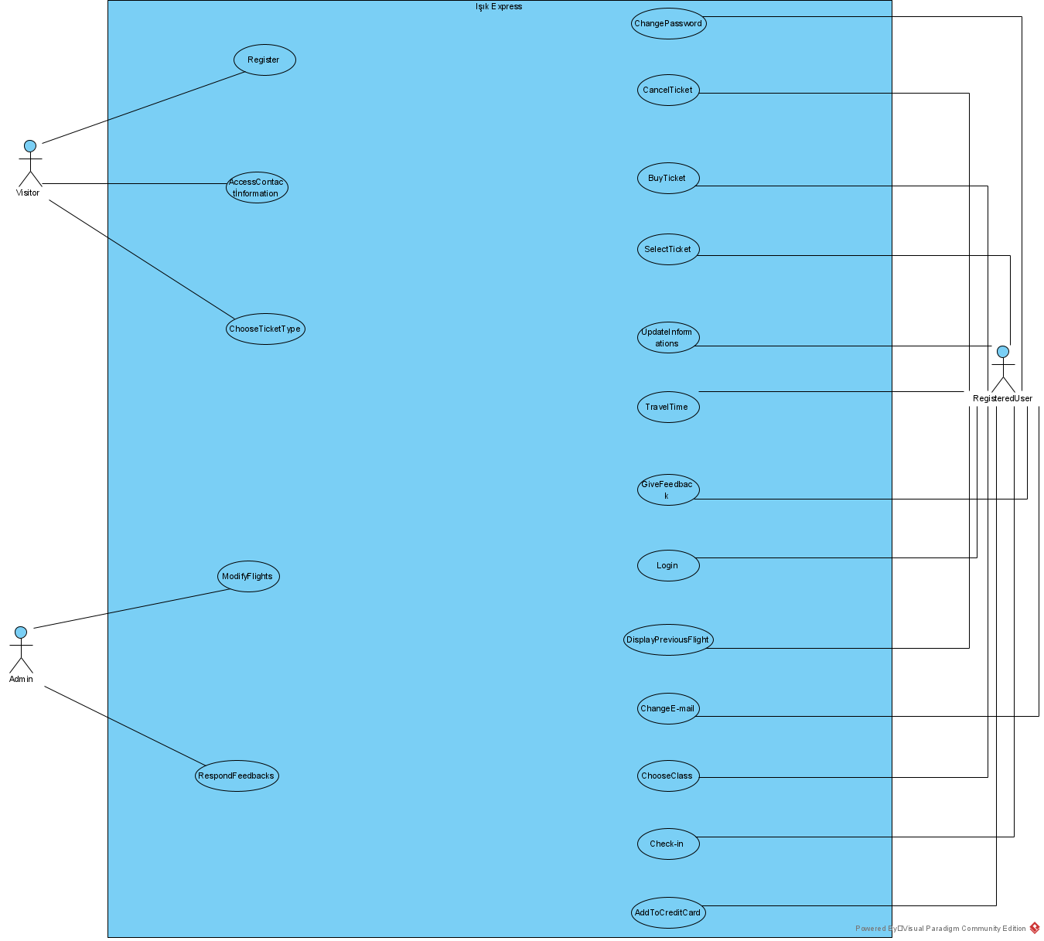

### Object model

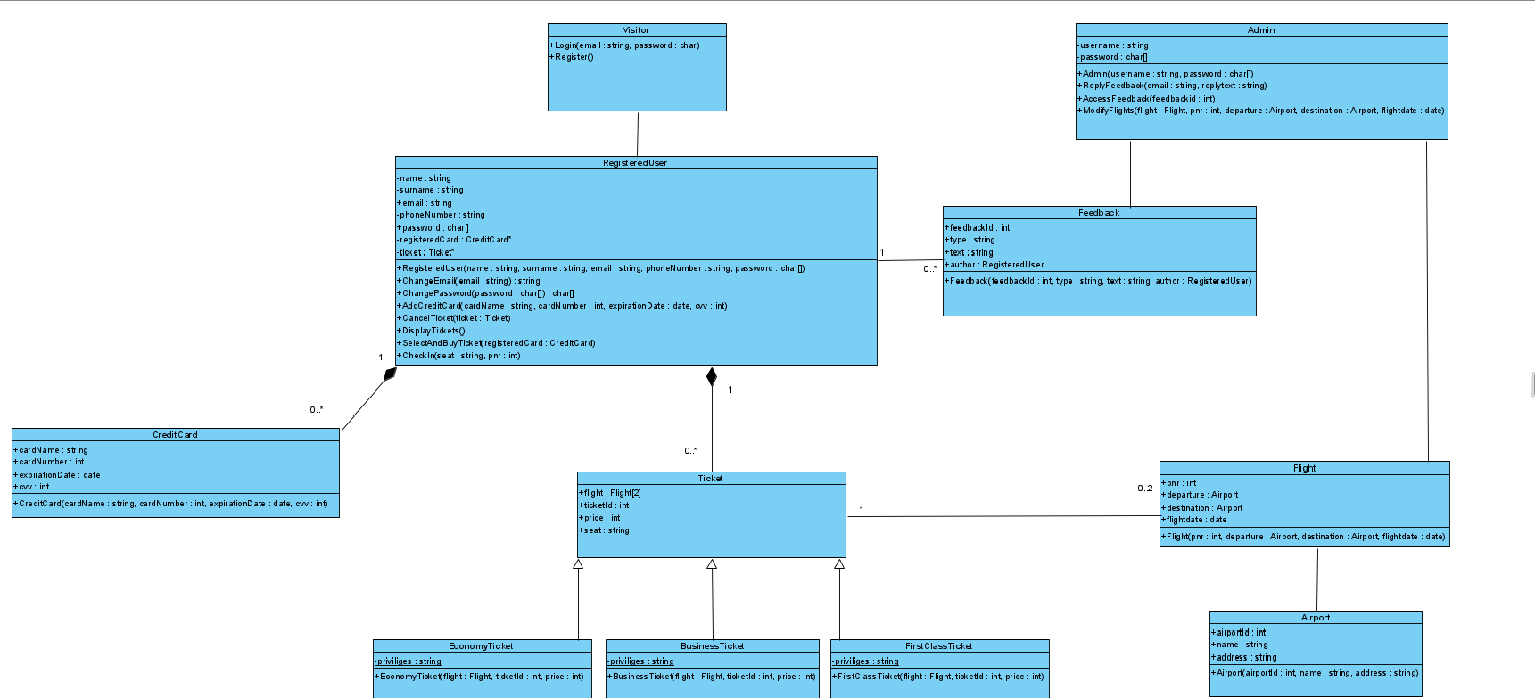

### Dynamic model

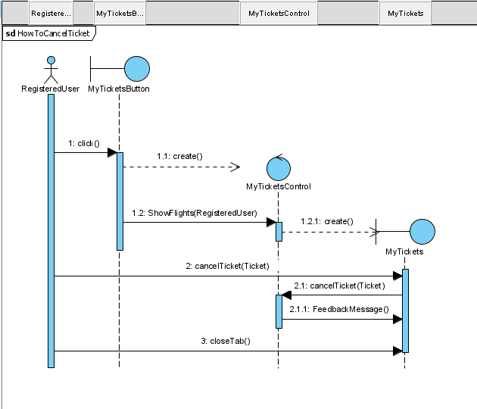

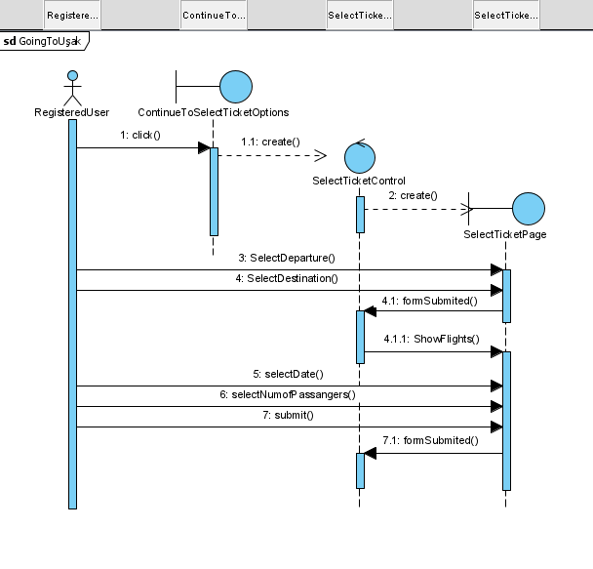

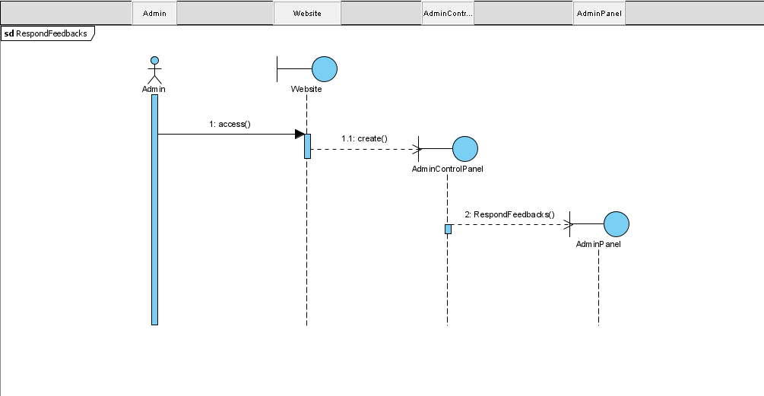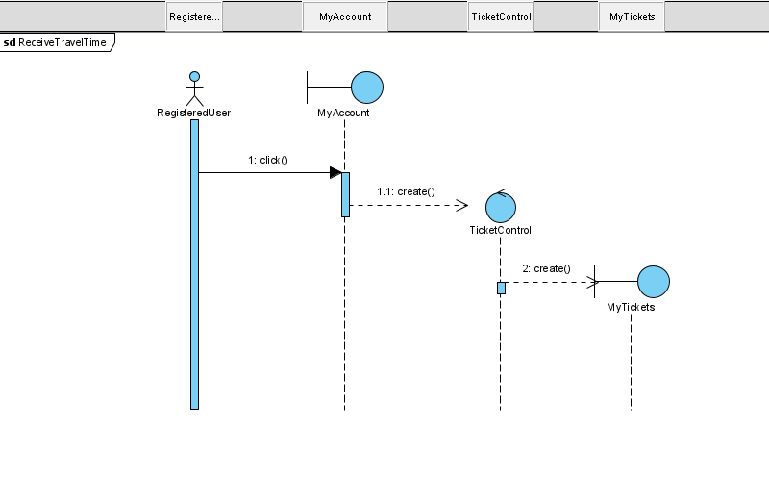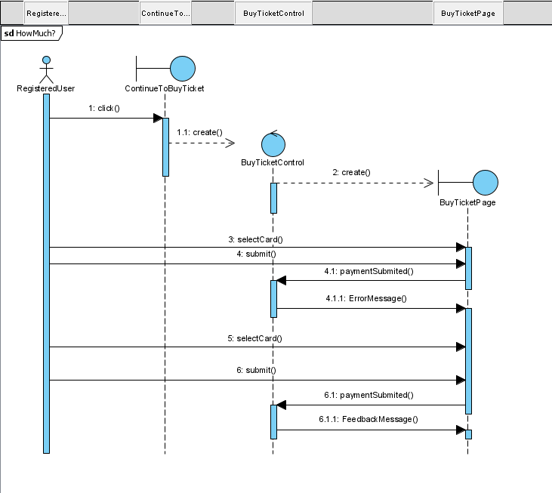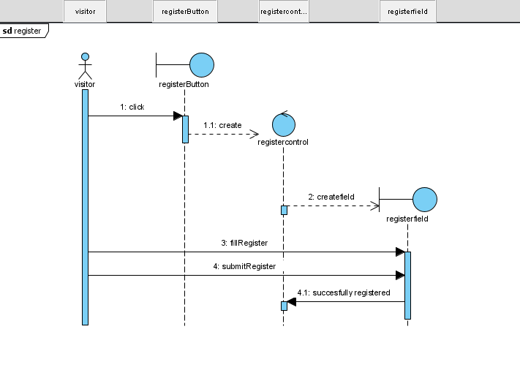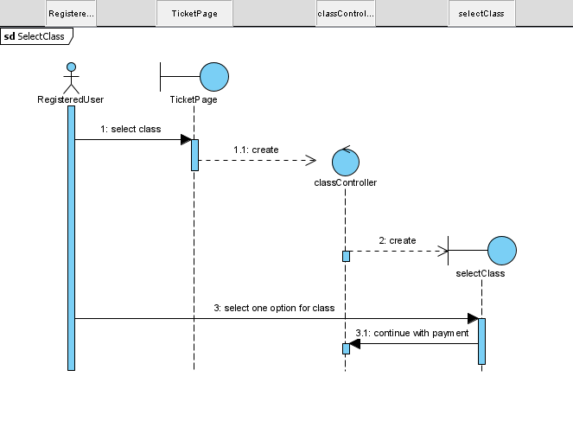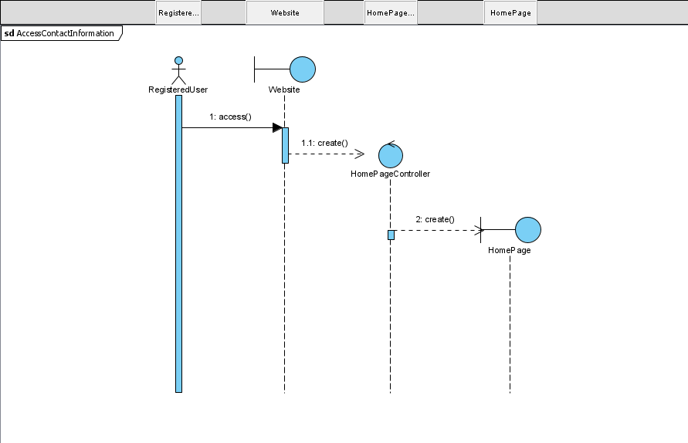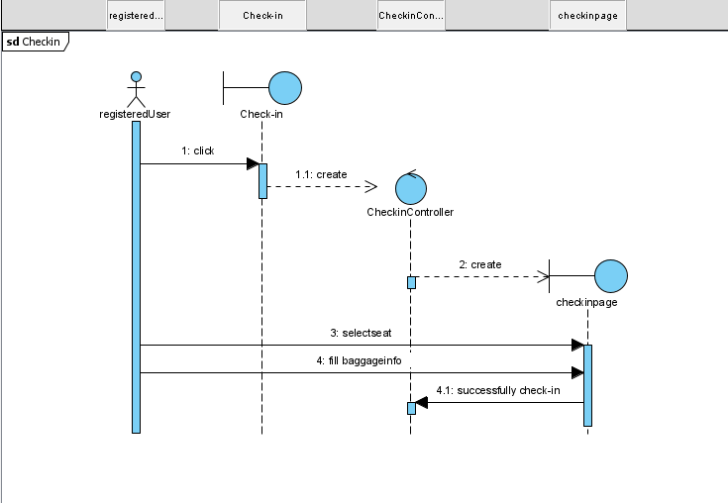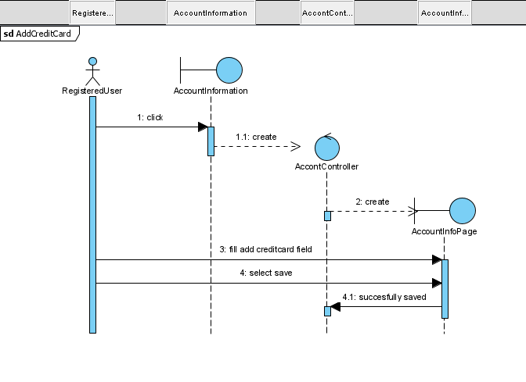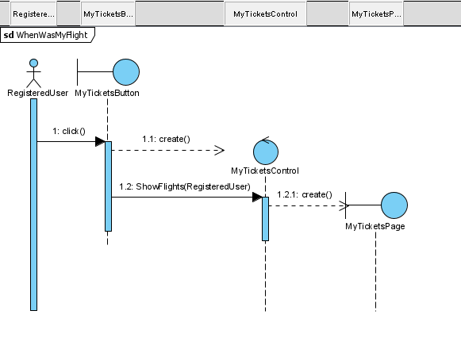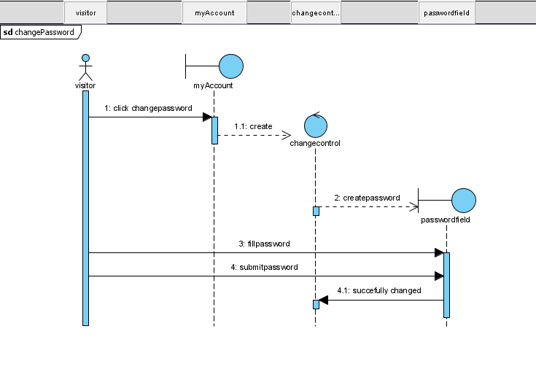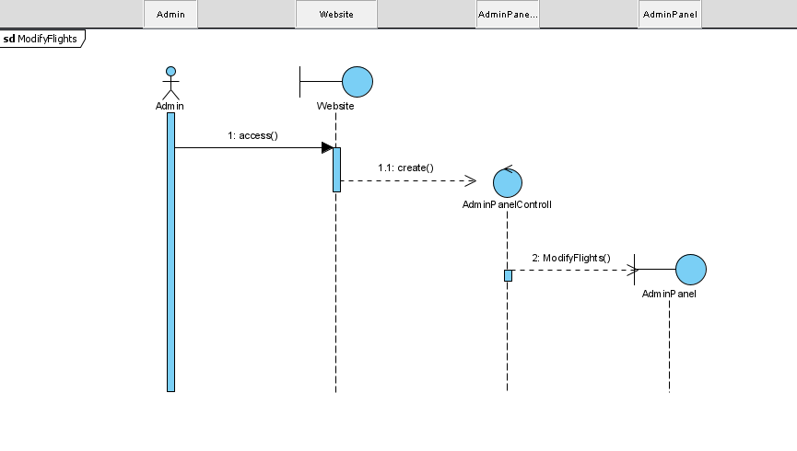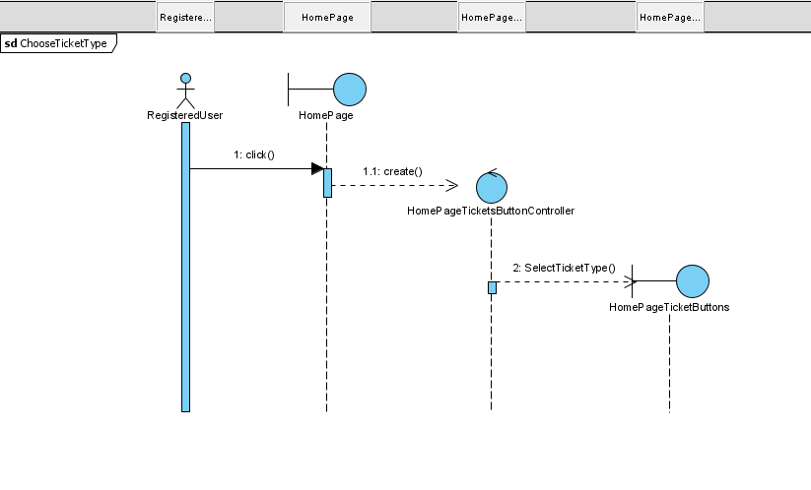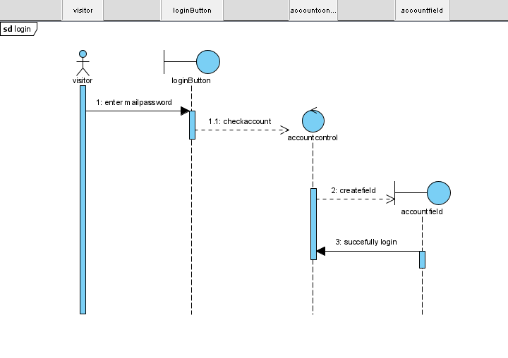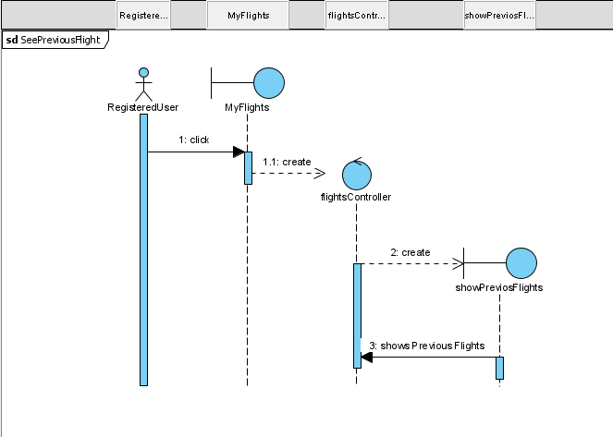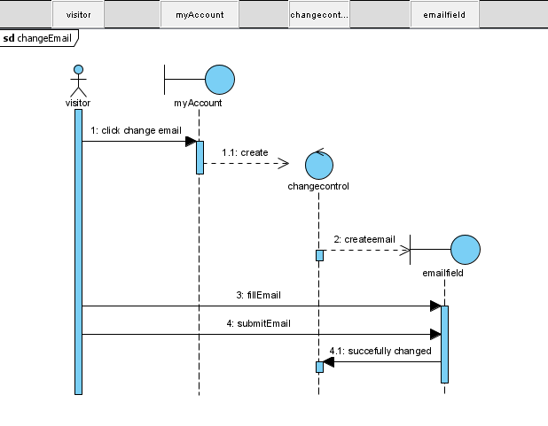

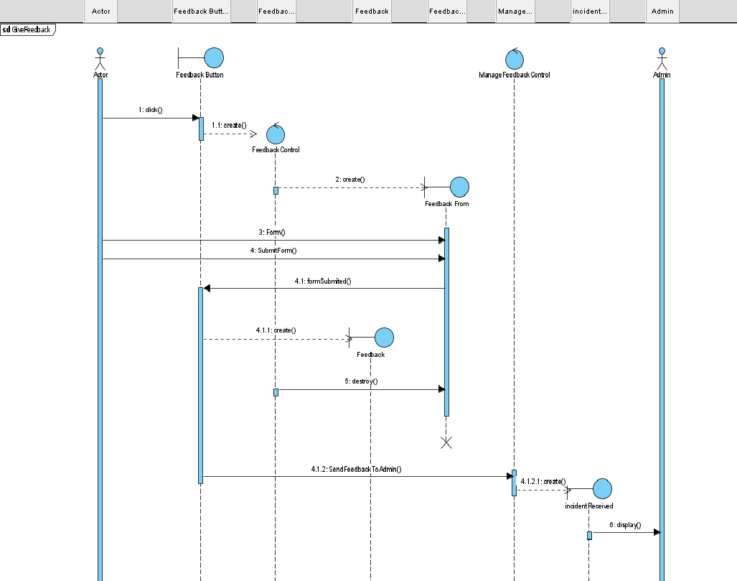

### User interface—navigational paths and screen mock-ups

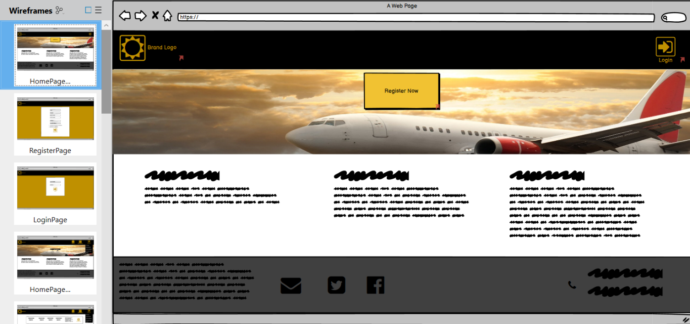

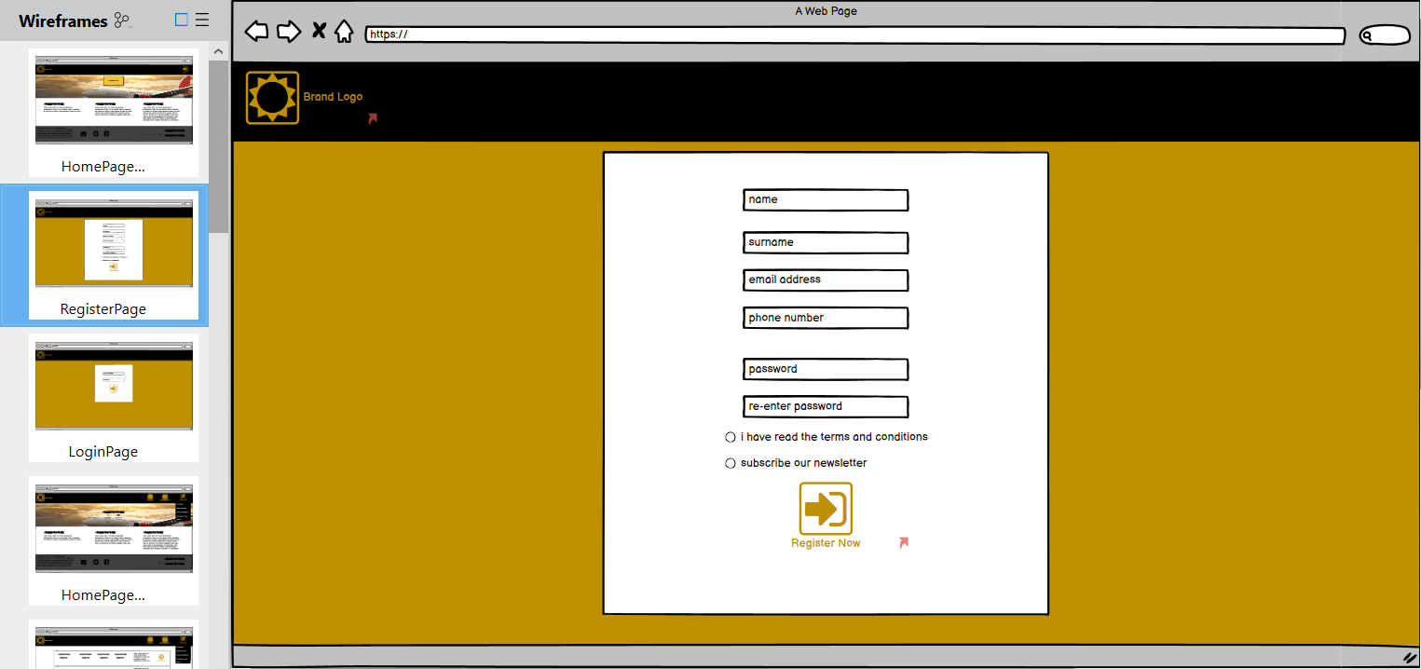

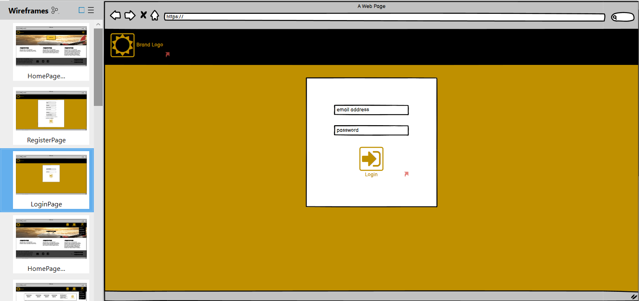

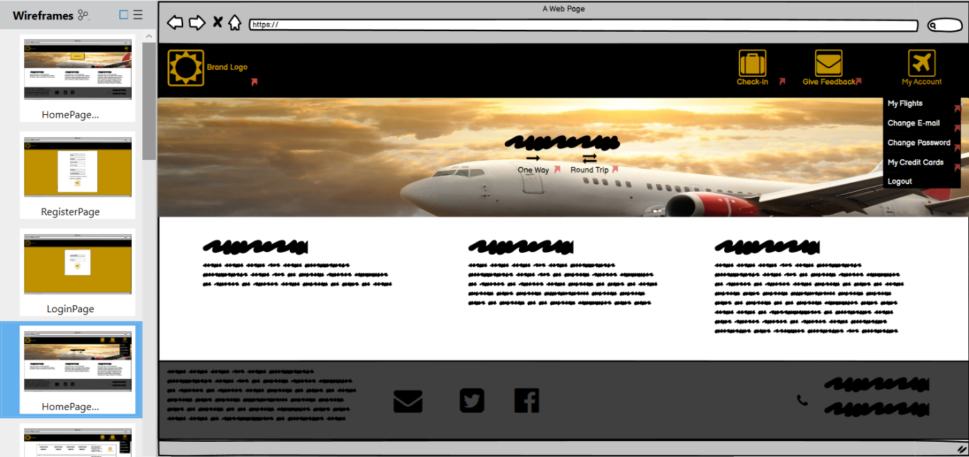

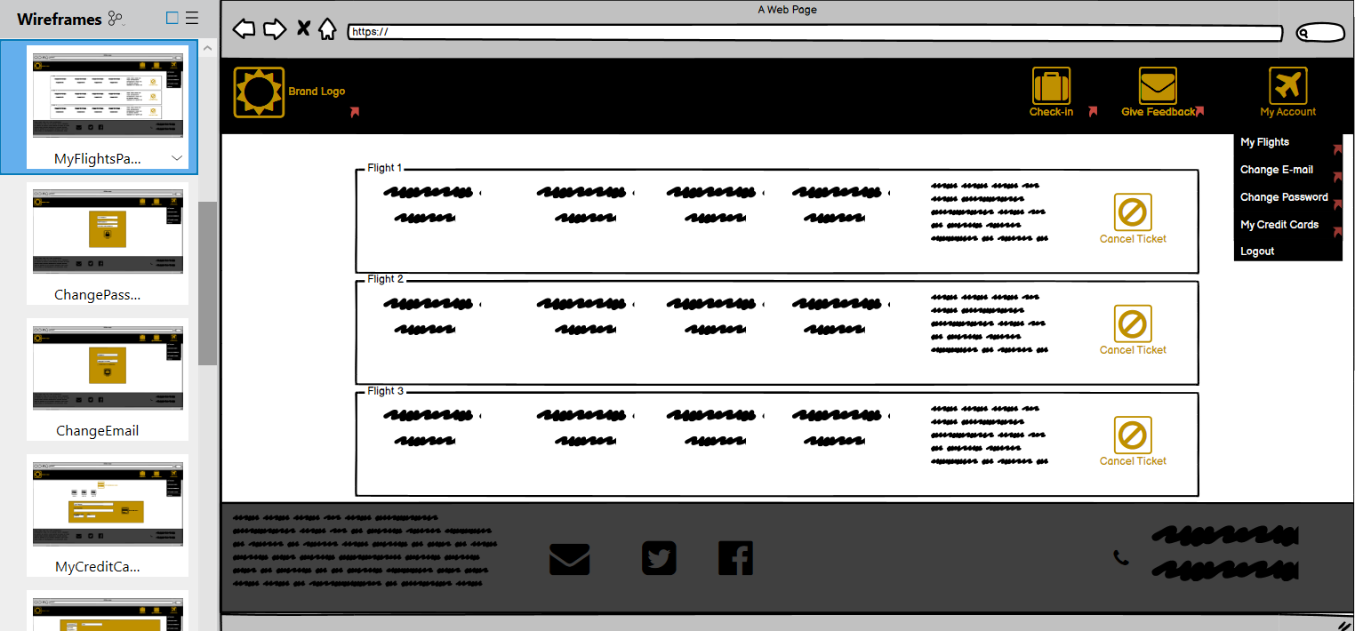

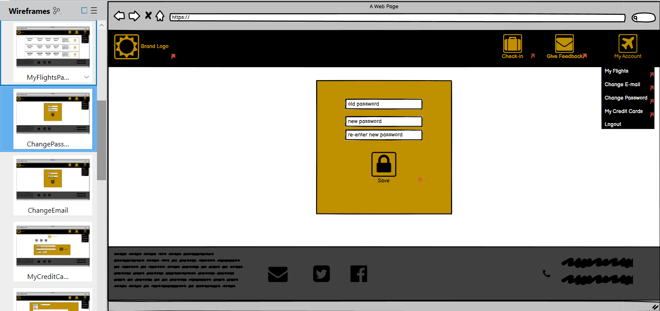

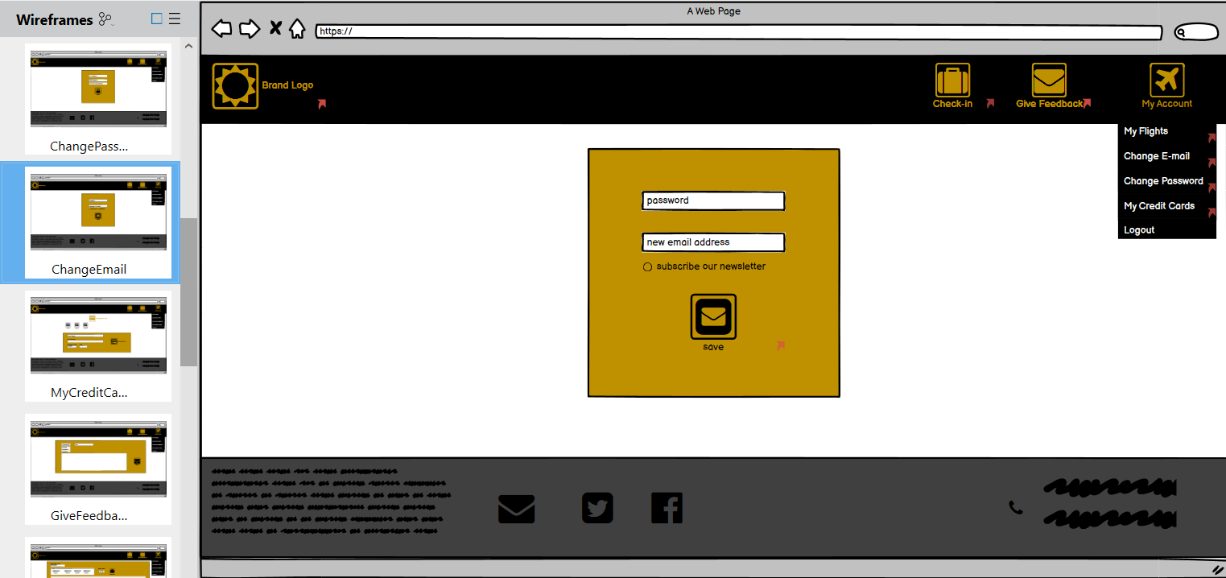

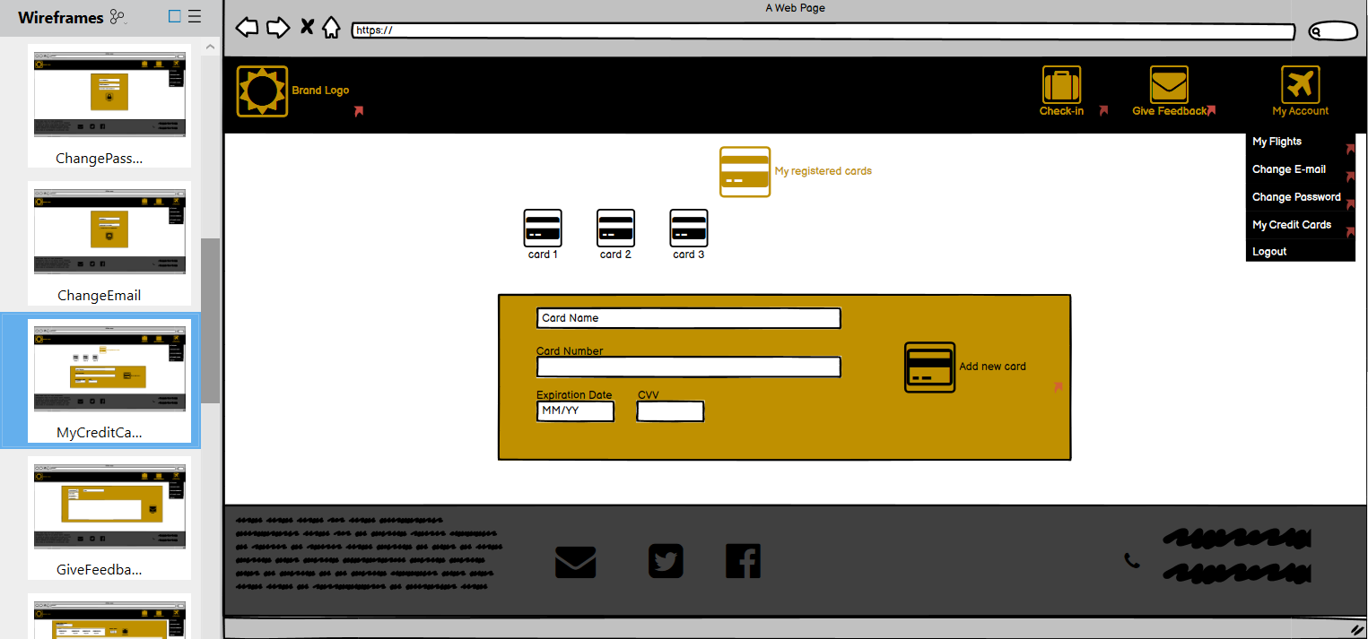

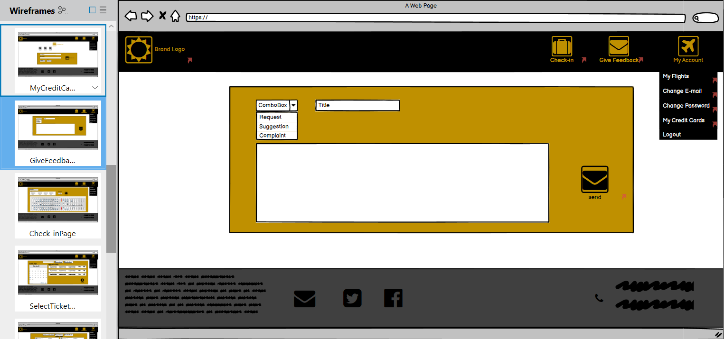

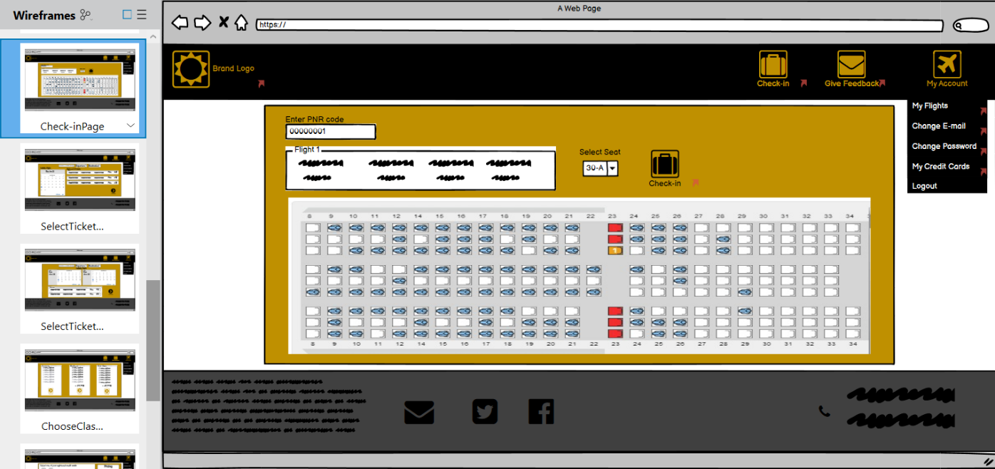

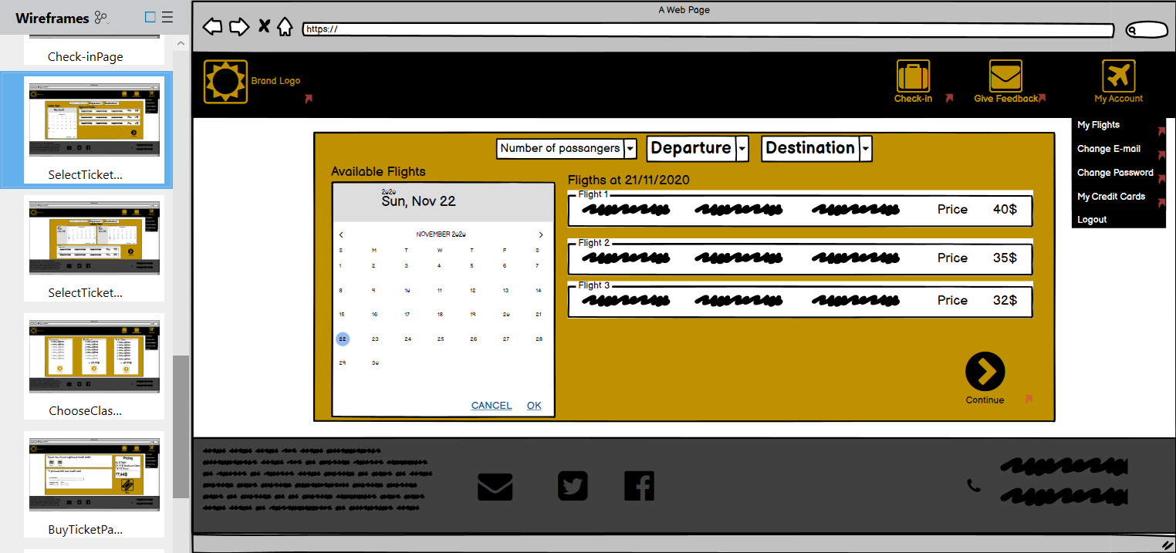

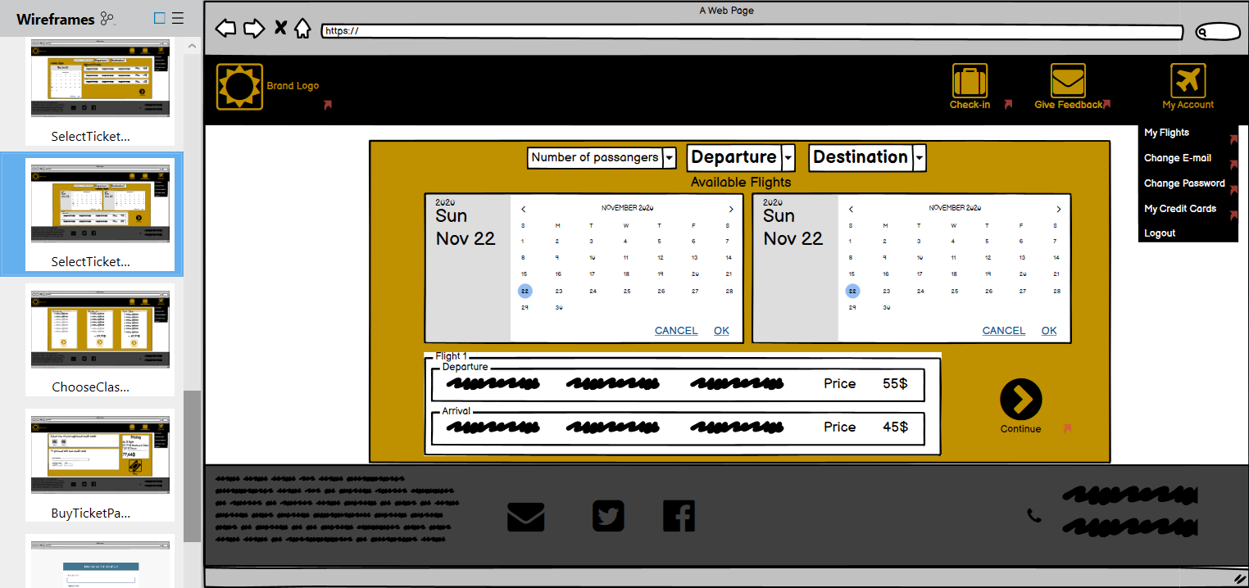

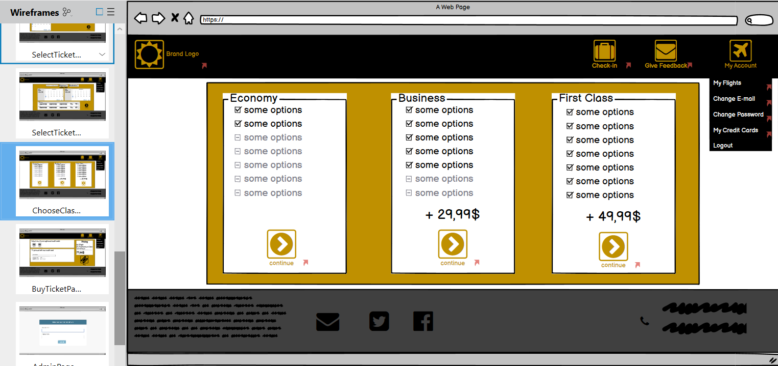

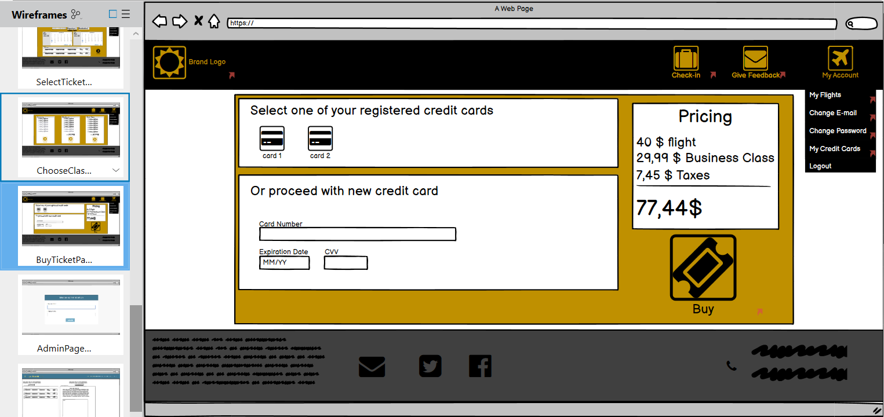

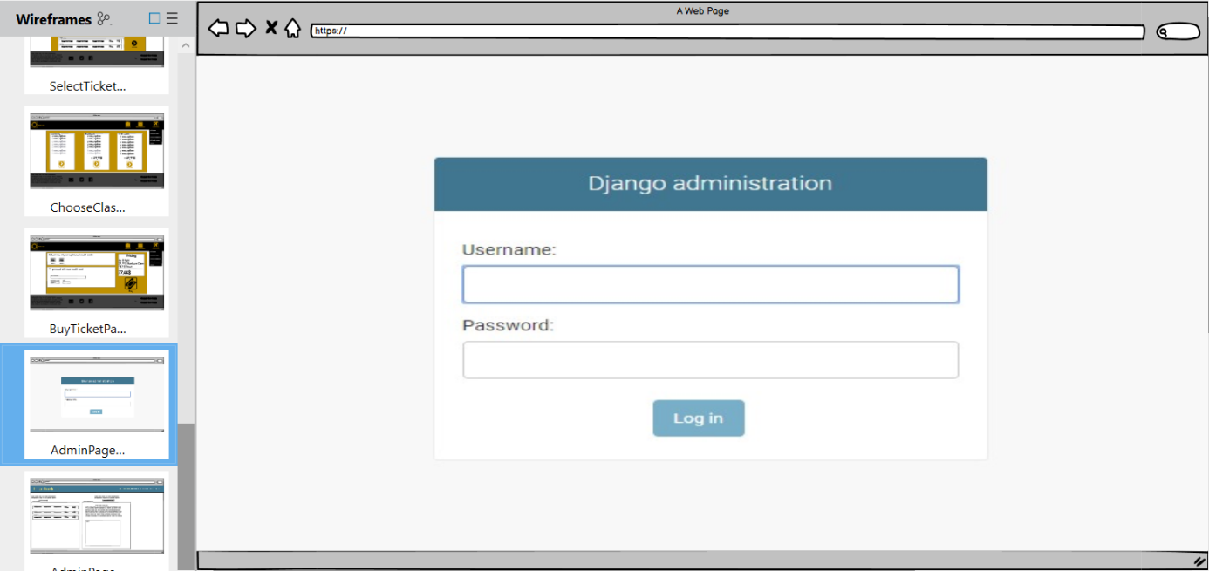

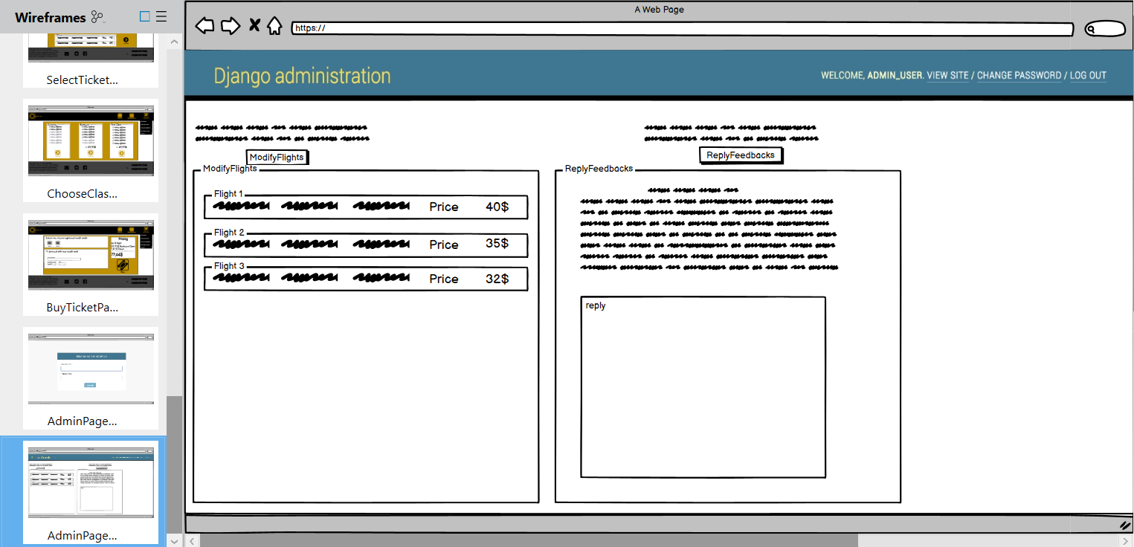

## Project Schedule

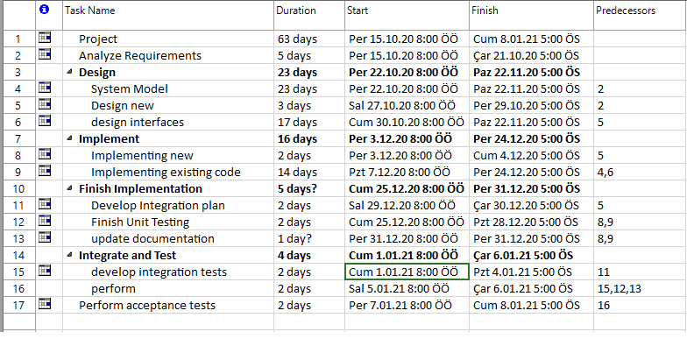

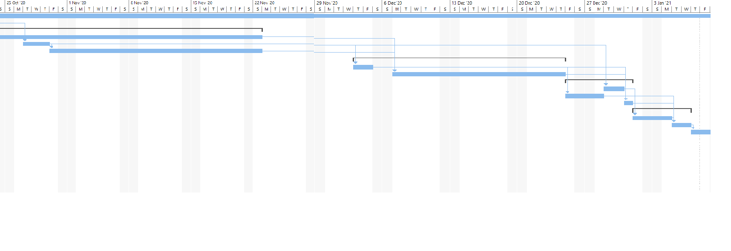

# Glossary

Visitor: Person who enters the website without registering.

Registered User: People who is registered on the website.

Admin: People who control the system.

System: Işık Express

# References

1.ClassDiagram.vpp

2.sequencediagrams1-18.vpp

3.MockupSOFT3101.bmpr

4.UseCaseDiagram

5. <https://www.flypgs.com/>

6. <https://www.etstur.com/>

7. <https://www.turkishairlines.com/tr-tr/>

8.Bernd Bruegge, Allen H. Dutoit, Object Oriented Software Engineering Using UML, Patterns and Java, 3rd ed., Prentice Hall