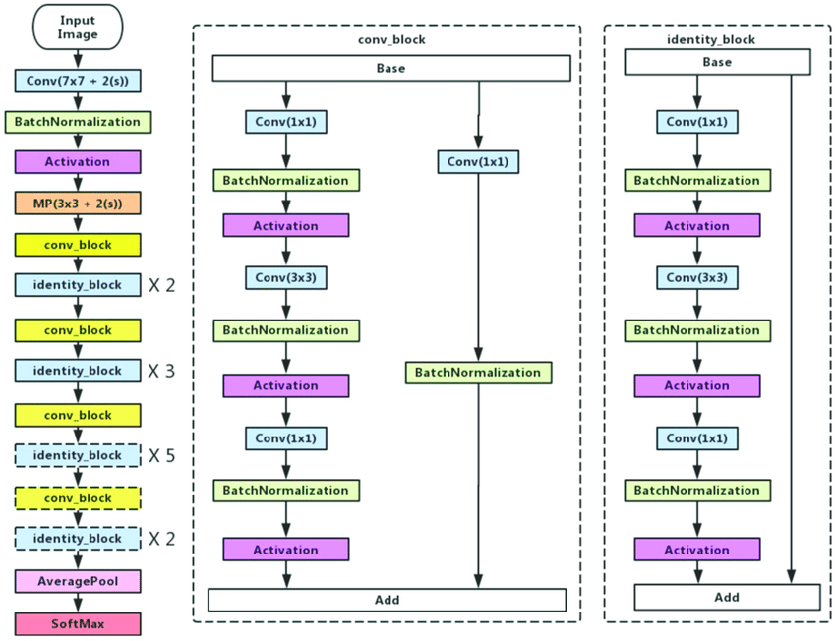

https://www.researchgate.net/figure/Left-ResNet50-architecture-Blocks-with-dotted-line-represents-modules-that-might-be_fig3_331364877