一、animation:

animation: name duration timing-function delay iteration-count direction fill-mode play-state;

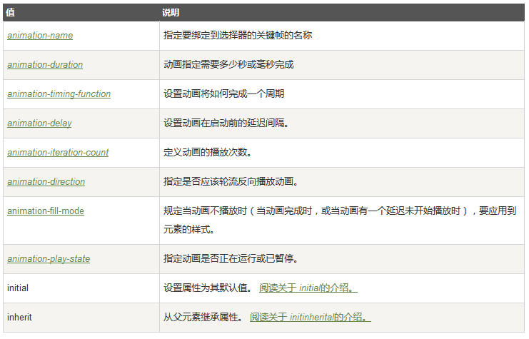

1. @keyframes

@keyframes animationname {keyframes-selector {css-styles;}}

