

**Business Sales Management System**

**Information System Security**

**May 28, 2019**

# **Overview**

A business person always wants that their business works fast and convenient daily. If they use the basic type of storing the information of all the products such as an excel, it might be too dangerous for the business to secure that sensitive information though there’s a lot of bad person who could actually destroyed or worst can delete those sensitive information in just a one single click. The manager is responsible for the production and profit of sales of the owners business. If monitoring the count of product supply was worst, it might also affect the cost of the business and might leads to bankrupt. Every business shall have to provide their business a system that will help them to manage properly their supplied products and secure their important information especially in their profits, away from that malicious person who are intended to bring their company down.

We come up with the idea of creating a Business Sales Management System for the purpose of managing the products and sales of the company’s business. Through this system, an admin may able to give a solution for the poor practices or can provide a simple and usable managing system for the company. It was convenient and easy to use because an admin can directly add or edit the products with the prices to the system, and may directly calculated all those prices according to the product. Only the admin who are already registered on the system will able to log-in into the system. If not, a person shall require to signing up or registers on the system. Right from the log in tab, you see for register button for registration. In the categories page from the add button, you shall create what type of category of product it was while in the manage tab of it was the record of the saved added category. Same as in the brand page was the kind of brand of the product with the manage tab. Both the added category and brands shall be directly recorded and saved in the product page. The date from when the product was calculated also stores into the product manage tab. In the product page, you can already add the name, price and quantity of the product. The category and brands that was added and recorded in the first page will be the choice for the final added save product. At the top of the category, the brand and the product is the new order page where you can make an invoice and create new orders. When you click the new order tab, inside you saw the managing system that intended for the customer’s transactions. In the make a list below the add customer name, your recorded, added or edited details of the product will be directly the choice for the customer’s transaction. The system able to print an invoice receipt for every transactions if required. It was seen after adding an customer’s order from the new order button.

The Business Sales Management System can also use by the company who are having a business that sells their own products. For example, the fast food chains business or the shopping mall. I want to bring our project system to the convenience store where there are different kinds of products, dresses, foods, clothing were in there. The store manager of the company shall able to add or edit a product, edit the prices of it, and the system shall calculate directly those things.

# **Web Information**

## Content Sections

* Admin’s Log In – the admin who already registered to the system can log in into the system. If not, he/she may register first clicking the register tab.
* Admin’s registration page – the admin register his or her information for log in into the system.
* Dashboard – it contains the new orders, category page, the brand page and the product page
* New Orders Page – It is when an admin manage a service for customers in ordering their want product. You saw in that page the added name of the customer, the direct choice for the product name, editing for product quantity and it’s total price. You can also remove and add for the customer’s request product and it was recorded directly on that page.
* Category – contains add and manage button. If you click the add button, you see the category name for adding the product category (for example: refrigerator) and parent category for searching what type of category it is (for example: appliances). In the manage tab, you saw the list of already saved category. The admin also can able to activate, edit or delete the product category.
* Brands – same as in the category page, you can also see the add and manage button. You can name the brand of the product (for example: LG), and in the manage button you can view the lists already recorded add brands.
* Product – in this page, you can view date for the added product, add a product name, choose a category, choose for the brand, enter for the product price, and quantity. In the manage tab of the product, you can view the whole record for the final added product.

## User Roles

* The admin of the system - the trusted one who knows the information inside the system, responsible for transferring data of information and the one who manage of the branch record sales of the company.

The admin shall:

* Able to log in into the system.
* Can able to add, edit or delete the product according to manager’s thoughts.
* Can able to view the list of products recorded in the system.
* Manage system service for the customers.
* Present record for all the customers who transact in their system.
* The manager of the branch store – someone who manage also the system if ever there are changes in the record of the product.
* Able to view the record of the product.
* Also can able to add, edit or delete the product in the system.
* Update all the customer’s transactions to the system admin.
* Marketing and Production Personnel – the one who assigned for the increased sales of the business and also responsible for any changes of the product.

## Screenshots

* Log in Page

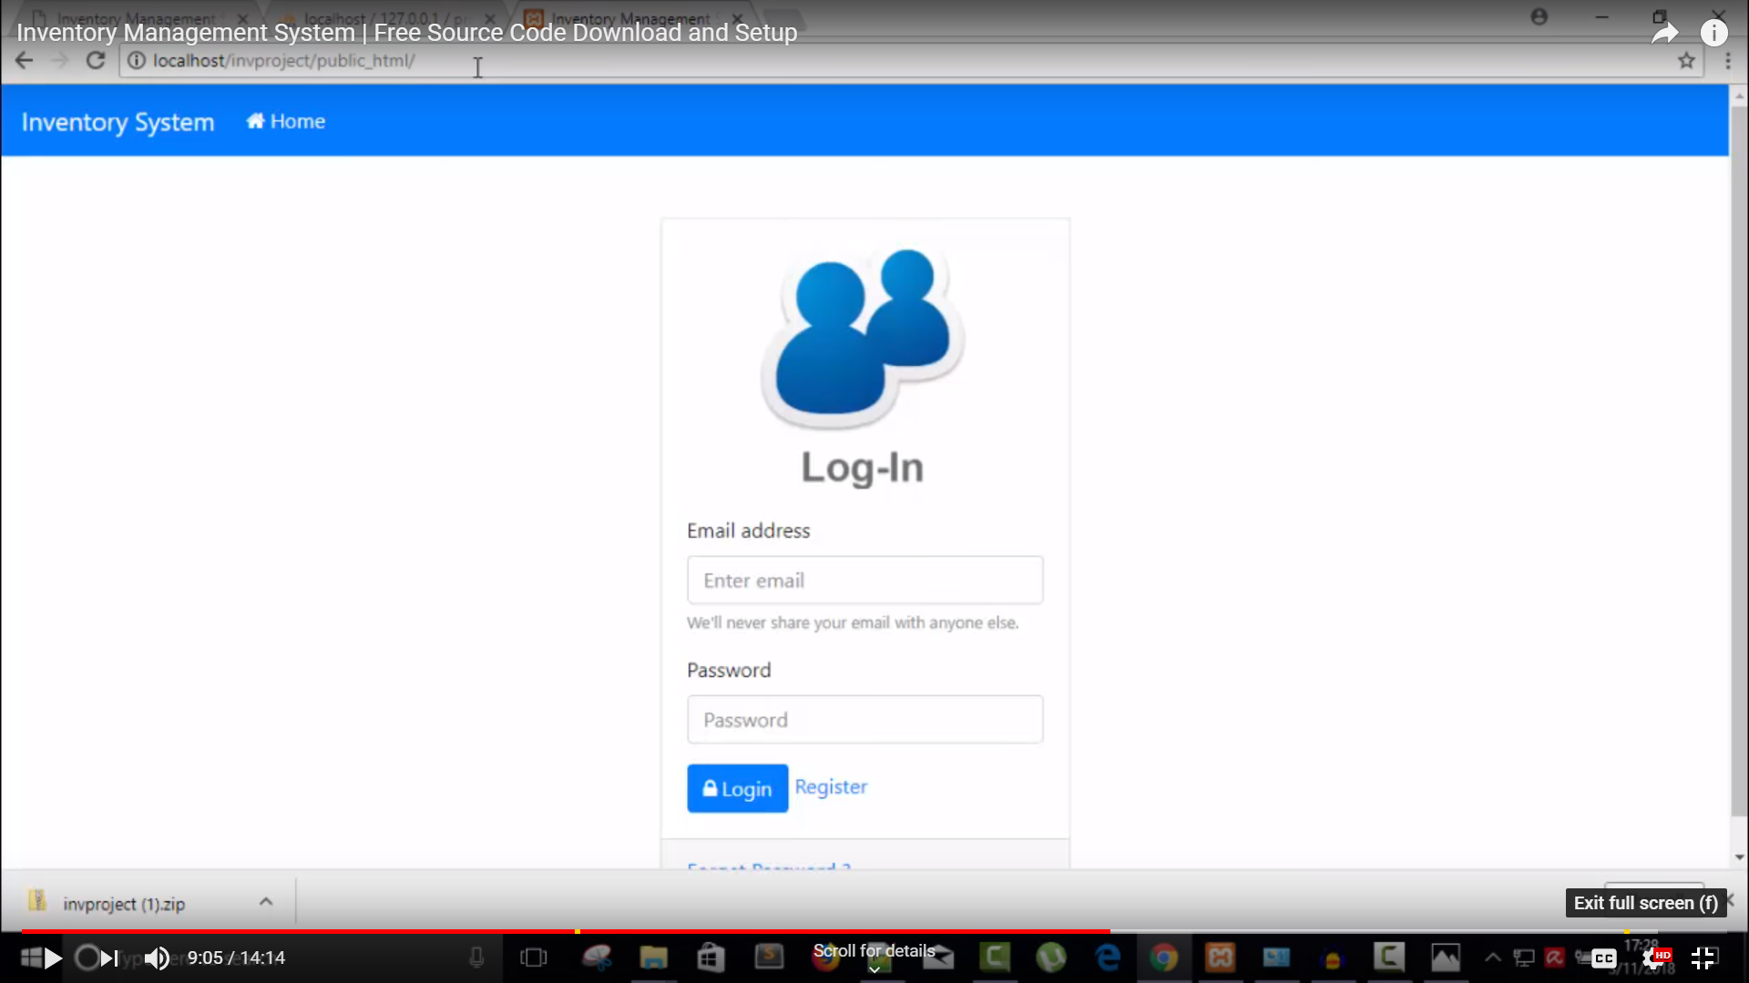

* Admin’s Registration Page

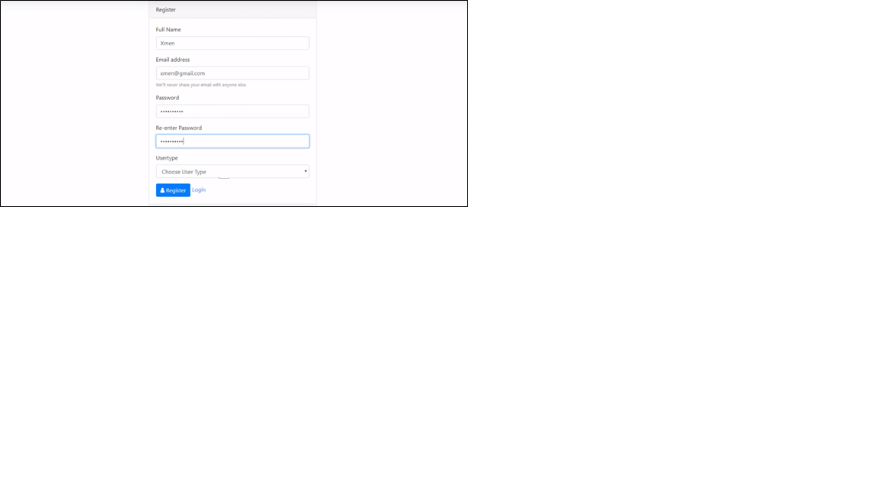

* Dashboard/ Admin Page

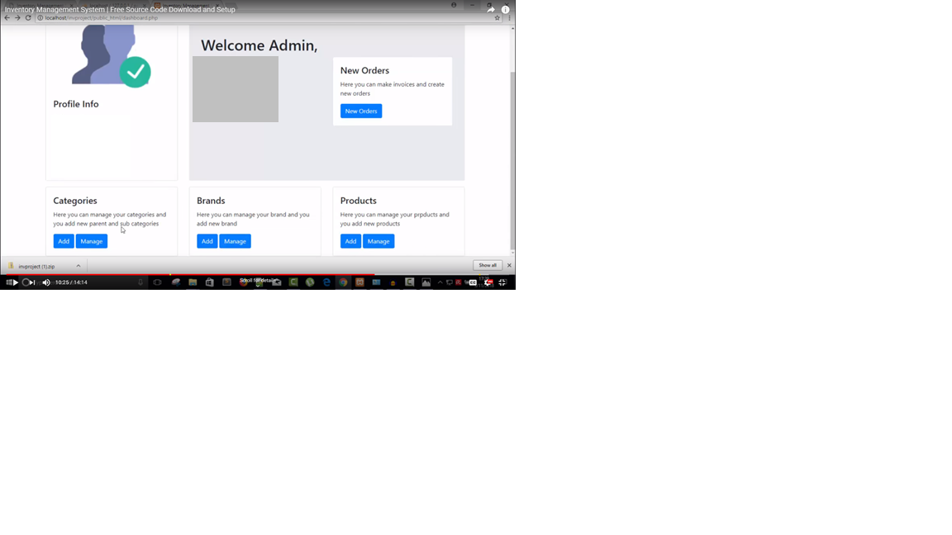

* Category
  + Add

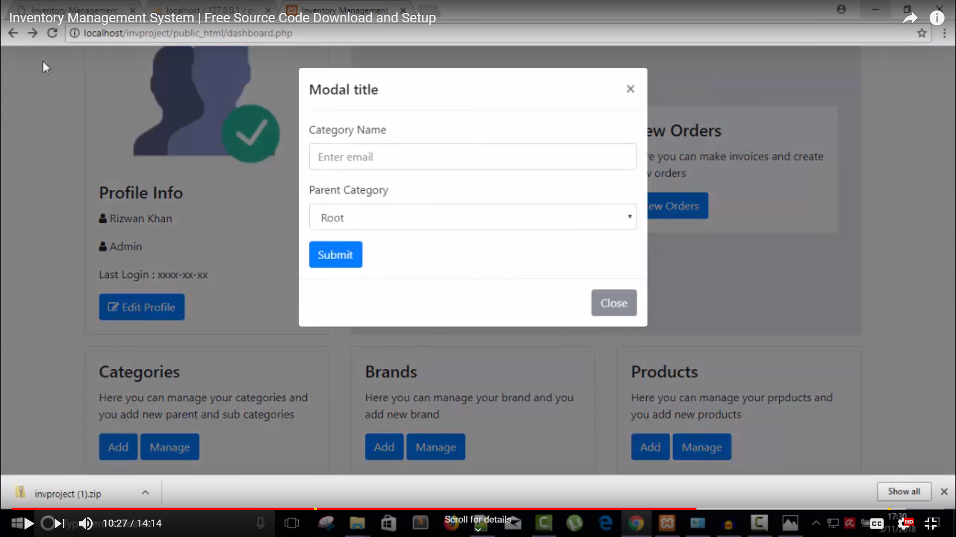

* 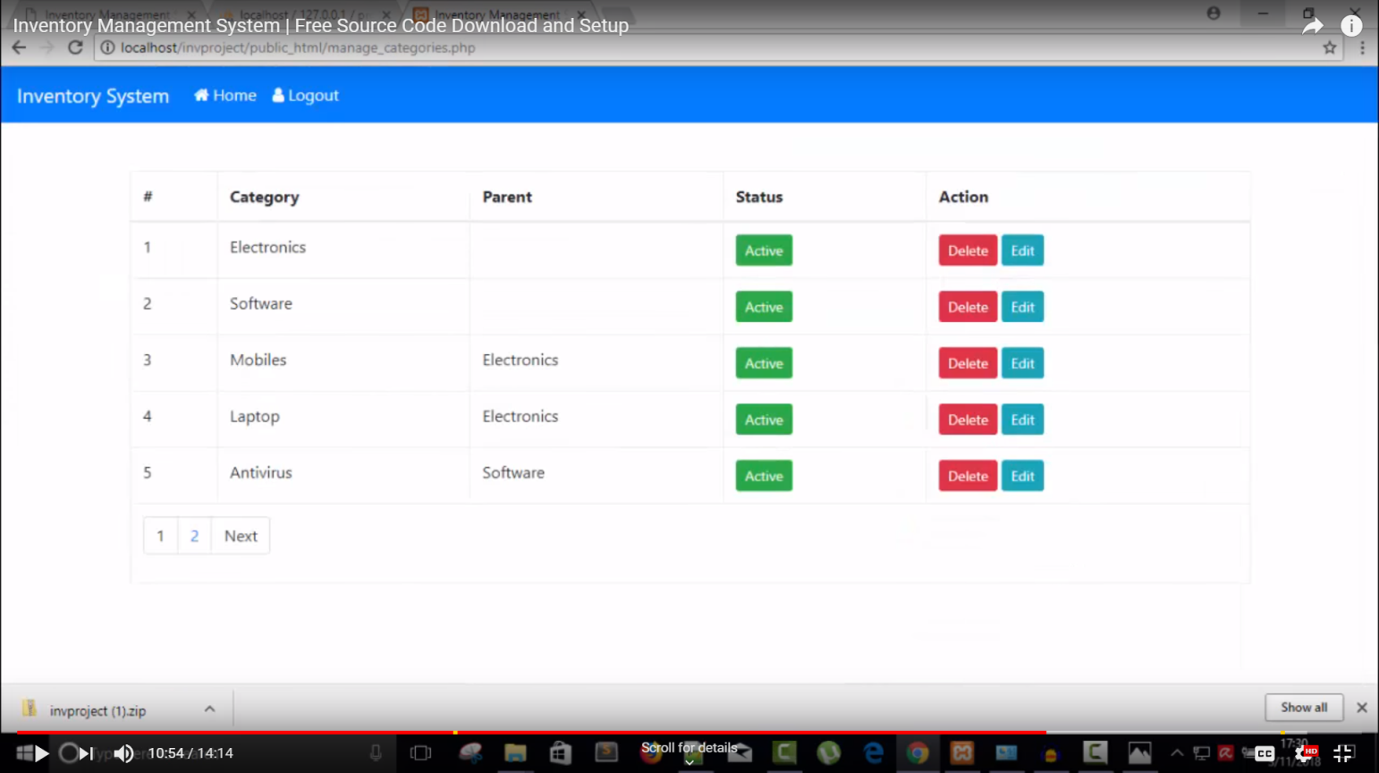Manage
* Brands
* Add

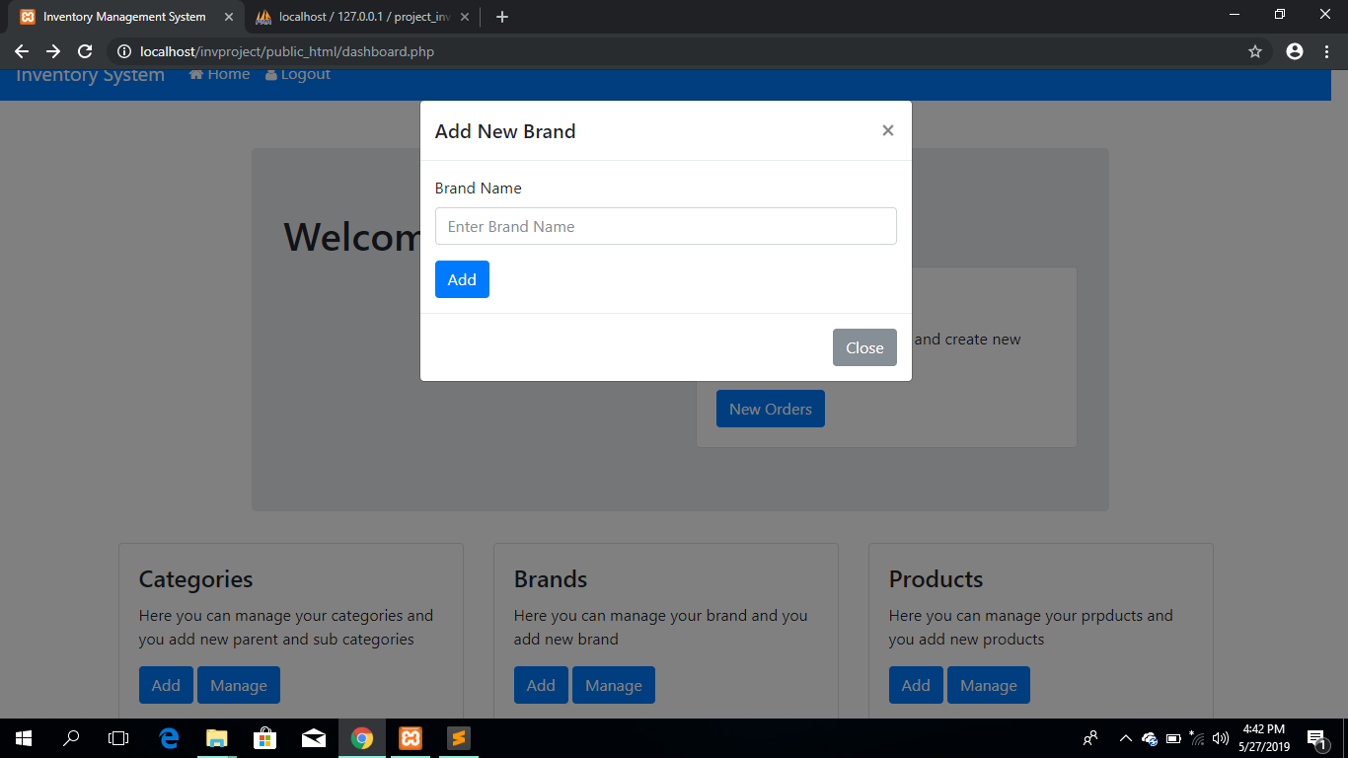

* Manage

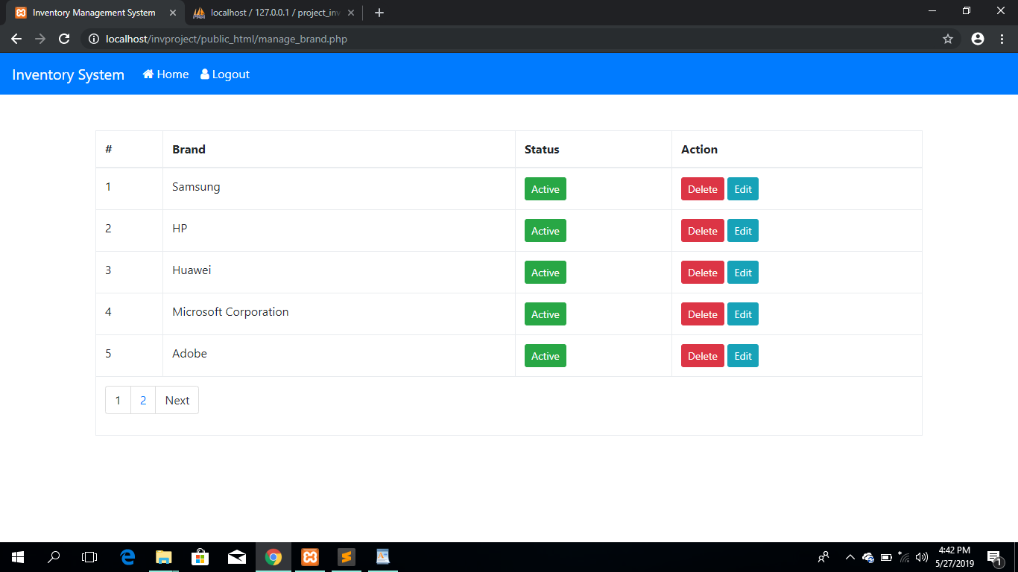

* Products
  + Add

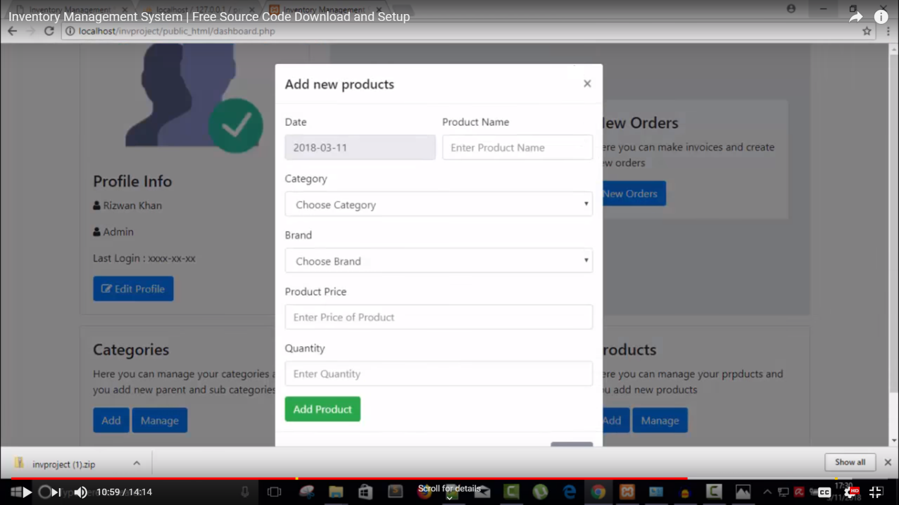

* Manage



* New Orders

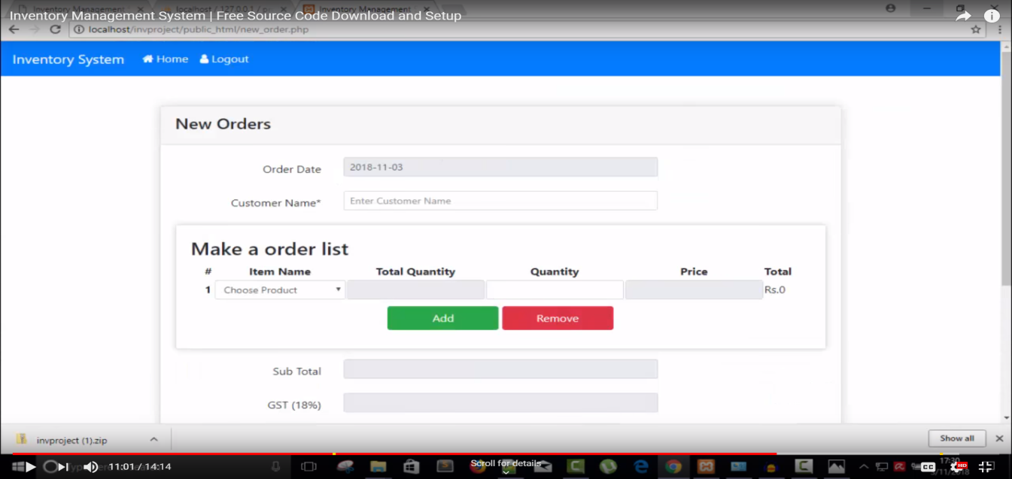

* Invoice

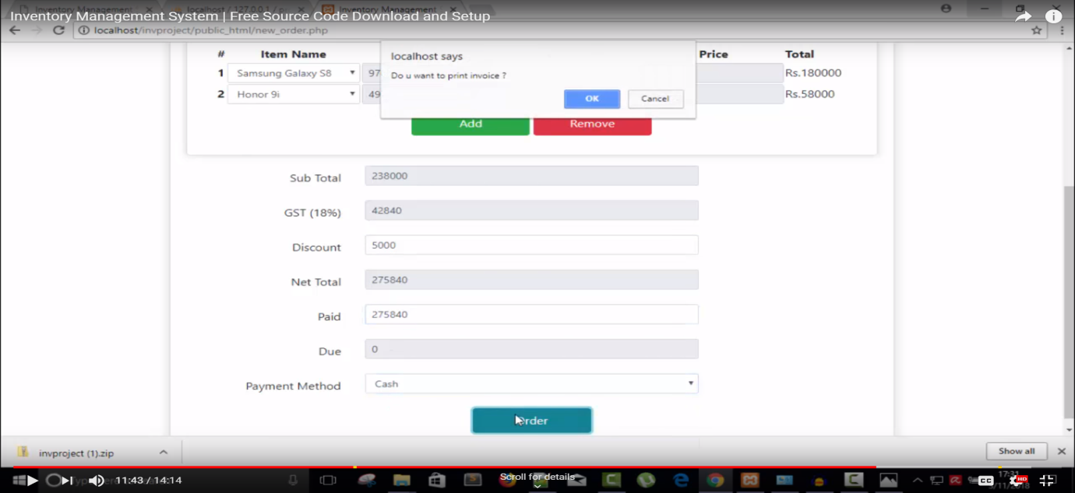

* Sample Receipt

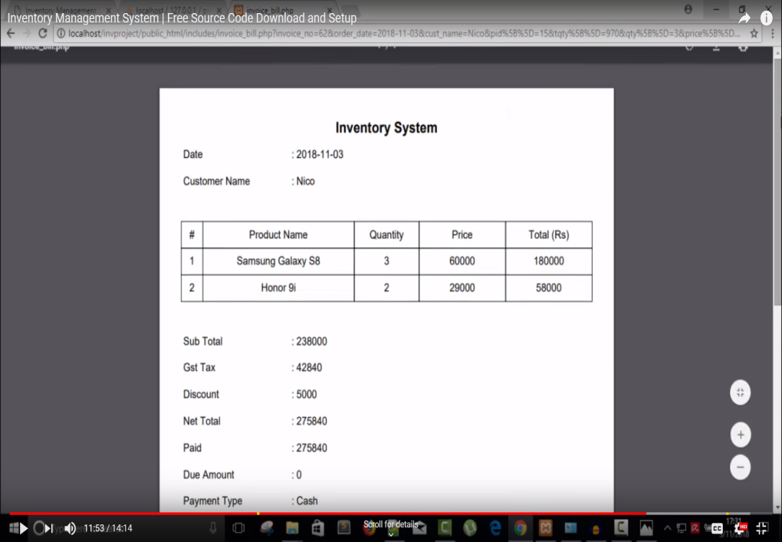

## Data Dictionary

* Category Table

|  |  |  |  |  |  |  |
| --- | --- | --- | --- | --- | --- | --- |
| Attribute | Description | Type | Size | Primary Key | Foreign Key | Source Table |
| category_name | Name of product category | varchar | 30 | Yes | Yes |  |
| parent_cat | Parent category | varchar | 30 | No | No |  |

* Brands Table

|  |  |  |  |  |  |  |
| --- | --- | --- | --- | --- | --- | --- |
| Attribute | Description | Type | Size | Primary Key | Foreign Key | Source Table |
| brand_name | Name of product brand | varchar | 30 | Yes | Yes |  |

* Invoice

|  |  |  |  |  |  |  |
| --- | --- | --- | --- | --- | --- | --- |
| Attribute | Description | Type | Size | Primary Key | Foreign Key | Source Table |
| customer_name | Name of the customer | varchar | 60 | Yes | No | products |
| discount | Discount for the price | int | 5 | No | No |  |
| paid | Amount of Customer’s Payment | int | 20 | No | No |  |
| payment_type | Type of Payment | varchar | 10 | No | No |  |

* Products

|  |  |  |  |  |  |  |
| --- | --- | --- | --- | --- | --- | --- |
| Attribute | Description | Type | Size | Primary Key | Foreign Key | Source Table |
|  |  |  |  |  |  |  |
| product_name | Product Name | varchar | 30 | No | Yes |  |
| product_price | Amount of product price | int | 20 | No | No |  |
| product_stock | Quantity of the product | int | 20 | No | No |  |

# User

|  |  |  |  |  |  |  |
| --- | --- | --- | --- | --- | --- | --- |
| Attribute | Description | Type | Size | Primary Key | Foreign Key | Source Table |
| id | Admin ID | int | 20 | Yes | Yes | users |
| username | Admin’s Username | varchar | 20 | No | No |  |
| email | Email Address | varchar | 40 | No | No |  |
| password | Password | varchar | 30 | No | No |  |
| usertype | User Type | varchar | 10 | No | No |  |

# **Acceptable Use Policy**

The following policy was listed below and shall be followed by the user. However, failure to do and follow the policies may lead for cancellation of privilege to manage the system.

* Employees must use the system that is authorized by the company. He or she is not allowed to use the computer without the consent of the manager who is responsible to lead and manage the business.
* Not using the computer if it is not that important to avoid losing a sensitive file that was stored inside the system.
* Don’t leave the system open at an unlocked computer.
* Not allowed to borrow the email and password of an already registered admin to anyone, even to his or her close person.
* The admin shall provide a security to the system by installing anti-virus to the computer and keep updated for some malicious threats around that may cause of destructing a system. Someone is not allowed to remove the installed anti-virus in the hardware.
* An unauthorized person shall not attempt to any changes inside the system (either adding or deleting any information in the software).
* The admin shall not allow revealing the secret information inside the system as part of company’s violating law.
* An admin shall not allow inserting their personal storage drive to the computer.
* The admin shall always follow the law and policy of the company for the sake of the business progress.
* Not attempting to use the computer by sending messages and use the company’s service in doing bad things to someone.

# **Security Checklist Documentation**