**Computer Organization**

**Architecture diagrams:**

**The Architecture diagram is totally the same as the original one :**

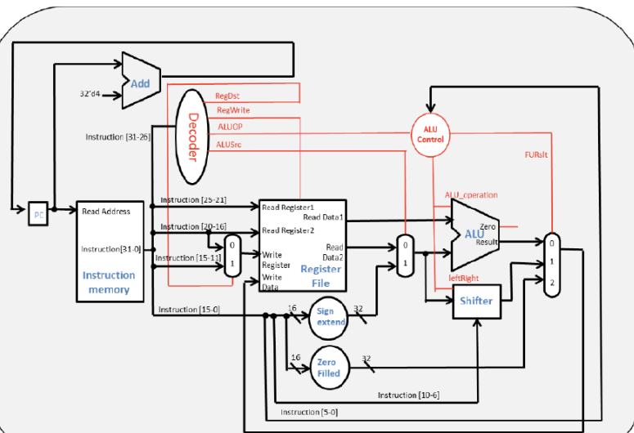

**Hardware module analysis:**

**ALU – basic computation**

**ALU_1bit - basic computation bit wise**

**ALU_crtl – deciding the input and function of ALU and the data to write back**

**Decoder – decide the selection of all the MUX in the cpu**

**Instr_memory – read the instructions from the memory**

**Mux2to1, 3to1 – work as how they are named**

**Program_counter – record the current PC address**

**Shifter – shift left or right**

**Sign_extension – expand a 16bit value to 32bit**

**Zero filled – fill 0 from 16 to 31bit**

**Finished part:**

**All the parts in this homework.**

**Problems you met and solutions:**

**At first, I try to finished all the module, and find out that most of the module can be done in 3 lines of code which is quite easy. However, the hard part is to connect the wire, for ALU_control, we can just check the table in HW3.pdf and obtain most of the ALUop that we want, but srl sll we need to find our way to get leftright. And we can just set the last bit of Alu control output as leftright. The hardest prat is to connect wires and input/out part in single cycle CPU, but with the diagram this part is less complicated or the this part can be super hard.**

**Summary:**

**At first I thought that this homework is very very hard and need to finish many lines of code, but actually the hard part is only wire connection, I learned a lot about the structure of a CPU and the concepts of designing it.**