Homework 1：Faulty Programs with Faults and Failures
Student：109700046 / 侯均頲

Section 1

From our study, the state-of-the-art branch predictor will be of tagged hyper-hybrid and consist of TAGE predictor, loop predictor, statistical corrector (SC) and IMLI (Inner Most Loop Iterator) counter.

Section 2

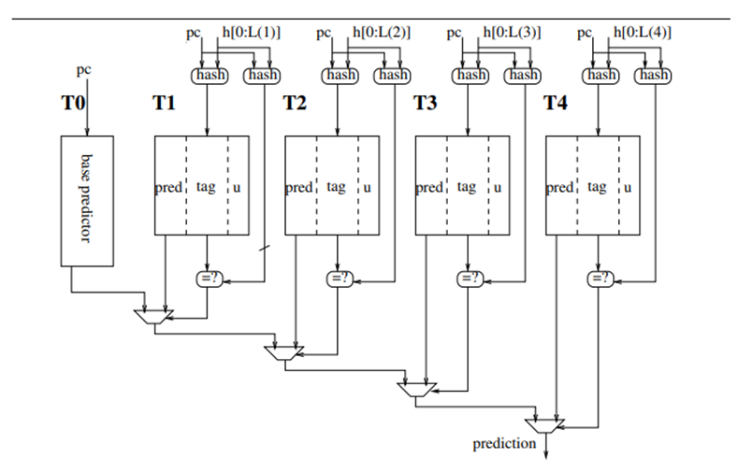
Figure 1 The architecture of TAGE.
The TAGE (TAgged GEometric length) branch predictor algorithm is designed to enhance branch prediction accuracy through the use of multiple predictor tables with varying history lengths. As shown in Figure 1, TAGE uses several tables indexed by different lengths of global branch history, it features a base predictor T0 in charge of providing a basic prediction and a set of tagged predictor components Ti This allows it to capture both short and long-term patterns in branch behavior.the base predictor will be a simple PC-indexed 2-bit counter bimodal table.An entry in a tagged component consists in a signed counter which sign provides the prediction, a tag and an unsigned useful counter.
Each tag in an entry is indexed by a hashed combination of the branch address and the global history. When a branch needs to be predicted, TAGE searches these tables starting from the one with the longest history. The predictor uses the entry from the longest history that matches the tag and is deemed useful.

Section 3

We analyzed that there are three reasons why tag works better than before.First is Entry tagging, most previous branch predictors had no mechanism for marking predictor entries. They just use the branch history and address to index certain predictor entries, if the entries represent the same branch scenario. For longer branch histories, multiple branch scenarios may be treated as the same entry. In contrast, TAGE hashes a specific length of branch history with PC, allowing TAGE to more accurately determine which branch scenario an entry corresponds to.

Table 2: The comparison of misprediction rate
Trace(s)\Budget | Unlimited(MPKI) | 64KB (MPKI) | 8KB (MPKI)
SHORT_MOBILE-2 | 0.032 | 0.060 | 3.375
SHORT_MOBILE-4 | 0.643 | 4.006 | 4.707
LONG_MOBILE-3 | 5.923 | 6.319 | 6.461
SHORT_MOBILE-28 | 0.001 | 0.001 | 0.001
random traces (AMEAN) | 0.522 | 0.855 | 1.308
All traces (AMEAN) | 2.596 | 3.986 | 4.991

Section 4

TAGE or Multi-TAGE [13]:
Immediate Update Mimicker, IUM, is an add-on to TAGE [7] for limiting extra mispredictions through predicting branches with inflight non-retired occurrences: When statistically correlated branches are not correctly predicted, the TAGE predictor must be updated at retire time to avoid pollution by the wrong path; this delayed up-date induces extra mispredictions compared with an optimistic at fetch time update.
References

[1] G. H. Loh and D. S. Henry. Predicting conditional branches with fusion-based hybrid predictors. In Proc. of the Int. Conf. on Parallel Architectures and Compilation Techniques, 2002.
[2] A. Seznec. Revisiting the perceptron predictor. PI-1620, IRISA, May 2004.

