NATIONAL UNIVERSITY OF SINGAPORE
CDE1302 Introduction to Unmanned Aerial Vehicles
Academic Year 2026/27

Autonomous AprilTag Search and Localisation with an Indoor Quadcopter
Mini Project Final Report
DRAFT

[Image placeholder] Photograph of the demonstration drone (about 7 cm tall).

Group [TO BE COMPLETED: group number] · Drone ID 2
Team members
Name | Matriculation number | Primary responsibilities
[TO BE COMPLETED: name] | [TO BE COMPLETED] | [TO BE COMPLETED]
[TO BE COMPLETED: name] | [TO BE COMPLETED] | [TO BE COMPLETED]
[TO BE COMPLETED: name] | [TO BE COMPLETED] | [TO BE COMPLETED]
[TO BE COMPLETED: name] | [TO BE COMPLETED] | [TO BE COMPLETED]

Source code: https://github.com/eggsacc/CDE1302-Autonomous-UAV
Submitted: [TO BE COMPLETED: date]

Summary
We built a pseudo-autonomous indoor quadcopter that sweeps an allocated rectangle, finds AprilTags on the floor, returns, lands on its start box and reports each tag's position. With no GPS or compass, PX4 estimates position from optical flow and a rangefinder. A laptop plans the sweep and detects tags in a camera stream whose frames carry the drone's pose at capture. The companion computer flies the sweep on board. In the demonstration flights all three search tags were found with no false detections. From the take-off command to the land command, the full sweep took 76 s and a faster two-lane sweep 36 s. Surveyed localisation tags cut the distance between the two flights' tag estimates from 19–28 cm to 1–17 cm. AI-assisted log analysis traced sudden multi-metre odometry jumps in earlier trials to PX4 switching between two estimators.

1 System Architecture and Data/Control Flow
The task is to search an allocated rectangle of an indoor arena for tag16h5 AprilTags [1], [2], then return, land and report each tag's position. The arena has no external positioning system. The operator starts the mission with two typed commands (takeoff, start) and holds the radio kill switch, but never steers.
Table 1. Vehicle and ground equipment.
Component | Part | Role
Flight controller | MicoAir H743 V2 AIO, PX4 v1.15.4 | Cascaded position, velocity, attitude and rate control; EKF2 estimation
Flow and range sensor | MTF-02P | Horizontal velocity; height above the floor
Companion computer | Seeed XIAO ESP32-S3 Sense | MAVLink bridge, Wi-Fi link, on-board trajectory player, camera
Camera | OV3660, facing down | 320 × 240 JPEG stream to the laptop
Ground station | Laptop, dedicated router | Mission logic, planning, detection, logs
Frame | Group-designed 3D-printed PLA | See below
Propulsion, battery | [TO BE COMPLETED] | [TO BE COMPLETED]

Control is split across three computers (Figure 1). The laptop runs a 10 Hz mission state machine, the planner, the tag detector and the logging. The ESP32-S3 talks MAVLink [5] to PX4 over a 921 600 baud UART and to the laptop over UDP. It arms, takes off and lands the drone, plays the uploaded trajectory at 20 Hz and streams the camera. PX4 [4] closes the control loops. The data loop runs as follows: the laptop uploads the planned path; the ESP32 turns it into position setpoints; PX4 flies them and reports its pose; the ESP32 stamps each camera frame with that pose; the laptop detects tags, updates the tag map and decides the next phase. Because the ESP32 flies the path itself, Wi-Fi delay or loss does not disturb the flight.
[Image placeholder] Block diagram: laptop ⇄ router ⇄ ESP32-S3 ⇄ PX4, camera and flow sensor, with the control cascade (10 Hz mission logic → 20 Hz setpoints → PX4 loops).
Figure 1. System architecture and data/control flow.
Positions are in PX4's local North-East-Down frame, with its origin at take-off and, with no compass, its x-axis wherever the nose pointed at power-up. Tags are reported in an arena frame centred on a home tag in the start box. The heading is held constant throughout the flight, so the drone flies sideways and backwards rather than turning.
Beyond the course baseline, we redesigned the frame. The course frame was made for carbon fibre but printed in PLA, which is 20–30 times less stiff, and it flexed visibly. The new arms place material in deep top and bottom lattices joined by trusses, cutting the simulated deflection under a 30 N·m bending load from 14.4 mm to 5.31 mm (−63 %) at the same 50 g. They also need no print supports and cut assembly time from about an hour to 15 minutes.

2 Exploration and Navigation Strategy
Mission phases and safety. The laptop steps through CONNECTING → READY → TAKING_OFF → HOVERING → EXPLORING → RETURNING → LANDING → DONE. The sweep starts only after the drone has held position within 10 cm for 2 s. A geofence 0.5 m around the area and path, or a 10 s telemetry time-out, triggers an automatic landing. The firmware cuts the motors if Wi-Fi is lost for about 3 s, and the kill switch has final authority.
Lawnmower sweep. The area is shrunk by a 0.3 m margin and covered by parallel lanes along its length. For a shrunk width W and a maximum spacing s_max:
n = ⌈W / s_max⌉ + 1, s = W / (n − 1) (1)
This puts the outer lanes on the boundary, with no gap larger than s_max. At height h = 0.8 m, with focal lengths f_x = 163.5 px and f_y = 153.2 px, the camera footprint is
w_across = h · 320 / f_x ≈ 1.57 m, w_along = h · 240 / f_y ≈ 1.25 m (2)
A tag must lie wholly in the image, so the usable swath is about 1.45 m. Four lanes 0.87 m apart therefore cover the area with overlap.
On-board execution. The laptop rotates the plan into PX4's frame and uploads it to the ESP32 in one go. The ESP32 sends PX4 the next lane end as the setpoint, moving on once the drone is within 15 cm, so PX4's speed limit MPC_XY_VEL_MAX sets the cruise speed. The weakness is sideways correction. PX4 limits the norm of the velocity demand, so with along-track error e_a and cross-track error e_c the corrective speed across the lane is only
v_c ≈ v_max · e_c / √(e_a² + e_c²) (3)
At the start of a long lane this is a few cm/s, which explains the cross-track bias seen in Section 5.
Alignment, return and landing. With no compass, a 3° placement error would put the far end of a lane 0.25 m off line. While hovering, the drone measures the orientation of the home tag, which is taped square to the floor tiles, and the plan is rotated to match. After the sweep it flies back and re-observes the home tag. If the tag is more than 8 cm away, it moves over it (at most three corrections in 10 s) and lands.

3 AprilTag Detection and Target Localisation
Pose at capture. Wi-Fi latency of 100–200 ms would shift every tag by 5–10 cm at 0.5 m/s. The ESP32 therefore keeps a short history of PX4 poses and embeds the pose nearest the capture time in each JPEG, as a comment segment that image viewers ignore. Frames with no PX4 sample within 100 ms are discarded.
Detection and geolocation. The laptop runs the course's AprilTag detector. Each detection gives the tag position t_c in the camera frame. This is mapped into the body frame (camera pitched 90°, lens 8 cm ahead of centre) and then into PX4's frame using the pose at capture:
p_NED = [x, y]_drone + R_z(ψ) · (R_bc · t_c + r_lens)_xy (4)
Confirmation. tag16h5 has only 30 codes, so false decodes are possible. Detections with a low decision margin, corrected bits, a poor pose fit, long range or a high yaw rate are rejected (Table 2). For each tag ID, the remaining sightings are clustered robustly. The seed is the sighting with the most neighbours within 0.2 m, and the estimate is the median of the sightings within 0.3 m of it. The tag is confirmed once five sightings agree within 0.2 m. An isolated false decode cannot gather five neighbours, so it is never confirmed.
Drift correction. Optical-flow odometry drifts in scale, heading and position. Five localisation tags (IDs 22–25 and 29) were placed at surveyed floor-grid positions. Each visit to one pairs its PX4 position with its surveyed position. After the flight, a 2-D similarity transform is fitted to all visits by least squares [3]:
p_arena = s · R(θ) · p_PX4 + t (5)
Here s absorbs the flow scale error, θ the heading error and t the offset. A hybrid model also interpolates the remaining drift between visits in time, and the software keeps whichever model best predicts held-out visits. The correction is applied only to the report and never fed back to PX4, so it cannot cause a jump in flight.

4 Important Parameters and Implementation Decisions
Table 2. Key parameters (Run 1, the full search) and the reasons for them.
Parameter | Value | Reason
Flight height | 0.8 m | 1.45 m swath; smaller relative rangefinder error
Lane spacing (max) / margin | 1.0 m / 0.3 m | Four lanes, 0.6 m overlap
Speed limit MPC_XY_VEL_MAX | 0.5 m/s | ≥ 5 frames per tag; tracking
Corner acceptance radius | 15 cm | Smooth corners without cutting lanes
Mission tick / setpoint rate | 10 Hz / 20 Hz | Laptop logic / on-board player
Detector gate | margin ≥ 55, ≤ 1 bit, ≤ 1.5 m, ≤ 30°/s | Reject weak, distant or blurred decodes
Pose match window | 100 ms | Reject frames with no pose
Tag confirmation | 5 sightings within 0.2 m | No false confirmations
Hover check | 10 cm for 2 s | Stable before the sweep
Precision landing | 8 cm, ≤ 3 moves, ≤ 10 s | Land on the start box
Geofence / link time-out | 0.5 m / 10 s | Automatic landing
IMU priority | BMI088 highest, BMI270 lowest | Avoid estimator switches (§6)

The main implementation decisions were:
- Fly the sweep on board, not by streaming waypoints from the laptop, so that Wi-Fi cannot disturb the path.
- Waypoint mode for the setpoints. A fixed look-ahead point and a velocity feed-forward follower were also built and flown. Waypoint mode was the fastest and smoothest, and the shorter flight left less time for drift.
- Detect on the laptop, with each frame carrying its own pose, so that the full frame rate is available and latency cannot bias the result.
- Localisation tags instead of UWB. A teammate trialled a LinkTrack UWB system [6] fused into PX4 as an external position source. It worked, with 5–7 cm static scatter, but it sometimes pulled the drone sideways near the far end. In a 5 m × 3 m arena the flow drift over a one-minute flight (10–25 cm) is similar to the UWB error, so the gain was insignificant and UWB was left out.

5 Experimental Results
Two demonstration flights from 11 November 2026 are reported. Run 1 was the full search at 0.5 m/s. Run 2 flew only the two outer lanes, with the speed limit raised to 1.5 m/s to find the tags faster. Both completed without steering or a safety trigger, and both confirmed the same three search tags with no false tags (Table 3). Mission time runs from the take-off command to the land command. Positions are PX4 estimates unless stated as corrected.
Table 3. Results of the two demonstration flights.
 | Run 1 (full) | Run 2 (truncated)
Lanes (spacing) | 4 (0.87 m) | 2 (2.62 m)
Speed limit / median lane speed (m/s) | 0.5 / 0.37 | 1.5 / 1.25
Sweep duration (s) | 47.8 | 11.0
All tags confirmed, from sweep start (s) | 37.1 | 7.7
Mission time, take-off to land command (s) | 75.6 | 36.1
Cross-track error RMS / worst overshoot (cm) | 4.7 / 12.0 | 18.7 / 38.9
Sightings per search tag | 24–41 | 6–13
Localisation fixes / fitted scale | 9 / 0.978 | 3 / 1.068
Home-tag offset on arrival / at landing (cm) | 9 / 3 | 17 / 5

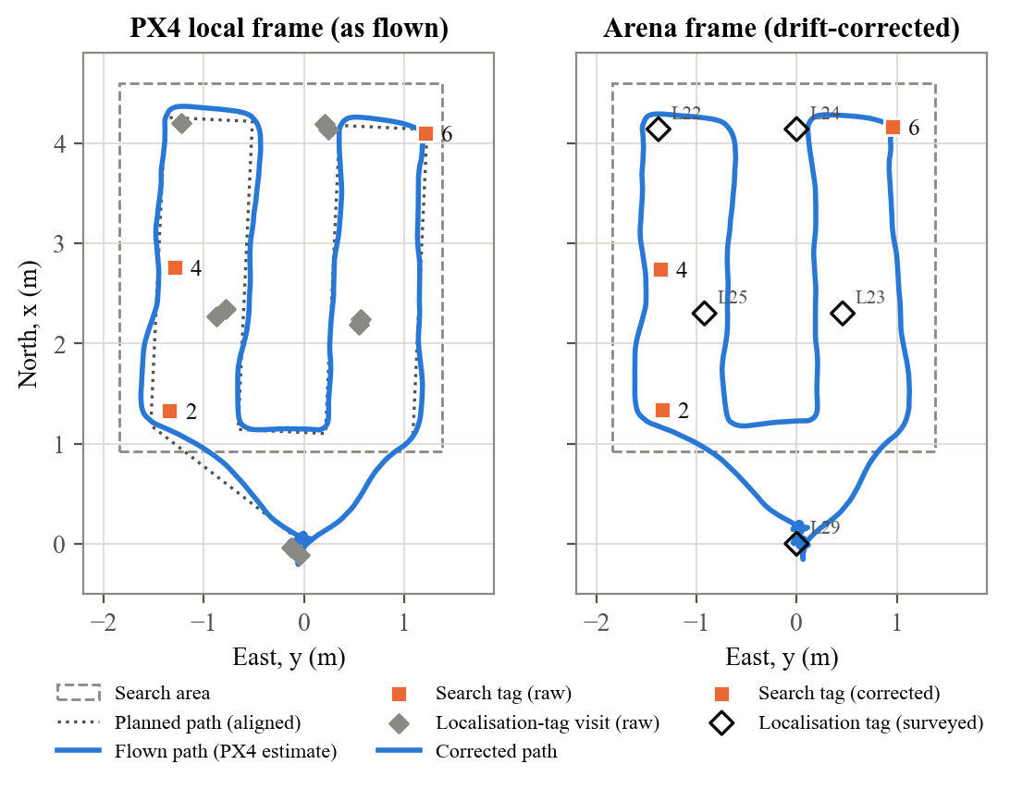
Figure 2. Run 1 (full sweep, 0.5 m/s). Left: PX4 frame, with the plan, raw tags and localisation-tag visits. Right: drift-corrected route and tags.
Speed and tracking. The median lane speed was 74 % of the limit in Run 1 and 83 % in Run 2. At 1.5 m/s the 4.6 m lanes were too short to reach a steady cruise. The cross-track error grew from 4.7 cm to 18.7 cm RMS, and the worst lane-end overshoot from 12.0 cm to 38.9 cm. At speed the error is mostly a bias towards the outside of the sweep: the drone enters each lane with sideways momentum, and Eq. (3) leaves little authority to remove it. The heading stayed within ±2°.
Detection. Each tag was confirmed 0.3–0.5 s after it first appeared (five frames at 7–10 frames/s). The measured range of 0.70–0.86 m agrees with the 0.8 m flight height. Sightings per tag fell with speed, from 24–41 to 6–13. In Run 2, tag 4 was confirmed with one sighting to spare, close to the camera's limit.
Table 4. Reported tag positions (x, y) in metres after drift correction, and the distance between the two runs' estimates before → after correction.
Tag | Run 1 | Run 2 | Run 1 to Run 2 (cm)
2 | (1.34, -1.34) | (1.33, -1.35) | 19.3 → 1.3
4 | (2.74, -1.36) | (2.77, -1.40) | 23.0 → 4.4
6 | (4.16, 0.96) | (4.28, 1.09) | 27.7 → 16.7

Localisation. The tags did not move between flights but the drift differed, so the distance between the two runs' estimates measures repeatability. Correction brought the estimates of tags 2 and 4 within 1.3 cm and 4.4 cm of each other (Table 4). Before correction, PX4 was off by 14.7 cm on average at the localisation tags in Run 1. Run 1's nine fixes gave a scale of 0.978, i.e. PX4 over-estimated distance by about 2.2 %. Run 2's three fixes barely determine the four-parameter fit, and its scale of 1.068 is implausible. This is why tag 6 still differs by 16.7 cm. On return the home tag was 9 and 17 cm from where PX4 placed it. Precision landing reduced this to 3 and 5 cm.
[TO BE COMPLETED] Absolute error of each tag against its surveyed demonstration position, and the number of search tags in the area.
Speed versus coverage. Run 2 confirmed all tags 7.7 s into the sweep, against 37.1 s, and cut the mission time from 75.6 s to 36.1 s. However, its two lanes 2.62 m apart never image a central strip about 1.2 m wide. It found every tag only because these tags lay near the outer lanes, so only Run 1 is a complete search.

6 AI-Assisted Flight-Data Analysis and Visualisation
Every flight produces two logs. The laptop records events, the 10 Hz telemetry route and every detection. PX4's onboard log (ULog) records estimator, controller and sensor data at up to several hundred hertz. We used an AI coding assistant [TO CONFIRM: tool name] to write Python analysis scripts (pandas, matplotlib, pyulog). These computed the metrics and figures in Section 5: lane-by-lane cross-track error, speed, sightings, drift fits and run-to-run differences. The team checked each result against what was seen in flight. This checking mattered: the first speed estimate showed 0.62 m/s under a 0.5 m/s limit, an artefact of differentiating jittery Wi-Fi timestamps that smoothing removed. Similarly, an automatic accuracy plot was found to use reference tag positions from an earlier layout, so it was left out.
Case study: sudden odometry jumps. In several trial flights the reported position jumped by metres, and the drone lunged or yawed violently. The ULogs of two such flights (A and B) showed this was not a sensor fault. The flight controller has two IMUs, a BMI088 and a BMI270. With PX4's default setting (EKF2_MULTI_IMU = 3) it runs one EKF2 instance per IMU and publishes whichever it rates healthier. With no compass, nothing measures yaw, so each instance integrates its own gyroscope. In flight the BMI270 read about 2°/s less yaw rate than the BMI088 (−2.5°/s in A, −1.8°/s in B), while both read near zero at rest. This suggests a vibration-related error. Because optical flow is rotated into the world frame using each instance's own heading, the two estimates diverged by 105° and 5.4 m in A, and by over 200° and 6.9 m in B (Figure 3). Each stayed self-consistent, so PX4's health checks saw nothing wrong.
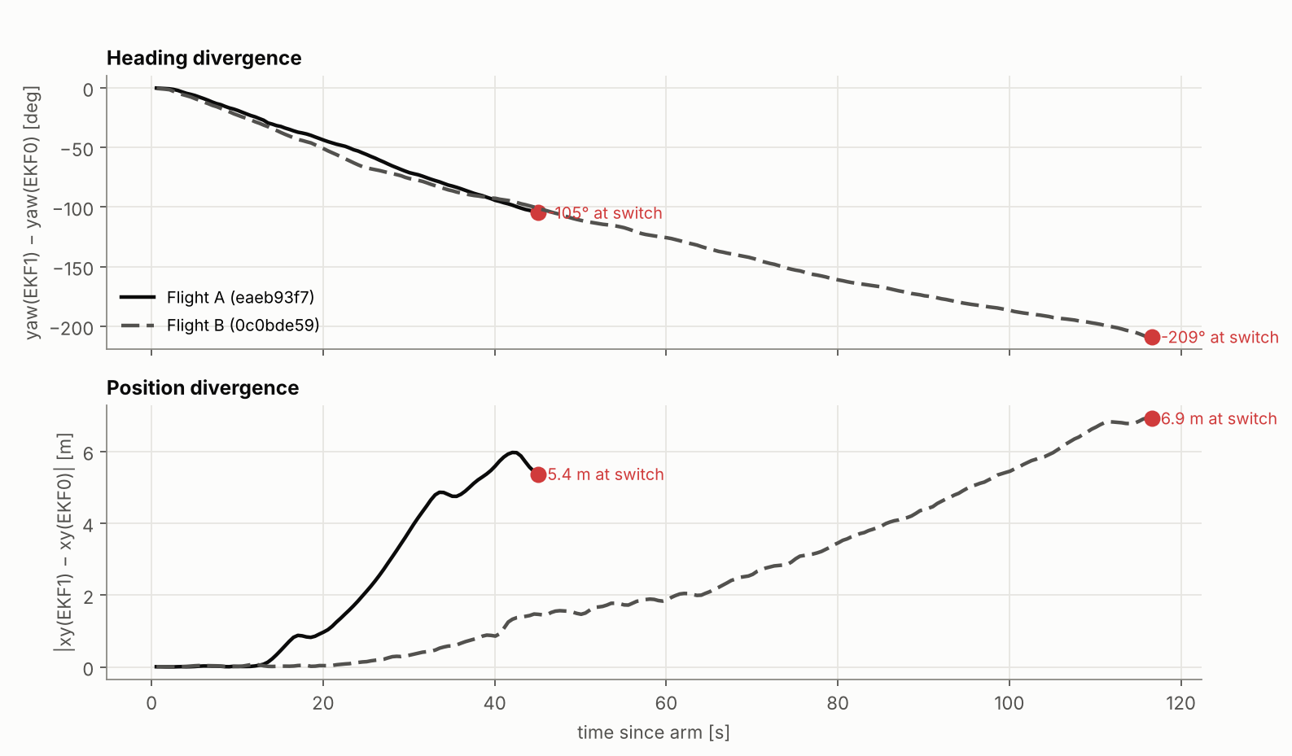
Figure 3. Heading (top) and position (bottom) divergence between the two estimator instances in trial flights A and B, until PX4 switched between them.
A 60 ms innovation spike on the healthy instance (descent onset in A, touchdown in B) made PX4 switch to the drifted one. It then published the whole difference as an instant reset: 5.3 m and −106° in A. A was airborne and its setpoints were still in the old frame, so the drone yawed at up to 94°/s until an automatic landing and the kill switch ended the flight. For the demonstration we gave the BMI088 the highest sensor priority and the BMI270 the lowest, so that PX4 falls back to the BMI270 only if the BMI088 fails. No jump occurred in any demonstration flight. The blame on the BMI270 rests on both IMUs sharing one rigid board and has not been checked against an external heading reference.
[TO BE COMPLETED] Analysis of the demonstration ULogs: the cause of the lane bias, tilt and motor margins at 1.5 m/s, and confirmation that no estimator switch occurred.

7 Limitations, Failure Cases and Improvements
- Coverage versus speed. The fast two-lane sweeps miss the centre of the area. Three lanes at the full 1.4 m swath and about 0.7 m/s would keep full coverage and cut the mission time by an estimated third [TO CONFIRM: not yet flown].
- Lane-start bias of up to 27 cm at 1.5 m/s (Eq. 3). Fix: a short velocity feed-forward segment after each corner, or an intermediate setpoint on the lane line.
- Detection margin at speed. Only 6 sightings for one tag in Run 2. Fix: a higher camera frame rate, or a lower speed.
- Sparse drift fixes. Run 2's three fixes gave an unreliable correction. Fix: place localisation tags under the lanes.
- Systematic flow scale error of 2.2 %. Fix: calibrate the flow sensor's scale.
- Precision-landing hold. The 8 cm radius is close to the hover wobble, so the drone corrected until the 10 s limit in both runs. A 10 cm radius would save about 5 s.
- Estimator switching (failure case, Section 6). The robust fix is a single estimator instance on the BMI088 (EKF2_MULTI_IMU = 0) plus a heading reference, and companion software that re-anchors its setpoints when PX4 reports a position reset.
- No ground truth. All positions are PX4 estimates corrected by the localisation tags. Two flights are too few for statistics, though every trend is consistent and explained.

8 Note to the Teaching Team
We saw severe odometry drift and sudden position and velocity snaps many times in trials. For a long time we blamed tuning or our own code. Section 6 shows that at least two came from the flight controller's default configuration. With two IMUs, no compass and PX4's default EKF2_MULTI_IMU = 3, PX4 can silently switch to an estimate whose heading has drifted by 100° or more. Nothing in QGroundControl or the telemetry warns of this. Other groups on the same board are probably exposed and may mistake it for a control bug. We suggest that the course baseline either run a single estimator on the BMI088 or set the IMU priorities as we did, and that the companion template handle PX4's position-reset counter.

9 Conclusion
The system took off, searched, localised the tags, returned and landed on its marker in every demonstration flight, with no false detections and no intervention. Four decisions mattered most: flying the sweep on board; stamping each frame with its pose; robust five-sighting confirmation; and surveyed localisation tags for alignment, landing and drift correction. Higher speed roughly halved the mission time, but cost coverage, tracking accuracy and detection margin. For a search with unknown tag positions, full coverage at moderate speed is the better trade. Source code: https://github.com/eggsacc/CDE1302-Autonomous-UAV.

References
[1] E. Olson, "AprilTag: A robust and flexible visual fiducial system," in Proc. IEEE ICRA, 2011, pp. 3400–3407.
[2] J. Wang and E. Olson, "AprilTag 2: Efficient and robust fiducial detection," in Proc. IEEE/RSJ IROS, 2016, pp. 4193–4198.
[3] S. Umeyama, "Least-squares estimation of transformation parameters between two point patterns," IEEE Trans. PAMI, vol. 13, no. 4, pp. 376–380, 1991.
[4] PX4 Autopilot, PX4 User Guide (v1.15). https://docs.px4.io/v1.15/
[5] MAVLink, MAVLink Developer Guide. https://mavlink.io/
[6] Nooploop, LinkTrack P-A Series User Manual.

