Power-System Rebuild and Hardware Reverse-Engineering of a Spot Hip Actuator
  - CDE2605 Undergraduate Research Opportunities Programme (UROP) · AY2025/2026 Special Term
Yizhang [full name — TBC] · [Matriculation No. — TBC]
AY2025/2026 Special Term
Table of Contents

List of Figures
- Figure 1 — Charge refusal on the OEM charger.
- Figure 2 — Staged bench recovery of the over-discharged cell groups.
- Figure 3 — The OEM charger reporting a false “full”.
- Figure 4 — The fully disassembled battery module.
- Figure 5 — The irregular OEM cell layout.
- Figure 6 — The BMS PCB and its pad layout.
- Figure 7 — One of the two flexible NTC-thermistor PCBs.
- Figure 8 — The four 3D-printed PC-CF cell spacers.
- Figure 9 — A cell sub-pack spot-welded with nickel strip.
- Figure 10 — The handheld spot-welder used after the bench welder failed.
- Figure 11 — BMS indicator LEDs responding during welding.
- Figure 12 — Per-group voltage sweep after the first full charge.
- Figure 13 — A defective / popped weld joint.
- Figure 14 — Sound versus poor weld resistance.
- Figure 15 — Third voltage sweep: group 1 phantom −0.5 V.
- Figure 16 — Phantom −0.5 V at the pads versus 3.71 V probed directly.
- Figure 17 — The sheared SoC flex cable and its repair.
- Figure 18 — Pack #2 V2 bracket CAD.
- Figure 19 — Pack #2 laser-cut nickel strips and welded BMS.
- Figure 20 — Spot opened for hind-leg removal.
- Figure 21 — The two hind hip-X motor driver boards compared.
- Figure 22 — The driver board, encoder side.
- Figure 23 — The secondary output-encoder Hall-IC at the harmonic-drive output.
- Figure 24 — The 50:1 harmonic drive.
- Figure 25 — The rotor / output-encoder assemblies during the swap.
- Figure 26 — The secondary output-encoder PCB, close up.
- Figure 27 — The secondary output-encoder PCB components.
- Figure 28 — The iC-MU pinout and connections.
- Figure 29 — The connector-flex test pads.
- Figure 30 — Test-pad map used for the bench read attempt.
- Figure 31 — Wires soldered to the flex-PCB test pads.
- Figure 32 — The oscilloscope bench read attempt.
- Figure 33 — The DB25 payload-port cover pin shorts (Appendix D).

List of Tables
- Table 1 — OEM battery module architecture (as found).
- Table 2 — Replacement-cell sourcing comparison.
- Table 3 — Inter-cell conductor sizing.
- Table 4 — Battery pack #1 state before and after the weld rework.
- Table 5 — Actuator component-swap actions and physical observations.
- Table 6 — iC-MU Port-A (ExtSSI) pinout, as wired.
- Table 7 — Hind hip-X full-range-of-motion mechanical offsets.
- Table 8 — Selected iC-MU EEPROM configuration registers (full map in Appendix B).

Introduction
The Boston Dynamics Spot quadruped (hereafter Spot) held by the programme was received non-operational, and this report documents the hardware-level work carried out to return it toward service. Two independent faults were present on arrival. First, the power subsystem was dead: both of Spot’s battery modules refused to charge, so the robot could not be powered from its own packs at all. Second, once external power was restored, one leg actuator — the left hind hip-X (abduction/adduction) joint (hereafter hip-X, and specifically left_hind_x) — behaved abnormally, with the joint failing to reach commanded positions while the other three legs moved normally. The mechanical and electrical nature of that actuator was, at the outset, entirely unknown: it had never been opened, and no internal documentation was available.
The work reported here pursues two objectives that together serve a single thesis — to rebuild Spot’s power system and to physically and electrically reverse-engineer its faulty hip actuator so that the hardware is characterised and the fault is localised to a physical part. The first objective was to restore the power subsystem by diagnosing the charge fault and, should the cells prove unrecoverable, rebuilding each pack on its original battery management system (BMS) in the OEM form factor. The second objective was to characterise the hip-X actuator as a piece of hardware — its mechanical construction, its dual-encoder architecture, and the electrical design of its output-encoder board — and, through a sequence of physical component swaps and bench measurements, to narrow the fault down to a specific physical part.
The scope of this report is deliberately confined to the hardware layer. It describes physical acts (teardown, cell replacement, spot-welding, component interchange, board probing) and the hardware and electrical facts observed during them. The complementary diagnostic interpretation of the actuator’s control-signal behaviour, together with the eventual encoder repair, was carried out on the signal/software layer and is reported in the companion report [Ming, SS-TBD]; those results are cited here as single premise sentences and are never re-derived. Every factual claim in this report is drawn from the project’s own dated session logs and reference pages; no external measurements were introduced.
The working approach throughout was bench-based and comparative. Because Spot’s two hind legs are nominally identical, the healthy hind leg served as a reference against which the faulty one could be compared part by part — a strategy that recurs across the actuator chapters. The remainder of the report is organised as follows. The Background section establishes the battery and actuator architectures as found. Three methodology chapters then cover, in turn, the power-system rebuild, the actuator mechanical investigation, and the encoder electrical reverse-engineering. A combined Evaluation, Limitations and Improvements section assesses what was achieved and what the bench work could not resolve, and the Conclusion summarises the outcome and the planned future work.

Background

Battery module architecture
Spot is powered by two identical, hot-swappable battery modules. Each module is a sealed assembly whose perimeter is held closed by a tough adhesive bead. The internal architecture was first established from a published third-party teardown of the Spot platform [3] and then confirmed directly during the project’s own disassembly (Section 4). Each module carries 56 Samsung INR18650-30Q lithium-ion cells — a 3000 mAh cell rated 15 A continuous / 30 A peak, identified from Boston Dynamics’ Spot Battery Safety Data Sheet [1] — arranged in a 14s4p configuration and physically built as two 7s4p sub-packs (labelled A and B). A single BMS PCB, built around an STM32 microcontroller, manages the module and communicates with the robot over a CAN bus. Table 1 summarises the construction as found.
Table 1 — OEM battery module architecture, as established from the teardown report [3] and confirmed on disassembly.
Property | Value
Nominal energy | ~500 Wh
Rated runtime | ~1.5 h
Cell | Samsung INR18650-30Q (3000 mAh, 15 A cont. / 30 A peak)
Cell count & topology | 56 cells in 14s4p, built as two 7s4p sub-packs (A & B)
BMS | Single PCB, STM32 MCU, CAN bus to the robot
Measurement pads | 28 pads — positives along the long PCB edges, common negative down the centre
Thermal sensing | One flexible PCB per sub-pack, each carrying five SMD NTC thermistors
Thermal / safety | Phase-change material around the cells; fish-paper terminal insulation; foam seating
Two construction details established here proved decisive for the rebuild. The cell layout is deliberately irregular — cells are unevenly spaced and are not even collinear within a row, the centre cells sitting slightly proud of their neighbours — so any replacement spacer had to reproduce those exact positions rather than assume a regular lattice. Thermal management is provided by a phase-change material packed around the cells, which absorbs heat through its latent heat of fusion and buffers thermal-runaway energy, supplemented by the two five-element NTC-thermistor strips that monitor temperature across each sub-pack.

Hip-X actuator architecture
Each of Spot’s legs is driven by three actuators; the one of interest here is the hip-X actuator, which abducts and adducts the leg. Its mechanical output is produced by a brushless motor turning through a 50:1 harmonic drive (strain-wave reducer), so that a large number of motor revolutions map to a small, high-torque motion of the leg. Bench measurements on the hip motor established a 20-pole, 18-slot machine (a slot/pole ratio of 0.9) with a phase resistance of approximately 0.5 Ω.
Crucially, the actuator carries two angle sensors rather than one, a fact that only became apparent once the motor was opened (Section 6). The primary encoder is a motor-side iC-MHM 14-bit absolute Hall encoder that reads rotor angle before the reduction. The secondary output encoder is a separate iC-Haus iC-MU Hall-IC mounted at the harmonic-drive output stage, reading the actual joint angle after the 50:1 reduction. The secondary encoder sits on its own small PCB — carrying, in addition to the iC-MU, an external configuration EEPROM and an RS-485/RS-422 differential transceiver — stacked with the joint’s load-cell PCB behind the main motor connector. The physical construction and electrical routing of that board are characterised in this report (Sections 6 and 7); the functional role of the two encoders within Spot’s joint-control signalling is described in [Ming, SS-TBD].

Methodology 1 — Power-system rebuild

Fault diagnosis and the decision to rebuild
The power subsystem was the first blocker: with both modules unable to charge, Spot could not be run from its own batteries. On the OEM charger the charge indicator flashed red briefly and then went dark, rather than the steady green blink that signals normal charging. The handheld controller, by contrast, powered on and connected normally (though it drained quickly), confirming that the fault was specific to the battery modules rather than the wider system.
To gain direct access to the cells and the BMS measurement pads, a module was opened along its adhesive seam. The initial cell-group voltages averaged only about 90 mV — far below the 2.5 V minimum safe voltage for an 18650 cell — indicating severe over-discharge. A staged recovery was nonetheless attempted before any decision to scrap the cells: each accessible group was bench-charged slowly at 2.0 V / 1.5 A, and once groups reached roughly 2.0 V the limits were raised to 16 V / 5 A across up to five groups at a time (Figure 2). The pack rose to about 14.5 V on the supply (P1–GND measured 13.3 V combined), demonstrating that it would take charge.
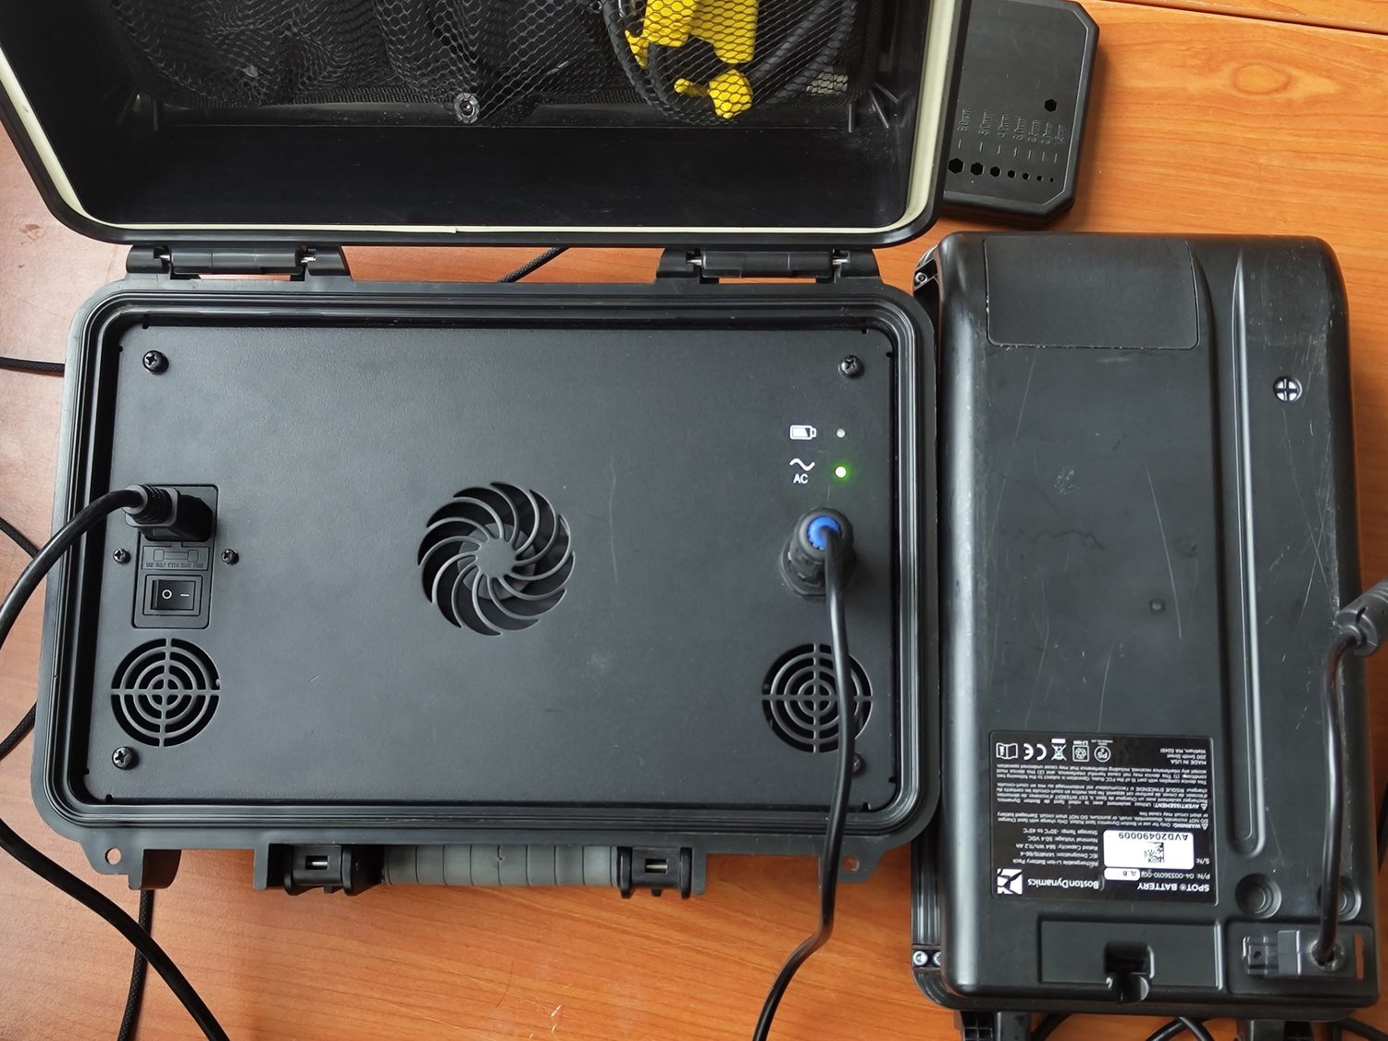
Figure 1 — Connecting a module to the OEM charger. The indicator flashes red and dies rather than blinking steady green, signalling a refused charge.
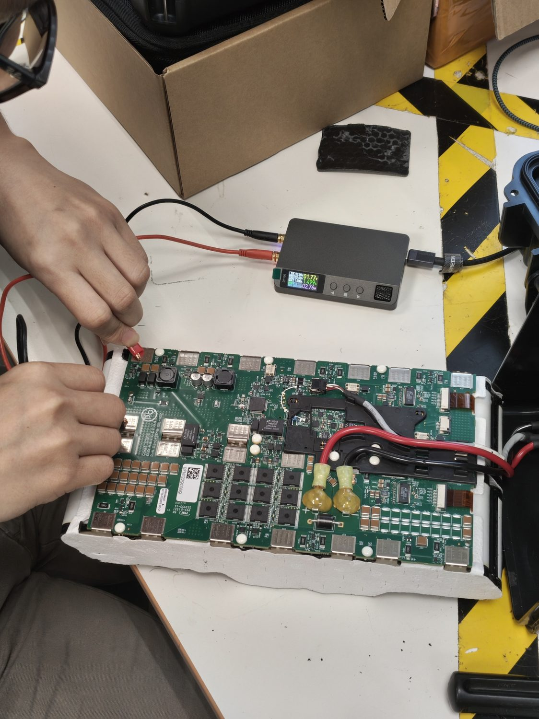
Figure 2 — Staged bench-charging of the individual cell groups, an attempt to nurse them back above the safe minimum before committing to a rebuild.
The recovery did not hold, and the manner of its failure was itself the diagnosis. Returned to the OEM charger, the BMS status LED blinked — a successful CAN handshake — but the charge indicator went green and then static, reporting a “full” charge on cells that were plainly empty (Figure 3). The Spot manual attributes a false “full” to highly imbalanced cells and suggests leaving the pack plugged in to auto-rebalance, which had no effect. After idling, the cells were warm to the touch and pack voltage collapsed from about 1.6 V to 0.6 V. The combination of warmth and rapid voltage collapse is consistent with resistive self-discharge through dead cells now behaving as internal short circuits; the cells were therefore judged degraded beyond recovery. The decision followed directly: replace the cells rather than recover them, and — to preserve the OEM BMS, CAN interface and casing — rebuild onto the original board in the standard 14s4p configuration by spot-welding replacement cells onto the original pads.
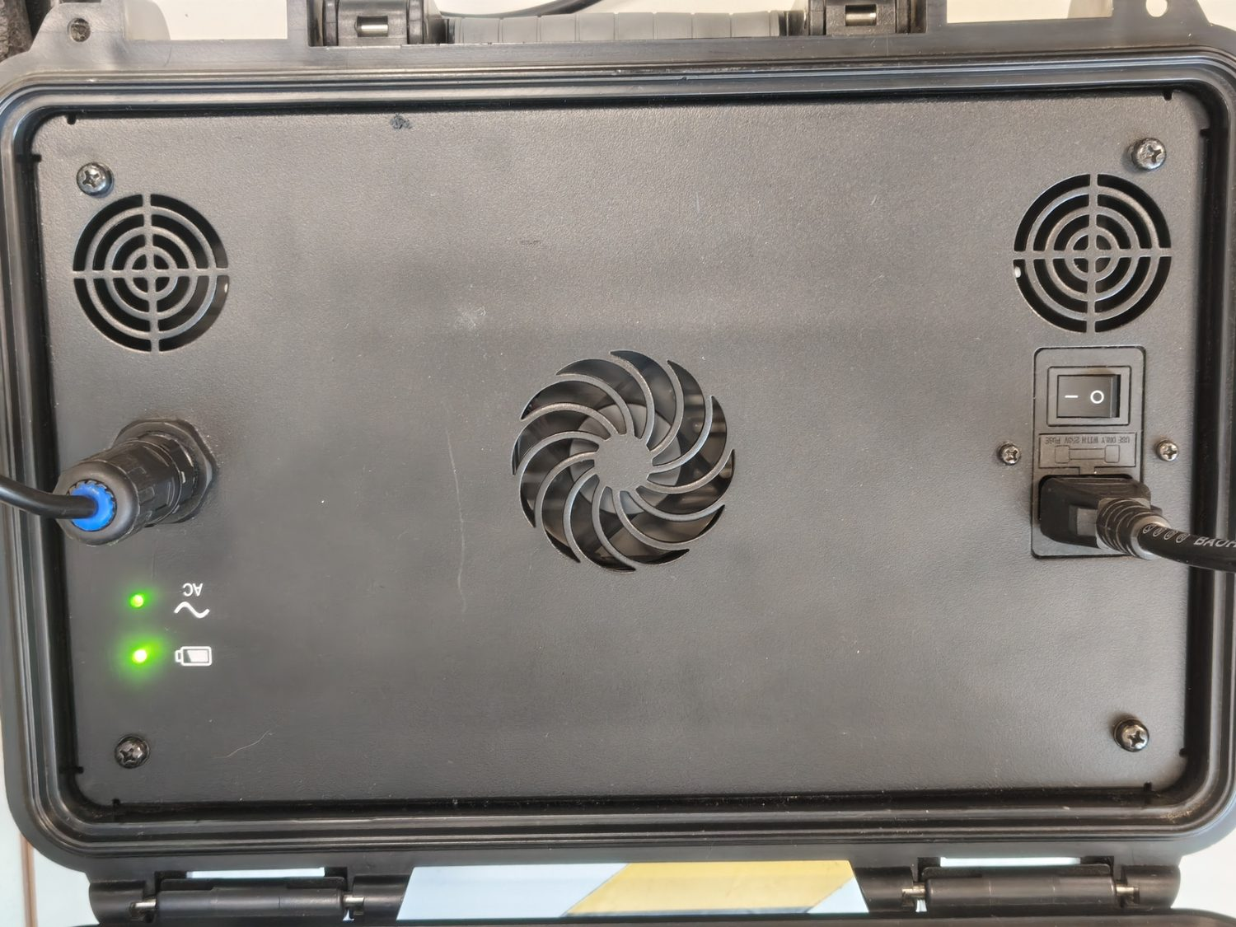
Figure 3 — The OEM charge indicator sitting static green (“full”) moments after the pack measured near-empty — the signature of dead, imbalanced cells.

Teardown and OEM construction
Having resolved to rebuild, the module was fully disassembled, both to strip out the dead cells and to document the OEM construction so the replacement pack could match it (Figure 4). The power cables were freed by cutting away a large securing glue blob piece by piece, then unscrewing the leads and unplugging the CAN cable; a plastic insulator covering three of the BMS pad sets was removed. The nickel strips are spot-welded to the BMS pads and could not be cut cleanly because the plastic frame blocked the cutter, so they were pried off the pads, leaving small welded-nickel bumps that required clean-up before re-welding. The two 7s4p sub-packs were then separated — a long plastic snap-connector releases by prying both ends and twisting the centre clips, and a shorter connector by pushing its centre axle out from below — and the two flexible thermistor strips (Figure 7) were unplugged and labelled A and B to preserve their original sides.
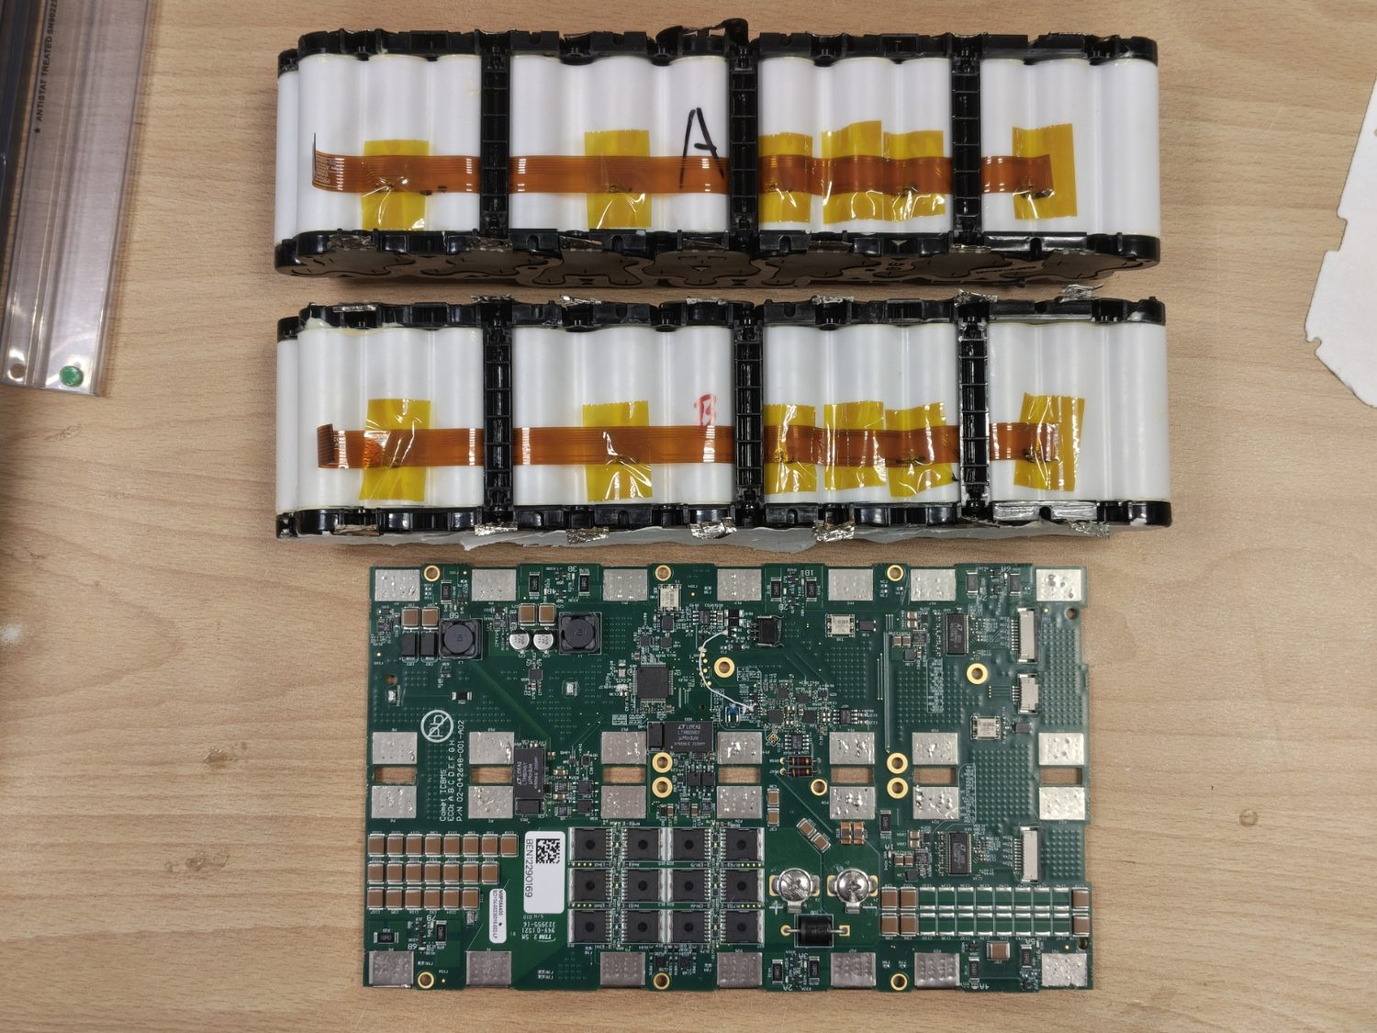
Figure 4 — The module fully separated into its sub-packs, BMS, frame, connectors and thermistor strips.
The teardown confirmed the topology of Table 1 and fixed the two design constraints noted in the Background: the irregular, non-collinear cell layout (Figure 5) that the replacement spacer would have to reproduce, and the 28-pad BMS layout (Figure 6) — positives along the long edges, common negative down the centre, with three pad sets awkwardly recessed beneath the power-wire insulator — onto which the new pack would weld.
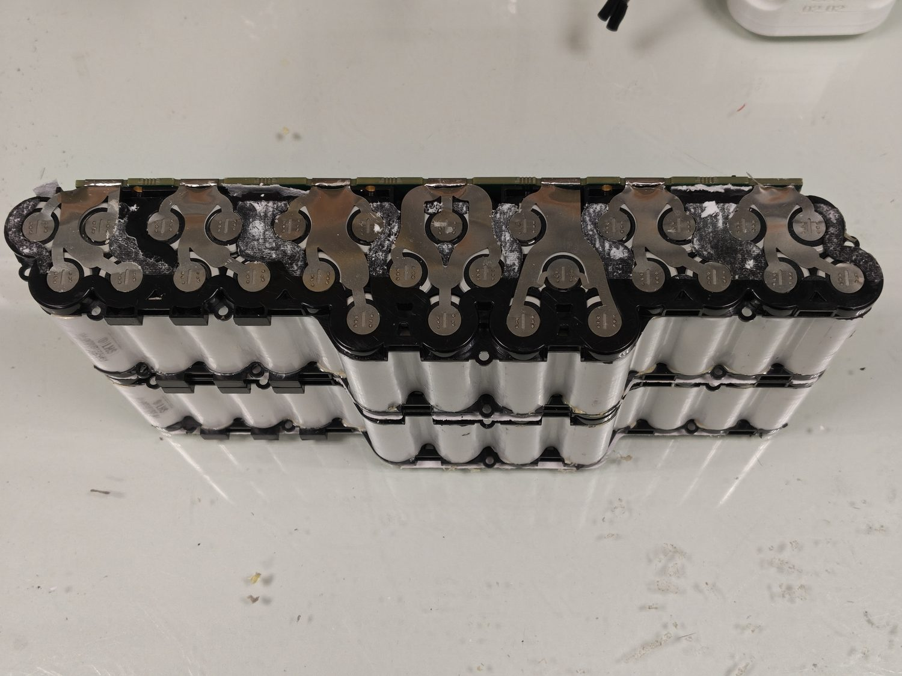
Figure 5 — The OEM cell arrangement. Spacing is irregular and the centre cells in each row sit proud of their neighbours.
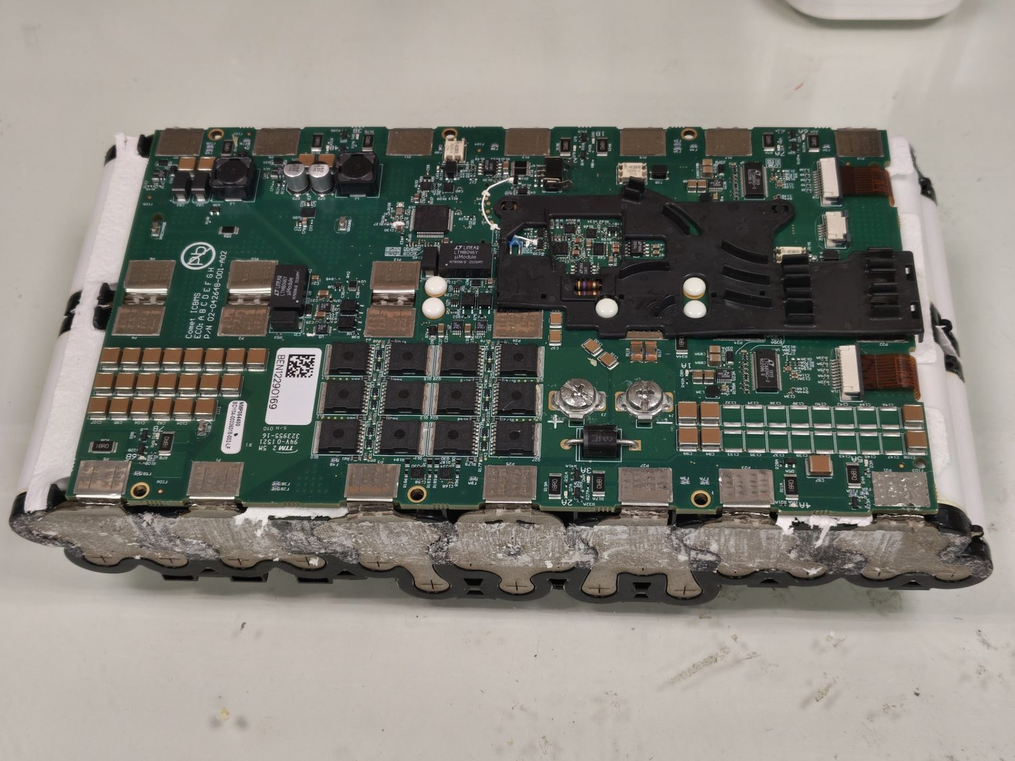
Figure 6 — The BMS PCB with cabling removed, showing the pad layout onto which the replacement packs weld.
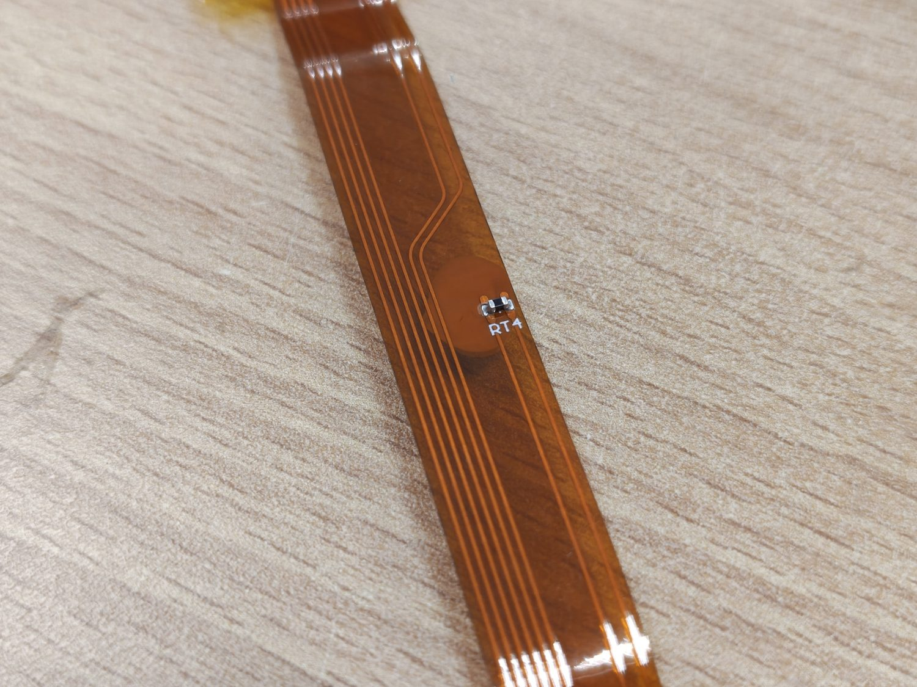
Figure 7 — One of the two flexible PCBs, each carrying five SMD NTC thermistors thermally bonded to the cells.

Cell sourcing
The replacement cell was fixed by the OEM specification: the Samsung INR18650-30Q identified from the Spot Battery Safety Data Sheet [1], of which 56 were required per module. Because local suppliers did not stock the exact cell, several options were compared (Table 2). The original 30Q was selected to keep the rebuild electrically identical to stock, the cheapest source being Falcon PEV [2]; higher-capacity alternatives were rejected as unnecessary deviations from the OEM design.
Table 2 — Replacement-cell sourcing comparison. The OEM cell was chosen to keep the pack identical to stock.
Cell | Capacity | Discharge | Notes
Samsung INR18650-30Q (chosen) | 3000 mAh | 15 A / 30 A peak | OEM spec; cheapest source found (Falcon PEV) [2].
LG HG2 | 3000 mAh | 20 A | Same capacity, slightly higher rating (~S$663 for 56).
Samsung INR18650-35E | 3500 mAh | higher | More capacity and current, but pricier.

Pack design
Two design questions had to be settled before assembly: how to size the inter-cell conductors, and how to hold the irregular cell lattice rigidly.
The conductor sizing followed from an estimate of Spot’s power draw. With the pack rated at about 500 Wh and a datasheet runtime of roughly 1.5 h, and assuming discharge to 20 % state of charge over that time, the average power is approximately 0.8 × 500 / 1.5 ≈ 267 W; against the manual’s 38–52 V supply this implies an operating current of about 5.1–7.0 A. Sizing to a 50 % margin (~400 W continuous) gives a peak pack current of about 10.5 A, or roughly 2.63 A per cell across the four parallel cells in each group. Those figures set the strip widths in Table 3; the OEM pack uses 12 mm strip throughout, which is comfortably conservative for the actual current.
Table 3 — Inter-cell conductor sizing, from the estimated ~10.5 A peak pack current.
Conductor | Spec | Basis
Inter-cell links | 0.1 × 8 mm pure nickel | Per-cell current only ~2.63 A
4s pack leads | 0.15 × 12 mm pure nickel | Rated ~17 A optimal / 25.5 A acceptable — ample for ~10.5 A pack max
The irregular OEM layout was replicated in CAD from direct measurement of the original pack and 3D-printed as a four-piece cell spacer in PC-CF (polycarbonate / carbon-fibre), chosen for its high operating-temperature limit and strong inter-layer bond, which maximise rigidity (Figure 8). The four spacers printed over roughly ten hours. The supplied filament adhered unusually well and printed very easily, raising a suspicion that it was PETG sold as PC-CF — functionally adequate for this part in any case. Safety and thermal provisions mirrored the OEM approach where practical: fish-paper insulation cut to shape across the cell terminals to prevent accidental shorts, and a silicone thermal sheet between the pack and the shell for heat transfer and to seat the cells firmly in the casing grooves. An off-the-shelf phase-change material equivalent to the OEM latent-heat filler [4] was researched but none easy to work with was found, so it was omitted from this rebuild — a deviation from stock noted here as a limitation.
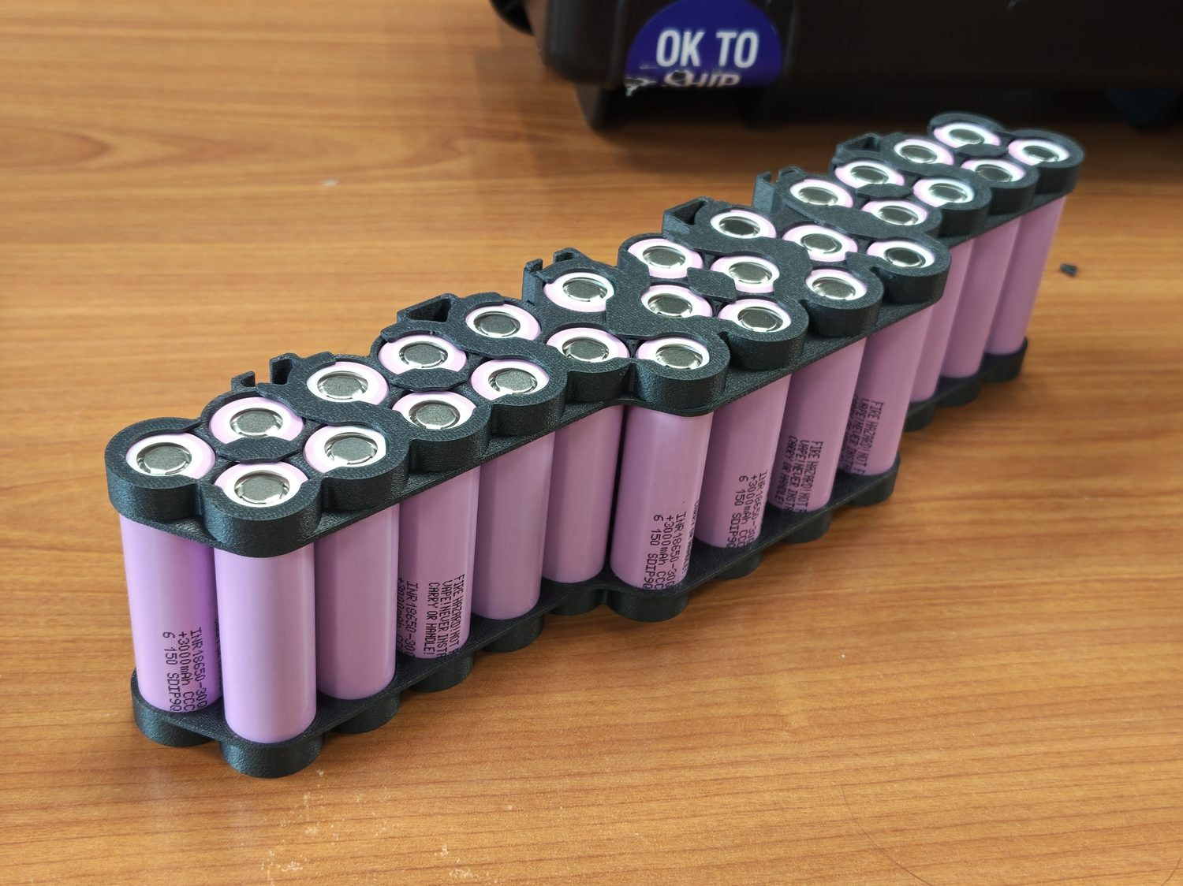
Figure 8 — The four 3D-printed PC-CF cell spacers, which replicate the irregular OEM cell positions.

Assembly and spot-welding
The cells were seated in the spacers and their terminals joined with nickel strip at a partner facility (Sodion Energy). Only 10 mm strip was available, so it was trimmed to about 8 mm before use (Figure 9). The 12 mm BMS PCB tabs tended to “explode” when welded onto the thinner strip beneath them, so those tabs were soldered rather than welded. A recurring practical constraint was that the welder could not reliably join more than one nickel strip at a time, which ruled out strip-stacking and shaped the later V2 design.
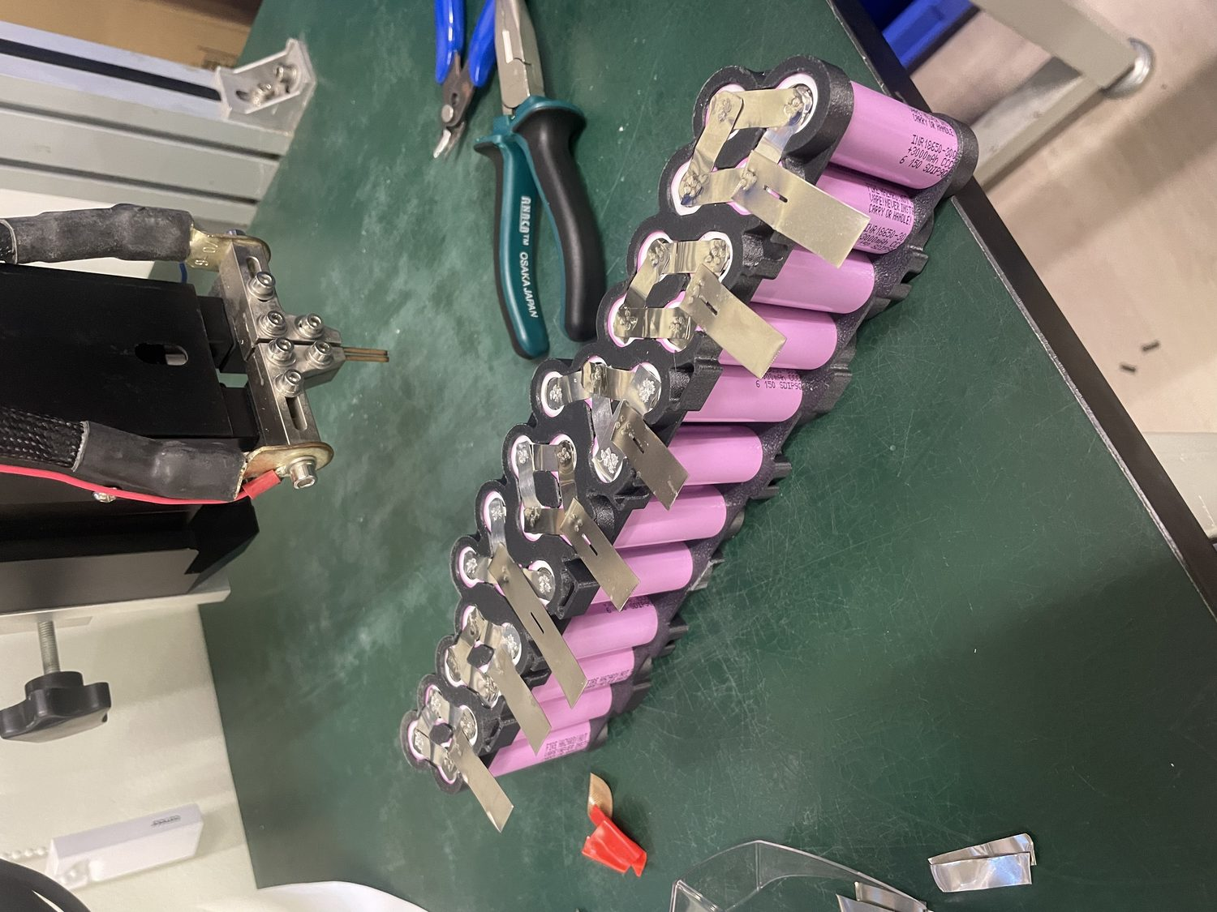
Figure 9 — A cell sub-pack with nickel strips spot-welded across the terminals.
Welder reliability was in fact the dominant obstacle of the whole rebuild. Partway through, the bench spot-welder failed with an Error 22 — transistor fault: after about thirty minutes of use there was an audible pop and a smell of smoke from the supply. The immediate contributors were assessed as electrode fouling and mushrooming, thermal saturation of the welder’s IGBTs, and contact-pressure drift; the underlying cause was later traced, on opening the unit, to a cracked solder joint on a capacitor module, with burn marks on the PCB beside an otherwise-healthy capacitor. A handheld spot-welder (Figure 10) was pressed into service to finish both packs while the bench unit was out of action.
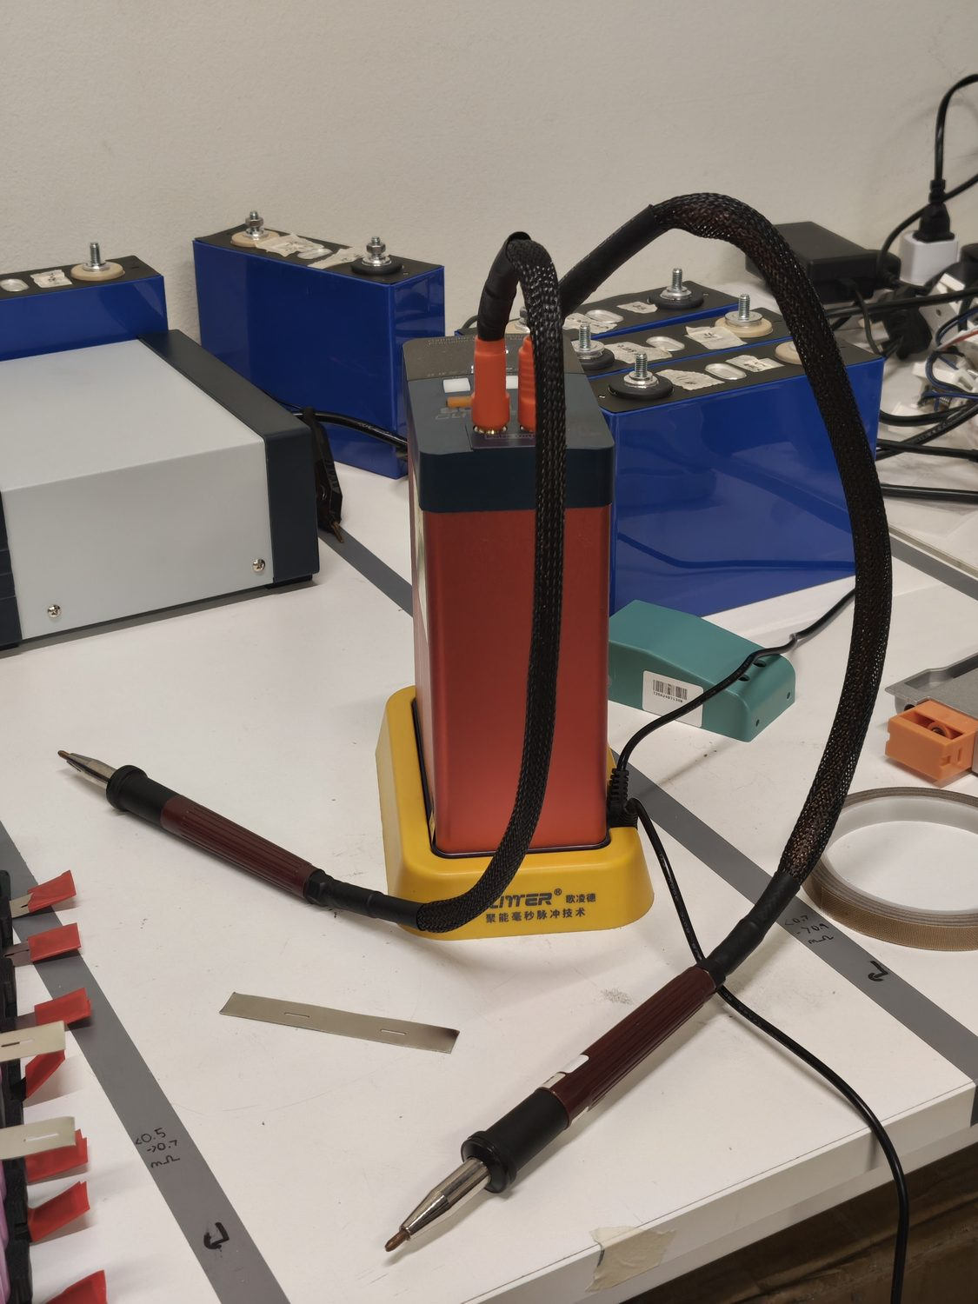
Figure 10 — The handheld spot-welder that completed the job after the bench welder failed with an Error 22 transistor fault.
The pack was then reattached to the BMS, ground ends first and positive ends second. As each cell group was welded on, the BMS’s red indicator LEDs blinked in response (Figure 11), providing a live confirmation that the group had connected. The module was finally closed with its original foam pieces reinserted to keep the cells seated.
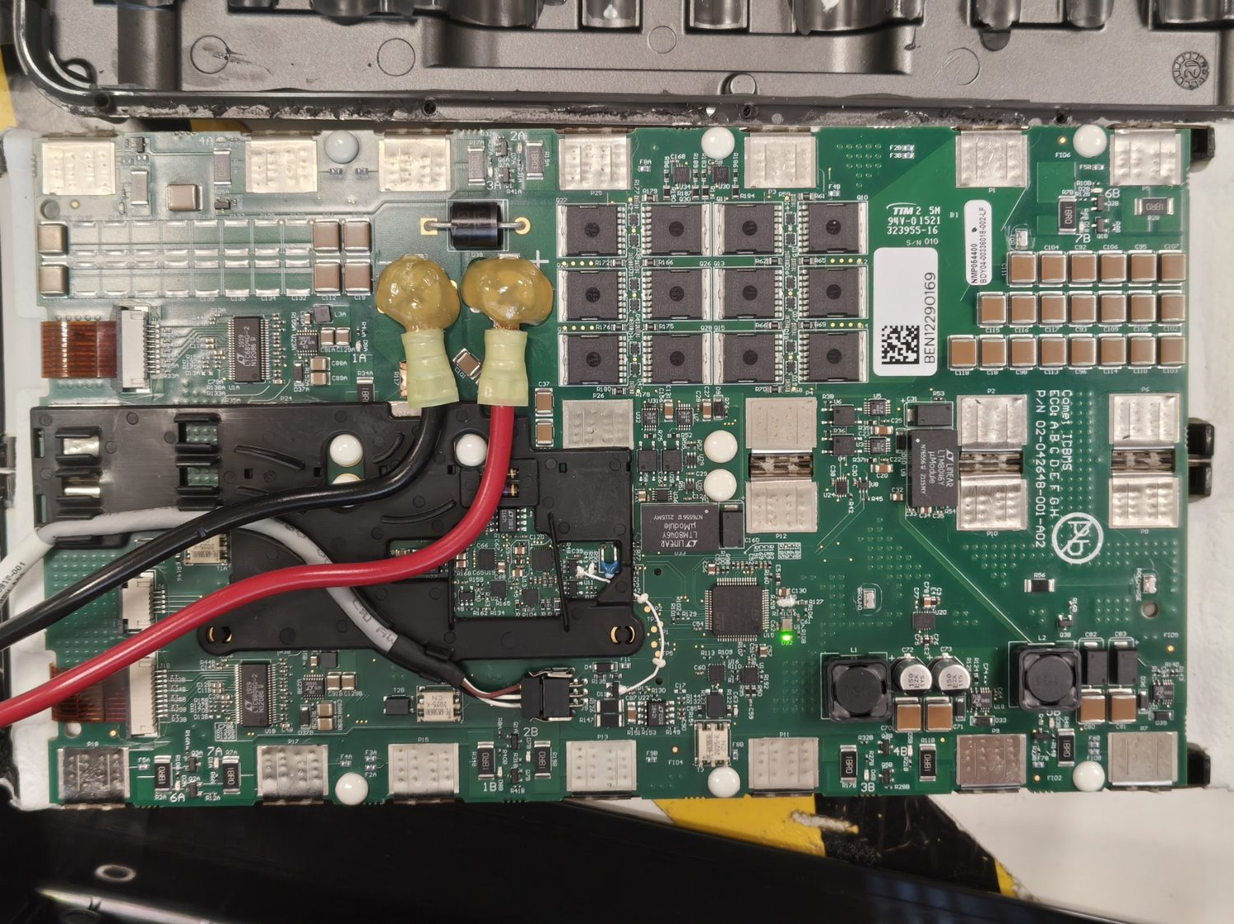
Figure 11 — BMS indicator LEDs responding as each cell group is welded onto the board.

Testing, fault-finding and rework
The first charge test exposed the rebuild’s central weakness. The state-of-charge (SoC) button showed a single blinking green bar; the charger flashed green (charging) but, after about twenty minutes, went static green (“full”) while the SoC still showed one bar. The BMS then flashed three red LEDs and extinguished its green STM32 LED, halting the charge. From the admin console the battery balance index read 0.213, well above the 0.1 threshold that calls for active balancing — but automatic balancing requires battery firmware later than V45, whereas the pack reported V33, so the legacy charger could not rebalance it. The rebuilt pack did successfully power the robot through a boot cycle, confirming that it could deliver load current even while imbalanced, which pointed the investigation at the cells’ connections rather than at the charging system.
After charging until the charger again reported “full”, each group’s voltage was measured and tabulated (Figure 12). Groups 1, 2 and 8 read abnormally while the remainder were well balanced, and inspection tied every anomaly to a bad weld on the positive side: on groups 2 and 8 the positive weld had popped off, leaving only two of the four parallel cells connected and so raising the group’s relative voltage; on group 1 a defective weld loosely joined the nickel strips, producing a high contact resistance. A resistance comparison across sound and poor joints (Figure 14) confirmed that an inconsistent weld raises the trace resistance substantially and unbalances the pack.
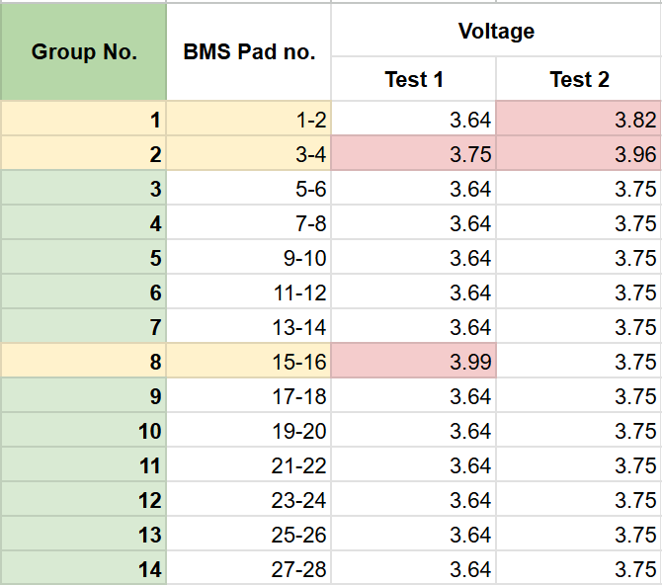
Figure 12 — Per-group voltage sweep after the first full charge; groups 1, 2 and 8 read abnormally relative to the balanced remainder.
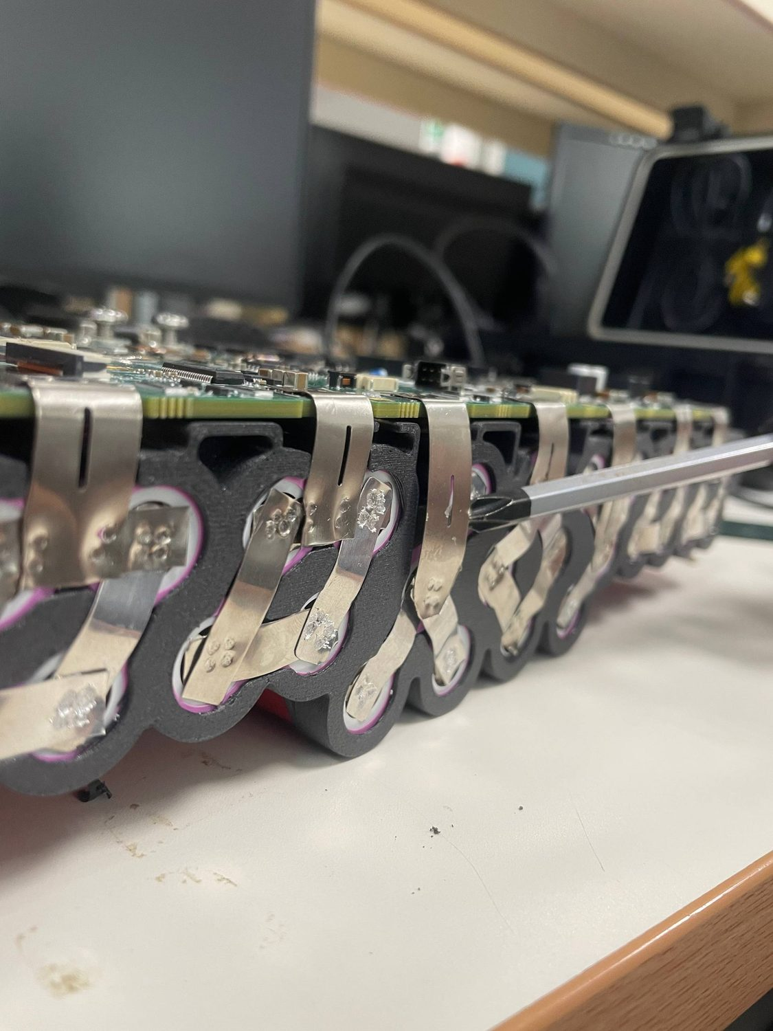
Figure 13 — A defective / popped weld joint of the type responsible for the group imbalance.
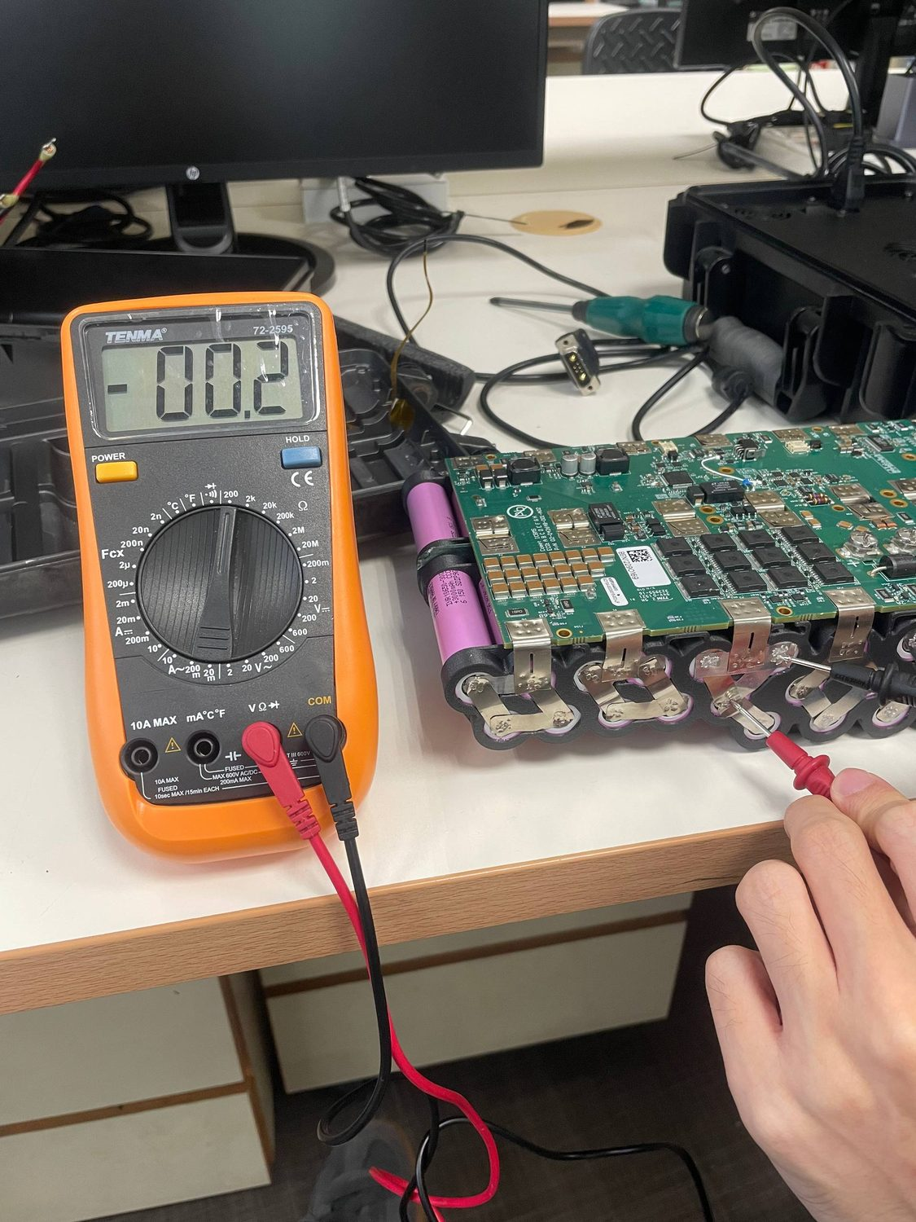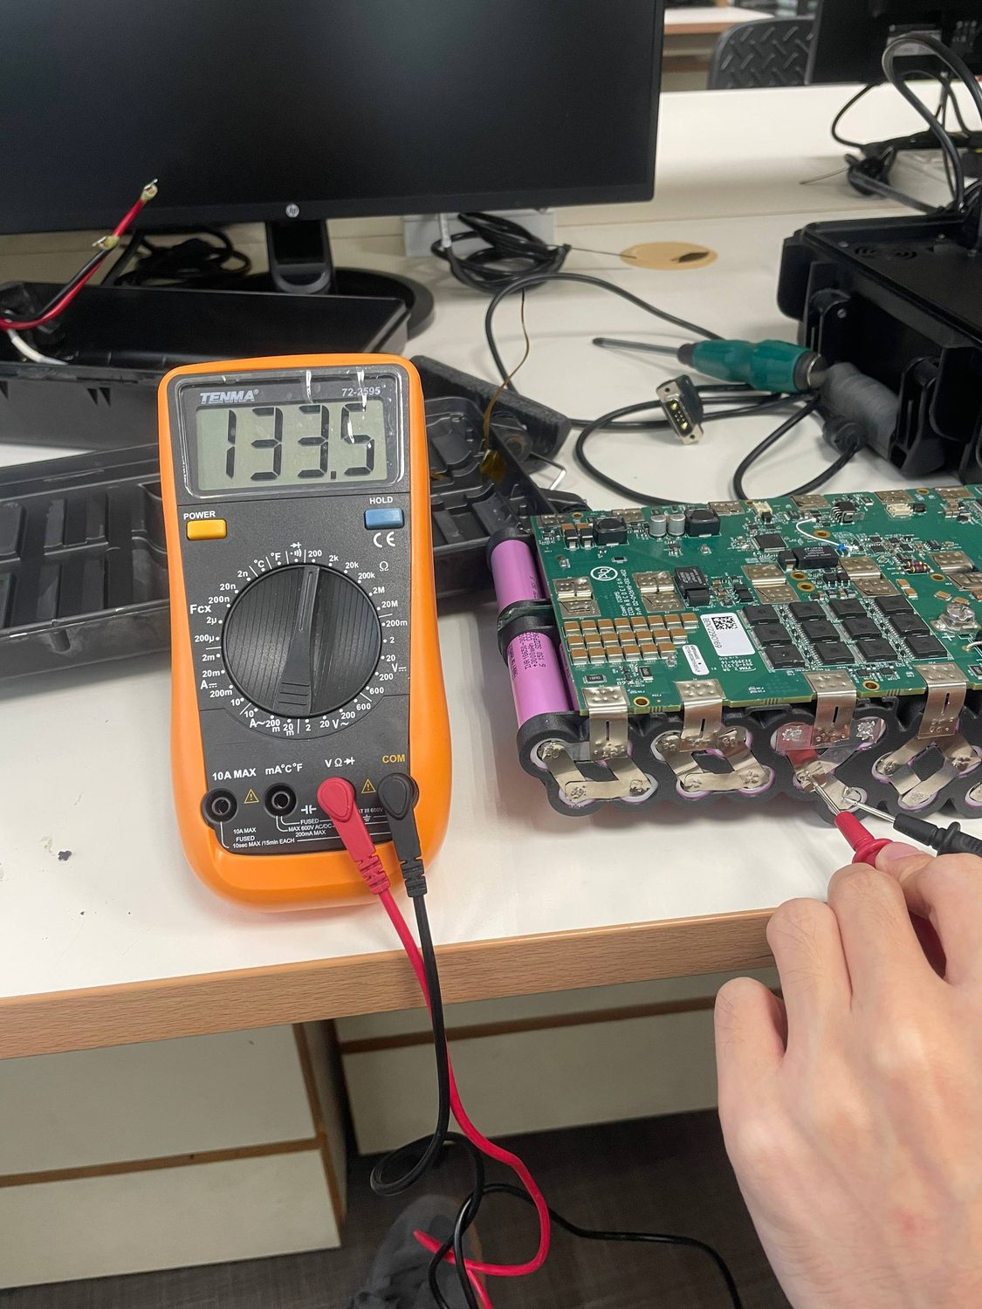
Figure 14 — Resistance across a sound weld (left) versus a poor one (right). The poor joint reads a substantially higher resistance.
The weld problem then escalated from imbalance to a hard lockout. After the pack was left overnight, Spot reported a battery fault and refused to power on, and charging produced the same fault with all SoC lights blinking. A third voltage sweep (Figure 15) showed group 1 reading an impossible −0.5 V while every other group — including the previously unbalanced ones — sat at a healthy 3.71–3.72 V. Candidate failure modes were narrowed by elimination: no visible BMS damage argued against a blown MOSFET or resistor; normal resistance along the positive nickel strips ruled out a positive-side weld; and the group’s good service history made cell degradation unlikely. Probing the group directly, with its negative terminal disconnected from the BMS, gave 3.71 V — but only when the negative nickel strip was pressed down hard (Figure 16). That intermittent contact isolated the fault to a broken weld on the group’s negative terminal: the group had effectively disconnected from the BMS, and the −0.5 V was a phantom reading, most plausibly the reverse bias of an internal protection diode or the drop across a balancing bleed-resistor on the BMS. The likely trigger was mechanical strain on the joint during operation of the robot.
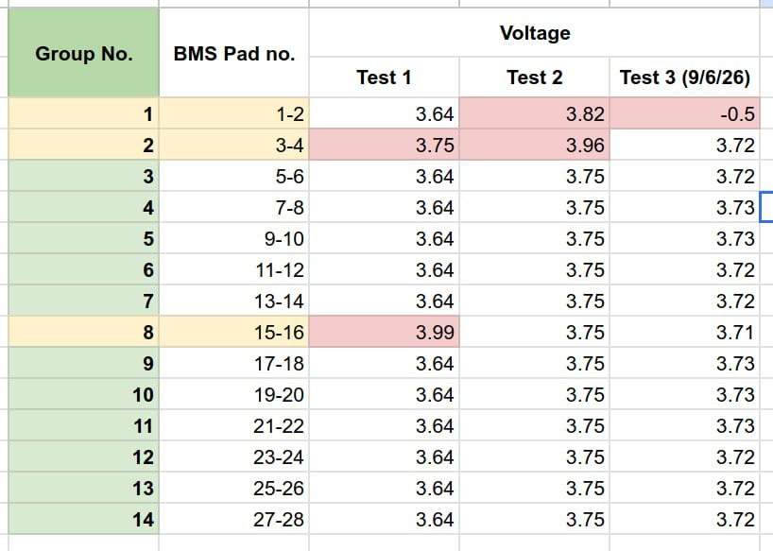
Figure 15 — Third voltage sweep. Every group is balanced at ~3.71 V except group 1, which reads a negative voltage.
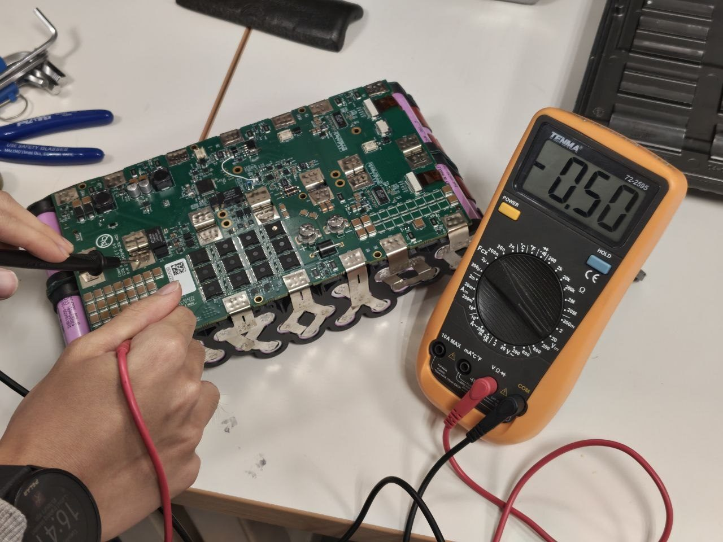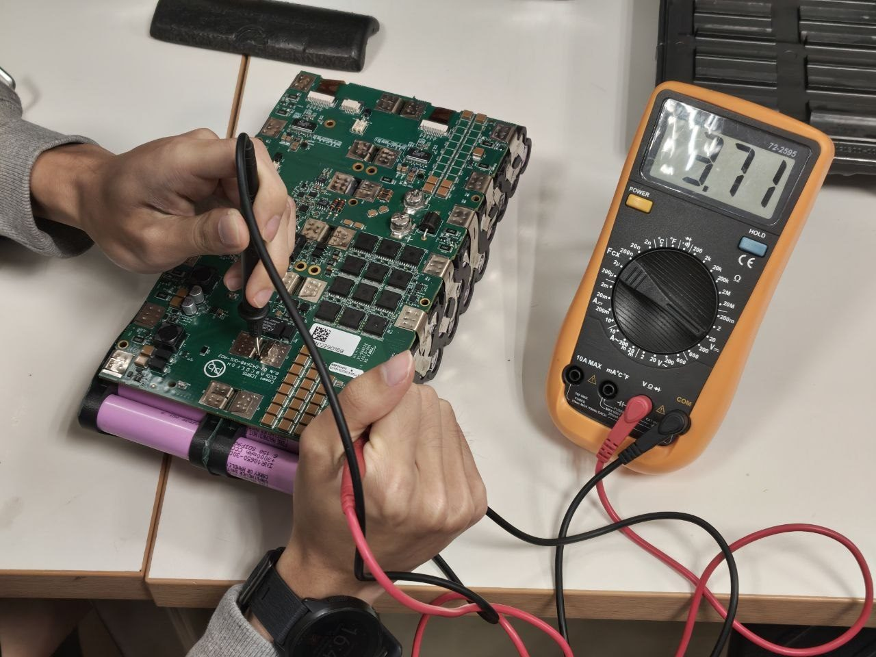
Figure 16 — Group 1 reads a phantom −0.5 V at the BMS pads (left) while probing the cell group directly reads a healthy 3.71 V (right) — confirming a broken negative-terminal weld, not a bad cell.
Rather than repair only the known-bad joints, the pack was returned to the partner facility and every weld was redone to eliminate any further intermittent connections. After re-welding, the SoC fault lights cleared, the pack charged normally, and it reached a full, balanced charge for the first time — the hallmark of sound welds allowing the cells to balance correctly (Table 4). Battery module #1 was thereby repaired and verified.
Table 4 — Battery pack #1 state before and after the weld rework.
 | Before rework | After rework
Group 1 (P1–P2) | −0.5 V (disconnected) | balanced, ~3.7 V
Charge behaviour | premature false “full”, fault lockout | charges to full, no fault
Cell balance | groups 1 / 2 / 8 anomalous | all groups balanced

Second module: a V2 pack that validated the fixes
The single dominant lesson of pack #1 — that reliability was governed almost entirely by spot-weld quality, and that weld failures traced to bends and stress points in the nickel-strip routing imposed by the bracket design — was carried directly into a second module. The V2 brackets (Figure 18) added a further set of braces with tighter tolerances to hold the cell lattice rigidly (pack #1’s brackets had allowed some play when flexed), reincorporated the OEM injection-moulded spacer positions for rigidity, and were re-dimensioned to fit the casing and PCB more accurately after the lessons of V1. They were printed in glass-filled ABS (ABS-GF) for dimensional stability at temperature, and the BMS mounting was changed from expanding rivets — which had split the printed layer lines — to captured M3 nuts under 1.2 mm of plastic, secured with M3×6 mm screws.
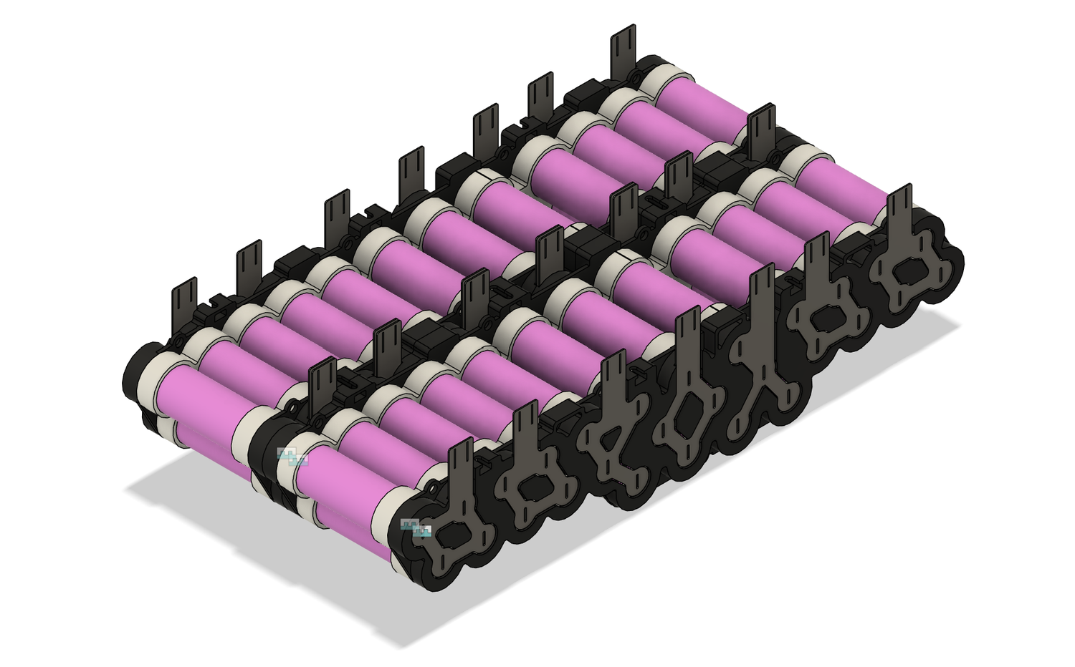
Figure 18 — The pack #2 V2 bracket CAD, adding braces, OEM spacer positions and captured-nut BMS mounting.
The improvement was borne out in assembly (Figure 19). With laser-cut nickel strips that eliminated strip-stacking, and a small slot cut-out at each weld site, welding produced little to no sparking and joints that held firmly when the tabs were pulled. Where pack #1 had taken two people three days, pack #2 was completed by one person in a single afternoon. After assembly, the SoC button was initially unresponsive; this was traced to a sheared SoC flat-flex cable near its base and a missing connector fastener (Figure 17). The broken cable was repaired by scraping back the insulation on both ends and soldering the exposed traces, with kapton tape added to relieve strain on the joints and a shim of cardboard standing in for the absent fastener; the SoC then read correctly. Pack #2 charged to full within about an hour, reported a very healthy balance index of 0.02, and accepted a battery firmware update once installed in Spot. Both modules were thereby restored to a full, balanced charge, meeting the power-system objective.
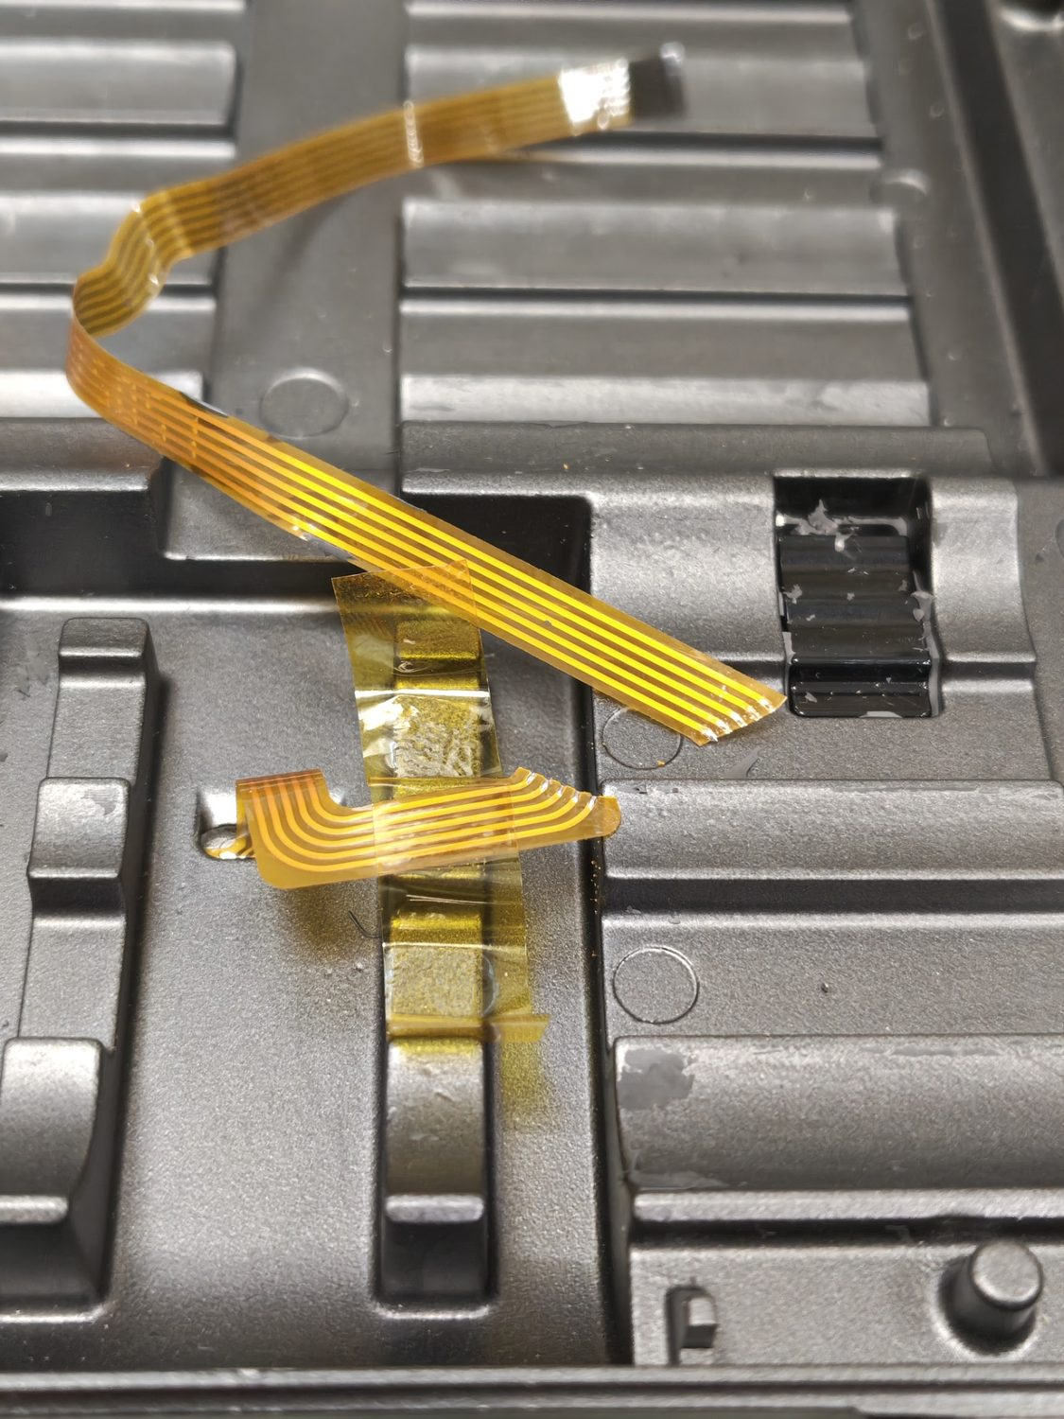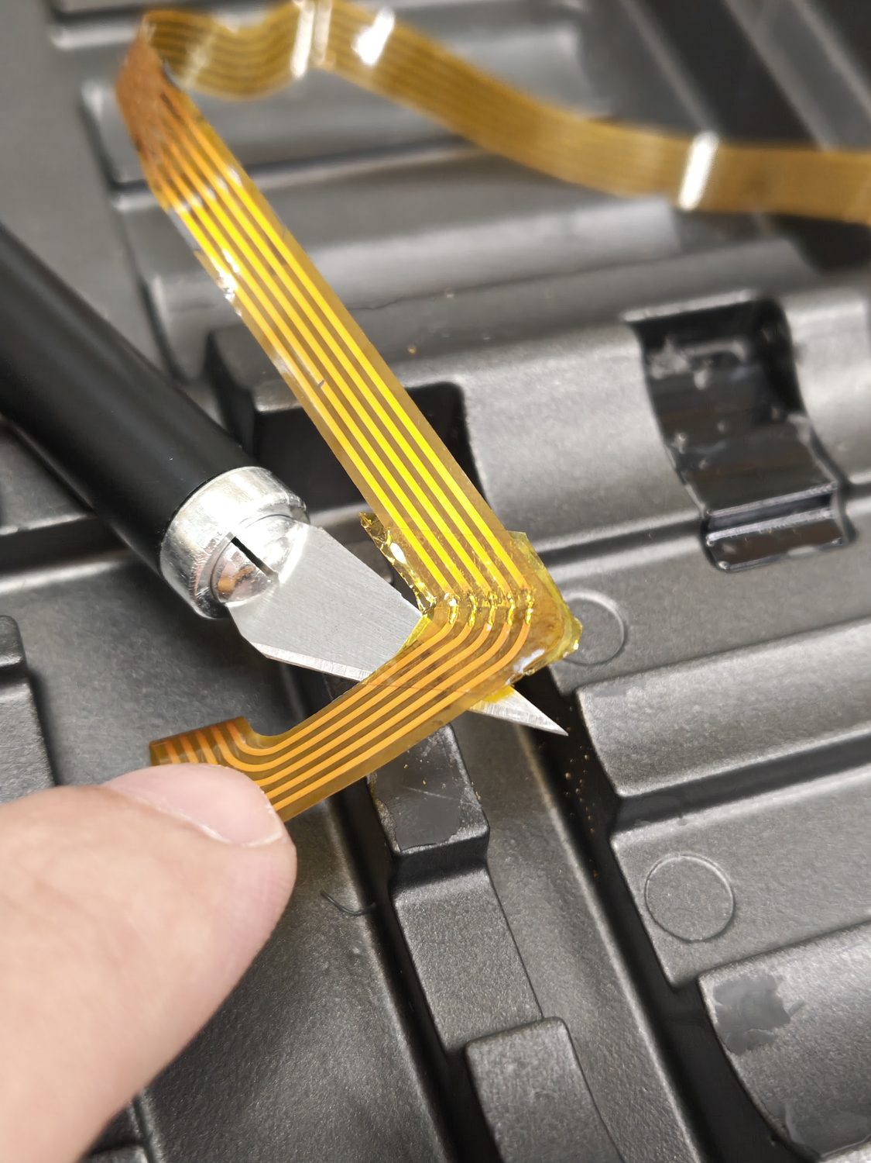
Figure 17 — The sheared SoC flat-flex cable (left) and the soldered, kapton-secured repair (right).
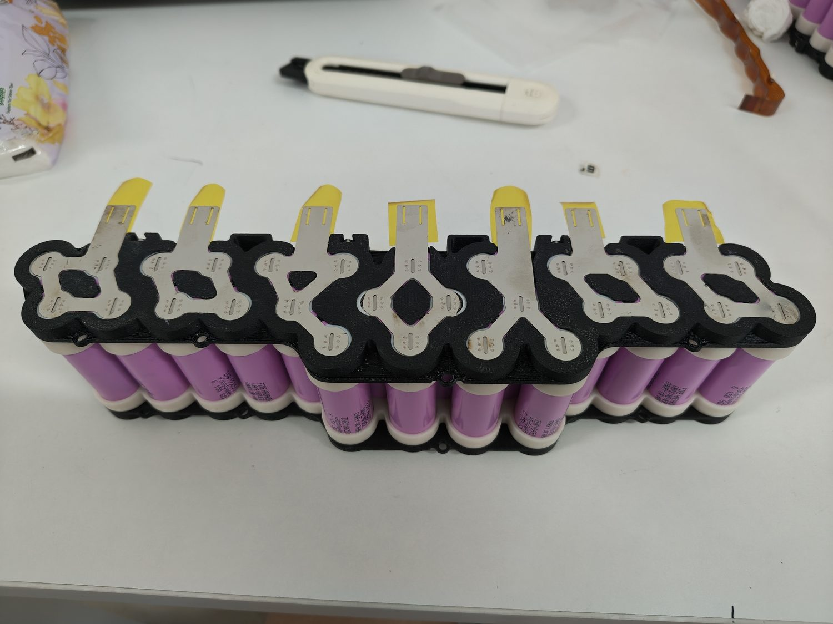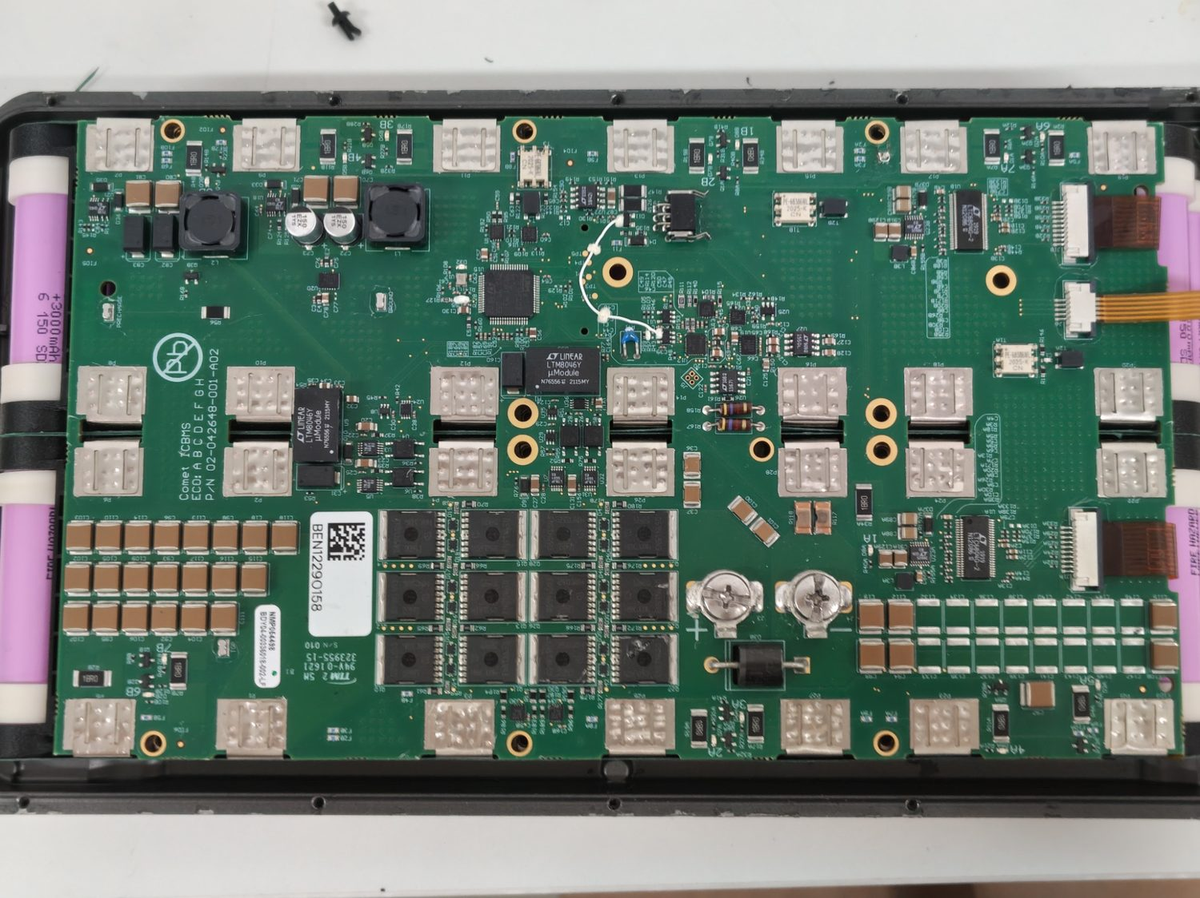
Figure 19 — Pack #2’s laser-cut nickel strips (left) and the completed BMS weld (right), both markedly cleaner than pack #1.

Methodology 2 — Actuator mechanical investigation
With power restored, attention turned to the faulty left_hind_x actuator. The investigation proceeded as a sequence of physical component swaps, each designed to move one candidate part between the faulty left and the healthy right hind hip-X actuators and observe whether the abnormal behaviour physically followed the part or stayed with the socket. This chapter reports the swap procedures and the physical observations; for each swap, the corresponding diagnostic reading and its interpretation belong to the signal layer and are reported in [Ming, SS-TBD].

Teardown and driver comparison
Spot was disassembled to extract the left hind leg together with its hip-X motor and controller (Figure 20). During teardown the leg wiring and controller board were inspected for physical defects and none were found; a layer of what appeared to be epoxy coating over the controller board frustrated any attempt to probe its test points, as contact could not be made without forcibly scraping the coating away. Because a purely visual inspection could not distinguish a mechanically-sound motor from a magnetically-faulty one, the investigation was framed around comparison with the healthy hind leg.
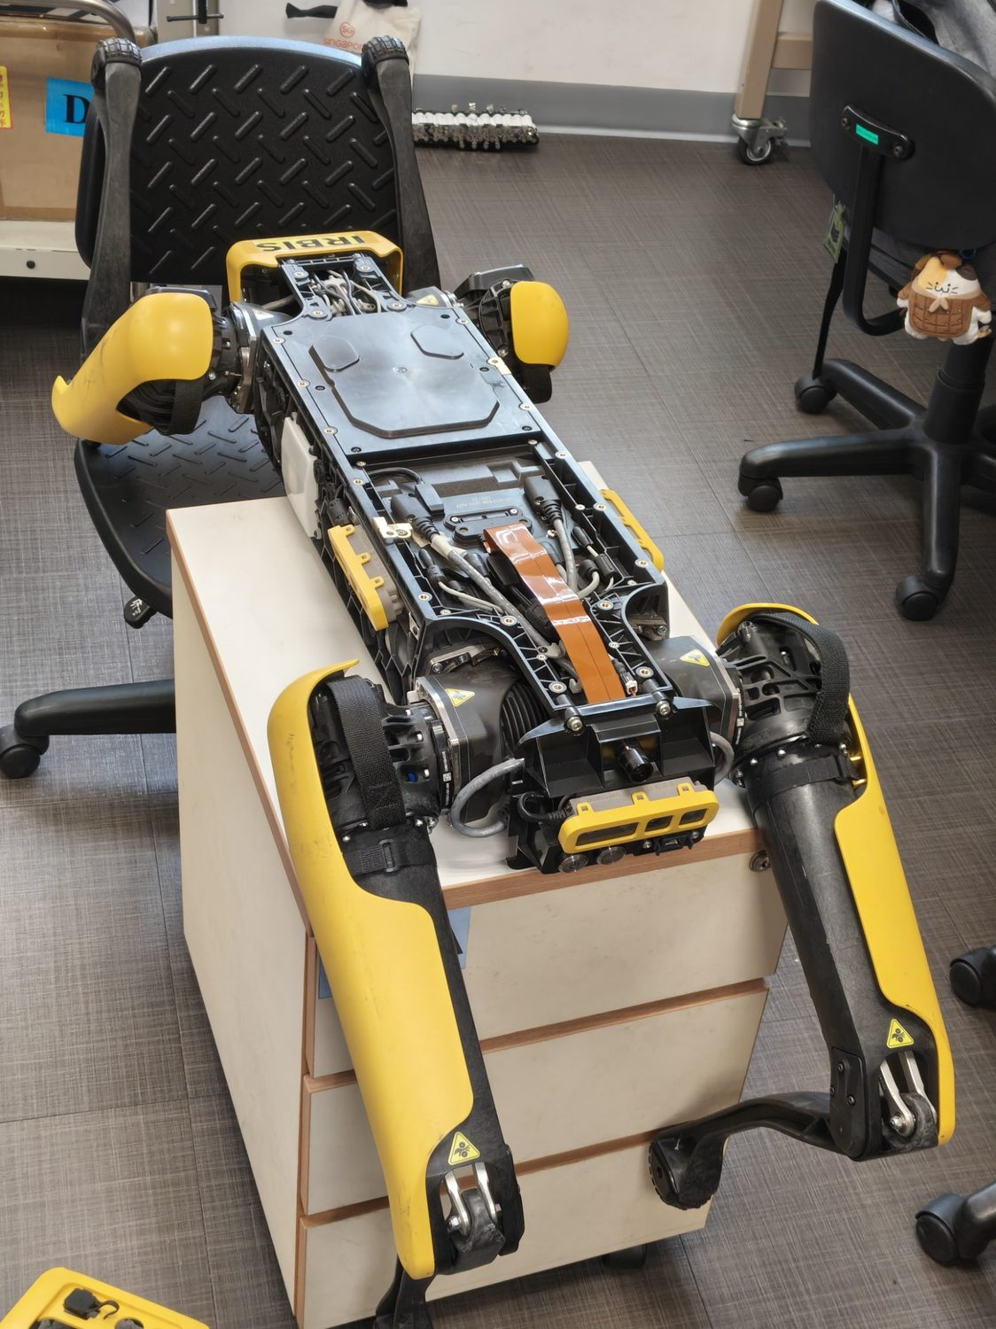
Figure 20 — Spot opened on the bench to remove the left hind leg and its hip-X actuator.
Both hind legs were then removed and their hip-X motor driver boards compared side by side (Figures 21 and 22). The two drivers were physically identical, with no sign of component degradation on either. Rotating each motor by hand confirmed that the encoder’s diametric rotor magnet was firmly seated, rotated freely, and stood at an identical protrusion height on both sides — ruling out an obviously displaced or loose magnet as the cause.
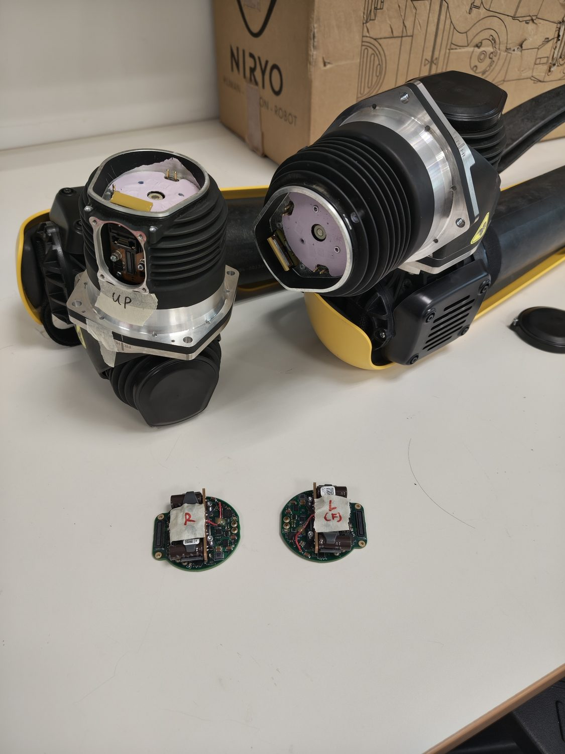
Figure 21 — The two hind hip-X motor driver boards removed for direct comparison.
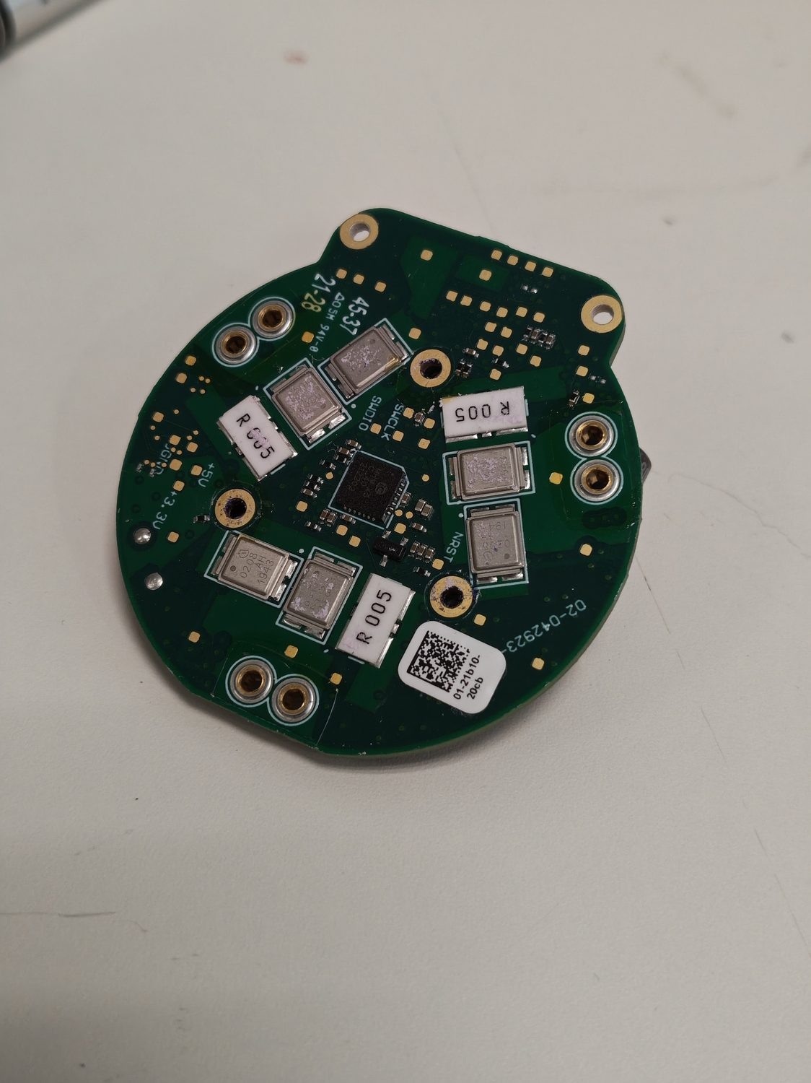
Figure 22 — The driver board, encoder side, showing the motor-side primary encoder region.

Driver and cable swaps
Two swaps tested the driver electronics and the wiring. First, the left and right hip-X driver boards were exchanged and the legs refitted; on power-up no motor faults were reported, but the abnormal joint behaviour physically remained with the left socket rather than following the swapped board. Second, the hip-X motor cables were exchanged — after probing the connector PCBs to confirm they were not mirror images and that power and ground would map correctly — and again the abnormal behaviour stayed with the left socket while the other joint operated normally. Table 5 records the physical actions and observations; in both cases the diagnostic reading that accompanied the swap, and the inference drawn from it, are reported in [Ming, SS-TBD].
Table 5 — Actuator component-swap actions and the physical observations recorded. The diagnostic reading and interpretation for each swap are reported in [Ming, SS-TBD].
Physical action | Physical observation
Exchange L/R hip-X driver boards | No motor faults on power-up; abnormal behaviour stayed with the left socket, not the board.
Exchange L/R hip-X connector cables | Abnormal behaviour stayed with the left socket; the other joint responsive and normal.
Exchange entire rotor + output-encoder + load-cell assemblies | Behaviour moved to the right socket, but a load-cell hard fault appeared (load cells are calibrated per joint).
Exchange output-encoder PCB only (rotors/load-cells returned to original sockets) | Abnormal frozen behaviour cleared on both joints; a residual mechanical offset remained on one joint.
Taken together at the hardware level, the driver and cable swaps physically eliminated the driver electronics and the motor wiring as the location of the fault, since neither swap moved the abnormal behaviour with the part. That left the angle-sensing hardware inside the motor as the remaining candidate, which motivated opening the motor itself.

Motor disassembly — discovering the secondary encoder
Each hip-X motor was disassembled to inspect its internal angle-sensing hardware. To isolate the hip-X (abduction) motor, the hip-Y (flexion) motor was first removed from the rotor housing by undoing four very tight torx screws, after which a flange serving as both cover and mechanical end-stop was freed by removing eight tight M3 hex screws; the X-motor assembly, held together without the flange only by a snug fit between the rotor bearing and housing, could then be pulled apart with some force. A notable construction detail was that the internal screws (beneath the flange, at the output shaft, and holding the stator) are numerically labelled, suggesting a defined tightening sequence to keep the rotor centred.
The disassembly revealed the key architectural fact of the whole investigation: a second Hall sensor, an iC-Haus device, mounted beside the harmonic-drive stage (Figures 23 and 24) — the secondary output encoder introduced in the Background, which had not been visible in any earlier inspection. Because the driver and cable swaps had already cleared the electronics and wiring, and because the primary iC-MHM rotor encoder is a robust four-Hall device whose reading is insensitive to small magnet-placement deviations (the rotor magnet having already been shown well-seated on both sides), this newly-exposed secondary encoder became the primary hardware suspect for the abnormal joint behaviour.
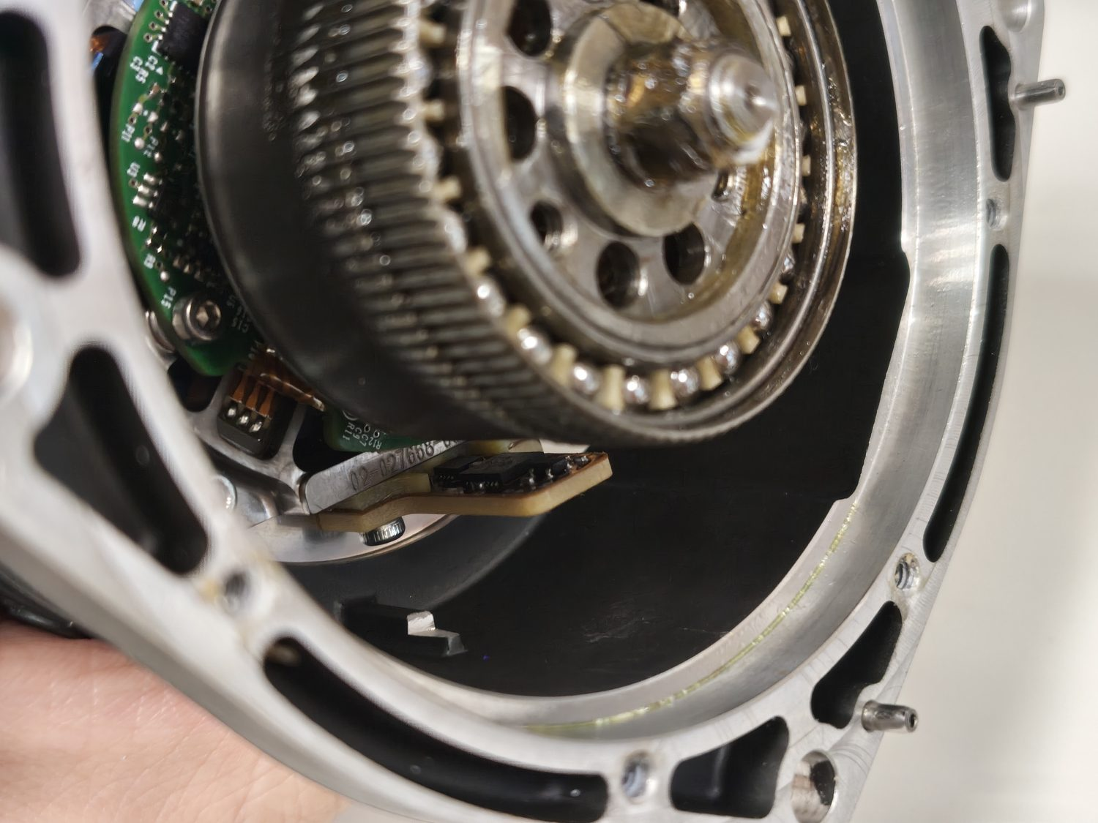
Figure 23 — The secondary output-encoder Hall-IC (iC-Haus iC-MU) found at the harmonic-drive output stage of the hip-X motor.
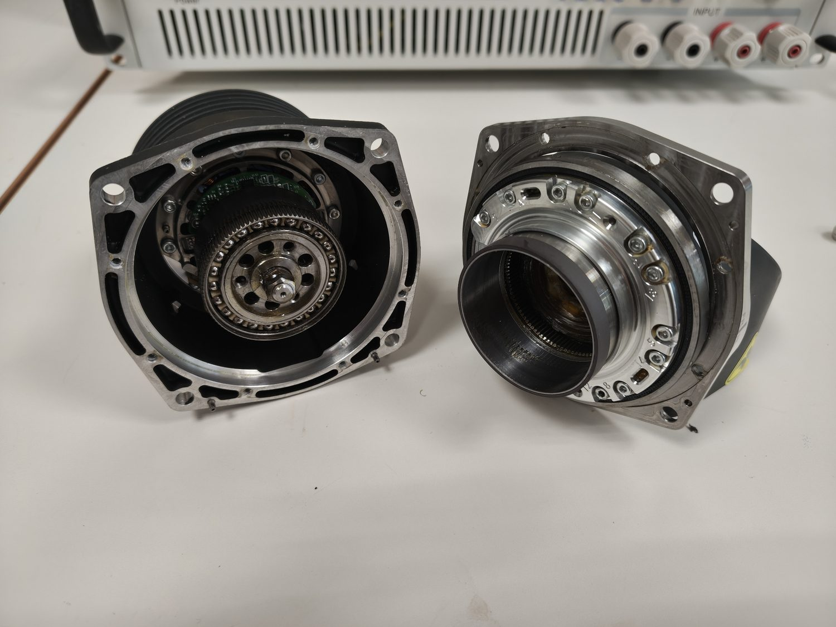
Figure 24 — The 50:1 harmonic drive of the hip-X actuator.

The output-encoder swap
The decisive swap concerned the output encoder itself. As a first step, the entire rotor assembly — main connector, encoder and force-feedback (load-cell) module together — was exchanged between the two hind hip-X sockets. This moved the abnormal behaviour to the right socket as intended, but it also raised a load-cell hard fault: the load cells are calibrated per joint, so swapping them was not admissible, and the fault prevented the motors from powering on. The swap was therefore refined (Figure 25): only the main connector PCB carrying the secondary output encoder was exchanged, while each rotor and its load cell were returned to their original stator. The driver boards were likewise returned to their original sides.
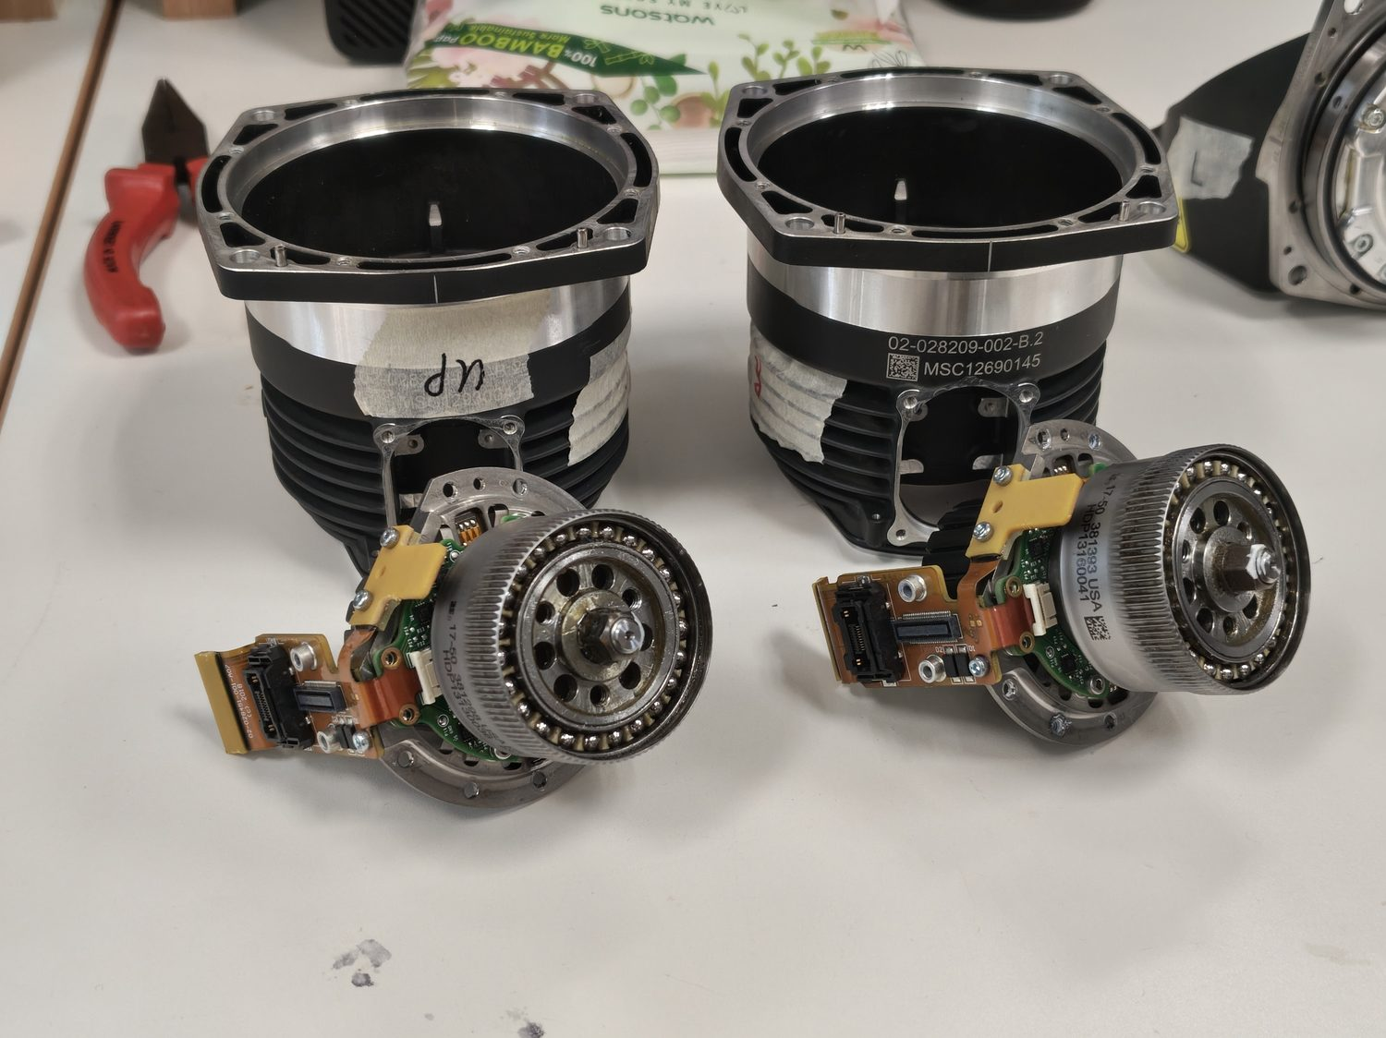
Figure 25 — The rotor / output-encoder assemblies during the swap; only the secondary output-encoder PCB was ultimately interchanged, with the load cells kept in their original joints.
With the output-encoder PCBs interchanged between the hind hip-X sockets and the magnets held fixed, the load-cell fault disappeared and both joints thereafter responded to articulation — the previously frozen behaviour was gone (Figure 26). A residual mechanical offset remained on the left joint, measurable as a consistent difference in the joint’s centre position relative to the opposite side when each leg was jogged by hand across its full range of motion; the per-joint offsets recorded in this way are given in Table 7. The physical range (the delta between the mechanical limits) was consistent across all four legs, indicating that the offset was a fixed calibration/seating shift rather than a change in travel. Because the mechanical resolution for correcting such an offset by re-clocking the rotor housing is coarse — only eight securing screws, hence 45° increments — no exact mechanical correction was attempted at the bench. The diagnostic interpretation of this swap — what the joint feedback showed and what it established about the fault — is reported in [Ming, SS-TBD].
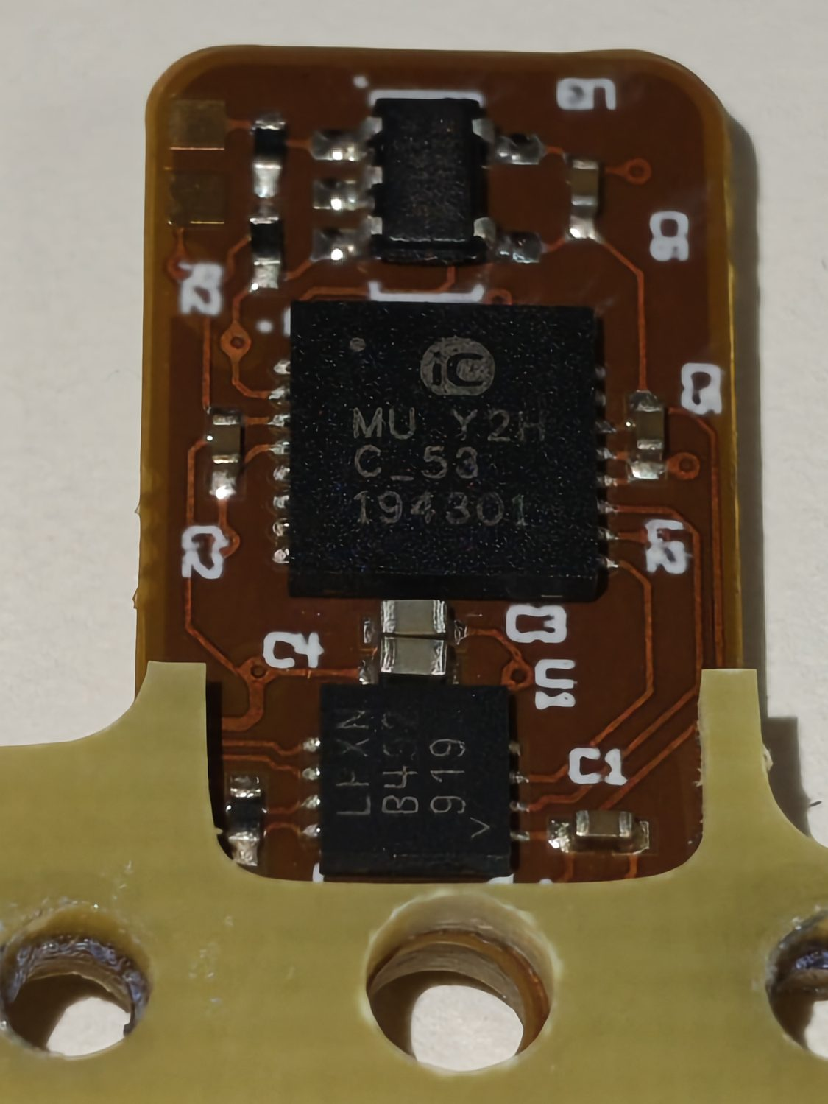
Figure 26 — The secondary output-encoder PCB, close up, after the swap.
Table 7 — Hind hip-X mechanical offsets from the horizontal centre, measured by manually jogging each leg to its limits. The physical range was consistent across joints. Interpretation of the readings is reported in [Ming, SS-TBD].
Joint | Offset from centre
Right hind hip-X (reference side) | ~0.12 rad (≈6.8°)
Left hind hip-X (faulty side) | ~0.53 rad (≈30°)
At the hardware level the swap sequence was conclusive in one specific sense: interchanging the secondary output-encoder PCB physically moved the abnormal behaviour between joints, whereas interchanging the drivers, cables, rotors and magnets did not. The fault therefore resides in a physical hardware difference at the secondary output encoder, and not in the driver, wiring, rotor or magnet. The electrical nature of that board — and the question of what, precisely, could differ between two nominally-identical encoders — is taken up in Section 7.

Methodology 3 — Encoder electrical reverse-engineering
Localising the fault to the secondary output-encoder board raised a hardware question that could only be answered by reverse-engineering the board’s electrical design: what does the board consist of, how is it wired, and could a configuration or connection difference — rather than a dead component — explain the behaviour? This chapter reports that reverse-engineering: the board’s components and pinout, the decoding of its configuration EEPROM, the routing that connects it to the rest of the actuator, and the bench attempt to read the sensor directly.

Board components and pinout
The secondary output-encoder PCB carries three principal devices: the iC-MU Hall-IC itself, an external EEPROM holding its configuration, and an RS-485/RS-422 differential transceiver (an Analog Devices LTC2863 [6]) that carries the sensor’s serial output off-board (Figure 27). A set of test pads exposes the EEPROM’s SDA/SCL lines — presumably for programming — and, near the main connector, the transceiver’s differential outputs and supply.
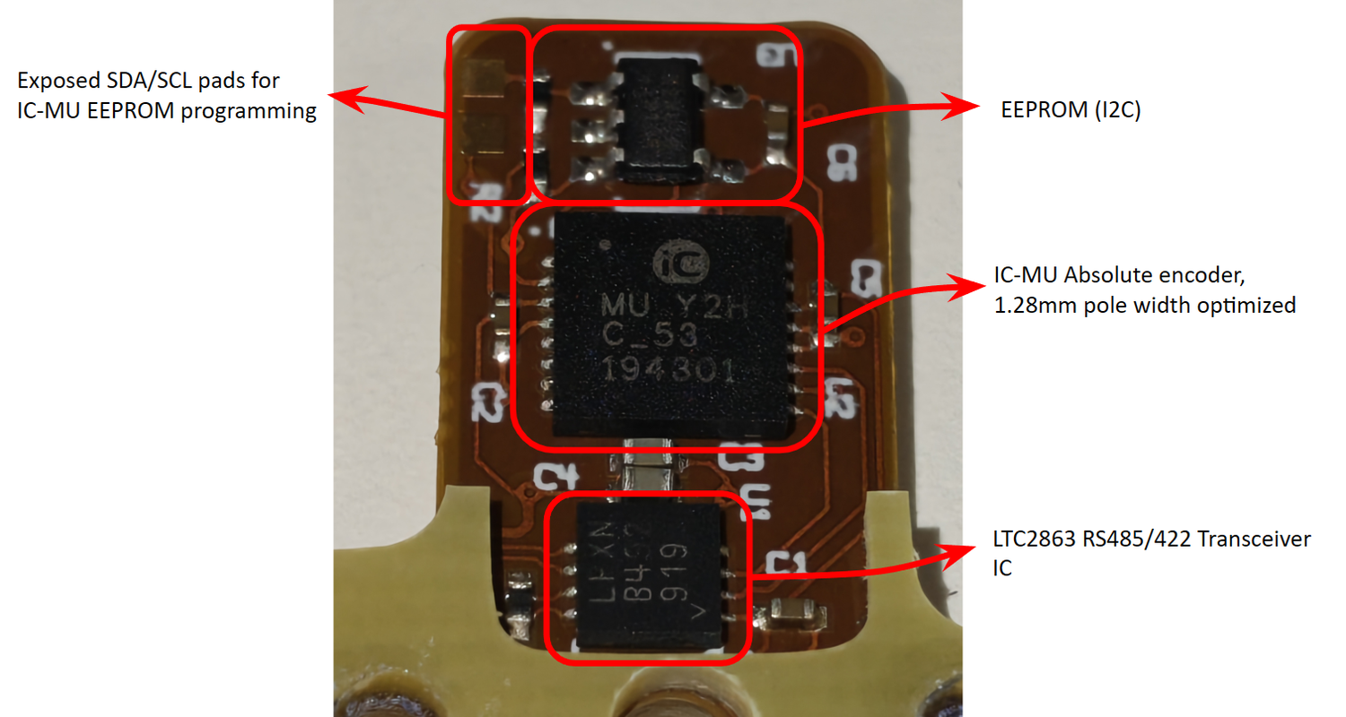
Figure 27 — The secondary output-encoder PCB, showing the iC-MU Hall-IC, the external configuration EEPROM and the RS-485/RS-422 transceiver.
Probing established the board’s wiring as a textbook ExtSSI slave node (Figure 28, Table 6). Pin PA0 of the iC-MU is tied to ground, which selects the BiSS fall-back protocol; the transceiver’s receiver output (RO) drives PA1 (the clock input, MA), and the transceiver’s driver input (DI) is fed from PA3 (the slave data output, SLO); PA2 (slave in, SLI) is grounded, correct for a single un-chained slave. This is exactly the connection the iC-MU datasheet [5] prescribes for its MODEA=7 ExtSSI mode, and it is consistent between the boards inspected.
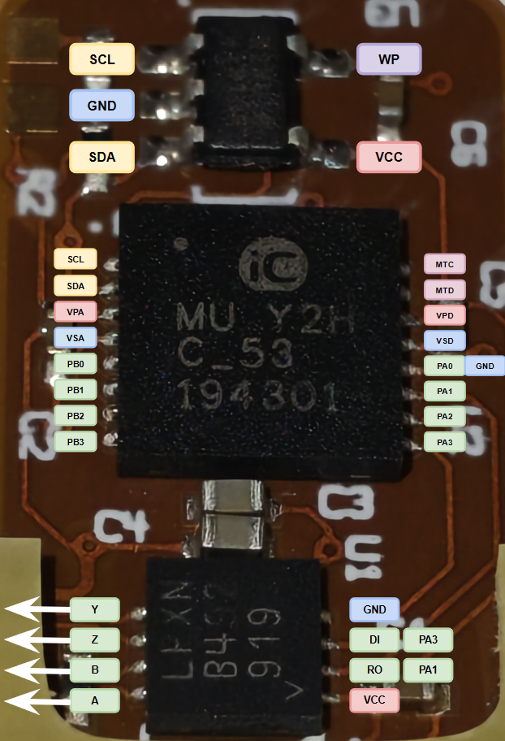
Figure 28 — The iC-MU pinout and connections, wired as an ExtSSI slave node.
Table 6 — iC-MU Port-A (ExtSSI, MODEA=7) pinout, as wired on the board and cross-checked against the datasheet [5].
iC-MU pin | Function (MODEA=7) | Connection
PA0 | NPRES | tied to GND (selects BiSS fall-back)
PA1 | MA (clock in) | ← LTC2863 RO
PA2 | SLI (slave in) | GND (correct for a single, un-chained slave)
PA3 | SLO (data out) | → LTC2863 DI

Configuration-EEPROM decode
To characterise the encoder’s configuration, the contents of its external EEPROM were decoded against the iC-MU datasheet [5], register by register. Per the datasheet, the iC-MU attempts to load its configuration from this EEPROM three times at start-up and, failing that, boots on default values — with the fall-back output protocol selected by PA0 (LOW → BiSS). The decode established that the stored configuration is a coherent, datasheet-normal ExtSSI set-up rather than anything corrupt or exotic: amplitude control is enabled (so the manual gain fields are intentionally inert), Port A is configured as ExtSSI and Port B as ABZ, the interpolation filter is set to the 14-bit / 39 dB FILT4 setting, the master/nonius period count MPC=5 gives up to 19-bit absolute resolution, and the config-range CRC16 (0x52A8) matches the value computed over the configuration bytes. Table 8 lists the most diagnostic registers; the full annotated map is given in Appendix B. The upper offset/preset region reads as erased (all 0xFF) with a non-matching CRC8, consistent with an unused absolute-offset block rather than a fault.
Table 8 — Selected iC-MU EEPROM configuration registers (full annotated map in Appendix B).
Addr | Raw | Field(s) | Decoded meaning
0x05 | 88 | ENAC=1, CIBM=8 | Amplitude control active; bias-current trim nominal (manual gains ignored).
0x0B | 07 | MODEA=7, MODEB=0 | Port A = ExtSSI (NPRES/MA/SLI/SLO); Port B = ABZ.
0x0E | 14 | LIN=1, FILT=4 | Linear/radial scanning; FILT4 = 39 dB, 14-bit interpolation.
0x0F | 05 | MPC=5 | 32 master / 31 nonius periods; ≤19-bit absolute resolution.
0x13–0x14 | FF 0F | RESABZ=0x0FFF | ABZ resolution = (0x0FFF + 1) × 4 = 16 384 edges.
0x21–0x22 | 52 A8 | CRC16 | Matches the CRC computed over the config ranges — configuration is intact.
0x3E–0x3F | 69 43 | MFG_ID | 0x6943 = ASCII “iC” (iC-Haus).
The significance of this decode is that it removes configuration corruption from the list of possible faults at the hardware level: the board’s programmed set-up is internally consistent and datasheet-normal. The complementary comparative result — the bench read that established the faulty and healthy encoders to be byte-identical in their stored configuration, and hence that the difference between them is physical rather than programmed — was performed on the signal layer and is reported in [Ming, SS-TBD]; this report owns the decode, not that comparative read.

Signal routing
Probing to trace the sensor signals out to the main motor connector showed that no such route exists: none of the transceiver’s differential A/B/Z/Y outputs reach the main connector. Instead, the secondary output encoder is wired directly to the motor driver’s STM32 microcontroller, which consumes the post-reduction joint angle locally, formats feedback, and streams it to the main compute module over the driver’s own CAN transceiver. This routing is a hardware finding in its own right, and it also explains — at the hardware level — why the driver, rather than the main computer, governs the joint’s local behaviour; the control-loop consequences of that routing are a signal-layer matter and are discussed in [Ming, SS-TBD].

Bench read attempt and its limit
A final effort was made to read the iC-MU directly on the bench while it remained installed in the actuator, so that the sensor’s raw output could be observed as hardware. The differential signal pairs proved inaccessible at the driver, but probing showed that the four test pads beside the main connector are the transceiver’s A/B/Y/Z differential pairs, with two further pads providing +5 V and ground (Figure 30). Wires were soldered to these pads (Figure 31) and the encoder section powered from a bench supply, drawing about 0.11 A at 5 V.
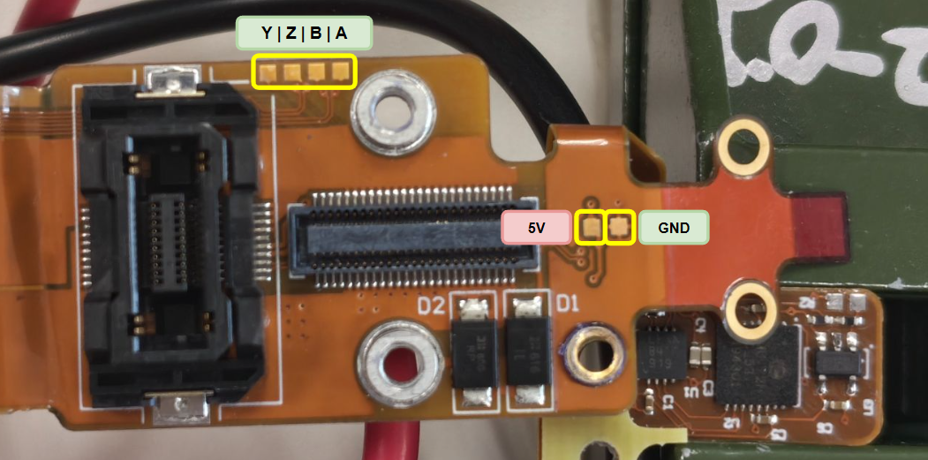
Figure 30 — The flex-PCB test-pad map: the four pads beside the main connector are the transceiver’s A/B/Y/Z differential pairs, with +5 V and ground alongside.
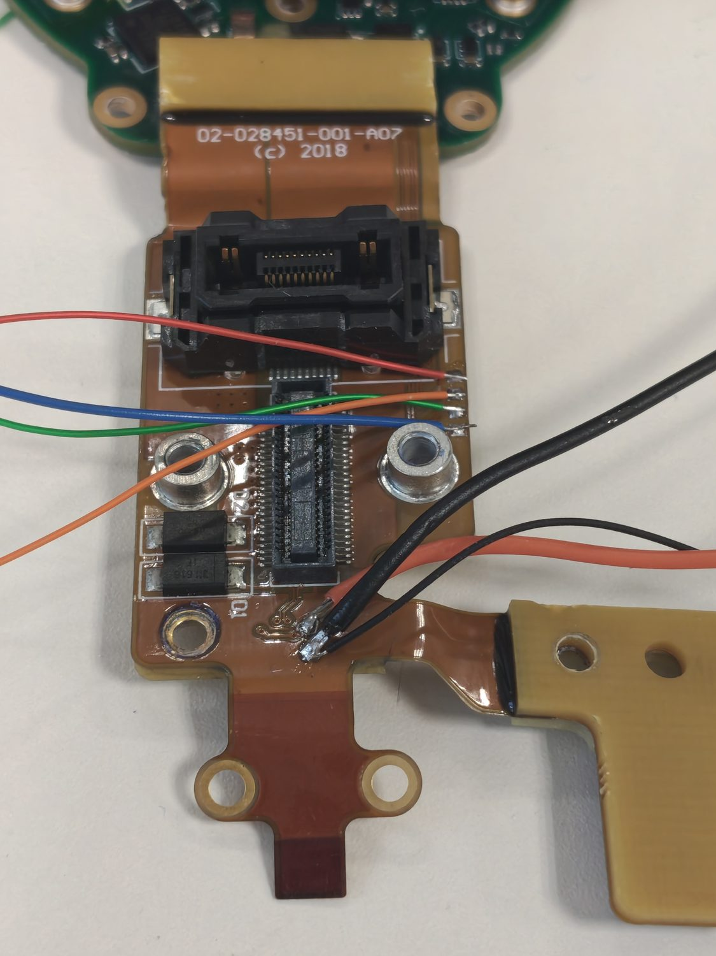
Figure 31 — Wires soldered to the flex-PCB test pads to power and monitor the encoder section on the bench.
The read did not succeed, and the reasons are themselves hardware findings. Establishing serial communication with the iC-MU over its RS-485/RS-422 transceiver required either a matching full-duplex four-wire transceiver or two standard RS-485 transceivers, neither of which was available. The alternative — driving the sensor with the motor driver’s own STM32 and observing the transceiver output lines on an oscilloscope (Figure 32) — was blocked by a power issue: although the driver’s 5 V rail measured a correct 4.994 V, the 3.3 V rail that supplies the STM32 sat at only about 0.4 V. Tracing the supply showed that the 5 V feeds an LT3029 LDO regulator [7] whose 3.3 V output was the dead rail, and that the LDO appeared to be enabled by another rail rather than by the 5 V supply, so the microcontroller never powered. Powering the STM32 directly from the 3.3 V pad still produced no edges on the monitored A and Y lines, indicating that the driver was not, under these bench conditions, periodically polling the sensor to generate an output. The bench read therefore reached its limit: reading the sensor’s raw registers requires either the correct RS-485/RS-422 interface hardware or a way to command the driver’s STM32 to poll the encoder, and neither was available within the project’s timeframe. This dead end is carried forward as a limitation and a concrete piece of future work.
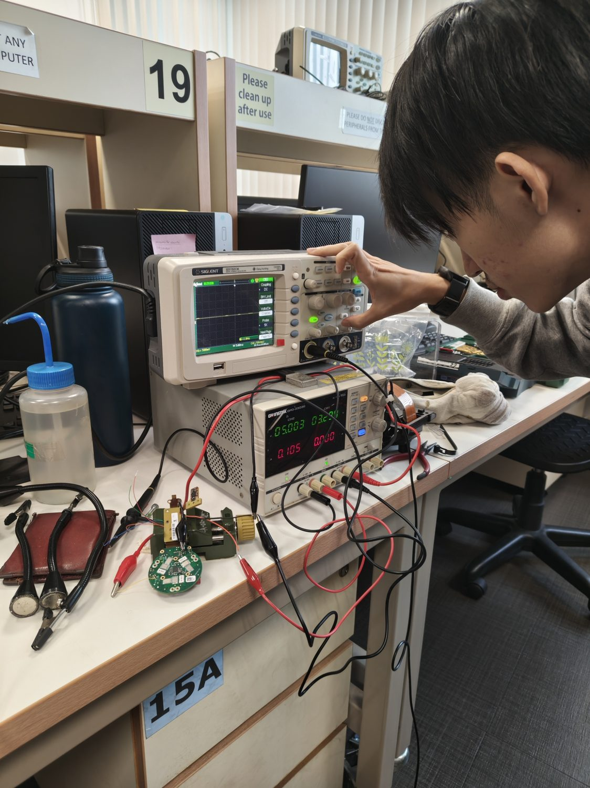
Figure 32 — The oscilloscope bench read attempt; no edges were observed on the monitored transceiver lines, the driver STM32 remaining unpowered on its 3.3 V rail.

The DB25 payload-port bypass
One further electrical obstacle stood between the restored power system and any motor test, and it was resolved by reverse-engineering a connector. Enabling motor power raised an “uncovered payload port” stop function: Spot detects whether its DB25 payload-port covers are fitted, and one cover was missing. Inspection showed the cover contained no active components — only a mating DB25 shell — so the detection had to be passive. Probing the cover for continuity revealed that four sets of pins are shorted together inside it, and replicating those shorts on the open port — first with tinned jumper wires, later with a female DB25 header wired to match — cleared the lockout and allowed motor power to be enabled. The pin-short map is given in Appendix D.

Evaluation, Limitations and Improvements

Power system
Against its objective, the power-system work succeeded in full: both battery modules were rebuilt on their original BMS boards in the OEM 14s4p form factor and both reached a full, balanced charge, with pack #2 reporting an excellent balance index of 0.02. The single most important finding is that the rebuild’s reliability was governed almost entirely by spot-weld quality: the same class of defect manifested first as cell-group imbalance and then as a battery-fault lockout from one disconnected joint, and both traced back to bends and stress points in the nickel-strip routing imposed by the first bracket design. The V2 pack turned that finding into a design improvement — added bracing, OEM-derived spacer positions, laser-cut slotted strips that avoid stacking, and captured-nut BMS mounting — and the result was a pack that welded cleanly and balanced correctly on the first attempt, assembled in a fraction of the time. Two limitations remain. The OEM phase-change thermal filler was not reproduced, because no workable off-the-shelf equivalent was found; the pack instead relies on the silicone thermal sheet and the retained NTC monitoring, and sourcing a suitable PCM is a clear improvement for a future build. And the pack #2 SoC repair depended on an improvised fastener (a cardboard shim in place of the missing flex-connector fastener), which should be replaced with a proper part.

Actuator, at the hardware level
The mechanical investigation met its objective of localising the fault to a physical part. By moving each candidate part in turn between the faulty and healthy hind hip-X actuators, the hardware work physically ruled out the driver electronics, the motor wiring, the rotor and its magnet, and the primary rotor encoder as the location of the fault, because none of those swaps carried the abnormal behaviour with the part. Conversely, interchanging the secondary output-encoder PCB did move the behaviour between joints, localising the fault to a physical hardware difference at that board. The subsequent electrical reverse-engineering then narrowed what that difference could be: the board is a datasheet-normal ExtSSI iC-MU node whose stored configuration decodes as internally consistent (CRC-valid), which removes configuration corruption as an explanation and points to a physical device-level difference rather than a programming one. The overarching limitation is that the hardware work stops, by design, at “the fault is a physical hardware difference”; the confirmation of that fault at the signal level, the comparative read establishing the two encoders’ configurations byte-identical, and the eventual repair are reported in [Ming, SS-TBD].
The most concrete hardware limitation was the bench read that could not be completed. Reading the iC-MU’s raw registers in situ was defeated by two independent obstacles: the absence of a suitable RS-485/RS-422 interface (a full-duplex four-wire transceiver, or two RS-485 transceivers), and the driver STM32 remaining unpowered because its 3.3 V LDO rail did not come up under bench conditions. Each obstacle implies its own improvement: procuring the correct transceiver hardware to read the sensor directly, and working out the LDO’s enable condition so the driver can be powered and commanded to poll the encoder on the bench. A further, per-joint limitation is the residual mechanical offset left after the encoder swap: correcting it by re-clocking the rotor housing is possible only in coarse 45° steps given the eight securing screws, so a finer calibration route would be needed to remove it cleanly. Finally, the epoxy coating over the controller board prevented direct probing of several test points, a practical constraint on any future in-situ electrical work.

Conclusion
The hardware objectives of the project were met. Spot’s power system was rebuilt from two dead modules into two modules that charge to a full, balanced state, by replacing the degraded cells with OEM-spec Samsung INR18650-30Q cells on the original BMS and — critically — by driving the rebuild’s reliability through spot-weld quality and a second-generation bracket design. In parallel, the faulty hip-X actuator, a previously undocumented piece of hardware, was characterised from the outside in: its 50:1 harmonic-drive, dual-encoder construction was established by teardown; a disciplined sequence of component swaps localised the fault to a physical difference at the secondary output-encoder board; and reverse-engineering that board established its ExtSSI iC-MU design, pinout, direct-to-STM32 routing and CRC-valid configuration, narrowing the fault to a physical device difference rather than a programming or wiring one.
The skills developed span the rebuild and characterisation of lithium battery systems and their BMS, the mechanical teardown and reassembly of a precision harmonic-drive actuator, and the electrical reverse-engineering of a Hall-encoder PCB — including datasheet-level EEPROM decoding and pinout tracing. The principal thread of future work follows directly from the one hardware task that could not be completed: instrumenting the iC-MU sensor with the correct RS-485/RS-422 interface (or a powered, polled driver STM32) to read its raw output on the bench. Beyond that, a physics-based simulation of the actuator and its encoder signal chain is proposed as a means of exploring the fault without repeated teardown; it is noted here strictly as planned work, no such simulation having been built within this project. The signal-layer confirmation of the fault and the encoder repair that returned the joint toward service are reported in the companion report [Ming, SS-TBD].

References
[1] Boston Dynamics, “Spot Battery Safety Data Sheets (SDS).” Available: https://support.bostondynamics.com/s/article/Spot-Battery-Safety-Data-Sheets-SDS-49922
[2] Falcon PEV, “18650 Samsung 30Q 3000 mAh Battery Cell.” Available: https://www.falconpev.com.sg/products/18650-samsung-30q-3000mah
[3] “Comprehensive Teardown Report of the Quadruped Robot Spot,” r/IndiaTech, Reddit. Available: https://www.reddit.com/r/IndiaTech/comments/1nwsba2/comprehensive_teardown_report_of_the_quadruped/
[4] LHS Materials, “Thermal Regulation.” Available: https://www.lhsmaterials.com/thermal-regulation
[5] iC-Haus, “iC-MU Position Encoder — Pole Width 1.28 mm,” datasheet. Available: https://ave-nl.com/wp-content/uploads/2021/12/MU_datasheet_F2en_AVE.pdf
[6] Analog Devices, “LTC2863 — RS-485/RS-422 Transceiver,” datasheet. Available: https://www.analog.com/media/en/technical-documentation/data-sheets/2862345fc.pdf
[7] Analog Devices, “LT3029 — Dual Low-Dropout Linear Regulator,” datasheet. Available: https://www.analog.com/media/en/technical-documentation/data-sheets/3029fb.pdf
[8] Boston Dynamics, “Spot Software Updates.” Available: https://support.bostondynamics.com/s/article/Spot-Software-Updates-70795

Appendices

Appendix A — Project timeline (Gantt)
The hardware work reported here ran from mid-May to mid-July 2026 across the phases below (dates from the project’s session logs). Diagnostic-interpretation and repair sessions on the signal layer are the companion report’s and are omitted.
Phase | Sessions (2026) | Dates
Battery diagnosis & decision to rebuild | Inspection → restoration attempt → disassembly & sourcing | 13, 20, 21 May
Pack #1 design | Pack-design research; spacer CAD | 25 May
Pack #1 assembly & welding | Assembly sessions 1–4 | 28, 29 May; 2, 4 Jun
Pack #1 test, fault-find & rework | Cell-group diagnosis + DB25 bypass; weld rework & verify | 5, 11 Jun
Spot teardown / leg extraction | Teardown; pack #2 disassembly | 15 Jun
Pack #2 (V2) | V2 design; assembly; SoC-cable repair & full charge | 16, 17, 18 Jun
Actuator swaps | Driver & cable swaps | 18, 19 Jun
Motor disassembly | Secondary encoder identified | 25 Jun
Output-encoder swap | PCB-only swap; ROM/offset measurement | 30 Jun
Encoder electrical RE | EEPROM decode; routing; bench read attempt | Jun–16 Jul

Appendix B — iC-MU EEPROM configuration register map
Full annotated decode of the external configuration EEPROM against the iC-MU datasheet [5]. Raw dump (hex), addresses 0x00–0x3F:
00000000 00 00 00 00 00 88 00 00 00 00 00 07 00 00 14 05
00000010 00 4e 20 ff 0f 13 10 02 00 00 00 00 00 00 00 00
00000020 00 52 a8 ff ff ff ff ff ff ff ff ff ff ff ff ff
00000030 00 00 00 00 00 00 00 00 4d 55 07 00 00 00 69 43
Addr | Raw | Register / fields | Decoded setting
0x00 | 00 | GC_M, GF_M | Master coarse/fine gain 0 (ignored — amplitude control enabled).
0x01 | 00 | GX_M | Master cosine gain adjust = 1.000.
0x02 | 00 | VOSS_M | Master sine offset = 0 mV.
0x03 | 00 | VOSC_M | Master cosine offset = 0 mV.
0x04 | 00 | PH_M | Master phase adjust = 0°.
0x05 | 88 | ENAC=1, CIBM=8 | Amplitude control active; bias-current trim nominal 0%.
0x06 | 00 | GC_N, GF_N | Nonius coarse/fine gain 0 (ignored).
0x07 | 00 | GX_N | Nonius cosine gain adjust = 1.000.
0x08 | 00 | VOSS_N | Nonius sine offset = 0 mV.
0x09 | 00 | VOSC_N | Nonius cosine offset = 0 mV.
0x0A | 00 | PH_N | Nonius phase adjust = 0°.
0x0B | 07 | MODEA=7, MODEB=0 | Port A = ExtSSI (NPRES/MA/SLI/SLO); Port B = ABZ (A/B/Z/NER).
0x0C | 00 | CFGEW | All error/warning messages enabled.
0x0D | 00 | ACC_STAT, NCHK_CRC, NCHK_NON, ACRM_RES, EMTD | Actual (non-accumulated) status; cyclic CRC + nonius verification active; no auto-reset; min error-display time 0 ms.
0x0E | 14 | LIN=1, FILT=4 | Linear/radial scanning; FILT4 = 39 dB suppression, 14-bit interpolation.
0x0F | 05 | MPC=5 | 32 master / 31 nonius periods; ≤19-bit absolute resolution.
0x10 | 00 | *_MT | No external multiturn data; MT chain/verification disabled.
0x11 | 4E | OUT_ZERO=2, OUT_MSB=14 | Serial output inserts 2 zero bits; output MSB = user-data bit 27.
0x12 | 20 | MODE_ST=2, … | Binary output, no SSI ring; raw master/nonius track data; LSB = bit 0.
0x13–0x14 | FF 0F | RESABZ=0x0FFF | ABZ / FlexCount resolution = (0x0FFF + 1) × 4 = 16 384 edges.
0x15 | 13 | SS_AB=1, FRQAB=3, … | AB step 1; startup counting visible; AB limit ≈ 781.25 kHz (320 ns edge distance).
0x16 | 10 | LENZ, CHYS_AB=1, PP60UVW, INV_* | Z index = 90°; AB hysteresis 0.175°; UVW 120°; A/B/Z not inverted.
0x17 | 02 | RPL=0, PPUVW=2 | Config mode, no restriction; UVW commutation = 1 pole pair.
0x18 | 00 | TEST | Normal mode.
0x19–0x20 | 00 | SPO_BASE, SPO_0…14 | Nonius track-offset slopes all zero.
0x21–0x22 | 52 A8 | CRC16 | 0x52A8 — matches CRC over config ranges 0x00–0x20, 0x30–0x3F.
0x23–0x27 | FF | OFF_ABZ | Absolute-output offset block reads erased (unused).
0x28–0x29 | FF FF | OFF_UVW | UVW offset reads erased.
0x2A–0x2E | FF | PRES_POS | Preset position reads erased.
0x2F | FF | CRC8 | Does not match posted offset/preset bytes (block unused).
0x30 | 00 | PA0_CONF | Falling edge on NPRES = NO_FUNCTION.
0x31 | 00 | EDSBANK | No EDS.
0x32–0x33 | 00 00 | PROFILE_ID | 0x0000.
0x34–0x37 | 00 | SERIAL | 0x00000000.
0x38–0x3D | 4D 55 07 00 00 00 | DEV_ID | ASCII “MU”, then 0x07 00 00 00.
0x3E–0x3F | 69 43 | MFG_ID | 0x6943 = ASCII “iC” (iC-Haus).

Appendix C — Encoder-board pinout
See Figure 28 and Table 6 for the ExtSSI wiring, and Figure 29 for the connector-flex test pads (the transceiver’s A/B/Y/Z differential pairs plus +5 V and ground) used for the bench read attempt of Section 7.
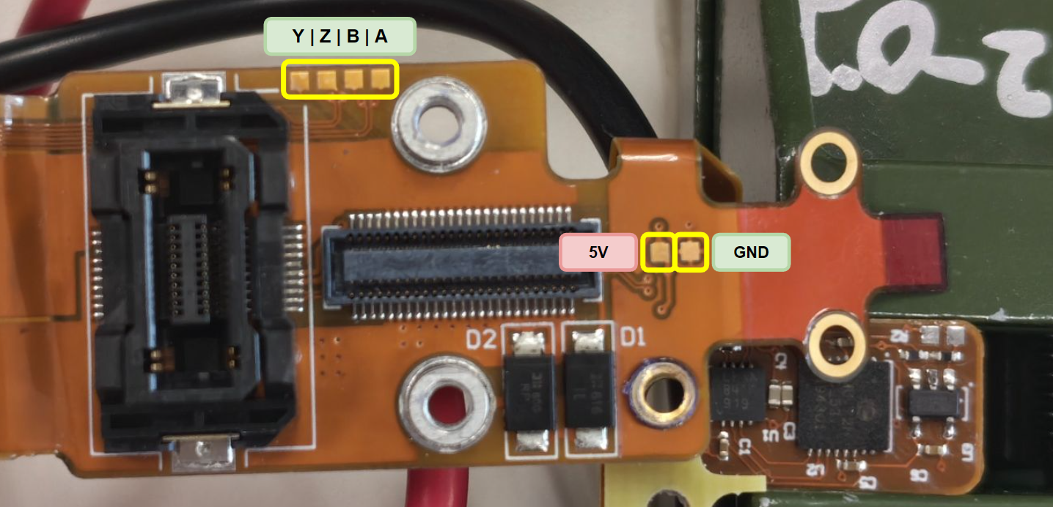
Figure 29 — The connector-flex test pads, mapping to the transceiver’s A/B/Y/Z outputs and the encoder supply rails.

Appendix D — DB25 payload-port cover pin shorts
The four sets of pins shorted inside the OEM payload-port cover, reverse-engineered by continuity probing and replicated on the open port to bypass the cover-detection lockout (Section 7).
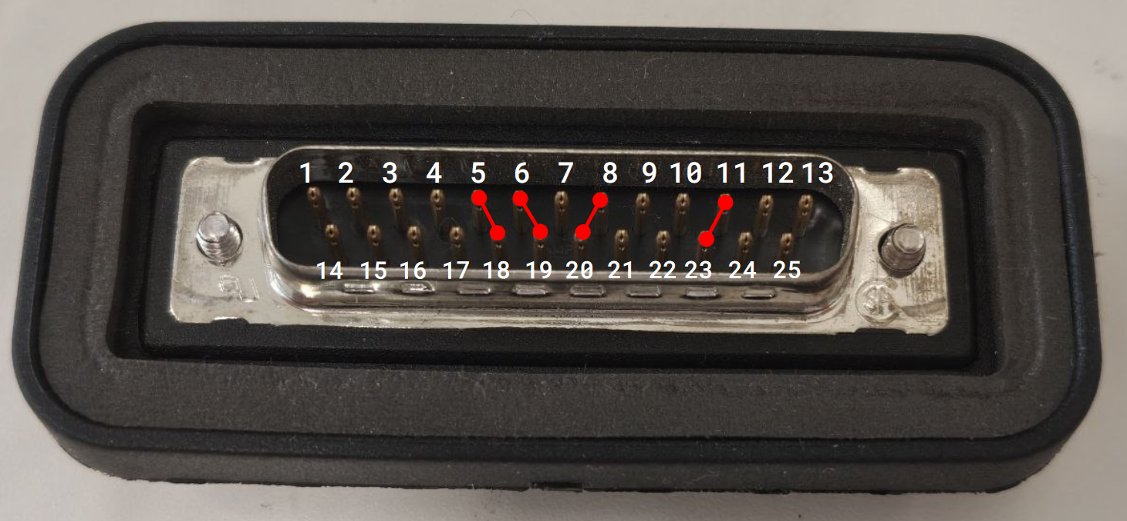
Figure 33 — The DB25 payload-port cover pin shorts. Replicating these four shorts on the open port clears the “uncovered payload port” motor-power lockout.

Appendix E — Battery CAD iterations
The V1 cell spacer (Figure 8) reproduced the irregular OEM cell positions in PC-CF. The V2 brackets (Figure 18) added bracing, OEM-derived spacer positions, ABS-GF construction and captured-nut BMS mounting, and are compared against the cleaner pack #2 weld result in Figure 19.

