**Moogfest Installation Proposal**

**“Geothermophone”**

**Egg Syntax**

egg@novonon.com

128 Courtland Ave

Asheville, NC 28801

828-778-4344

**Geothermophone Proposal**

I’ve written custom open-source software, Sonify (bit.ly/1hSGKvq), which turns arbitrary time-series data into audio. For Moogfest, I propose to use this software to turn fifty years of global temperature data into 30 minutes of audio. The audio will be musical (somewhat in the tradition of American minimalist composers like Steve Reich), while also directly representing the data, such that to listen to it is to actually hear global warming happen.

Visually, the piece is centered on a translucent plastic globe, 4 feet in diameter, with a stylized outline of the continents on it. LED lights inside shift over the course of the piece, so that the colors on the surface of the globe are representing temperature (shifting from blue for cold to red for warm). The sphere is suspended within a regular tetrahedron made up of metal pipes, with a solid base. The tetrahedron is 10’ on each side. The base, which is 1’ in height, contains the hardware: a computer, two speakers, and a controller for the LED lights. Simple LCD displays on each side of the base show the viewer what month and year they’re currently hearing and seeing.

Climate change is a process which is likely to affect the lives of nearly every human being; nonetheless it’s an abstract process, and difficult for most people to connect with emotionally. This should be clear from the fact that, although it’s widely recognized in the scientific community that climate change threatens our way of life, there has never yet been the political will to take serious steps to minimize it.

The Geothermophone aims to take that abstract process and make it a visceral sensory experience, in the hope of making it more emotionally real to people. For me, it's also part of a long-term interest in process-based music and particularly sonification (a subject being addressed by some of the speakers at Moogfest as well). It attempts to take a somewhat novel approach to the long history of attempting to turn data into interesting music, by approaching sonification through timbre rather than pitch.

**Bio and description for program:**

**Artist Bio**

Egg Syntax has been exploring process-based art and music for several decades. He makes music as Tin Pan Algorithm, often writing custom software to generate music from data or mathematical processes. The Moogfest installation is built using his Sonify software (https://github.com/eggsyntax/Sonify), which is a framework for turning arbitrary time-based data into various forms of audio. He is currently creating virtual audio installations, which overlay realistic physics-based models of virtual audio onto physical spaces. Previous work includes algorithmically-modeled, 3D-printed objects, kinetic sculpture, and music written for film, theatre, and dance.

**Description**

Geothermophone is a translucent globe which displays changing temperature over a fifty-year period (1960-2010), while the audio accompaniment reflects temperature along with other climate variables. Over the course of thirty minutes you can clearly see and hear our changing climate. The music and lighting are directly derived from scientific data obtained through Asheville’s own National Climatic Data Center, using custom software and microcontrollers. Pamphlets are available at the base of the piece with more information about the process, or online at http://www.novonon.com/moogfest. **Sketch** (http://bit.ly/1gdh8Ma)

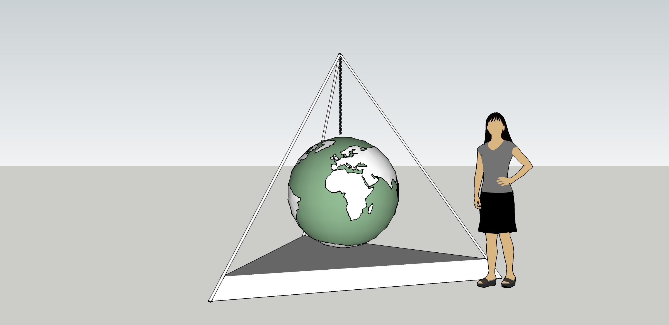

**Artist photo** (http://on.fb.me/1dBGCxU )

