Nama : Eggy Bintang Negara

NPM : 1817051013

Screenshot Gmeet

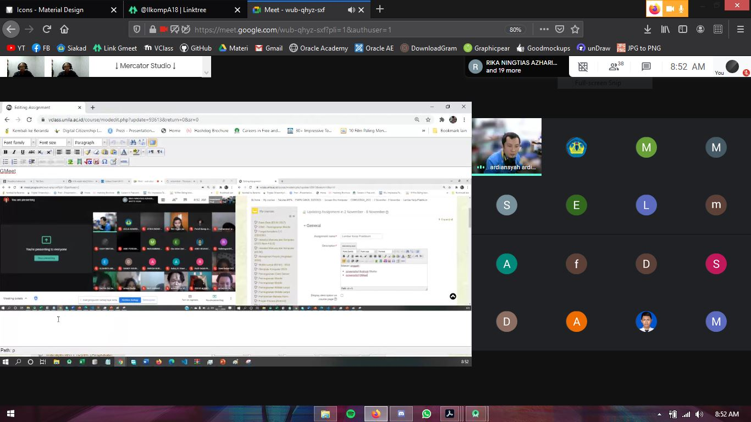

Screenshot Style and Theme

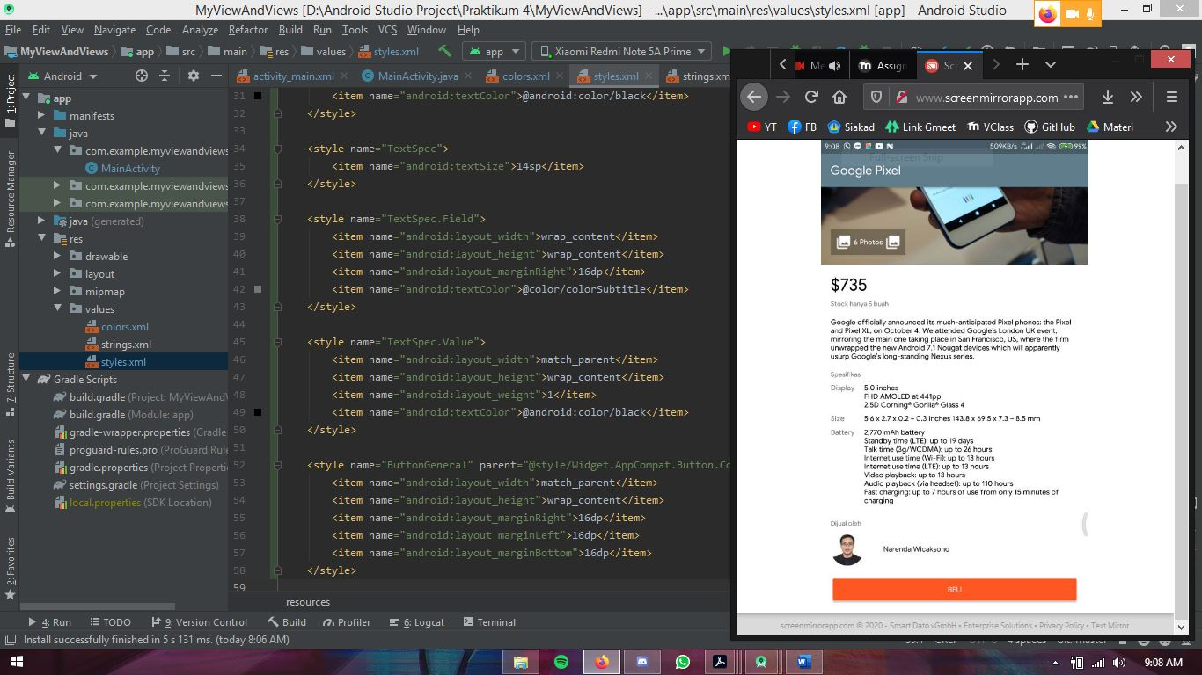

Screenshot MyActionBar

