**STACK**

Here are the classes, structs, unions and interfaces with brief descriptions:

|  |  |
| --- | --- |
| [**AppAdvisoryButtonBase**](class_app_advisory_button_base.html) | Base for all button script |
| [**AppAdvisoryHelper**](class_app_advisory_helper.html) | An helper to avoid duplicate code |
| [**ButtonLike**](class_button_like.html) | Attached to like button |
| [**ButtonMoreGames**](class_button_more_games.html) | Attached to the button more games. |
| [**ButtonRate**](class_button_rate.html) | Attached to the button rate. |
| [**ButtonShare**](class_button_share.html) | Attached to the button share |
| [**CanvasManager**](class_canvas_manager.html) | Attached to the "Canvas" Game Object in the hierarchy. In charge to all the logic of the UI |
| [**GameManager**](class_game_manager.html) | Attached to the "GameManager" Game Object in the hierarchy. In charge to all the logic of the game |
| [**SetAlphaPodium**](class_set_alpha_podium.html) | To change the alpha of the podium start |
| [**SetColorPodium**](class_set_color_podium.html) | Attached to tthe "big" cube in the scene. In charge to change the coor of this "big cube" according to the start color |
| [**StackColor**](struct_stack_color.html) | A class to create new pastel color easily |
| [**Utils**](class_utils.html) | An utility static clss |

Full documentation avalable here :

<https://db.tt/2YiKG8OV>

**ADS :**

Everything is done for you :

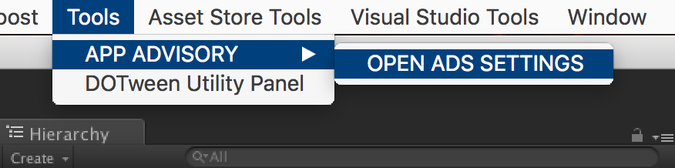

And Select the networks you want (don’t forget to get the SDKs if needed) :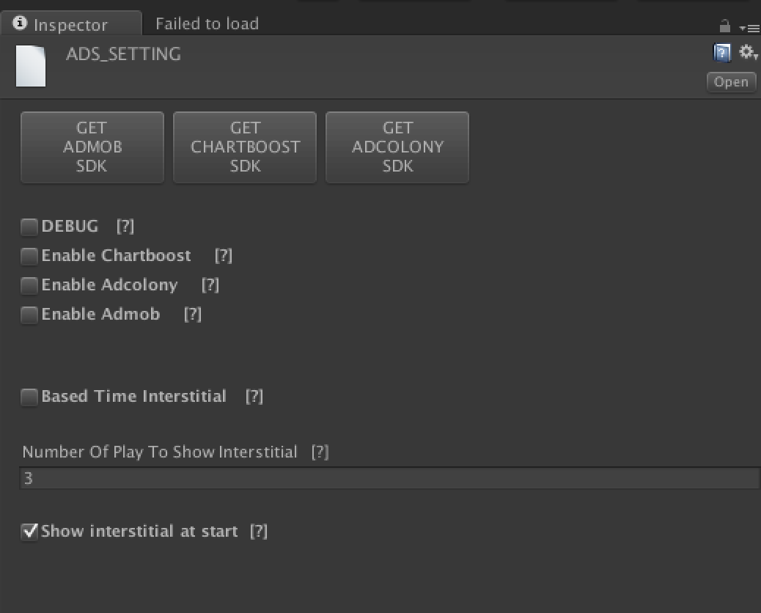

For Unity Ads, please visit my website :

<https://appadvisory.zendesk.com/hc/en-us>

**CHANGE THE CUBES:**

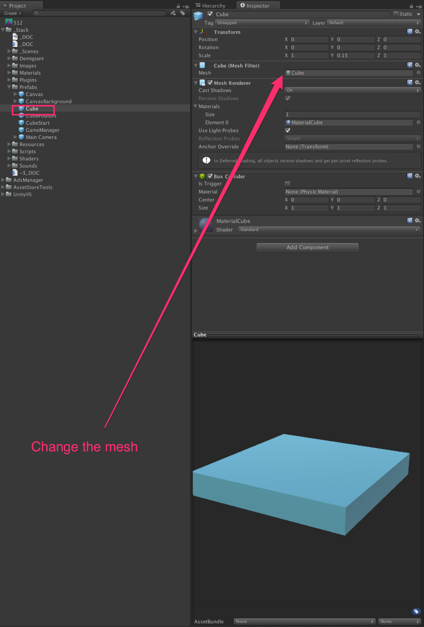

ABOUT THE COLOR :

The colors are randomly generated by the Utils class and the StackColor class.