**WEB TECHNOLOGY LAB (AIDS-259)**

**FACULTY NAME: -** Mr. NITISH KUMAR **STUDENT NAME:** TANISHQ BHARGAVA

**ROLL NO :** 02214811922 **GROUP: -** 3AIDS1 **SEMESTER: - 3**



Maharaja Agrasen Institute Of Technology, PSV Area, Sector-22, Rohini, New Delhi-110085

**EXPERIMENT 1**

**Aim :** Create a web page that covers your CV using HTML.

**CODE:**

<!DOCTYPE html>

<html>

<head>

<title>My CV</title>

<style>

body {

font-family: Arial, sans-serif;

}

h1,

h2,

h3 {

margin-top: 0;

}

table {

border-collapse: collapse;

width: 100%;

}

th,

td {

padding: 8px;

text-align: left;

border-bottom: 1px solid #ddd;

}

th {

background-color: #f2f2f2;

}

</style>

</head>

<body>

<header>

<h1>Tanishq Bhargava</h1>

<p>Email: bhargavatanishq@gmail.com</p>

</header>

<main>

<section>

<h3>Summary</h3>

<p>I want to become a software developer/video game developer in a well name company and fulfill my profound love for computers.</p>

</section>

<section>

<h3>Skills</h3>

<ul>

<li>HTML5</li>

<li>CSS3</li>

<li>JavaScript</li>

<li>C++/C</li>

<li>Basic C# and Node.JS</li>

<li>MySQL</li>

<li>Python</li>

</ul>

</section>

<section>

<h3>Education</h3>

<table>

<thead>

<tr>

<th>University/college </th>

<th>Course </th>

<th>Percentage/CGPA</th>

</tr>

</thead>

<tbody>

<tr>

<td>Maharaja Agrasen Institute of Technology(MAIT),IPU</td>

<td>B.Tech</td>

<td>2022 - Present</td>

</tr>

<tr>

<td>Ryan International School</td>

<td>12th</td>

<td>2021</td>

</tr>

</tbody>

</table>

</section>

<section>

<h3>Certifications</h3>

<ul>

<li>None, Self Taught. </li>

</ul>

</section>

**OUTPUT :**

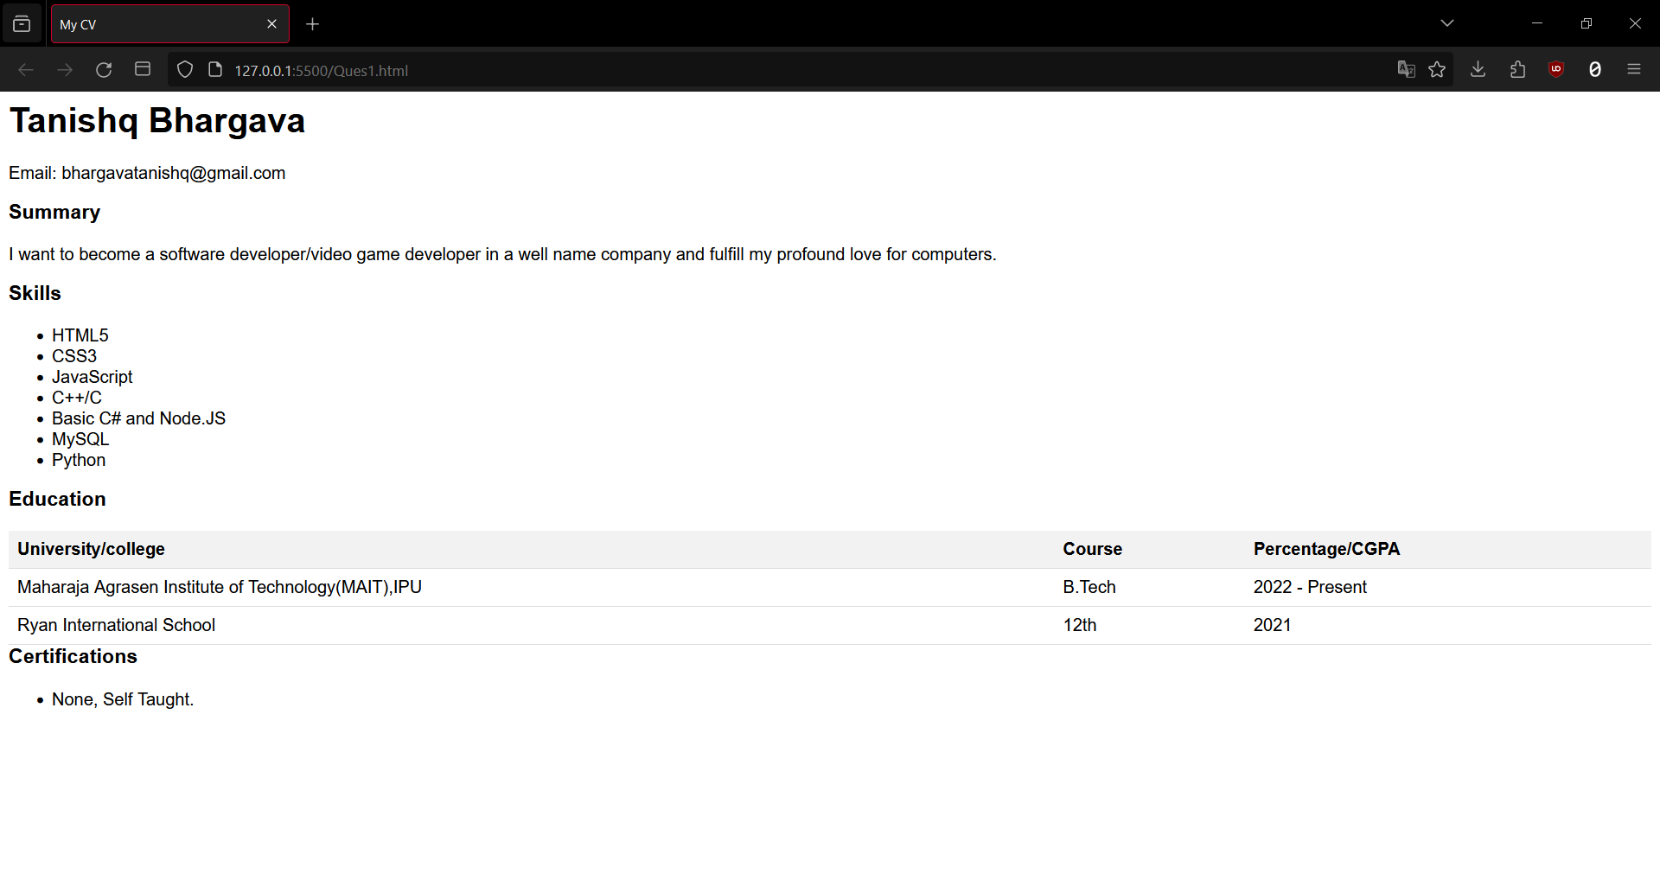

**EXPERIMENT – 2**

**Aim :** Create a web page that displays brief details of various programming languages using various types of CSS.

**CODE :**

**HTML CODE :**

<!DOCTYPE html>

<html>

<head>

<title>

Simple web Development Template

</title>

<link rel="stylesheet" href="Ques2.css">

</head>

<body>

<nav class="navbar background">

<ul class="nav-list">

<li><a href="#web">Web Technology</a></li>

<li><a href="#program">C Programming</a></li>

<li><a href="#course">Courses</a></li>

</ul>

<div class="rightNav">

<input type="text" name="search" id="search">

<button class="btn btn-sm">Search</button>

7

</div>

</nav>

<section class="firstsection">

<div class="box-main">

<div class="firstHalf">

<h1 class="text-big" id="web">

Web Technology

</h1>

<p class="text-small">

HTML stands for Hyper Text Markup Language. It is used to design web pages using

a markup language. HTML is the combination of Hypertext and Markup language.

Hypertext defines the link between the web pages. A markup language is used to

define the text document within tag which defines the structure of web pages.

HTML is a markup language that is used by the browser to manipulate text, images,

and other content to display it in the required format.

</p>

</div>

</div>

</section>

<section class="secondsection">

<div class="box-main">

<div class="secondHalf">

<h1 class="text-big" id="program">

C Programming

</h1>

<p class="text-small">

C is a procedural programming language. It was initially developed by Dennis

Ritchie as a system programming language to write operating system. The main

features of C language include low-level access to memory, simple set of keywords,

and clean style, these features make C language suitable for system programming

like operating system or compiler development.

</p>

</div>

</div>

</section>

<section class="section">

<div class="paras">

<h1 class="sectionTag text-big">Java</h1>

<p class="sectionSubTag text-small">

Java has been one of the most popular programming language for many years. Java

is Object Oriented. However it is not considered as pure object oriented as it

provides support for primitive data types (like int, char, etc) The Java codes are first

compiled into byte code (machine independent code). Then the byte code is run on

Java Virtual Machine (JVM) regardless of the underlying architecture.

</p>

</div>

</section>

<footer class="background">

<p class="text-footer">

<b>Almanya Sehgal</b>

</p>

</footer>

</body>

</html>

**CSS CODE :**

* {

margin: 0;

padding: 0;

}

.navbar {

display: flex;

align-items: center;

justify-content: center;

position: sticky;

top: 0;

cursor: pointer;

}

.background {

background: black;

background-blend-mode: darken;

background-size: cover;

}

.nav-list {

width: 70%;

display: flex;

align-items: center;

10

}

.nav-list li {

list-style: none;

padding: 26px 30px;

}

.nav-list li a {

text-decoration: none;

color: white;

}

.nav-list li a:hover {

color: grey;

}

.rightnav {

width: 30%;

text-align: right;

}

#search {

padding: 5px;

font-size: 17px;

border: 2px solid grey;

border-radius: 9px;

}

11 .firstsection {

background-color: rgb(255, 255, 255);

height: 400px;

border: 2px solid rgb(0, 0, 0);

}

.secondsection {

background-color: rgb(255, 255, 255);

height: 400px;

border: 2px solid rgb(0, 0, 0);

}

.box-main {

display: flex;

justify-content: center;

align-items: center;

color: black;

max-width: 80%;

margin: auto;

height: 80%;

}

.firsthalf {

width: 100%;

display: flex;

12 flex-direction: column;

justify-content: center;

}

.secondhalf {

width: 30%;

}

.text-big {

font-family: 'Piazzolla', serif;

font-weight: bold;

font-size: 35px;

}

.text-small {

font-size: 18px;

}

.btn {

padding: 8px 20px;

margin: 7px 0;

border: 2px solid white;

border-radius: 8px;

background: none;

color: white;

cursor: pointer;

13

}

.btn-sm {

padding: 6px 10px;

vertical-align: middle;

}

.section {

height: 400px;

display: flex;

align-items: center;

justify-content: center;

max-width: 100%;

margin: auto;

border: 2px solid rgb(0, 0, 0);

}

.section-Left {

flex-direction: row-reverse;

}

.paras {

padding: 0px 280px;

}

.center {

text-align: center;

14

}

.text-footer {

text-align: center;

padding: 30px 0;

font-family: 'Ubuntu', sans-serif;

display: flex;

justify-content: center;

color: white;

}

**OUTPUT :**

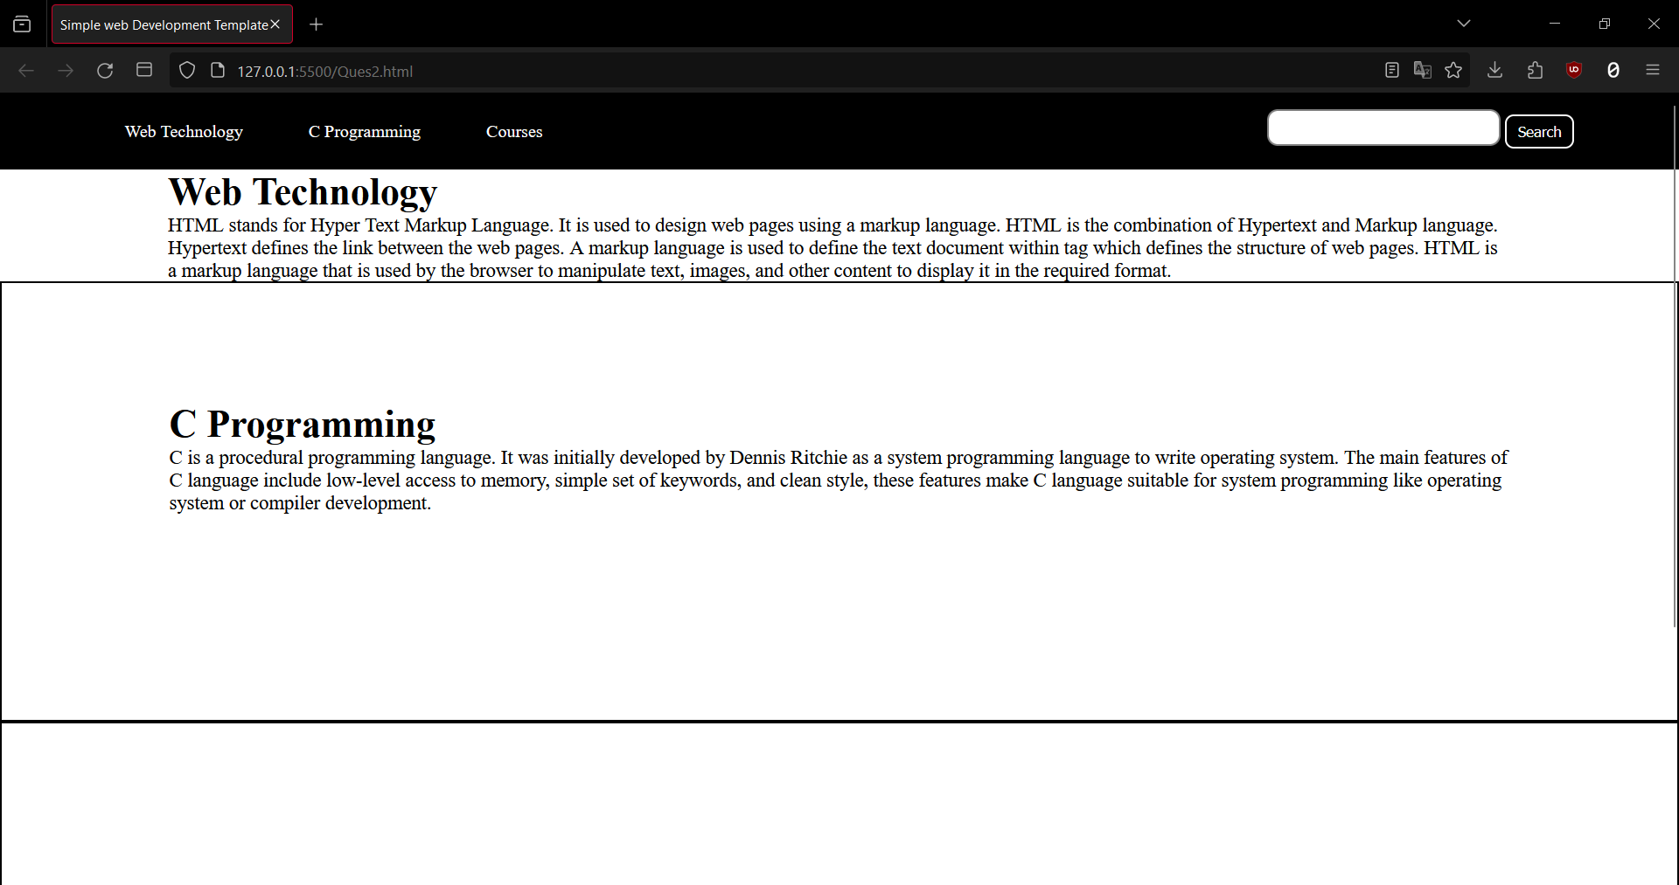

**EXPERIMENT – 3**

**AIM :** Create a web page using java-script and HTML to demonstrate Simple Calculator Application.

**CODE :**

<html>

<head>

<title>Simple Calculator</title>

<style>

body {

font-family: Arial, sans-serif;

text-align: center;

}

.container {

width: 300px;

margin: 0 auto;

border: 1px solid black;

padding: 10px;

}

.display {

width: 280px;

height: 40px;

margin: 10px;

border: 1px solid gray;

font-size: 24px;

text-align: right;

}

.button {

width: 60px;

height: 40px;

margin: 5px;

font-size: 18px;

}

</style>

</head>

<body>

<div class="container">

<h1>Simple Calculator</h1>

<input type="text" id="display" class="display" value="0" readonly>

<div>

<button id="btn7" class="button" onclick="appendNumber(7)">7</button>

<button id="btn8" class="button" onclick="appendNumber(8)">8</button>

<button id="btn9" class="button" onclick="appendNumber(9)">9</button>

<button id="btnDiv" class="button" onclick="appendOperator('/')">/</button>

</div>

<div>

<button id="btn4" class="button" onclick="appendNumber(4)">4</button>

<button id="btn5" class="button" onclick="appendNumber(5)">5</button>

<button id="btn6" class="button" onclick="appendNumber(6)">6</button>

<button id="btnMul" class="button" onclick="appendOperator('*')">*</button>

</div>

<div>

<button id="btn1" class="button" onclick="appendNumber(1)">1</button>

<button id="btn2" class="button" onclick="appendNumber(2)">2</button>

<button id="btn3" class="button" onclick="appendNumber(3)">3</button>

<button id="btnSub" class="button" onclick="appendOperator('-')">-</button>

</div>

<div>

<button id="btn0" class="button" onclick="appendNumber(0)">0</button>

<button id="btnDot" class="button" onclick="appendNumber('.')">.</button>

<button id="btnEq" class="button" onclick="calculate()">=</button>

<button id="btnAdd" class="button" onclick="appendOperator('+')">+</button>

</div>

<div>

<button id="btnClr" class="button" onclick="clearDisplay()">C</button>

<button id="btnDel" class="button" onclick="deleteLast()">DEL</button>

</div>

</div>

<script>

var display = document.getElementById("display");

function appendNumber(num) {

if (display.value == "0") {

display.value = num;

}

else {

display.value += num;

}

}

function appendOperator(op) {

if (display.value != "" && !isOperator(display.value.slice(-1))) {

display.value += op;

}

}

function isOperator(char) {

return char == "+" || char == "-" || char == "*" || char == "/";

}

function calculate() {

try {

var result = eval(display.value);

if (!isNaN(result)) {

display.value = result;

}

else {

display.value = "Error";

}

}

catch (e) {

display.value = "Error";

}

}

function clearDisplay() {

display.value = "0";

}

function deleteLast() {

if (display.value != "") {

display.value = display.value.slice(0, -1);

}

if (display.value == "") {

display.value = "0";

}

}

</script>

</body>

</html>

**OUTPUT :** 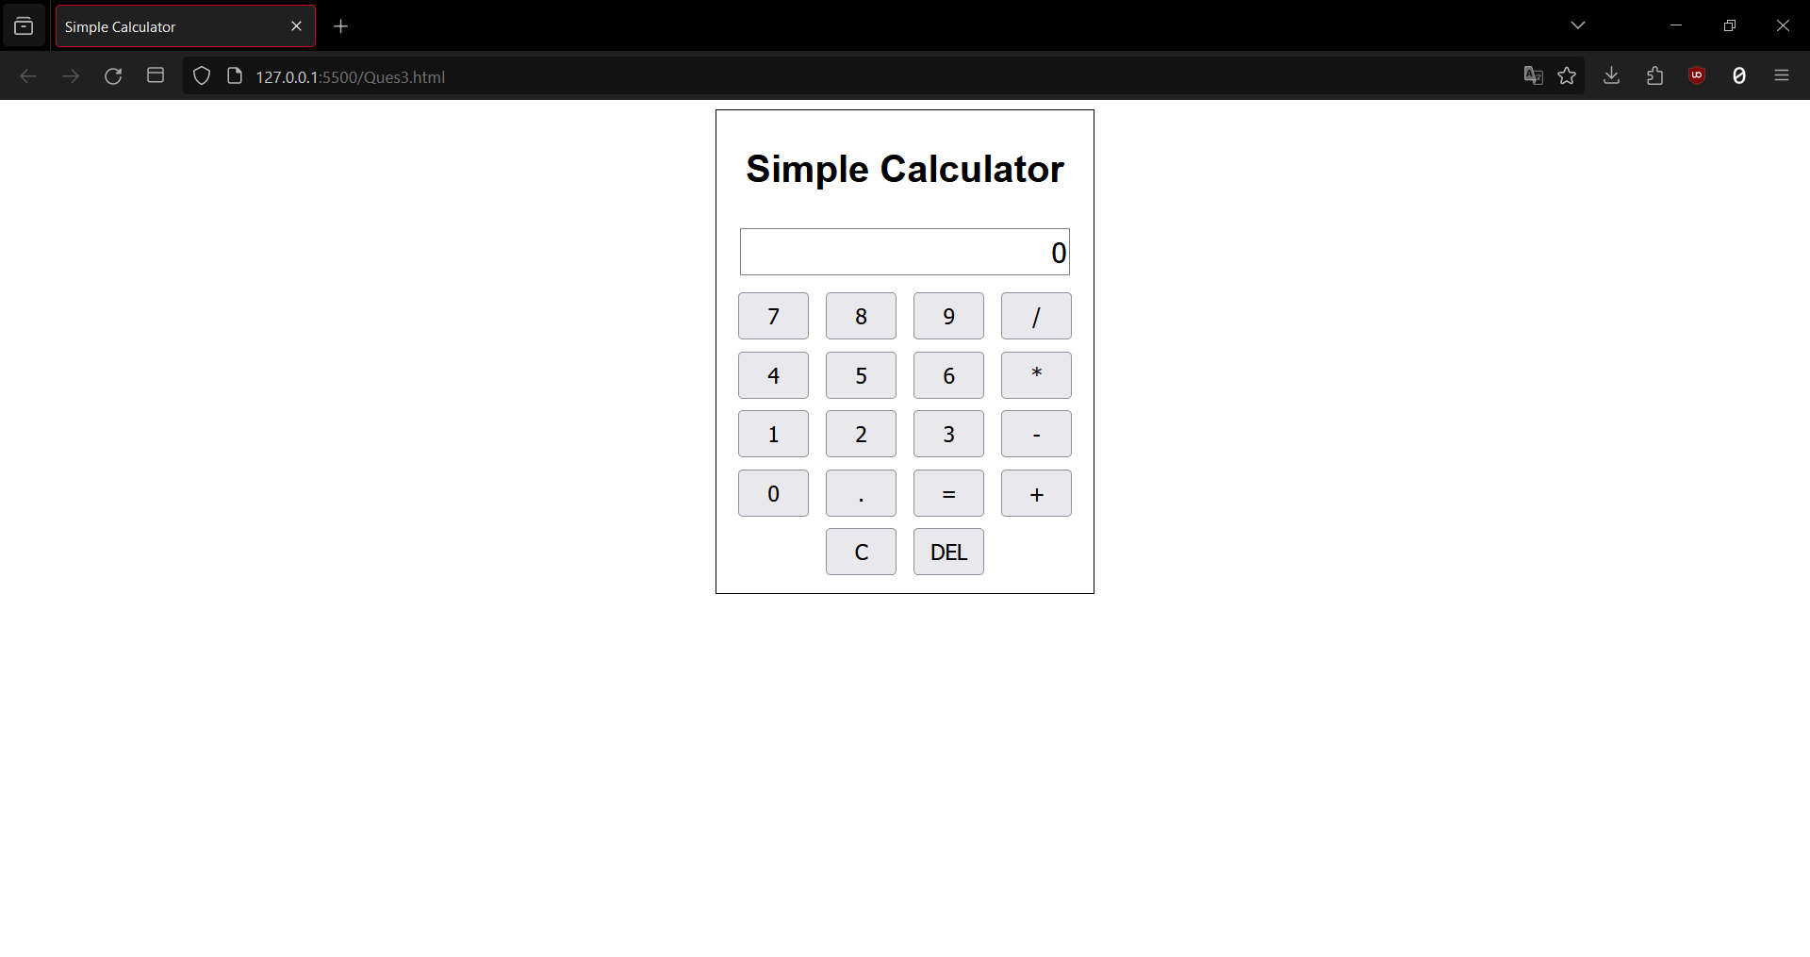

**EXPERIMENT – 4**

**AIM :** Create a web page covering the basic CRUD operations (Create, Read,Update, Delete) that implements To-do/Grocery lists using JavaScript and HTML

**CODE :**

<html>

<head>

<title>To-do/Grocery List</title>

<style>

body {

font-family: Arial, sans-serif;

text-align: center;

}

.container {

width: 500px;

margin: 0 auto;

border: 1px solid black;

padding: 10px;

}

.input {

width: 400px;

height: 30px;

margin: 10px;

border: 1px solid gray;

font-size: 18px;

}

.button {

width: 80px;

height: 30px;

margin: 10px;

font-size: 18px;

}

.list {

width: 480px;

margin: 10px;

border: 1px solid gray;

font-size: 18px;

}

.item {

display: flex;

align-items: center;

justify-content: space-between;

padding: 5px;

}

.item:hover {

background-color: lightgray;

}

.text {

flex: 1;

margin-left: 10px;

}

.edit {

width: 50px;

height: 25px;

margin-right: 10px;

}

.delete {

width: 50px;

height: 25px;

margin-right: 10px;

}

</style>

</head>

<body>

<div class="container">

<h1>To-do/Grocery List</h1>

<input type="text" id="input" class="input" placeholder="Enter an item">

<button id="add" class="button" onclick="addItem()">Add</button>

<ul id="list" class="list"></ul>

</div>

<script>

var input = document.getElementById("input");

var add = document.getElementById("add");

var list = document.getElementById("list");

function createItem(text) {

var item = document.createElement("li");

item.className = "item";

var span = document.createElement("span");

span.className = "text";

span.textContent = text;

var edit = document.createElement("button");

edit.className = "edit";

edit.textContent = "Edit";

edit.onclick = function () {

var newText = prompt("Enter a new text for the item", text);

if (newText && newText.trim() != "") {

span.textContent = newText;

}

};

var del = document.createElement("button");

del.className = "delete";

del.textContent = "Delete";

del.onclick = function () {

list.removeChild(item);

};

item.appendChild(span);

item.appendChild(edit);

item.appendChild(del);

return item;

}

function addItem() {

var text = input.value;

if (text && text.trim() != "") {

var item = createItem(text);

list.appendChild(item);

input.value = "";

}

}

</script>

</body></html>

**OUTPUT :**

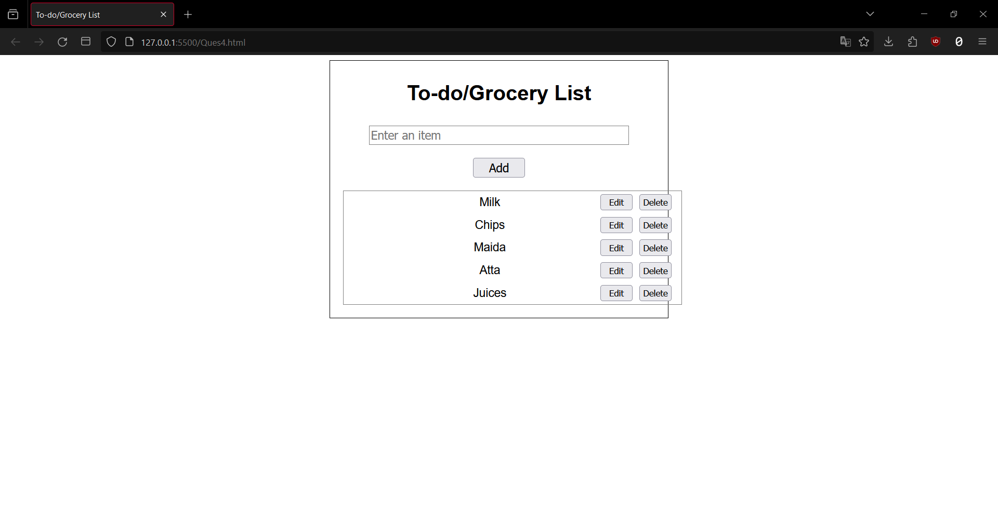

**EXPERIMENT – 5**

**AIM :** Create a JavaScript application based (Tic-Tac-Toe Game) on various Data Types, Statements, Keywords, and Operators.

**CODE :**

**HTML :**

<!DOCTYPE html>

<html>

<head>

<meta name="viewport" content=

"width=device-width, initial-scale=1.0">

<!-- CSS file Included -->

<link rel="stylesheet" type="text/css" href="Ques5.css">

<!-- JavaScript file included -->

<script src="Ques5.js"></script>

</head>

<body>

<div id="main">

<h1>TIC TAC TOE</h1>

<p id="ins">

Game starts by just Tap on

box<br><br>First Player starts as

<b>Player X </b>And Second Player as

<b>Player 0</b>

</p>

<br><br>

<div class = "ui">

<div class="row">

<input type="text" id= "b1"

class="cell" onclick="myfunc_3(); myfunc();"

readonly>

<input type="text" id= "b2"

class="cell" onclick="myfunc_4(); myfunc();"

readonly>

<input type="text" id= "b3" class="cell"

onclick="myfunc_5(); myfunc();"

readonly>

</div>

<div class="row">

<input type="text" id= "b4"

class="cell" onclick="myfunc_6(); myfunc();"

readonly>

<input type="text" id= "b5"

class="cell" onclick="myfunc_7(); myfunc();"

readonly>

<input type="text" id= "b6"

class="cell" onclick="myfunc_8(); myfunc();"

readonly>

</div>

<div class="row">

<input type="text" id= "b7"

class="cell" onclick="myfunc_9(); myfunc();"

readonly>

<input type="text" id= "b8"

class="cell" onclick="myfunc_10();myfunc();"

readonly>

<input type="text" id= "b9"

class="cell" onclick="myfunc_11();myfunc();"

readonly>

</div>

</div>

<br><br><br>

<button id="but" onclick="myfunc_2()">

RESET

</button>

<br><br>

<p id="print"></p>

</div>

</body>

</html>

**CSS :**

h1 {

color: orangered;

margin-bottom: -5px;

}

p {

margin-bottom: -10px;

}

.ui {

display: flex;

flex-direction: column;

align-items: center;

}

.row {

display: flex;

}

.cell {

border: none;

width: 80px;

height: 80px;

display: flex;

align-items: center;

justify-content: center;

font-size: 24px;

text-align: center;

cursor: pointer;

}

.cell:active {

outline: none;

}

/* 3*3 Grid */

#b1{

border-bottom: 1px solid gray;

border-right: 1px solid gray;

}

#b2 {

border-bottom: 1px solid gray;

border-right: 1px solid gray;

border-left: 1px solid gray;

}

#b3 {

border-bottom: 1px solid gray;

border-left: 1px solid gray;

}

#b4 {

border-top: 1px solid gray;

border-bottom: 1px solid gray;

border-right: 1px solid gray;

}

#b5 {

border: 1px solid gray;

}

#b6 {

border-top: 1px solid gray;

border-bottom: 1px solid gray;

border-left: 1px solid gray;

}

#b7 {

border-top: 1px solid gray;

border-right: 1px solid gray;

}

#b8 {

border-top: 1px solid gray;

border-right: 1px solid gray;

border-left: 1px solid gray;

}

#b9 {

border-top: 1px solid gray;

border-left: 1px solid gray;

}

#but {

box-sizing: border-box;

width: 95px;

height: 40px;

border: 1px solid dodgerblue;

margin-left: auto;

border-radius: 8px;

font-family: Verdana,

Geneva, Tahoma, sans-serif;

background-color: whitesmoke;

color: dodgerblue;

font-size: 20px;

cursor: pointer;

}

#print {

font-family: Verdana,

Geneva, Tahoma, sans-serif;

color: dodgerblue;

font-size: 20px;

}

#main {

text-align: center;

}

#ins {

font-family: Verdana,Geneva,

Tahoma, sans-serif;

color: dodgerblue;

}

**JavaScript :**

function myfunc() {

// Setting DOM to all boxes or input field

var b1, b2, b3, b4, b5, b6, b7, b8, b9;

b1 = document.getElementById("b1").value;

b2 = document.getElementById("b2").value;

b3 = document.getElementById("b3").value;

b4 = document.getElementById("b4").value;

b5 = document.getElementById("b5").value;

b6 = document.getElementById("b6").value;

b7 = document.getElementById("b7").value;

b8 = document.getElementById("b8").value;

b9 = document.getElementById("b9").value;

var b1btn, b2btn, b3btn, b4btn, b5btn,

b6btn, b7btn, b8btn, b9btn;

b1btn = document.getElementById("b1");

b2btn = document.getElementById("b2");

b3btn = document.getElementById("b3");

b4btn = document.getElementById("b4");

b5btn = document.getElementById("b5");

b6btn = document.getElementById("b6");

b7btn = document.getElementById("b7");

b8btn = document.getElementById("b8");

b9btn = document.getElementById("b9");

if ((b1 == 'x' || b1 == 'X') && (b2 == 'x' ||

b2 == 'X') && (b3 == 'x' || b3 == 'X')) {

document.getElementById('print')

.innerHTML = "Player X won";

b4btn.disabled = true;

b5btn.disabled = true;

b6btn.disabled = true;

b7btn.disabled = true;

b8btn.disabled = true;

b9btn.disabled = true;

b1btn.style.color = "red";

b2btn.style.color = "red";

b3btn.style.color = "red";

}

else if ((b1 == 'x' || b1 == 'X') && (b4 == 'x' ||

b4 == 'X') && (b7 == 'x' || b7 == 'X')) {

document.getElementById('print')

.innerHTML = "Player X won";

b2btn.disabled = true;

b3btn.disabled = true;

b5btn.disabled = true;

b6btn.disabled = true;

b8btn.disabled = true;

b9btn.disabled = true;

b1btn.style.color = "red";

b4btn.style.color = "red";

b7btn.style.color = "red";

}

else if ((b7 == 'x' || b7 == 'X') && (b8 == 'x' ||

b8 == 'X') && (b9 == 'x' || b9 == 'X')) {

document.getElementById('print')

.innerHTML = "Player X won";

b1btn.disabled = true;

b2btn.disabled = true;

b3btn.disabled = true;

b4btn.disabled = true;

b5btn.disabled = true;

b6btn.disabled = true;

b7btn.style.color = "red";

b8btn.style.color = "red";

b9btn.style.color = "red";

}

else if ((b3 == 'x' || b3 == 'X') && (b6 == 'x' ||

b6 == 'X') && (b9 == 'x' || b9 == 'X')) {

document.getElementById('print')

.innerHTML = "Player X won";

b1btn.disabled = true;

b2btn.disabled = true;

b4btn.disabled = true;

b5btn.disabled = true;

b7btn.disabled = true;

b8btn.disabled = true;

b3btn.style.color = "red";

b6btn.style.color = "red";

b9btn.style.color = "red";

}

else if ((b1 == 'x' || b1 == 'X') && (b5 == 'x' ||

b5 == 'X') && (b9 == 'x' || b9 == 'X')) {

document.getElementById('print')

.innerHTML = "Player X won";

b2btn.disabled = true;

b3btn.disabled = true;

b4btn.disabled = true;

b6btn.disabled = true;

b7btn.disabled = true;

b8btn.disabled = true;

b1btn.style.color = "red";

b5btn.style.color = "red";

b9btn.style.color = "red";

}

else if ((b3 == 'x' || b3 == 'X') && (b5 == 'x' ||

b5 == 'X') && (b7 == 'x' || b7 == 'X')) {

document.getElementById('print')

.innerHTML = "Player X won";

b1btn.disabled = true;

b2btn.disabled = true;

b4btn.disabled = true;

b6btn.disabled = true;

b8btn.disabled = true;

b9btn.disabled = true;

b3btn.style.color = "red";

b5btn.style.color = "red";

b7btn.style.color = "red";

}

else if ((b2 == 'x' || b2 == 'X') && (b5 == 'x' ||

b5 == 'X') && (b8 == 'x' || b8 == 'X')) {

document.getElementById('print')

.innerHTML = "Player X won";

b1btn.disabled = true;

b2btn.disabled = true;

b4btn.disabled = true;

b6btn.disabled = true;

b7btn.disabled = true;

b9btn.disabled = true;

b2btn.style.color = "red";

b5btn.style.color = "red";

b8btn.style.color = "red";

}

else if ((b4 == 'x' || b4 == 'X') && (b5 == 'x' ||

b5 == 'X') && (b6 == 'x' || b6 == 'X')) {

document.getElementById('print')

.innerHTML = "Player X won";

b1btn.disabled = true;

b2btn.disabled = true;

b3btn.disabled = true;

b7btn.disabled = true;

b8btn.disabled = true;

b9btn.disabled = true;

b4btn.style.color = "red";

b5btn.style.color = "red";

b6btn.style.color = "red";

}

else if ((b1 == '0' || b1 == '0') && (b2 == '0' ||

b2 == '0') && (b3 == '0' || b3 == '0')) {

document.getElementById('print')

.innerHTML = "Player 0 won";

b4btn.disabled = true;

b5btn.disabled = true;

b6btn.disabled = true;

b7btn.disabled = true;

b8btn.disabled = true;

b9btn.disabled = true;

b1btn.style.color = "red";

b2btn.style.color = "red";

b3btn.style.color = "red";

}

else if ((b1 == '0' || b1 == '0') && (b4 == '0' ||

b4 == '0') && (b7 == '0' || b7 == '0')) {

document.getElementById('print')

.innerHTML = "Player 0 won";

b2btn.disabled = true;

b3btn.disabled = true;

b5btn.disabled = true;

b6btn.disabled = true;

b8btn.disabled = true;

b9btn.disabled = true;

b1btn.style.color = "red";

b4btn.style.color = "red";

b7btn.style.color = "red";

}

else if ((b7 == '0' || b7 == '0') && (b8 == '0' ||

b8 == '0') && (b9 == '0' || b9 == '0')) {

document.getElementById('print')

.innerHTML = "Player 0 won";

b1btn.disabled = true;

b2btn.disabled = true;

b3btn.disabled = true;

b4btn.disabled = true;

b5btn.disabled = true;

b6btn.disabled = true;

b7btn.style.color = "red";

b8btn.style.color = "red";

b9btn.style.color = "red";

}

else if ((b3 == '0' || b3 == '0') && (b6 == '0' ||

b6 == '0') && (b9 == '0' || b9 == '0')) {

document.getElementById('print')

.innerHTML = "Player 0 won";

b1btn.disabled = true;

b2btn.disabled = true;

b4btn.disabled = true;

b5btn.disabled = true;

b7btn.disabled = true;

b8btn.disabled = true;

b3btn.style.color = "red";

b6btn.style.color = "red";

b9btn.style.color = "red";

}

else if ((b1 == '0' || b1 == '0') && (b5 == '0' ||

b5 == '0') && (b9 == '0' || b9 == '0')) {

document.getElementById('print')

.innerHTML = "Player 0 won";

b2btn.disabled = true;

b3btn.disabled = true;

b4btn.disabled = true;

b6btn.disabled = true;

b7btn.disabled = true;

b8btn.disabled = true;

b1btn.style.color = "red";

b5btn.style.color = "red";

b9btn.style.color = "red";

}

else if ((b3 == '0' || b3 == '0') && (b5 == '0' ||

b5 == '0') && (b7 == '0' || b7 == '0')) {

document.getElementById('print')

.innerHTML = "Player 0 won";

b1btn.disabled = true;

b2btn.disabled = true;

b4btn.disabled = true;

b6btn.disabled = true;

b8btn.disabled = true;

b9btn.disabled = true;

b3btn.style.color = "red";

b5btn.style.color = "red";

b7btn.style.color = "red";

}

else if ((b2 == '0' || b2 == '0') && (b5 == '0' ||

b5 == '0') && (b8 == '0' || b8 == '0')) {

document.getElementById('print')

.innerHTML = "Player 0 won";

b1btn.disabled = true;

b3btn.disabled = true;

b4btn.disabled = true;

b6btn.disabled = true;

b7btn.disabled = true;

b9btn.disabled = true;

b2btn.style.color = "red";

b5btn.style.color = "red";

b8btn.style.color = "red";

}

else if ((b4 == '0' || b4 == '0') && (b5 == '0' ||

b5 == '0') && (b6 == '0' || b6 == '0')) {

document.getElementById('print')

.innerHTML = "Player 0 won";

b1btn.disabled = true;

b2btn.disabled = true;

b3btn.disabled = true;

b7btn.disabled = true;

b8btn.disabled = true;

b9btn.disabled = true;

b4btn.style.color = "red";

b5btn.style.color = "red";

b6btn.style.color = "red";

}

else if ((b1 == 'X' || b1 == '0') && (b2 == 'X'

|| b2 == '0') && (b3 == 'X' || b3 == '0') &&

(b4 == 'X' || b4 == '0') && (b5 == 'X' ||

b5 == '0') && (b6 == 'X' || b6 == '0') &&

(b7 == 'X' || b7 == '0') && (b8 == 'X' ||

b8 == '0') && (b9 == 'X' || b9 == '0')) {

document.getElementById('print')

.innerHTML = "Match Tie";

}

else {

// Here, Printing Result

if (flag == 1) {

document.getElementById('print')

.innerHTML = "Player X Turn";

}

else {

document.getElementById('print')

.innerHTML = "Player 0 Turn";

}

}

}

function myfunc_2() {

location.reload();

b1 = b2 = b3 = b4 = b5 = b6 = b7 = b8 = b9 = '';

}

flag = 1;

function myfunc_3() {

if (flag == 1) {

document.getElementById("b1").value = "X";

document.getElementById("b1").disabled = true;

flag = 0;

}

else {

document.getElementById("b1").value = "0";

document.getElementById("b1").disabled = true;

flag = 1;

}

}

function myfunc_4() {

if (flag == 1) {

document.getElementById("b2").value = "X";

document.getElementById("b2").disabled = true;

flag = 0;

}

else {

document.getElementById("b2").value = "0";

document.getElementById("b2").disabled = true;

flag = 1;

}

}

function myfunc_5() {

if (flag == 1) {

document.getElementById("b3").value = "X";

document.getElementById("b3").disabled = true;

flag = 0;

}

else {

document.getElementById("b3").value = "0";

document.getElementById("b3").disabled = true;

flag = 1;

}

}

function myfunc_6() {

if (flag == 1) {

document.getElementById("b4").value = "X";

document.getElementById("b4").disabled = true;

flag = 0;

}

else {

document.getElementById("b4").value = "0";

document.getElementById("b4").disabled = true;

flag = 1;

}

}

function myfunc_7() {

if (flag == 1) {

document.getElementById("b5").value = "X";

document.getElementById("b5").disabled = true;

flag = 0;

}

else {

document.getElementById("b5").value = "0";

document.getElementById("b5").disabled = true;

flag = 1;

}

}

function myfunc_8() {

if (flag == 1) {

document.getElementById("b6").value = "X";

document.getElementById("b6").disabled = true;

flag = 0;

}

else {

document.getElementById("b6").value = "0";

document.getElementById("b6").disabled = true;

flag = 1;

}

}

function myfunc_9() {

if (flag == 1) {

document.getElementById("b7").value = "X";

document.getElementById("b7").disabled = true;

flag = 0;

}

else {

document.getElementById("b7").value = "0";

document.getElementById("b7").disabled = true;

flag = 1;

}

}

function myfunc_10() {

if (flag == 1) {

document.getElementById("b8").value = "X";

document.getElementById("b8").disabled = true;

flag = 0;

}

else {

document.getElementById("b8").value = "0";

document.getElementById("b8").disabled = true;

flag = 1;

}

}

function myfunc_11() {

if (flag == 1) {

document.getElementById("b9").value = "X";

document.getElementById("b9").disabled = true;

flag = 0;

}

else {

document.getElementById("b9").value = "0";

document.getElementById("b9").disabled = true;

flag = 1;

}

}

**OUTPUT :**

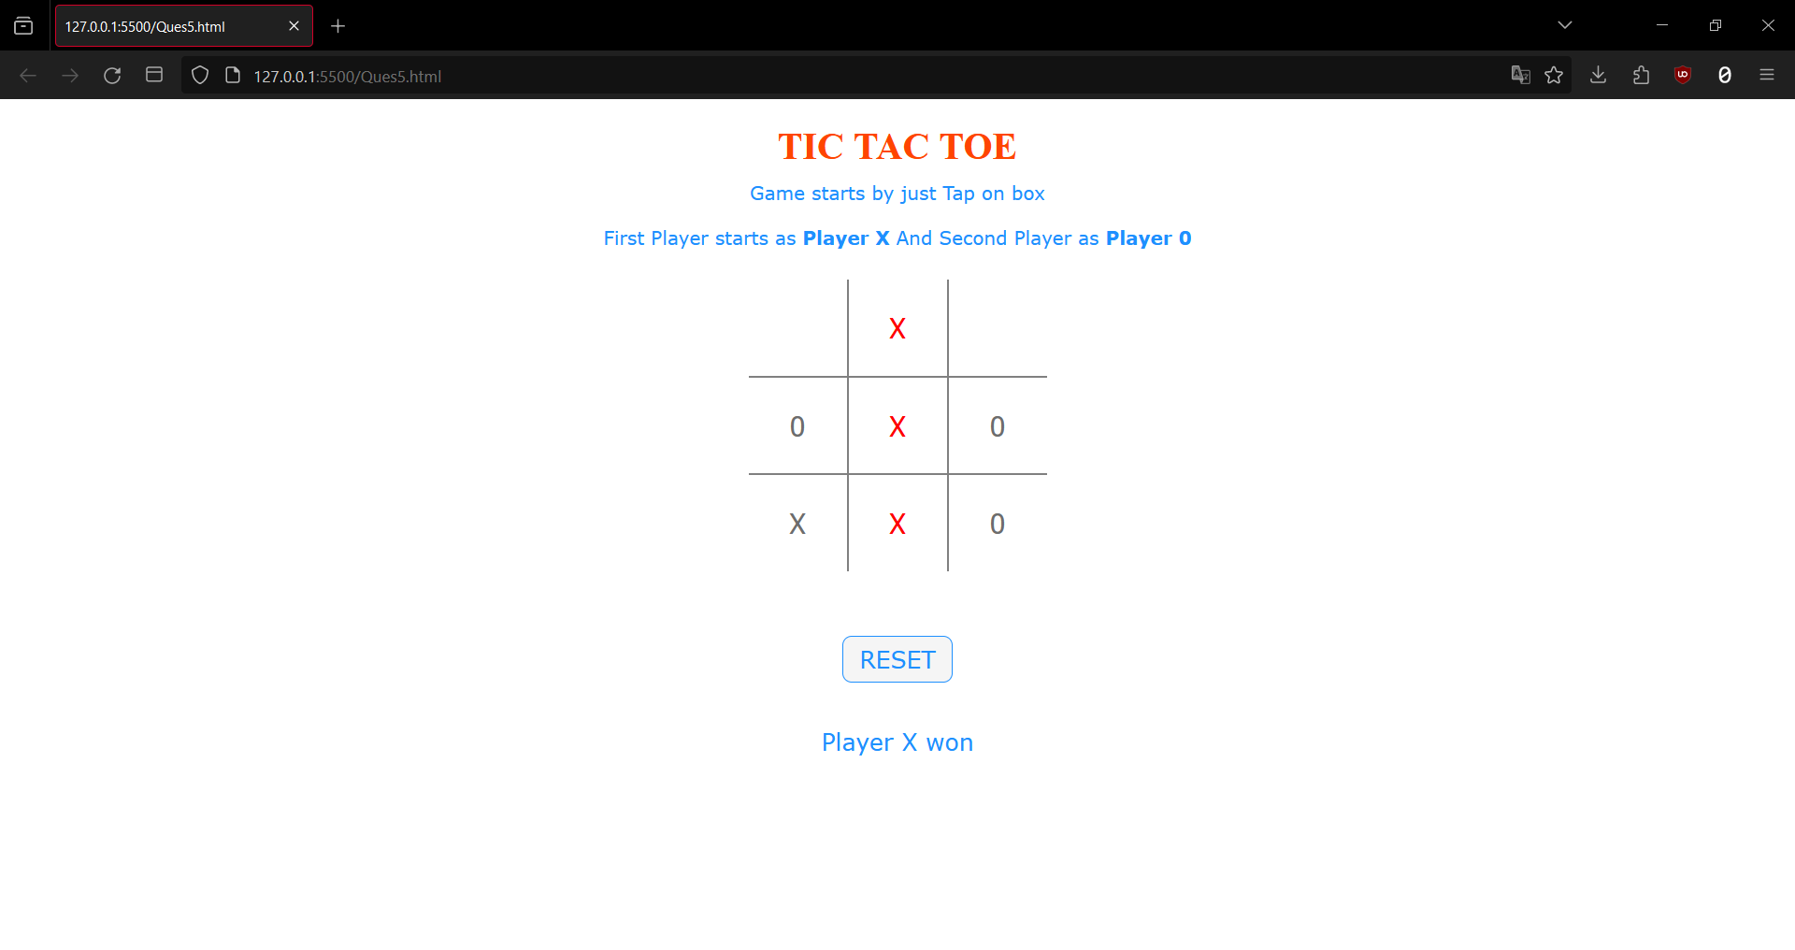

**EXPERIMENT – 6**

**AIM :** Create a JavaScript application with window objects and document object.

**CODE :**

**HTML :**

<!DOCTYPE html>

<html lang="en">

<head>

<meta charset="UTF-8">

<meta name="viewport" content="width=device-width, initial-scale=1.0">

<title>Window and Document Objects Example</title>

<link rel="stylesheet" href="Ques6.css">

</head>

<body>

<div class="container">

<h1>Window and Document Objects Example</h1>

<button onclick="showAlert()">Click me</button>

</div>

<script src="Ques6.js"></script>

</body>

</html>

**CSS :**

body {

font-family: 'Arial', sans-serif;

background-color: #f4f4f4;

margin: 0;

display: flex;

align-items: center;

justify-content: center;

height: 100vh;

}

.container {

text-align: center;

background-color: #fff;

padding: 20px;

border-radius: 8px;

box-shadow: 0 0 10px rgba(0, 0, 0, 0.1);

}

h1 {

color: #333;

}

button {

padding: 10px 20px;

cursor: pointer;

background-color: #4caf50;

color: #fff;

border: none;

border-radius: 4px;

font-size: 16px;

}

button:hover {

background-color: #45a049;

}

**JS :**

function showAlert() {

window.alert("Hello, this is an alert!");

document.body.style.backgroundColor = getRandomColor();

}

function getRandomColor() {

return '#' + Math.floor(Math.random()*16777215).toString(16);

}

**OUTPUT :**

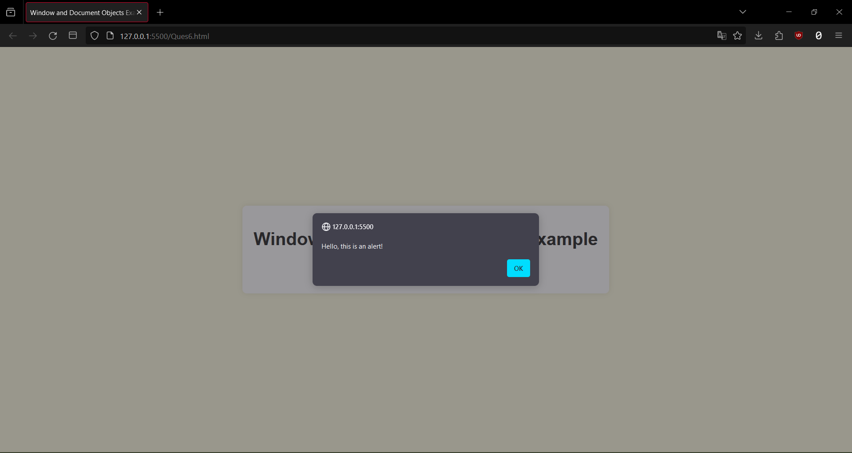

**EXPERIMENT – 7**

**AIM :** Create a JavaScript application with Object Creation and by adding methods of objects.

**CODE :**

**HTML**

<!DOCTYPE html>

<html lang="en">

<head>

<meta charset="UTF-8">

<meta name="viewport" content="width=device-width, initial-scale=1.0">

<title>Object Creation and Methods Example</title>

<link rel="stylesheet" href="Ques6.css">

</head>

<body>

<div class="container">

<h1>Object Creation and Methods Example</h1>

<div id="output"></div>

</div>

<script src="Ques6.js"></script>

</body>

</html>

**CSS**

body {

font-family: 'Arial', sans-serif;

background-color: #f4f4f4;

margin: 0;

display: flex;

align-items: center;

justify-content: center;

height: 100vh;

}

.

container {

text-align: center;

background-color: #fff;

padding: 20px;

border-radius: 8px;

box-shadow: 0 0 10px rgba(0, 0, 0, 0.1);

}

h1 {

color: #333;

}

#output {

margin-top: 20px;

font-size: 18px;

color: #333;

}

**JAVASCRIPT**

function Person(name, age) {

this.name = name;

this.age = age;

this.sayHello = function () {

return "Hello, my name is " + this.name + " and I am " + this.age + " years old.";

};

}

var person1 = new Person("John", 25);

var outputElement = document.getElementById('output');

outputElement.textContent = person1.sayHello();

**OUTPUT :**

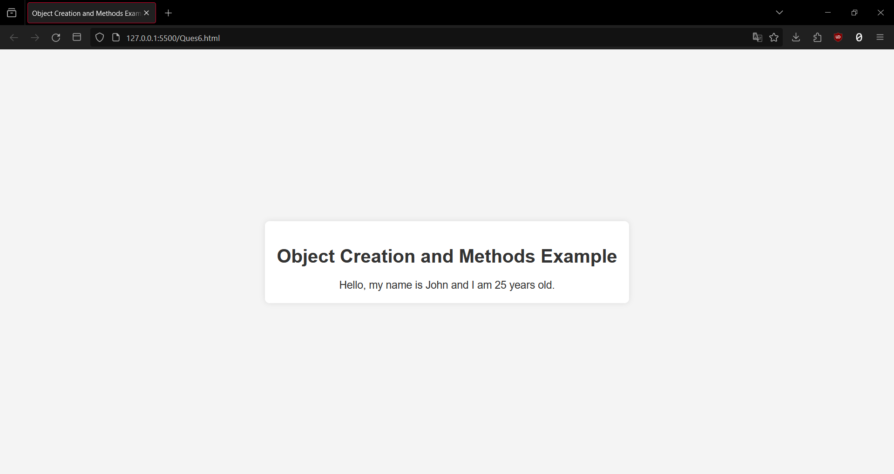

**EXPERIMENT – 8**

**AIM :** Create a JavaScript application with loops to incorporate the concept of iteration.

**CODE :**

**HTML:-**

<!DOCTYPE html>

<html lang="en">

<head>

<meta charset="UTF-8">

<meta name="viewport" content="width=device-width, initial-scale=1.0">

<title>Iteration with Loops Example</title>

<link rel="stylesheet" href="style.css">

</head>

<body>

<div class="container">

<h1>Iteration with Loops Example</h1>

<label for="numbersInput">Enter numbers separated by commas:</label>

<input type="text" id="numbersInput" placeholder="e.g., 1, 2, 3">

<button onclick="calculateSum()">Calculate Sum</button>

<div id="output"></div>

</div>

<script src="script.js"></script>

</body>

</html>

**CSS:-**

body {

font-family: 'Arial', sans-serif;

background-color: #f4f4f4;

margin: 0;

display: flex;

align-items: center;

justify-content: center;

height: 100vh;

}

.container {

text-align: center;

background-color: #fff;

padding: 20px;

border-radius: 8px;

box-shadow: 0 0 10px rgba(0, 0, 0, 0.1);

}

h1 {

color: #333;

}

#output {

margin-top: 20px;

font-size: 18px;

color: #333;

}

**JS:-**

function calculateSum() {

var input = document.getElementById('numbersInput').value;

var numbers = input.split(',').map(function (num) {

return parseInt(num.trim(), 10);

});

if (numbers.some(isNaN)) {

alert('Please enter valid numbers separated by commas.');

return;

}

var sum = 0;

for (var i = 0; i < numbers.length; i++) {

sum += numbers[i];

}

var outputElement = document.getElementById('output');

outputElement.textContent = 'The sum of numbers ' + numbers.join(', ') + ' is: ' + sum;

}

**OUTPUT :**

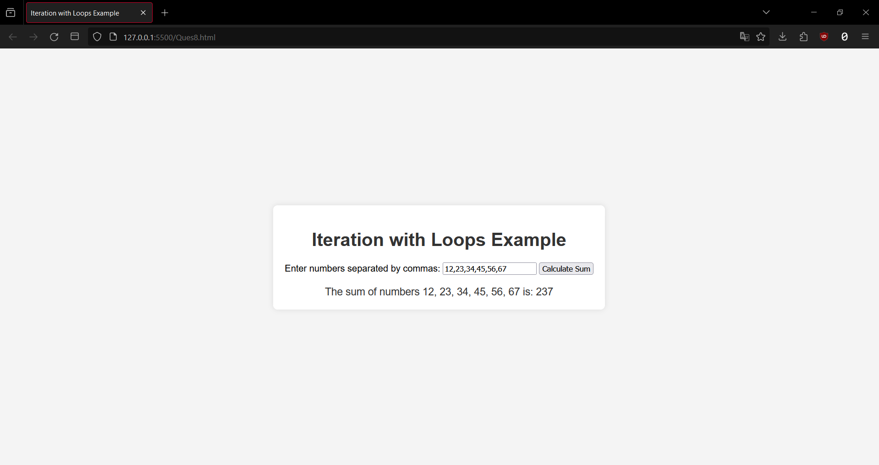

**EXPERIMENT – 9**

**AIM :** Create a JavaScript application for random number generation.

**CODE :**

**HTML:-**

<!DOCTYPE html>

<html lang="en">

<head>

<meta charset="UTF-8">

<meta name="viewport" content="width=device-width, initial-scale=1.0">

<title>Random Number Generator</title>

<link rel="stylesheet" href="style.css">

</head>

<body>

<div class="container">

<h1>Random Number Generator</h1>

<label for="minInput">Minimum Value:</label>

<input type="number" id="minInput" value="1">

<label for="maxInput">Maximum Value:</label>

<input type="number" id="maxInput" value="100">

<button onclick="generateRandomNumber()">Generate Random Number</button>

<div id="output"></div>

</div>

<script src="script.js"></script>

</body>

</html>

**CSS:-**

body {

font-family: 'Arial', sans-serif;

background-color: #f4f4f4;

margin: 0;

display: flex;

align-items: center;

justify-content: center;

height: 100vh;

}

.container {

text-align: center;

background-color: #fff;

padding: 20px;

border-radius: 8px;

box-shadow: 0 0 10px rgba(0, 0, 0, 0.1);

}

h1 {

color: #333;

}

label {

display: block;

margin-bottom: 5px;

}

input {

padding: 10px;

margin-bottom: 10px;

}

button {

padding: 10px 20px;

cursor: pointer;

background-color: #4caf50;

color: #fff;

border: none;

border-radius: 4px;

font-size: 16px;

}

button:hover {

background-color: #45a049;

}

#output {

margin-top: 20px;

font-size: 18px;

color: #333;

}

**JS:-**

function generateRandomNumber() {

var minInput = document.getElementById('minInput');

var maxInput = document.getElementById('maxInput');

var outputElement = document.getElementById('output');

var min = parseInt(minInput.value, 10);

var max = parseInt(maxInput.value, 10);

if (isNaN(min) || isNaN(max) || min >= max) {

alert('Please enter valid minimum and maximum values.');

return;

}

var randomNumber = Math.floor(Math.random() * (max - min + 1)) + min;

outputElement.textContent = 'Random Number: ' + randomNumber;

}

**OUTPUT :**

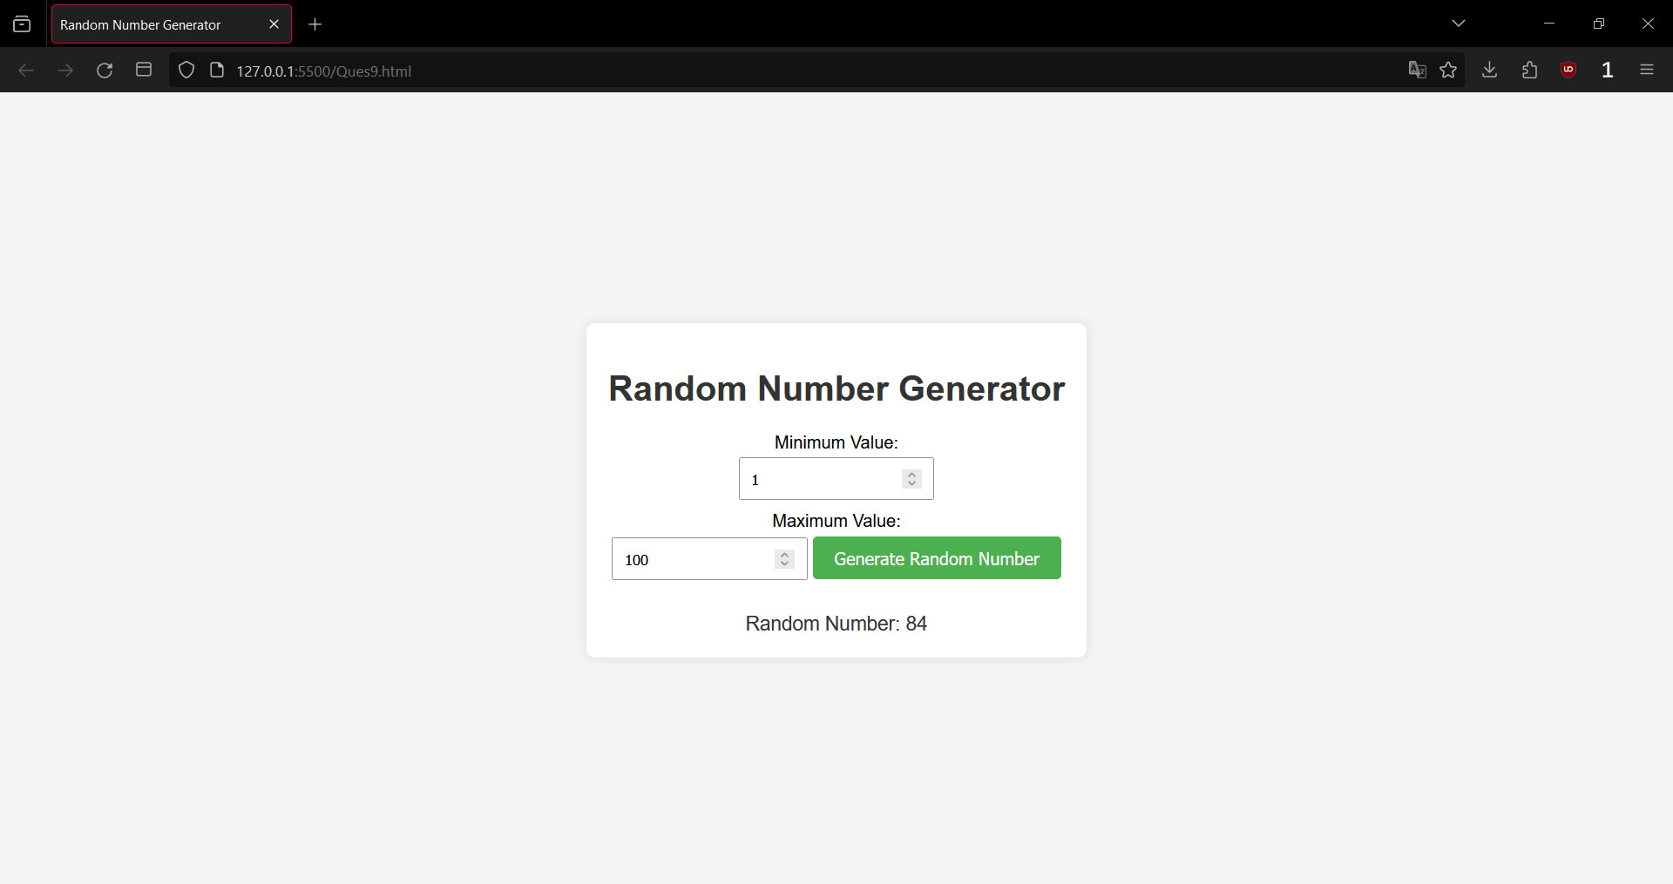

**EXPERIMENT – 10**

**AIM :** Build a unit converter application using HTML & JavaScript.

**CODE :**

**HTML:-**

<!DOCTYPE html>

<html lang="en">

<head>

<meta charset="UTF-8">

<meta name="viewport" content="width=device-width, initial-scale=1.0">

<title>Unit Converter</title>

<link rel="stylesheet" href="style.css">

</head>

<body>

<div class="container">

<h1>Unit Converter</h1>

<label for="lengthInput">Enter Length:</label>

<input type="number" id="lengthInput">

<select id="unitSelect">

<option value="meters">Meters</option>

<option value="feet">Feet</option>

</select>

<button onclick="convertLength()">Convert</button>

<div id="output"></div>

</div>

<script src="script.js"></script>

</body>

</html>

**CSS:-**

body {

font-family: 'Arial', sans-serif;

background-color: #f4f4f4;

margin: 0;

display: flex;

align-items: center;

justify-content: center;

height: 100vh;

}

.container {

text-align: center;

background-color: #fff;

padding: 20px;

border-radius: 8px;

box-shadow: 0 0 10px rgba(0, 0, 0, 0.1);

}

h1 {

color: #333;

}

label {

display: block;

margin-bottom: 5px;

}

input {

padding: 10px;

margin-bottom: 10px;

}

select {

padding: 10px;

margin-bottom: 10px;

}

button {

padding: 10px 20px;

cursor: pointer;

background-color: #4caf50;

color: #fff;

border: none;

border-radius: 4px;

font-size: 16px;

}

button:hover {

background-color: #45a049;

}

#output {

margin-top: 20px;

font-size: 18px;

color: #333;

}

**JS:-**

function convertLength() {

var lengthInput = document.getElementById('lengthInput').value;

var unitSelect = document.getElementById('unitSelect');

var outputElement = document.getElementById('output');

var length = parseFloat(lengthInput);

var unit = unitSelect.value;

if (isNaN(length)) {

alert('Please enter a valid number for length.');

return;

}

var convertedLength = 0;

if (unit === 'meters') {

convertedLength = length * 3.28084; // Convert meters to feet

outputElement.textContent = length + ' meters is approximately ' + convertedLength.toFixed(2) + ' feet.';

} else if (unit === 'feet') {

convertedLength = length / 3.28084; // Convert feet to meters

outputElement.textContent = length + ' feet is approximately ' + convertedLength.toFixed(2) + ' meters.';

}

}

**OUTPUT :**

