U01_langloc_audio_vFeb2021

This experiment was developed at MIT by Evelina Fedorenko and Hannah Small. For any question, please contact [hsmall@mit.edu](mailto:hsmall@mit.edu) (or alan.bush@mgh.harvard.edu).

<https://github.com/Brain-Modulation-Lab/Task_MIT_Fedorenko>

## Required Hardware:

* Presentation monitor
* Keyboard for participant

**Brief Description (for the experimenters)**

This is a language localizer experiment where participants listen to linguistic materials. There are two conditions: sentences and nonword lists. Each trial contains a sequence of 12 words or nonwords and ends with a memory probe (in blue). For the memory probe, participants have to decide whether the probe word/nonword was in the list of words they just heard. They are asked to press “1” for yes, and “2” for no. On half of the trials, the memory probe is indeed from the preceding sequence; on the other half, the probe is taken from a different stimulus. The purpose of the memory probe task is to keep the participant alert and paying attention to the stimuli.

There are rest breaks every 8 trials. The task continues upon pressing the spacebar.

We need 2-3 runs of this task. Each run is ~4.5 minutes without the rest breaks.

You should run them in this order: list 1, 2, 3.

## How to run the task:

1. Verify Neural Signal Processors are recording.
2. Set the presentation monitor for visual task.
3. The keyboard should be accessible to the participant.
4. Set the speaker in front of the participant.
5. Open Desktop\MIT\Task_MIT_Fedorenko\ U01_langloc_audio_vFeb2021\START_ LANGLOC_AUDIO_EMU.m in Matlab and click RUN on the “Editor” tab in the toolbar or press F5. The following dialog box will appear:

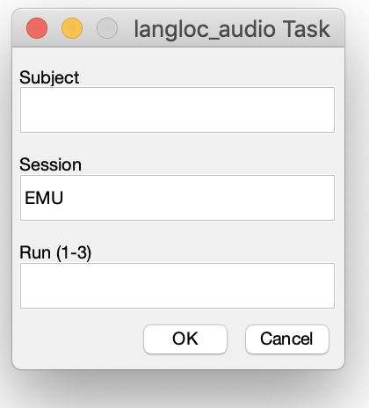

* + Subject: enter the Subject ID (e.g. ‘MG001’)
  + Session: enter session type. For the experiment in the EMU enter ‘EMU’. If testing the task enter ‘test’.
  + Run: Enter run id (possible options in parenthesis)
  1. Click OK
  2. A concise task instruction will appear on screen. Remind task instructions to participant if deemed necessary.

“You will listen to some sentences. After, you will see a word in blue. Press 1 if that word was in the sentence you just heard and 2 if not.”

* 1. Press the SPACE key to start the experiment.

1. If time allows and the participant is willing to do another run after a short break go to step ‘5’. 4 runs would be ideal, 2 runs are good.
2. Download the log files from Desktop\MIT\Data_LangLoc

**Problems**

If the task has to be exited for some reason, you can press the escape button and all data will be saved. To resume the same list, just enter the same command and you will be prompted to either resume (press 1) or restart (press 2) that list. Then press enter and the task will resume. Make a note if this happens.

**Subject Instructions**

* In this task, you will listen to sentences and lists of nonwords.

At the end of each sequence, you will see a **blue word / nonword**, and you have to decide whether that was in the sequence you just read.

For YES, please press button 1, and for NO, press button 2.

Remember: your main task is the **listening** task. The **memory probe task** is not a test, it is included to help you stay awake and alert.

The task may seem too fast at first. Just keep trying to pay attention, and you will get used to it

**Fallback strategy:** If a participant gets frustrated due to not being able to press the correct key in time, instruct him/her to just pay attention to the words and forget about the keyboard. Take note of the level of attention, that is, your subjective assessment if the participant is reading the words.