支付接口整理(openapi)
支付接口整理(openapi) 1
1. 线上充值(insertAccountRechargeOrderForOnlineRecharge) 2
2. 消费(insertAccountDetailConsume) 3
3. 预授权-冻结(insertPreAuthorizedBill) 5
4. 提现(insertAccountWithdrawOrder) 6
5. 内转? 8
6. 消撤(insertCancelAccountDetailConsume) 9
7. 充值查询 9
8. 预授权-解冻(insertCancelPreAuthorizedBill) 10
9. 预授权-消费(insertPreAuthorizedConsumeBill) 11
10. 消费查询(selectBillExistByBusinessNumber) 13

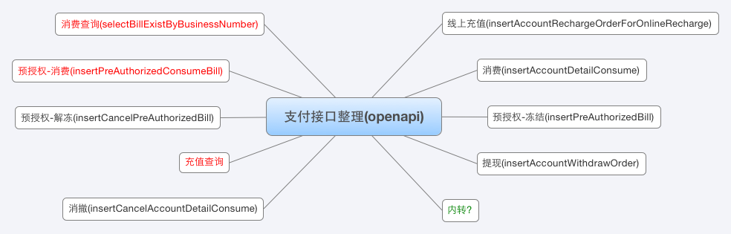

线上充值(insertAccountRechargeOrderForOnlineRecharge)
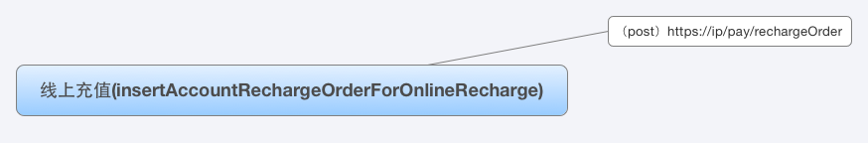

（post）https://ip/pay/rechargeOrder
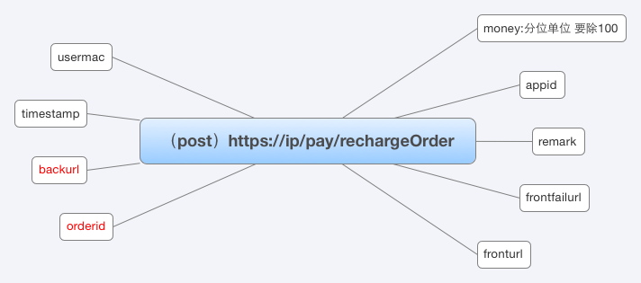

money:分位单位 要除100

appid

remark

frontfailurl

fronturl

usermac

timestamp

backurl

orderid

消费(insertAccountDetailConsume)
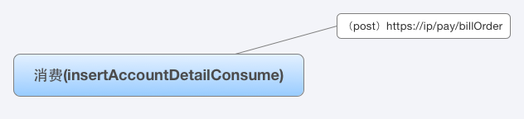

（post）https://ip/pay/billOrder
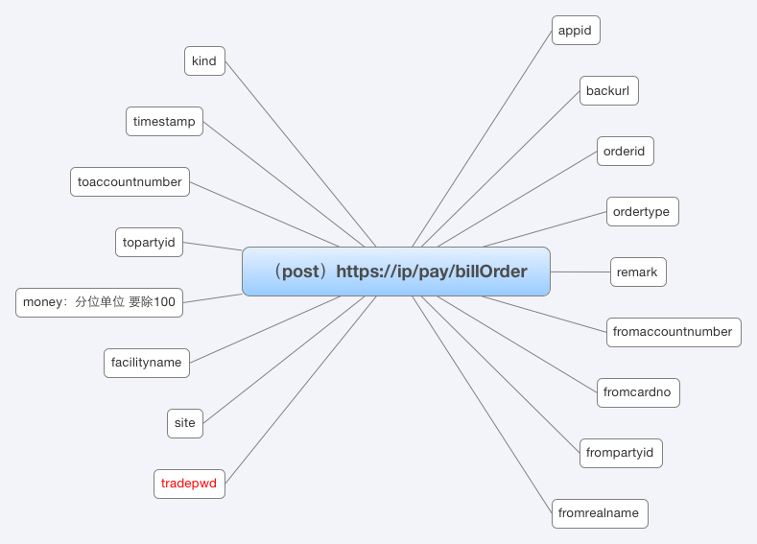

appid

backurl

orderid

ordertype

remark

fromaccountnumber

fromcardno

frompartyid

fromrealname

kind

timestamp

toaccountnumber

topartyid

money：分位单位 要除100

facilityname

site

tradepwd

预授权-冻结(insertPreAuthorizedBill)
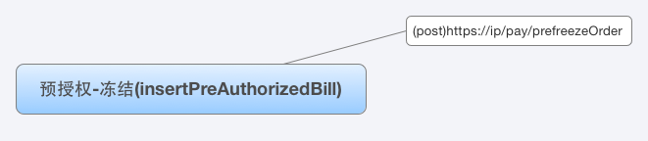

(post)https://ip/pay/prefreezeOrder
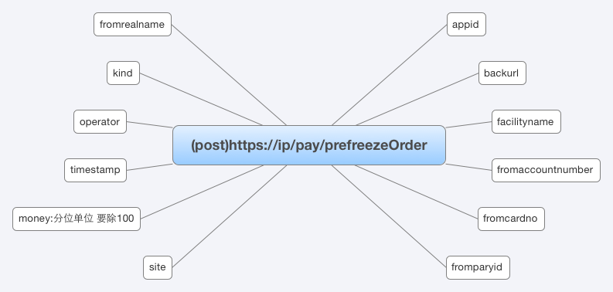

appid

backurl

facilityname

fromaccountnumber

fromcardno

fromparyid

fromrealname

kind

operator

timestamp

money:分位单位 要除100

site

提现(insertAccountWithdrawOrder)
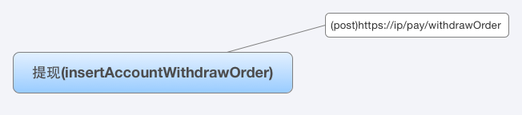

(post)https://ip/pay/withdrawOrder
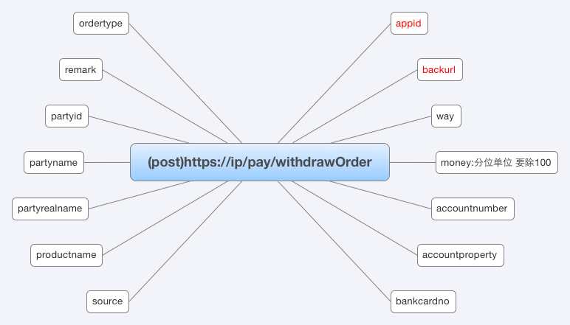

appid

backurl

way

money:分位单位 要除100

accountnumber

accountproperty

bankcardno

ordertype

remark

partyid

partyname

partyrealname

productname

source

内转?
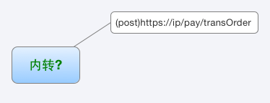

(post)https://ip/pay/transOrder
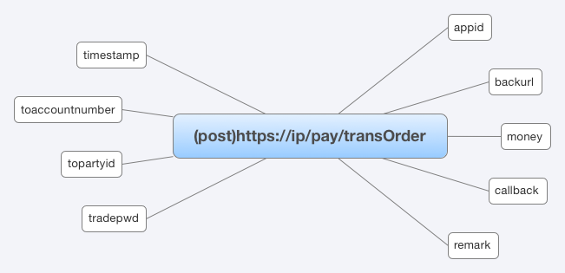

appid

backurl

money

callback

remark

timestamp

toaccountnumber

topartyid

tradepwd

消撤(insertCancelAccountDetailConsume)
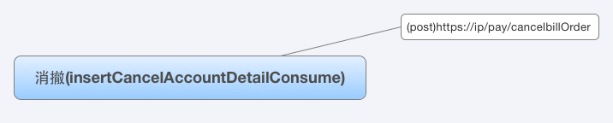

(post)https://ip/pay/cancelbillOrder
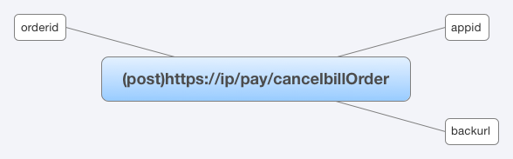

appid

backurl

orderid

充值查询
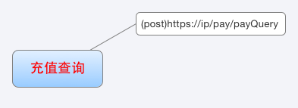

(post)https://ip/pay/payQuery
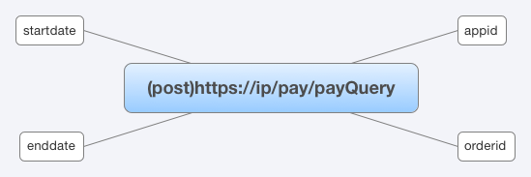

appid

orderid

startdate

enddate

预授权-解冻(insertCancelPreAuthorizedBill)
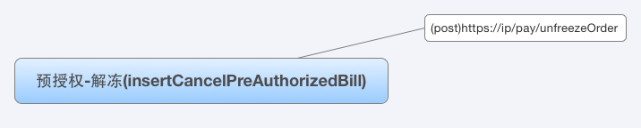

(post)https://ip/pay/unfreezeOrder
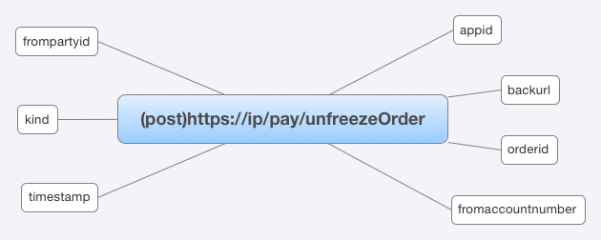

appid

backurl

orderid

fromaccountnumber

frompartyid

kind

timestamp

预授权-消费(insertPreAuthorizedConsumeBill)
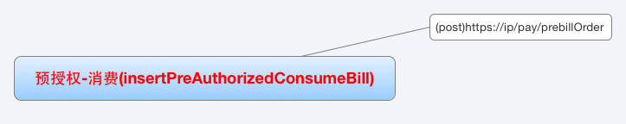

(post)https://ip/pay/prebillOrder
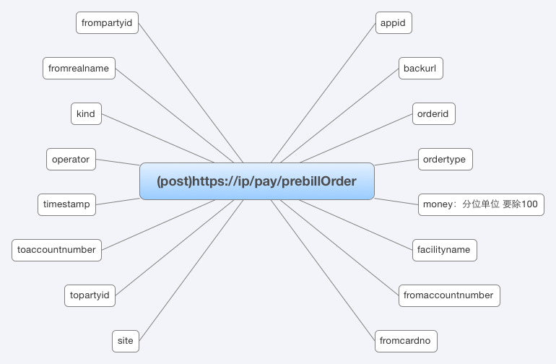

appid

backurl

orderid

ordertype

money：分位单位 要除100

facilityname

fromaccountnumber

fromcardno

frompartyid

fromrealname

kind

operator

timestamp

toaccountnumber

topartyid

site

消费查询(selectBillExistByBusinessNumber)
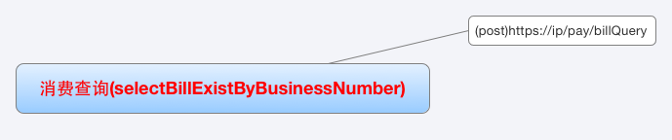

(post)https://ip/pay/billQuery
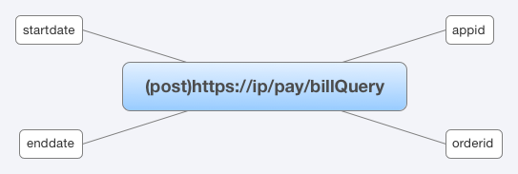

appid

orderid

startdate

enddate

