TASK OF C PROGRAMMING

Activity 1:The tools needed to run C program

* Dev C++
* Python
* VS code
* Jana
* Javascript

*The chosen one is called Dev c++*

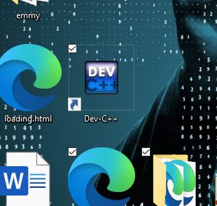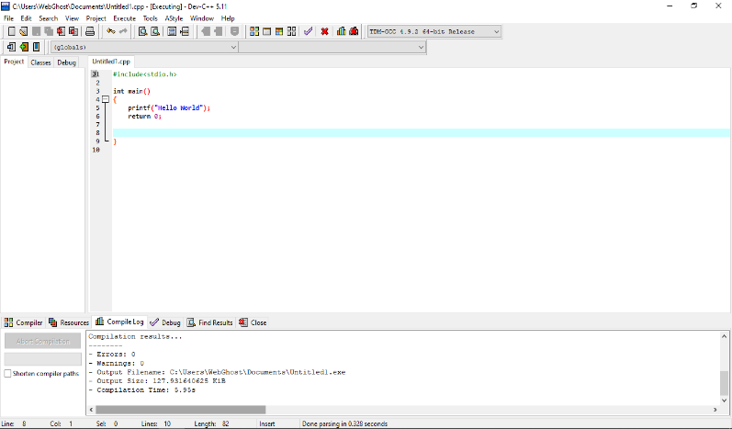

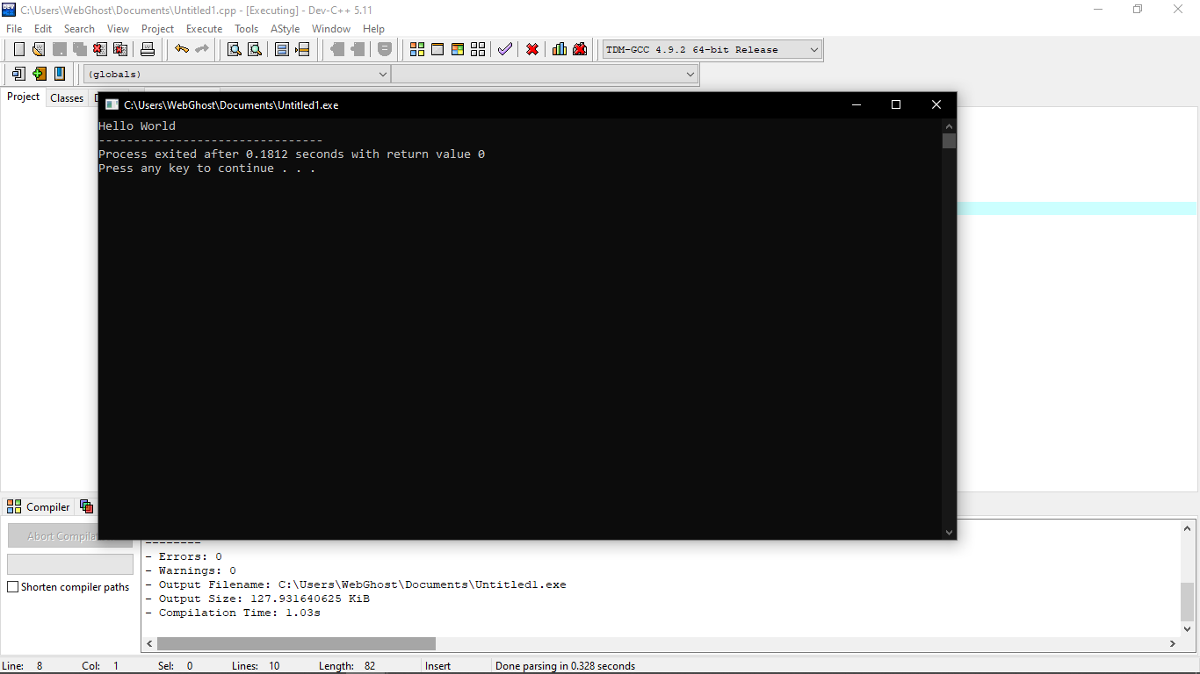

Activity 2:About Github

