BUSINESS PLAN

COMPANY DESCRIPTION
Company Name: BoardHub
Date of Establishment:
Founders: Jonas Lim, John Louise Cantina, Raven Jann P. Laran, Jetler Egido, Justin Endico
Location: Tunga-Tunga Maasin City Southern Leyte
Background:
BoardHub was established with the mission of making affordable and flexible boarding houses more accessible to students, professionals, and travelers. It was founded by a group of passionate entrepreneurs who envisioned a transparent and user-friendly platform to simplify the process of finding boarding houses.
Before turning into a full-fledged corporation, BoardHub began as a small directory service for local boarding houses in [City/Country]. Over time, the founders realized the potential of building a digital solution that seamlessly connects landlords with renters.
By 2025, BoardHub had officially grown into a corporation, receiving recognition for its innovation in improving the housing search experience. Today, BoardHub continues to expand its reach, helping people find secure, affordable, and convenient boarding accommodations.

PRODUCTS
Product Name: BoardHub Platform
Main Features:
- Property Listings: Comprehensive boarding house listings with filters for location, price, and amenities.
- User Reviews & Ratings: Real-time feedback from tenants to enhance trust and credibility.
- Map Integration: Interactive maps to view nearby properties.
- Booking System: Direct inquiry and booking with landlords.
- Payment Integration: Secure payment options for fees and deposits.
- Landlord Dashboard: Management tools for property listings, inquiries, and bookings.
Product Description:
The BoardHub platform connects tenants (students, young professionals, travelers) with landlords who offer boarding houses. It provides a simple and intelligent search engine for tenants while empowering landlords with tools to manage their properties effectively. The result is a more transparent, reliable, and accessible rental process for both parties.
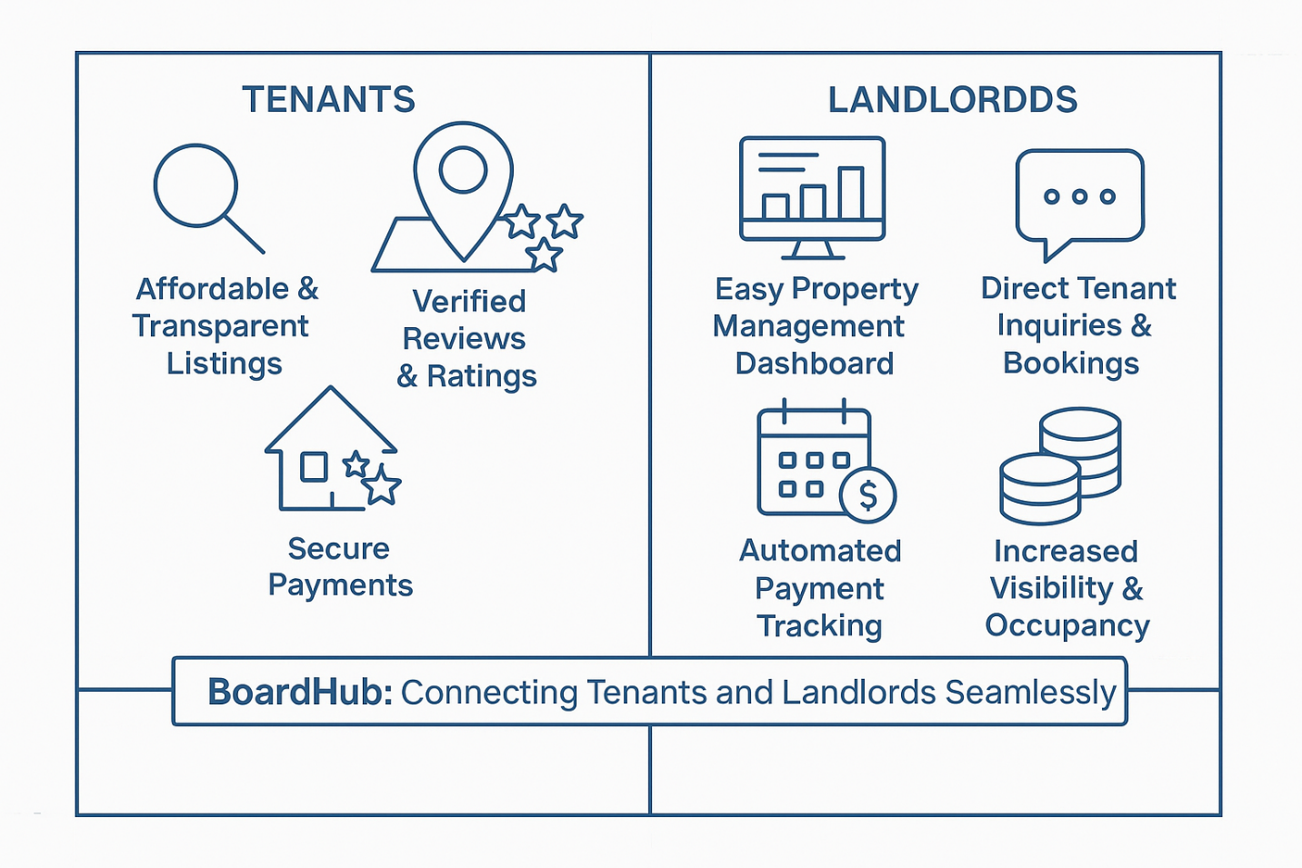

MARKET ANALYSIS
Current Market:
BoardHub operates in the growing housing sector, focusing on boarding houses as a cost-effective and flexible option for students, professionals, and travelers. With the rise of digital property platforms, BoardHub positions itself as a specialized solution that prioritizes convenience, affordability, and trust.
Competitors:
- Craigslist: Offers general classifieds with limited search filters.
- Facebook Marketplace: Large audience reach but lacks features tailored for housing.
- Airbnb: Focused more on short-term stays than long-term boarding houses.
- Local Real Estate Websites: Provide general rentals but not specialized in boarding houses.
Competitive Edge:
BoardHub differentiates itself by specializing in boarding houses, offering detailed listings, transparent tenant reviews, and landlord management tools—all in one dedicated platform.
Target Market:
- Students: Affordable housing near schools and universities.
- Young Professionals: Flexible, budget-friendly accommodations near workplaces.
- Travelers/Expatriates: Mid- to long-term housing options in urban areas.
The platform will be marketed in cities with a high density of universities, corporate offices, and expat communities. Accessibility will be ensured through both web and mobile apps.

STRATEGY AND IMPLEMENTATION
Product Workflow:
- User visits the website or mobile app.
- Searches for boarding houses using filters (location, price, amenities, etc.).
- Views detailed listings with photos, maps, and reviews.
- Makes an inquiry or books directly through the platform.
- Payment is processed securely through integrated payment options.
- Landlords manage their properties through their dashboard, responding to inquiries and tracking bookings.
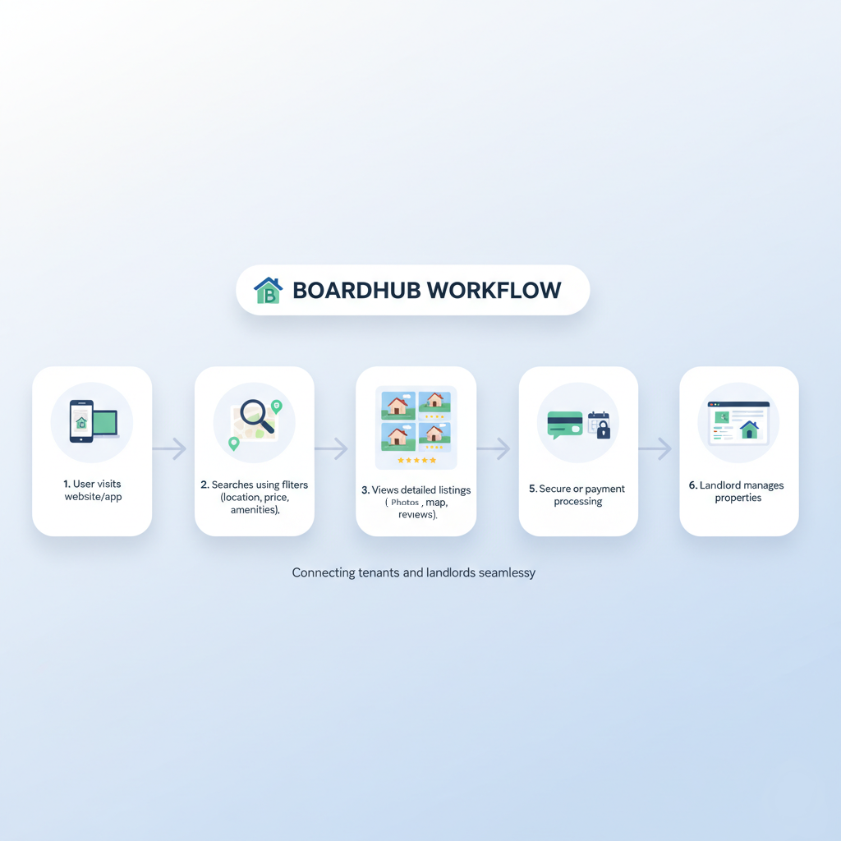

Promotions:
To build visibility and user adoption, BoardHub will implement:
- Social Media Presence:
  - Facebook: facebook.com/boardhub
  - Instagram: User stories, property highlights, and reels.
  - LinkedIn: Professional campaigns targeting young professionals.
- Influencer Marketing: Collaborations with student leaders and lifestyle influencers.
- SEO & Content Marketing: Blogs and guides about student housing, budget tips, and relocation.
- Partnerships: Tie-ups with universities, relocation agencies, and student organizations.
- Digital Ads: Paid ads on Google, Facebook, and Instagram to reach target users.

MANAGEMENT TEAM
- Founder/CEO:
Oversees company direction, partnerships, and growth.
- Chief Technology Officer (CTO):
Leads development, ensuring scalability, usability, and security of the platform.
- Marketing Director:
Creates and executes marketing campaigns to drive adoption and retention.
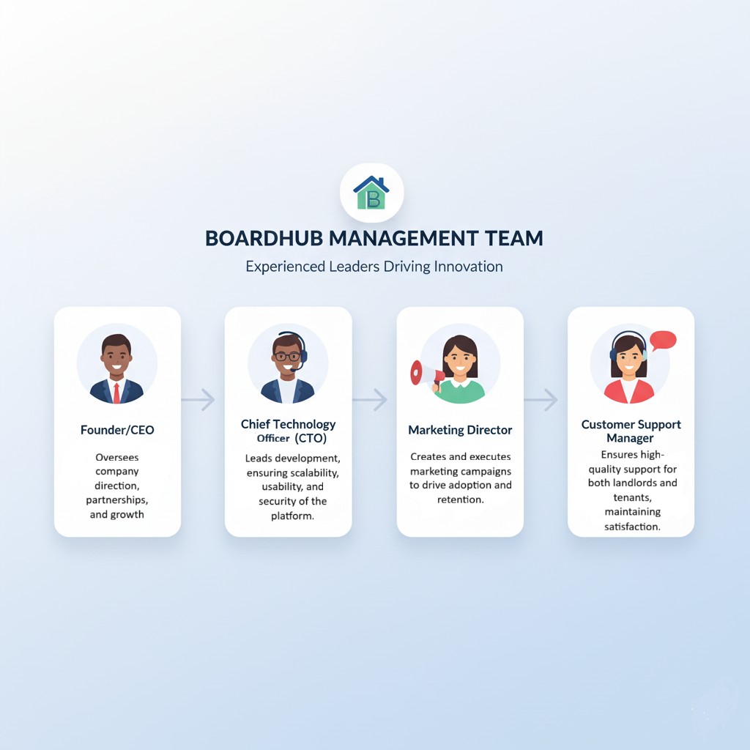
- Customer Support Manager:
Ensures high-quality support for both landlords and tenants, maintaining satisfaction.

FINANCIAL PLAN
First Batch (Beta Release):
Item | Description | Estimated Cost (₱)
Domain & Hosting | 1-year website setup | ₱2,000
Marketing | Posters, Facebook boosts | ₱1,000
Transportation | For checking listings | ₱500
Miscellaneous | Small expenses | ₱500
Total Startup Cost |  | ₱4,000

Profit and Loss:
Category | Description | Amount (₱)
Revenue | Listing and premium fees | ₱3,000 / month
Expenses | Internet, maintenance, marketing | ₱2,000 / month
Net Profit | ₱1,000 / month (₱12,000 / year)

Summary:
BoardHub expects to break even in around 4–6 months with steady listing growth and low operational costs.

Cash Flow Projections:

Year 1 – Launch and Beta Testing:
Description | Calculation | Estimated Income (₱)
Listing Fees | 20 landlords × ₱100 × 6 months | ₱12,000
Premium Listings | 10 premium listings × ₱200 × 6 months | ₱12,000
Referral Fees | 10 matches × ₱50 × 6 months | ₱3,000
Total Revenue (Year 1) |  | ₱27,000
Expenses | Domain, hosting, ads, transport, maintenance | ₱20,000
Net Profit |  | ₱7,000

Year 2 -
Description | Calculation | Estimated Income (₱)
Listing Fees | 50 landlords × ₱100 × 12 months | ₱60,000
Premium Listings | 20 listings × ₱200 × 12 months | ₱48,000
Referral Fees | 25 matches × ₱50 × 12 months | ₱15,000
Total Revenue (Year 2) |  | ₱123,000
Expenses | Marketing, hosting renewal, small upgrades | ₱40,000
Net Profit |  | ₱83,000

Year 3 -
Description | Calculation | Estimated Income (₱)
Listing Fees | 100 landlords × ₱100 × 12 months | ₱120,000
Premium Listings | 40 listings × ₱200 × 12 months | ₱96,000
Referral Fees | 40 matches × ₱50 × 12 months | ₱24,000
Total Revenue (Year 3) |  | ₱240,000
Expenses | Upgraded tools, stronger marketing, events | ₱70,000
Net Profit |  | ₱170,000

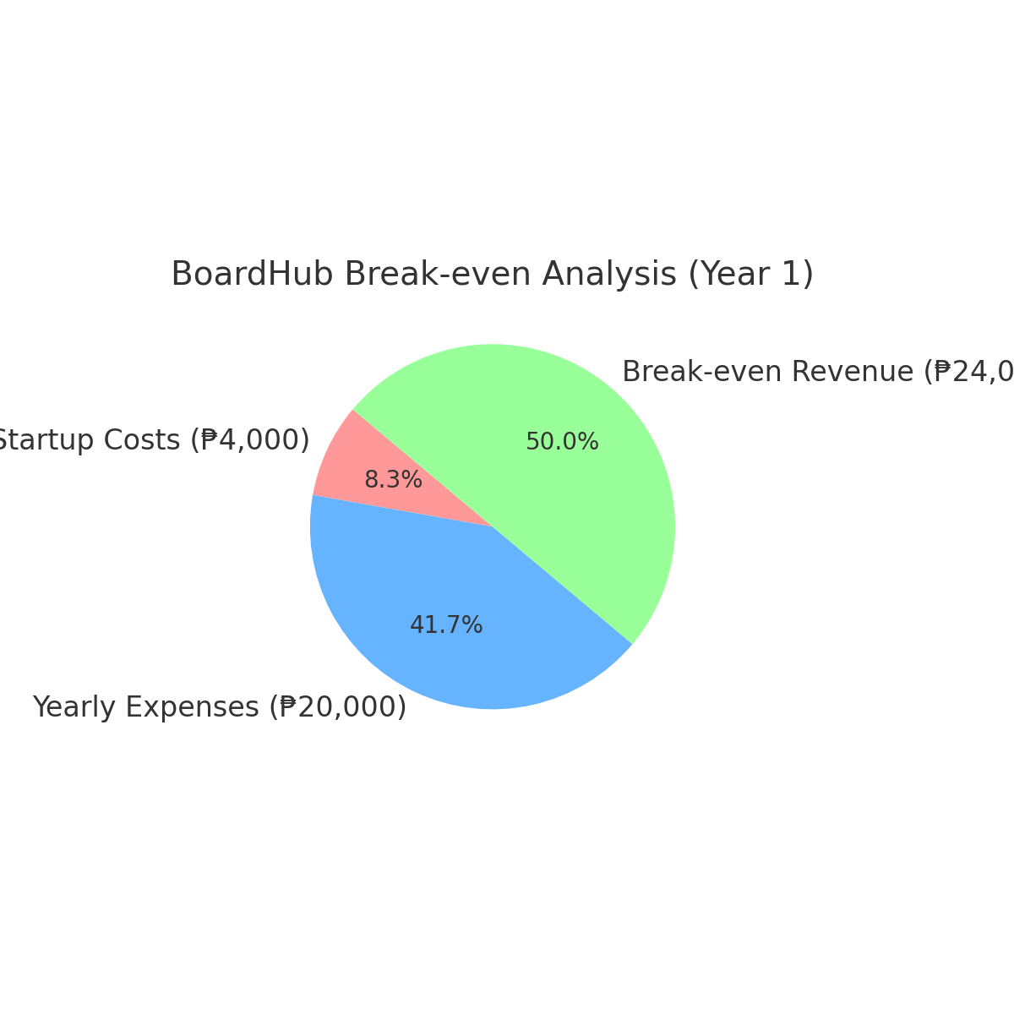
Break-Even Analysis:

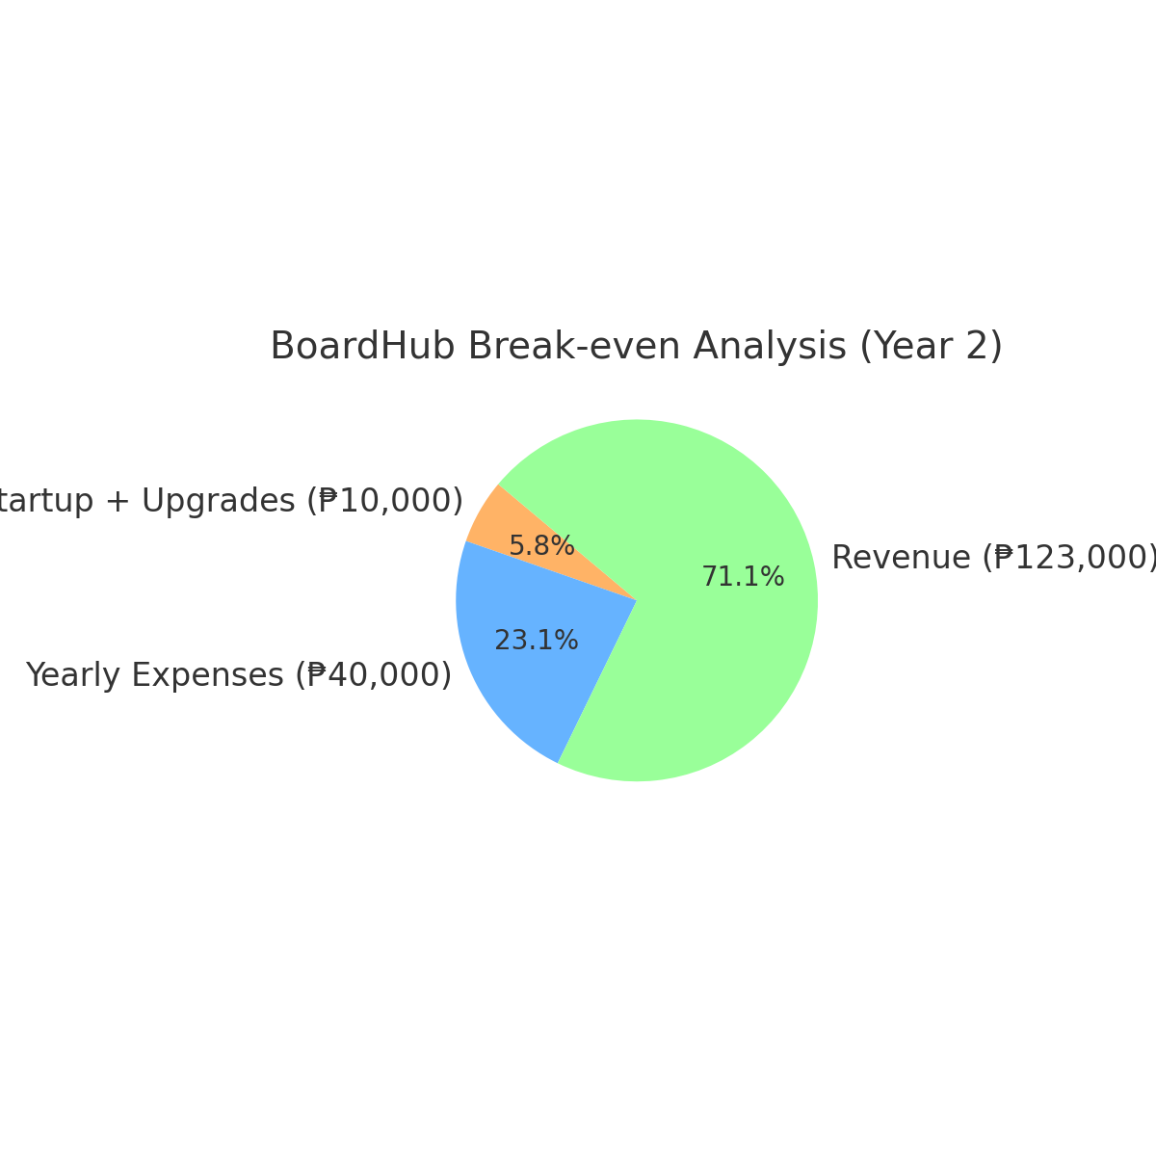
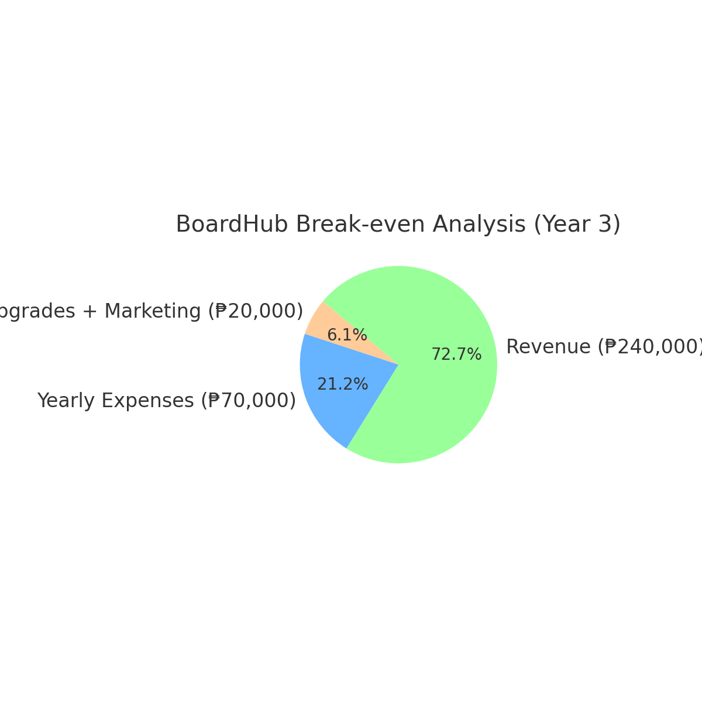

ASSUMPTIONS:
- Low Startup Capital:
The team operates with minimal funding (₱4,000–₱10,000), covering basic web hosting, marketing, and materials.
- Self-Development:
Website creation, marketing, and operations are handled by student founders using free or low-cost tools like WordPress, Canva, and Google Workspace.
- Organic Growth:
User base and listings grow naturally through social media sharing, word of mouth, and school partnerships, not paid ads.
- Affordable Services:
Listing fees and premium features remain budget-friendly (₱100–₱200) to attract student landlords and small renters.
- Gradual Revenue Increase:
Income is expected to increase by 50–100% yearly as more landlords join and premium listings grow.
- Stable Monthly Costs:
Operating expenses (₱2,000–₱3,000/month) remain low due to minimal staff and digital tools.
- Break-even Timeline:
BoardHub is projected to break even within 4–6 months, with sustained profitability starting in Year 2.

