

Saint Joseph College
College of Computer Studies
Maasin City, Southern Leyte

Final Project
in
Human Computer Interaction - 2
Interface Design
Maasin ByaheNow App

Conceptual Designers:
Camille Barola
John Eric Palarca
Joymay Anne Lador

Instructor: Marnuld F. Climaco

Title Page: Maasin ByaheNow App
Names of Designers: Camille Barola, John Eric Palarca, Joymay Anne Lador

Introduction

Interface design in human-computer interaction refers to the process of creating the visual and functional layout of software or devices, focusing on how users interact with the system to ensure it is intuitive, aesthetically pleasing, and efficient. It involves elements like buttons, menus, and layouts that serve as the point of contact between humans and computers, emphasizing style and usability to enhance the overall user experience.

To gather data and information regarding the present transportation system in Maasin City, we collected insights from various sources. From the end users (UI perspective), we interviewed commuters such as students and daily workers who face delays in flagging tricycles or multicabs on the street. From customers or clients, we surveyed residents and visitors about their commuting challenges, including lack of real-time tracking and seat availability information. From supervisors or heads in departments (as UX experts), we consulted local transportation operators and government officials in the transport sector to understand operational inefficiencies, such as drivers' idle time and fuel wastage due to unnecessary roaming.

Interaction Design (IxD) is the practice of designing interactive digital products, environments, systems, and services, focusing on creating meaningful dialogues between users and the system. It goes beyond static interfaces by emphasizing how users engage with the product through actions and responses. Interactive Design involves achieving goals within constraints and trade-offs, where a trade-off means sacrificing one feature, such as advanced customization, to prioritize another, like simplicity, due to limitations in time, cost, or user needs. It requires understanding the raw materials: computers (with their processing power and interfaces) and humans (with cognitive and physical capabilities). Additionally, it entails accepting limitations of humans in design, such as prone to misremembering observations, mixing emotions with senses, irritability, and cognitive load constraints, which can lead to errors if not accounted for. For example, in Maasin ByaheNow, we designed engaging buttons and icons for ride requests, ensuring an intuitive interactive system that minimizes user frustration during peak hours.

Documentation Process

The documentation process for Maasin ByaheNow began with initial research into Maasin City's transportation challenges, including interviews with commuters and drivers to identify pain points like long wait times and inefficient routing. We then conducted user analysis by creating personas for target groups, such as students needing quick campus rides and drivers seeking to maximize earnings. This led to ideation sessions where we brainstormed features like real-time tracking and optimized routes. Following that, we developed wireframes and prototypes, iterating based on feedback to refine the user interface. Finally, we reached the implementation stage by outlining the app's technical stack, including React Native for the frontend and integration with maps APIs, ensuring alignment with our financial and market plans. Throughout, we documented each step with notes, sketches, and user feedback logs to maintain a clear progression toward a user-centered solution.

Showcases Stages

Loading Screen Sign Up page for Passengers
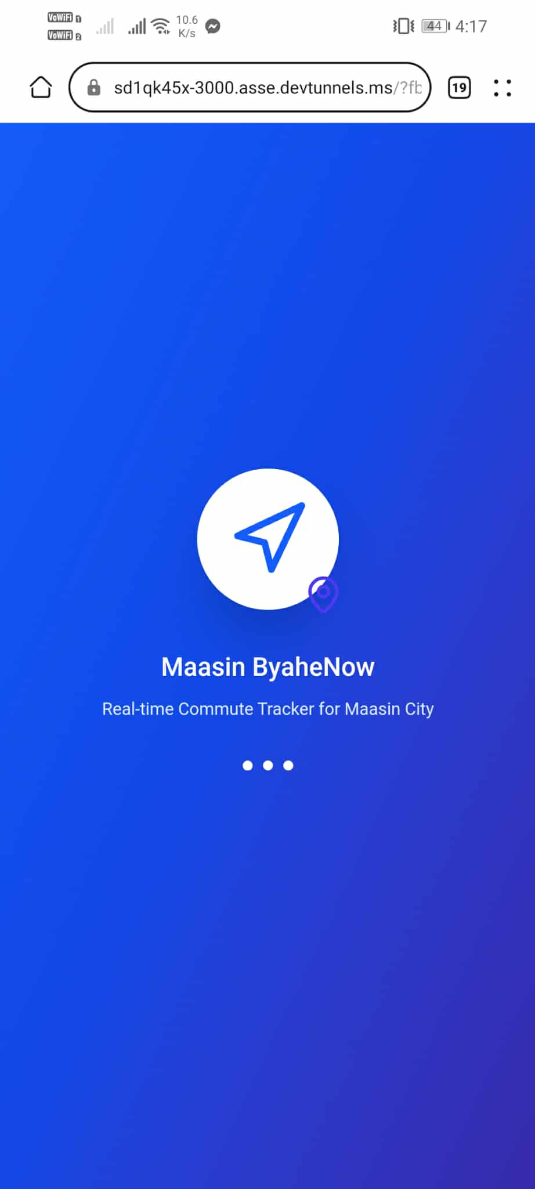
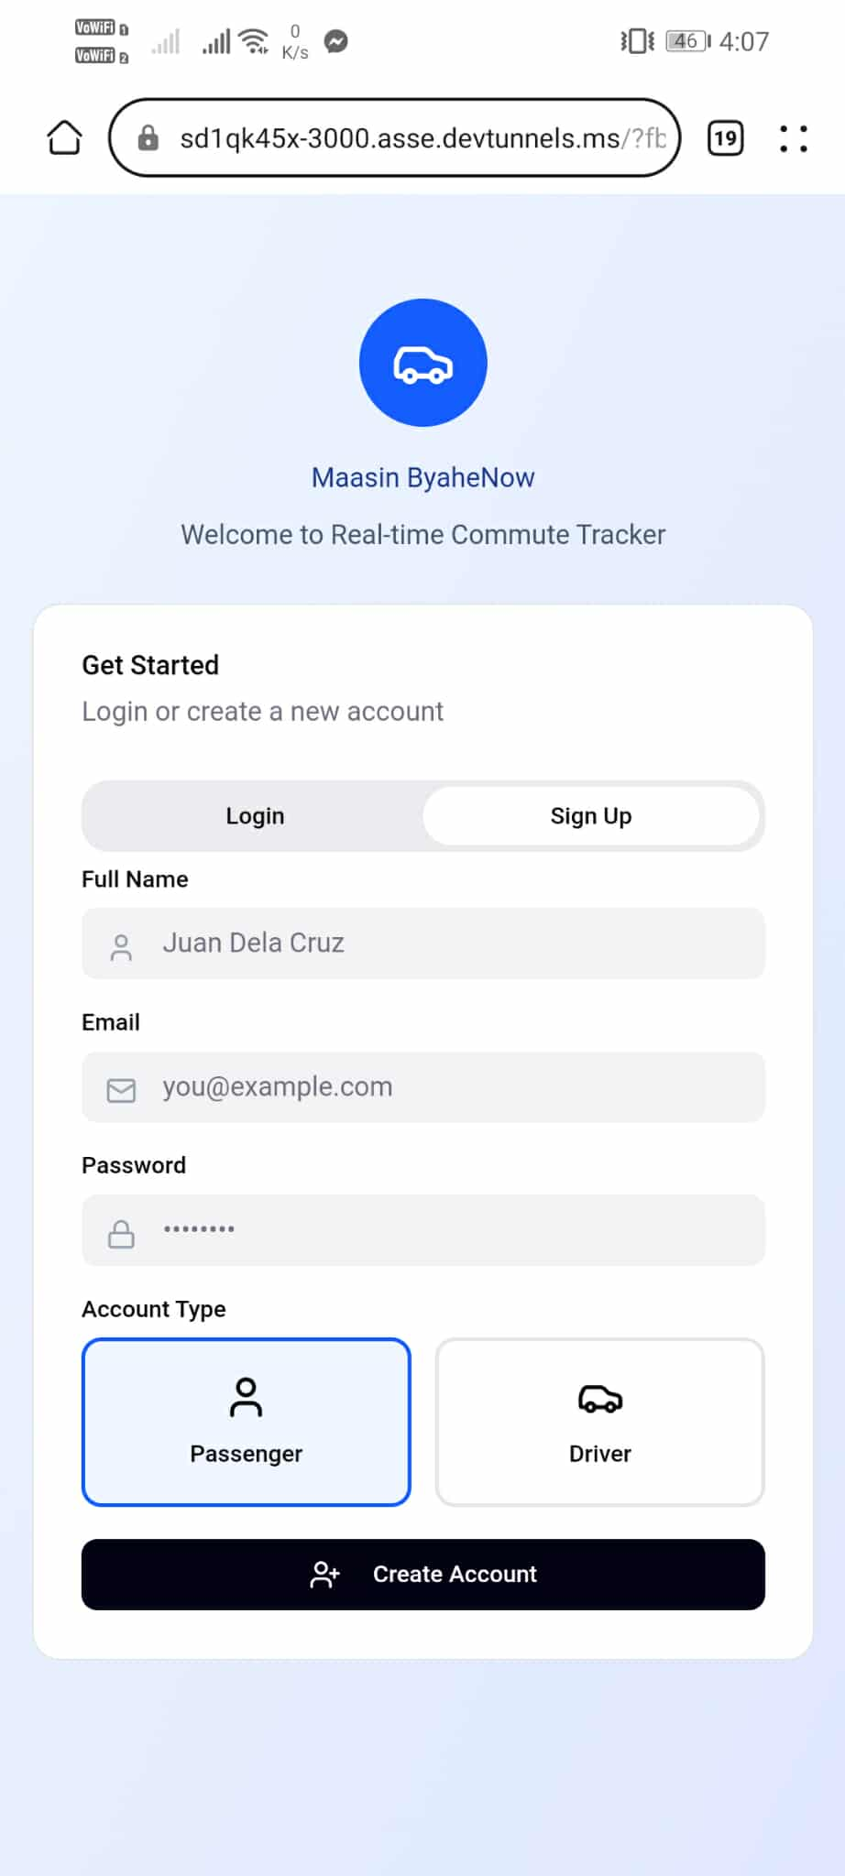

Sign Up page for Drivers Login Page
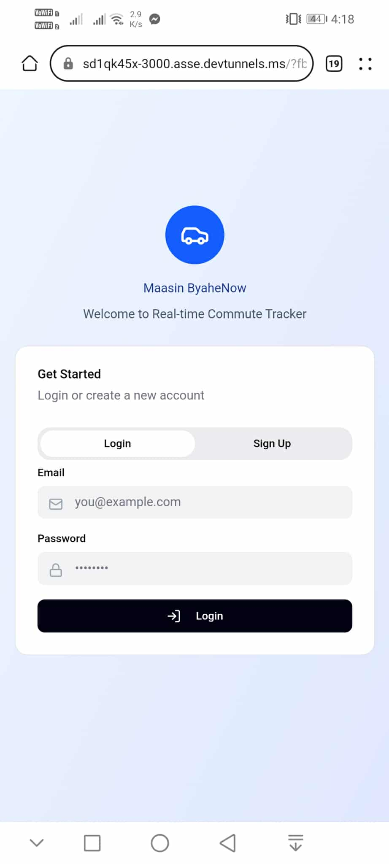
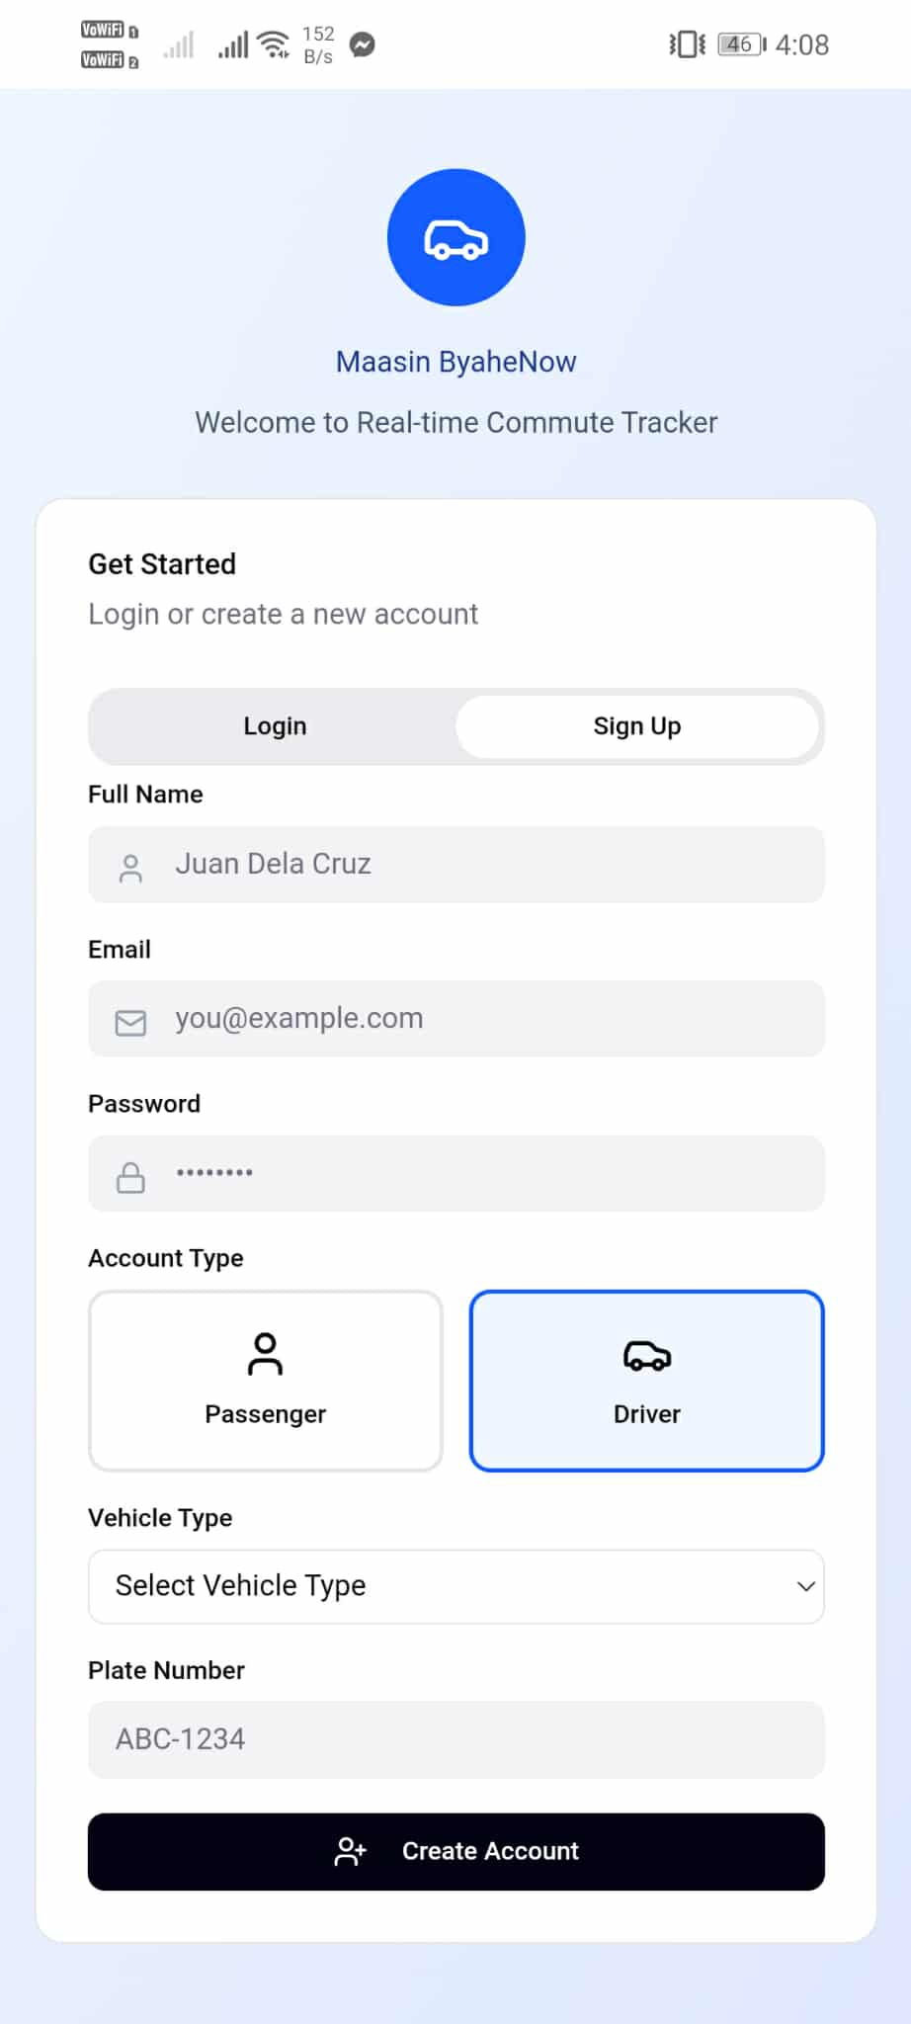

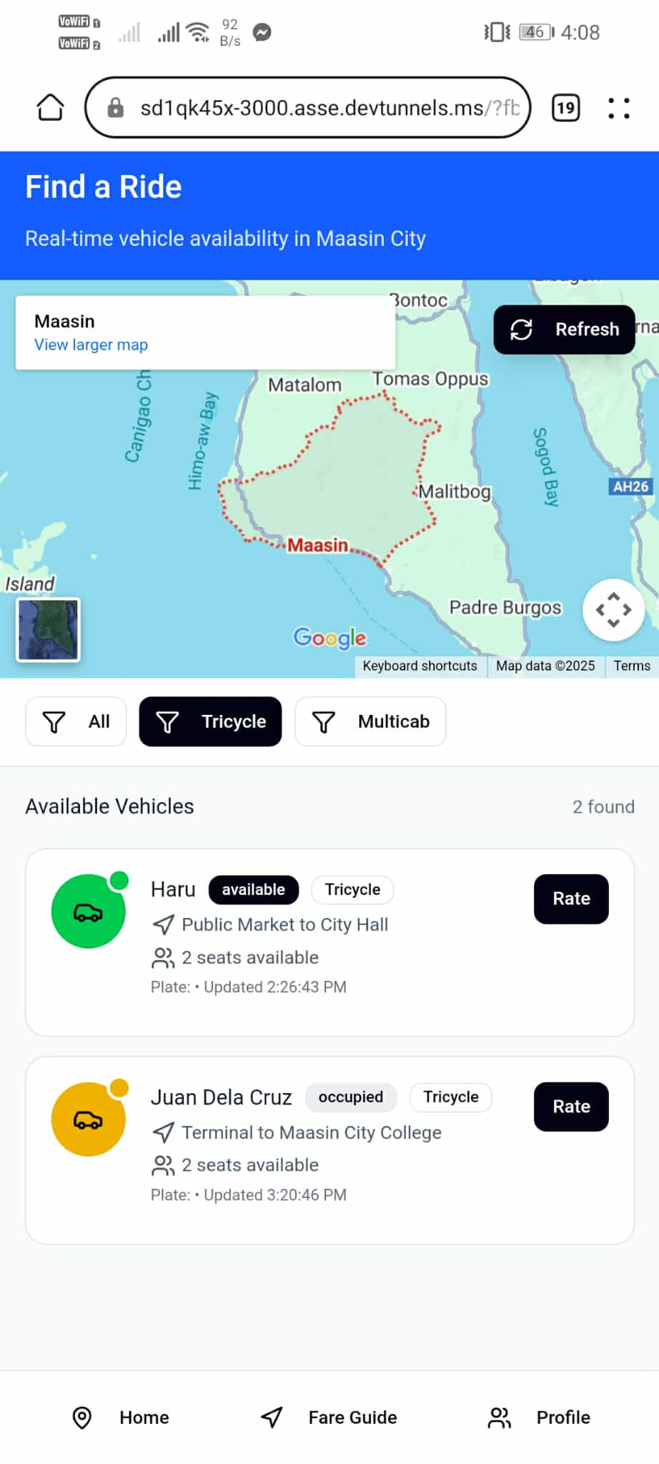
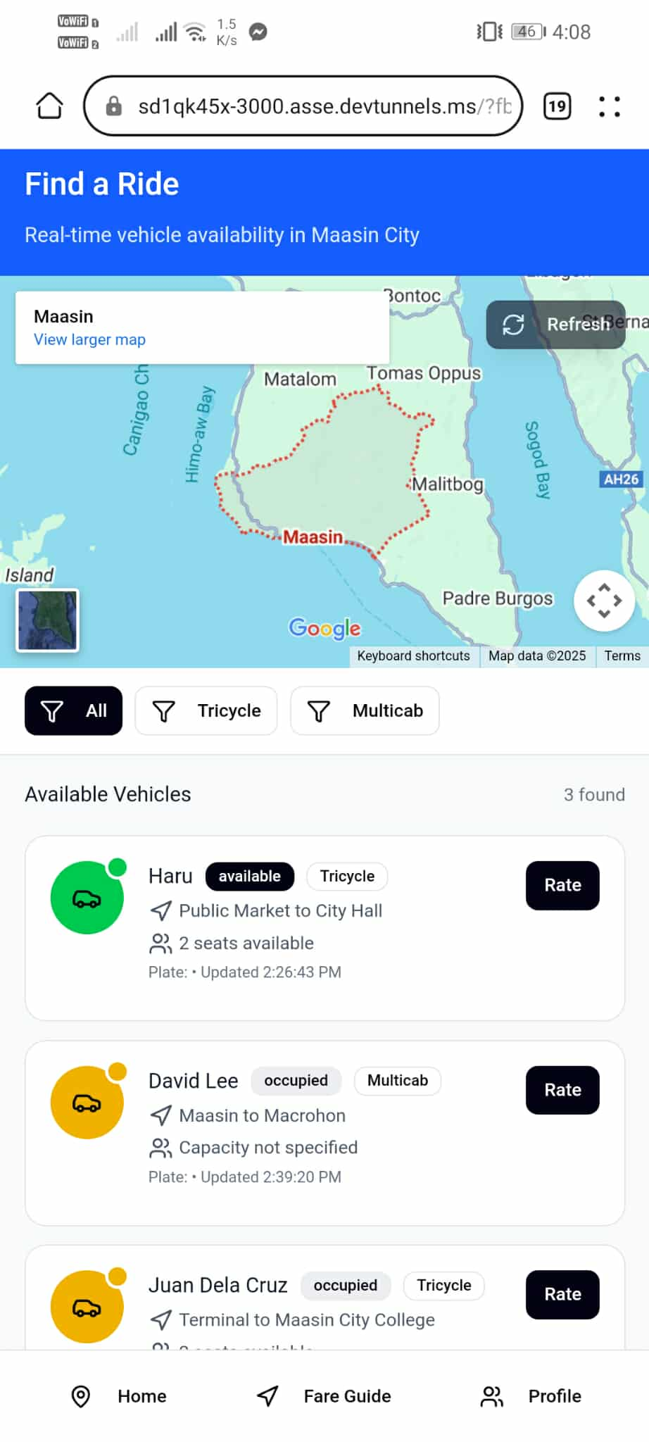
Passengers Home Page Tricyle Available

Multicab Available Passenger Tricyle Fare Guide
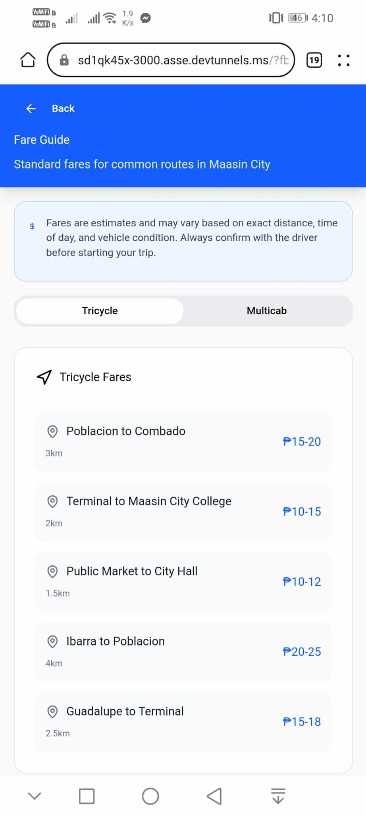
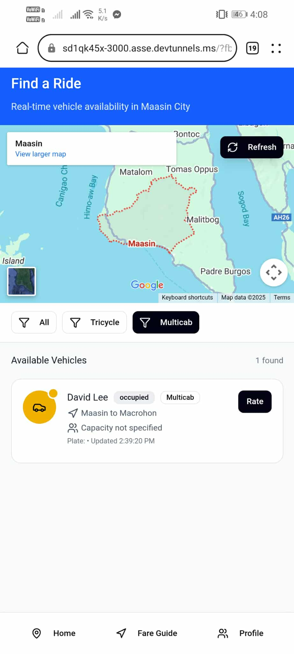

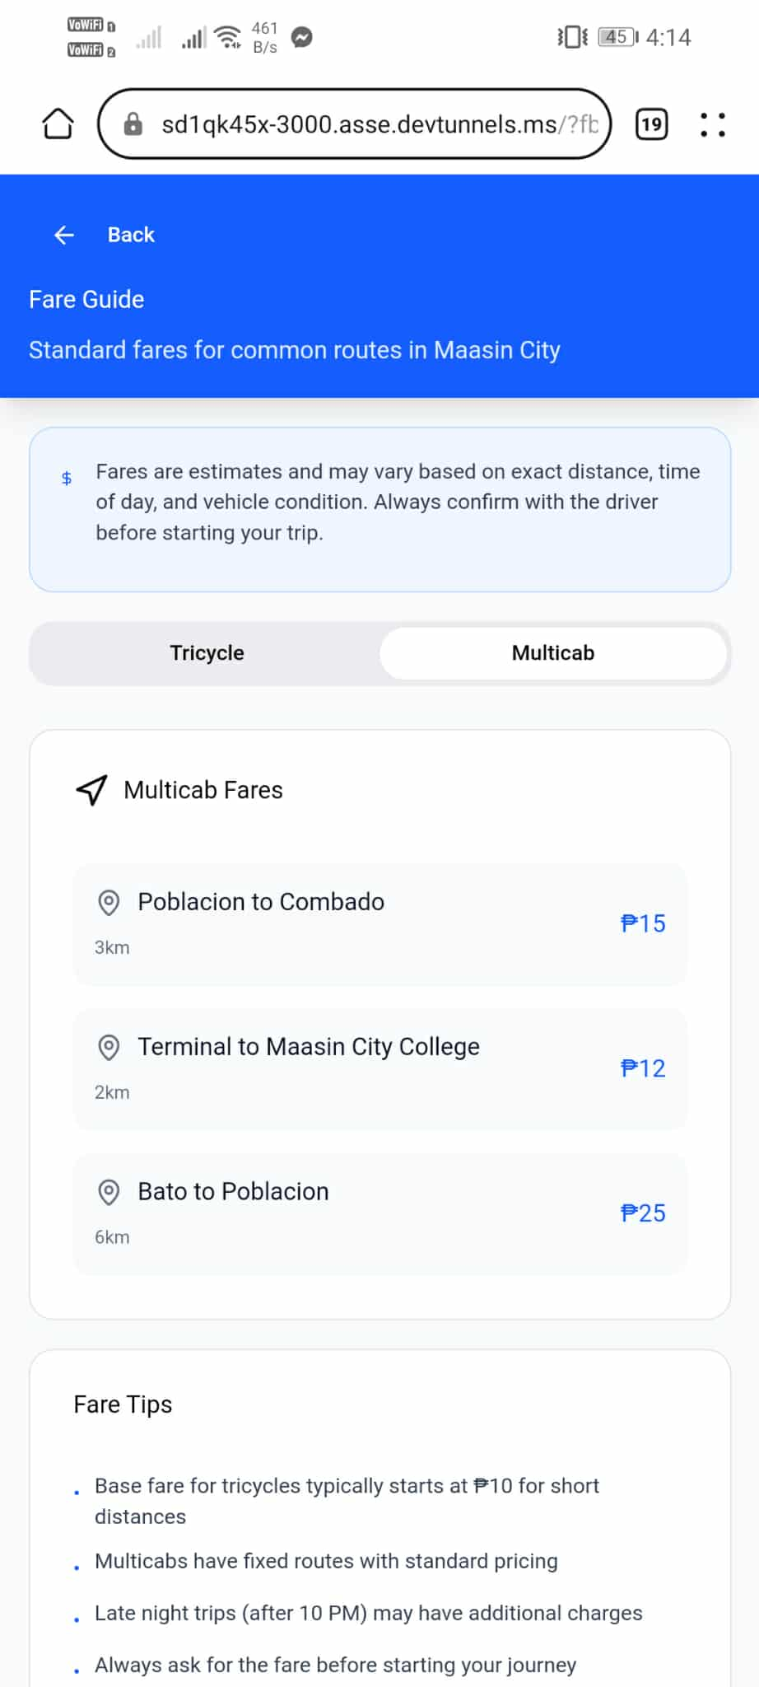
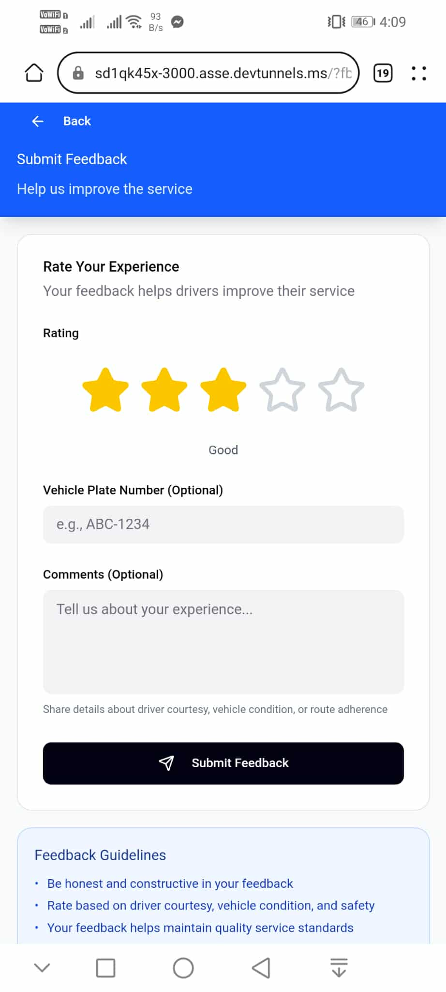
Passenger Multicab Fare Guide Feedback

Feedback Submitted Passenger Profile

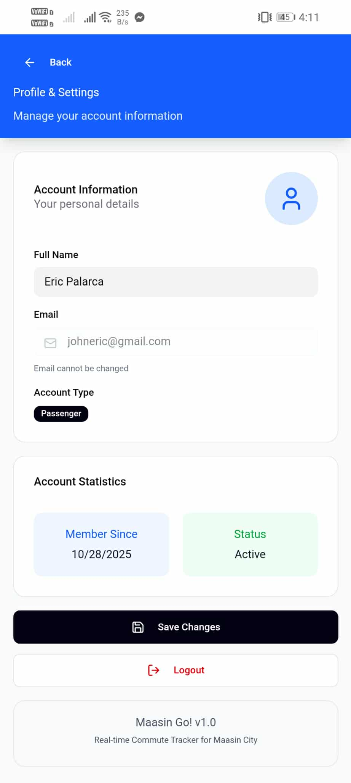
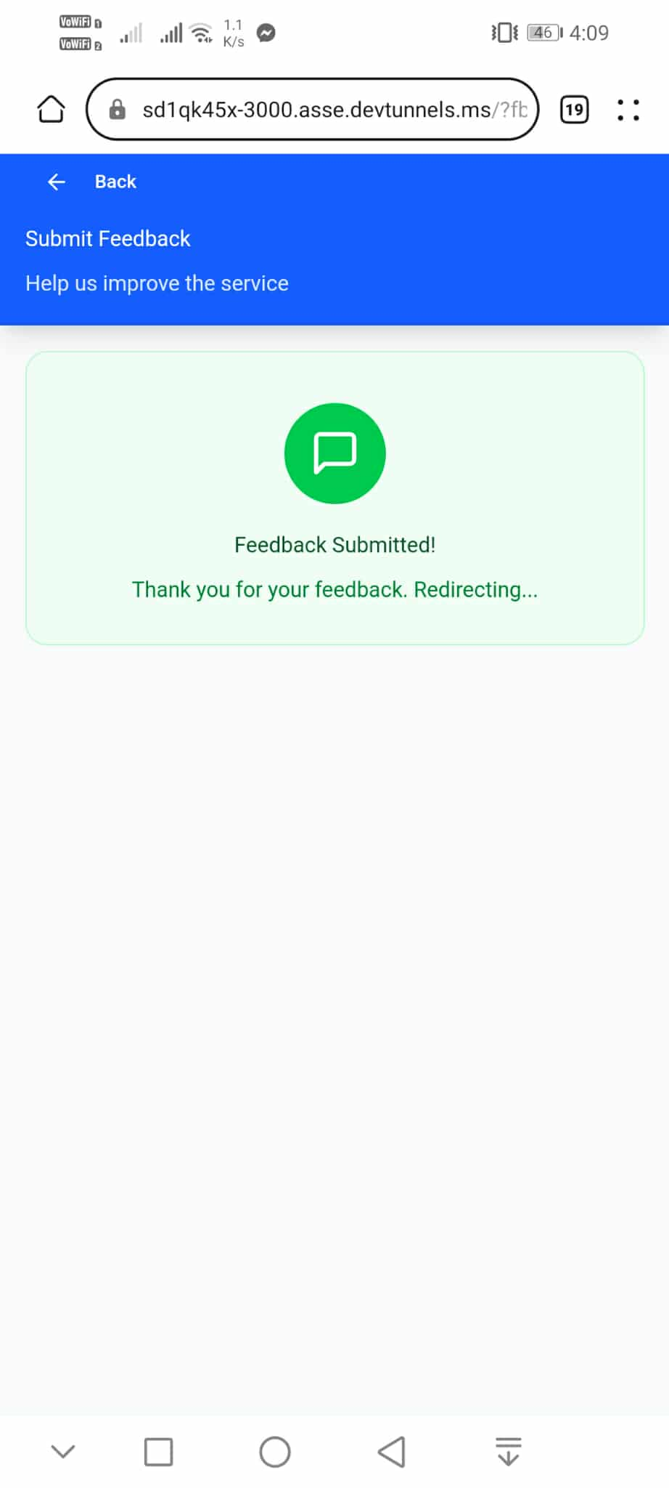

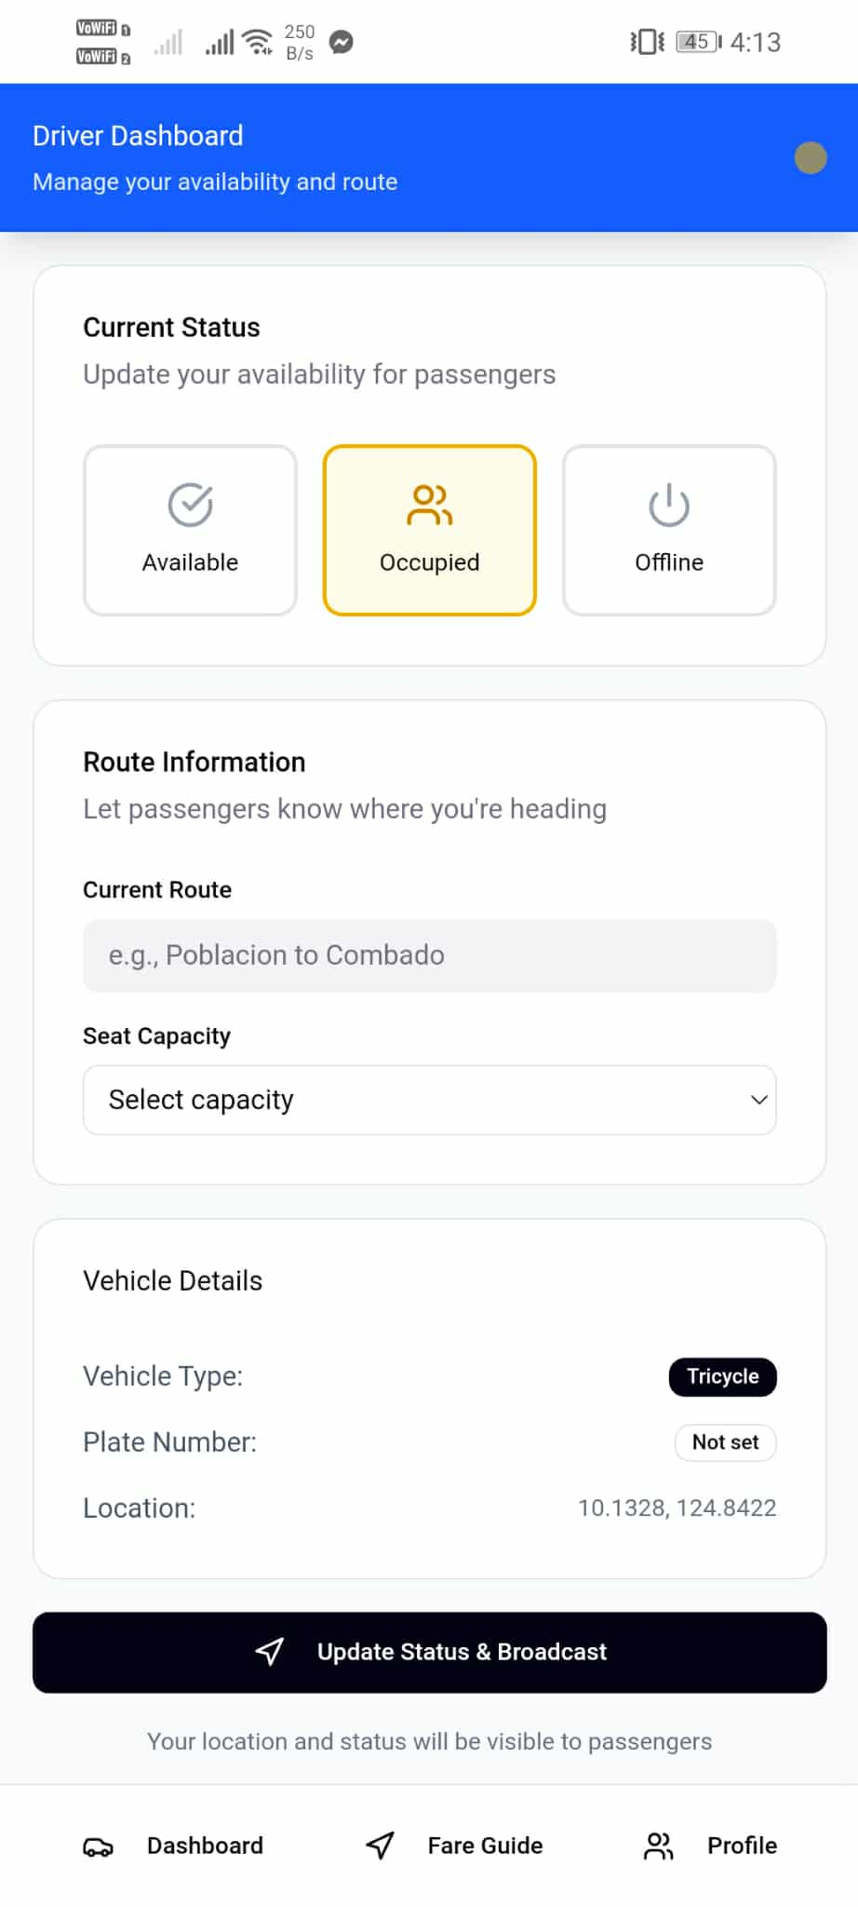
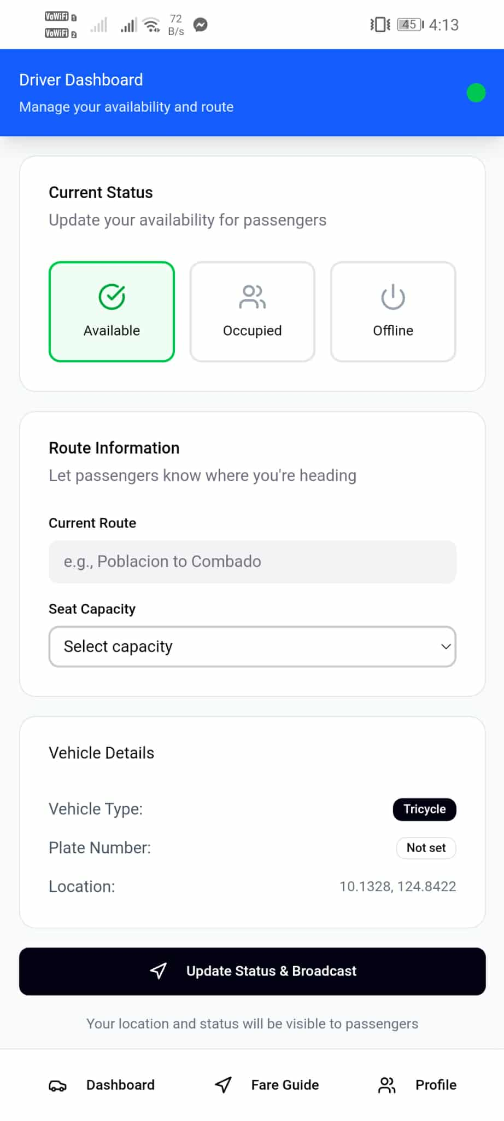
Drivers Home Page
Status - Available Status - Occupied

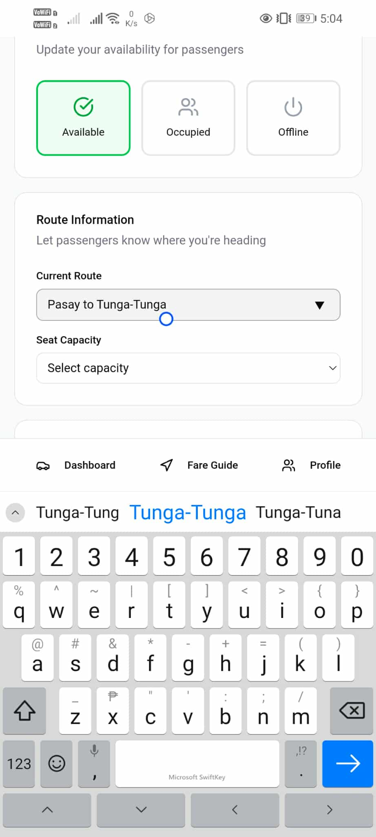
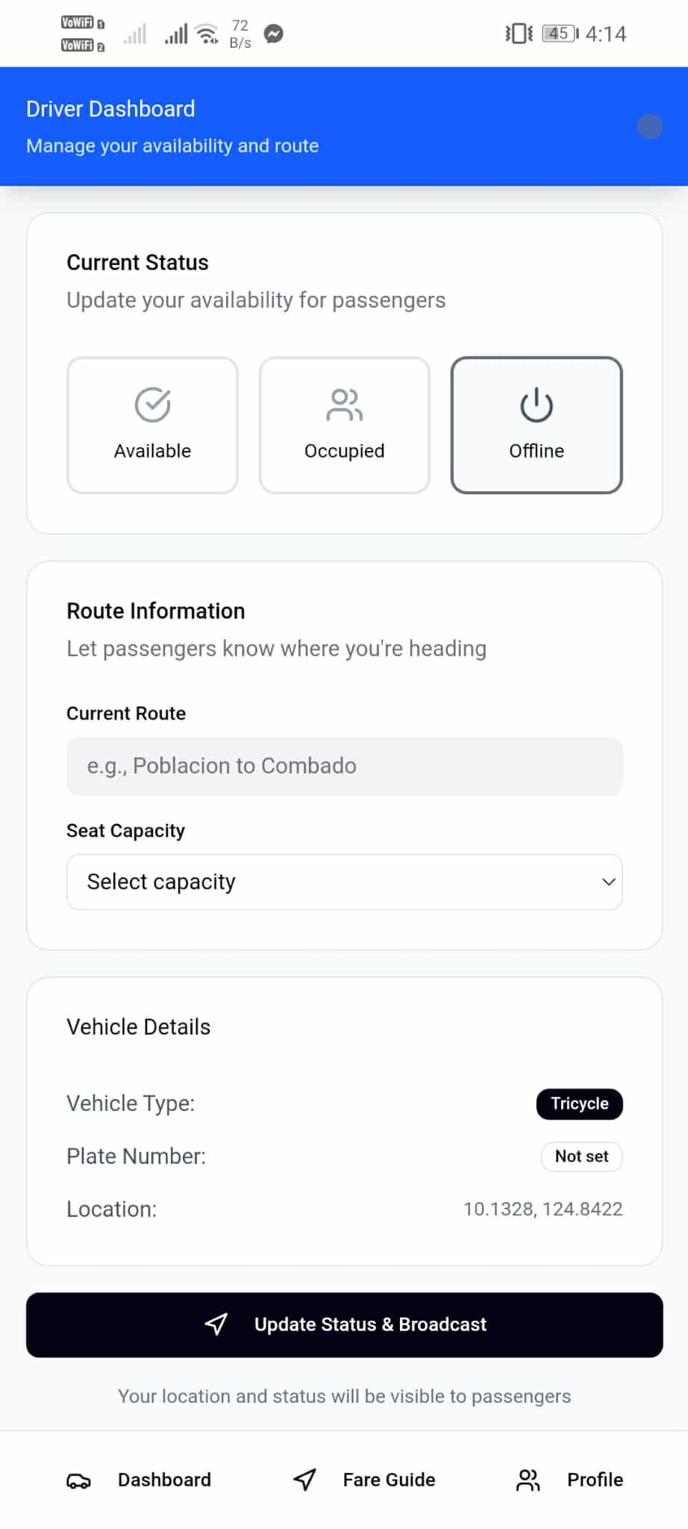
Status – Offline Route Selector

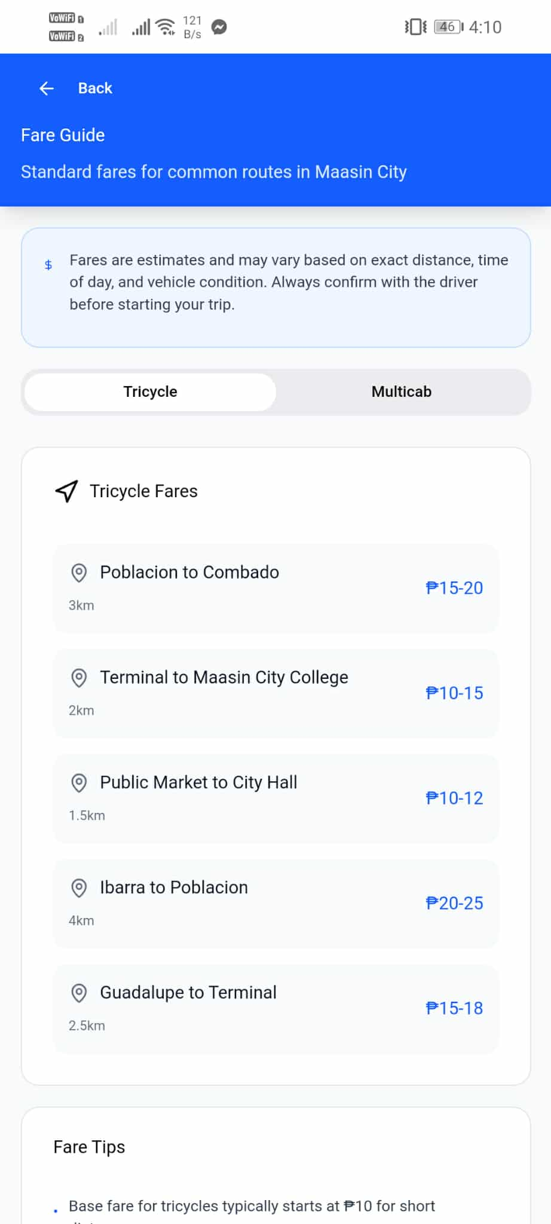
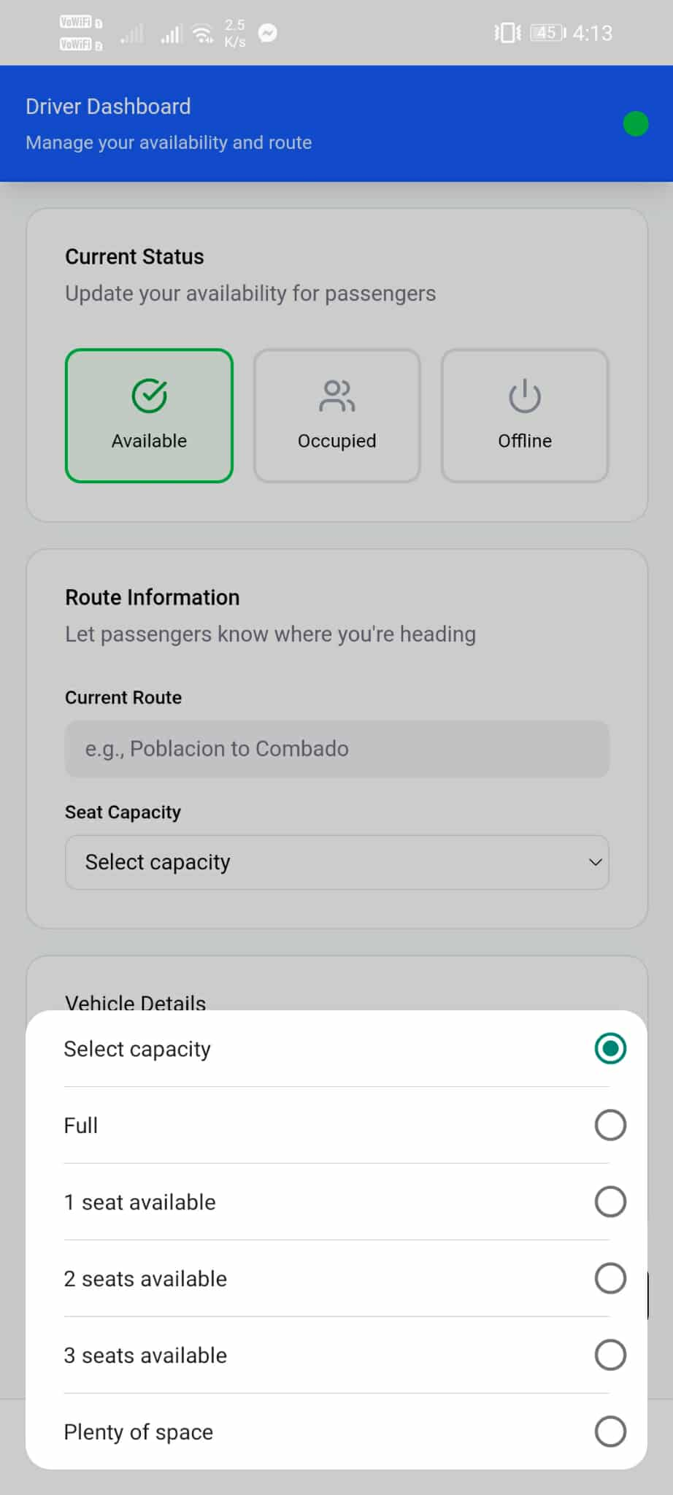
Capacity Selector Drivers Tricyle Fare Guide

Drivers Multicab Fair Guide Drivers Profile
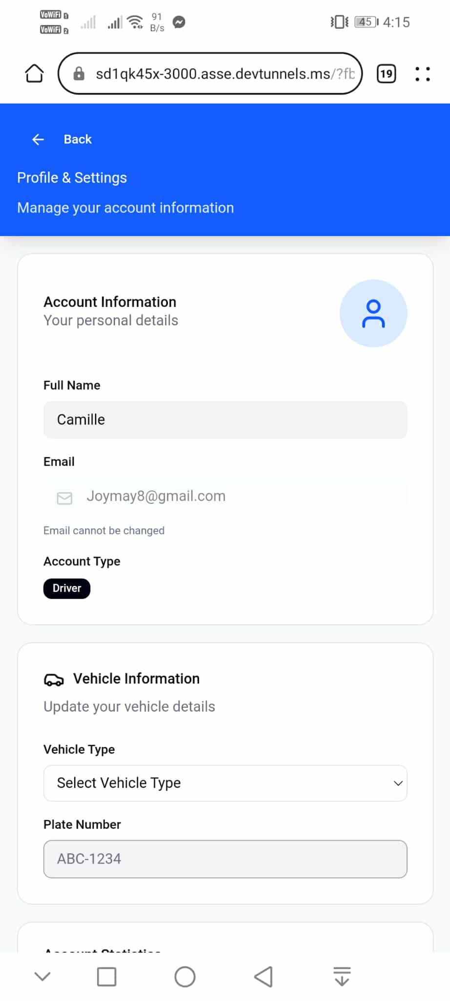
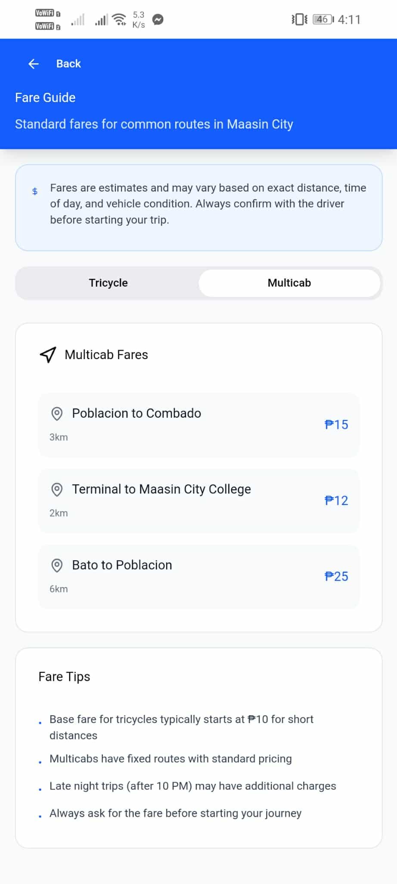
Visualizing the Human-Computer Interaction (HCI) design process typically involves representing the stages of a user-centered design (UCD) approach. This iterative process, also known as design thinking, ensures products are designed with user needs at the forefront.

Stages:
1. Empathize: Understand the users. For Maasin ByaheNow, we empathized by conducting interviews and observations with commuters in Maasin City, revealing frustrations with unpredictable wait times for tricycles and multicabs, especially for students during school hours and residents in public markets.
2. Define: State the user's needs. Based on our design, we defined key needs such as real-time ride availability for passengers to reduce delays and route optimization for drivers to minimize fuel costs and idle time.
3. Ideate: Challenge assumptions and create ideas. Designers brainstorm and generate a wide range of creative solutions for the problem statement. The problem statement came from user interviews, questionnaire responses (e.g., surveys on commuting habits), and observations, leading to ideas like in-app promotions and loyalty points to encourage adoption.
4. Prototype: Start to create solutions. This phase involves turning ideas into tangible artifacts that can be tested and evaluated. For our app, we created initial wireframes for commuter and driver interfaces, focusing on simple booking flows and real-time maps.
Demonstrate the Final Design

Mockups are realistic, static models or renderings of a design or product that showcase what the final outcome will look like. Designers use them to present and test their visual concepts in real-world settings without having to build a fully functional product.

For Maasin ByaheNow, the final design includes a user-friendly mobile interface with a map-centric home screen for commuters to request rides, real-time tracking, and driver profiles. Drivers have dashboards for accepting requests and viewing earnings. These are presented within mockups on smartphone screens to simulate real application use in Maasin City.

SUMMARY

Maasin ByaheNow represents a tailored solution to Maasin City's transportation inefficiencies through thoughtful interface and interaction design. By incorporating user-centered stages from empathy to prototyping, we created an app that connects commuters and drivers seamlessly, reducing wait times and boosting productivity. The final mockups demonstrate a practical, intuitive system ready for implementation, contributing to local mobility and economic growth.

