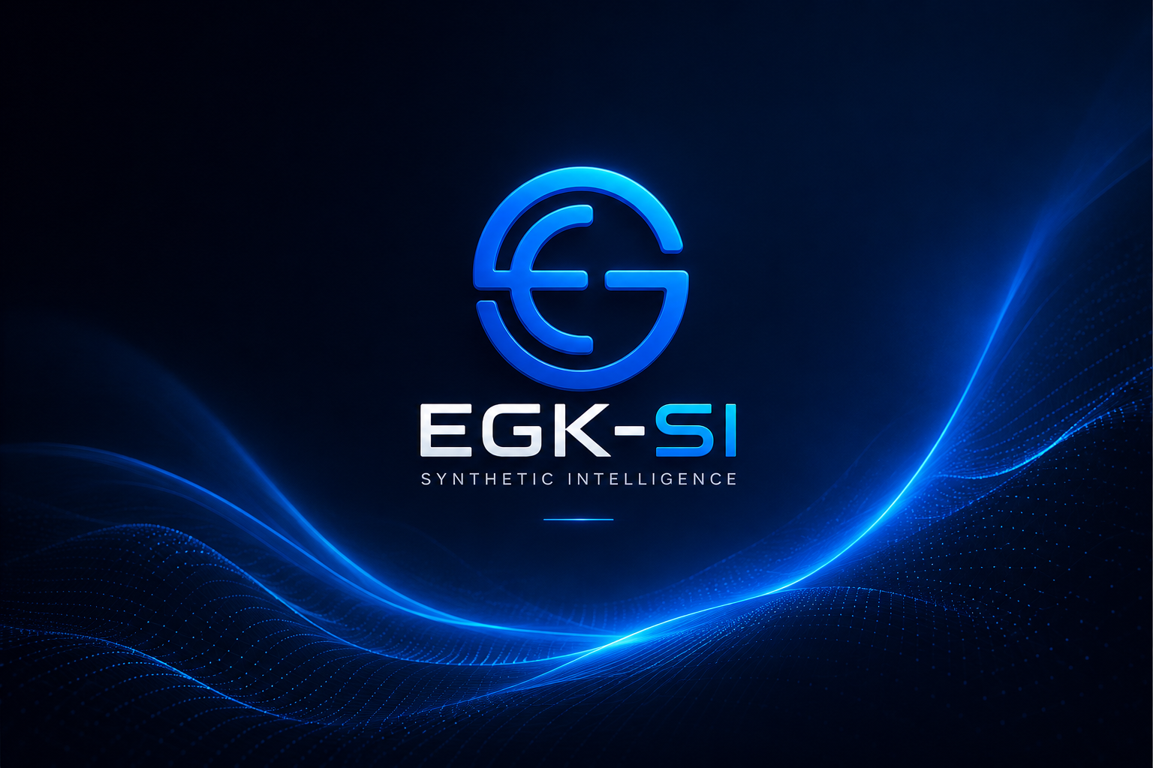
EGK-SI
SYNTHETIC INTELLIGENCE
Official Documentation & User Manual

EGK Microelectronic Solutions Group Sdn. Bhd.
Diamond Valley Industrial Park, Bukit Mertajam, Penang, Malaysia
Reg. No. 202501002992 | sales@egkhor.com.my | egkhor.com.my
Version 0.1.0-ALPHA | Build 2026.05 | Isaac Khor Eng Gian, Founder & CEO

Table of Contents
Chapter 1 — What Is EGK-SI? 3
1.1 The Intelligence Continuum: AI → AGI → SI → Quantum 3
1.2 Why Synthetic Intelligence Matters 3
1.3 EGK's Position in the SI Landscape 4
Chapter 2 — Cognitive Architecture 5
2.1 The Five Cognitive Layers 5
2.2 Memory Architecture 5
2.3 Three-Tier AI Backend (The Cognition Stack) 6
2.4 The Quantum Layer (Phase 5 — Reserved) 6
Chapter 3 — Installation & First Run 7
3.1 System Requirements 7
3.2 What Happens When You First Launch EGK-SI 7
3.3 Adding Cloud API Keys (Optional) 7
Chapter 4 — User Manual 9
4.1 The Interface Overview 9
4.2 Keyboard Shortcuts 9
4.3 Understanding the Self-Reflection Stream 9
4.4 The Reflection Block 10
Chapter 5 — Troubleshooting 11
5.1 Common Issues 11
5.2 Where Data Is Stored 11
Chapter 6 — EGK-SI Roadmap 12

Chapter 1 — What Is EGK-SI?
EGK-SI (Synthetic Intelligence) is the flagship desktop cognition platform developed by EGK Microelectronic Solutions Group Sdn. Bhd. It is not a chatbot. It is not a wrapper around a cloud AI. It is a layered, self-reflective synthetic cognition engine that runs local AI models on your own hardware, augmented by cloud AI backbones when needed — all within a single sovereign desktop application.

EGK-SI represents EGK's long-term thesis: that intelligence, whether natural or machine, will ultimately be defined by its architecture — not the size of the model or the data centre behind it.

1.1 The Intelligence Continuum: AI → AGI → SI → Quantum
To understand EGK-SI's place in technology history, you must understand the four stages of machine intelligence that define the 21st century.

Stage | Definition | Core Capability | Where We Are
AI | Artificial Intelligence | Pattern recognition, language models, task specialisation. Narrow — does one thing very well. | Mass deployment. GPT-4, Claude, Grok, Gemini. Powerful but stateless and tool-like.
AGI | Artificial General Intelligence | Cross-domain reasoning, goal pursuit, planning. Matches human cognitive range. | Approaching. Frontier models show emergent AGI traits. Widely estimated 2025–2030.
SI | Synthetic Intelligence | Self-aware architecture, persistent memory, layered cognition, reflection, identity kernel. Exceeds human cognitive range in structured domains. | Early prototype stage. EGK-SI is one of the first desktop implementations of an SI architecture framework.
Quantum AI | Quantum-Accelerated Cognition | Quantum superposition for parallel reasoning paths. Exponential inference speed. Cryptographically sovereign. | Phase 5 roadmap. EGK Quantum Layer is a reserved architecture layer in EGK-SI.

1.2 Why Synthetic Intelligence Matters
The leap from AI to SI is not incremental — it is architectural. Current AI systems (including the most advanced LLMs) share a fundamental limitation: they are stateless. Every conversation starts from zero. They have no persistent memory of who you are, no continuous thread of reasoning, no self-correction beyond the single inference call, and no coherent identity that evolves over time.

Synthetic Intelligence addresses all four of these gaps through explicit architectural design:

- Stateful persistent memory (STM, LTM, Episodic Graph)
- Continuous self-reflection and assumption checking
- Identity kernel — a stable behavioural core that persists across sessions
- Layered cognition pipeline: Sensory → Memory → Cognitive → Reflection → Response

This is the architecture EGK-SI implements today, running entirely on your own hardware.

1.3 EGK's Position in the SI Landscape
EGK Microelectronic Solutions Group is not a software-only company. Our foundation is semiconductor ESD protection, precision hardware fabrication, and aerospace-grade materials engineering. EGK-SI emerges from a conviction shared by our founder, Isaac Khor Eng Gian: that the most meaningful AI systems will be those embedded in the physical world — in hardware, in industrial environments, in sovereign national infrastructure — not those that exist only in cloud data centres.

EGK-SI is the cognitive core of EGK's broader technology vision: a platform that learns, remembers, reflects, and grows alongside the humans and organisations that use it.

Chapter 2 — Cognitive Architecture
EGK-SI's cognitive pipeline is inspired by neuroscience models of human cognition and engineering principles from fault-tolerant embedded systems. Every response you receive has passed through five discrete cognitive layers.

2.1 The Five Cognitive Layers
# | Layer | Function | Analogy
1 | Sensory Cortex | Receives and classifies all incoming input. Detects type, length, intent, emotional weight. | Your senses + thalamus — the gateway that decides what the brain processes next.
2 | Memory Matrix | Maintains three memory tiers: STM (recent context), LTM (persistent knowledge), Episodic Graph (turn-by-turn interaction history). | Hippocampus — encodes short-term events and consolidates them into long-term memory.
3 | Cognitive Engine | Core reasoning, inference, goal evaluation, and language generation. The primary compute layer. | Prefrontal cortex — planning, reasoning, decision-making.
4 | Self-Reflection | Checks the Cognitive Engine's output for contradictions, confidence gaps, and assumptions. Generates the Reflection Block appended to responses. | Metacognition — thinking about your own thinking.
5 | Identity Kernel | Maintains EGK-SI's behavioural consistency, persona, values, and organisational alignment across all sessions. | Core personality and values — what remains stable when everything else changes.

2.2 Memory Architecture
EGK-SI implements a three-tier memory system that mirrors the temporal structure of human memory:

Short-Term Memory (STM)
A rolling buffer of the most recent 8 conversation inputs. Feeds directly into the system prompt at inference time. Cleared on New Session.

Long-Term Memory (LTM)
Consolidated memory written every 5 turns. Contains distilled topics, key facts, and contextual anchors. Persisted to disk. Survives app restarts.

Episodic Graph
A timestamped log of every turn in the current session. Tracks turn number, input summary, and timestamp. Used to build temporal context awareness.

2.3 Three-Tier AI Backend (The Cognition Stack)
EGK-SI does not depend on a single AI provider. It implements a priority-ordered failover architecture:

TIER 1 — Ollama (Local / Offline)
Runs on your own CPU or GPU. Zero network calls. Zero API cost. Maximum privacy.
Default model: llama3.2:3b. Also supports mistral:7b, gemma3:4b, deepseek-r1:8b, phi4:14b, qwen2.5:7b.
Status: Primary. Used whenever Ollama is running and the model is available.

TIER 2 — xAI Grok (Cloud Fallback #1)
xAI's frontier model — capable, fast, and aligned with EGK's technical philosophy.
Models: grok-3 (most capable), grok-3-mini (fast/efficient), grok-2-1212.
Status: Active when Ollama is offline and an xAI API key is configured in Settings.

TIER 3 — Anthropic Claude (Cloud Fallback #2)
Best-in-class for analytical, technical, and long-form reasoning tasks.
Model: claude-sonnet-4-20250514.
Status: Active only if both Ollama and Grok are unavailable, and an Anthropic key is configured.

2.4 The Quantum Layer (Phase 5 — Reserved)
EGK-SI's left sidebar displays a "Quantum Layer — PHASE 5" entry. This is not a placeholder. It is a reserved architectural slot for quantum-accelerated inference integration.

When quantum computing reaches the threshold of practical utility for AI inference — estimated by EGK's roadmap as a 3–5 year horizon — EGK-SI's modular architecture allows the Cognitive Engine to be extended with quantum co-processors without redesigning the rest of the system. The five-layer pipeline remains unchanged; the Quantum Layer slots in between the Memory Matrix and the Cognitive Engine as a sixth cognitive substrate.

Chapter 3 — Installation & First Run

3.1 System Requirements
Requirement | Minimum | Recommended
OS | Windows 10 x64 | macOS 12 | Ubuntu 20.04 | Windows 11 | macOS 14 (Apple Silicon) | Ubuntu 22.04
RAM | 8 GB | 16 GB or more
Storage | 5 GB free (for model download) | 20 GB (for multiple models)
CPU | Any modern x64 CPU (4 cores) | Apple M1/M2/M3 or AMD Ryzen 7+ for fast local inference
GPU | Not required | NVIDIA CUDA or Apple Metal — dramatically accelerates local inference
Internet | Required for first-time Ollama and model download only | After first setup, EGK-SI runs fully offline

3.2 What Happens When You First Launch EGK-SI
EGK-SI handles everything automatically. You do not need to open a terminal.

- App launches and Electron window opens.
- EGK-SI silently checks if Ollama is installed on your system.
- If not installed, a native dialog asks your permission to install it.
- On Windows: the Ollama installer (.exe) is downloaded and run silently. UAC may prompt for your password.
- On macOS (with Homebrew): ollama is installed via "brew install --cask ollama" automatically.
- On macOS (without Homebrew): Terminal opens with the official curl install command ready — just press Enter.
- On Linux: the official install script runs via curl.
- Once Ollama is installed and started, EGK-SI checks whether llama3.2:3b is downloaded.
- If not, it pulls the model (~2 GB) automatically with a live progress bar in the app.
- Once the model is ready, EGK-SI boots fully and you can start chatting.

The entire first-run setup requires no terminal commands from the user. This is by design. EGK-SI is a professional desktop application, not a developer tool.

3.3 Adding Cloud API Keys (Optional)
Cloud keys activate Tiers 2 and 3 of the cognition stack, giving you AI access even when offline mode fails or during model downloads.

- Press Ctrl+, (Windows/Linux) or Cmd+, (macOS) to open Settings.
- Paste your xAI API key in the "xAI GROK API KEY" field. Get one at console.x.ai.
- Paste your Anthropic API key in the "ANTHROPIC CLAUDE API KEY" field. Get one at console.anthropic.com.
- Select your preferred Grok model (grok-3 recommended).
- Click Save. Keys are stored encrypted on disk using Electron's safeStorage.

Keys are never transmitted except directly to the respective API endpoint. EGK does not collect or store your API keys.

Chapter 4 — User Manual

4.1 The Interface Overview
Panel | Description
Header Bar | Logo, cortex status pill (green=online), active model display, Settings button, Save Log button, live clock.
Left Sidebar | Cognitive layer activity bars, sensory mode toggles (Text/Voice/Vision), memory type indicators, plugin status.
Centre — Chat View | Main conversation interface. User messages right-aligned. EGK-SI messages left-aligned with badge labels (SENSORY, COGNITIVE, REFLECT, MEMORY).
Centre — Neural View | Interactive topology diagram showing the five cognitive layers and their weighted connections, redrawn each time you switch to this tab.
Right Sidebar | Ollama endpoint URL, Ollama and Grok status indicators, model chips (click to change model), synthetic memory panel, identity kernel, session stats.
Bottom Bar | Three panels: Memory Snapshot (last known user context), Cognitive Metrics (confidence, coherence, uncertainty, depth), Self-Reflection Stream (live log of EGK-SI's internal reasoning process).
Input Area | Textarea for input. Layer badges (MEMORY, REFLECT, VOICE, VISION) toggle active processing layers. Character count displayed live.

4.2 Keyboard Shortcuts
Shortcut | Action
Enter | Send message
Shift+Enter | New line in input (do not send)
Ctrl/Cmd + , | Open Settings
Ctrl/Cmd + S | Save chat log to file
Ctrl/Cmd + E | Export memory snapshot to JSON
Ctrl/Cmd + I | Import memory snapshot from JSON
Ctrl/Cmd + N | New session (clears STM)
Ctrl/Cmd + 1 | Switch to Chat View
Ctrl/Cmd + 2 | Switch to Neural View
Escape | Close any open modal/dialog

4.3 Understanding the Self-Reflection Stream
The bottom-right panel labelled "SELF-REFLECTION STREAM" is one of EGK-SI's most distinctive features. It is a live log of the system's internal reasoning process — not the output, but the meta-cognition behind it.

Tag | Meaning
OK | A cognitive step completed successfully. Backend received response, memory written, reflection done.
INFO | Informational state change — model selected, session started, tier routing decision made.
WARN | Recoverable issue — Ollama offline, model not found, fallback to cloud tier triggered.
ERR | All tiers failed. No response generated. Check backend configuration.

4.4 The Reflection Block
When the Reflection Layer is enabled in Settings, every EGK-SI response includes a "REFLECTION:" block at the end. This is the system's self-assessment of its own response, generated as part of the same inference pass.

The reflection block contains three elements:
- Confidence level — how certain EGK-SI is about the claims in its response.
- Stated assumptions — what the system assumed to be true in order to generate the response.
- What was learned — how this exchange updates EGK-SI's working model of the current context.

This feature is unique to EGK-SI's SI architecture. Standard AI assistants do not have this layer. It is the most direct expression of the distinction between AI and Synthetic Intelligence.

Chapter 5 — Troubleshooting

5.1 Common Issues
Symptom | Cause | Solution
Ollama shows OFFLINE | Ollama service not running or model not downloaded. | Wait for auto-setup to complete on first launch. Or restart the app to re-trigger setup.
CORTEX ERROR — all tiers failed | Ollama offline + no API keys configured. | Add xAI or Anthropic API key in Settings (Ctrl+,). Or ensure Ollama is running.
Grok shows NO KEY | xAI API key not entered. | Open Settings → paste xAI key → Save.
xAI Grok error on send | Invalid key, quota exceeded, or network issue. | Check key at console.x.ai. Ensure billing is active.
Model chip selected but Ollama still OFFLINE | Ollama running but that specific model not pulled. | EGK-SI auto-pulls models on first launch. If skipped, the model manager (coming in v0.2) will allow in-app pulls.
Memory not saved between sessions | Memory persistence is disabled in Settings. | Open Settings → set Memory Persistence to "Enabled — save to disk".

5.2 Where Data Is Stored
All EGK-SI data is stored locally on your machine. There are no cloud backups. You control your data entirely.

- Windows: %APPDATA%\egk-si\ (typically C:\Users\{you}\AppData\Roaming\egk-si\)
- macOS: ~/Library/Application Support/egk-si/
- Linux: ~/.config/egk-si/

Files in this directory:
- si_memory.json — your persistent STM, LTM, and Episodic memory
- si_settings.json — all settings including API keys (encrypted by OS keychain via Electron safeStorage)
- si_logs/ — reflection log files written by the logging system

Chapter 6 — EGK-SI Roadmap
Phase | Version | Key Capabilities
1 | 0.1.0-ALPHA | 5-layer cognitive pipeline, 3-tier backend (Ollama + Grok + Claude), persistent STM/LTM memory, self-reflection engine, identity kernel, neural topology view, memory export/import. [CURRENT]
2 | 0.2.0 | In-app Ollama model manager (pull/delete without terminal), voice input via Whisper, file and document analysis (drag-and-drop PDF/DOCX), EGK Aida persona integration.
3 | 0.3.0 | Vision input (screenshot + image analysis), code execution sandbox, multi-agent task orchestration, EGK-SI API server (expose local cognition to other apps on LAN).
4 | 1.0.0 | Stable production release. Full memory graph with semantic search. Adaptive persona learning. EGK-SI Workspace — persistent projects with long-horizon memory.
5 | 2.0.0+ | Quantum Layer integration. Post-quantum encrypted memory. Quantum-accelerated inference co-processor support. EGK-SI Network — multi-device federated cognition.

EGK Microelectronic Solutions Group Sdn. Bhd.
Diamond Valley Industrial Park, Penang, Malaysia

Divisions: Semiconductor ESD Protection · Precision Hardware Fabrication
Proprietary ESD Coatings · iOS/Android Software · UAV Engineering · EGK Publishing House
sales@egkhor.com.my | admin@egkhor.com.my | +604-505-9700
WhatsApp: +6012-625-1171 | egkhor.com.my

Copyright © 2026 EGK Microelectronic Solutions Group Sdn. Bhd. | Reg. No. 202501002992
EGK-SI Synthetic Intelligence is proprietary software. Unauthorised reproduction or distribution prohibited.

