Game Pitch Document

Demon Parasol  
Setsuko

Producer: Garret Huxtable  
Narrative Designer: Jason Clark  
Technical Lead: Eric Gleiser  
Art Lead: Travis Moore

Table of Contents

Game Pitch Document 3 – 7

Introduction 3

Target Audience 3

Selling Points 4

Competitive Titles 4

Technology 4

Art Examples 4 – 5

SWOT 6 – 7

Strengths 6

Weaknesses 6

Opportunities 6

Threats 7

Game Pitch Document

Introduction

Setsuko is top-down, action-adventure game where the player takes on the role of a young Japanese girl in post-WWII Japan. She and her family have moved away from the destruction of the major cities to a countryside so that the mother of the family, who has taken ill, might attempt to recover. Setsuko is tasked with traveling to a nearby cave where an ascetic Monk has made his home in the hopes of finding some type of aid. While Setsuko is warned that she must not deviate from the path that leads straight to the cave, there are other forces, darker forces, at work who would entice and then manipulate Setsuko for their own ends…

Instead of the melee-based combat one usually finds in action-adventure games, our game has taken a far more defensive approach to combat. Using a magical parasol—a Japanese mythological *Yokai* monster called “Kasa-Obake”—she is able to defend herself from attacks, manipulate enemies and the environment by pulling them to her, and quickly maneuver around the environment using the parasol’s tongue. This method of combat and interacting with the environment creates a novel experience within the game’s genre while also being complementary to the overall theme and narrative.

The gameplay will be broken down into three different “day” segments, with each day having its own unique narrative, over world, and dungeon segments. Each day that passes will see both an increase in the stakes for the main character as well as the game’s difficulty. As the player reaches the finale of the game, he or she will be completely invested in the story and find the gameplay challenging, without being frustrating. Ultimately, our game will be an innovative, dramatic, and compelling take on a popular genre, providing an unforgettable experience for the player.

Target Audience

*Setsuko* for a wide spectrum of players, both male and female and ages 10 and up. More specifically, our game will be of particular interest to players who either enjoy action-adventure games similar to the Legend of Zelda series or those who are drawn to story-driven, dialogue games.

Selling Points

* Traditional top-down action-adventure experience, but with an innovative, defensive-based combat system.
* Expressionistic, immersive environments inspired by the realities of life in post-WWII Japan.
* Custom, dynamic music that uses a wide array of traditional Japanese instruments
* Engaging, compelling narrative, but spiked with enough humor to keep it lively.

Competitive Titles

There is no lack of excellent games within the action-adventure genre, as seen in The Legend of Zelda series (the classic example of the top-down adventure game), Okami (an innovative adventure based on Japanese folklore), and Bastion (a combat-heavy action-adventure game with a strong narrative). Our game, however, provides a unique experience for players already familiar with this genre though our innovative combat system as well the thematic mixture of modern history with traditional Japanese mythology.

Technology

We are privileged to be using the Zero Engine to build our game. We have taken full advantage of the features the Zero Editor provides, including its robust physics system, atmospheric lighting tools, and versatile graphics engine.

Art Examples

The art style for *Setsuko* is meant to evoke a different place and time. Since our game is set in Japan during the 1950s, a turbulent time in Japanese history not long after the World War II bombings, we wanted to create a world that looks slightly off from normal. The low-polygon style is not only workable for us as far as creating assets, but it also allows us to achieve this slightly off and different look. This style also meshes well from our character’s point of view, that of a child still trying to make sense of the world around her.

The concept art for the game is meant to show a difference between day and night in our game from Setsuko’s point of view. During the day time creatures look friendly, but during the night they are much scarier.

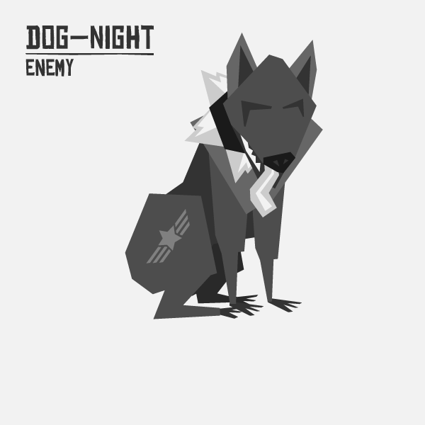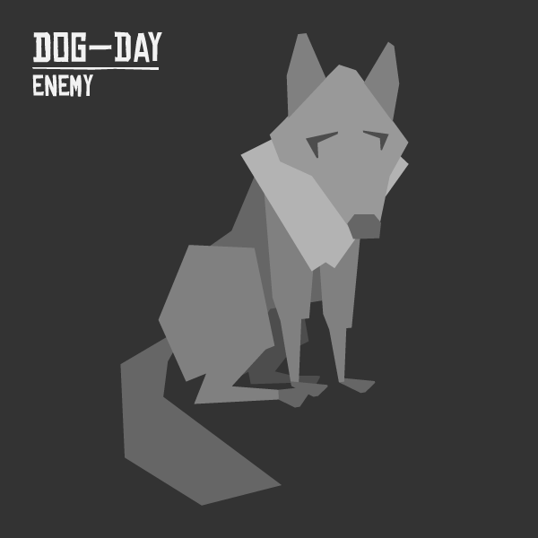

As for the actual art assets in the game, we tried our best to match the style of the concept art, but we were unable to get to the theme of having both day and night versions of the artwork.

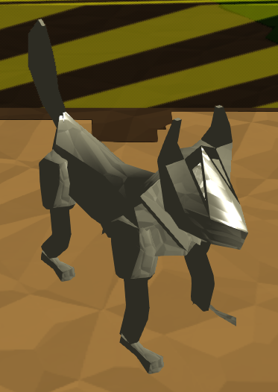

The in game art is a combination of the low-poly style from the concept art, achievable at our current 3D modeling skills. In the following semester we plan on supplementing our art assets by finding a dedicated 3D artist to help us really achieve the style that we want to have for our game.

SWOT

Strengths

* Our team is comprised of exceptional, award-winning game designers and developers.
* Our team is intimately familiar with the Zero Engine and its capabilities.
* We have the direct support of the Zero Engine Development team.
* We all share and are passionate about the same, unique vision for the game
* All of our team members bring a multi-faceted, distinctive skill set to bear on the game.

Weaknesses

* Various members of our team have had personal issues arise throughout the semester.
* Communication has not always come easy to us.
* We are all in the BAGD program and do not have the same comprehensive coding knowledge of other majors.
* We still lack dedicated artists and animators.
* Our scope, while flexible, is relatively large for a student game.

Opportunities

* Our game belongs to a genre that already has mass appeal.
* That same mass appeal means the vast majority of our players should be comfortable with our game’s controls and basic mechanics.
* Games (and media of all sorts) that have dealt with aspects of WWII have enjoyed a great deal of popularity for decades.
* The increased attention brought to the fact that there are very few female protagonists in video games could work very well in our game’s favor.
* The theme of our game lends itself to competitive favor.

Threats

* Games involving traditional Japanese folklore have not always been popular with Western audiences (i.e. the disappointing sales of *Okami* despite critical acclaim).
* A counterpoint to one of the opportunities, a game with a female protagonist might not interest a major game-playing demographics (i.e male teens).
* The wealth of top-down action-adventure games out there, especially in the indie scene.
* Certain players might not respond well to a combat system that favors tactical, defensive maneuvers over straight-forward melee.