ML Final

Liz G

12/9/2021

Table of Contents

# Set Up

## Packages and Import

require(caret)

## Loading required package: caret

## Loading required package: ggplot2

## Loading required package: lattice

require(recipes)

## Loading required package: recipes

## Loading required package: dplyr

##   
## Attaching package: 'dplyr'

## The following objects are masked from 'package:stats':  
##   
## filter, lag

## The following objects are masked from 'package:base':  
##   
## intersect, setdiff, setequal, union

##   
## Attaching package: 'recipes'

## The following object is masked from 'package:stats':  
##   
## step

require(ranger)

## Loading required package: ranger

require(tidyverse)

## Loading required package: tidyverse

## -- Attaching packages --------------------------------------- tidyverse 1.3.1 --

## v tibble 3.1.5 v purrr 0.3.4  
## v tidyr 1.1.4 v stringr 1.4.0  
## v readr 2.0.2 v forcats 0.5.1

## -- Conflicts ------------------------------------------ tidyverse_conflicts() --  
## x dplyr::filter() masks stats::filter()  
## x stringr::fixed() masks recipes::fixed()  
## x dplyr::lag() masks stats::lag()  
## x purrr::lift() masks caret::lift()

require(ModelMetrics)

## Loading required package: ModelMetrics

##   
## Attaching package: 'ModelMetrics'

## The following objects are masked from 'package:caret':  
##   
## confusionMatrix, precision, recall, sensitivity, specificity

## The following object is masked from 'package:base':  
##   
## kappa

require(here)

## Loading required package: here

## here() starts at C:/Users/epgle/Desktop/Fall 2021 Classes/EDLD 654 Machine Learning/Class Assignments/Final Project/ML-Final

require(finalfit)

## Loading required package: finalfit

require(Hmisc)

## Loading required package: Hmisc

## Loading required package: survival

##   
## Attaching package: 'survival'

## The following object is masked from 'package:caret':  
##   
## cluster

## Loading required package: Formula

##   
## Attaching package: 'Hmisc'

## The following objects are masked from 'package:dplyr':  
##   
## src, summarize

## The following objects are masked from 'package:base':  
##   
## format.pval, units

require(rsample)

## Loading required package: rsample

require(vip)

## Loading required package: vip

##   
## Attaching package: 'vip'

## The following object is masked from 'package:utils':  
##   
## vi

og_data <- read.csv(here("data", "OPP_PRO_Clean.csv"), na.strings = "")  
  
og_data <- og_data %>% select(-starts_with("x")) %>% #taking out unwanted variables  
 select(-matches("PSI_total_r|PSI_total_PR")) %>%  
 select(study_id, PSI_total_clinical, any_of(names(og_data))) %>%  
 filter(!is.na(PSI_total_clinical))  
  
  
#taking out unwanted variables, putting in order  
  
head(og_data)

## study_id PSI_total_clinical TC_age_mos PC_age AC_age TC_gender PC_gender  
## 1 OP101 Yes 42 37 40 Male Female  
## 2 OP102 Yes 32 27 NA Female Female  
## 3 OP103 Yes 42 30 29 Male Female  
## 4 OP104 No 30 38 35 Male Male  
## 5 OP105 Yes 41 32 37 Male Female  
## 6 OP106 Yes 41 37 38 Male Female  
## PC_reltoTC PC_marital_status PC_partner_inhome TC_race_Wh TC_race_Bl  
## 1 Bio Mom Married Yes 1 0  
## 2 Bio Mom Single No 1 0  
## 3 Bio Mom Married Yes 1 0  
## 4 Bio Dad Living together Yes 1 0  
## 5 Bio Mom Married Yes 1 0  
## 6 Foster Mom Married Yes 0 0  
## TC_race_His TC_race_As TC_race_Nat TC_race_Pac TC_race_Oth  
## 1 0 0 0 0 0  
## 2 0 0 0 0 0  
## 3 0 0 0 0 0  
## 4 0 0 0 0 0  
## 5 0 0 0 0 0  
## 6 0 0 1 0 0  
## PC_yrs_ed AC_yrs_ed  
## 1 HS grad-GED Specialized training  
## 2 HS grad-GED <NA>  
## 3 Partial high school Partial high school  
## 4 Partial college Partial college  
## 5 Partial college Partial college  
## 6 Standard college-university graduate Junior college-Associates degree  
## PC_employment PC_employ_hours AC_employment PC_annual_income  
## 1 Full time homemaker 0 Full time $80,000 to $89,999  
## 2 Unemployed 0 <NA> $5,000 to $9,999  
## 3 Full time homemaker 0 Full time $20,000 to $24,999  
## 4 Part time 24 Full time homemaker $10,000 to $14,999  
## 5 Full time homemaker 0 Part time $40,000 to $49,999  
## 6 Part time 20 Full time $80,000 to $89,999  
## gov_assist PC_fam_learning PC_fam_mentalh TC_diagnosis  
## 1 1 No No ASD  
## 2 1 No Yes Speech/Language Delay  
## 3 1 No Yes Social-Emotional Disorder  
## 4 1 Yes No ASD  
## 5 1 No No Speech/Language Delay  
## 6 1 Yes No Speech/Language Delay  
## TC_diagnosis_age TC_SPED TC_other_services dyad_adjust  
## 1 Two-years old (24-35 months) Yes Yes 104  
## 2 One-year old (12-23 months) Yes Yes 102  
## 3 Three-years old (36-47 months) Yes Yes 112  
## 4 One-year old (12-23 months) Yes Yes 98  
## 5 Three-years old (36-47 months) Yes Yes 84  
## 6 Two-years old (24-35 months) Yes Yes 139  
## fam_support informal_support formal_support CES_D CBCL_int_r CBCL_ext_r  
## 1 3 13 13 30 29 19  
## 2 8 6 20 19 32 46  
## 3 8 11 20 38 26 25  
## 4 9 8 25 17 21 17  
## 5 11 8 6 22 22 39  
## 6 23 23 23 1 25 28  
## VABS_comm_ss VABS_dls_ss VABS_soc_ss VABS_mot_ss PCBOS_Aggr_CU  
## 1 59 64 65 81 0  
## 2 69 78 80 69 0  
## 3 65 75 66 78 0  
## 4 66 87 68 100 0  
## 5 74 83 61 88 0  
## 6 69 81 85 91 0  
## PCBOS_Aggr_Play PCBOS_Aggr_SA PCBOS_Crit_CU PCBOS_Crit_Play PCBOS_Crit_SA  
## 1 0 0 0 0 0  
## 2 0 0 0 0 2  
## 3 0 0 0 0 0  
## 4 0 0 0 0 0  
## 5 0 0 0 0 4  
## 6 0 0 0 0 0  
## PCBOS_CU_Comm PCBOS_CU_Comp PCBOS_DescComm_CU PCBOS_DescComm_Play  
## 1 8 0 1 1  
## 2 31 2 0 5  
## 3 8 8 0 6  
## 4 7 0 0 2  
## 5 16 12 0 3  
## 6 1 1 1 7  
## PCBOS_DescComm_SA PCBOS_Disr_CU PCBOS_Disr_Play PCBOS_Disr_SA PCBOS_InComm_CU  
## 1 0 0 0 0 2  
## 2 0 0 3 0 4  
## 3 4 0 0 0 3  
## 4 3 0 0 0 1  
## 5 3 0 0 0 3  
## 6 2 0 0 0 0  
## PCBOS_InComm_Play PCBOS_InComm_SA PCBOS_Intr_CU PCBOS_Intr_Play PCBOS_Intr_SA  
## 1 7 4 1 4 2  
## 2 9 5 0 3 3  
## 3 10 1 0 0 1  
## 4 7 4 0 0 0  
## 5 4 0 1 1 5  
## 6 3 1 0 2 0  
## PCBOS_IP_CU PCBOS_IP_Play PCBOS_IP_SA PCBOS_LackFT_CU PCBOS_LackFT_Play  
## 1 0 15 5 1 10  
## 2 0 8 3 4 7  
## 3 0 12 2 3 1  
## 4 0 4 3 0 0  
## 5 0 4 1 3 0  
## 6 0 6 4 0 0  
## PCBOS_LackFT_SA PCBOS_NegV_CU PCBOS_NegV_Play PCBOS_NegV_SA PCBOS_PhysAgg_CU  
## 1 2 3 14 6 0  
## 2 4 4 0 0 0  
## 3 0 0 0 0 0  
## 4 1 3 0 0 0  
## 5 0 1 1 0 0  
## 6 1 0 0 0 0  
## PCBOS_PhysAgg_Play PCBOS_PhysAgg_SA PCBOS_PosConsq_CU PCBOS_PosConsq_Play  
## 1 0 0 0 0  
## 2 0 0 4 2  
## 3 0 0 0 0  
## 4 0 0 0 0  
## 5 0 0 0 0  
## 6 0 0 0 0  
## PCBOS_PosConsq_SA PCBOS_PosV_CU PCBOS_PosV_Play PCBOS_PosV_SA PCBOS_Praise_CU  
## 1 0 0 4 0 2  
## 2 0 3 17 2 3  
## 3 0 0 0 0 1  
## 4 0 0 0 0 0  
## 5 0 3 17 5 1  
## 6 0 4 19 6 3  
## PCBOS_Praise_Play PCBOS_Praise_SA TC_sib_age_mean TC_sib_behavior_ct  
## 1 3 0 7.000000 0  
## 2 6 8 4.666667 2  
## 3 3 5 7.000000 1  
## 4 7 3 15.000000 0  
## 5 2 5 8.500000 0  
## 6 11 2 9.000000 3  
## TC_sib_learning_ct TC_sib_mentalh_ct TC_sib_n_ct TC_sib_yes_ct  
## 1 1 0 1 1  
## 2 2 0 3 1  
## 3 0 1 2 1  
## 4 1 0 1 1  
## 5 1 0 2 1  
## 6 3 4 7 1

## Visualizing Missing Data

look <- ff_glimpse(og_data)  
  
look$Continuous %>% arrange(missing_n)

## label var_type n missing_n missing_percent  
## TC_age_mos TC_age_mos <int> 358 1 0.3  
## TC_race_Wh TC_race_Wh <int> 358 1 0.3  
## TC_race_Bl TC_race_Bl <int> 358 1 0.3  
## TC_race_His TC_race_His <int> 358 1 0.3  
## TC_race_As TC_race_As <int> 358 1 0.3  
## TC_race_Nat TC_race_Nat <int> 358 1 0.3  
## TC_race_Pac TC_race_Pac <int> 358 1 0.3  
## TC_race_Oth TC_race_Oth <int> 358 1 0.3  
## PC_employ_hours PC_employ_hours <int> 358 1 0.3  
## gov_assist gov_assist <int> 358 1 0.3  
## TC_sib_yes_ct TC_sib_yes_ct <int> 358 1 0.3  
## CBCL_int_r CBCL_int_r <int> 352 7 1.9  
## CBCL_ext_r CBCL_ext_r <int> 352 7 1.9  
## PC_age PC_age <int> 350 9 2.5  
## PCBOS_Aggr_CU PCBOS_Aggr_CU <int> 344 15 4.2  
## PCBOS_Aggr_Play PCBOS_Aggr_Play <int> 344 15 4.2  
## PCBOS_Aggr_SA PCBOS_Aggr_SA <int> 344 15 4.2  
## PCBOS_Crit_CU PCBOS_Crit_CU <int> 344 15 4.2  
## PCBOS_Crit_Play PCBOS_Crit_Play <int> 344 15 4.2  
## PCBOS_Crit_SA PCBOS_Crit_SA <int> 344 15 4.2  
## PCBOS_CU_Comm PCBOS_CU_Comm <int> 344 15 4.2  
## PCBOS_CU_Comp PCBOS_CU_Comp <int> 344 15 4.2  
## PCBOS_DescComm_CU PCBOS_DescComm_CU <int> 344 15 4.2  
## PCBOS_DescComm_Play PCBOS_DescComm_Play <int> 344 15 4.2  
## PCBOS_DescComm_SA PCBOS_DescComm_SA <int> 344 15 4.2  
## PCBOS_Disr_CU PCBOS_Disr_CU <int> 344 15 4.2  
## PCBOS_Disr_Play PCBOS_Disr_Play <int> 344 15 4.2  
## PCBOS_Disr_SA PCBOS_Disr_SA <int> 344 15 4.2  
## PCBOS_InComm_CU PCBOS_InComm_CU <int> 344 15 4.2  
## PCBOS_InComm_Play PCBOS_InComm_Play <int> 344 15 4.2  
## PCBOS_InComm_SA PCBOS_InComm_SA <int> 344 15 4.2  
## PCBOS_Intr_CU PCBOS_Intr_CU <int> 344 15 4.2  
## PCBOS_Intr_Play PCBOS_Intr_Play <int> 344 15 4.2  
## PCBOS_Intr_SA PCBOS_Intr_SA <int> 344 15 4.2  
## PCBOS_IP_CU PCBOS_IP_CU <int> 344 15 4.2  
## PCBOS_IP_Play PCBOS_IP_Play <int> 344 15 4.2  
## PCBOS_IP_SA PCBOS_IP_SA <int> 344 15 4.2  
## PCBOS_LackFT_CU PCBOS_LackFT_CU <int> 344 15 4.2  
## PCBOS_LackFT_Play PCBOS_LackFT_Play <int> 344 15 4.2  
## PCBOS_LackFT_SA PCBOS_LackFT_SA <int> 344 15 4.2  
## PCBOS_NegV_CU PCBOS_NegV_CU <int> 344 15 4.2  
## PCBOS_NegV_Play PCBOS_NegV_Play <int> 344 15 4.2  
## PCBOS_NegV_SA PCBOS_NegV_SA <int> 344 15 4.2  
## PCBOS_PhysAgg_CU PCBOS_PhysAgg_CU <int> 344 15 4.2  
## PCBOS_PhysAgg_Play PCBOS_PhysAgg_Play <int> 344 15 4.2  
## PCBOS_PhysAgg_SA PCBOS_PhysAgg_SA <int> 344 15 4.2  
## PCBOS_PosConsq_CU PCBOS_PosConsq_CU <int> 344 15 4.2  
## PCBOS_PosConsq_Play PCBOS_PosConsq_Play <int> 344 15 4.2  
## PCBOS_PosConsq_SA PCBOS_PosConsq_SA <int> 344 15 4.2  
## PCBOS_PosV_CU PCBOS_PosV_CU <int> 344 15 4.2  
## PCBOS_PosV_Play PCBOS_PosV_Play <int> 344 15 4.2  
## PCBOS_PosV_SA PCBOS_PosV_SA <int> 344 15 4.2  
## PCBOS_Praise_CU PCBOS_Praise_CU <int> 344 15 4.2  
## PCBOS_Praise_Play PCBOS_Praise_Play <int> 344 15 4.2  
## PCBOS_Praise_SA PCBOS_Praise_SA <int> 344 15 4.2  
## fam_support fam_support <int> 334 25 7.0  
## informal_support informal_support <int> 334 25 7.0  
## formal_support formal_support <int> 334 25 7.0  
## CES_D CES_D <dbl> 334 25 7.0  
## AC_age AC_age <int> 297 62 17.3  
## VABS_comm_ss VABS_comm_ss <int> 285 74 20.6  
## VABS_dls_ss VABS_dls_ss <int> 285 74 20.6  
## VABS_soc_ss VABS_soc_ss <int> 285 74 20.6  
## dyad_adjust dyad_adjust <int> 279 80 22.3  
## TC_sib_behavior_ct TC_sib_behavior_ct <int> 279 80 22.3  
## TC_sib_learning_ct TC_sib_learning_ct <int> 279 80 22.3  
## TC_sib_mentalh_ct TC_sib_mentalh_ct <int> 279 80 22.3  
## TC_sib_n_ct TC_sib_n_ct <int> 279 80 22.3  
## TC_sib_age_mean TC_sib_age_mean <dbl> 278 81 22.6  
## VABS_mot_ss VABS_mot_ss <int> 273 86 24.0  
## mean sd min quartile_25 median quartile_75 max  
## TC_age_mos 43.4 10.5 24.0 36.0 41.0 48.0 71.0  
## TC_race_Wh 0.7 0.5 0.0 0.0 1.0 1.0 1.0  
## TC_race_Bl 0.1 0.3 0.0 0.0 0.0 0.0 1.0  
## TC_race_His 0.4 0.5 0.0 0.0 0.0 1.0 1.0  
## TC_race_As 0.0 0.2 0.0 0.0 0.0 0.0 1.0  
## TC_race_Nat 0.1 0.2 0.0 0.0 0.0 0.0 1.0  
## TC_race_Pac 0.0 0.1 0.0 0.0 0.0 0.0 1.0  
## TC_race_Oth 0.0 0.2 0.0 0.0 0.0 0.0 1.0  
## PC_employ_hours 21.8 26.6 0.0 0.0 11.0 40.0 99.0  
## gov_assist 0.6 0.5 0.0 0.0 1.0 1.0 1.0  
## TC_sib_yes_ct 0.8 0.4 0.0 1.0 1.0 1.0 1.0  
## CBCL_int_r 36.8 25.7 0.0 11.0 36.0 59.0 100.0  
## CBCL_ext_r 42.0 25.0 0.0 19.0 42.5 64.0 100.0  
## PC_age 34.6 7.9 19.0 29.0 34.0 39.0 67.0  
## PCBOS_Aggr_CU 0.0 0.3 0.0 0.0 0.0 0.0 3.0  
## PCBOS_Aggr_Play 0.0 0.3 0.0 0.0 0.0 0.0 3.0  
## PCBOS_Aggr_SA 0.0 0.2 0.0 0.0 0.0 0.0 2.0  
## PCBOS_Crit_CU 0.0 0.2 0.0 0.0 0.0 0.0 3.0  
## PCBOS_Crit_Play 0.1 0.4 0.0 0.0 0.0 0.0 4.0  
## PCBOS_Crit_SA 0.1 0.4 0.0 0.0 0.0 0.0 4.0  
## PCBOS_CU_Comm 20.1 12.8 0.0 11.0 18.0 27.0 68.0  
## PCBOS_CU_Comp 5.2 4.0 0.0 2.0 5.0 8.0 21.0  
## PCBOS_DescComm_CU 0.3 0.7 0.0 0.0 0.0 0.2 4.0  
## PCBOS_DescComm_Play 6.3 3.8 0.0 3.0 6.0 9.0 18.0  
## PCBOS_DescComm_SA 1.9 1.5 0.0 1.0 2.0 3.0 6.0  
## PCBOS_Disr_CU 0.2 0.6 0.0 0.0 0.0 0.0 4.0  
## PCBOS_Disr_Play 0.3 1.2 0.0 0.0 0.0 0.0 13.0  
## PCBOS_Disr_SA 0.1 0.6 0.0 0.0 0.0 0.0 5.0  
## PCBOS_InComm_CU 3.1 1.0 0.0 3.0 3.0 4.0 4.0  
## PCBOS_InComm_Play 6.7 4.5 0.0 3.0 6.0 9.2 19.0  
## PCBOS_InComm_SA 2.9 1.8 0.0 2.0 3.0 4.0 6.0  
## PCBOS_Intr_CU 0.5 0.9 0.0 0.0 0.0 1.0 4.0  
## PCBOS_Intr_Play 5.6 4.0 0.0 3.0 5.0 8.0 20.0  
## PCBOS_Intr_SA 3.0 1.8 0.0 2.0 3.0 5.0 6.0  
## PCBOS_IP_CU 0.1 0.3 0.0 0.0 0.0 0.0 3.0  
## PCBOS_IP_Play 3.8 3.3 0.0 1.0 3.0 6.0 19.0  
## PCBOS_IP_SA 1.5 1.4 0.0 0.0 1.0 2.0 6.0  
## PCBOS_LackFT_CU 2.9 1.2 0.0 2.0 3.0 4.0 4.0  
## PCBOS_LackFT_Play 6.7 4.7 0.0 3.0 6.0 10.0 19.0  
## PCBOS_LackFT_SA 2.8 1.9 0.0 1.0 3.0 5.0 6.0  
## PCBOS_NegV_CU 1.1 1.4 0.0 0.0 0.0 2.0 4.0  
## PCBOS_NegV_Play 1.1 2.7 0.0 0.0 0.0 1.0 20.0  
## PCBOS_NegV_SA 0.8 1.5 0.0 0.0 0.0 1.0 6.0  
## PCBOS_PhysAgg_CU 0.0 0.1 0.0 0.0 0.0 0.0 2.0  
## PCBOS_PhysAgg_Play 0.0 0.2 0.0 0.0 0.0 0.0 2.0  
## PCBOS_PhysAgg_SA 0.0 0.2 0.0 0.0 0.0 0.0 2.0  
## PCBOS_PosConsq_CU 0.2 0.7 0.0 0.0 0.0 0.0 4.0  
## PCBOS_PosConsq_Play 0.2 0.7 0.0 0.0 0.0 0.0 7.0  
## PCBOS_PosConsq_SA 0.0 0.3 0.0 0.0 0.0 0.0 4.0  
## PCBOS_PosV_CU 2.3 1.6 0.0 1.0 3.0 4.0 4.0  
## PCBOS_PosV_Play 14.7 6.7 0.0 12.0 18.0 20.0 20.0  
## PCBOS_PosV_SA 4.2 2.1 0.0 3.0 5.0 6.0 6.0  
## PCBOS_Praise_CU 2.8 3.2 0.0 0.0 2.0 4.0 15.0  
## PCBOS_Praise_Play 6.5 6.5 0.0 2.0 5.0 9.0 41.0  
## PCBOS_Praise_SA 6.2 4.6 0.0 2.0 5.0 9.0 24.0  
## fam_support 12.8 6.1 0.0 9.0 12.0 17.0 30.0  
## informal_support 7.3 5.6 0.0 3.0 6.0 10.0 26.0  
## formal_support 13.9 6.4 0.0 9.0 13.0 19.0 30.0  
## CES_D 13.4 10.4 0.0 6.0 10.5 18.0 48.0  
## AC_age 37.6 8.7 21.0 31.0 36.0 42.0 67.0  
## VABS_comm_ss 75.8 13.8 17.0 67.0 76.0 84.0 143.0  
## VABS_dls_ss 81.2 14.9 35.0 71.0 81.0 91.0 143.0  
## VABS_soc_ss 80.2 12.6 40.0 74.0 79.0 88.0 152.0  
## dyad_adjust 108.4 24.2 5.0 97.0 113.0 125.0 151.0  
## TC_sib_behavior_ct 0.4 0.7 0.0 0.0 0.0 1.0 3.0  
## TC_sib_learning_ct 0.3 0.6 0.0 0.0 0.0 0.0 3.0  
## TC_sib_mentalh_ct 0.3 0.6 0.0 0.0 0.0 0.0 4.0  
## TC_sib_n_ct 1.8 1.2 1.0 1.0 1.0 2.0 7.0  
## TC_sib_age_mean 6.9 4.9 0.0 3.0 6.0 10.0 26.0  
## VABS_mot_ss 83.3 14.4 37.0 73.0 82.0 93.0 144.0

look$Categorical %>% arrange(missing_n)

## label var_type n missing_n missing_percent  
## study_id study_id <chr> 359 0 0.0  
## PSI_total_clinical PSI_total_clinical <chr> 359 0 0.0  
## TC_gender TC_gender <chr> 358 1 0.3  
## PC_gender PC_gender <chr> 358 1 0.3  
## PC_reltoTC PC_reltoTC <chr> 358 1 0.3  
## PC_marital_status PC_marital_status <chr> 358 1 0.3  
## PC_partner_inhome PC_partner_inhome <chr> 358 1 0.3  
## PC_yrs_ed PC_yrs_ed <chr> 358 1 0.3  
## PC_employment PC_employment <chr> 358 1 0.3  
## PC_fam_learning PC_fam_learning <chr> 358 1 0.3  
## PC_fam_mentalh PC_fam_mentalh <chr> 358 1 0.3  
## PC_annual_income PC_annual_income <chr> 357 2 0.6  
## TC_other_services TC_other_services <chr> 357 2 0.6  
## TC_diagnosis TC_diagnosis <chr> 356 3 0.8  
## TC_SPED TC_SPED <chr> 350 9 2.5  
## TC_diagnosis_age TC_diagnosis_age <chr> 346 13 3.6  
## AC_yrs_ed AC_yrs_ed <chr> 301 58 16.2  
## AC_employment AC_employment <chr> 300 59 16.4  
## levels_n levels levels_count levels_percent  
## study_id 359 - - -  
## PSI_total_clinical 2 - - -  
## TC_gender 2 - - -  
## PC_gender 2 - - -  
## PC_reltoTC 9 - - -  
## PC_marital_status 6 - - -  
## PC_partner_inhome 2 - - -  
## PC_yrs_ed 16 - - -  
## PC_employment 10 - - -  
## PC_fam_learning 2 - - -  
## PC_fam_mentalh 2 - - -  
## PC_annual_income 13 - - -  
## TC_other_services 2 - - -  
## TC_diagnosis 15 - - -  
## TC_SPED 4 - - -  
## TC_diagnosis_age 6 - - -  
## AC_yrs_ed 15 - - -  
## AC_employment 9 - - -

#Examine levels for categorical data  
look$Categorical %>% select(label, n, levels_n)

## label n levels_n  
## study_id study_id 359 359  
## PSI_total_clinical PSI_total_clinical 359 2  
## TC_gender TC_gender 358 2  
## PC_gender PC_gender 358 2  
## PC_reltoTC PC_reltoTC 358 9  
## PC_marital_status PC_marital_status 358 6  
## PC_partner_inhome PC_partner_inhome 358 2  
## PC_yrs_ed PC_yrs_ed 358 16  
## AC_yrs_ed AC_yrs_ed 301 15  
## PC_employment PC_employment 358 10  
## AC_employment AC_employment 300 9  
## PC_annual_income PC_annual_income 357 13  
## PC_fam_learning PC_fam_learning 358 2  
## PC_fam_mentalh PC_fam_mentalh 358 2  
## TC_diagnosis TC_diagnosis 356 15  
## TC_diagnosis_age TC_diagnosis_age 346 6  
## TC_SPED TC_SPED 350 4  
## TC_other_services TC_other_services 357 2

#look @ distributions of numeric data  
cont_labels <- look$Continuous$label  
  
for (i in cont_labels) {  
 hist(og_data %>% select(i))  
}

## Note: Using an external vector in selections is ambiguous.  
## i Use `all_of(i)` instead of `i` to silence this message.  
## i See <https://tidyselect.r-lib.org/reference/faq-external-vector.html>.  
## This message is displayed once per session.

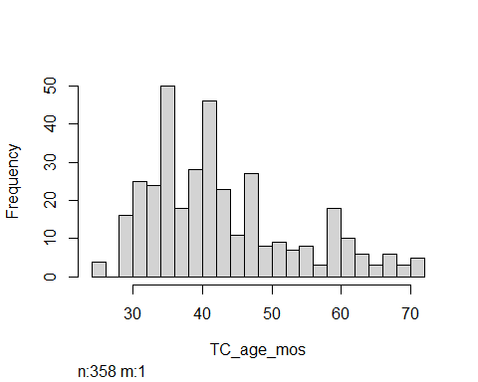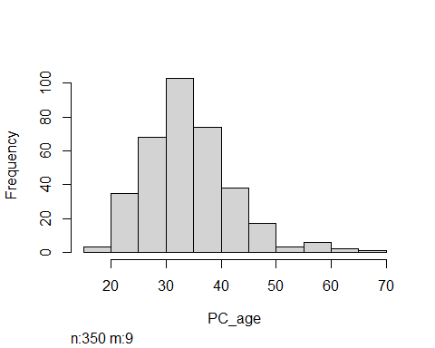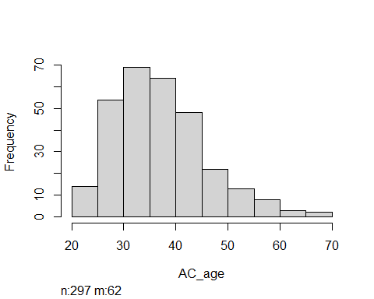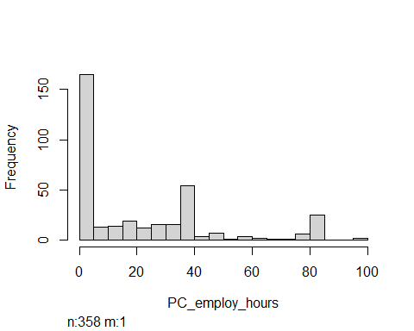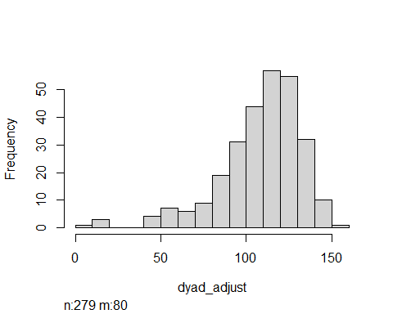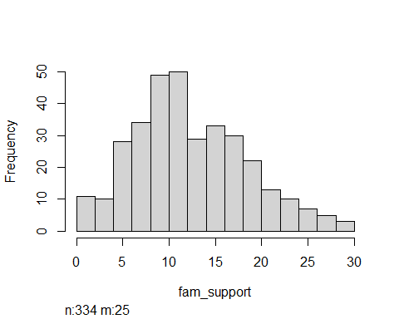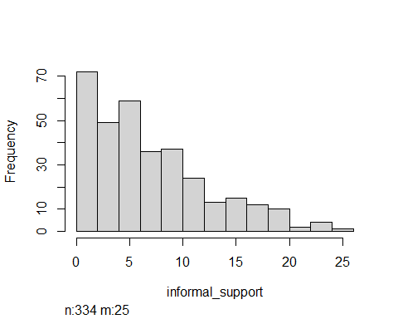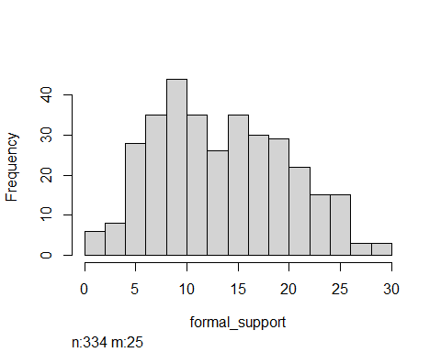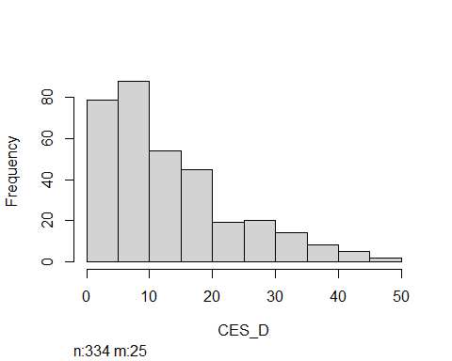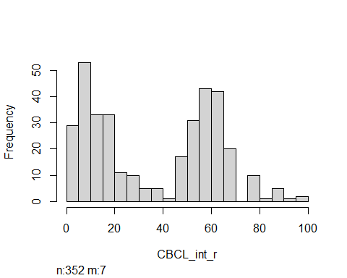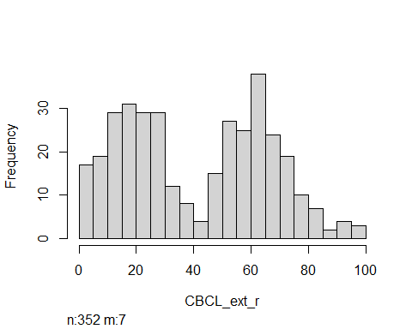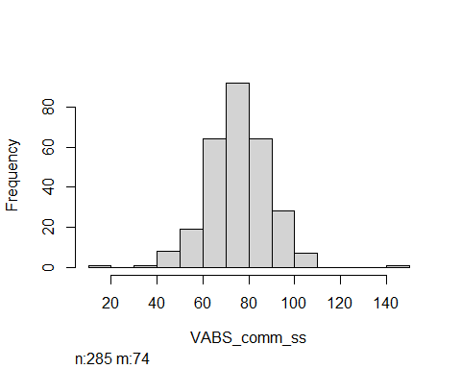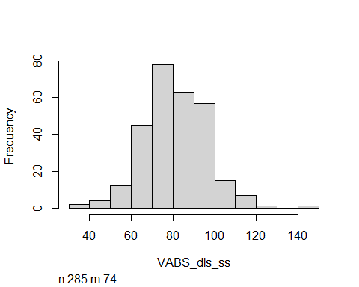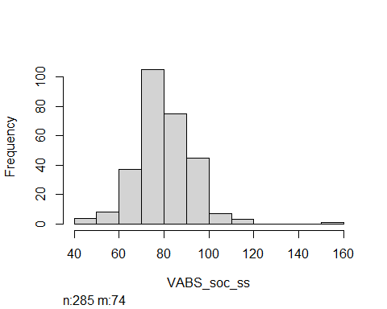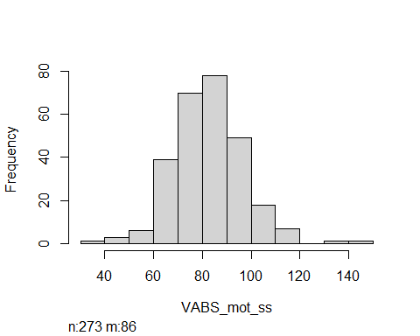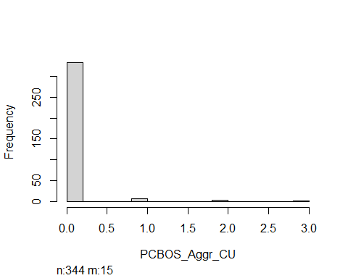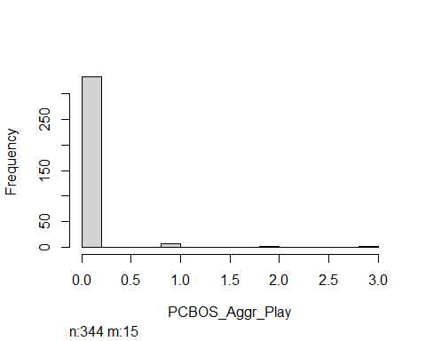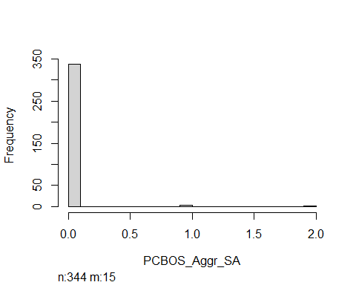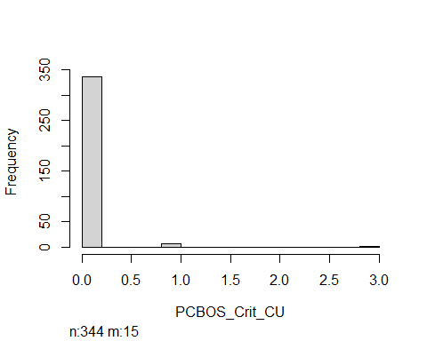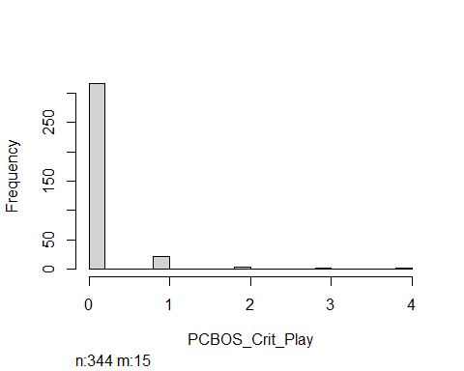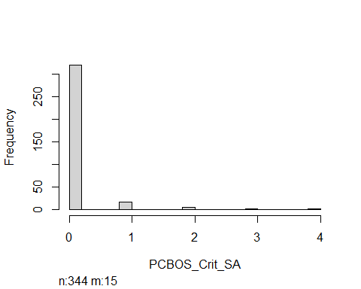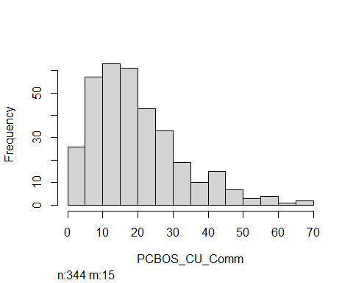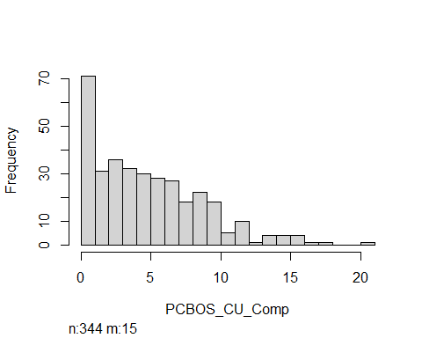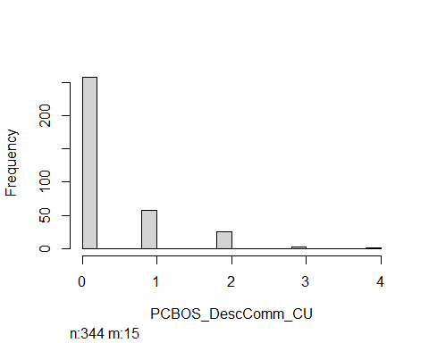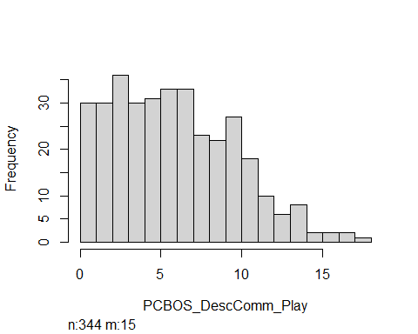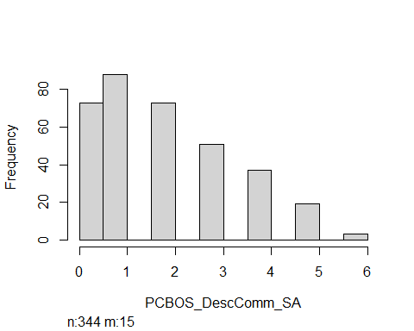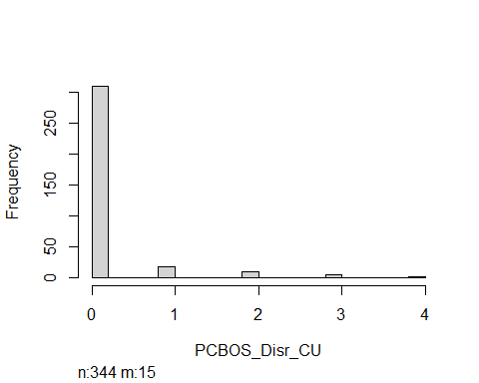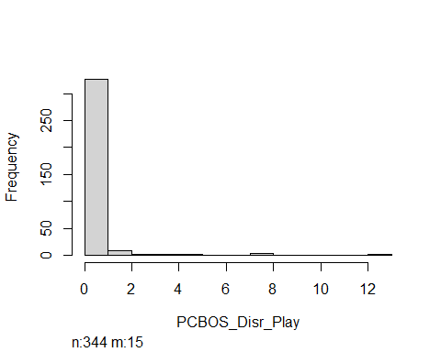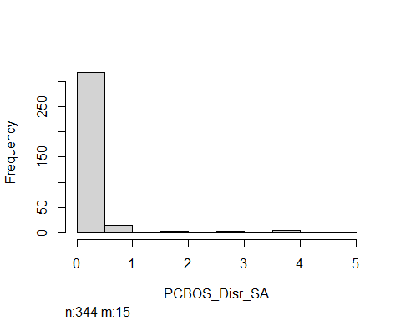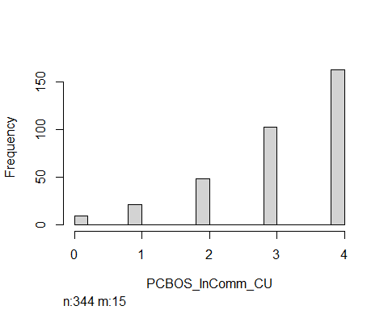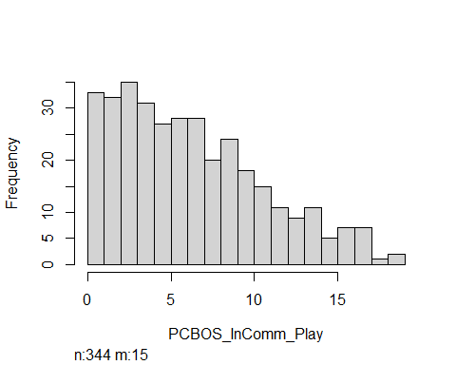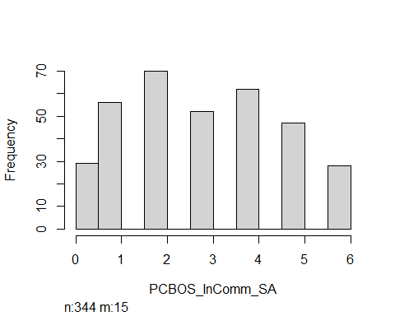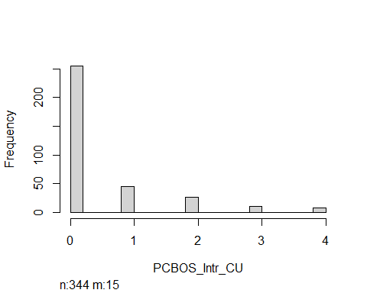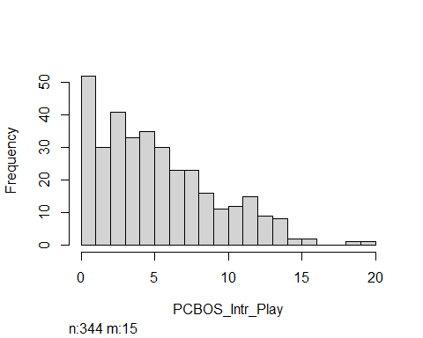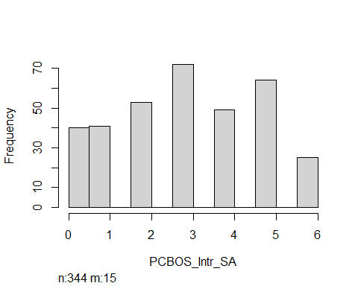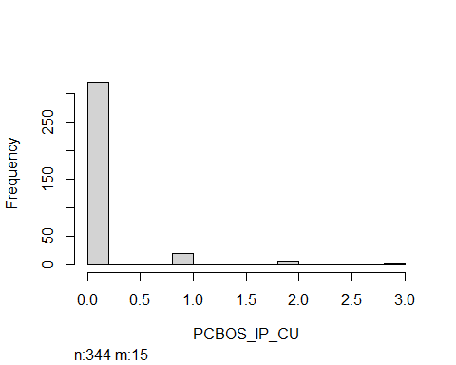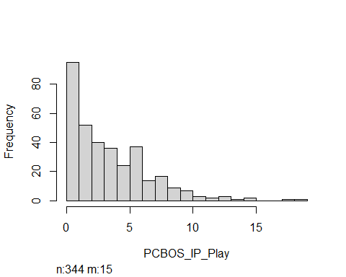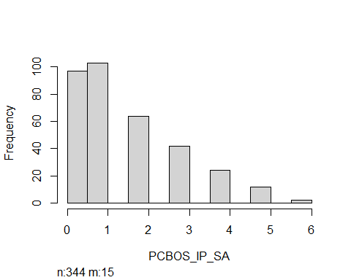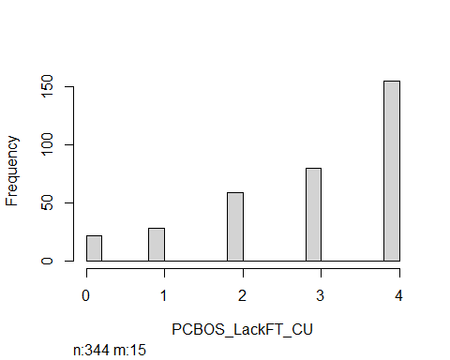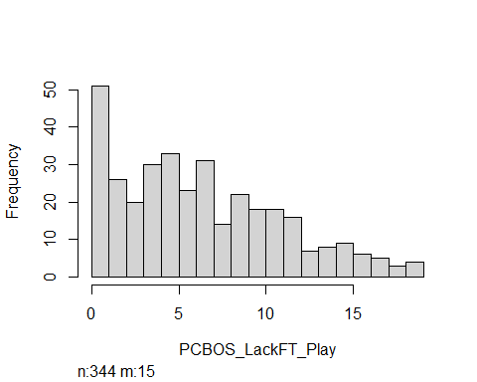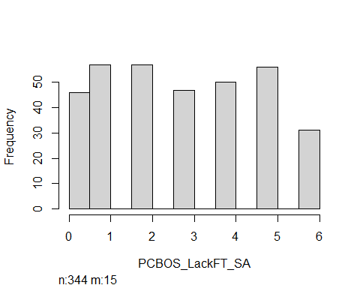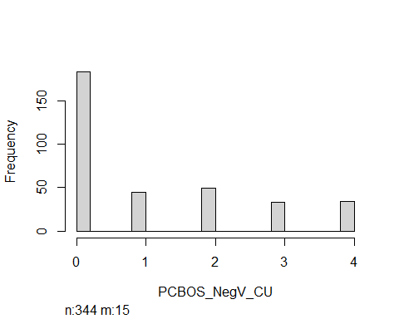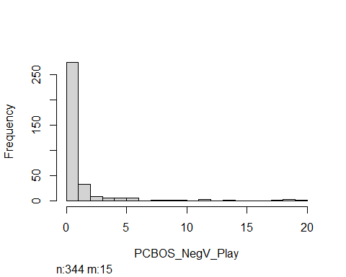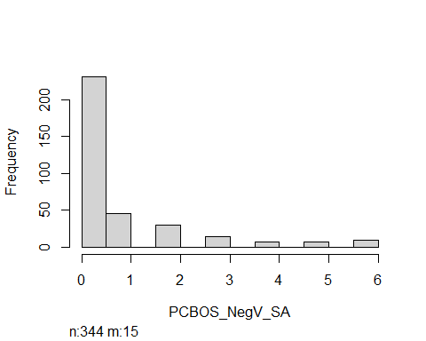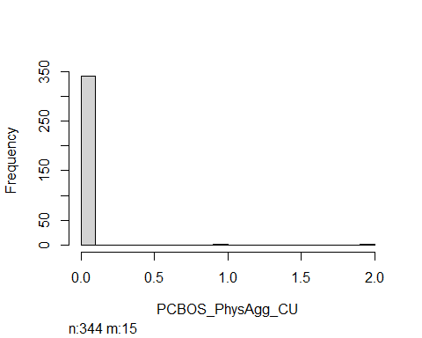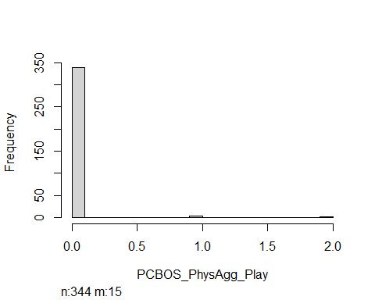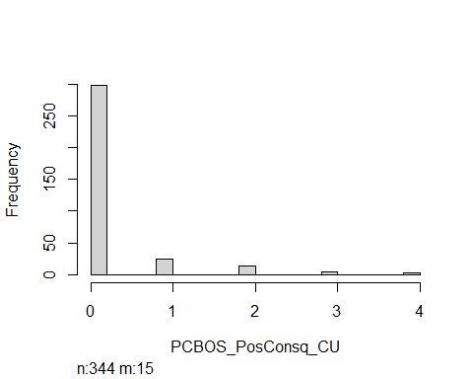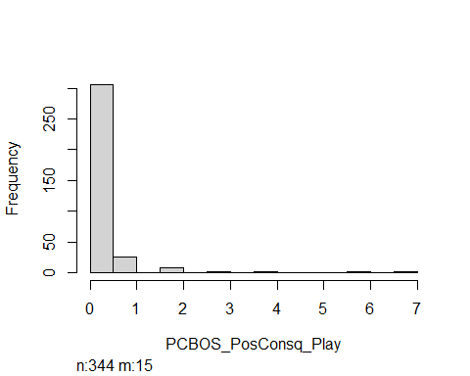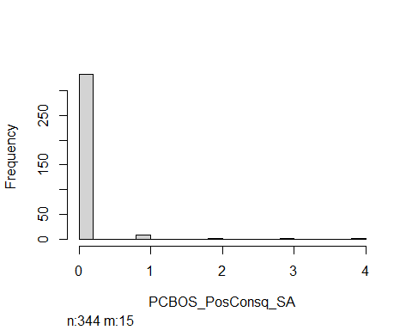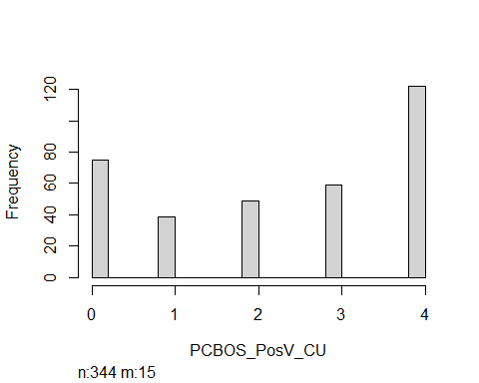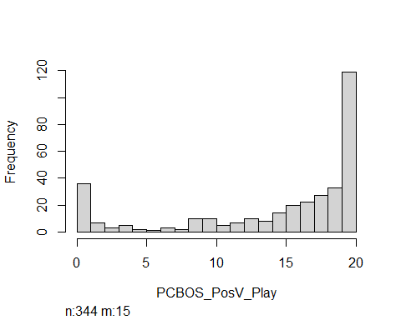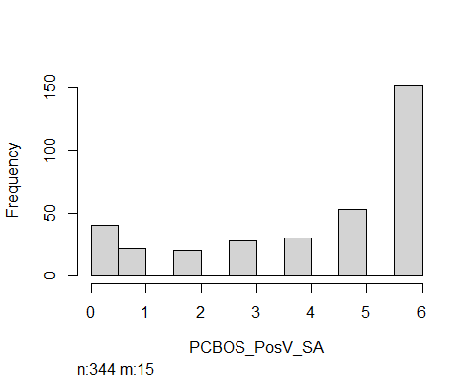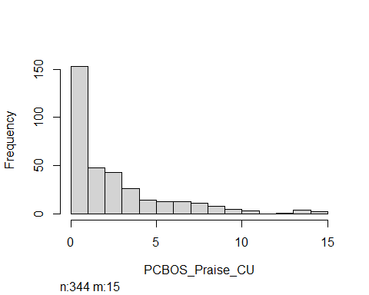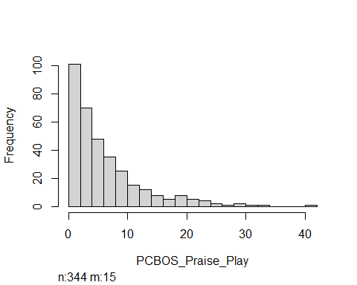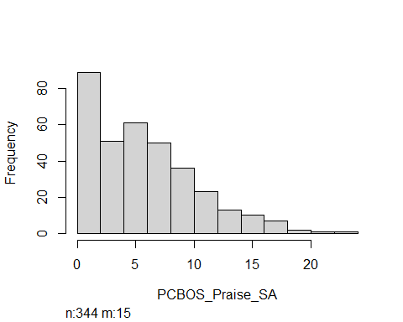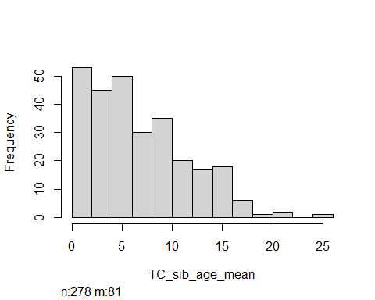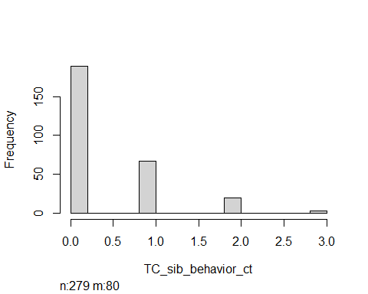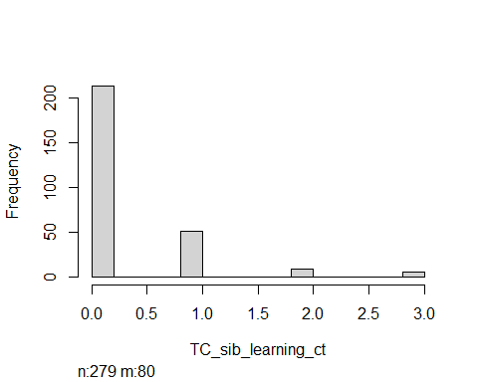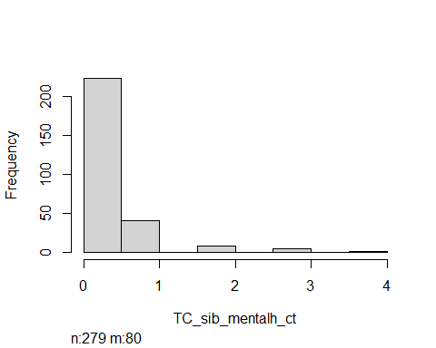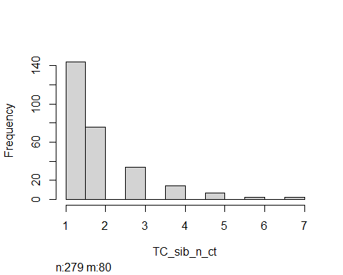

Preprocessing Steps - 1) Get rid of rows with no outcome data (moved out of blueprint for error testing) 2) Missing variable column for - AC Age, TC_sib (NA is meaningful) 3) Make yrs ed into numeric variable Make income into numeric variable Make age @ dx into numeric variable 4) For factor variables w/ high number of levels, make “other” 5) Dummy code categorical variables, and drop OG 6) Multiple imputation is reasonable for most variables 7) For variables where NA is meaningful (= absence of AC or sib, set remaining values to 0 for regression models)

## Making a Blueprint

outcome <- "PSI_total_clinical"  
cat2num <- names(select(og_data, matches("yrs_ed|diagnosis_age|income"))) #variables that will be recoded to be numeric  
categorical <- names(select(og_data, where(is.character) & !(matches("id|PSI"))))  
categorical <- categorical[!categorical %in% cat2num]  
numeric <- c(names(select(og_data, where(is.numeric))), cat2num)  
already_dum <- names(select(og_data, matches("TC_race|gov_assist|TC_sib_yes_ct"))) #some variables already "dummy" coded  
true_numeric <- numeric[!numeric %in% already_dum]  
na_true <- names(select(og_data, matches("AC|TC_sib", ignore.case = FALSE))) #don't impute data for alternate caregiver or subling variables  
impute_vars <- true_numeric[!true_numeric %in% na_true]  
  
stress_blueprint <- recipe(x = og_data,   
 vars = names(og_data),  
 roles = c("ID", "outcome", rep("predictor", 86))) %>%   
 #step_filter(!is.na(PSI_total_clinical), skip = FALSE) %>% #causing error   
 step_indicate_na(matches("AC_age", "TC_sib_yes_ct")) %>%  
 step_other(matches("PC_reltoTC|employment|TC_diagnosis|PC_marital_status|TC_SPED")) %>%  
 #making yrs ed numeric  
 step_mutate(across(matches("yrs_ed"), ~case_when(  
 str_detect(., "No formal") ~ 0,  
 str_detect(., "7th grade") ~ 7,   
 str_detect(., "Junior high") ~ 8,  
 str_detect(., "Partial high school") ~ 9,  
 str_detect(., "GED") ~ 12,  
 str_detect(., "Partial college") ~ 13,  
 str_detect(., "Specialized") ~ 14,  
 str_detect(., "Associates") ~ 14,  
 str_detect(., "university grad") ~ 16,  
 str_detect(., "Grad prof") ~ 18))) %>%  
 #making dx age numeric  
 step_mutate(across(matches("diagnosis_age"), ~case_when(  
 str_detect(., "At birth") ~ 6,  
 str_detect(., "One") ~ 18,   
 str_detect(., "Two") ~ 30,  
 str_detect(., "Three") ~ 42,  
 str_detect(., "Four") ~ 54,  
 str_detect(., "Five") ~ 66))) %>%  
 #making annual income numeric  
 step_mutate(PC_annual_income =   
 ifelse(str_detect(PC_annual_income, "less"), 2500,  
 ifelse(str_detect(PC_annual_income, "14,999"), 12500,  
 ifelse(str_detect(PC_annual_income, "19,999"), 17500,  
 ifelse(str_detect(PC_annual_income, "24,999"), 22500,  
 ifelse(str_detect(PC_annual_income, "29,999"), 27500,  
 ifelse(str_detect(PC_annual_income, "39,999"), 35000,  
 ifelse(str_detect(PC_annual_income, "49,999"), 45000,  
 ifelse(str_detect(PC_annual_income, "59,999"), 55000,  
 ifelse(str_detect(PC_annual_income, "69,999"), 65000,  
 ifelse(str_detect(PC_annual_income, "79,999"), 75000,  
 ifelse(str_detect(PC_annual_income, "89,999"), 85000,  
 ifelse(str_detect(PC_annual_income, "more"), 95000,  
 ifelse(is.na(PC_annual_income), NA, 7500)))))))))))))) %>% #5,000 and $9,999 in all others  
 step_impute_mode(all_of(categorical)) %>%  
 step_zv(all_of(numeric)) %>%  
 step_dummy(all_of(categorical)) %>%  
 step_mutate(across(matches("AC|TC_sib", ignore.case = FALSE),   
 ~replace_na(., 0))) %>%  
 step_impute_knn(all_of(impute_vars), all_of(already_dum)) %>%  
 step_normalize(all_of(true_numeric))

prepare <- prep(stress_blueprint, training = og_data)  
stress_data <- bake(prepare, new_data = og_data)  
  
head(stress_data)

## # A tibble: 6 x 101  
## study_id PSI_total_clinical TC_age_mos PC_age AC_age TC_race_Wh TC_race_Bl  
## <fct> <fct> <dbl> <dbl> <dbl> <int> <int>  
## 1 OP101 Yes -0.131 0.303 0.548 1 0  
## 2 OP102 Yes -1.08 -0.968 -1.91 1 0  
## 3 OP103 Yes -0.131 -0.587 -0.127 1 0  
## 4 OP104 No -1.27 0.430 0.241 1 0  
## 5 OP105 Yes -0.226 -0.332 0.364 1 0  
## 6 OP106 Yes -0.226 0.303 0.425 0 0  
## # ... with 94 more variables: TC_race_His <int>, TC_race_As <int>,  
## # TC_race_Nat <int>, TC_race_Pac <int>, TC_race_Oth <int>, PC_yrs_ed <dbl>,  
## # AC_yrs_ed <dbl>, PC_employ_hours <dbl>, PC_annual_income <dbl>,  
## # gov_assist <int>, TC_diagnosis_age <dbl>, dyad_adjust <dbl>,  
## # fam_support <dbl>, informal_support <dbl>, formal_support <dbl>,  
## # CES_D <dbl>, CBCL_int_r <dbl>, CBCL_ext_r <dbl>, VABS_comm_ss <dbl>,  
## # VABS_dls_ss <dbl>, VABS_soc_ss <dbl>, VABS_mot_ss <dbl>, ...

#Check for missingness  
look2 <- ff_glimpse(stress_data)  
  
look2$Continuous %>% arrange(desc(missing_n)) %>% filter(missing_n > 0)

## [1] label var_type n missing_n   
## [5] missing_percent mean sd min   
## [9] quartile_25 median quartile_75 max   
## <0 rows> (or 0-length row.names)

look2$Categorical %>% arrange(missing_n) %>% filter(missing_n > 0)

## [1] label var_type n missing_n   
## [5] missing_percent levels_n levels levels_count   
## [9] levels_percent   
## <0 rows> (or 0-length row.names)

## Test and Training Set

set.seed(121221)  
 split <- initial_split(og_data, prop = .75)  
 stress_train <- training(split)  
 stress_test <- testing(split)  
   
prepare <- prep(stress_blueprint,   
 training = stress_train)  
  
baked_train <- bake(prepare, new_data = stress_train)  
baked_test <- bake(prepare, new_data = stress_test)

## Functions

##Making a crossfold function  
  
crossfold_log <- function(training_data, folds){  
   
 #shuffle data  
 traning_data <- training_data[sample(nrow(training_data)),]  
   
  
 # Create 10 folds with equal size  
  
 N_folds = cut(seq(1,nrow(training_data)),breaks= folds,labels=FALSE)  
   
 # Create the list for each fold   
   
 my.indices <- vector('list',folds)  
 for(i in 1:folds){  
 my.indices[[i]] <- which(N_folds!=i)  
 }  
   
 #cross validation settings  
   
 cv <- trainControl(method = "cv",  
 index = my.indices,  
 classProbs = TRUE,  
 summaryFunction = mnLogLoss)  
   
   
return(cv)  
}  
  
#Making an accuracy function   
  
accuracy <- function(observed_vector, predicted_vector){  
tab <- table(predicted_vector,  
 observed_vector,  
 dnn = c('Predicted','Observed'))  
  
  
  
tn <- tab[1,1]  
tp <- tab[2,2]  
fp <- tab[2,1]  
fn <- tab[1,2]  
  
acc <- (tp + tn)/(tp+tn+fp+fn)  
  
return(acc)  
}

# Model Building

## Model 1

Ridge Regression

cf <- crossfold_log(stress_train, 10) #error occurs for both stress_train and baked_train  
   
folds <- vfold_cv(stress_train, 10)  
  
cv <- trainControl(method = "cv",  
 number = 10,  
 classProbs = TRUE,  
 summaryFunction = mnLogLoss)  
  
  
  
ridge_grid <- data.frame(alpha = 0, lambda = c(seq(.01, 5, .1)))  
  
  
  
mod_1 <- caret::train(stress_blueprint,  
 data = stress_train,   
 method = "glmnet",  
 family = 'binomial',  
 metric = 'logLoss',  
 trControl = cf,  
 tuneGrid = ridge_grid)  
mod_1$bestTune  
plot(mod_1)

I get an error - “number of rows of result is not a multiple of vector length (arg 1)”… It’s possible rows are not lining up correctly either w/ the blueprint or cross validation settings. blueprint seems to be working to “bake” data… This goes away when filtering step is applied outside of blueprint

When filter step applied prior to blueprint, get errors for applying blueprint within model..

## Model Eval Metrics and Variable Importance

predicted_test <- predict(mod_1, stress_test) %>%   
 as.numeric() %>% -1 #subtracting 1 b/c factor levels come out as 1/2 rather than 0/1  
observed_test <- stress_test$PSI_total_clinical %>% as.numeric()  
  
  
#LogLoss ACC ROC Sensitivity Specificity PPV  
  
#LogLoss  
LL <- logLoss(observed_test, predicted_test)  
   
#AUC  
AUC <- auc(observed_test, predicted_test)  
  
#Accuracy  
ACC <- accuracy(observed_test, predicted_test)  
  
#Sensitivity  
TPR <- tpr(observed_test, predicted_test, cutoff = .5)  
  
#Specificity  
TNR <- tnr(observed_test, predicted_test, cutoff = .5)  
  
#PPV  
PRE <- precision(observed_test, predicted_test, cutoff = .5)  
  
mod_1_stats <- c("Ridge Regression", LL, AUC, TPR, TNR, PRE)  
  
#Looking @ VIP for 20 feats  
  
vip(mod_1,   
 num_features = 20,   
 geom = "point") +   
 theme_bw()

## Model 2

Random Forests

cf <- crossfold_log(stress_train, 10)  
  
#tune trees   
#Can do similar tuning for max depth  
  
mod_tune <- vector('list',200)  
   
 for(i in 1:200){  
   
 mod_tune[[i]] <- caret::train(blueprint_recidivism,  
 data = recidivism_tr,  
 method = 'ranger',  
 trControl = cv,  
 tuneGrid = grid,  
 metric = 'logLoss',  
 num.trees = i,  
 max.depth = 60)  
 }  
  
  
logLoss_ <- c()  
  
for(i in 1:200){  
   
 logLoss_[i] = mod_tune[[i]]$results$logLoss  
   
}  
  
  
ggplot()+  
 geom_line(aes(x=1:200,y=logLoss_))+  
 xlab('Number of Tree Models')+  
 ylab('Negative LogLoss')+  
 ylim(c(0,12))+  
 theme_bw()

Only tune N predictors

# Grid settings  
grid <- expand.grid(mtry = 30,  
 splitrule='gini',  
 min.node.size=2)  
  
  
mod_2 <- caret::train(stress_blueprint,  
 data = stress_train,  
 method = 'ranger',  
 trControl = cf,  
 tuneGrid = grid,  
 num.trees = 500,  
 max.depth = 10)

When filter in blueprint - Similar error occurs here, x Existing data has 27 rows. x Assigned data has 28 rows.

It seems something is potentially going badly when making the cv setting - perhaps because blueprint uses some filter function?

With filter not in blueprint: Currently get errors – Warning in gower_work(x = x, y = y, pair_x = pair_x, pair_y = pair_y, n = n, : skipping variable with zero or non-finite range Warning: model fit failed for Resample09: mtry=30, splitrule=gini, min.node.size=2 Error : Can’t subset columns that don’t exist. x Column PCBOS_PhysAgg_SA doesn’t exist.

Error in { : task 1 failed - “$ operator is invalid for atomic vectors”

## Model 2 Performance

predicted_test <- predict(mod_2, stress_test) %>%   
 as.numeric() %>% -1 #subtracting 1 b/c factor levels come out as 1/2 rather than 0/1  
observed_test <- stress_test$PSI_total_clinical %>% as.numeric()  
  
  
#LogLoss ACC ROC Sensitivity Specificity PPV  
  
#LogLoss  
LL <- logLoss(observed_test, predicted_test)  
   
#AUC  
AUC <- auc(observed_test, predicted_test)  
  
#Accuracy  
ACC <- accuracy(observed_test, predicted_test)  
  
#Sensitivity  
TPR <- tpr(observed_test, predicted_test, cutoff = .5)  
  
#Specificity  
TNR <- tnr(observed_test, predicted_test, cutoff = .5)  
  
#PPV  
PRE <- precision(observed_test, predicted_test, cutoff = .5)  
  
mod_2_stats <- c("Ridge Regression", LL, AUC, TPR, TNR, PRE)  
  
#Looking @ VIP for 20 feats  
  
vip(mod_2,   
 num_features = 20,   
 geom = "point") +   
 theme_bw()

## Code Graveyard

#step_mutate(PC_reltoTC =   
 #ifelse(str_detect(PC_reltoTC, "Grandma|Grandpa|Aunt|Uncle"), "Kinship",   
 #ifelse(str_detect(PC_reltoTC, "Bio"), "Bio Parent",   
 #ifelse(str_detect(PC_reltoTC, "Adoptive|Partner|Step"), "Adoptive",   
 #ifelse(str_detect(PC_reltoTC, "Foster"), "Foster", NA)))))  
 #taken out for now, but could re-implement if need to get more specific