Please make sure you have OpenGL version >= 4.5

Please use CMake to compile the code.

Please make sure you have GLEW library installed.

This project is written by OpenGL DSA-only code

Press ‘g’ to switch between 3 modes of rendering:

1. Manuel lighting calculation
2. OpenGL fixed function pipeline
3. Modern OpenGL with DSA-only functions (version>=4.5)

In mode “Modern OpenGL”, the point size is determined by the averaged neighbor distance and the camera distance.

For comparing of performance, Vsync is turned off, otherwise the framerate is limited by monitor.

I got the same render result in 3 modes. For the example file of “african_statue.pn”, the framerate of 3 rendering modes are 23, 266, 4210.

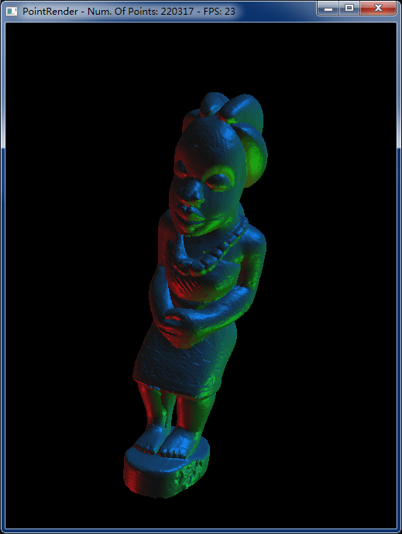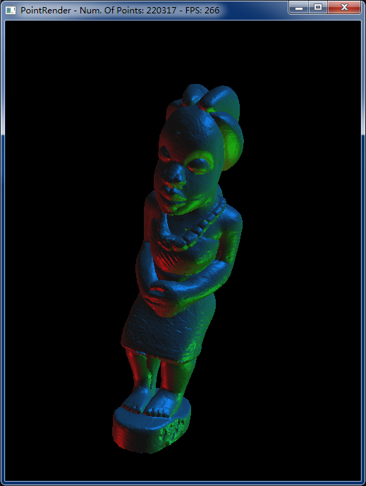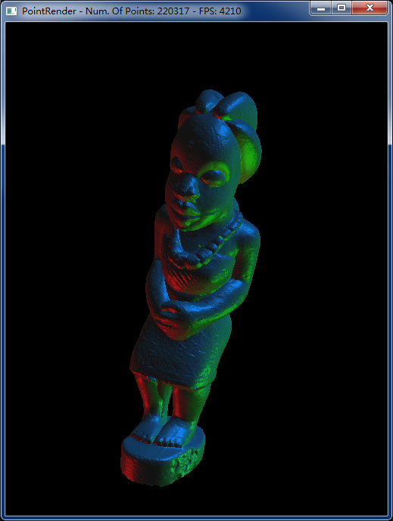

You can change the parameter of lighting using key ‘w, s, a, d, z, x, e, r’, please check console output for the usage.

Rendering with high shininess parameter.

