TP 1 : Basic operations and structures on point clouds

NPM3D - January 15th, 2018

[hugues.thomas@mines-paristech.fr](mailto:hugues.thomas@mines-paristech.fr)

# Objectives

* Load and visualize point clouds on CloudCompare
* Understand basic operations like subsampling and neighborhood search.
* Understand how optimized structures help to compute basic operations faster.

The report should be a pdf containing the answers to the **Questions** and named “TPX_LASTNAME_Firstname.pdf”. Your code should be in a zip file named “TPX_LASTNAME_Firstname.zip”. You can do the report as a pair, just state both your names inside the report.

Send your code along with the report to the email address above. The object of the mail must be “[MVA_NPM3D] TPX LASTNAME Firstname”.

# A. Point clouds manipulations

In the first part of the practical session, you will use CloudCompare software to visualize various point clouds, and you will write a python script applying a simple transformation to a point cloud.

1. CloudCompare installation : <http://www.danielgm.net/cc/>   
   Download and install the latest stable release (2.9.1 Omnia)
2. Python installation : you need to install python > 3.5 and the following packages:
   1. numpy
   2. scikit-learn
   3. scipy
   4. matplotlib
3. If you never used python, install the IDE [pycharm](https://www.jetbrains.com/pycharm/) and ask for teacher’s help to install packages.
4. In CloudCompare, open the PLY file : bunny.ply  
   Drag and drop the file or “File > Open > Choose file”
5. Play with the visualization :
   1. Change point size
   2. Test orthographic projection and perspective view
   3. Activate/Remove EDL (Eye-Dome Lighting)
   4. Show RGB or Scalar field
6. In transformation.py, complete the code to apply the transformations described by the following steps:
   1. Center the cloud on its centroid.
   2. Divide its scale by a factor 2.
   3. Apply a -90° rotation around z-axis
   4. Recenter the cloud at the original position
   5. Apply a -10cm translation of along y-axis

Apply this transformation to bunny and save the result.

*Tip 1 : You might find the following functions useful :* [np.mean](https://docs.scipy.org/doc/numpy-1.13.0/reference/generated/numpy.mean.html), [np.dot](https://docs.scipy.org/doc/numpy-1.13.0/reference/generated/numpy.dot.html) *Tip 2 : In “utils/ply.py” we provided the functions* read_ply *and* write_ply *with a help in their definition*

**Question 1 (1 point): Show a screenshot of the original bunny and the transformed bunny together. Pay attention to the appearance of the point cloud (activating EDL with perspective projection generally gives better visualizations). You should obtain something looking like figure 1.**

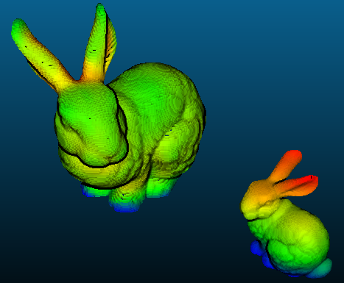

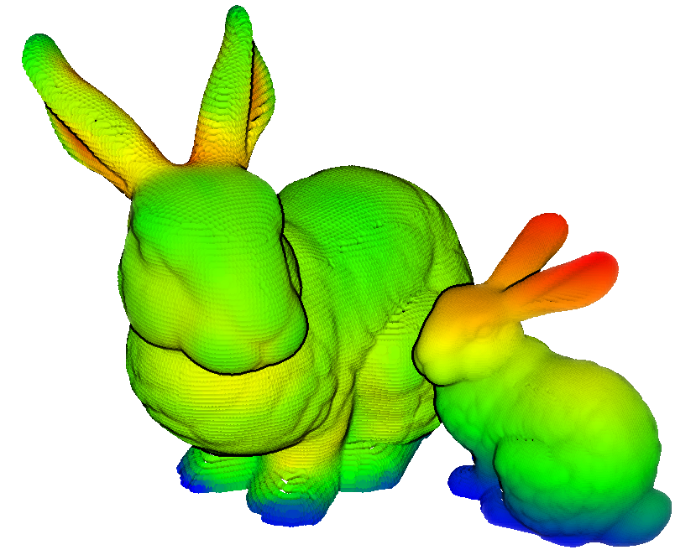

Figure 1 : original and transformed bunnies

# B. Subsampling methods

In this part you will experiment two subsampling methods on point clouds: decimation and grid subsampling.

If we define a point cloud as a matrix then the **decimated cloud** is obtained by keeping one row out of of this matrix :

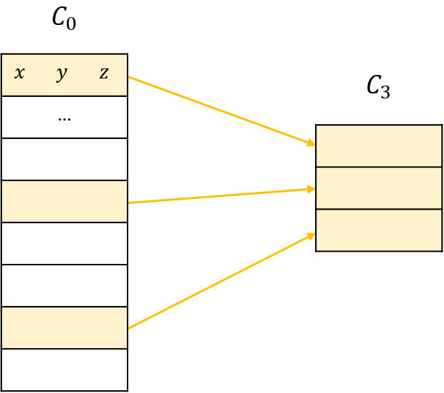

Figure 2 : illustration of decimation

The **grid subsampling** is based on the division of the 3D space in regular cubic cells called voxels. For each cell of this grid, we only keep one point. This point, the representant of the cell, can be chosen in different ways, for example, it can be the barycenter of the points in that cell.

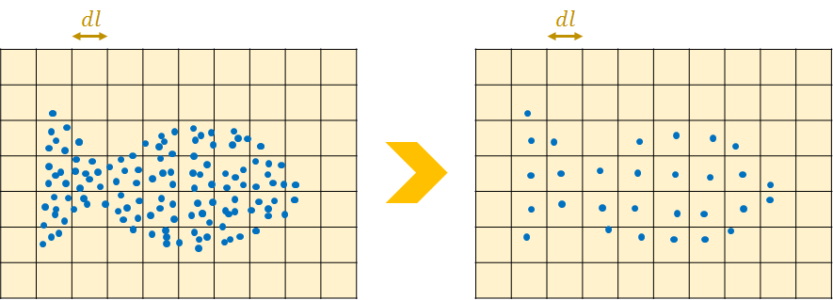

Figure 3 : illustration of grid subsampling in 2D

1. In subsampling.py, complete the function cloud_decimation to decimate the point cloud indoor_scan.ply. You will use a factor .  
   *Tip : Slicing a list in python is pretty simple with the commande*  a[start:end:step]
2. In subsampling.py, complete the function grid_subsampling to subsample the point cloud regularly. You will keep the barycenter of each voxel as new points, and use 20 cm voxels.  
   *Tip 1 : You will find some help in the python file where the function is defined.  
   Tip 2 : You may use python dictionaries to keep the sum and the number of points in each voxel. This sparse structure is more adapted than full arrays which will use all your memory on bigger point clouds (see* [*Mapping Types - dict*](https://docs.python.org/2/library/stdtypes.html#typesmapping)*).  
   Tip 3 : A dictionary cannot take a [i, j, k] vector of coordinates as key if it is a list. However converting it to a tuple (i, j, k) will make it work.*
3. Add the color to the subsampled cloud in the function grid_subsampling_colors. You can keep the color barycenter in each voxel.  
   *Tip : Be careful with the numpy dtype of the sum of colors. The normal color type “uint8” can take values from 0 to 255. Change the type when summing and come back to uint8 after the final division.*

**Question 2 (2 points): Show screenshots of the decimated point cloud and the grid subsampled point cloud in color. Comment on the advantages and drawbacks of each method.**

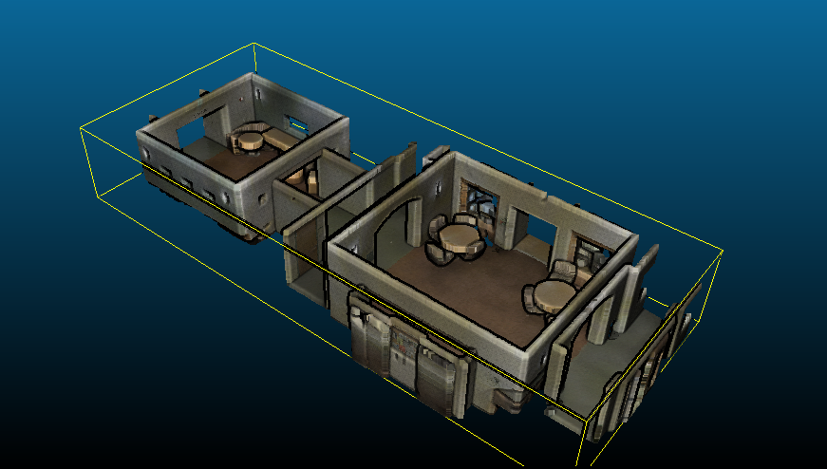

Above : original point cloud with color

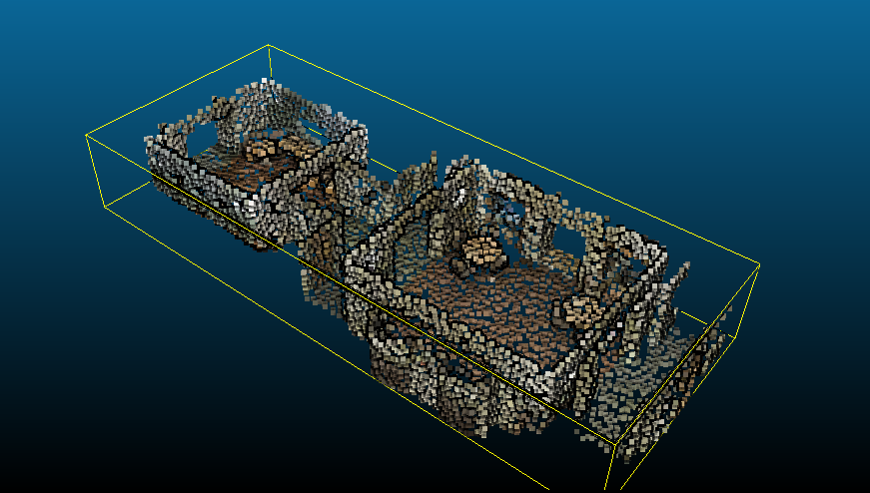

Above : decimated point cloud with color

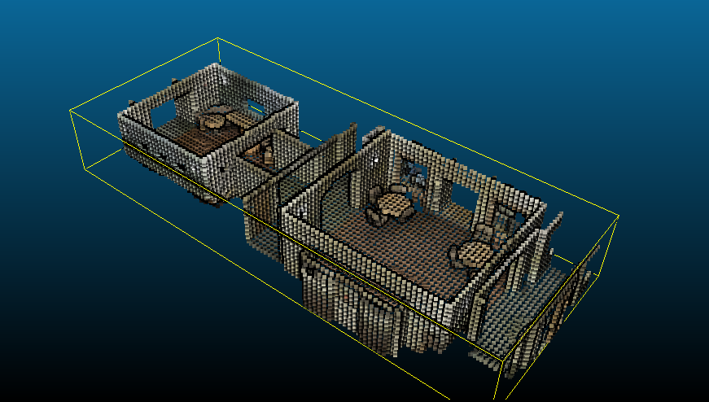

Above : grid subsampled point cloud with color

Comment : Decimation is easy to implement and fast to run. But if the point cloud data has a special pattern in the order of points, decimation will fail. Grid subsampling is slower, but it can guarantee a uniform subsampling.

**Question 2 (Bonus) : Show a screenshot of the grid subsampled point cloud with labels.**

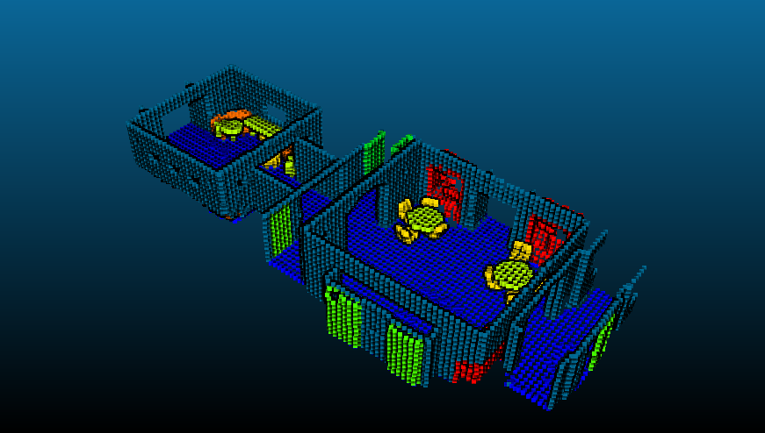

# C. Structures and neighborhoods

The last part of the practical session will introduce the concept of point neighborhoods. You will have to understand the concept of point cloud structures to implement a fast neighborhood computation.

## The concept of neighborhoods

In the case of 3D points, the two most commonly used neighborhood definitions are the **spherical neighborhood** and the **k-nearest neighbors** (KNN). For a chosen point , the spherical neighborhood comprises the points situated less than a fixed radius from , and

the k-nearest neighbors comprises a fixed number of closest points to .

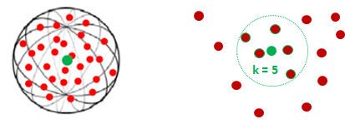

Figure 4 : spherical neighborhood (left) and KNN (right)

1. In neighborhoods.py, implement the functions brute_force_spherical and brute_force_knn to search the neighbors of some points (the queries) in a point cloud (the supports). Use the indoor scan as support. For the spherical neighborhoods, use a 20cm radius and for the KNN, use .  
   *Tip : Compute the distances from queries to supports one query at a time, or you might consume all of your RAM if you have many queries.*

**Question 3 (1 points): Try to search the neighborhoods for 10 queries with both methods. Report the time spent. How long would it take to search the neighborhoods for all points in the cloud?**

Time spend for 10 queries:

Spherical : 1.012 s

KNN: 64 s

Time needed for all queries:

Spherical: 85 hours

KNN: 5486 hours

## Spatial grid structure for point clouds

When searching the neighborhood of a query point, computing distances to all points in the cloud is very slow, and not really necessary. Indeed, we would need much fewer computations if we knew which points are too far away to even have a chance to be a neighbor. This is where structures will help us. The most simple structure is a **spatial grid**, like the one we used for our subsampling, with the difference that we need to keep all point coordinates in the voxels. Knowing in which voxel the query point is, we only need to compute distances to the points in the neighboring voxels, thus, tremendously reducing the computational time.

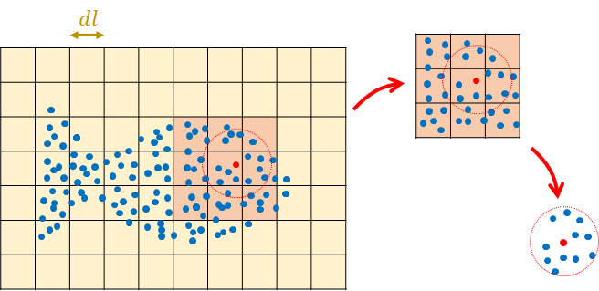

Figure 5 : Illustration of a fast neighborhood search using a grid structure

1. Complete the initiation method of the class called neighborhood_grid. In this method, you should create a grid structure containing all points of the cloud. The size of the voxels should be a parameter of this function.

*Tip : Use a dictionary in the same way as for subsampling, but keep all points in voxels instead of barycenters.*

1. Complete the method called query_radius in neighborhood_grid class, taking query points and radius as input, and returning the spherical neighborhoods for each query. Verify your results by comparing some queries with the brute force method.
2. Create a grid with 20cm voxels, and time the computation of 10 random queries with radius values in [10cm, 20cm, 40cm, 60cm, 80cm, 100cm, 120m, 140cm].
3. Time the computation of 10 random queries with the same radius values on a grid with 1m voxels. Eventually, time the same computation with a brute force search.

**Question 4 (2 points): plot the timings obtained as a function of radius. You should have 3 curves. What is the best solution to compute 20cm radius neighborhood? 1m radius neighborhood? In your opinion, what is the weakness of grid structure for neighborhoods computations?**

|  |  |  |  |
| --- | --- | --- | --- |
| Radius(cm) | 20cm | 100cm | Brute force |
| 10 | 0.005 | 0.014 | 1.131 |
| 20 | 0.021 | 0.023 | 1.04 |
| 40 | 0.084 | 0.091 | 1.198 |
| 60 | 0.229 | 0.187 | 1.14 |
| 80 | 0.546 | 0.29 | 1.138 |
| 100 | 2.025 | 0.751 | 1.101 |
| 120 | 4.154 | 1.022 | 1.112 |
| 140 | 9.877 | 1.285 | 1.149 |

Best solution to compute 20cm radius neighborhood: 20cm voxel size

Best solution to compute 1m radius neighborhood: 1m voxel size

Weakness of grid structure : the efficiency is highly dependent to query radius.

## Hierarchical structures

If you want to search neighborhoods with multiple radiuses, hierarchical structures are more appropriate than a fixed grid structure. The two most commonly used structures are **octrees** and **kd-trees**. These two structures are very similar, as they are both hierarchical trees defining a partition of the space.

An octree is specifically designed for three-dimensional space, recursively subdividing it into eight octants. Each node of an octree thus has exactly eight children. Octrees are the three-dimensional analog of quadtrees. A kd-tree is more general and can partition any k-dimensional space.

As opposed to octrees, kd-trees nodes exactly have two children, which are half-spaces separated by a hyperplane. This structure thus recursively subdivides a space into convex sets by hyperplanes, with the condition that the hyperplanes directions follow the space axes successively.

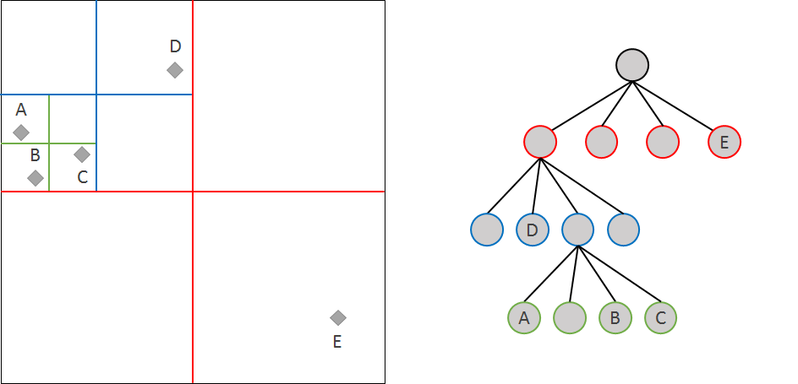

Figure 6 : A quadtree (equivalent of an octree in 2-dimensional space)

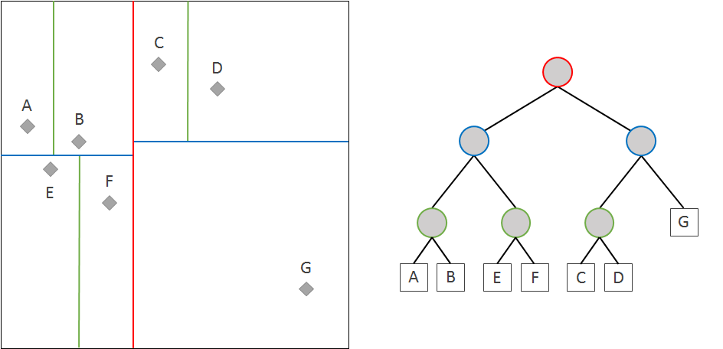

Figure 7 : A kd-tree in 2-dimensional space

1. Scikit-learn offers an efficient implementation of [KDTree](http://scikit-learn.org/stable/modules/generated/sklearn.neighbors.KDTree.html). Explore the documentation of this class to implement a spherical neighborhood search. Play with the parameter leaf_size.

**Question 5 (2 points): which leaf size allows the fastest spherical neighborhoods search? In your opinion, why the optimal leaf size is not 1?**

1. With the optimal leaf_size, time the computation of 1000 random queries with the same radius values as before.

|  |  |  |  |  |  |
| --- | --- | --- | --- | --- | --- |
| Radius(cm) | leaf 1 | leaf 4 | leaf 16 | leaf 128 | leaf 1024 |
| 10 | 0.197 | 0.241 | 0.238 | 0.076 | 0.144 |
| 20 | 0.393 | 0.375 | 0.303 | 0.143 | 0.244 |
| 40 | 0.873 | 0.604 | 0.435 | 0.333 | 0.497 |
| 60 | 1.41 | 1.003 | 0.726 | 0.549 | 0.892 |
| 80 | 2.018 | 1.464 | 1.03 | 0.837 | 1.218 |
| 100 | 2.68 | 1.999 | 1.425 | 1.197 | 1.755 |
| 120 | 3.256 | 2.439 | 1.814 | 1.565 | 2.329 |
| 140 | 3.886 | 3.093 | 2.177 | 2.009 | 2.917 |

Optimal leaf size is around 128.

Optimal leaf size is not one. Because when points in one leaf occupy a small enough cell which is inside the query sphere, these points can be directly collected.

**Question 6 (2 points): plot the timings obtained with KDTree as a function of radius. How does timing evolve with radius compared to what you observed with grid structure? How long would it take now to search 20cm neighborhoods for all points in the cloud?**

See figure above.

Grid structure: timing evolves exponentially w.r.t radius

Kd-tree: timing evolves linearly w.r.t radius

1000 spherical neighborhood computed in 0.133 seconds

Computing spherical neighborhoods on whole cloud: 405 seconds

**Question 6 (Bonus) : In your opinion, which is the fastest between grid, kd-tree and octree? Don’t trust your own timings, scikit learn use a C++ core for KDTree and your grid is in python.**

It should be the Kd-tree.

Grid structure is very sensitive to query radius.

The subdivision of octree is not adapted to points density.

**Question 7 (SUPER BONUS) : Implement your own octree class to compute spherical neighborhood search. Compare its performance to your grid structure.**

With leaf size = 10000, all query time for 10 spherical queries are below 1 second

|  |  |  |  |  |  |  |
| --- | --- | --- | --- | --- | --- | --- |
| **Radius(cm)** | **leaf 10** | **leaf 100** | **leaf 1000** | **leaf 10000** | **leaf 100000** | **leaf 1000000** |
| **10** | **0.108** | **0.035** | **0.038** | **0.025** | **0.096** | **0.729** |
| **20** | **0.183** | **0.067** | **0.066** | **0.047** | **0.105** | **0.723** |
| **40** | **0.457** | **0.156** | **0.11** | **0.082** | **0.176** | **0.939** |
| **60** | **0.646** | **0.301** | **0.203** | **0.189** | **0.27** | **1.112** |
| **80** | **0.957** | **0.44** | **0.427** | **0.269** | **0.439** | **1.088** |
| **100** | **1.437** | **0.551** | **0.516** | **0.508** | **0.598** | **1.476** |
| **120** | **2.002** | **0.907** | **0.625** | **0.66** | **0.939** | **1.703** |
| **140** | **2.263** | **0.83** | **1.192** | **0.877** | **0.999** | **1.888** |