TP 2 : Iterative Closest Points algorithm for point cloud registration

NPM3D - January 22th, 2018

[hugues.thomas@mines-paristech.fr](mailto:hugues.thomas@mines-paristech.fr)

# Objectives

* Test ICP algorithm on CloudCompare
* Implement your own ICP and analyse its behaviour

The report should be a pdf containing the answers to the **Questions** and named “TPX_LASTNAME_Firstname.pdf”. Your code should be in a zip file named “TPX_LASTNAME_Firstname.zip”. You can do the report as a pair, just state both your names inside the report.

Send your code along with the report to the email address above. The object of the mail must be “[MVA_NPM3D] TPX LASTNAME Firstname”.

# A. CloudCompare ICP

In the first part of the practical session, you will use the registration tool in CloudCompare software to visualize a point cloud registration.

1. Load bunny_original.ply and bunny_perturbed.ply artificial clouds in CloudCompare. Select both clouds and start ICP : “Tools > Registration > Fine Registration (ICP)”. You can use the default parameters.
2. Load bunny_original.ply and bunny_returned.ply artificial clouds in CloudCompare and try to use ICP on those clouds.
3. Load Notre_Dame_Des_Champs_1.ply and Notre_Dame_Des_Champs_2.ply real 3D scans. and try to use ICP on those clouds.

**Question 1 (2 points) : How well does ICP perform on those examples? What is the difference between the aligned cloud and the reference cloud? In the last example (Notre Dame), which cloud should be reference and why?**  
When the two clouds are nearly aligned, ICP can converge. But bad initialization like the question (2) can ruin ICP. For question (3), we should align cloud 2 to cloud 1 because cloud 2 is only a small part in cloud 1, then most points in cloud 2 can find its nearest neighbor in cloud 1. But if we align cloud 1 to cloud 2, many nearest neighbor to points in cloud 1 don’t make sense.

# B. Rigid transformation between matched set of points

The ICP algorithm relies on finding the best transformation at each step. It is defined as the transformation minimizing the distances between matched points. Finding such a transformation is not only useful for ICP : when using targets to align two clouds, you have two set of matched points and need the transformation aligning them.

Let’s call $P$ the reference points and $P^{'}$ the points we need to align with $P$. Both $P$ and $P^{'}$ are $(d×n)$ matrices where $n$ is the number of points and $d$ the dimension. Our goal is to find the rotation matrix $R$ and the translation vector $T$ minimizing :

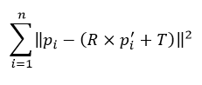

As a reminder here are the steps to do it:

* Calculate barycenters $p_{m }$ and $p_{m}^{'}$
* Compute centered clouds $Q$ and $Q^{'}$
* Get matrix $H=Q^{'}×Q^{T}$
* Find the singular value decomposition $USV^{T}$ of $H$
* Return $R = VU^{T}$ and $T = p-Rp^{'}$

This method is quite simple but have a flaw : it only ensure that the matrix $R$ is orthogonal. As we don’t want $R$ to be a reflexion, but only a rotation, we have to make sure that $det(R)=1$. This can be done by a simple trick : in the case $det(R)<0$, multiply the last column of $U$ by -1 and and compute $R = VU^{T}$ again.

1. In ICP.py, implement the function best_rigid_transform with the SVD method described above.   
   *Tip : you can use the function* [np.linalg.svd](https://docs.scipy.org/doc/numpy-1.13.0/reference/generated/numpy.linalg.svd.html) *to find a singular value decomposition.*
2. To verify your implementation, apply your best rigid transformation function to align bunny_original.ply and bunny_returned.ply. Both clouds have their points in the same order, so you don't need to find any match. Visualize the result on CloudCompare. To measure the distance between two set of points, we will use the same metric as CloudCompare : the root mean square error (RMS) defined below. Compute the RMS error between the points of each cloud before and after applying the best rigid transform.

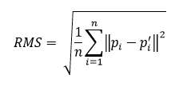

**Question 2 (3 points) : Report the RMS errors obtained. Why did the alignment worked while CloudCompare ICP could not align those two clouds? Would this function align the real 3D scans of “Notre Dame des Champs”? Why?**

RMS = 1.77e-8

Because we know the correct pairing of points between two clouds. While ICP can only guess this pairing by nearest neighbor.

This function will not align the “Notre Dame des Champs” because we don’t know the correct pairing, and the number of points in two point clouds are different

# C. Point to point ICP

To align two point clouds, without knowing the matches between their points, we have to proceed step by step. This is why the ICP algorithm is iterative. Each iteration of the ICP algorithm is a succession of two operations:

* Match points
* Apply the transformation minimizing the distances between matched points

As you already implemented the transformation, you only need a point matching strategy to code your own ICP. As the name of this algorithm suggest, every point of the data cloud will be matched with its closest neighbor in the reference cloud.

ICP iterations have to stop at a certain point. The most obvious condition is to stop when reaching a certain number of iterations. The algorithm can also be stopped when the RMS error between clouds gets below a threshold.

1. In ICP.py, implement the function icp_point_to_point. As input, this function takes the data cloud, the reference cloud, and the two control parameters max_iter and dist_threshold. It should return the aligned cloud, two lists of transformations (R_list and T_list) containing the successive transformations found by ICP, and the list of neighbor indices in the reference cloud at each iteration  
   *Tip 1 : Use a kd-tree built on the reference cloud to compute the nearest neighbors  
   Tip 2 : Use the method* [list.append](https://docs.python.org/2/tutorial/datastructures.html) *to add an element to a list*
2. Use your ICP implementation to align ref2D.ply and data2D.ply.
3. Read the docstring (little text at the beginning of the function) of the function show_icp in utils folder. Pay attention to the remark on R_list and T_list. Use this function to visualize the convergence of your ICP on 2D data
4. Use your ICP implementation to align bunny_original.ply and bunny_perturbed.ply. You can try to visualize the convergence with show_icp, however 3D plot in python are not very beautiful and quite slow.
5. Modify your ICP implementation so that it returns the RMS between matched points at each step

**Question 3 (2 points) : Plot the RMS during ICP convergence for those two examples (2D and bunny).**

1. With your current implementation, the two clouds Notre_Dame_Des_Champs_1.ply and Notre_Dame_Des_Champs_2.ply are too big. However, a simple trick can help to reduce the computation time : at each iteration, only search the neighbors of a fixed number of points. You can chose those points randomly across the data cloud. Following the model of icp_point_to_point, implement a function icp_point_to_point_fast, which uses this trick. It should have one more parameter named sampling_limit controlling the number of point used at each iteration.  
   *Tip : Numpy provide useful function like* [np.random.choice](https://docs.scipy.org/doc/numpy-1.13.0/reference/generated/numpy.random.choice.html) *to select random indices in a list. Pay attention to the “replace” parameter of this function.*

**Question 4 (3 points) : Plot the RMS during ICP convergence for the “Notre Dame Des Champs” clouds with 1000, 10000 and 50000 points used at each iteration. What do you think of those curves?**

More samples lead to a smoother curve since ICP is more stable.

# D. Going further (BONUS)

In the last part of this practical session, you are going to learn tricks to optimize your ICP results and maybe even do better than CloudCompare.

1. Load Notre_Dame_Des_Champs_1.ply and Notre_Dame_Des_Champs_2.ply in CloudCompare. For each point of Notre_Dame_Des_Champs_2 you can compute the distance to Notre_Dame_Des_Champs_1 with the cloud to cloud distance tool (Tools > Distances > Cloud/Cloud Dist.). This tool will save the distances as a scalar field.   
     
   *Tip (for a better visualization): When this is done, select the cloud and find the scalar field display options in the “Properties” panel. Here you can adjust the saturation of the scalar field (slide the red triangle or directly enter a specific value in the saturation box)*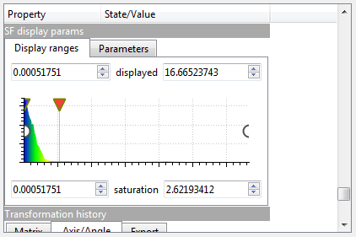

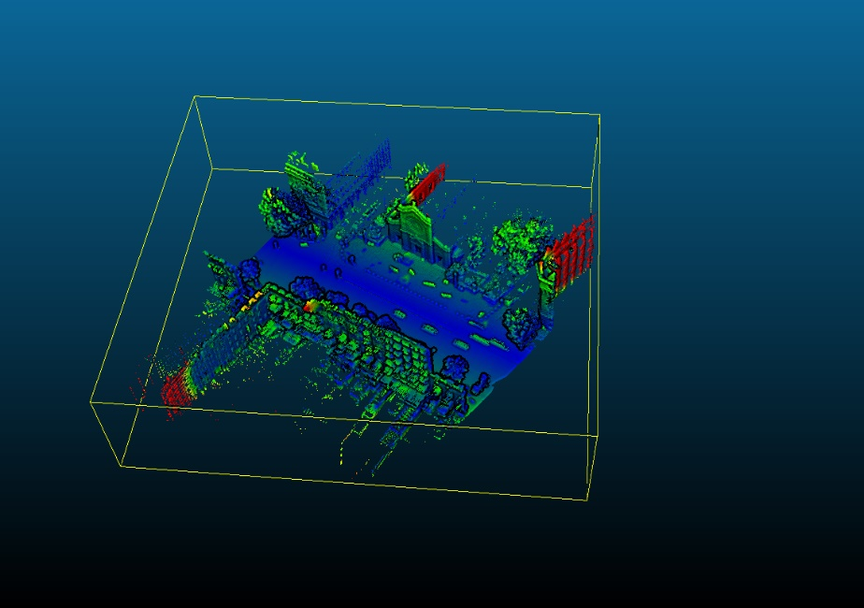

**Question 5 (BONUS) : Do the farthest points (in red color) have a corresponding point in the reference cloud? What effect do they have on ICP convergence? Do you think that computing RMS on the whole data cloud is a relevant measure of the convergence in that case? Why?**

No, they “fall off” the reference cloud.

These points will contribute to fake pairing and then ruin the transformation.

So the RMS on the whole data has no sense since some points will always be far from the reference cloud.

1. Now try ICP on those two clouds, but this time, play with the “Final overlap” parameter. Here is what CloudCompare documentation says about it :

***Final overlap:*** *this is a new parameter for the version 2.6.1. It lets the user specify the actual portion of the data/registered cloud that would actually overlap the model/reference cloud if both clouds were registered. This let the user register entities with only a partial overlap (down to 10% or even less).*

1. When using this parameter, CloudCompare RMS becomes irrelevant as a measure of the alignment quality. To be able to compare the results, you have two choices :
   1. Look at the clouds yourself with CloudCompare and check visually if some object are well aligned (you can look at lamp post, or road signs for example). Using the cloud to cloud distance tool can help the visualization.
   2. Save the aligned clouds as .ply files (choose binary when asked) and create your own python function to compute a relevant RMS measure between two clouds. Following your answer at question 5, instead of computing RMS on all points, you can compute RMS on the 50%, 70% or 90% closest points, or even all 3 to have more relevant measures.

**Question 6 (BONUS) : With the method of your choice, compare the results of you ICP with the results of CloudCompare ICP (with and without changing final overlap parameter).**

1. In your icp_point_to_point_fast implementation, add a final_overlap parameter and modify the function following this idea : at each iteration, when choosing a random number of point to compute one step, remove a % of the farthest points depending on the final overlap parameter.
2. In the data folder, you can find Notre_Dame_Des_Champs_2_CCbest.ply, this is the best alignment that can be obtained with CloudCompare.

**Question 7 (BONUS) : Compare your best ICP result with the best results obtained by CloudCompare. Could you beat CloudCompare ICP?**