TP 6 : Modelling

FENG Leman

# Objectives

* Implement RANSAC and analyses its behaviour.
* Implement Region Growing algorithm and analyse its behaviour.

**Question 1 (2 points) : Explain what produces this behaviour.**

There are three problems

1. The random choice of triple points will not always return a meaningful plane even after several trials, so we need a criterion to refuse the extracted plane.
2. Some meaningful extraction may contain too many points which outside the real plane, such as the yellow points outside the round table in the following image.
3. Keeping the plane with most inside points is not the best option. Consider the bounding box of this room, a vertical plane must cover less area than a horizontal plane. So it’s better to calculate the point density instead of point number.

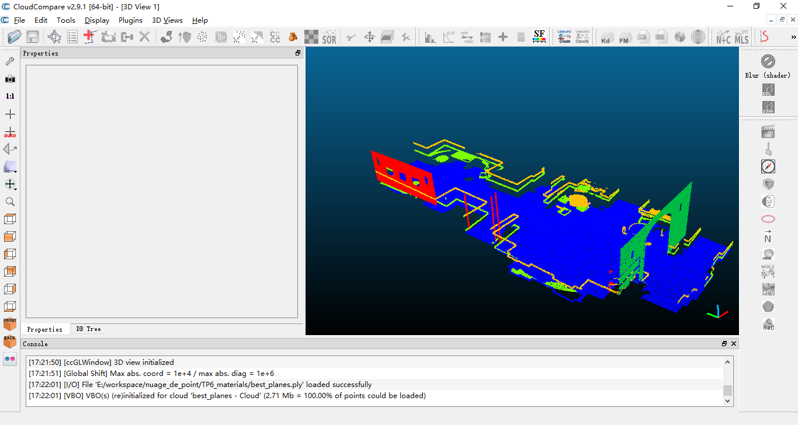

**Question 2 (Bonus) : Do you have any ideas to prevent this behavior from happening?**

Solutions:

1. We need to be capable of telling if one extraction of plane is significant. We need to analysis using probability. Number of false alarm is a good criterion to use. But this might be too complicated for this TP. One possible reference is : *Lezama J, Morel J M, Randall G, et al. A contrario 2D point alignment detection[J]. IEEE transactions on pattern analysis and machine intelligence, 2015, 37(3): 499-512.*
2. We can combine region growing method to extract only the continuous plane, and using features to wipe out irrelevant linear segments
3. To calculate the point density in plane, we need to calculate the area of our plane inside the bounding box. Consider in 2D firstly:

$$l$$

$$n$$

$$N$$

$$L$$

Two horizontal blue lines is one pair of lines of the bounding box, with distance $l$ between them. Then the length of red line inside the bounding box is:

$$L=\frac{l}{\overset{⃑}{n} ⋅\overset{⃑}{N}}$$

While we also need to consider the other pair of lines of the bounding box:

A simplification is to consider the interior length as the minimum intersection of all pairs of line of bounding box. This approach can be extended to 3D.

The result is better than the original one:

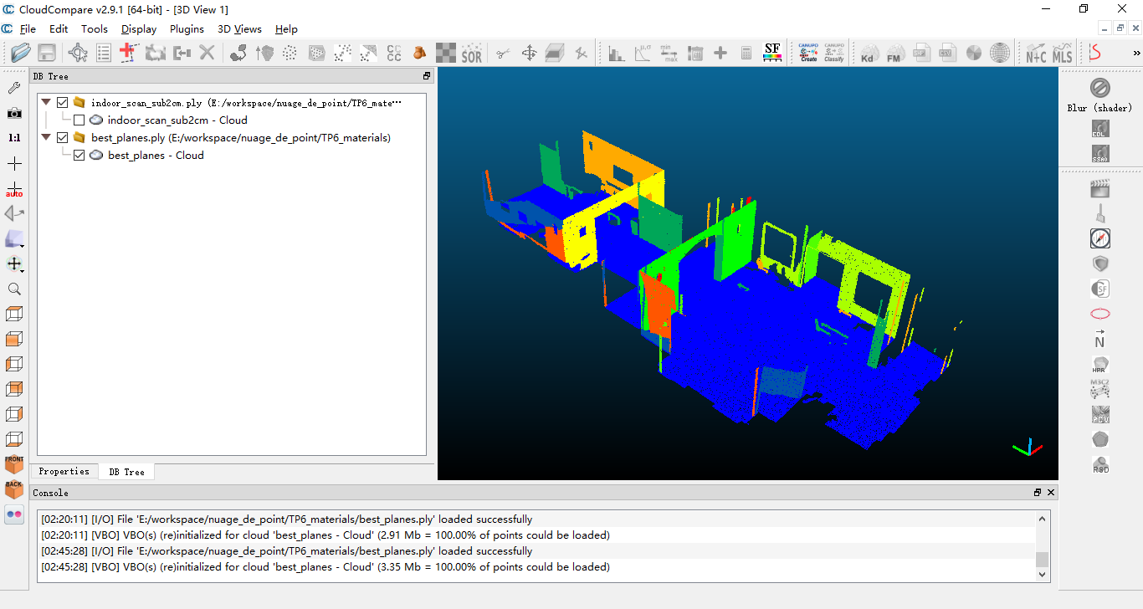

# Region Growing

**Question 3 (4 points) : How does the values of** radius **and thresholds affect the plane segmentation?**

A large radius is sensitive to nearby objects and the extracted plane will have a round corners.

A small threshold of plane-distance and normal alignment will not tolerate the sampling error of point cloud and the result will be fuzzy, shown below.

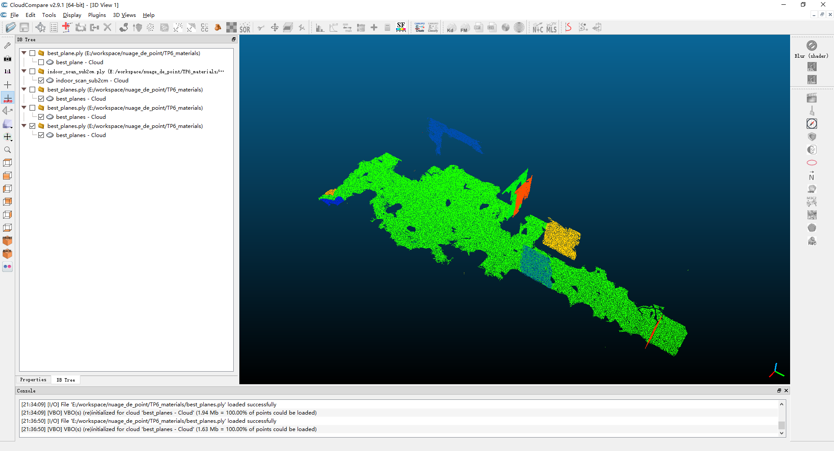

**Question 4 (2 points) : Do you have any ideas to find a seed which increases the chances of finding a plane?**

We can begin with the point which has a good planarity measured by a large radius.

**Question 5 (2 points) : Show a screenshot of the extracted planes, with a different color for each plane. You should obtain something like in figure 2.**

