AQS-HSE-001
Hazard Separation, Containment, and US Code Basis
Revision A · 27 September 2026 · Closed-loop microcosm / recycle campus
This is a design-basis review against the editions named below. It is not a professional-engineer stamp, not an AHJ permit set, and not a guarantee that a given city will accept the 2026 NEC. Construction documents still need a licensed engineer of record in the project state, local amendments, and listed equipment cut sheets.

1. Scope and editions
The plant is a single-building campus: recycle core (Salria leach, EW, BMED, oil pyrolysis, glass/ceramic), outdoor ZnBr2 flow battery and power yard, CRYO gas plant, WAFER FAB, FARM, HABITATION, MFG SHOP. Locked process rules (separate gas headers, no FR-4 in the pyrolyzer, etch closed to REGEN LEACH) already do most of the incompatible-materials work. This review turns those rules into occupancy, inventory, classified-area, and containment requirements.
Editions used as the design target (current NFPA publications as of this date; enforcement is local):
Instrument | Edition used here | What it governs on this site
NFPA 70 NEC | 2026 | Wiring, classified locations, ESS Art. 706, working space
NFPA 70E | 2024 | Arc-flash / shock work practice
NFPA 1 / 5000 / IBC analog | current adopted | Fire areas, mixed occupancy, egress
NFPA 400 | 2025 | Oxidizers, corrosives, MAQ, protection levels
NFPA 2 / 55 | 2023 / current | Hydrogen and compressed / cryogenic gas
NFPA 30 / 69 | current | Flammable liquids; explosion prevention
NFPA 855 | 2026 | Stationary ESS including flow / Zn-Br
NFPA 13 / 101 | current | Sprinklers; means of egress
29 CFR 1910 | current OSHA | PSM, LOTO, confined space, HazCom, electrical
EPA RMP / CWA | current | Cl2/H2/Br2 thresholds; no process to sewer
NEC 2026 is published and, as of late September 2026, enforced in a minority of states including Texas. Dallas construction still requires a check of city amendments. Design to 2026; permit to whatever the AHJ has adopted.

2. Findings — what already holds
Four process headers (DUST, ACID_GAS, H2, OIL_VAPOR) plus HDR_CAUSTIC never enter FARM, WAFER FAB, or HABITATION. Life headers are a separate rack at different elevations (AQS-PIP-002). That is the correct NFPA 400 incompatible-materials control.
ZnBr2 Br2 tower is already isolated from CRU and from CRYO. EW bund returns to CSTR 1, not a drain. WET BENCH has no floor drain. FR-4 is banned from the induction pyrolyzer. Those locks stay.
Gaps that were not construction-ready: fire-area ratings between hab and process, NEC classified envelopes around H2 and oil vapor, PSM/RMP inventory caps, NFPA 855 siting of the 120 kWh flow battery, and potable/process water isolation. Those are locked in cad/HAZARD_SEPARATION.md and drawn on hazard_separation_pfd.png.

3. Occupancy and fire areas
One roof is not one fire area. NFPA 400 Table 6.2.1.3 does not permit Protection Level 1 contents against residential occupancies. Habitation is treated as an R-2 analog. Recycle core is F-1 industrial; if NaClO3 / acid inventories exceed indoor MAQ it becomes an H-3 overlay (Protection Level 3). Required separation, residential vs PL-3, is 3 hours. Design uses 3 hour HAB–CORE and 2 hour HAB–FARM / FAB–CORE / CRYO.
No process-atmosphere duct crosses a fire barrier. Q4 water may. HVAC that must cross is a listed fire/smoke damper and a separate air handler. Sleeping rooms have egress that does not pass through the recycle aisle.
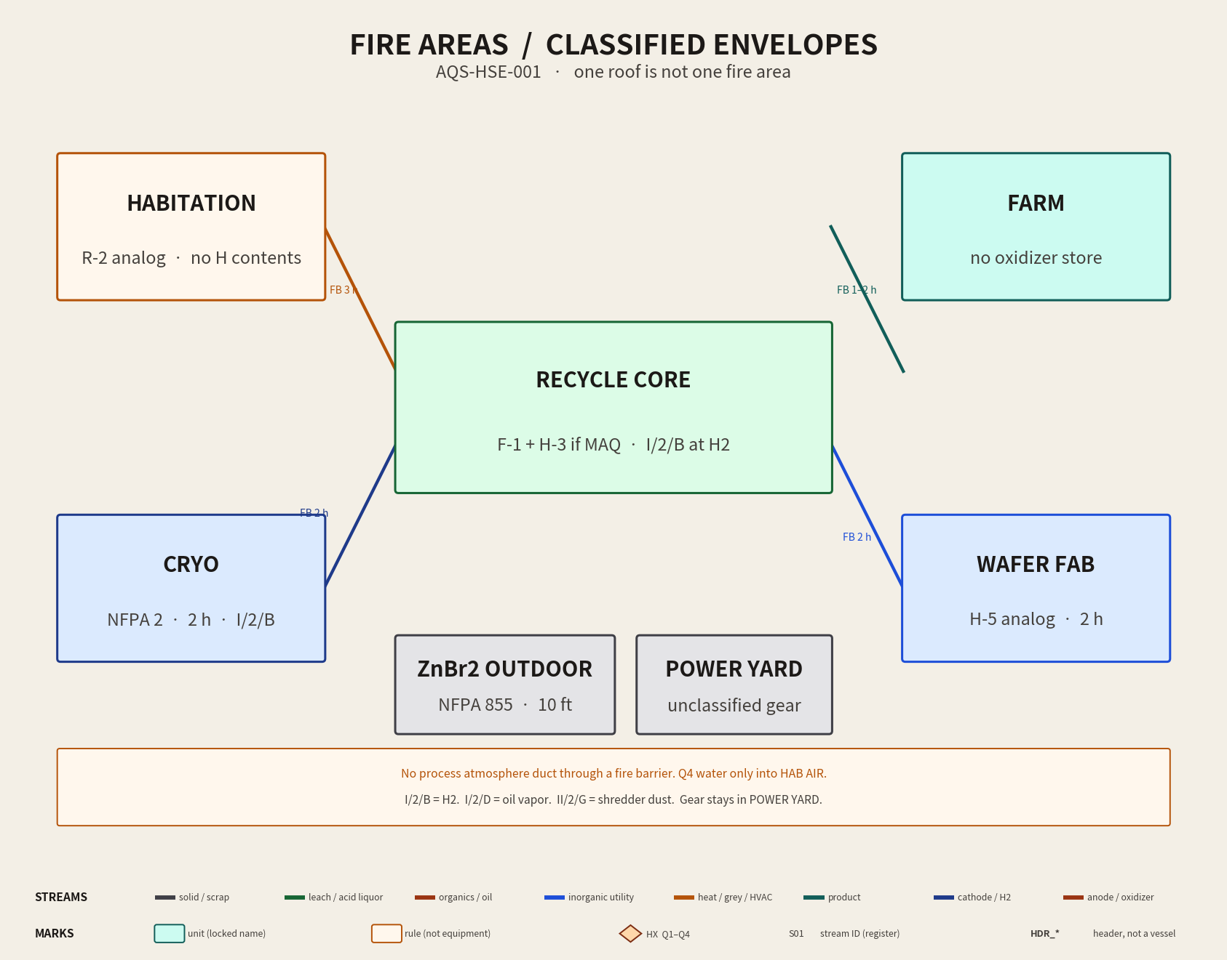
Figure 1. Fire areas and classified envelopes (hazard_separation_pfd.png).

4. Hazardous materials and MAQ
Sodium chlorate is an NFPA 400 Class 3 oxidizer. Keep it in solution in CRU / REGEN LEACH / CSTR 1. Do not warehouse dry bags next to the oil line or in the farm. Class 3 oxidizer indoor MAQ is small (order 10 lb / 2 gal in an unprotected control area; sprinklered industrial rooms are larger). If the plant holds more than the AHJ MAQ in one fire area, that fire area is Protection Level 3 — not a control-area workaround.
Aqueous HCl (BMED product) is a corrosive, not OSHA PSM Appendix A (that listing is anhydrous HCl / HCl gas). EPA RMP still lists hydrochloric acid ≥37% at 15,000 lb. Size and document the acid tanks.
Oxidizer containers stay ≥25 ft from combustible-liquid containers, or a 1-hour partition, per NFPA 400 Chapter 15 practice.

5. OSHA PSM / EPA RMP inventory caps
1910.119 applies if the process holds a listed chemical at or above TQ, or ≥10,000 lb of Category 1 flammable gas. Design caps so the module does not become a PSM facility by accident. If a future scale-up crosses a cap, stop and write the PSM program before adding tankage.
Material | PSM TQ | RMP TQ | Design cap on this plant
Chlorine | 1,500 lb | 2,500 lb | No Cl2 receiver. Generate → alkali pack → CRU. Free Cl2 < 100 lb eq.
Hydrogen (flammable gas) | 10,000 lb | 10,000 lb | CRYO_H2 + dryer hold < 150 lb. No tube trailer indoors.
Bromine | 1,500 lb | see RMP list | Free Br2 vapor < 50 lb. Complexed Br3− in outdoor PVDF tank.
Anhydrous HCl | 5,000 lb | 5,000 lb | Not stored. Aqueous BMED acid only.
NaClO3 (solid) | not App. A | — | Keep wet in CRU. No dry oxidizer warehouse.
Cathode hydrogen is a generation rate. It only becomes inventory in H2_DRYER and CRYO_H2. Size those vessels to the cap, then use or vent through the listed train — do not add a bulk GH2 pack to “simplify” operations.

6. Electrical — NEC 2026
Classified locations use Article 500 Division (not Zone) unless the AHJ requires 505.
Location | Class / Div / Group | Extent | Equipment
HDR_H2, H2_DRYER, CRYO_H2, cathode hood | I / 2 / B | 3 ft flanges; 5 ft dryer | XP or purged; 316
Oil vapor / quench / fractionator vent | I / 2 / D | 3 ft around vents | XP or purged
Afterburner front | I / 2 / D | per burner listing | Listed train
Hopper / shredder dust | II / 2 / G | 10 ft around dump | Dust-tight
EW aisle general | Unclassified if capture documented | LEL < 10% of H2 LFL | Ordinary + GFCI
POWER YARD / Sol-Ark / rectifiers | Unclassified | Outside Class I | NEMA 3R/4, 110.26 space
ZnBr2 outdoor skid | I / 2 / D at vents if off-gas | 3 ft | XP instruments
Working space in front of 480 Y/277 gear: 3 ft 6 in (110.26 Condition 2). Bonding per Art. 250; the existing GND_RING stays. Wet locations (EW aisle, farm, hab water) get GFCI where 210.8 requires it. Emergency disconnect and EPO for the ESS per Art. 706 and NFPA 855. Arc-flash labels per 70E on the MCC and rectifier.
The 120 kWh / 60 kW ZnBr2 pack exceeds the historic indoor flow-battery trigger (20 kWh in IFC Table 1207.1.3). It remains an outdoor skid, ≥10 ft from building openings, with its own Br2 scrubber, EPO, and 110% bund. NFPA 855-2026 makes a hazard-mitigation analysis the default for ESS in scope; write that HMA before energizing, even outdoors.

7. Hydrogen and cryogenics — NFPA 2 / 55
Indoor non-bulk GH2 above the MAQ and below 5,000 scf: ventilated room, 25 ft from ignition, 50 ft from HVAC intakes in the same room (reducible to 10 ft with listed detection that trips at 25% LFL and closes fuel). Detection already belongs on HDR_H2. Do not tee CRYO_H2 into HDR_O2. Oxygen enrichment of hab air is a separate, cleaned HDR_O2 system with its own shutoff.
CRYO is a 2-hour fire area. It does not share a cold box or a relief header with the ZnBr2 tower.

8. Containment
Secondary containment is 110% of the largest tank in that spill group. Process liquor spills go back to CSTR 1 or CRU. Storm, farm irrigation, and hab drains are not in that group.
Group | Primary | Secondary | Forbidden path
Salria / EW / PK | CPVC cells | Aisle bund → CSTR 1 | Sewer, farm, hab
BMED acid/base / CRU | CPVC/PP | Acid-resistant sump 110% | Storm
Oil cuts / quench | 304 / CS | NFPA 30 dike, remote from oxidizer | Oxidizer room
ZnBr2 tanks | PP / PVDF | Outdoor 110% one tank | CRU liquor
Etch return | PVDF closed | No floor drain | HDR_GREY, sewer
Farm / hab water | PP | Grey header only | Salria

9. Ventilation, detection, life safety
Anode hoods → HDR_ACID_GAS → alkali pack → fan → stack (fan after the pack). Cathode hoods → HDR_H2 → arrestor → dryer. Oil vapor → quench → afterburner. Dust → baghouse → CSTR 1. Four atmospheres stay four atmospheres.
H2 detectors at 25% LFL trip rectifiers and isolate HDR_H2 (NFPA 69 combustible-concentration reduction). Br2 detector on the battery skid trips pumps and holds the scrubber.
Sprinklers: NFPA 13 throughout occupied indoor fire areas. Oxidizer / oil rooms need a design density the fire-protection engineer sets; do not assume ordinary-hazard density is enough. Two exits from the recycle aisle. Hab sleeping egress does not enter an H fire area. Emergency lighting NEC 700.
Potable water: reduced-pressure principle backflow preventer or air gap between any process makeup and the hab/farm potable split (IPC). HDR_UPW is process UPW, not a drinking fountain.

10. OSHA programs that run regardless of PSM
1910.147 LOTO on shredder, pyro, rectifiers, Sol-Ark. 1910.146 permit-required confined space for CSTR 1, fractionator, scrubbers. 1910.134 respirator program for Salria, Cl2, Br2 tasks. 1910.1200 HazCom. 1910.212 guarding on the shredder. 1910.95 noise survey. 1910.303–305 and 333 for electrical work. Mezzanine guardrails 1910.29.

11. What to build (construction rules)
CAD objects FB_HAB_CORE (3 h), FB_HAB_FARM (2 h), FB_FAB_CORE (2 h), FB_CRYO (2 h), FB_ESS (2 h or open-air setback) are in cad/freecad/fire_barriers.py. Rated walls are listed gypsum, CMU, or equivalent assembly — not a painted line on the PFD.
POWER YARD and ZnBr2 stay outdoors. Sol-Ark, ATS, and rectifiers are not mounted in the EW aisle. Cable tray may cross a fire area only in a listed through-penetration.
Wet process valves on oxidizer service remain GF 546 Pro V PVC-C FKM. Utility water and HX loops stay non-vented. That is material compatibility, which is how you keep the containment intact.

12. Open items the AHJ will still ask for
Site-specific occupancy classification letter. NFPA 855 HMA for the ZnBr2 skid. Area classification drawing stamped with the actual LEL survey basis. Hydraulic sprinkler calculations. Stack dispersion if the county requires it beyond AQS-GAS-003. Backflow-preventer spec. Emergency action plan (1910.38) and, if a cap is later exceeded, full PSM. Licensed EOR in the permit jurisdiction.
Project file of record for these rules: cad/HAZARD_SEPARATION.md. Plan: hazard_separation_pfd.png.

