Comparison of novel method based on 3-D reconstruction for pig weight prediction

Liang Shihao1, Yin Ling1,2※, Shi Shuai1

(1. *College of Mathematics and Informatics*, *South China Agricultural University*, *Guangzhou* 510642, *China*; 2. *National Engineering Research Center for Swine Breeding Industry, Guangzhou 510642, China;*)

# Abstract:

3D machine vision has an important role in the prediction of weight of live pigs, mainly for the purpose of selecting animals for process of real production. The present work proposed a novel non-contact measurement solution and compared it with state-of-the-art machine vision methods and traditional methods for pigs’ weight measurement. In the present work, a fast, non-contact measurement for pigs’ weight is implemented by process of estimating the volume of point clouds using Microsoft Kinect v2 depth camera. Moreover, body dimensions of pigs such as withers width, heart girth, length are manually measured to verify the precision of the non-contact measurement. Based on it, some models including linear and non-linear regression model are established to compare the Kinect and manual measurement data. Compared with several methods (PCR, SVR, GBDT), our method showed high coefficients of determination ( > 0.97) with less data acquisition, which performed well in predicting live weight of pigs. The non-contact pig weight measurement system shows its potential to be applied in the real farm environment.

Keywords: Pig, Principal components regression, Body measurement, Predictive model

Table 1 Collected body dimensions of pigs for BW prediction

|  |  |
| --- | --- |
| Body dimensions | Abbreviation |
| Body length | BL |
| Body weight | BW |
| Withers height | WH |
| Hip height | HH |
| Withers width | WW |
| Abdominal width | AW |
| Hip width | HW |
| Heart girth | HRG |
| Abdominal girth | AG |
| Hip girth | HG |

# Introduction

Live weight is a vital indicator in pig production. Traditional method of BW measurement is driving pigs from the pigsty to the weighing equipment. The entire process is time-consuming and laborious (Pezzuolo et al., 2018). Measuring 2 pigs takes 3 to 5 minutes for a pig's mass, which also causes severe stress on pigs. Some solutions such as installing automatic feeding station equipped with a load cell could monitor the pig's BW. However, such equipment needs to be transformed into a piggery, which is expensive for most breeder.

To address these problems, new technologies such as two-dimension (2-D) and three-dimension (3-D) imaging are developed for animal production. 2-D imaging shows its outstanding performance in measuring body length and body height (xxx). Nevertheless, BW estimation is less effective even using binocular stereo system based on 2-D cameras (Tasdemir et al., 2011; Shi et al., 2016). Due to the lack of morphological information in 2-D images, some vital body dimensions such as HG and BW are difficult to acquire. In addition, second, it is necessary to provide a suitable environment such as a dark background, to distinguish the pig body from the surroundings (Wongsriworaphon, A., et al., 2015). In terms of the problems, 3-D images are more advantageous for it.

The popularity of inexpensive three-dimensional image equipment including Microsoft Kinect, RealSense and X-tion in recent years makes it possible to reconstruct the complete morphology of pigs so that to predict the volume and live weight. Mobile measuring system is presented to acquire point cloud data for body measurement or BW prediction (Kuzuhara et al., 2014; Kongsro, 2014; Guo et al., 2017a,b), while multiple depth sensors could get more body morphology information (Kawasue et al., 2013).

Many methods using 3-D imaging is estimating the length and other body dimensions to predict BW. The errors would be accumulated by the two times estimation (Kuzuhara et al., 2015). Instead, determination of BW by volume could directly acquire most morphology traits. The Morpho3D scanning device was developed to determine the dairy cow volume accurately (Le Cozler, et al., 2019).

In this present work, the Kinect depth devices were developed to acquire the morphological traits from three different view (upper, left and right). Point cloud preprocessing is operated by Random Sampling Consistency (RANSAC) and PointNet++ (Qi et al., 2017b) to extract pig contour. After the process of triangulation and hole-filling, the closed surface is generated for the calculation of the volume to predict the weight of the pigs.

Results can be compared against a linear regression model, and a so-called transfer function (TF) model, as developed by Kashiha et al. (2014). In the paper, several models such as the state-of-the-art machine learning (ML) would be compared with our method based on volume estimation.

# Materials and methods

## data acquisition and reconstruction

### 1.1.1 data acquisition

Raw data were acquired from a pig experimental farm located at Xinxing County, Yunfu City, Guangdong Province in China. 75 data acquisition procedure is in summer,

The local point clouds data were collected by three Kinect v2 depth sensors from different views (upward, left and right). Due to the relative robustness against uncertainty in different illumination conditions, Kinect v2 depth sensors could work in day and night.

**Fig. 1.** 3D data acquisition measurement scene

①: Kinects ②: railings

### 1.1.2 point cloud reconstruction

Raw data from three depth cameras were reconstructed into a complete pig point cloud by the cube reference registration method, which is showed in Fig.1.2.

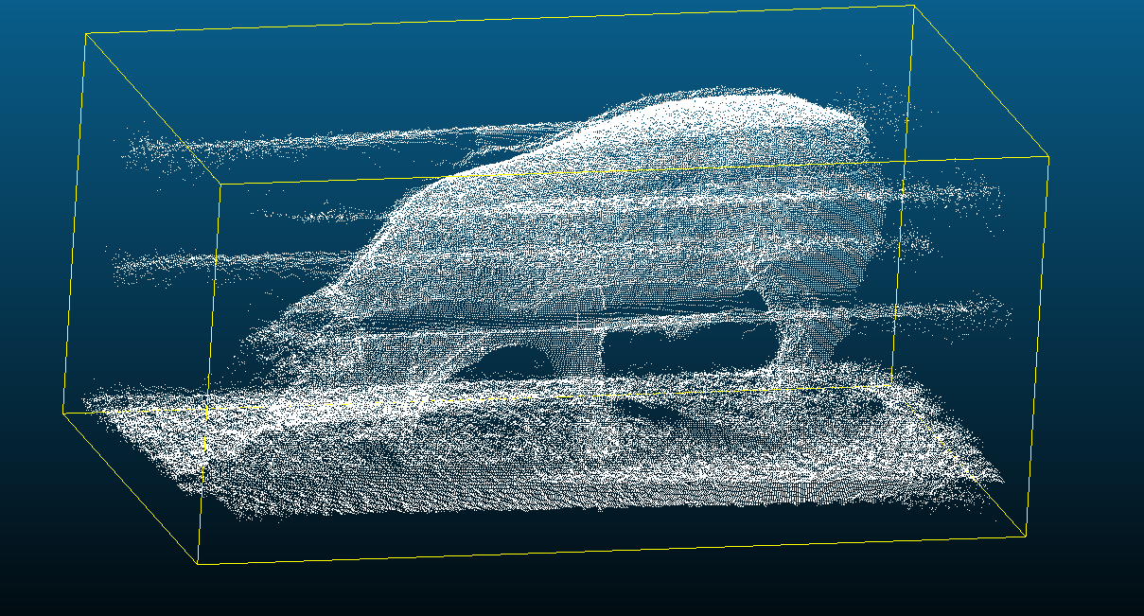

**Fig. 2.** The procedure of point clouds reconstruction. Getting point clouds of reference (a cuboid) from three different views and plane-fitting, calculating the transformation matrix according to their relative position of the cuboid. The transformation matrix is used in point cloud registration of pig contour.

As Fig. x showed, the reconstruction parameters were obtained using a rectangular cuboid as a reference, and then the point clouds in three different coordinates were transformed into a uniform world coordinate system. Based on geometric features of the rectangular cuboid surface, multi-view cuboid point clouds were acquired when the rectangular cuboid was placed in the best viewing area in the walkway, then each corresponding plane of the cuboid was estimated and the geometric feature points were extracted to calculate rotation matrix and translation matrix. Finally, by using this rotation matrix and translation matrix, the registration and fusion of multi-view point clouds data could be performed.

The noise was concentrated on the ground. Noise is the key to denoising. Multiple experiments have proved that the above noise will cause serious interference to 3D body measurement.

## Pig contour extraction

As seen in Fig. 2, the reconstructed point cloud contained pig contour and other points mainly including the ground, railings. Firstly, some outlier and noise are trimmed using Gaussian distribution. The ground is approximate plane which could be extracted by RANSAC. However, other points are irregular for general methods for noise reduction. The PointNet based on deep neural network is applied in this paper.

### outlier and ground removal

With the above process, there were some outlier distributed around the pig. These irregularities can be solved by performing a statistical analysis on each point’s neighborhood and trimming those which do not meet a certain criterion. The sparse outlier removal is based on the computation of the distribution of point to neighbors’ distances in the input dataset. For each point, we compute the mean distance from it to all its neighbors. By assuming that the resulted distribution is Gaussian with a mean and a standard deviation, all points whose mean distances are outside an interval defined by the global distances mean and standard deviation can be considered as outliers and trimmed from the dataset.

The ground point clouds are detected by using random sample consensus algorithm (RANSAC). In each round of the RANSAC process, RANSAC randomly selects one set of sample points from each point cloud and uses the points to calculate the transformation parameters. By applying the transformation parameters to the all point clouds, the number of inliers, namely, successfully aligned points, is counted. During the iteration, the transformation parameters of the iteration round with the largest number of inliers are regarded as the final transformation parameters. The result of RANSAC is shown belowed

Fig. x. RANSAC method to estimate the plane. The red points represent the outliers and the blue points represent the points fitted to the plane.

An advantage of RANSAC is its ability to do robust estimation of the model parameters. As shown in Fig. x, it can estimate the parameters with a high degree of accuracy even when a significant number of outliers are present in the data set. A disadvantage of RANSAC is that there is no upper bound on the time it takes to compute these parameters. When the number of iterations computed is limited the solution obtained may not be optimal, and it may not even be one that fits the data in a good way. In this way RANSAC offers a trade-off; by computing a greater number of iterations the probability of a reasonable model being produced is increased. Another disadvantage of RANSAC is that it requires the setting of problem-specific thresholds. RANSAC can only estimate one model including line, plane and some common model for a particular data set. As for any one-model approach when two (or more) models exist, RANSAC may fail to find either one.

In this paper, plane is set to the sample consensus model recognized in reconstructed point cloud. The distance to model threshold is another important parameter to be tuned. If threshold is too large, too many points would be extracted while the points belong to the ground could not be recognized fully. After testing, the distance to model threshold is set to 0.05 meter.

The result showed that the RANSAC algorithm for the ground plane segmentation effectively deleted the ground points and extracted the target pig points.

 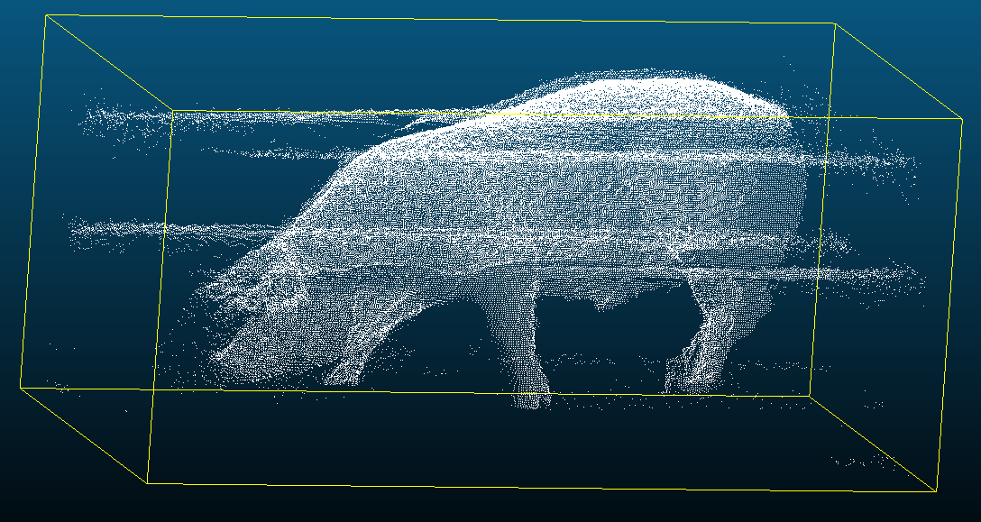

a b

Fig. 5 a. Points before RANSAC b. points after RANSAC

### 1.2.2 PointNet filter

Because of the diversity and specificity of point cloud data, it is difficult to use regular clustering methods directly in pig contour extraction. In order to solve these problems, researchers propose some networks using point cloud directly as input. These networks usually have delicate structures. PointNet (C.R. Qi, 2017a) uses max-pooling and T-Net to obtain global features of point cloud.

The main problem with point cloud deep learning is that typical convolutional architecture requires highly regular input data format, like image or temporal features. As point cloud are not in regular format, the common approaches are to transform the data to regular 3D voxel grid or projections. PointNet is a seminal method in 3D perception, applying deep learning to point clouds for object classification and part semantic segmentation.

Pointnet was the initial approach for novel type of neural network that directly consumes unordered point clouds, which also takes care of the permutation invariance of points in the point cloud. Pointnet can do object classification, part segmentation, to scene semantic parsing. The main feature of Pointnet is the network is robust with respect to input perturbation and corruption. Also, the network can learn to summarize a shape by a sparse set of key points.

Given that PointNet consumes raw point cloud data, it was necessary to develop an architecture that conformed to the unique properties of point sets. Among these, the authors emphasize:

* Permutation (Order) Invariance given the unstructured nature of point cloud data, a scan made up of N points has N! permutations. The subsequent data processing must be invariant to the different representations.
* Transformation Invariance: classification and segmentation outputs should be unchanged if the object undergoes certain transformations, including rotation and translation.
* Point Interactions: the interaction between neighboring points often carries useful information (i.e., a single point should not be treated in isolation). Whereas classification need only make use of global features, segmentation must be able to leverage local point features along with global point features.

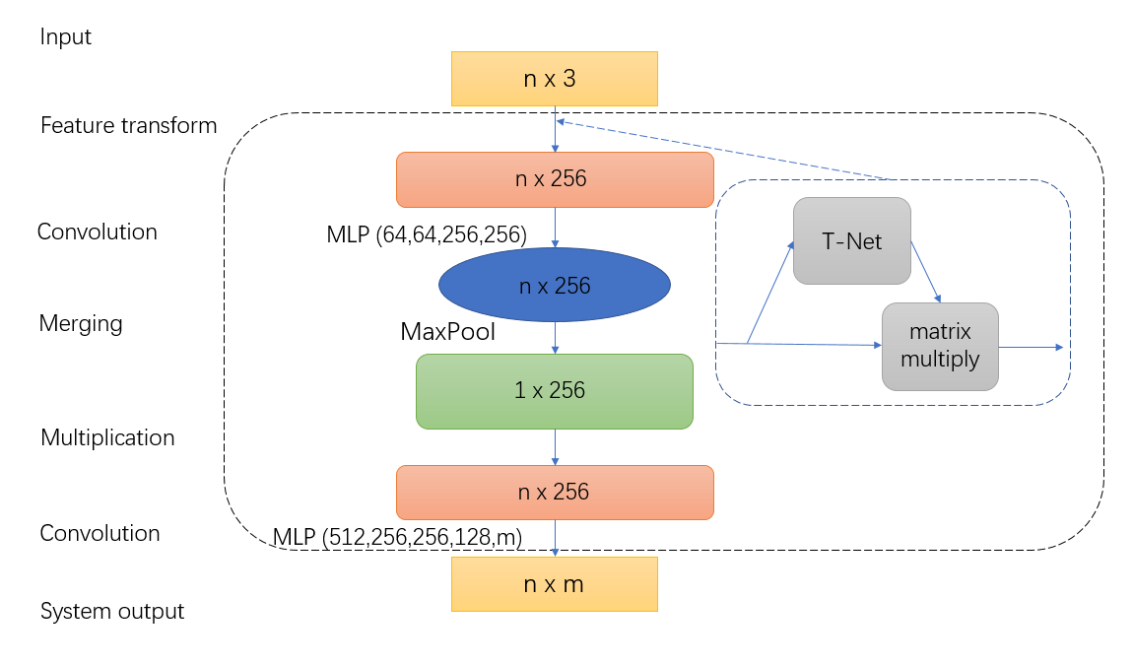

Fig. 4. Block diagram of the neural network

The PointNet model has been adapted to the classification of properly pre-processed point cloud data. The block diagram of the whole Deep Neural Network (DNN) system is shown in figure 4, where sharp rectangles point to a data block, and rounded rectangles indicate data operations. The input data of the system is a cloud of raw points, which is a list of points with their initial geometrical and physical features.

The segmentation network uses a shared multi-layer perceptron (MLP) to map each of the n points from three dimensions (x, y, z) to 256 dimensions. It’s important to note that a single multi-layer perceptron is shared for each of the n points (i.e., mapping is identical and independent on the n points). With the points in a higher-dimensional embedding space, max pooling is used to create a global feature vector in . Finally, a three-layer fully connected network is used to map the global feature vector to m output classification scores. The details on the “feature transform” is covered in the T-Net section below.

The output of the system is a matrix n × m. The rows correspond to *n* classified points, and the positions in the individual columns indicate the probability with which each point belongs to each of the adopted *m* classes.

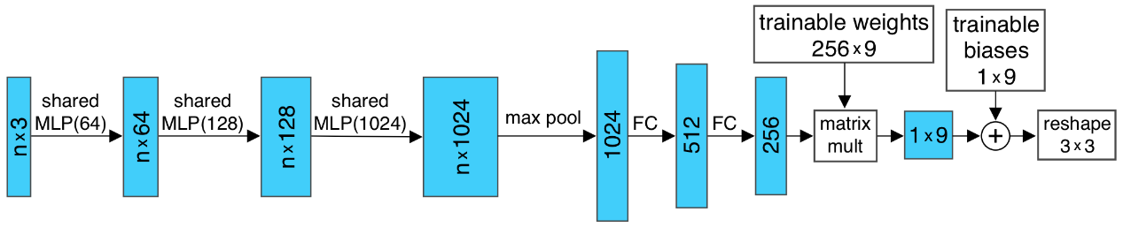

Fig. x. Architecture of T-Net

One of the key design of Pointnet is T-Net. The T-Net is a regression network that is tasked with predicting an input-dependent 3-by-3 transformation matrix that is then matrix multiplied with the n-by-3 input. The corresponding T-Net is nearly identical to that of Fig. x except for the dimensionality of the trainable weights and biases, which become 256-by-4096 and 4096, respectively resulting in a 64-by-64 transformation matrix. The increased number of trainable parameters leads to the potential for overfitting and instability during training, so a regularization term is added to the loss function. The regularization term is shown below and encourages the resulting 64-by-64 transformation matrix (represented as A below) to approximate an orthogonal transformation, as follows

where is the feature alignment matrix predicted by a mini network, is the transposed matrix of , represents the identity matrix and is the regularization term added to loss function. An orthogonal transformation would not lose information in the input. By adding the regularization term, the optimization becomes more stable and the model achieves better performance.

It is worth to have as much training data as possible to train neural networks. A cloud of depth data measurement often contains many points and there is usually no problem finding important sections that should be classified. It is much more difficult to find data already well classified (with high accuracy), which can be used as training data for the model being taught. This problem could be solved, for example, rotation or movement to generate new data based on existing data.

We trained PointNet by taking labeled points set (shown in figure 3.b) as input training set for classifying railings and pig.

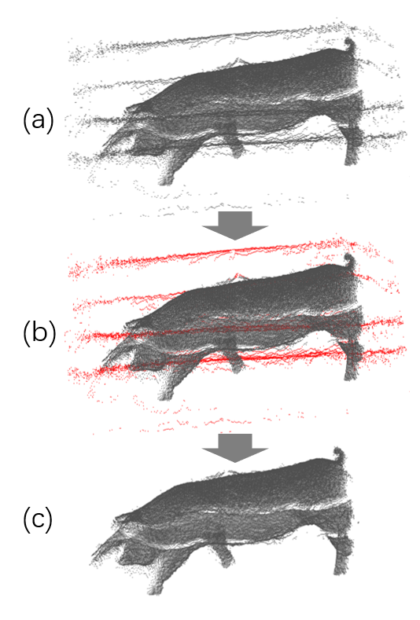

Fig. 3. The procedure of the PointNet. a) raw data. b) input data labeled noise as red and pig contour as grey. c) output data

### (1.2.2 DBSCAN based filter)

Density-Based Spatial Clustering of Applications with Noise (DBSCAN) clustering defines cluster as region, the objects of the region are dense. The main concept of DBSCAN algorithm is to locate regions of high density that are separated from one another by regions of low density. So, how do we measure density of a region. Below are the 2 steps:

1. Density at a point P: Number of points within a circle of Radius Eps (ϵ) from point P.
2. Dense Region: For each point in the cluster, the circle with radius ϵ contains at least minimum number of points (MinPts).

The Epsilon neighborhood of a point P in the database D is defined as followed

Following the definition of dense region, a point can be classified as a Core Point if |N (p)|≥ MinPts. The Core Points, as the name suggests, lie usually within the interior of a cluster. A Border Point has fewer than MinPts within its ϵ-neighborhood (N), but it lies in the neighborhood of another core point. Noise is any data point that is neither core nor border point as shown in fig. x.

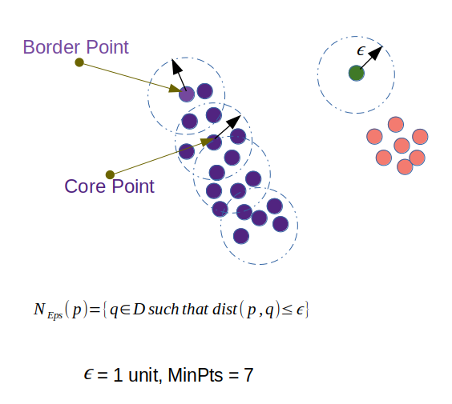

Fig. x Core and border points in a point cloud data D; green data point is noise when ϵ equals 1 and MinPts equals 7

With the definitions above, we can go through the steps of DBSCAN algorithm as below:

* The algorithm starts with an arbitrary point which has not been visited and its neighborhood information is retrieved from the ϵ parameter.
* If this point contains MinPts within ϵ neighborhood, cluster formation starts. Otherwise the point is labeled as noise. This point can be later found within the ϵ neighborhood of a different point and, thus can be made a part of the cluster. Concept of density reachable and density connected points are important here.
* If a point is found to be a core point then the points within the ϵ neighborhood is also part of the cluster. So, all the points found within ϵ neighborhood are added, along with their own ϵ neighborhood, if they are also core points.
* The above process continues until the density-connected cluster is completely found.
* The process restarts with a new point which can be a part of a new cluster or labeled as noise.

The reason we choose DBSCAN clustering is that it has significant advantages over partitional and hierarchical clustering algorithms. It can discover clusters of arbitrary shapes. The computational complexity can be reduced to O (∗) by building some special data structures. In addition, it is able to effectively identify noise points. But density-based clustering algorithms easily lead to memory problem when facing large databases. Some researches show that current density-based clustering algorithms often have difficulties with complex data sets in which the clusters are different densities. Before training, data was scaled appropriately to highlight the difference of railings, noise and pig. Tuned by grid search, the neighborhood of a given radius (Eps) is set to 0.007 and the minimum number (MinPts) of objects is set to 3. The procedure is showed below:

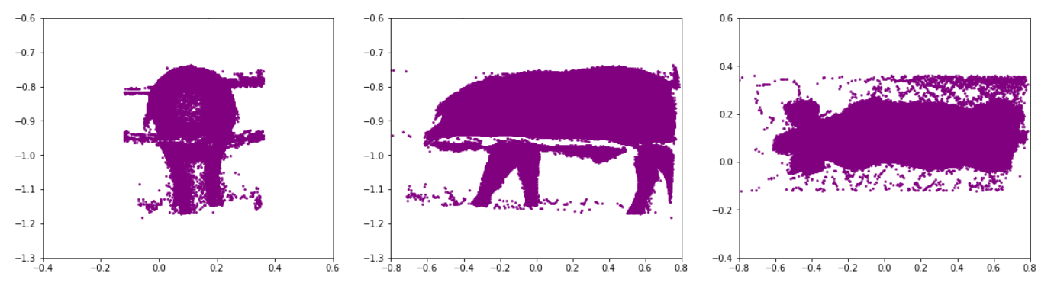

1. Points before filter

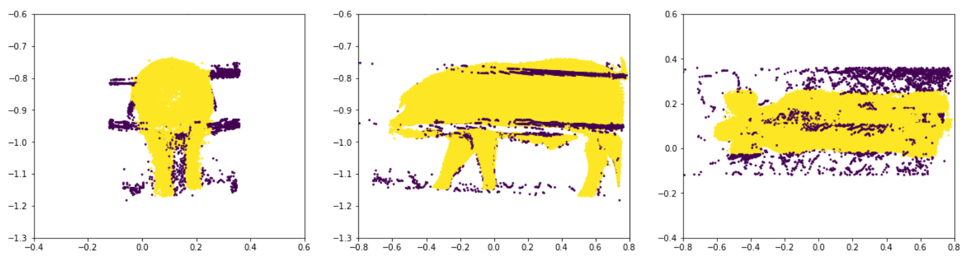

1. Points clustered by DBSCAN.

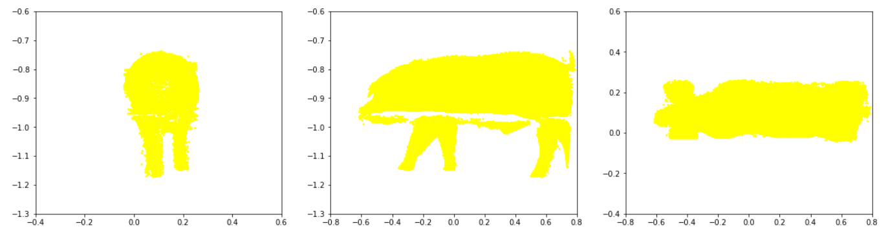

1. Pig extracted

Fig. x. the procedure of DBSCAN

## Point cloud triangulation and hole filling on the surface

Point cloud data should be transformed to mesh data for volume estimation. Triangulation method generates a simplicial complex that covers the convex hull of point set, and whose vertices belong to points. (De Loera, 2010) In the plane, triangulations are made up of triangles, together with their edges and vertices.

The Greedy Triangulation is a method to compute a polygon triangulation or a point set triangulation using a greedy schema, which adds edges one by one to the solution in strict increasing order by length, with the condition that an edge cannot cut a previously inserted edge. Before triangulation, subsampling performs a down sampling operation, which decrease the points to one-tenth. GreedyProjectionTriangulation modules in Point Cloud Library (PCL) (Rusu, R., 2011) is used for the implementation of greedy triangulation.

The module requires several user-defined parameters to be determined:

* setMaximumNearestNeighbors(unsigned) and setMu(double) control the size of the neighborhood. The former defines how many neighbors are searched for, while the latter specifies the maximum acceptable distance for a point to be considered, relative to the distance of the nearest point (in order to adjust to changing densities). Typical values are 50-100 and 2.5-3 (or 1.5 for grids).
* setSearchRadius(double) is practically the maximum edge length for every triangle. This has to be set by the user such that to allow for the biggest triangles that should be possible.
* setMinimumAngle(double) and setMaximumAngle(double) are the minimum and maximum angles in each triangle. While the first is not guaranteed, the second is. Typical values are 10 and 120 degrees (in radians).
* setMaximumSurfaceAgle(double) and setNormalConsistency(bool) are meant to deal with the cases where there are sharp edges or corners and where two sides of a surface run very close to each other. To achieve this, points are not connected to the current point if their normal deviate more than the specified angle (note that most surface normal estimation methods produce smooth transitions between normal angles even at sharp edges). This angle is computed as the angle between the lines defined by the normal (disregarding the normal’s direction) if the normal-consistency-flag is not set, as not all normal estimation methods can guarantee consistently oriented normal. Typically, 45 degrees (in radians) and false works on most datasets.

In this paper, setMu is set to 2.5 and setMaximumNearestNeighbors is tuned to 70. For the data was not consisted of normal information, setNormalConsistency is set to False. MaximumAngle, MinimumAngle and MaximumAngle is set to 45, 25 and 120 degrees respectively.

The input and output of the program is shown below.

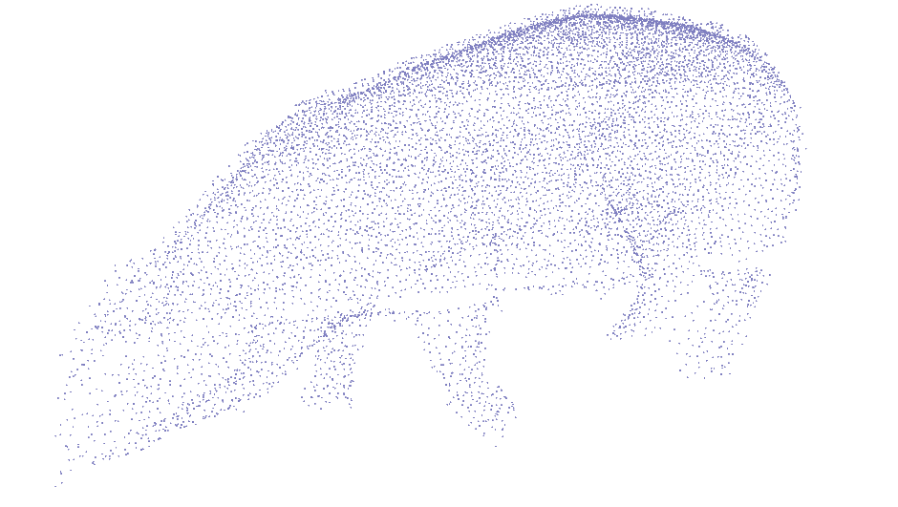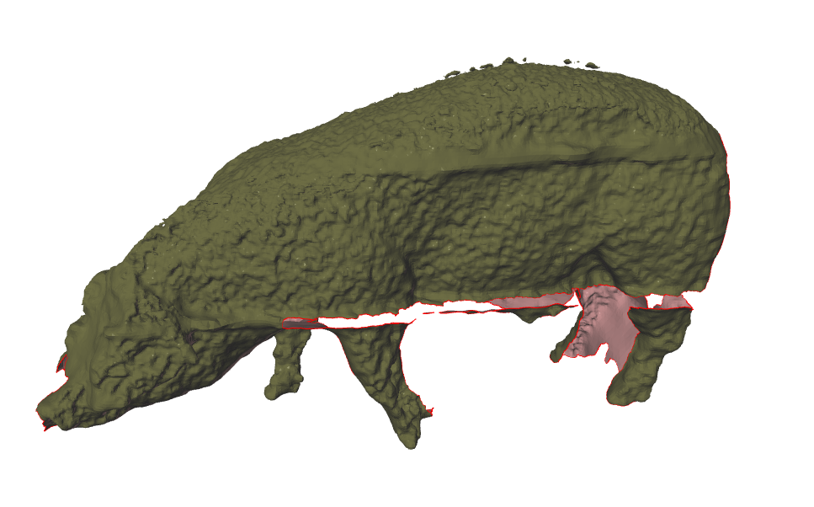

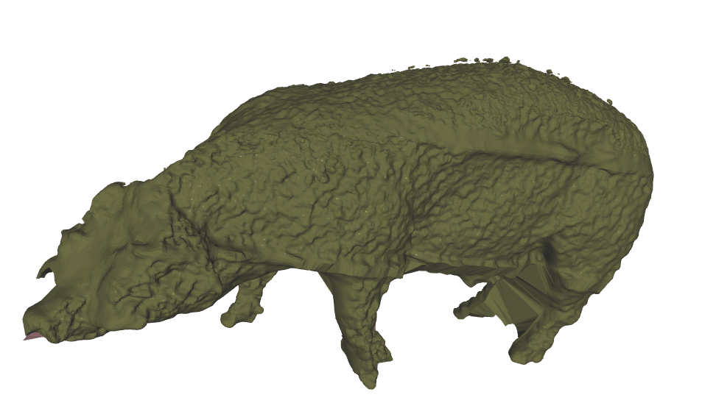

Fig. x the process of (a)subsampling, (b)triangulation, (c)hole filling

As shown as Fig.x(b), some holes in the mesh data is the obstacle to calculate the volume of the mesh. A hole-filing method based on Poisson Equation is applied for the data (Morel et al., 2018). The key ideas consist of two aspects. First, the advancing front mesh technique is employed to generate the initial patch mesh to make the algorithm more robust and efficient. Secondly, the triangles involved in the initial patch mesh are modified by estimating their desirable normal instead of relocating them directly, and are re-positioned finally by solving the Poisson equation according to the desirable normal and the boundary vertices of the hole to make the algorithm more accurate.

## volume calculation and weight prediction

Volume was calculated using the method of Mirtich (1996), based on divergence theorem and Green's theorem. In it, volume equals the volumetric integral of the characteristic function of the object, but this integral cannot be calculated directly for a complex volume. Instead, faces and points, from which calculations can be made, must be introduced. The divergence theorem transforms an integral of the volume into an integral of the area, as follows

where v is the volume, is the surface around the volume, ∇ is the nabla operator which characterizes the divergence, F is the vector field of the volume and n is the normal to the surface oriented towards the outside. (Le Cozler, 2019)

A linear regression model is established to estimate BW.

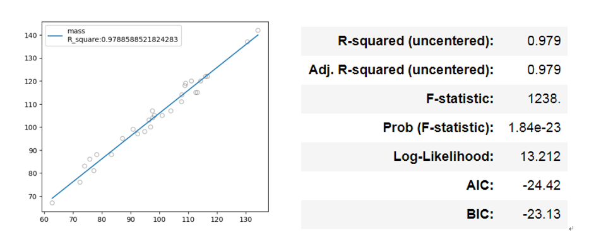

# 3. Compared with other methods

## 3.1 Correlation analysis and linear regression model

Nine body dimensions is acquired by tape for analysis to verify the accuracy of our method. First, correlation analysis is operated to acknowledge the relationship between weight and the nine factors.

HRG HG AG BL WH HH WW HW AW

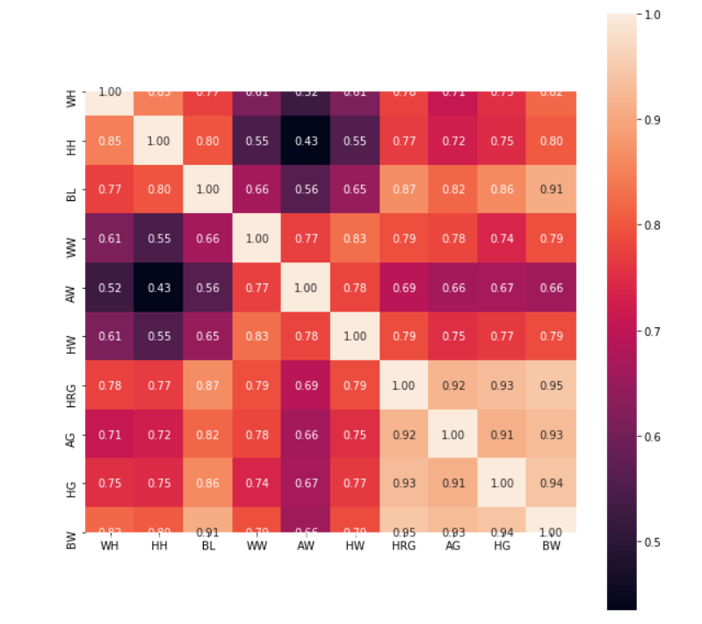

Fig. x. Correlation analysis between variables

The heatmap above shows the correlation between the explanation variances and predictor variance. BW has a high correlation with girths (HRG, AG, HG) and BL.

calculate body weight using the formula

BW = girth girth BL

where girth can be tested including HRG, WG, HG

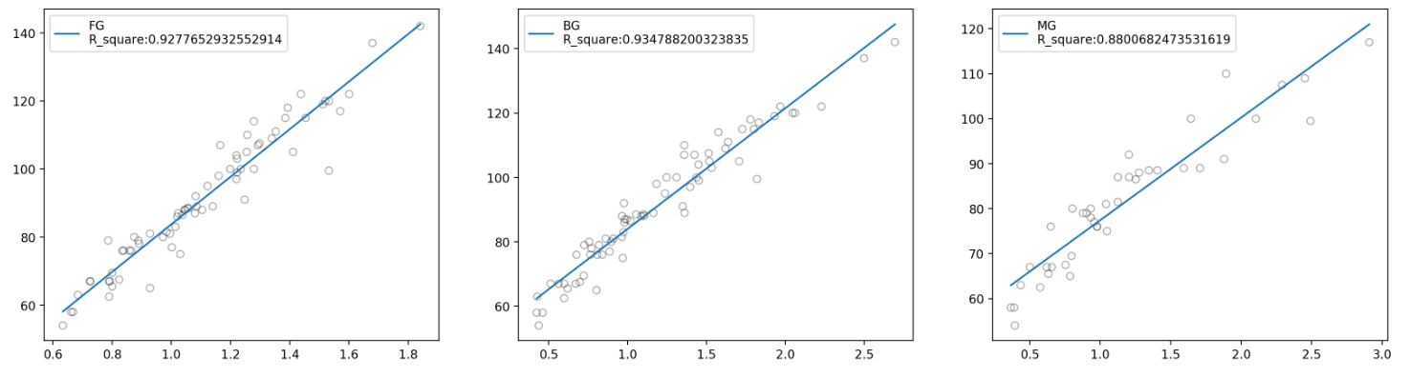

|  |  |  |  |  |  |  |
| --- | --- | --- | --- | --- | --- | --- |
| girth | formula |  | RMSE | MAE |  |  |
| HRG |  | 0.969 | 4.123 | 3.245 |  |  |
| AG |  | 0.932 | 6.069 | 4.702 |  |  |
| HG |  | 0.954 | 4.987 | 4.366 |  |  |

figures show the highest correlation between HRG and BW.

## 3.2 PCR model

As mentioned above, nine body dimensions are acquired for weight prediction. Multicollinearity could be in these explanation variances. In statistics, multicollinearity is a phenomenon in which one predictor variable in a multiple regression model can be linearly predicted from the others with a substantial degree of accuracy.  Principal component analysis (PCA) is an effective procedure to solve it. PCA is mostly used as a tool in [exploratory data analysis](https://en.wikipedia.org/wiki/Exploratory_data_analysis) and for making predictive models. Principal component regression (PCR) is a regression method using PCA, usually after a normalization step of the initial data. The predict result showed in fig. 1, which indicate a high precision in PCR procedure. However, the procedure needs too much parameters to conduct.

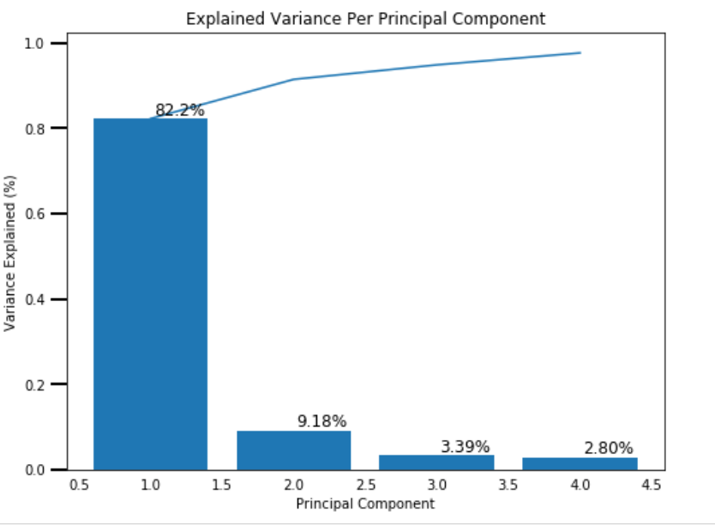

## 3.3 SVR model

Support vector machine (SVM) is a learning algorithm widely used to solve classification problems, especially for problems of small sample, high dimension and nonlinear data. Support vector regression (SVR) can be used to study the regression relationship between independent variables and continuous dependent variable and solve forecasting problems.

SVR gives us the flexibility to define how much error is acceptable in our model and will find an appropriate line (or hyperplane in higher dimensions) to fit the data.

In contrast to Ordinary least squares (OLS), the objective function of SVR is to minimize the coefficients more specifically and L2-norm of the coefficient vector instead of the squared error in OLS. The error term is instead handled in the constraints, where we set the absolute error less than or equal to a specified margin, called the maximum error ϵ, which is tuned to gain the desired accuracy of our model.

In this paper, the radial basis function (RBF) was used to train SVR model. At the same time, the regularization constant C and the kernel function parameter gamma need to be set reasonably. C is loss penalty term; if C is too large, the classification error would have a large percentage of the error, if the value of C is too small, error depends too much on margin error. Increasing the parameter gamma can improve the predictive accuracy but may lead to over-fitting; decreasing the parameter gamma will reduce the deviation but will cause the instability. The training data were used for the parameter selection. The grid search for optimal C ranged from (0, 10] and gamma ranged from (0, 1]. Consequently, a total of 500 (50 x 10) different combinations of {C, gamma} were generated and tested. The mean square error in the 5-fold cross-validation results was used as evaluation to select the optimal {C, gamma}. In this research, the optimal C and gamma were selected as 2 and 0.08.

After preprocessing and regularization of the initial data, over 400 data featured including length, girth is spliced into train set and test set. SVR model is fitted by train set with above parameters. The test set showed the mean absolute error (MAE) of 2.83 and the 0.89.

As shown in fig. x, the maximum located on the number of features is four (nine features are listed as HRG HG AG BL WH HH WW HW AW from highest to lowest according to the correlation with BW).

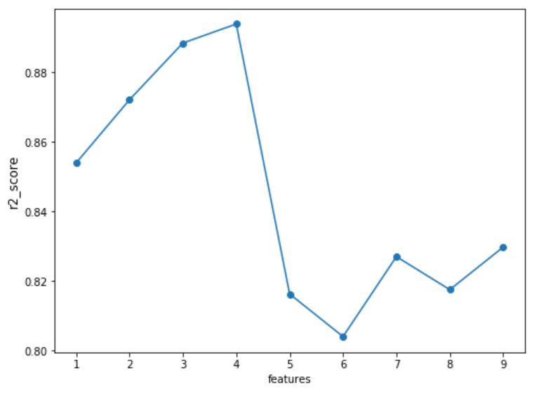

Fig. x the changes by the amount of features

## 3.4 RF model

Random Forest (RF) is a commonly used machine learning algorithm proposed by Leo Breiman in 2001. It is flexible and practical, and good at handling high-dimensional data. RF is based on the idea of ensemble learning to integrate many decision trees, which belongs to the ensemble learning method.

RF integrates all the classification voting results and specifies the category with the highest number of votes (classified target variable) or the average value (continuous target variable) as the final output. More formally we can write this class of models as:

where the final model g is the sum of simple base models . The essence of RF is to apply the bootstrap method (replacement sampling method) to the CART (Classification and Regression Tree) algorithm, that is, the original training sample is sampled back, so that the sample size is as same as the original one. The training dataset uses the undrawn samples as an Out-Of-Bag (OOB) Dataset for evaluation.

The RF model development requires three user-defined parameters to be determined. They are the minimum number of terminal nodes for each tree (nodesize), the number of trees in the forest (ntree), and the number of randomly selected variables to grow the tree (mtry). The nodesize parameter controls the size of each tree within the forest. Essentially, the selection of this parameter determines when to stop the tree splitting process. A large nodesize will cause shallow trees because of limits in the tree splitting process, the predictive accuracy of each tree could not be guaranteed. On the contrary, a small nodesize would bring deep tree structure which creates comprehensive learning from the data, which would cost more computation time and may encounter overfitting. This study used the default value of 5, which is also a commonly used and recommended value. The ntree parameter determines the number of trees generated in an RF model. A larger ntree will improve the predictive performance of RF because more trees would be considered and the problem of overfitting would be avoided, but the calculation time would be increased at the same time. In this paper, ntree is set to 800. It was found that when the number of trees is more than 500, the mean square error of regression model has become stable. Mtry affects the accuracy of predictive by introducing randomness in the model development, which affects the predictive accuracy of the decision tree in the forest and the correlation between decision trees. Usually, the larger the mtry is, the better the predictive performance will be, but that will increase the correlation between decision trees. In this paper, mtry was set to 1–9, then the model’s interpretable variance percentage and residual mean square were obtained. The regression model has optimal predictive accuracy when mtry was set to 4.

## 3.5 GBDT model

As another most important application of ensemble learning, gradient boosting decision tree (GBDT) is used as usual as RF model. Gradient boosting is a machine learning technique for regression and classification problems, which produces a prediction model in the form of an ensemble of weak prediction models, typically decision trees. It builds the model in a stage-wise fashion like other boosting methods do, and it generalizes them by allowing optimization of an arbitrary differentiable loss function.

Extreme Gradient Boosting (XGBoost) is a specific implementation of the Gradient Boosting method which uses more accurate approximations to find the best tree model. It employs several nifty tricks that make it exceptionally successful, particularly with structured data. The improvement mainly consists of two aspects. Firstly, second-order gradients are computed, which provides more information about the direction of gradients and how to get to the minimum of our loss function. While regular gradient boosting uses the loss function of the base model (e.g. decision tree) as a proxy for minimizing the error of the overall model, XGBoost uses the 2nd order derivative as an approximation. Secondly, advanced regularization (L1 & L2) improves model generalization.

XGBoost model advantages in many machine learning competition, which training is very fast and can be parallelized across clusters.

# 4. result and discussion

In this paper, volume is calculated from the pig contour acquired by Kinect depth sensor, which is modeled to estimate the BW of pigs. PCR, RF, GBDT and SVR were used to develop regression model of BW respectively for comparison with our method. The evaluation indices of each regression model are shown in Table 3.

Table 3 Comparison of our method and other regression method

|  |  |  |  |  |  |  |  |
| --- | --- | --- | --- | --- | --- | --- | --- |
| Model |  |  | RMSE | MAE | features |  |  |
| Our method |  | 0.974 | 3.439 | 3.064 | - |  |  |
| Empirical formula |  | 0.969 | 4.123 | 3.245 | 2 |  |  |
| PCR model |  | 0.976 | 3.571 | 2.829 | 5 |  |  |
| SVR model |  | 0.894 | 7.583 | 4.816 | 4 |  |  |
| RF model |  | 0.968 | 4.145 | 3.147 | 7 |  |  |
| GBDT model |  | 0.968 | 4.185 | 3.703 | 6 |  |  |
| XGBoost model |  | 0.960 | 4.677 | 3.859 | 5 |  |  |

As shown in table 3, our method shows high accuracy compared of other methods. Moreover, the least number of features should be acquired manually in other methods is two using empirical formula in other method. Compared with it, the data used in our method should only be acquired from depth camera.

# 5. Conclusion

Conventional measurement methods of pig body weight rely on manual measurement. In recent years, detailed data of various body dimension is collected from sensors for machine learning to reduce the stress to pigs. However, body dimensions only show part of the information of the pig, which limits the accuracy of non-contact body measurement. Our method based on volume calculation using point cloud acquire most morphological traits of pigs to predict body weight. The data acquisition system and improved preprocessing methods make weight prediction more efficient.

Limited by ability and time, this paper only conducted research in a farm on summer. In the follow-up work, the characteristics of season and influencing factors of different postures of pigs and different types of pigs should be studied.

# References

Kashiha, M., Bahr, C., Ott, S., Moons, C.P., Niewold, T.A., Ödberg, F.O., Berckmans, D., 2014. Automatic weight estimation of individual pigs using image analysis. Comput. Electron. Agric. 107, 38–44.

Morel J, Bac A, Véga C. 2018. Surface reconstruction of incomplete datasets: a novel Poisson surface approach based on CSRBF. Comput. Graph. 74, 44-65. <http://www.sciencedirect.com/science/article/pii/S0097849318300633>

Guo, H., Ma, X., Ma, Q., Wang, K., Su, W., Zhu, D., 2017a. LSSA_CAU: an interactive 3d point clouds analysis software for body measurement of livestock with similar forms of cows and pigs. Comput. Electron. Agric. 138, 60–68. <https://www.sciencedirect.com/science/article/pii/S0168169917301746>

Tasdemir, S., Urkmez, A., Inal, 2011. Determination of body measurements on the Holstein cows using digital image analysis and estimation of live weight with regression analysis. Comput. Electron. Agr. 76 (2), 189–197. <https://www.sciencedirect.com/science/article/pii/S0168169911000366>

Guo, H., Wang, K., Su, W., Zhu, D.H., Liu, W.L., Xing, C., Chen, Z.R., 2017b. 3d scanning of live pigs system and its application in body measurements. ISPRS – Int. Archiv. Photogram. Remote Sens. Spat. Inform. Sci. XLII-2/W7, 211-217. [https://doi.org/10. 5194/isprs-archives-XLII-2-W7-211-2017.](https://doi.org/10.%205194/isprs-archives-XLII-2-W7-211-2017.)

Kongsro, J., 2014. Estimation of pig weight using a Microsoft Kinect prototype imaging system. Comput. Electron. Agric. 109, 32–35. <https://www.sciencedirect.com/science/article/pii/S0168169914002075>

Kuzuhara, Y., Kawamura, K., Yoshitoshi, R., Tamaki, T., Sugai, S., Ikegami, M., Kurokawa, Y., Obitsu, T., Okita, M., Sugino, T., Yasuda, T., 2015. A preliminarily study for predicting body weight and milk properties in lactating Holstein cows using a three dimensional camera system. Comput. Electron. Agric. 111, 186–193. <https://www.sciencedirect.com/science/article/pii/S0168169914003305>

Kawasue, K., Ikeda, T., Tokunaga, T., Harada, H., 2013. Three-dimensional shape measurement system for black cattle using KINECT sensor. Int. J. Circ., Syst. Signal Process. 7 (4), 222-230. <http://refhub.elsevier.com/S0168-1699(17)30174-6/h0050>

Kuzuhara, Y., Kawamura, K., Yoshitoshi, R., Tamaki, T., Sugai, S., Ikegami, M., Kurokawa, Y., Obitsu, T., Okita, M., Sugino, T., Yasuda, T., 2015. A preliminarily study for predicting body weight and milk properties in lactating Holstein cows using a three-dimensional camera system. Comput. Electron. Agric. 111, 186-193. <http://dx.doi.org/10.1016/j.compag.2014.12.020>

Wongsriworaphon, A., Arnonkijpanich, B., Pathumnakul, S., 2015. An approach based on digital image analysis to estimate the live weights of pigs in farm environments. Comput. Electron. Agric. 115, 26–33. <https://www.sciencedirect.com/science/article/pii/S016816991500126X>

Pezzuolo, A., Guarino, M., Sartori, L., Gonzlez, L.A., Marinello, F., 2018. On-barn pig weight estimation based on body measurements by a Kinect v1 depth camera. Comput. Electron. Agric. 148, 29-36. <https://doi.org/10.1016/j.compag.2018.03.003>

Le Cozler, Y., Allain, Xavier, C., Depuille, L., Faverdin, P., 2019. Volume and surface area of Holstein dairy cows calculated from complete 3D shapes acquired using a high-precision scanning system: Interest for body weight estimation. Comput. Electron. Agric. 165, 104977. <https://doi.org/10.1016/j.compag.2019.104977>

Shi, C., Teng, G., Li, Z., 2016. An approach of pig weight estimation using binocular stereo system based on LabVIEW. Comput. Electron. Agric. 129, 37–43. <https://www.sciencedirect.com/science/article/pii/S0168169916306329>

De Loera, Jesús A.; Rambau, Jörg; Santos, Francisco 2010. Triangulations, Structures for Algorithms and Applications. Algorithms and Computation in Mathematics. 25. Springer.

Rusu, R., & Cousins, S. 2011. 3D is here: Point cloud library (PCL). In Proceedings of the IEEE international conference on robotics and automation (pp. 1–4).

L. Breiman, Random forests, Mach. Learn. 45 (2001) 5–32

C.R. Qi, H. Su , K. Mo , L.J. Guibas , PointNet: deep learning on point sets for 3D classification and segmentation, in: Proceedings of the IEEE Conference on Computer Vision and Pattern Recognition, 2017 .

C.R. Qi, L. Yi, H. Su , L.J. Guibas. 2017. PointNet ++ : deep hierarchical feature learning on point sets in a metric space, in: I. Guyon, U.V. Luxburg, S. Bengio, H. Wal- lach, R. Fergus, S. Vishwanathan, R. Garnett (Eds.), Advances in Neural Infor- mation Processing Systems 30, Curran Associates, Inc., 2017, pp. 5099–5108 .