EyeBrownVsRestRecod

Estefanía Gómez Guil

2023-06-11

Table of Contents

## 1.Importación de los datos

params <- list(  
 Brown="Brown",  
 Rest="Rest",  
 directorio= "/Users/estefaniagomezguil/Desktop/EyeBrownVsRestRecod"  
)  
ruta_brown<- file.path(params$directorio, "Brown")  
ruta_rest<- file.path(params$directorio, "Resto")  
  
files_brown <- list.files(path = ruta_brown, pattern = ".txt", full.names = TRUE)  
files_rest <- list.files(path = ruta_rest, pattern = ".txt", full.names = TRUE)  
Grupo <- c (rep(params$Brown, length(files_brown)), rep(params$Rest, length(files_rest)))  
files <- c(files_brown, files_rest)  
print(files)

## [1] "/Users/estefaniagomezguil/Desktop/EyeBrownVsRestRecod/Brown/2708.txt"  
## [2] "/Users/estefaniagomezguil/Desktop/EyeBrownVsRestRecod/Brown/2711.txt"  
## [3] "/Users/estefaniagomezguil/Desktop/EyeBrownVsRestRecod/Brown/2712.txt"  
## [4] "/Users/estefaniagomezguil/Desktop/EyeBrownVsRestRecod/Brown/2724.txt"  
## [5] "/Users/estefaniagomezguil/Desktop/EyeBrownVsRestRecod/Brown/2729.txt"  
## [6] "/Users/estefaniagomezguil/Desktop/EyeBrownVsRestRecod/Brown/2730.txt"  
## [7] "/Users/estefaniagomezguil/Desktop/EyeBrownVsRestRecod/Brown/2740.txt"  
## [8] "/Users/estefaniagomezguil/Desktop/EyeBrownVsRestRecod/Brown/2750.txt"  
## [9] "/Users/estefaniagomezguil/Desktop/EyeBrownVsRestRecod/Brown/2769.txt"  
## [10] "/Users/estefaniagomezguil/Desktop/EyeBrownVsRestRecod/Brown/2777.txt"  
## [11] "/Users/estefaniagomezguil/Desktop/EyeBrownVsRestRecod/Brown/2801.txt"  
## [12] "/Users/estefaniagomezguil/Desktop/EyeBrownVsRestRecod/Brown/2807.txt"  
## [13] "/Users/estefaniagomezguil/Desktop/EyeBrownVsRestRecod/Brown/2823.txt"  
## [14] "/Users/estefaniagomezguil/Desktop/EyeBrownVsRestRecod/Brown/2824.txt"  
## [15] "/Users/estefaniagomezguil/Desktop/EyeBrownVsRestRecod/Brown/2871.txt"  
## [16] "/Users/estefaniagomezguil/Desktop/EyeBrownVsRestRecod/Brown/2880.txt"  
## [17] "/Users/estefaniagomezguil/Desktop/EyeBrownVsRestRecod/Brown/2881.txt"  
## [18] "/Users/estefaniagomezguil/Desktop/EyeBrownVsRestRecod/Brown/2891.txt"  
## [19] "/Users/estefaniagomezguil/Desktop/EyeBrownVsRestRecod/Brown/2892.txt"  
## [20] "/Users/estefaniagomezguil/Desktop/EyeBrownVsRestRecod/Brown/2893.txt"  
## [21] "/Users/estefaniagomezguil/Desktop/EyeBrownVsRestRecod/Brown/2894.txt"  
## [22] "/Users/estefaniagomezguil/Desktop/EyeBrownVsRestRecod/Brown/2898.txt"  
## [23] "/Users/estefaniagomezguil/Desktop/EyeBrownVsRestRecod/Brown/2899.txt"  
## [24] "/Users/estefaniagomezguil/Desktop/EyeBrownVsRestRecod/Brown/2908.txt"  
## [25] "/Users/estefaniagomezguil/Desktop/EyeBrownVsRestRecod/Brown/2915.txt"  
## [26] "/Users/estefaniagomezguil/Desktop/EyeBrownVsRestRecod/Brown/2929.txt"  
## [27] "/Users/estefaniagomezguil/Desktop/EyeBrownVsRestRecod/Brown/2933.txt"  
## [28] "/Users/estefaniagomezguil/Desktop/EyeBrownVsRestRecod/Brown/2934.txt"  
## [29] "/Users/estefaniagomezguil/Desktop/EyeBrownVsRestRecod/Brown/2939.txt"  
## [30] "/Users/estefaniagomezguil/Desktop/EyeBrownVsRestRecod/Brown/2948.txt"  
## [31] "/Users/estefaniagomezguil/Desktop/EyeBrownVsRestRecod/Resto/2701.txt"  
## [32] "/Users/estefaniagomezguil/Desktop/EyeBrownVsRestRecod/Resto/2710.txt"  
## [33] "/Users/estefaniagomezguil/Desktop/EyeBrownVsRestRecod/Resto/2727.txt"  
## [34] "/Users/estefaniagomezguil/Desktop/EyeBrownVsRestRecod/Resto/2736.txt"  
## [35] "/Users/estefaniagomezguil/Desktop/EyeBrownVsRestRecod/Resto/2748.txt"  
## [36] "/Users/estefaniagomezguil/Desktop/EyeBrownVsRestRecod/Resto/2749.txt"  
## [37] "/Users/estefaniagomezguil/Desktop/EyeBrownVsRestRecod/Resto/2790.txt"  
## [38] "/Users/estefaniagomezguil/Desktop/EyeBrownVsRestRecod/Resto/2799.txt"  
## [39] "/Users/estefaniagomezguil/Desktop/EyeBrownVsRestRecod/Resto/2810.txt"  
## [40] "/Users/estefaniagomezguil/Desktop/EyeBrownVsRestRecod/Resto/2858.txt"  
## [41] "/Users/estefaniagomezguil/Desktop/EyeBrownVsRestRecod/Resto/2890.txt"  
## [42] "/Users/estefaniagomezguil/Desktop/EyeBrownVsRestRecod/Resto/2895.txt"  
## [43] "/Users/estefaniagomezguil/Desktop/EyeBrownVsRestRecod/Resto/2907.txt"  
## [44] "/Users/estefaniagomezguil/Desktop/EyeBrownVsRestRecod/Resto/2911.txt"  
## [45] "/Users/estefaniagomezguil/Desktop/EyeBrownVsRestRecod/Resto/2912.txt"  
## [46] "/Users/estefaniagomezguil/Desktop/EyeBrownVsRestRecod/Resto/2949.txt"

targets = read.maimages(file=files, source="agilent", green.only=TRUE)

## Read /Users/estefaniagomezguil/Desktop/EyeBrownVsRestRecod/Brown/2708.txt   
## Read /Users/estefaniagomezguil/Desktop/EyeBrownVsRestRecod/Brown/2711.txt   
## Read /Users/estefaniagomezguil/Desktop/EyeBrownVsRestRecod/Brown/2712.txt   
## Read /Users/estefaniagomezguil/Desktop/EyeBrownVsRestRecod/Brown/2724.txt   
## Read /Users/estefaniagomezguil/Desktop/EyeBrownVsRestRecod/Brown/2729.txt   
## Read /Users/estefaniagomezguil/Desktop/EyeBrownVsRestRecod/Brown/2730.txt   
## Read /Users/estefaniagomezguil/Desktop/EyeBrownVsRestRecod/Brown/2740.txt   
## Read /Users/estefaniagomezguil/Desktop/EyeBrownVsRestRecod/Brown/2750.txt   
## Read /Users/estefaniagomezguil/Desktop/EyeBrownVsRestRecod/Brown/2769.txt   
## Read /Users/estefaniagomezguil/Desktop/EyeBrownVsRestRecod/Brown/2777.txt   
## Read /Users/estefaniagomezguil/Desktop/EyeBrownVsRestRecod/Brown/2801.txt   
## Read /Users/estefaniagomezguil/Desktop/EyeBrownVsRestRecod/Brown/2807.txt   
## Read /Users/estefaniagomezguil/Desktop/EyeBrownVsRestRecod/Brown/2823.txt   
## Read /Users/estefaniagomezguil/Desktop/EyeBrownVsRestRecod/Brown/2824.txt   
## Read /Users/estefaniagomezguil/Desktop/EyeBrownVsRestRecod/Brown/2871.txt   
## Read /Users/estefaniagomezguil/Desktop/EyeBrownVsRestRecod/Brown/2880.txt   
## Read /Users/estefaniagomezguil/Desktop/EyeBrownVsRestRecod/Brown/2881.txt   
## Read /Users/estefaniagomezguil/Desktop/EyeBrownVsRestRecod/Brown/2891.txt   
## Read /Users/estefaniagomezguil/Desktop/EyeBrownVsRestRecod/Brown/2892.txt   
## Read /Users/estefaniagomezguil/Desktop/EyeBrownVsRestRecod/Brown/2893.txt   
## Read /Users/estefaniagomezguil/Desktop/EyeBrownVsRestRecod/Brown/2894.txt   
## Read /Users/estefaniagomezguil/Desktop/EyeBrownVsRestRecod/Brown/2898.txt   
## Read /Users/estefaniagomezguil/Desktop/EyeBrownVsRestRecod/Brown/2899.txt   
## Read /Users/estefaniagomezguil/Desktop/EyeBrownVsRestRecod/Brown/2908.txt   
## Read /Users/estefaniagomezguil/Desktop/EyeBrownVsRestRecod/Brown/2915.txt   
## Read /Users/estefaniagomezguil/Desktop/EyeBrownVsRestRecod/Brown/2929.txt   
## Read /Users/estefaniagomezguil/Desktop/EyeBrownVsRestRecod/Brown/2933.txt   
## Read /Users/estefaniagomezguil/Desktop/EyeBrownVsRestRecod/Brown/2934.txt   
## Read /Users/estefaniagomezguil/Desktop/EyeBrownVsRestRecod/Brown/2939.txt   
## Read /Users/estefaniagomezguil/Desktop/EyeBrownVsRestRecod/Brown/2948.txt   
## Read /Users/estefaniagomezguil/Desktop/EyeBrownVsRestRecod/Resto/2701.txt   
## Read /Users/estefaniagomezguil/Desktop/EyeBrownVsRestRecod/Resto/2710.txt   
## Read /Users/estefaniagomezguil/Desktop/EyeBrownVsRestRecod/Resto/2727.txt   
## Read /Users/estefaniagomezguil/Desktop/EyeBrownVsRestRecod/Resto/2736.txt   
## Read /Users/estefaniagomezguil/Desktop/EyeBrownVsRestRecod/Resto/2748.txt   
## Read /Users/estefaniagomezguil/Desktop/EyeBrownVsRestRecod/Resto/2749.txt   
## Read /Users/estefaniagomezguil/Desktop/EyeBrownVsRestRecod/Resto/2790.txt   
## Read /Users/estefaniagomezguil/Desktop/EyeBrownVsRestRecod/Resto/2799.txt   
## Read /Users/estefaniagomezguil/Desktop/EyeBrownVsRestRecod/Resto/2810.txt   
## Read /Users/estefaniagomezguil/Desktop/EyeBrownVsRestRecod/Resto/2858.txt   
## Read /Users/estefaniagomezguil/Desktop/EyeBrownVsRestRecod/Resto/2890.txt   
## Read /Users/estefaniagomezguil/Desktop/EyeBrownVsRestRecod/Resto/2895.txt   
## Read /Users/estefaniagomezguil/Desktop/EyeBrownVsRestRecod/Resto/2907.txt   
## Read /Users/estefaniagomezguil/Desktop/EyeBrownVsRestRecod/Resto/2911.txt   
## Read /Users/estefaniagomezguil/Desktop/EyeBrownVsRestRecod/Resto/2912.txt   
## Read /Users/estefaniagomezguil/Desktop/EyeBrownVsRestRecod/Resto/2949.txt

targets$targets$class <- Grupo  
files2<- str_remove_all(string=files, pattern= "US85003608_253949442215")  
files2<- str_remove_all(string=files2, patter= "_S01_GE1_107_Sep09")

## 2. Control de calidad

limma::plotMA3by2(targets, status = targets$genes$ControlType, prefix = "MA", device = "pdf")  
# Obtener los grupos únicos y sus correspondientes colores  
grupos_unicos <- unique(Grupo)  
colores <- 1:4  
Grupo2<-colores  
plotMDS(targets, top = 100, gene.selection = "pairwise", pch=colores, type="p", plot = TRUE)  
  
# Agregar la leyenda  
legend("topright", legend = grupos_unicos, pch = colores, title = "Grupos")  
legend("topright", legend = grupos_unicos, pch = colores, title = "Grupos")

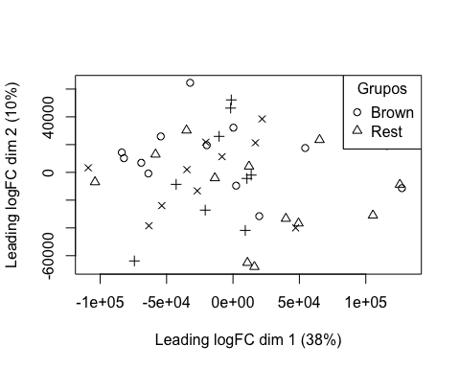

boxplot(targets$E, col = "royalblue", names = str_trunc(targets$targets$FileName, width = 10, side = "left"))

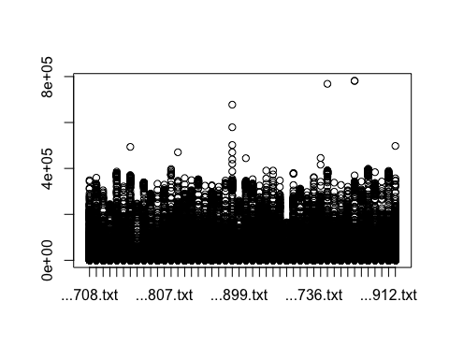

## 3. Preprocesado

### 3.1 Background

BK <- backgroundCorrect(targets, method ="normexp", printer=targets$printer, verbose=TRUE)

## Array 1 corrected  
## Array 2 corrected  
## Array 3 corrected  
## Array 4 corrected  
## Array 5 corrected  
## Array 6 corrected  
## Array 7 corrected  
## Array 8 corrected  
## Array 9 corrected  
## Array 10 corrected  
## Array 11 corrected  
## Array 12 corrected  
## Array 13 corrected  
## Array 14 corrected  
## Array 15 corrected  
## Array 16 corrected  
## Array 17 corrected  
## Array 18 corrected  
## Array 19 corrected  
## Array 20 corrected  
## Array 21 corrected  
## Array 22 corrected  
## Array 23 corrected  
## Array 24 corrected  
## Array 25 corrected  
## Array 26 corrected  
## Array 27 corrected  
## Array 28 corrected  
## Array 29 corrected  
## Array 30 corrected  
## Array 31 corrected  
## Array 32 corrected  
## Array 33 corrected  
## Array 34 corrected  
## Array 35 corrected  
## Array 36 corrected  
## Array 37 corrected  
## Array 38 corrected  
## Array 39 corrected  
## Array 40 corrected  
## Array 41 corrected  
## Array 42 corrected  
## Array 43 corrected  
## Array 44 corrected  
## Array 45 corrected  
## Array 46 corrected

### 3.2 Normalización

MA.p<-normalizeBetweenArrays(BK, method = 'quantile')  
transposed <- t(MA.p$E)  
df<-data.frame(value = transposed, group = as.character(Grupo))  
plotDensities(MA.p, legend = FALSE, type="1")

## Warning: In density.default(E[, a], n = npoint, na.rm = TRUE, ...) :  
## extra argument 'type' will be disregarded  
  
## Warning: In density.default(E[, a], n = npoint, na.rm = TRUE, ...) :  
## extra argument 'type' will be disregarded  
  
## Warning: In density.default(E[, a], n = npoint, na.rm = TRUE, ...) :  
## extra argument 'type' will be disregarded  
  
## Warning: In density.default(E[, a], n = npoint, na.rm = TRUE, ...) :  
## extra argument 'type' will be disregarded  
  
## Warning: In density.default(E[, a], n = npoint, na.rm = TRUE, ...) :  
## extra argument 'type' will be disregarded  
  
## Warning: In density.default(E[, a], n = npoint, na.rm = TRUE, ...) :  
## extra argument 'type' will be disregarded  
  
## Warning: In density.default(E[, a], n = npoint, na.rm = TRUE, ...) :  
## extra argument 'type' will be disregarded  
  
## Warning: In density.default(E[, a], n = npoint, na.rm = TRUE, ...) :  
## extra argument 'type' will be disregarded  
  
## Warning: In density.default(E[, a], n = npoint, na.rm = TRUE, ...) :  
## extra argument 'type' will be disregarded  
  
## Warning: In density.default(E[, a], n = npoint, na.rm = TRUE, ...) :  
## extra argument 'type' will be disregarded  
  
## Warning: In density.default(E[, a], n = npoint, na.rm = TRUE, ...) :  
## extra argument 'type' will be disregarded  
  
## Warning: In density.default(E[, a], n = npoint, na.rm = TRUE, ...) :  
## extra argument 'type' will be disregarded  
  
## Warning: In density.default(E[, a], n = npoint, na.rm = TRUE, ...) :  
## extra argument 'type' will be disregarded  
  
## Warning: In density.default(E[, a], n = npoint, na.rm = TRUE, ...) :  
## extra argument 'type' will be disregarded  
  
## Warning: In density.default(E[, a], n = npoint, na.rm = TRUE, ...) :  
## extra argument 'type' will be disregarded  
  
## Warning: In density.default(E[, a], n = npoint, na.rm = TRUE, ...) :  
## extra argument 'type' will be disregarded  
  
## Warning: In density.default(E[, a], n = npoint, na.rm = TRUE, ...) :  
## extra argument 'type' will be disregarded  
  
## Warning: In density.default(E[, a], n = npoint, na.rm = TRUE, ...) :  
## extra argument 'type' will be disregarded  
  
## Warning: In density.default(E[, a], n = npoint, na.rm = TRUE, ...) :  
## extra argument 'type' will be disregarded  
  
## Warning: In density.default(E[, a], n = npoint, na.rm = TRUE, ...) :  
## extra argument 'type' will be disregarded  
  
## Warning: In density.default(E[, a], n = npoint, na.rm = TRUE, ...) :  
## extra argument 'type' will be disregarded  
  
## Warning: In density.default(E[, a], n = npoint, na.rm = TRUE, ...) :  
## extra argument 'type' will be disregarded  
  
## Warning: In density.default(E[, a], n = npoint, na.rm = TRUE, ...) :  
## extra argument 'type' will be disregarded  
  
## Warning: In density.default(E[, a], n = npoint, na.rm = TRUE, ...) :  
## extra argument 'type' will be disregarded  
  
## Warning: In density.default(E[, a], n = npoint, na.rm = TRUE, ...) :  
## extra argument 'type' will be disregarded  
  
## Warning: In density.default(E[, a], n = npoint, na.rm = TRUE, ...) :  
## extra argument 'type' will be disregarded  
  
## Warning: In density.default(E[, a], n = npoint, na.rm = TRUE, ...) :  
## extra argument 'type' will be disregarded  
  
## Warning: In density.default(E[, a], n = npoint, na.rm = TRUE, ...) :  
## extra argument 'type' will be disregarded  
  
## Warning: In density.default(E[, a], n = npoint, na.rm = TRUE, ...) :  
## extra argument 'type' will be disregarded  
  
## Warning: In density.default(E[, a], n = npoint, na.rm = TRUE, ...) :  
## extra argument 'type' will be disregarded  
  
## Warning: In density.default(E[, a], n = npoint, na.rm = TRUE, ...) :  
## extra argument 'type' will be disregarded  
  
## Warning: In density.default(E[, a], n = npoint, na.rm = TRUE, ...) :  
## extra argument 'type' will be disregarded  
  
## Warning: In density.default(E[, a], n = npoint, na.rm = TRUE, ...) :  
## extra argument 'type' will be disregarded  
  
## Warning: In density.default(E[, a], n = npoint, na.rm = TRUE, ...) :  
## extra argument 'type' will be disregarded  
  
## Warning: In density.default(E[, a], n = npoint, na.rm = TRUE, ...) :  
## extra argument 'type' will be disregarded  
  
## Warning: In density.default(E[, a], n = npoint, na.rm = TRUE, ...) :  
## extra argument 'type' will be disregarded  
  
## Warning: In density.default(E[, a], n = npoint, na.rm = TRUE, ...) :  
## extra argument 'type' will be disregarded  
  
## Warning: In density.default(E[, a], n = npoint, na.rm = TRUE, ...) :  
## extra argument 'type' will be disregarded  
  
## Warning: In density.default(E[, a], n = npoint, na.rm = TRUE, ...) :  
## extra argument 'type' will be disregarded  
  
## Warning: In density.default(E[, a], n = npoint, na.rm = TRUE, ...) :  
## extra argument 'type' will be disregarded  
  
## Warning: In density.default(E[, a], n = npoint, na.rm = TRUE, ...) :  
## extra argument 'type' will be disregarded  
  
## Warning: In density.default(E[, a], n = npoint, na.rm = TRUE, ...) :  
## extra argument 'type' will be disregarded  
  
## Warning: In density.default(E[, a], n = npoint, na.rm = TRUE, ...) :  
## extra argument 'type' will be disregarded  
  
## Warning: In density.default(E[, a], n = npoint, na.rm = TRUE, ...) :  
## extra argument 'type' will be disregarded  
  
## Warning: In density.default(E[, a], n = npoint, na.rm = TRUE, ...) :  
## extra argument 'type' will be disregarded  
  
## Warning: In density.default(E[, a], n = npoint, na.rm = TRUE, ...) :  
## extra argument 'type' will be disregarded

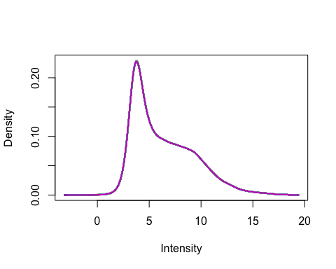

### 3.3 Anotación

MA.p$genes$EntrezID<- mapIds(HsAgilentDesign026652.db, MA.p$genes$ProbeName, keytype = "PROBEID", column = "ENTREZID")

## 'select()' returned 1:1 mapping between keys and columns

MA.p$genes$Symbol <- mapIds(HsAgilentDesign026652.db, MA.p$genes$ProbeName, keytype = "PROBEID", column = "SYMBOL")

## 'select()' returned 1:1 mapping between keys and columns

map=getGEO("GPL20844")

### 3.3 Filtrado

control_1 =MA.p$genes$ControlType == 1  
control_b= MA.p$genes$ControlType == -1

NoSym = is.na(MA.p$genes$Symbol)  
NoEnID= is.na(MA.p$genes$EntrezID)  
table(NoEnID)

## NoEnID  
## FALSE TRUE   
## 36037 26939

yfilt = MA.p[!control_1& !control_b & !NoSym & !NoEnID,]

boxplot(yfilt$E, col = "royalblue", names = str_trunc(targets$targets$FileName, width = 10, side = "left"))

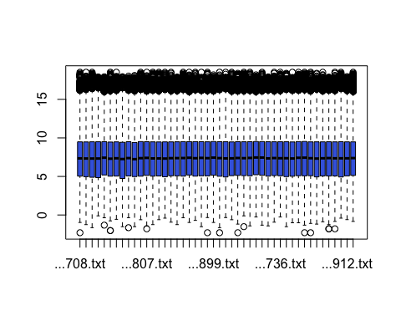

pcomp=prcomp(yfilt$E, scale. = TRUE)  
eso=summary(pcomp)  
eso

## Importance of components:  
## PC1 PC2 PC3 PC4 PC5 PC6 PC7  
## Standard deviation 6.5071 0.92585 0.54649 0.47827 0.47377 0.45669 0.35493  
## Proportion of Variance 0.9205 0.01863 0.00649 0.00497 0.00488 0.00453 0.00274  
## Cumulative Proportion 0.9205 0.93911 0.94561 0.95058 0.95546 0.95999 0.96273  
## PC8 PC9 PC10 PC11 PC12 PC13 PC14  
## Standard deviation 0.32985 0.32571 0.31129 0.29972 0.29730 0.28217 0.26379  
## Proportion of Variance 0.00237 0.00231 0.00211 0.00195 0.00192 0.00173 0.00151  
## Cumulative Proportion 0.96510 0.96740 0.96951 0.97146 0.97338 0.97511 0.97663  
## PC15 PC16 PC17 PC18 PC19 PC20 PC21  
## Standard deviation 0.26047 0.24819 0.24130 0.23602 0.2252 0.22088 0.21376  
## Proportion of Variance 0.00147 0.00134 0.00127 0.00121 0.0011 0.00106 0.00099  
## Cumulative Proportion 0.97810 0.97944 0.98071 0.98192 0.9830 0.98408 0.98507  
## PC22 PC23 PC24 PC25 PC26 PC27 PC28  
## Standard deviation 0.21149 0.20993 0.20580 0.19896 0.18778 0.18575 0.18195  
## Proportion of Variance 0.00097 0.00096 0.00092 0.00086 0.00077 0.00075 0.00072  
## Cumulative Proportion 0.98605 0.98700 0.98793 0.98879 0.98955 0.99030 0.99102  
## PC29 PC30 PC31 PC32 PC33 PC34 PC35  
## Standard deviation 0.17873 0.17700 0.17399 0.16827 0.16482 0.16282 0.15839  
## Proportion of Variance 0.00069 0.00068 0.00066 0.00062 0.00059 0.00058 0.00055  
## Cumulative Proportion 0.99172 0.99240 0.99306 0.99367 0.99426 0.99484 0.99538  
## PC36 PC37 PC38 PC39 PC40 PC41 PC42  
## Standard deviation 0.15660 0.15277 0.14789 0.14622 0.13827 0.13764 0.1361  
## Proportion of Variance 0.00053 0.00051 0.00048 0.00046 0.00042 0.00041 0.0004  
## Cumulative Proportion 0.99592 0.99642 0.99690 0.99736 0.99778 0.99819 0.9986  
## PC43 PC44 PC45 PC46  
## Standard deviation 0.13025 0.12902 0.12643 0.12266  
## Proportion of Variance 0.00037 0.00036 0.00035 0.00033  
## Cumulative Proportion 0.99896 0.99933 0.99967 1.00000

com=as.data.frame(pcomp$x)  
ggplot(com, aes(PC1, PC2)) + geom_point()+theme_bw(base_size=32)+xlab(paste("PC1:",eso$importance[2,1])) + ylab(paste("PC2:",eso$importance[2,2]))+theme(legend.position="top")

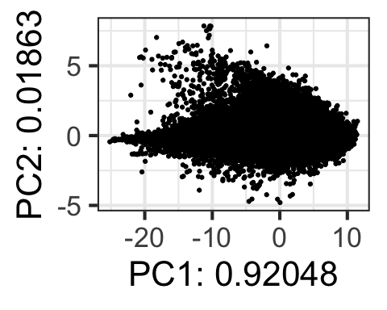

## 4. Expresión Diferencial

### 4.1 Modelización i Regresión

design <- model.matrix(~0+Grupo)  
colnames(design) = c(params$Brown, params$Rest)  
design

## Brown Rest  
## 1 1 0  
## 2 1 0  
## 3 1 0  
## 4 1 0  
## 5 1 0  
## 6 1 0  
## 7 1 0  
## 8 1 0  
## 9 1 0  
## 10 1 0  
## 11 1 0  
## 12 1 0  
## 13 1 0  
## 14 1 0  
## 15 1 0  
## 16 1 0  
## 17 1 0  
## 18 1 0  
## 19 1 0  
## 20 1 0  
## 21 1 0  
## 22 1 0  
## 23 1 0  
## 24 1 0  
## 25 1 0  
## 26 1 0  
## 27 1 0  
## 28 1 0  
## 29 1 0  
## 30 1 0  
## 31 0 1  
## 32 0 1  
## 33 0 1  
## 34 0 1  
## 35 0 1  
## 36 0 1  
## 37 0 1  
## 38 0 1  
## 39 0 1  
## 40 0 1  
## 41 0 1  
## 42 0 1  
## 43 0 1  
## 44 0 1  
## 45 0 1  
## 46 0 1  
## attr(,"assign")  
## [1] 1 1  
## attr(,"contrasts")  
## attr(,"contrasts")$Grupo  
## [1] "contr.treatment"

fit = lmFit(yfilt, design)

parametre1 = params$Brown  
parametre2 = params$Rest  
  
contraste = makeContrasts(Brown-Rest, levels = design)  
fit2 = contrasts.fit(fit, contraste)  
fit2 = eBayes(fit2)

### 4.2 Resultados

topTable(fit2, adjust.method = "bonferroni", n=30)

## Row Col ControlType ProbeName SystematicName EntrezID Symbol  
## 1648 11 8 0 A_23_P37914 NM_052944 115584 SLC5A11  
## 59451 363 83 0 A_33_P3219537 NR_028409 388910 LINC00207  
## 57826 353 98 0 A_23_P38365 NM_006852 11011 TLK2  
## 58251 356 31 0 A_33_P3645505 NR_126029 340512 LOC340512  
## 273 2 109 0 A_24_P251734 NM_020116 56884 FSTL5  
## 60854 372 10 0 A_23_P396626 NM_007247 11276 SYNRG  
## 59583 364 51 0 A_33_P3331335 NM_001287491 200424 TET3  
## 5917 37 13 0 A_33_P3410232 NR_024541 79136 LY6G6E  
## 50775 310 99 0 A_33_P3217958 NM_014824 9873 FCHSD2  
## 33437 204 145 0 A_33_P3290477 NM_001009992 127665 ZNF648  
## 28194 172 150 0 A_24_P356916 NM_001011554 64849 SLC13A3  
## 37252 228 24 0 A_23_P215956 NM_002467 4609 MYC  
## 37682 230 126 0 A_23_P155688 NM_021114 6691 SPINK2  
## 39253 240 57 0 A_24_P162244 ENST00000303521 49855 SCAPER  
## 48711 298 3 0 A_23_P146084 NM_000637 2936 GSR  
## 8369 52 5 0 A_33_P3329467 NM_016086 51657 STYXL1  
## 7460 46 80 0 A_33_P3247175 NM_001114357 441054 C4orf47  
## 48078 294 26 0 A_33_P3266839 NM_001145720 728116 ZBTB8B  
## 54520 333 72 0 A_23_P170587 NM_020197 56950 SMYD2  
## 49057 300 21 0 A_23_P215956 NM_002467 4609 MYC  
## 13259 81 139 0 A_23_P215956 NM_002467 4609 MYC  
## 57501 351 101 0 A_33_P3317258 ENST00000390344 445347 TARP  
## 40098 245 82 0 A_33_P3210637 NM_001004701 219428 OR4C16  
## 44242 270 126 0 A_33_P3307486 NM_001163547 11276 SYNRG  
## 18538 114 6 0 A_23_P108404 NM_001037131 116987 AGAP1  
## 23201 142 77 0 A_33_P3212167 NM_001278344 88 ACTN2  
## 7607 47 63 0 A_23_P132041 ENST00000538900 140894 CNBD2  
## 57959 354 67 0 A_23_P71880 NM_014471 27290 SPINK4  
## 54777 335 1 0 A_33_P3295173 ENST00000371377 51668 IFT25  
## 49019 299 147 0 A_33_P3880078 NR_024472 100133308 RSU1P2  
## logFC AveExpr t P.Value adj.P.Val B  
## 1648 -0.6121856 4.298956 -3.776135 0.0004384299 1 -3.430078  
## 59451 0.7368977 3.638407 3.742562 0.0004862395 1 -3.448257  
## 57826 0.4694488 9.089593 3.726909 0.0005102069 1 -3.456723  
## 58251 0.6389100 3.506432 3.675877 0.0005964861 1 -3.484276  
## 273 -1.9684565 5.621697 -3.503369 0.0010040848 1 -3.576797  
## 60854 0.4136088 7.353599 3.454996 0.0011594882 1 -3.602541  
## 59583 0.4868200 3.994685 3.443405 0.0011999939 1 -3.608694  
## 5917 -0.4659266 3.834719 -3.414583 0.0013066401 1 -3.623971  
## 50775 0.4687023 5.014172 3.393652 0.0013896757 1 -3.635041  
## 33437 0.5769548 3.656248 3.228136 0.0022470169 1 -3.721817  
## 28194 -0.8895674 8.383773 -3.183731 0.0025508837 1 -3.744842  
## 37252 -0.6504444 11.695433 -3.164700 0.0026926395 1 -3.754674  
## 37682 0.8570392 5.213563 3.155304 0.0027653342 1 -3.759520  
## 39253 -0.5385060 6.905696 -3.141972 0.0028716562 1 -3.766387  
## 48711 0.5607213 8.467280 3.138531 0.0028997118 1 -3.768157  
## 8369 0.4446512 11.558025 3.130942 0.0029625114 1 -3.772060  
## 7460 -0.6749843 6.672015 -3.128209 0.0029854458 1 -3.773464  
## 48078 0.5957990 3.797894 3.126908 0.0029964193 1 -3.774133  
## 54520 -0.4259679 10.170316 -3.125992 0.0030041634 1 -3.774603  
## 49057 -0.6508770 11.653094 -3.118381 0.0030692822 1 -3.778511  
## 13259 -0.6376128 11.689085 -3.065226 0.0035624030 1 -3.805694  
## 57501 0.5686707 5.916886 3.058506 0.0036297928 1 -3.809117  
## 40098 0.5365623 3.852587 3.058037 0.0036345380 1 -3.809355  
## 44242 0.4341261 5.896124 3.053093 0.0036849390 1 -3.811872  
## 18538 -0.4513215 7.415534 -3.031400 0.0039139315 1 -3.822893  
## 23201 -0.4341705 4.573278 -3.027109 0.0039607755 1 -3.825069  
## 7607 -0.7279992 3.176374 -3.023493 0.0040006605 1 -3.826901  
## 57959 0.5786929 3.948132 3.010480 0.0041473197 1 -3.833489  
## 54777 0.3839946 5.203432 3.001034 0.0042569180 1 -3.838263  
## 49019 0.4456601 4.303094 2.997184 0.0043023647 1 -3.840208

tT=topTable(fit2, adjust.method = "bonferroni", n=3000)  
  
results = decideTests(fit2, p.value = 0.1)  
summary(decideTests(fit2), p.value = 0.1)

## Brown - Rest  
## Down 0  
## NotSig 36037  
## Up 0

EnhancedVolcano(tT, lab = tT$Symbol, x = "logFC", y = "adj.P.Val", pCutoff = 0.05, FCcutoff=2, labSize = 6.0, ylim=0.95)

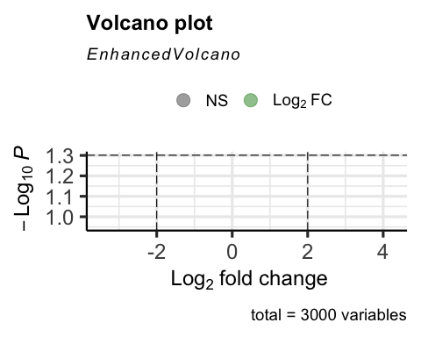

vennDiagram(results, include=c("both"), circle.col = "red", counts.col = "blue", names = c("CHD9-CTL"))

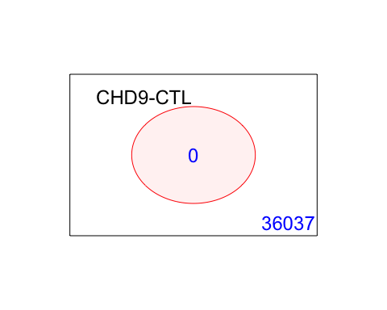

## 5. Gene Enrichment Analysis

### Gene Ontology

g = goana(fit2, species="Hs", geneid = fit2$genes$EntrezID, FDR = 0.05)

## No DE genes

topGO(g, n=20)

## data frame with 0 columns and 0 rows

### KEGG

k = kegga(fit2, species="Hs", geneid = fit2$genes$EntrezID, FDR = 0.05)

## No DE genes

topKEGG(k, number = 20)

## data frame with 0 columns and 0 rows