Fototipos12Vs34Recod

Estefanía Gómez Guil

2023-06-11

Table of Contents

## 1.Importación de datos

params <- list(  
 Fot12="Fot12",  
 Fot34="Fot34",  
 directorio= "/Users/estefaniagomezguil/Desktop/Fototipo12vs34Recod"  
)  
ruta_12<- file.path(params$directorio, "12")  
ruta_34<- file.path(params$directorio, "34")  
  
files_12 <- list.files(path = ruta_12, pattern = ".txt", full.names = TRUE)  
files_34 <- list.files(path = ruta_34, pattern = ".txt", full.names = TRUE)  
Grupo <- c (rep(params$Fot12, length(files_12)), rep(params$Fot34, length(files_34)))  
files <- c(files_12, files_34)  
print(files)

## [1] "/Users/estefaniagomezguil/Desktop/Fototipo12vs34Recod/12/2708.txt"  
## [2] "/Users/estefaniagomezguil/Desktop/Fototipo12vs34Recod/12/2710.txt"  
## [3] "/Users/estefaniagomezguil/Desktop/Fototipo12vs34Recod/12/2724.txt"  
## [4] "/Users/estefaniagomezguil/Desktop/Fototipo12vs34Recod/12/2727.txt"  
## [5] "/Users/estefaniagomezguil/Desktop/Fototipo12vs34Recod/12/2729.txt"  
## [6] "/Users/estefaniagomezguil/Desktop/Fototipo12vs34Recod/12/2730.txt"  
## [7] "/Users/estefaniagomezguil/Desktop/Fototipo12vs34Recod/12/2736.txt"  
## [8] "/Users/estefaniagomezguil/Desktop/Fototipo12vs34Recod/12/2750.txt"  
## [9] "/Users/estefaniagomezguil/Desktop/Fototipo12vs34Recod/12/2790.txt"  
## [10] "/Users/estefaniagomezguil/Desktop/Fototipo12vs34Recod/12/2799.txt"  
## [11] "/Users/estefaniagomezguil/Desktop/Fototipo12vs34Recod/12/2807.txt"  
## [12] "/Users/estefaniagomezguil/Desktop/Fototipo12vs34Recod/12/2810.txt"  
## [13] "/Users/estefaniagomezguil/Desktop/Fototipo12vs34Recod/12/2823.txt"  
## [14] "/Users/estefaniagomezguil/Desktop/Fototipo12vs34Recod/12/2824.txt"  
## [15] "/Users/estefaniagomezguil/Desktop/Fototipo12vs34Recod/12/2871.txt"  
## [16] "/Users/estefaniagomezguil/Desktop/Fototipo12vs34Recod/12/2891.txt"  
## [17] "/Users/estefaniagomezguil/Desktop/Fototipo12vs34Recod/12/2892.txt"  
## [18] "/Users/estefaniagomezguil/Desktop/Fototipo12vs34Recod/12/2893.txt"  
## [19] "/Users/estefaniagomezguil/Desktop/Fototipo12vs34Recod/12/2894.txt"  
## [20] "/Users/estefaniagomezguil/Desktop/Fototipo12vs34Recod/12/2895.txt"  
## [21] "/Users/estefaniagomezguil/Desktop/Fototipo12vs34Recod/12/2911.txt"  
## [22] "/Users/estefaniagomezguil/Desktop/Fototipo12vs34Recod/12/2912.txt"  
## [23] "/Users/estefaniagomezguil/Desktop/Fototipo12vs34Recod/12/2949.txt"  
## [24] "/Users/estefaniagomezguil/Desktop/Fototipo12vs34Recod/34/2711.txt"  
## [25] "/Users/estefaniagomezguil/Desktop/Fototipo12vs34Recod/34/2712.txt"  
## [26] "/Users/estefaniagomezguil/Desktop/Fototipo12vs34Recod/34/2740.txt"  
## [27] "/Users/estefaniagomezguil/Desktop/Fototipo12vs34Recod/34/2769.txt"  
## [28] "/Users/estefaniagomezguil/Desktop/Fototipo12vs34Recod/34/2777.txt"  
## [29] "/Users/estefaniagomezguil/Desktop/Fototipo12vs34Recod/34/2801.txt"  
## [30] "/Users/estefaniagomezguil/Desktop/Fototipo12vs34Recod/34/2880.txt"  
## [31] "/Users/estefaniagomezguil/Desktop/Fototipo12vs34Recod/34/2881.txt"  
## [32] "/Users/estefaniagomezguil/Desktop/Fototipo12vs34Recod/34/2898.txt"  
## [33] "/Users/estefaniagomezguil/Desktop/Fototipo12vs34Recod/34/2899.txt"  
## [34] "/Users/estefaniagomezguil/Desktop/Fototipo12vs34Recod/34/2908.txt"  
## [35] "/Users/estefaniagomezguil/Desktop/Fototipo12vs34Recod/34/2929.txt"  
## [36] "/Users/estefaniagomezguil/Desktop/Fototipo12vs34Recod/34/2933.txt"  
## [37] "/Users/estefaniagomezguil/Desktop/Fototipo12vs34Recod/34/2934.txt"  
## [38] "/Users/estefaniagomezguil/Desktop/Fototipo12vs34Recod/34/2939.txt"  
## [39] "/Users/estefaniagomezguil/Desktop/Fototipo12vs34Recod/34/2948.txt"

targets = read.maimages(file=files, source="agilent", green.only=TRUE)

## Read /Users/estefaniagomezguil/Desktop/Fototipo12vs34Recod/12/2708.txt   
## Read /Users/estefaniagomezguil/Desktop/Fototipo12vs34Recod/12/2710.txt   
## Read /Users/estefaniagomezguil/Desktop/Fototipo12vs34Recod/12/2724.txt   
## Read /Users/estefaniagomezguil/Desktop/Fototipo12vs34Recod/12/2727.txt   
## Read /Users/estefaniagomezguil/Desktop/Fototipo12vs34Recod/12/2729.txt   
## Read /Users/estefaniagomezguil/Desktop/Fototipo12vs34Recod/12/2730.txt   
## Read /Users/estefaniagomezguil/Desktop/Fototipo12vs34Recod/12/2736.txt   
## Read /Users/estefaniagomezguil/Desktop/Fototipo12vs34Recod/12/2750.txt   
## Read /Users/estefaniagomezguil/Desktop/Fototipo12vs34Recod/12/2790.txt   
## Read /Users/estefaniagomezguil/Desktop/Fototipo12vs34Recod/12/2799.txt   
## Read /Users/estefaniagomezguil/Desktop/Fototipo12vs34Recod/12/2807.txt   
## Read /Users/estefaniagomezguil/Desktop/Fototipo12vs34Recod/12/2810.txt   
## Read /Users/estefaniagomezguil/Desktop/Fototipo12vs34Recod/12/2823.txt   
## Read /Users/estefaniagomezguil/Desktop/Fototipo12vs34Recod/12/2824.txt   
## Read /Users/estefaniagomezguil/Desktop/Fototipo12vs34Recod/12/2871.txt   
## Read /Users/estefaniagomezguil/Desktop/Fototipo12vs34Recod/12/2891.txt   
## Read /Users/estefaniagomezguil/Desktop/Fototipo12vs34Recod/12/2892.txt   
## Read /Users/estefaniagomezguil/Desktop/Fototipo12vs34Recod/12/2893.txt   
## Read /Users/estefaniagomezguil/Desktop/Fototipo12vs34Recod/12/2894.txt   
## Read /Users/estefaniagomezguil/Desktop/Fototipo12vs34Recod/12/2895.txt   
## Read /Users/estefaniagomezguil/Desktop/Fototipo12vs34Recod/12/2911.txt   
## Read /Users/estefaniagomezguil/Desktop/Fototipo12vs34Recod/12/2912.txt   
## Read /Users/estefaniagomezguil/Desktop/Fototipo12vs34Recod/12/2949.txt   
## Read /Users/estefaniagomezguil/Desktop/Fototipo12vs34Recod/34/2711.txt   
## Read /Users/estefaniagomezguil/Desktop/Fototipo12vs34Recod/34/2712.txt   
## Read /Users/estefaniagomezguil/Desktop/Fototipo12vs34Recod/34/2740.txt   
## Read /Users/estefaniagomezguil/Desktop/Fototipo12vs34Recod/34/2769.txt   
## Read /Users/estefaniagomezguil/Desktop/Fototipo12vs34Recod/34/2777.txt   
## Read /Users/estefaniagomezguil/Desktop/Fototipo12vs34Recod/34/2801.txt   
## Read /Users/estefaniagomezguil/Desktop/Fototipo12vs34Recod/34/2880.txt   
## Read /Users/estefaniagomezguil/Desktop/Fototipo12vs34Recod/34/2881.txt   
## Read /Users/estefaniagomezguil/Desktop/Fototipo12vs34Recod/34/2898.txt   
## Read /Users/estefaniagomezguil/Desktop/Fototipo12vs34Recod/34/2899.txt   
## Read /Users/estefaniagomezguil/Desktop/Fototipo12vs34Recod/34/2908.txt   
## Read /Users/estefaniagomezguil/Desktop/Fototipo12vs34Recod/34/2929.txt   
## Read /Users/estefaniagomezguil/Desktop/Fototipo12vs34Recod/34/2933.txt   
## Read /Users/estefaniagomezguil/Desktop/Fototipo12vs34Recod/34/2934.txt   
## Read /Users/estefaniagomezguil/Desktop/Fototipo12vs34Recod/34/2939.txt   
## Read /Users/estefaniagomezguil/Desktop/Fototipo12vs34Recod/34/2948.txt

targets$targets$class <- Grupo  
files2<- str_remove_all(string=files, pattern= "US85003608_253949442215")  
files2<- str_remove_all(string=files2, patter= "_S01_GE1_107_Sep09")

## 2.Control de calidad

limma::plotMA3by2(targets, status = targets$genes$ControlType, prefix = "MA", device = "pdf")  
# Obtener los grupos únicos y sus correspondientes colores  
grupos_unicos <- unique(Grupo)  
colores <- 1:4  
Grupo2<-colores  
plotMDS(targets, top = 100, gene.selection = "pairwise", pch=colores, type="p", plot = TRUE)  
  
# Agregar la leyenda  
legend("topright", legend = grupos_unicos, pch = colores, title = "Grupos")  
legend("topright", legend = grupos_unicos, pch = colores, title = "Grupos")

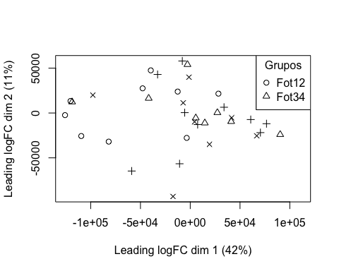

boxplot(targets$E, col = "royalblue", names = str_trunc(targets$targets$FileName, width = 10, side = "left"))

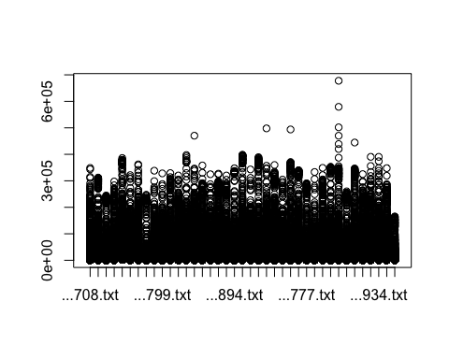

## 3. Preprocesado

### 3.1 Background

BK <- backgroundCorrect(targets, method ="normexp", printer=targets$printer, verbose=TRUE)

## Array 1 corrected  
## Array 2 corrected  
## Array 3 corrected  
## Array 4 corrected  
## Array 5 corrected  
## Array 6 corrected  
## Array 7 corrected  
## Array 8 corrected  
## Array 9 corrected  
## Array 10 corrected  
## Array 11 corrected  
## Array 12 corrected  
## Array 13 corrected  
## Array 14 corrected  
## Array 15 corrected  
## Array 16 corrected  
## Array 17 corrected  
## Array 18 corrected  
## Array 19 corrected  
## Array 20 corrected  
## Array 21 corrected  
## Array 22 corrected  
## Array 23 corrected  
## Array 24 corrected  
## Array 25 corrected  
## Array 26 corrected  
## Array 27 corrected  
## Array 28 corrected  
## Array 29 corrected  
## Array 30 corrected  
## Array 31 corrected  
## Array 32 corrected  
## Array 33 corrected  
## Array 34 corrected  
## Array 35 corrected  
## Array 36 corrected  
## Array 37 corrected  
## Array 38 corrected  
## Array 39 corrected

### 3.2 Normalización

MA.p<-normalizeBetweenArrays(BK, method = 'quantile')  
transposed <- t(MA.p$E)  
df<-data.frame(value = transposed, group = as.character(Grupo))  
plotDensities(MA.p, legend = FALSE, type="1")

## Warning: In density.default(E[, a], n = npoint, na.rm = TRUE, ...) :  
## extra argument 'type' will be disregarded  
  
## Warning: In density.default(E[, a], n = npoint, na.rm = TRUE, ...) :  
## extra argument 'type' will be disregarded  
  
## Warning: In density.default(E[, a], n = npoint, na.rm = TRUE, ...) :  
## extra argument 'type' will be disregarded  
  
## Warning: In density.default(E[, a], n = npoint, na.rm = TRUE, ...) :  
## extra argument 'type' will be disregarded  
  
## Warning: In density.default(E[, a], n = npoint, na.rm = TRUE, ...) :  
## extra argument 'type' will be disregarded  
  
## Warning: In density.default(E[, a], n = npoint, na.rm = TRUE, ...) :  
## extra argument 'type' will be disregarded  
  
## Warning: In density.default(E[, a], n = npoint, na.rm = TRUE, ...) :  
## extra argument 'type' will be disregarded  
  
## Warning: In density.default(E[, a], n = npoint, na.rm = TRUE, ...) :  
## extra argument 'type' will be disregarded  
  
## Warning: In density.default(E[, a], n = npoint, na.rm = TRUE, ...) :  
## extra argument 'type' will be disregarded  
  
## Warning: In density.default(E[, a], n = npoint, na.rm = TRUE, ...) :  
## extra argument 'type' will be disregarded  
  
## Warning: In density.default(E[, a], n = npoint, na.rm = TRUE, ...) :  
## extra argument 'type' will be disregarded  
  
## Warning: In density.default(E[, a], n = npoint, na.rm = TRUE, ...) :  
## extra argument 'type' will be disregarded  
  
## Warning: In density.default(E[, a], n = npoint, na.rm = TRUE, ...) :  
## extra argument 'type' will be disregarded  
  
## Warning: In density.default(E[, a], n = npoint, na.rm = TRUE, ...) :  
## extra argument 'type' will be disregarded  
  
## Warning: In density.default(E[, a], n = npoint, na.rm = TRUE, ...) :  
## extra argument 'type' will be disregarded  
  
## Warning: In density.default(E[, a], n = npoint, na.rm = TRUE, ...) :  
## extra argument 'type' will be disregarded  
  
## Warning: In density.default(E[, a], n = npoint, na.rm = TRUE, ...) :  
## extra argument 'type' will be disregarded  
  
## Warning: In density.default(E[, a], n = npoint, na.rm = TRUE, ...) :  
## extra argument 'type' will be disregarded  
  
## Warning: In density.default(E[, a], n = npoint, na.rm = TRUE, ...) :  
## extra argument 'type' will be disregarded  
  
## Warning: In density.default(E[, a], n = npoint, na.rm = TRUE, ...) :  
## extra argument 'type' will be disregarded  
  
## Warning: In density.default(E[, a], n = npoint, na.rm = TRUE, ...) :  
## extra argument 'type' will be disregarded  
  
## Warning: In density.default(E[, a], n = npoint, na.rm = TRUE, ...) :  
## extra argument 'type' will be disregarded  
  
## Warning: In density.default(E[, a], n = npoint, na.rm = TRUE, ...) :  
## extra argument 'type' will be disregarded  
  
## Warning: In density.default(E[, a], n = npoint, na.rm = TRUE, ...) :  
## extra argument 'type' will be disregarded  
  
## Warning: In density.default(E[, a], n = npoint, na.rm = TRUE, ...) :  
## extra argument 'type' will be disregarded  
  
## Warning: In density.default(E[, a], n = npoint, na.rm = TRUE, ...) :  
## extra argument 'type' will be disregarded  
  
## Warning: In density.default(E[, a], n = npoint, na.rm = TRUE, ...) :  
## extra argument 'type' will be disregarded  
  
## Warning: In density.default(E[, a], n = npoint, na.rm = TRUE, ...) :  
## extra argument 'type' will be disregarded  
  
## Warning: In density.default(E[, a], n = npoint, na.rm = TRUE, ...) :  
## extra argument 'type' will be disregarded  
  
## Warning: In density.default(E[, a], n = npoint, na.rm = TRUE, ...) :  
## extra argument 'type' will be disregarded  
  
## Warning: In density.default(E[, a], n = npoint, na.rm = TRUE, ...) :  
## extra argument 'type' will be disregarded  
  
## Warning: In density.default(E[, a], n = npoint, na.rm = TRUE, ...) :  
## extra argument 'type' will be disregarded  
  
## Warning: In density.default(E[, a], n = npoint, na.rm = TRUE, ...) :  
## extra argument 'type' will be disregarded  
  
## Warning: In density.default(E[, a], n = npoint, na.rm = TRUE, ...) :  
## extra argument 'type' will be disregarded  
  
## Warning: In density.default(E[, a], n = npoint, na.rm = TRUE, ...) :  
## extra argument 'type' will be disregarded  
  
## Warning: In density.default(E[, a], n = npoint, na.rm = TRUE, ...) :  
## extra argument 'type' will be disregarded  
  
## Warning: In density.default(E[, a], n = npoint, na.rm = TRUE, ...) :  
## extra argument 'type' will be disregarded  
  
## Warning: In density.default(E[, a], n = npoint, na.rm = TRUE, ...) :  
## extra argument 'type' will be disregarded  
  
## Warning: In density.default(E[, a], n = npoint, na.rm = TRUE, ...) :  
## extra argument 'type' will be disregarded

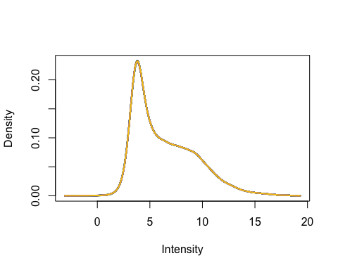

### 3.3 Anotación

MA.p$genes$EntrezID<- mapIds(HsAgilentDesign026652.db, MA.p$genes$ProbeName, keytype = "PROBEID", column = "ENTREZID")

## 'select()' returned 1:1 mapping between keys and columns

MA.p$genes$Symbol <- mapIds(HsAgilentDesign026652.db, MA.p$genes$ProbeName, keytype = "PROBEID", column = "SYMBOL")

## 'select()' returned 1:1 mapping between keys and columns

map=getGEO("GPL20844")

### 3.3 Filtrado

control_1 =MA.p$genes$ControlType == 1  
control_b= MA.p$genes$ControlType == -1

NoSym = is.na(MA.p$genes$Symbol)  
NoEnID= is.na(MA.p$genes$EntrezID)  
table(NoEnID)

## NoEnID  
## FALSE TRUE   
## 36037 26939

yfilt = MA.p[!control_1& !control_b & !NoSym & !NoEnID,]

boxplot(yfilt$E, col = "royalblue", names = str_trunc(targets$targets$FileName, width = 10, side = "left"))

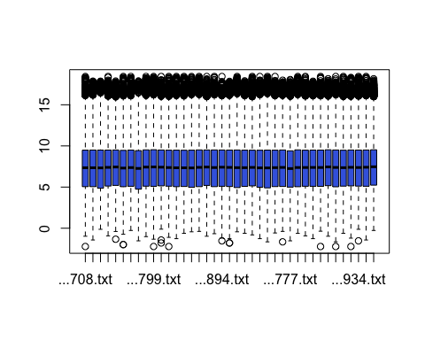

pcomp=prcomp(yfilt$E, scale. = TRUE)  
eso=summary(pcomp)  
eso

## Importance of components:  
## PC1 PC2 PC3 PC4 PC5 PC6 PC7  
## Standard deviation 6.0010 0.80996 0.53789 0.46997 0.44326 0.3848 0.35266  
## Proportion of Variance 0.9234 0.01682 0.00742 0.00566 0.00504 0.0038 0.00319  
## Cumulative Proportion 0.9234 0.94021 0.94763 0.95329 0.95833 0.9621 0.96531  
## PC8 PC9 PC10 PC11 PC12 PC13 PC14  
## Standard deviation 0.31186 0.30773 0.29361 0.27818 0.27182 0.26742 0.24838  
## Proportion of Variance 0.00249 0.00243 0.00221 0.00198 0.00189 0.00183 0.00158  
## Cumulative Proportion 0.96781 0.97024 0.97245 0.97443 0.97632 0.97816 0.97974  
## PC15 PC16 PC17 PC18 PC19 PC20 PC21  
## Standard deviation 0.24123 0.2333 0.2250 0.21365 0.21188 0.20861 0.20305  
## Proportion of Variance 0.00149 0.0014 0.0013 0.00117 0.00115 0.00112 0.00106  
## Cumulative Proportion 0.98123 0.9826 0.9839 0.98510 0.98625 0.98736 0.98842  
## PC22 PC23 PC24 PC25 PC26 PC27 PC28  
## Standard deviation 0.19047 0.18563 0.18205 0.17910 0.1765 0.17344 0.16630  
## Proportion of Variance 0.00093 0.00088 0.00085 0.00082 0.0008 0.00077 0.00071  
## Cumulative Proportion 0.98935 0.99023 0.99108 0.99191 0.9927 0.99348 0.99419  
## PC29 PC30 PC31 PC32 PC33 PC34 PC35  
## Standard deviation 0.16414 0.15892 0.15496 0.15029 0.14796 0.1401 0.1390  
## Proportion of Variance 0.00069 0.00065 0.00062 0.00058 0.00056 0.0005 0.0005  
## Cumulative Proportion 0.99488 0.99552 0.99614 0.99672 0.99728 0.9978 0.9983  
## PC36 PC37 PC38 PC39  
## Standard deviation 0.13507 0.13040 0.12723 0.1252  
## Proportion of Variance 0.00047 0.00044 0.00042 0.0004  
## Cumulative Proportion 0.99875 0.99918 0.99960 1.0000

com=as.data.frame(pcomp$x)  
ggplot(com, aes(PC1, PC2)) + geom_point()+theme_bw(base_size=32)+xlab(paste("PC1:",eso$importance[2,1])) + ylab(paste("PC2:",eso$importance[2,2]))+theme(legend.position="top")

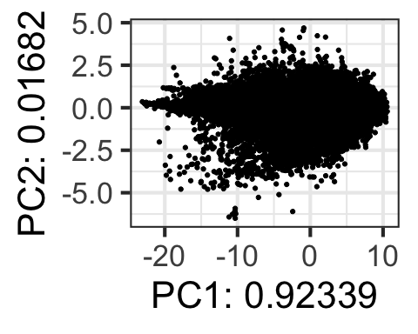

## 4. Expresión Diferencial

### 4.1 Modelización i Regresión

design <- model.matrix(~0+Grupo)  
colnames(design) = c(params$Fot12, params$Fot34)  
design

## Fot12 Fot34  
## 1 1 0  
## 2 1 0  
## 3 1 0  
## 4 1 0  
## 5 1 0  
## 6 1 0  
## 7 1 0  
## 8 1 0  
## 9 1 0  
## 10 1 0  
## 11 1 0  
## 12 1 0  
## 13 1 0  
## 14 1 0  
## 15 1 0  
## 16 1 0  
## 17 1 0  
## 18 1 0  
## 19 1 0  
## 20 1 0  
## 21 1 0  
## 22 1 0  
## 23 1 0  
## 24 0 1  
## 25 0 1  
## 26 0 1  
## 27 0 1  
## 28 0 1  
## 29 0 1  
## 30 0 1  
## 31 0 1  
## 32 0 1  
## 33 0 1  
## 34 0 1  
## 35 0 1  
## 36 0 1  
## 37 0 1  
## 38 0 1  
## 39 0 1  
## attr(,"assign")  
## [1] 1 1  
## attr(,"contrasts")  
## attr(,"contrasts")$Grupo  
## [1] "contr.treatment"

fit = lmFit(yfilt, design)

parametre1 = params$Fot12  
parametre2 = params$Fot34  
  
contraste = makeContrasts(Fot12-Fot34, levels = design)  
fit2 = contrasts.fit(fit, contraste)  
fit2 = eBayes(fit2)

### 4.2 Resultados

topTable(fit2, adjust.method = "bonferroni", n=30)

## Row Col ControlType ProbeName SystematicName EntrezID Symbol  
## 58671 358 123 0 A_23_P84118 NM_004934 1016 CDH18  
## 16326 100 90 0 A_23_P28834 NM_080672 116154 PHACTR3  
## 45776 280 20 0 A_33_P3339531 NM_138481 150356 CHADL  
## 50421 308 73 0 A_33_P3302393 ENST00000258157 79786 KLHL36  
## 43358 265 62 0 A_23_P386478 NM_024873 79931 TNIP3  
## 36591 224 19 0 A_33_P3324186 NR_046243 642366 ISL1-DT  
## 54851 335 75 0 A_33_P3404729 AK075182 23189 KANK1  
## 29755 182 71 0 A_23_P4536 NM_012307 23136 EPB41L3  
## 54446 332 162 0 A_23_P111621 NM_005685 9569 GTF2IRD1  
## 60595 370 79 0 A_23_P110052 NM_023067 668 FOXL2  
## 24120 148 12 0 A_23_P106389 NM_003612 8482 SEMA7A  
## 15204 93 116 0 A_33_P3413483 ENST00000267814 6652 SORD  
## 46503 284 91 0 A_23_P162142 NM_015516 25987 TSKU  
## 50169 306 149 0 A_23_P77731 NM_001888 1428 CRYM  
## 59817 365 121 0 A_23_P111621 NM_005685 9569 GTF2IRD1  
## 13874 85 98 0 A_23_P106389 NM_003612 8482 SEMA7A  
## 61937 378 109 0 A_24_P158718 NM_015177 23220 DTX4  
## 20023 123 15 0 A_23_P112801 NM_007236 11261 CHP1  
## 40312 246 132 0 A_23_P13604 NM_002567 5037 PEBP1  
## 35121 215 25 0 A_23_P106389 NM_003612 8482 SEMA7A  
## 45567 278 139 0 A_24_P26897 NM_005539 3632 INPP5A  
## 54919 335 143 0 A_23_P106389 NM_003612 8482 SEMA7A  
## 4280 27 16 0 A_23_P111621 NM_005685 9569 GTF2IRD1  
## 9708 60 32 0 A_23_P106389 NM_003612 8482 SEMA7A  
## 4661 29 69 0 A_23_P111621 NM_005685 9569 GTF2IRD1  
## 30367 186 27 0 A_33_P3323298 NM_002228 3725 JUN  
## 31539 193 51 0 A_23_P111621 NM_005685 9569 GTF2IRD1  
## 12321 76 21 0 A_23_P106389 NM_003612 8482 SEMA7A  
## 11723 72 79 0 A_23_P111621 NM_005685 9569 GTF2IRD1  
## 43595 266 135 0 A_33_P3410654 NM_205852 387837 CLEC12B  
## logFC AveExpr t P.Value adj.P.Val B  
## 58671 -1.0328095 4.684613 -4.355951 8.577755e-05 1 -1.947657  
## 16326 1.3824911 5.898473 4.270996 1.117401e-04 1 -2.031042  
## 45776 1.8198750 9.870503 4.228964 1.272838e-04 1 -2.072318  
## 50421 0.6582755 7.680298 4.183662 1.464012e-04 1 -2.116811  
## 43358 -0.6230205 4.255721 -4.155889 1.594768e-04 1 -2.144087  
## 36591 0.8473060 4.883505 4.141601 1.666410e-04 1 -2.158120  
## 54851 -0.7248177 5.389276 -4.124252 1.757616e-04 1 -2.175156  
## 29755 -0.8940687 8.470354 -4.114058 1.813460e-04 1 -2.185166  
## 54446 0.5072109 9.518375 3.931619 3.159933e-04 1 -2.364107  
## 60595 0.9319796 4.892416 3.906964 3.403881e-04 1 -2.388243  
## 24120 0.9092992 7.348778 3.886458 3.620603e-04 1 -2.408306  
## 15204 1.2008352 6.794392 3.883712 3.650627e-04 1 -2.410993  
## 46503 0.8463255 9.762291 3.813938 4.499515e-04 1 -2.479163  
## 50169 1.1056444 9.168179 3.812193 4.523012e-04 1 -2.480866  
## 59817 0.4920144 9.763329 3.791386 4.812609e-04 1 -2.501163  
## 13874 0.8970458 7.590252 3.777152 5.020958e-04 1 -2.515039  
## 61937 0.7231187 5.493053 3.747784 5.478695e-04 1 -2.543644  
## 20023 0.5433432 13.278979 3.726618 5.833322e-04 1 -2.564239  
## 40312 0.4437236 13.652066 3.725734 5.848601e-04 1 -2.565098  
## 35121 0.8511718 7.397178 3.721122 5.928954e-04 1 -2.569583  
## 45567 0.5290152 8.387712 3.716562 6.009464e-04 1 -2.574017  
## 54919 0.8533474 7.388505 3.713698 6.060564e-04 1 -2.576801  
## 4280 0.4763534 9.576498 3.691926 6.462927e-04 1 -2.597952  
## 9708 0.8576051 7.369746 3.685177 6.592802e-04 1 -2.604505  
## 4661 0.4645564 9.820642 3.682763 6.639866e-04 1 -2.606848  
## 30367 1.1365939 10.040121 3.679719 6.699669e-04 1 -2.609802  
## 31539 0.4576761 9.962278 3.652919 7.249078e-04 1 -2.635793  
## 12321 0.8774060 7.327371 3.624594 7.876793e-04 1 -2.663223  
## 11723 0.4581684 9.913914 3.600974 8.439925e-04 1 -2.686064  
## 43595 1.0720554 5.442923 3.587758 8.771699e-04 1 -2.698831

tT=topTable(fit2, adjust.method = "bonferroni", n=3000)  
  
results = decideTests(fit2, p.value = 0.1)  
summary(decideTests(fit2), p.value = 0.1)

## Fot12 - Fot34  
## Down 0  
## NotSig 36037  
## Up 0

EnhancedVolcano(tT, lab = tT$Symbol, x = "logFC", y = "adj.P.Val", pCutoff = 0.05, FCcutoff=2, labSize = 6.0, ylim=0.95)

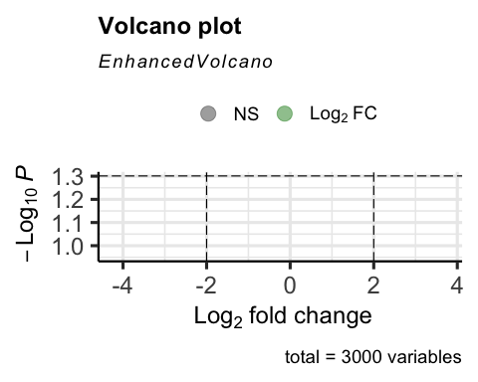

vennDiagram(results, include=c("both"), circle.col = "red", counts.col = "blue", names = c("CHD9-CTL"))

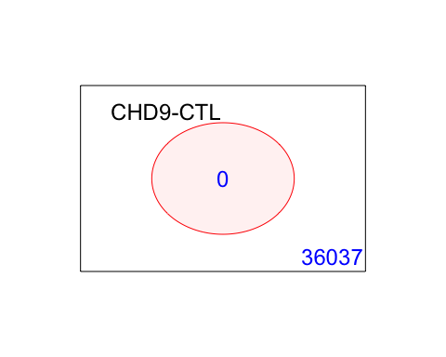

## 5. Gene Enrichment Analysis

### Gene Ontology

g = goana(fit2, species="Hs", geneid = fit2$genes$EntrezID, FDR = 0.05)

## No DE genes

topGO(g, n=20)

## data frame with 0 columns and 0 rows

### KEGG

k = kegga(fit2, species="Hs", geneid = fit2$genes$EntrezID, FDR = 0.05)

## No DE genes

topKEGG(k, number = 20)

## data frame with 0 columns and 0 rows