HairBrownVsRestRecod

Estefanía Gómez Guil

2023-06-11

Table of Contents

## 1. Importación de datos

params <- list(  
 Brown="Brown",  
 Rest="Rest",  
 directorio= "/Users/estefaniagomezguil/Desktop/HairBrownVsRestRecod"  
)  
ruta_brown<- file.path(params$directorio, "Brown")  
ruta_rest<- file.path(params$directorio, "Resto")  
  
files_brown <- list.files(path = ruta_brown, pattern = ".txt", full.names = TRUE)  
files_rest <- list.files(path = ruta_rest, pattern = ".txt", full.names = TRUE)  
Grupo <- c (rep(params$Brown, length(files_brown)), rep(params$Rest, length(files_rest)))  
files <- c(files_brown, files_rest)  
print(files)

## [1] "/Users/estefaniagomezguil/Desktop/HairBrownVsRestRecod/Brown/2711.txt"  
## [2] "/Users/estefaniagomezguil/Desktop/HairBrownVsRestRecod/Brown/2712.txt"  
## [3] "/Users/estefaniagomezguil/Desktop/HairBrownVsRestRecod/Brown/2724.txt"  
## [4] "/Users/estefaniagomezguil/Desktop/HairBrownVsRestRecod/Brown/2729.txt"  
## [5] "/Users/estefaniagomezguil/Desktop/HairBrownVsRestRecod/Brown/2730.txt"  
## [6] "/Users/estefaniagomezguil/Desktop/HairBrownVsRestRecod/Brown/2750.txt"  
## [7] "/Users/estefaniagomezguil/Desktop/HairBrownVsRestRecod/Brown/2769.txt"  
## [8] "/Users/estefaniagomezguil/Desktop/HairBrownVsRestRecod/Brown/2777.txt"  
## [9] "/Users/estefaniagomezguil/Desktop/HairBrownVsRestRecod/Brown/2790.txt"  
## [10] "/Users/estefaniagomezguil/Desktop/HairBrownVsRestRecod/Brown/2801.txt"  
## [11] "/Users/estefaniagomezguil/Desktop/HairBrownVsRestRecod/Brown/2807.txt"  
## [12] "/Users/estefaniagomezguil/Desktop/HairBrownVsRestRecod/Brown/2823.txt"  
## [13] "/Users/estefaniagomezguil/Desktop/HairBrownVsRestRecod/Brown/2824.txt"  
## [14] "/Users/estefaniagomezguil/Desktop/HairBrownVsRestRecod/Brown/2858.txt"  
## [15] "/Users/estefaniagomezguil/Desktop/HairBrownVsRestRecod/Brown/2871.txt"  
## [16] "/Users/estefaniagomezguil/Desktop/HairBrownVsRestRecod/Brown/2880.txt"  
## [17] "/Users/estefaniagomezguil/Desktop/HairBrownVsRestRecod/Brown/2881.txt"  
## [18] "/Users/estefaniagomezguil/Desktop/HairBrownVsRestRecod/Brown/2891.txt"  
## [19] "/Users/estefaniagomezguil/Desktop/HairBrownVsRestRecod/Brown/2892.txt"  
## [20] "/Users/estefaniagomezguil/Desktop/HairBrownVsRestRecod/Brown/2895.txt"  
## [21] "/Users/estefaniagomezguil/Desktop/HairBrownVsRestRecod/Brown/2908.txt"  
## [22] "/Users/estefaniagomezguil/Desktop/HairBrownVsRestRecod/Brown/2912.txt"  
## [23] "/Users/estefaniagomezguil/Desktop/HairBrownVsRestRecod/Brown/2915.txt"  
## [24] "/Users/estefaniagomezguil/Desktop/HairBrownVsRestRecod/Brown/2929.txt"  
## [25] "/Users/estefaniagomezguil/Desktop/HairBrownVsRestRecod/Brown/2933.txt"  
## [26] "/Users/estefaniagomezguil/Desktop/HairBrownVsRestRecod/Brown/2934.txt"  
## [27] "/Users/estefaniagomezguil/Desktop/HairBrownVsRestRecod/Brown/2939.txt"  
## [28] "/Users/estefaniagomezguil/Desktop/HairBrownVsRestRecod/Resto/2727.txt"  
## [29] "/Users/estefaniagomezguil/Desktop/HairBrownVsRestRecod/Resto/2736.txt"  
## [30] "/Users/estefaniagomezguil/Desktop/HairBrownVsRestRecod/Resto/2740.txt"  
## [31] "/Users/estefaniagomezguil/Desktop/HairBrownVsRestRecod/Resto/2799.txt"  
## [32] "/Users/estefaniagomezguil/Desktop/HairBrownVsRestRecod/Resto/2810.txt"  
## [33] "/Users/estefaniagomezguil/Desktop/HairBrownVsRestRecod/Resto/2893.txt"  
## [34] "/Users/estefaniagomezguil/Desktop/HairBrownVsRestRecod/Resto/2894.txt"  
## [35] "/Users/estefaniagomezguil/Desktop/HairBrownVsRestRecod/Resto/2898.txt"  
## [36] "/Users/estefaniagomezguil/Desktop/HairBrownVsRestRecod/Resto/2899.txt"  
## [37] "/Users/estefaniagomezguil/Desktop/HairBrownVsRestRecod/Resto/2911.txt"  
## [38] "/Users/estefaniagomezguil/Desktop/HairBrownVsRestRecod/Resto/2948.txt"  
## [39] "/Users/estefaniagomezguil/Desktop/HairBrownVsRestRecod/Resto/2949.txt"

targets = read.maimages(file=files, source="agilent", green.only=TRUE)

## Read /Users/estefaniagomezguil/Desktop/HairBrownVsRestRecod/Brown/2711.txt   
## Read /Users/estefaniagomezguil/Desktop/HairBrownVsRestRecod/Brown/2712.txt   
## Read /Users/estefaniagomezguil/Desktop/HairBrownVsRestRecod/Brown/2724.txt   
## Read /Users/estefaniagomezguil/Desktop/HairBrownVsRestRecod/Brown/2729.txt   
## Read /Users/estefaniagomezguil/Desktop/HairBrownVsRestRecod/Brown/2730.txt   
## Read /Users/estefaniagomezguil/Desktop/HairBrownVsRestRecod/Brown/2750.txt   
## Read /Users/estefaniagomezguil/Desktop/HairBrownVsRestRecod/Brown/2769.txt   
## Read /Users/estefaniagomezguil/Desktop/HairBrownVsRestRecod/Brown/2777.txt   
## Read /Users/estefaniagomezguil/Desktop/HairBrownVsRestRecod/Brown/2790.txt   
## Read /Users/estefaniagomezguil/Desktop/HairBrownVsRestRecod/Brown/2801.txt   
## Read /Users/estefaniagomezguil/Desktop/HairBrownVsRestRecod/Brown/2807.txt   
## Read /Users/estefaniagomezguil/Desktop/HairBrownVsRestRecod/Brown/2823.txt   
## Read /Users/estefaniagomezguil/Desktop/HairBrownVsRestRecod/Brown/2824.txt   
## Read /Users/estefaniagomezguil/Desktop/HairBrownVsRestRecod/Brown/2858.txt   
## Read /Users/estefaniagomezguil/Desktop/HairBrownVsRestRecod/Brown/2871.txt   
## Read /Users/estefaniagomezguil/Desktop/HairBrownVsRestRecod/Brown/2880.txt   
## Read /Users/estefaniagomezguil/Desktop/HairBrownVsRestRecod/Brown/2881.txt   
## Read /Users/estefaniagomezguil/Desktop/HairBrownVsRestRecod/Brown/2891.txt   
## Read /Users/estefaniagomezguil/Desktop/HairBrownVsRestRecod/Brown/2892.txt   
## Read /Users/estefaniagomezguil/Desktop/HairBrownVsRestRecod/Brown/2895.txt   
## Read /Users/estefaniagomezguil/Desktop/HairBrownVsRestRecod/Brown/2908.txt   
## Read /Users/estefaniagomezguil/Desktop/HairBrownVsRestRecod/Brown/2912.txt   
## Read /Users/estefaniagomezguil/Desktop/HairBrownVsRestRecod/Brown/2915.txt   
## Read /Users/estefaniagomezguil/Desktop/HairBrownVsRestRecod/Brown/2929.txt   
## Read /Users/estefaniagomezguil/Desktop/HairBrownVsRestRecod/Brown/2933.txt   
## Read /Users/estefaniagomezguil/Desktop/HairBrownVsRestRecod/Brown/2934.txt   
## Read /Users/estefaniagomezguil/Desktop/HairBrownVsRestRecod/Brown/2939.txt   
## Read /Users/estefaniagomezguil/Desktop/HairBrownVsRestRecod/Resto/2727.txt   
## Read /Users/estefaniagomezguil/Desktop/HairBrownVsRestRecod/Resto/2736.txt   
## Read /Users/estefaniagomezguil/Desktop/HairBrownVsRestRecod/Resto/2740.txt   
## Read /Users/estefaniagomezguil/Desktop/HairBrownVsRestRecod/Resto/2799.txt   
## Read /Users/estefaniagomezguil/Desktop/HairBrownVsRestRecod/Resto/2810.txt   
## Read /Users/estefaniagomezguil/Desktop/HairBrownVsRestRecod/Resto/2893.txt   
## Read /Users/estefaniagomezguil/Desktop/HairBrownVsRestRecod/Resto/2894.txt   
## Read /Users/estefaniagomezguil/Desktop/HairBrownVsRestRecod/Resto/2898.txt   
## Read /Users/estefaniagomezguil/Desktop/HairBrownVsRestRecod/Resto/2899.txt   
## Read /Users/estefaniagomezguil/Desktop/HairBrownVsRestRecod/Resto/2911.txt   
## Read /Users/estefaniagomezguil/Desktop/HairBrownVsRestRecod/Resto/2948.txt   
## Read /Users/estefaniagomezguil/Desktop/HairBrownVsRestRecod/Resto/2949.txt

targets$targets$class <- Grupo  
files2<- str_remove_all(string=files, pattern= "US85003608_253949442215")  
files2<- str_remove_all(string=files2, patter= "_S01_GE1_107_Sep09")

## 2. Control de calidad

limma::plotMA3by2(targets, status = targets$genes$ControlType, prefix = "MA", device = "pdf")  
# Obtener los grupos únicos y sus correspondientes colores  
grupos_unicos <- unique(Grupo)  
  
colores <- 1:4  
Grupo2<-colores  
plotMDS(targets, top = 100, gene.selection = "pairwise", pch=colores, type="p", plot = TRUE)  
  
# Agregar la leyenda  
legend("topright", legend = grupos_unicos, pch = colores, title = "Grupos")  
legend("topright", legend = grupos_unicos, pch = colores, title = "Grupos")

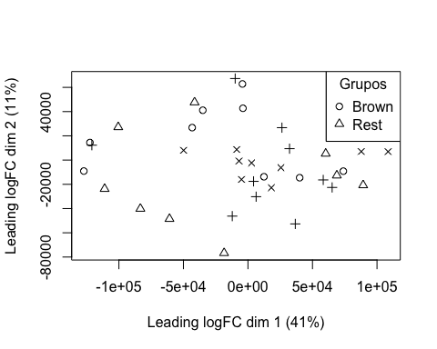

boxplot(targets$E, col = "royalblue", names = str_trunc(targets$targets$FileName, width = 10, side = "left"))

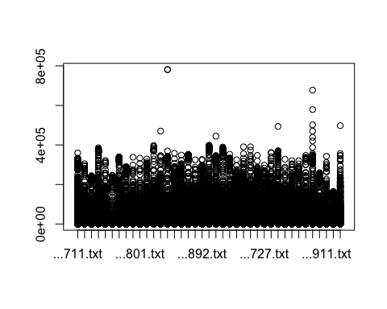

## 3. Preprocesado

### 3.1 Background

BK <- backgroundCorrect(targets, method ="normexp", printer=targets$printer, verbose=TRUE)

## Array 1 corrected  
## Array 2 corrected  
## Array 3 corrected  
## Array 4 corrected  
## Array 5 corrected  
## Array 6 corrected  
## Array 7 corrected  
## Array 8 corrected  
## Array 9 corrected  
## Array 10 corrected  
## Array 11 corrected  
## Array 12 corrected  
## Array 13 corrected  
## Array 14 corrected  
## Array 15 corrected  
## Array 16 corrected  
## Array 17 corrected  
## Array 18 corrected  
## Array 19 corrected  
## Array 20 corrected  
## Array 21 corrected  
## Array 22 corrected  
## Array 23 corrected  
## Array 24 corrected  
## Array 25 corrected  
## Array 26 corrected  
## Array 27 corrected  
## Array 28 corrected  
## Array 29 corrected  
## Array 30 corrected  
## Array 31 corrected  
## Array 32 corrected  
## Array 33 corrected  
## Array 34 corrected  
## Array 35 corrected  
## Array 36 corrected  
## Array 37 corrected  
## Array 38 corrected  
## Array 39 corrected

### 3.2 Normalización

MA.p<-normalizeBetweenArrays(BK, method = 'quantile')  
transposed <- t(MA.p$E)  
df<-data.frame(value = transposed, group = as.character(Grupo))  
plotDensities(MA.p, legend = FALSE, type="1")

## Warning: In density.default(E[, a], n = npoint, na.rm = TRUE, ...) :  
## extra argument 'type' will be disregarded  
  
## Warning: In density.default(E[, a], n = npoint, na.rm = TRUE, ...) :  
## extra argument 'type' will be disregarded  
  
## Warning: In density.default(E[, a], n = npoint, na.rm = TRUE, ...) :  
## extra argument 'type' will be disregarded  
  
## Warning: In density.default(E[, a], n = npoint, na.rm = TRUE, ...) :  
## extra argument 'type' will be disregarded  
  
## Warning: In density.default(E[, a], n = npoint, na.rm = TRUE, ...) :  
## extra argument 'type' will be disregarded  
  
## Warning: In density.default(E[, a], n = npoint, na.rm = TRUE, ...) :  
## extra argument 'type' will be disregarded  
  
## Warning: In density.default(E[, a], n = npoint, na.rm = TRUE, ...) :  
## extra argument 'type' will be disregarded  
  
## Warning: In density.default(E[, a], n = npoint, na.rm = TRUE, ...) :  
## extra argument 'type' will be disregarded  
  
## Warning: In density.default(E[, a], n = npoint, na.rm = TRUE, ...) :  
## extra argument 'type' will be disregarded  
  
## Warning: In density.default(E[, a], n = npoint, na.rm = TRUE, ...) :  
## extra argument 'type' will be disregarded  
  
## Warning: In density.default(E[, a], n = npoint, na.rm = TRUE, ...) :  
## extra argument 'type' will be disregarded  
  
## Warning: In density.default(E[, a], n = npoint, na.rm = TRUE, ...) :  
## extra argument 'type' will be disregarded  
  
## Warning: In density.default(E[, a], n = npoint, na.rm = TRUE, ...) :  
## extra argument 'type' will be disregarded  
  
## Warning: In density.default(E[, a], n = npoint, na.rm = TRUE, ...) :  
## extra argument 'type' will be disregarded  
  
## Warning: In density.default(E[, a], n = npoint, na.rm = TRUE, ...) :  
## extra argument 'type' will be disregarded  
  
## Warning: In density.default(E[, a], n = npoint, na.rm = TRUE, ...) :  
## extra argument 'type' will be disregarded  
  
## Warning: In density.default(E[, a], n = npoint, na.rm = TRUE, ...) :  
## extra argument 'type' will be disregarded  
  
## Warning: In density.default(E[, a], n = npoint, na.rm = TRUE, ...) :  
## extra argument 'type' will be disregarded  
  
## Warning: In density.default(E[, a], n = npoint, na.rm = TRUE, ...) :  
## extra argument 'type' will be disregarded  
  
## Warning: In density.default(E[, a], n = npoint, na.rm = TRUE, ...) :  
## extra argument 'type' will be disregarded  
  
## Warning: In density.default(E[, a], n = npoint, na.rm = TRUE, ...) :  
## extra argument 'type' will be disregarded  
  
## Warning: In density.default(E[, a], n = npoint, na.rm = TRUE, ...) :  
## extra argument 'type' will be disregarded  
  
## Warning: In density.default(E[, a], n = npoint, na.rm = TRUE, ...) :  
## extra argument 'type' will be disregarded  
  
## Warning: In density.default(E[, a], n = npoint, na.rm = TRUE, ...) :  
## extra argument 'type' will be disregarded  
  
## Warning: In density.default(E[, a], n = npoint, na.rm = TRUE, ...) :  
## extra argument 'type' will be disregarded  
  
## Warning: In density.default(E[, a], n = npoint, na.rm = TRUE, ...) :  
## extra argument 'type' will be disregarded  
  
## Warning: In density.default(E[, a], n = npoint, na.rm = TRUE, ...) :  
## extra argument 'type' will be disregarded  
  
## Warning: In density.default(E[, a], n = npoint, na.rm = TRUE, ...) :  
## extra argument 'type' will be disregarded  
  
## Warning: In density.default(E[, a], n = npoint, na.rm = TRUE, ...) :  
## extra argument 'type' will be disregarded  
  
## Warning: In density.default(E[, a], n = npoint, na.rm = TRUE, ...) :  
## extra argument 'type' will be disregarded  
  
## Warning: In density.default(E[, a], n = npoint, na.rm = TRUE, ...) :  
## extra argument 'type' will be disregarded  
  
## Warning: In density.default(E[, a], n = npoint, na.rm = TRUE, ...) :  
## extra argument 'type' will be disregarded  
  
## Warning: In density.default(E[, a], n = npoint, na.rm = TRUE, ...) :  
## extra argument 'type' will be disregarded  
  
## Warning: In density.default(E[, a], n = npoint, na.rm = TRUE, ...) :  
## extra argument 'type' will be disregarded  
  
## Warning: In density.default(E[, a], n = npoint, na.rm = TRUE, ...) :  
## extra argument 'type' will be disregarded  
  
## Warning: In density.default(E[, a], n = npoint, na.rm = TRUE, ...) :  
## extra argument 'type' will be disregarded  
  
## Warning: In density.default(E[, a], n = npoint, na.rm = TRUE, ...) :  
## extra argument 'type' will be disregarded  
  
## Warning: In density.default(E[, a], n = npoint, na.rm = TRUE, ...) :  
## extra argument 'type' will be disregarded  
  
## Warning: In density.default(E[, a], n = npoint, na.rm = TRUE, ...) :  
## extra argument 'type' will be disregarded

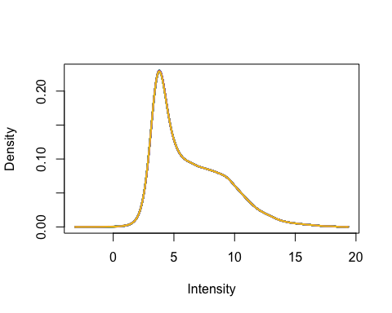

### 3.3 Anotación

MA.p$genes$EntrezID<- mapIds(HsAgilentDesign026652.db, MA.p$genes$ProbeName, keytype = "PROBEID", column = "ENTREZID")

## 'select()' returned 1:1 mapping between keys and columns

MA.p$genes$Symbol <- mapIds(HsAgilentDesign026652.db, MA.p$genes$ProbeName, keytype = "PROBEID", column = "SYMBOL")

## 'select()' returned 1:1 mapping between keys and columns

map=getGEO("GPL20844")

### 3.3 Filtrado

control_1 =MA.p$genes$ControlType == 1  
control_b= MA.p$genes$ControlType == -1

NoSym = is.na(MA.p$genes$Symbol)  
NoEnID= is.na(MA.p$genes$EntrezID)  
table(NoEnID)

## NoEnID  
## FALSE TRUE   
## 36037 26939

yfilt = MA.p[!control_1& !control_b & !NoSym & !NoEnID,]

boxplot(yfilt$E, col = "royalblue", names = str_trunc(targets$targets$FileName, width = 10, side = "left"))

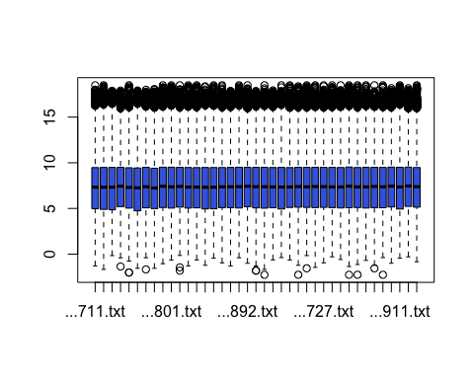

pcomp=prcomp(yfilt$E, scale. = TRUE)  
eso=summary(pcomp)  
eso

## Importance of components:  
## PC1 PC2 PC3 PC4 PC5 PC6 PC7  
## Standard deviation 5.9883 0.8653 0.53394 0.46688 0.43883 0.42001 0.34450  
## Proportion of Variance 0.9195 0.0192 0.00731 0.00559 0.00494 0.00452 0.00304  
## Cumulative Proportion 0.9195 0.9387 0.94599 0.95158 0.95652 0.96104 0.96409  
## PC8 PC9 PC10 PC11 PC12 PC13 PC14  
## Standard deviation 0.3119 0.30343 0.29611 0.27969 0.27484 0.27261 0.2578  
## Proportion of Variance 0.0025 0.00236 0.00225 0.00201 0.00194 0.00191 0.0017  
## Cumulative Proportion 0.9666 0.96894 0.97119 0.97320 0.97513 0.97704 0.9787  
## PC15 PC16 PC17 PC18 PC19 PC20 PC21  
## Standard deviation 0.24694 0.24071 0.2334 0.22342 0.21276 0.20853 0.20470  
## Proportion of Variance 0.00156 0.00149 0.0014 0.00128 0.00116 0.00111 0.00107  
## Cumulative Proportion 0.98031 0.98179 0.9832 0.98447 0.98563 0.98674 0.98782  
## PC22 PC23 PC24 PC25 PC26 PC27 PC28  
## Standard deviation 0.20002 0.19583 0.18451 0.18241 0.17720 0.17556 0.17334  
## Proportion of Variance 0.00103 0.00098 0.00087 0.00085 0.00081 0.00079 0.00077  
## Cumulative Proportion 0.98884 0.98983 0.99070 0.99155 0.99236 0.99315 0.99392  
## PC29 PC30 PC31 PC32 PC33 PC34 PC35  
## Standard deviation 0.16962 0.16195 0.15903 0.15560 0.15007 0.14640 0.1402  
## Proportion of Variance 0.00074 0.00067 0.00065 0.00062 0.00058 0.00055 0.0005  
## Cumulative Proportion 0.99466 0.99533 0.99598 0.99660 0.99718 0.99773 0.9982  
## PC36 PC37 PC38 PC39  
## Standard deviation 0.13771 0.13191 0.13073 0.1249  
## Proportion of Variance 0.00049 0.00045 0.00044 0.0004  
## Cumulative Proportion 0.99872 0.99916 0.99960 1.0000

com=as.data.frame(pcomp$x)  
ggplot(com, aes(PC1, PC2)) + geom_point()+theme_bw(base_size=32)+xlab(paste("PC1:",eso$importance[2,1])) + ylab(paste("PC2:",eso$importance[2,2]))+theme(legend.position="top")

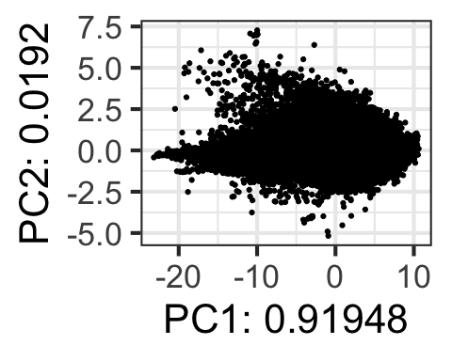

## 4. Expresión Diferencial

### 4.1 Modelización i Regresión

design <- model.matrix(~0+Grupo)  
colnames(design) = c(params$Brown, params$Rest)  
design

## Brown Rest  
## 1 1 0  
## 2 1 0  
## 3 1 0  
## 4 1 0  
## 5 1 0  
## 6 1 0  
## 7 1 0  
## 8 1 0  
## 9 1 0  
## 10 1 0  
## 11 1 0  
## 12 1 0  
## 13 1 0  
## 14 1 0  
## 15 1 0  
## 16 1 0  
## 17 1 0  
## 18 1 0  
## 19 1 0  
## 20 1 0  
## 21 1 0  
## 22 1 0  
## 23 1 0  
## 24 1 0  
## 25 1 0  
## 26 1 0  
## 27 1 0  
## 28 0 1  
## 29 0 1  
## 30 0 1  
## 31 0 1  
## 32 0 1  
## 33 0 1  
## 34 0 1  
## 35 0 1  
## 36 0 1  
## 37 0 1  
## 38 0 1  
## 39 0 1  
## attr(,"assign")  
## [1] 1 1  
## attr(,"contrasts")  
## attr(,"contrasts")$Grupo  
## [1] "contr.treatment"

fit = lmFit(yfilt, design)

parametre1 = params$Brown  
parametre2 = params$Rest  
  
contraste = makeContrasts(Brown-Rest, levels = design)  
fit2 = contrasts.fit(fit, contraste)  
fit2 = eBayes(fit2)

### 4.2 Resultados

topTable(fit2, adjust.method = "bonferroni", n=30)

## Row Col ControlType ProbeName SystematicName EntrezID Symbol  
## 40173 245 157 0 A_24_P410408 NM_002282 3889 KRT83  
## 49567 303 39 0 A_23_P92552 NM_004564 5188 GATB  
## 19788 121 108 0 A_33_P3295518 NM_203405 388818 KRTAP26-1  
## 37835 231 115 0 A_23_P38584 NM_181537 342574 KRT27  
## 48734 298 26 0 A_33_P3348348 NM_001080526 646480 FABP9  
## 50534 309 22 0 A_23_P66858 NM_031964 83902 KRTAP17-1  
## 32539 199 67 0 A_33_P3315284 NM_175053 121391 KRT74  
## 58925 360 49 0 A_33_P3223318 NM_175857 337879 KRTAP8-1  
## 12729 78 101 0 A_23_P101671 NM_033064 85300 ATCAY  
## 17121 105 65 0 A_23_P31816 NM_005217 1668 DEFA3  
## 39431 241 71 0 A_23_P107454 NM_031958 83896 KRTAP3-1  
## 9260 57 76 0 A_33_P3235400 NM_004494 3068 HDGF  
## 5731 35 155 0 A_33_P3341906 XM_006717655 170371 TMEM273  
## 18081 111 41 0 A_33_P3307457 NM_031963 83901 KRTAP9-8  
## 4328 27 64 0 A_33_P3254579 NM_031957 83895 KRTAP1-5  
## 27392 168 4 0 A_32_P481377 NM_175858 337880 KRTAP11-1  
## 12771 78 143 0 A_23_P10936 NM_033060 85285 KRTAP4-1  
## 61610 376 110 0 A_23_P118842 NM_031957 83895 KRTAP1-5  
## 53907 329 115 0 A_23_P107454 NM_031958 83896 KRTAP3-1  
## 41167 252 3 0 A_32_P489662 NM_181535 162605 KRT28  
## 21574 132 90 0 A_23_P58396 NM_016205 56034 PDGFC  
## 55186 337 82 0 A_23_P99044 NM_033448 112802 KRT71  
## 19063 117 39 0 A_23_P15786 NM_181534 147183 KRT25  
## 58908 360 32 0 A_23_P65307 NM_032229 84189 SLITRK6  
## 21376 131 56 0 A_23_P107454 NM_031958 83896 KRTAP3-1  
## 9721 60 45 0 A_33_P3334877 NM_198687 386672 KRTAP10-4  
## 22638 139 6 0 A_23_P9255 NM_003177 6850 SYK  
## 30509 187 5 0 A_23_P10936 NM_033060 85285 KRTAP4-1  
## 38757 237 53 0 A_33_P3293888 NM_002025 2334 AFF2  
## 22728 139 96 0 A_23_P10936 NM_033060 85285 KRTAP4-1  
## logFC AveExpr t P.Value adj.P.Val B  
## 40173 -1.8117835 4.128221 -3.852265 0.0004019463 1 -3.650437  
## 49567 -0.6384251 8.970766 -3.805467 0.0004622966 1 -3.669575  
## 19788 -2.2785273 4.635883 -3.640352 0.0007533102 1 -3.737007  
## 37835 -2.8581290 6.387135 -3.563050 0.0009439564 1 -3.768488  
## 48734 -2.1574616 4.357539 -3.559543 0.0009536214 1 -3.769914  
## 50534 -2.6975825 4.438267 -3.466070 0.0012491821 1 -3.807859  
## 32539 -2.2983305 6.375797 -3.428244 0.0013921762 1 -3.823169  
## 58925 -1.5055800 3.559708 -3.415550 0.0014435727 1 -3.828300  
## 12729 0.7575229 2.822758 3.397137 0.0015213619 1 -3.835737  
## 17121 1.4654619 4.686833 3.336070 0.0018089882 1 -3.860346  
## 39431 -2.5780901 5.356431 -3.274404 0.0021515572 1 -3.885099  
## 9260 0.8519598 9.779852 3.257843 0.0022535690 1 -3.891728  
## 5731 0.6050149 3.419184 3.255905 0.0022658013 1 -3.892503  
## 18081 -2.4403892 4.713573 -3.238301 0.0023798537 1 -3.899541  
## 4328 -2.1312541 4.754793 -3.234286 0.0024066174 1 -3.901144  
## 27392 -1.9598006 5.665983 -3.233061 0.0024148381 1 -3.901633  
## 12771 -2.1973716 3.712892 -3.220883 0.0024980391 1 -3.906494  
## 61610 -2.5091076 5.278518 -3.209862 0.0025756772 1 -3.910889  
## 53907 -2.3122677 5.708152 -3.208135 0.0025880487 1 -3.911577  
## 41167 -1.0036076 4.323797 -3.207249 0.0025944101 1 -3.911930  
## 21574 -0.6779511 8.620548 -3.200827 0.0026410220 1 -3.914489  
## 55186 -2.2040224 6.073357 -3.189016 0.0027288150 1 -3.919190  
## 19063 -2.6840541 5.959460 -3.159207 0.0029628332 1 -3.931036  
## 58908 -1.5347457 7.113376 -3.156239 0.0029871418 1 -3.932214  
## 21376 -2.4317347 5.417336 -3.154807 0.0029989433 1 -3.932782  
## 9721 -1.5688137 4.407420 -3.149132 0.0030461338 1 -3.935033  
## 22638 -0.6242499 8.973961 -3.143866 0.0030905418 1 -3.937120  
## 30509 -2.0923018 3.949866 -3.131101 0.0032007663 1 -3.942177  
## 38757 0.6934039 4.121635 3.126159 0.0032444204 1 -3.944133  
## 22728 -2.2145697 4.025590 -3.124615 0.0032581792 1 -3.944744

tT=topTable(fit2, adjust.method = "bonferroni", n=3000)  
  
results = decideTests(fit2, p.value = 0.1)  
summary(decideTests(fit2), p.value = 0.1)

## Brown - Rest  
## Down 0  
## NotSig 36037  
## Up 0

EnhancedVolcano(tT, lab = tT$Symbol, x = "logFC", y = "adj.P.Val", pCutoff = 0.05, FCcutoff=2, labSize = 6.0, ylim=0.95)

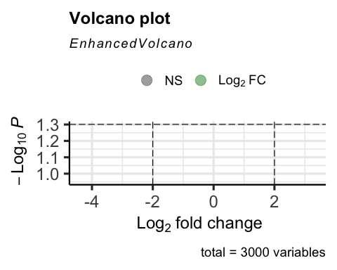

vennDiagram(results, include=c("both"), circle.col = "red", counts.col = "blue", names = c("CHD9-CTL"))

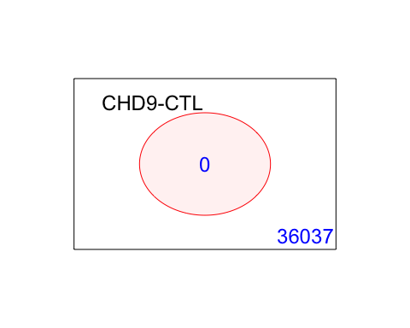

## 5. Gene Enrichment Analysis

### Gene Ontology

g = goana(fit2, species="Hs", geneid = fit2$genes$EntrezID, FDR = 0.05)

## No DE genes

topGO(g, n=20)

## data frame with 0 columns and 0 rows

### KEGG

k = kegga(fit2, species="Hs", geneid = fit2$genes$EntrezID, FDR = 0.05)

## No DE genes

topKEGG(k, number = 20)

## data frame with 0 columns and 0 rows