Análisis por sexo con datos recodificados

Estefanía Gómez Guil

2023-06-02

Table of Contents

## 1. Importación de los datos

params <- list(  
 hombre="H",  
 mujer="M",  
 directorio= "/Users/estefaniagomezguil/Desktop/Sexo Recod"  
)  
ruta_hombre<- file.path(params$directorio, "H")  
ruta_mujer<- file.path(params$directorio, "M")  
  
files_hombre <- list.files(path = ruta_hombre, pattern = ".txt", full.names = TRUE)  
files_mujer <- list.files(path = ruta_mujer, pattern = ".txt", full.names = TRUE)  
Grupo <- c (rep(params$hombre, length(files_hombre)), rep(params$mujer, length(files_mujer)))  
files <- c(files_hombre, files_mujer)  
print(files)

## [1] "/Users/estefaniagomezguil/Desktop/Sexo Recod/H/2701.txt"  
## [2] "/Users/estefaniagomezguil/Desktop/Sexo Recod/H/2708.txt"  
## [3] "/Users/estefaniagomezguil/Desktop/Sexo Recod/H/2710.txt"  
## [4] "/Users/estefaniagomezguil/Desktop/Sexo Recod/H/2711.txt"  
## [5] "/Users/estefaniagomezguil/Desktop/Sexo Recod/H/2712.txt"  
## [6] "/Users/estefaniagomezguil/Desktop/Sexo Recod/H/2724.txt"  
## [7] "/Users/estefaniagomezguil/Desktop/Sexo Recod/H/2727.txt"  
## [8] "/Users/estefaniagomezguil/Desktop/Sexo Recod/H/2736.txt"  
## [9] "/Users/estefaniagomezguil/Desktop/Sexo Recod/H/2749.txt"  
## [10] "/Users/estefaniagomezguil/Desktop/Sexo Recod/H/2750.txt"  
## [11] "/Users/estefaniagomezguil/Desktop/Sexo Recod/H/2769.txt"  
## [12] "/Users/estefaniagomezguil/Desktop/Sexo Recod/H/2777.txt"  
## [13] "/Users/estefaniagomezguil/Desktop/Sexo Recod/H/2790.txt"  
## [14] "/Users/estefaniagomezguil/Desktop/Sexo Recod/H/2799.txt"  
## [15] "/Users/estefaniagomezguil/Desktop/Sexo Recod/H/2801.txt"  
## [16] "/Users/estefaniagomezguil/Desktop/Sexo Recod/H/2810.txt"  
## [17] "/Users/estefaniagomezguil/Desktop/Sexo Recod/H/2824.txt"  
## [18] "/Users/estefaniagomezguil/Desktop/Sexo Recod/H/2858.txt"  
## [19] "/Users/estefaniagomezguil/Desktop/Sexo Recod/H/2871.txt"  
## [20] "/Users/estefaniagomezguil/Desktop/Sexo Recod/H/2881.txt"  
## [21] "/Users/estefaniagomezguil/Desktop/Sexo Recod/H/2890.txt"  
## [22] "/Users/estefaniagomezguil/Desktop/Sexo Recod/H/2893.txt"  
## [23] "/Users/estefaniagomezguil/Desktop/Sexo Recod/H/2894.txt"  
## [24] "/Users/estefaniagomezguil/Desktop/Sexo Recod/H/2895.txt"  
## [25] "/Users/estefaniagomezguil/Desktop/Sexo Recod/H/2898.txt"  
## [26] "/Users/estefaniagomezguil/Desktop/Sexo Recod/H/2899.txt"  
## [27] "/Users/estefaniagomezguil/Desktop/Sexo Recod/H/2907.txt"  
## [28] "/Users/estefaniagomezguil/Desktop/Sexo Recod/H/2911.txt"  
## [29] "/Users/estefaniagomezguil/Desktop/Sexo Recod/H/2915.txt"  
## [30] "/Users/estefaniagomezguil/Desktop/Sexo Recod/H/2929.txt"  
## [31] "/Users/estefaniagomezguil/Desktop/Sexo Recod/H/2934.txt"  
## [32] "/Users/estefaniagomezguil/Desktop/Sexo Recod/H/2939.txt"  
## [33] "/Users/estefaniagomezguil/Desktop/Sexo Recod/M/2729.txt"  
## [34] "/Users/estefaniagomezguil/Desktop/Sexo Recod/M/2730.txt"  
## [35] "/Users/estefaniagomezguil/Desktop/Sexo Recod/M/2740.txt"  
## [36] "/Users/estefaniagomezguil/Desktop/Sexo Recod/M/2748.txt"  
## [37] "/Users/estefaniagomezguil/Desktop/Sexo Recod/M/2807.txt"  
## [38] "/Users/estefaniagomezguil/Desktop/Sexo Recod/M/2823.txt"  
## [39] "/Users/estefaniagomezguil/Desktop/Sexo Recod/M/2880.txt"  
## [40] "/Users/estefaniagomezguil/Desktop/Sexo Recod/M/2891.txt"  
## [41] "/Users/estefaniagomezguil/Desktop/Sexo Recod/M/2892.txt"  
## [42] "/Users/estefaniagomezguil/Desktop/Sexo Recod/M/2908.txt"  
## [43] "/Users/estefaniagomezguil/Desktop/Sexo Recod/M/2912.txt"  
## [44] "/Users/estefaniagomezguil/Desktop/Sexo Recod/M/2933.txt"  
## [45] "/Users/estefaniagomezguil/Desktop/Sexo Recod/M/2948.txt"  
## [46] "/Users/estefaniagomezguil/Desktop/Sexo Recod/M/2949.txt"

targets = read.maimages(file=files, source="agilent", green.only=TRUE)

## Read /Users/estefaniagomezguil/Desktop/Sexo Recod/H/2701.txt   
## Read /Users/estefaniagomezguil/Desktop/Sexo Recod/H/2708.txt   
## Read /Users/estefaniagomezguil/Desktop/Sexo Recod/H/2710.txt   
## Read /Users/estefaniagomezguil/Desktop/Sexo Recod/H/2711.txt   
## Read /Users/estefaniagomezguil/Desktop/Sexo Recod/H/2712.txt   
## Read /Users/estefaniagomezguil/Desktop/Sexo Recod/H/2724.txt   
## Read /Users/estefaniagomezguil/Desktop/Sexo Recod/H/2727.txt   
## Read /Users/estefaniagomezguil/Desktop/Sexo Recod/H/2736.txt   
## Read /Users/estefaniagomezguil/Desktop/Sexo Recod/H/2749.txt   
## Read /Users/estefaniagomezguil/Desktop/Sexo Recod/H/2750.txt   
## Read /Users/estefaniagomezguil/Desktop/Sexo Recod/H/2769.txt   
## Read /Users/estefaniagomezguil/Desktop/Sexo Recod/H/2777.txt   
## Read /Users/estefaniagomezguil/Desktop/Sexo Recod/H/2790.txt   
## Read /Users/estefaniagomezguil/Desktop/Sexo Recod/H/2799.txt   
## Read /Users/estefaniagomezguil/Desktop/Sexo Recod/H/2801.txt   
## Read /Users/estefaniagomezguil/Desktop/Sexo Recod/H/2810.txt   
## Read /Users/estefaniagomezguil/Desktop/Sexo Recod/H/2824.txt   
## Read /Users/estefaniagomezguil/Desktop/Sexo Recod/H/2858.txt   
## Read /Users/estefaniagomezguil/Desktop/Sexo Recod/H/2871.txt   
## Read /Users/estefaniagomezguil/Desktop/Sexo Recod/H/2881.txt   
## Read /Users/estefaniagomezguil/Desktop/Sexo Recod/H/2890.txt   
## Read /Users/estefaniagomezguil/Desktop/Sexo Recod/H/2893.txt   
## Read /Users/estefaniagomezguil/Desktop/Sexo Recod/H/2894.txt   
## Read /Users/estefaniagomezguil/Desktop/Sexo Recod/H/2895.txt   
## Read /Users/estefaniagomezguil/Desktop/Sexo Recod/H/2898.txt   
## Read /Users/estefaniagomezguil/Desktop/Sexo Recod/H/2899.txt   
## Read /Users/estefaniagomezguil/Desktop/Sexo Recod/H/2907.txt   
## Read /Users/estefaniagomezguil/Desktop/Sexo Recod/H/2911.txt   
## Read /Users/estefaniagomezguil/Desktop/Sexo Recod/H/2915.txt   
## Read /Users/estefaniagomezguil/Desktop/Sexo Recod/H/2929.txt   
## Read /Users/estefaniagomezguil/Desktop/Sexo Recod/H/2934.txt   
## Read /Users/estefaniagomezguil/Desktop/Sexo Recod/H/2939.txt   
## Read /Users/estefaniagomezguil/Desktop/Sexo Recod/M/2729.txt   
## Read /Users/estefaniagomezguil/Desktop/Sexo Recod/M/2730.txt   
## Read /Users/estefaniagomezguil/Desktop/Sexo Recod/M/2740.txt   
## Read /Users/estefaniagomezguil/Desktop/Sexo Recod/M/2748.txt   
## Read /Users/estefaniagomezguil/Desktop/Sexo Recod/M/2807.txt   
## Read /Users/estefaniagomezguil/Desktop/Sexo Recod/M/2823.txt   
## Read /Users/estefaniagomezguil/Desktop/Sexo Recod/M/2880.txt   
## Read /Users/estefaniagomezguil/Desktop/Sexo Recod/M/2891.txt   
## Read /Users/estefaniagomezguil/Desktop/Sexo Recod/M/2892.txt   
## Read /Users/estefaniagomezguil/Desktop/Sexo Recod/M/2908.txt   
## Read /Users/estefaniagomezguil/Desktop/Sexo Recod/M/2912.txt   
## Read /Users/estefaniagomezguil/Desktop/Sexo Recod/M/2933.txt   
## Read /Users/estefaniagomezguil/Desktop/Sexo Recod/M/2948.txt   
## Read /Users/estefaniagomezguil/Desktop/Sexo Recod/M/2949.txt

targets$targets$class <- Grupo  
files2<- str_remove_all(string=files, pattern= "US85003608_253949442215")  
files2<- str_remove_all(string=files2, patter= "_S01_GE1_107_Sep09")

## 2. Control de calidad

limma::plotMA3by2(targets, status = targets$genes$ControlType, prefix = "MA", device = "pdf")  
# Obtener los grupos únicos y sus correspondientes colores  
grupos_unicos <- unique(Grupo)  
  
colores <- 1:4  
Grupo2<-colores  
plotMDS(targets, top = 100, gene.selection = "pairwise", pch=colores, type="p", plot = TRUE)  
  
# Agregar la leyenda  
legend("topright", legend = grupos_unicos, pch = colores, title = "Grupos")  
legend("topright", legend = grupos_unicos, pch = colores, title = "Grupos")

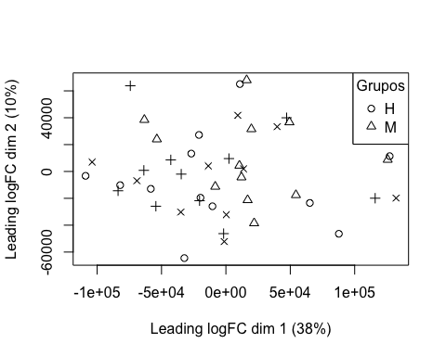

boxplot(targets$E, col = "royalblue", names = str_trunc(targets$targets$FileName, width = 10, side = "left"))

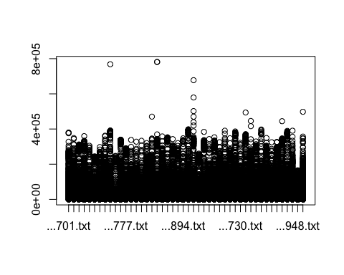

## 3. Preprocesado

### 3.1 Background

BK <- backgroundCorrect(targets, method ="normexp", printer=targets$printer, verbose=TRUE)

## Array 1 corrected  
## Array 2 corrected  
## Array 3 corrected  
## Array 4 corrected  
## Array 5 corrected  
## Array 6 corrected  
## Array 7 corrected  
## Array 8 corrected  
## Array 9 corrected  
## Array 10 corrected  
## Array 11 corrected  
## Array 12 corrected  
## Array 13 corrected  
## Array 14 corrected  
## Array 15 corrected  
## Array 16 corrected  
## Array 17 corrected  
## Array 18 corrected  
## Array 19 corrected  
## Array 20 corrected  
## Array 21 corrected  
## Array 22 corrected  
## Array 23 corrected  
## Array 24 corrected  
## Array 25 corrected  
## Array 26 corrected  
## Array 27 corrected  
## Array 28 corrected  
## Array 29 corrected  
## Array 30 corrected  
## Array 31 corrected  
## Array 32 corrected  
## Array 33 corrected  
## Array 34 corrected  
## Array 35 corrected  
## Array 36 corrected  
## Array 37 corrected  
## Array 38 corrected  
## Array 39 corrected  
## Array 40 corrected  
## Array 41 corrected  
## Array 42 corrected  
## Array 43 corrected  
## Array 44 corrected  
## Array 45 corrected  
## Array 46 corrected

### 3.2 Normalización

MA.p<-normalizeBetweenArrays(BK, method = 'quantile')  
transposed <- t(MA.p$E)  
df<-data.frame(value = transposed, group = as.character(Grupo))  
plotDensities(MA.p, legend = FALSE, type="1")

## Warning: In density.default(E[, a], n = npoint, na.rm = TRUE, ...) :  
## extra argument 'type' will be disregarded  
  
## Warning: In density.default(E[, a], n = npoint, na.rm = TRUE, ...) :  
## extra argument 'type' will be disregarded  
  
## Warning: In density.default(E[, a], n = npoint, na.rm = TRUE, ...) :  
## extra argument 'type' will be disregarded  
  
## Warning: In density.default(E[, a], n = npoint, na.rm = TRUE, ...) :  
## extra argument 'type' will be disregarded  
  
## Warning: In density.default(E[, a], n = npoint, na.rm = TRUE, ...) :  
## extra argument 'type' will be disregarded  
  
## Warning: In density.default(E[, a], n = npoint, na.rm = TRUE, ...) :  
## extra argument 'type' will be disregarded  
  
## Warning: In density.default(E[, a], n = npoint, na.rm = TRUE, ...) :  
## extra argument 'type' will be disregarded  
  
## Warning: In density.default(E[, a], n = npoint, na.rm = TRUE, ...) :  
## extra argument 'type' will be disregarded  
  
## Warning: In density.default(E[, a], n = npoint, na.rm = TRUE, ...) :  
## extra argument 'type' will be disregarded  
  
## Warning: In density.default(E[, a], n = npoint, na.rm = TRUE, ...) :  
## extra argument 'type' will be disregarded  
  
## Warning: In density.default(E[, a], n = npoint, na.rm = TRUE, ...) :  
## extra argument 'type' will be disregarded  
  
## Warning: In density.default(E[, a], n = npoint, na.rm = TRUE, ...) :  
## extra argument 'type' will be disregarded  
  
## Warning: In density.default(E[, a], n = npoint, na.rm = TRUE, ...) :  
## extra argument 'type' will be disregarded  
  
## Warning: In density.default(E[, a], n = npoint, na.rm = TRUE, ...) :  
## extra argument 'type' will be disregarded  
  
## Warning: In density.default(E[, a], n = npoint, na.rm = TRUE, ...) :  
## extra argument 'type' will be disregarded  
  
## Warning: In density.default(E[, a], n = npoint, na.rm = TRUE, ...) :  
## extra argument 'type' will be disregarded  
  
## Warning: In density.default(E[, a], n = npoint, na.rm = TRUE, ...) :  
## extra argument 'type' will be disregarded  
  
## Warning: In density.default(E[, a], n = npoint, na.rm = TRUE, ...) :  
## extra argument 'type' will be disregarded  
  
## Warning: In density.default(E[, a], n = npoint, na.rm = TRUE, ...) :  
## extra argument 'type' will be disregarded  
  
## Warning: In density.default(E[, a], n = npoint, na.rm = TRUE, ...) :  
## extra argument 'type' will be disregarded  
  
## Warning: In density.default(E[, a], n = npoint, na.rm = TRUE, ...) :  
## extra argument 'type' will be disregarded  
  
## Warning: In density.default(E[, a], n = npoint, na.rm = TRUE, ...) :  
## extra argument 'type' will be disregarded  
  
## Warning: In density.default(E[, a], n = npoint, na.rm = TRUE, ...) :  
## extra argument 'type' will be disregarded  
  
## Warning: In density.default(E[, a], n = npoint, na.rm = TRUE, ...) :  
## extra argument 'type' will be disregarded  
  
## Warning: In density.default(E[, a], n = npoint, na.rm = TRUE, ...) :  
## extra argument 'type' will be disregarded  
  
## Warning: In density.default(E[, a], n = npoint, na.rm = TRUE, ...) :  
## extra argument 'type' will be disregarded  
  
## Warning: In density.default(E[, a], n = npoint, na.rm = TRUE, ...) :  
## extra argument 'type' will be disregarded  
  
## Warning: In density.default(E[, a], n = npoint, na.rm = TRUE, ...) :  
## extra argument 'type' will be disregarded  
  
## Warning: In density.default(E[, a], n = npoint, na.rm = TRUE, ...) :  
## extra argument 'type' will be disregarded  
  
## Warning: In density.default(E[, a], n = npoint, na.rm = TRUE, ...) :  
## extra argument 'type' will be disregarded  
  
## Warning: In density.default(E[, a], n = npoint, na.rm = TRUE, ...) :  
## extra argument 'type' will be disregarded  
  
## Warning: In density.default(E[, a], n = npoint, na.rm = TRUE, ...) :  
## extra argument 'type' will be disregarded  
  
## Warning: In density.default(E[, a], n = npoint, na.rm = TRUE, ...) :  
## extra argument 'type' will be disregarded  
  
## Warning: In density.default(E[, a], n = npoint, na.rm = TRUE, ...) :  
## extra argument 'type' will be disregarded  
  
## Warning: In density.default(E[, a], n = npoint, na.rm = TRUE, ...) :  
## extra argument 'type' will be disregarded  
  
## Warning: In density.default(E[, a], n = npoint, na.rm = TRUE, ...) :  
## extra argument 'type' will be disregarded  
  
## Warning: In density.default(E[, a], n = npoint, na.rm = TRUE, ...) :  
## extra argument 'type' will be disregarded  
  
## Warning: In density.default(E[, a], n = npoint, na.rm = TRUE, ...) :  
## extra argument 'type' will be disregarded  
  
## Warning: In density.default(E[, a], n = npoint, na.rm = TRUE, ...) :  
## extra argument 'type' will be disregarded  
  
## Warning: In density.default(E[, a], n = npoint, na.rm = TRUE, ...) :  
## extra argument 'type' will be disregarded  
  
## Warning: In density.default(E[, a], n = npoint, na.rm = TRUE, ...) :  
## extra argument 'type' will be disregarded  
  
## Warning: In density.default(E[, a], n = npoint, na.rm = TRUE, ...) :  
## extra argument 'type' will be disregarded  
  
## Warning: In density.default(E[, a], n = npoint, na.rm = TRUE, ...) :  
## extra argument 'type' will be disregarded  
  
## Warning: In density.default(E[, a], n = npoint, na.rm = TRUE, ...) :  
## extra argument 'type' will be disregarded  
  
## Warning: In density.default(E[, a], n = npoint, na.rm = TRUE, ...) :  
## extra argument 'type' will be disregarded  
  
## Warning: In density.default(E[, a], n = npoint, na.rm = TRUE, ...) :  
## extra argument 'type' will be disregarded

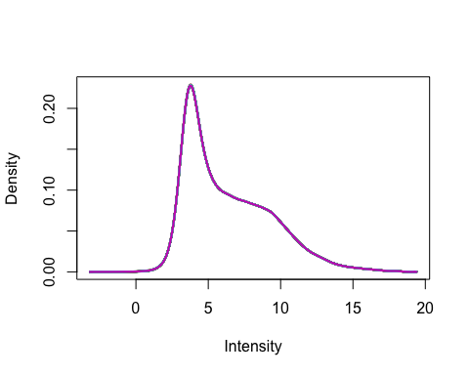

### 3.3 Anotación

MA.p$genes$EntrezID<- mapIds(HsAgilentDesign026652.db, MA.p$genes$ProbeName, keytype = "PROBEID", column = "ENTREZID")

## 'select()' returned 1:1 mapping between keys and columns

MA.p$genes$Symbol <- mapIds(HsAgilentDesign026652.db, MA.p$genes$ProbeName, keytype = "PROBEID", column = "SYMBOL")

## 'select()' returned 1:1 mapping between keys and columns

map=getGEO("GPL20844")

### 3.3 Filtrado

control_1 =MA.p$genes$ControlType == 1  
control_b= MA.p$genes$ControlType == -1

NoSym = is.na(MA.p$genes$Symbol)  
NoEnID= is.na(MA.p$genes$EntrezID)  
table(NoEnID)

## NoEnID  
## FALSE TRUE   
## 36037 26939

yfilt = MA.p[!control_1& !control_b & !NoSym & !NoEnID,]

boxplot(yfilt$E, col = "royalblue", names = str_trunc(targets$targets$FileName, width = 10, side = "left"))

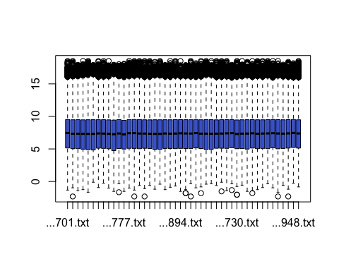

pcomp=prcomp(yfilt$E, scale. = TRUE)  
eso=summary(pcomp)  
eso

## Importance of components:  
## PC1 PC2 PC3 PC4 PC5 PC6 PC7  
## Standard deviation 6.5071 0.92585 0.54649 0.47827 0.47377 0.45669 0.35493  
## Proportion of Variance 0.9205 0.01863 0.00649 0.00497 0.00488 0.00453 0.00274  
## Cumulative Proportion 0.9205 0.93911 0.94561 0.95058 0.95546 0.95999 0.96273  
## PC8 PC9 PC10 PC11 PC12 PC13 PC14  
## Standard deviation 0.32985 0.32571 0.31129 0.29972 0.29730 0.28217 0.26379  
## Proportion of Variance 0.00237 0.00231 0.00211 0.00195 0.00192 0.00173 0.00151  
## Cumulative Proportion 0.96510 0.96740 0.96951 0.97146 0.97338 0.97511 0.97663  
## PC15 PC16 PC17 PC18 PC19 PC20 PC21  
## Standard deviation 0.26047 0.24819 0.24130 0.23602 0.2252 0.22088 0.21376  
## Proportion of Variance 0.00147 0.00134 0.00127 0.00121 0.0011 0.00106 0.00099  
## Cumulative Proportion 0.97810 0.97944 0.98071 0.98192 0.9830 0.98408 0.98507  
## PC22 PC23 PC24 PC25 PC26 PC27 PC28  
## Standard deviation 0.21149 0.20993 0.20580 0.19896 0.18778 0.18575 0.18195  
## Proportion of Variance 0.00097 0.00096 0.00092 0.00086 0.00077 0.00075 0.00072  
## Cumulative Proportion 0.98605 0.98700 0.98793 0.98879 0.98955 0.99030 0.99102  
## PC29 PC30 PC31 PC32 PC33 PC34 PC35  
## Standard deviation 0.17873 0.17700 0.17399 0.16827 0.16482 0.16282 0.15839  
## Proportion of Variance 0.00069 0.00068 0.00066 0.00062 0.00059 0.00058 0.00055  
## Cumulative Proportion 0.99172 0.99240 0.99306 0.99367 0.99426 0.99484 0.99538  
## PC36 PC37 PC38 PC39 PC40 PC41 PC42  
## Standard deviation 0.15660 0.15277 0.14789 0.14622 0.13827 0.13764 0.1361  
## Proportion of Variance 0.00053 0.00051 0.00048 0.00046 0.00042 0.00041 0.0004  
## Cumulative Proportion 0.99592 0.99642 0.99690 0.99736 0.99778 0.99819 0.9986  
## PC43 PC44 PC45 PC46  
## Standard deviation 0.13025 0.12902 0.12643 0.12266  
## Proportion of Variance 0.00037 0.00036 0.00035 0.00033  
## Cumulative Proportion 0.99896 0.99933 0.99967 1.00000

com=as.data.frame(pcomp$x)  
ggplot(com, aes(PC1, PC2)) + geom_point()+theme_bw(base_size=32)+xlab(paste("PC1:",eso$importance[2,1])) + ylab(paste("PC2:",eso$importance[2,2]))+theme(legend.position="top")

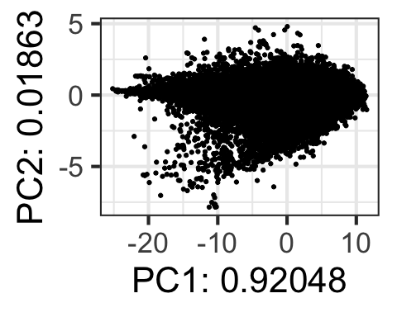

## 4. Expresión Diferencial

### 4.1 Modelización i Regresión

design <- model.matrix(~0+Grupo)  
colnames(design) = c(params$hombre, params$mujer)  
design

## H M  
## 1 1 0  
## 2 1 0  
## 3 1 0  
## 4 1 0  
## 5 1 0  
## 6 1 0  
## 7 1 0  
## 8 1 0  
## 9 1 0  
## 10 1 0  
## 11 1 0  
## 12 1 0  
## 13 1 0  
## 14 1 0  
## 15 1 0  
## 16 1 0  
## 17 1 0  
## 18 1 0  
## 19 1 0  
## 20 1 0  
## 21 1 0  
## 22 1 0  
## 23 1 0  
## 24 1 0  
## 25 1 0  
## 26 1 0  
## 27 1 0  
## 28 1 0  
## 29 1 0  
## 30 1 0  
## 31 1 0  
## 32 1 0  
## 33 0 1  
## 34 0 1  
## 35 0 1  
## 36 0 1  
## 37 0 1  
## 38 0 1  
## 39 0 1  
## 40 0 1  
## 41 0 1  
## 42 0 1  
## 43 0 1  
## 44 0 1  
## 45 0 1  
## 46 0 1  
## attr(,"assign")  
## [1] 1 1  
## attr(,"contrasts")  
## attr(,"contrasts")$Grupo  
## [1] "contr.treatment"

fit = lmFit(yfilt, design)

parametre1 = params$hombre  
parametre2 = params$mujer  
  
contraste = makeContrasts(H-M, levels = design)  
fit2 = contrasts.fit(fit, contraste)  
fit2 = eBayes(fit2)

### 4.2 Resultados

topTable(fit2, adjust.method = "BH", n=30)

## Row Col ControlType ProbeName SystematicName EntrezID Symbol  
## 5161 32 77 0 A_23_P141665 NM_014565 8383 OR1A1  
## 26893 164 161 0 A_33_P3254082 ENST00000485981 55064 SPATA6L  
## 42718 261 78 0 A_33_P3355921 NR_034083 100130894 VAC14-AS1  
## 21805 133 157 0 A_23_P214459 NM_000322 5961 PRPH2  
## 29651 181 131 0 A_32_P174164 NR_003034 441601 SEPTIN7P11  
## 20465 125 129 0 A_23_P100189 NM_002761 5619 PRM1  
## 31836 195 20 0 A_24_P66545 NM_001145642 9711 RUBCN  
## 3746 23 138 0 A_33_P3230598 NM_001191055 100271846 ERVV-2  
## 60054 367 30 0 A_23_P202245 NM_020975 5979 RET  
## 60470 369 118 0 A_23_P125435 NM_000812 2560 GABRB1  
## 19823 121 143 0 A_33_P3296789 NM_001166422 55869 HDAC8  
## 33520 205 64 0 A_33_P3309551 NM_002839 5789 PTPRD  
## 6394 39 162 0 A_23_P326760 NM_015460 25924 MYRIP  
## 19946 122 102 0 A_33_P3839760 NM_017914 55009 FAM174C  
## 42258 258 110 0 A_24_P186944 ENST00000439124 6133 RPL9  
## 29648 181 128 0 A_23_P216361 NM_021110 7373 COL14A1  
## 58245 356 25 0 A_33_P3365228 NM_001256346 54437 SEMA5B  
## 44649 273 41 0 A_33_P3217776 NM_002723 5545 PRB4  
## 38107 233 59 0 A_23_P402765 NM_198060 4892 NRAP  
## 19618 120 102 0 A_23_P319640 NR_024606 151534 LBX2-AS1  
## 6017 37 113 0 A_23_P109821 NM_006354 10474 TADA3  
## 4460 28 32 0 A_33_P3398448 NM_032789 84875 PARP10  
## 54304 332 20 0 A_23_P256413 NM_138410 112616 CMTM7  
## 29490 180 134 0 A_23_P148556 NM_000033 215 ABCD1  
## 34161 209 49 0 A_23_P109821 NM_006354 10474 TADA3  
## 51625 315 129 0 A_23_P102286 NM_000233 3973 LHCGR  
## 40675 249 3 0 A_23_P109821 NM_006354 10474 TADA3  
## 45662 279 70 0 A_32_P80850 NM_021110 7373 COL14A1  
## 12583 77 119 0 A_23_P109821 NM_006354 10474 TADA3  
## 54734 334 122 0 A_24_P199251 NM_005447 9182 RASSF9  
## logFC AveExpr t P.Value adj.P.Val B  
## 5161 0.5490763 3.608714 4.552610 3.621517e-05 0.7072627 -3.073064  
## 26893 -0.5570543 4.439497 -4.528318 3.925203e-05 0.7072627 -3.085740  
## 42718 -0.6498408 3.788082 -4.344569 7.183914e-05 0.7279613 -3.181800  
## 21805 -0.9114620 4.830753 -4.308517 8.080154e-05 0.7279613 -3.200672  
## 29651 2.2206641 4.244295 3.939149 2.637256e-04 0.8741038 -3.393858  
## 20465 0.5078173 5.134997 3.867200 3.304100e-04 0.8741038 -3.431338  
## 31836 0.5793121 3.995334 3.865892 3.317615e-04 0.8741038 -3.432019  
## 3746 0.6173565 3.530614 3.775844 4.387783e-04 0.8741038 -3.478791  
## 60054 -0.8004595 4.528661 -3.650792 6.438113e-04 0.8741038 -3.543432  
## 60470 -0.7341425 3.894051 -3.567266 8.289905e-04 0.8741038 -3.586358  
## 19823 0.3700000 7.687435 3.548330 8.775564e-04 0.8741038 -3.596057  
## 33520 -1.1029181 5.730706 -3.528657 9.308876e-04 0.8741038 -3.606121  
## 6394 -1.2178919 5.977836 -3.488682 1.048947e-03 0.8741038 -3.626527  
## 19946 0.4326290 13.275666 3.484486 1.062137e-03 0.8741038 -3.628666  
## 42258 -0.5171624 15.221869 -3.469608 1.110190e-03 0.8741038 -3.636242  
## 29648 -1.0058713 6.689562 -3.433101 1.237033e-03 0.8741038 -3.654796  
## 58245 -0.5381511 4.402349 -3.415223 1.304078e-03 0.8741038 -3.663862  
## 44649 -0.6425041 3.944394 -3.367954 1.498386e-03 0.8741038 -3.687764  
## 38107 1.2326460 4.865108 3.361230 1.528167e-03 0.8741038 -3.691156  
## 19618 0.7294674 8.450485 3.351514 1.572194e-03 0.8741038 -3.696054  
## 6017 0.3783632 12.597803 3.339298 1.629257e-03 0.8741038 -3.702205  
## 4460 0.6178715 11.680711 3.334967 1.649958e-03 0.8741038 -3.704385  
## 54304 0.6836307 11.385303 3.326786 1.689742e-03 0.8741038 -3.708499  
## 29490 1.2042344 7.735846 3.319698 1.724942e-03 0.8741038 -3.712060  
## 34161 0.3671740 12.697914 3.315678 1.745214e-03 0.8741038 -3.714079  
## 51625 -0.6591009 3.240873 -3.313951 1.753993e-03 0.8741038 -3.714947  
## 40675 0.3558833 12.420575 3.311899 1.764477e-03 0.8741038 -3.715977  
## 45662 -0.7899921 6.969311 -3.311385 1.767113e-03 0.8741038 -3.716235  
## 12583 0.3784065 12.593125 3.308359 1.782704e-03 0.8741038 -3.717753  
## 54734 -0.8317840 4.839482 -3.294156 1.857644e-03 0.8741038 -3.724875

tT=topTable(fit2, adjust.method = "BH", n=3000)  
  
results = decideTests(fit2, p.value = 0.05)  
summary(decideTests(fit2), p.value = 0.05)

## H - M  
## Down 0  
## NotSig 36037  
## Up 0

EnhancedVolcano(tT, lab = tT$Symbol, x = "logFC", y = "adj.P.Val", pCutoff = 0.05, FCcutoff=2, labSize = 6.0, ylim=0.95)

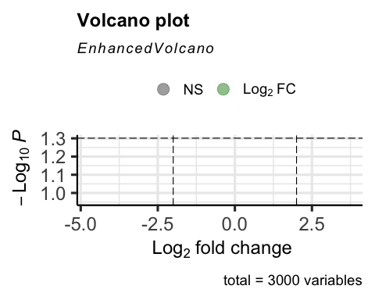

vennDiagram(results, include=c("both"), circle.col = "red", counts.col = "blue", names = c("CHD9-CTL"))

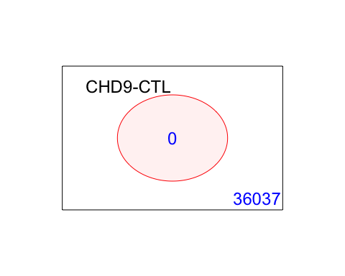

## 5. Gene Enrichment Analysis

### Gene Ontology

g = goana(fit2, species="Hs", geneid = fit2$genes$EntrezID, FDR = 0.05)

## No DE genes

topGO(g, n=20)

## data frame with 0 columns and 0 rows

### KEGG

k = kegga(fit2, species="Hs", geneid = fit2$genes$EntrezID, FDR = 0.05)

## No DE genes

topKEGG(k, number = 20)

## data frame with 0 columns and 0 rows