RecaidaRecod

Estefanía Gómez Guil

2023-06-09

Table of Contents

## 1. Importación de los datos

params <- list(  
 Rec0="Rec0",  
 Rec1= "Rec1",  
 directorio= "/Users/estefaniagomezguil/Desktop/RecaidaRecod"  
)  
Rec0<- file.path(params$directorio, "0")  
Rec1<- file.path(params$directorio, "1")  
files_rec0<- list.files(path= Rec0, pattern = ".txt", full.names=TRUE)  
files_rec1<- list.files(path= Rec1, pattern = ".txt", full.names=TRUE)  
Grupo<- c(rep(params$Rec0, length(files_rec0)), rep(params$Rec1, length(files_rec1)))  
files<-c(files_rec0, files_rec1)  
print(files)

## [1] "/Users/estefaniagomezguil/Desktop/RecaidaRecod/0/2708.txt"  
## [2] "/Users/estefaniagomezguil/Desktop/RecaidaRecod/0/2711.txt"  
## [3] "/Users/estefaniagomezguil/Desktop/RecaidaRecod/0/2712.txt"  
## [4] "/Users/estefaniagomezguil/Desktop/RecaidaRecod/0/2727.txt"  
## [5] "/Users/estefaniagomezguil/Desktop/RecaidaRecod/0/2729.txt"  
## [6] "/Users/estefaniagomezguil/Desktop/RecaidaRecod/0/2730.txt"  
## [7] "/Users/estefaniagomezguil/Desktop/RecaidaRecod/0/2736.txt"  
## [8] "/Users/estefaniagomezguil/Desktop/RecaidaRecod/0/2750.txt"  
## [9] "/Users/estefaniagomezguil/Desktop/RecaidaRecod/0/2769.txt"  
## [10] "/Users/estefaniagomezguil/Desktop/RecaidaRecod/0/2777.txt"  
## [11] "/Users/estefaniagomezguil/Desktop/RecaidaRecod/0/2790.txt"  
## [12] "/Users/estefaniagomezguil/Desktop/RecaidaRecod/0/2801.txt"  
## [13] "/Users/estefaniagomezguil/Desktop/RecaidaRecod/0/2807.txt"  
## [14] "/Users/estefaniagomezguil/Desktop/RecaidaRecod/0/2823.txt"  
## [15] "/Users/estefaniagomezguil/Desktop/RecaidaRecod/0/2824.txt"  
## [16] "/Users/estefaniagomezguil/Desktop/RecaidaRecod/0/2858.txt"  
## [17] "/Users/estefaniagomezguil/Desktop/RecaidaRecod/0/2891.txt"  
## [18] "/Users/estefaniagomezguil/Desktop/RecaidaRecod/0/2892.txt"  
## [19] "/Users/estefaniagomezguil/Desktop/RecaidaRecod/0/2895.txt"  
## [20] "/Users/estefaniagomezguil/Desktop/RecaidaRecod/0/2898.txt"  
## [21] "/Users/estefaniagomezguil/Desktop/RecaidaRecod/0/2899.txt"  
## [22] "/Users/estefaniagomezguil/Desktop/RecaidaRecod/0/2907.txt"  
## [23] "/Users/estefaniagomezguil/Desktop/RecaidaRecod/0/2912.txt"  
## [24] "/Users/estefaniagomezguil/Desktop/RecaidaRecod/0/2915.txt"  
## [25] "/Users/estefaniagomezguil/Desktop/RecaidaRecod/0/2929.txt"  
## [26] "/Users/estefaniagomezguil/Desktop/RecaidaRecod/0/2949.txt"  
## [27] "/Users/estefaniagomezguil/Desktop/RecaidaRecod/1/2701.txt"  
## [28] "/Users/estefaniagomezguil/Desktop/RecaidaRecod/1/2710.txt"  
## [29] "/Users/estefaniagomezguil/Desktop/RecaidaRecod/1/2724.txt"  
## [30] "/Users/estefaniagomezguil/Desktop/RecaidaRecod/1/2740.txt"  
## [31] "/Users/estefaniagomezguil/Desktop/RecaidaRecod/1/2748.txt"  
## [32] "/Users/estefaniagomezguil/Desktop/RecaidaRecod/1/2749.txt"  
## [33] "/Users/estefaniagomezguil/Desktop/RecaidaRecod/1/2799.txt"  
## [34] "/Users/estefaniagomezguil/Desktop/RecaidaRecod/1/2810.txt"  
## [35] "/Users/estefaniagomezguil/Desktop/RecaidaRecod/1/2871.txt"  
## [36] "/Users/estefaniagomezguil/Desktop/RecaidaRecod/1/2880.txt"  
## [37] "/Users/estefaniagomezguil/Desktop/RecaidaRecod/1/2881.txt"  
## [38] "/Users/estefaniagomezguil/Desktop/RecaidaRecod/1/2890.txt"  
## [39] "/Users/estefaniagomezguil/Desktop/RecaidaRecod/1/2893.txt"  
## [40] "/Users/estefaniagomezguil/Desktop/RecaidaRecod/1/2894.txt"  
## [41] "/Users/estefaniagomezguil/Desktop/RecaidaRecod/1/2908.txt"  
## [42] "/Users/estefaniagomezguil/Desktop/RecaidaRecod/1/2911.txt"  
## [43] "/Users/estefaniagomezguil/Desktop/RecaidaRecod/1/2933.txt"  
## [44] "/Users/estefaniagomezguil/Desktop/RecaidaRecod/1/2934.txt"  
## [45] "/Users/estefaniagomezguil/Desktop/RecaidaRecod/1/2939.txt"  
## [46] "/Users/estefaniagomezguil/Desktop/RecaidaRecod/1/2948.txt"

targets<-read.maimages(files=files, source="agilent", green.only= TRUE)

## Read /Users/estefaniagomezguil/Desktop/RecaidaRecod/0/2708.txt   
## Read /Users/estefaniagomezguil/Desktop/RecaidaRecod/0/2711.txt   
## Read /Users/estefaniagomezguil/Desktop/RecaidaRecod/0/2712.txt   
## Read /Users/estefaniagomezguil/Desktop/RecaidaRecod/0/2727.txt   
## Read /Users/estefaniagomezguil/Desktop/RecaidaRecod/0/2729.txt   
## Read /Users/estefaniagomezguil/Desktop/RecaidaRecod/0/2730.txt   
## Read /Users/estefaniagomezguil/Desktop/RecaidaRecod/0/2736.txt   
## Read /Users/estefaniagomezguil/Desktop/RecaidaRecod/0/2750.txt   
## Read /Users/estefaniagomezguil/Desktop/RecaidaRecod/0/2769.txt   
## Read /Users/estefaniagomezguil/Desktop/RecaidaRecod/0/2777.txt   
## Read /Users/estefaniagomezguil/Desktop/RecaidaRecod/0/2790.txt   
## Read /Users/estefaniagomezguil/Desktop/RecaidaRecod/0/2801.txt   
## Read /Users/estefaniagomezguil/Desktop/RecaidaRecod/0/2807.txt   
## Read /Users/estefaniagomezguil/Desktop/RecaidaRecod/0/2823.txt   
## Read /Users/estefaniagomezguil/Desktop/RecaidaRecod/0/2824.txt   
## Read /Users/estefaniagomezguil/Desktop/RecaidaRecod/0/2858.txt   
## Read /Users/estefaniagomezguil/Desktop/RecaidaRecod/0/2891.txt   
## Read /Users/estefaniagomezguil/Desktop/RecaidaRecod/0/2892.txt   
## Read /Users/estefaniagomezguil/Desktop/RecaidaRecod/0/2895.txt   
## Read /Users/estefaniagomezguil/Desktop/RecaidaRecod/0/2898.txt   
## Read /Users/estefaniagomezguil/Desktop/RecaidaRecod/0/2899.txt   
## Read /Users/estefaniagomezguil/Desktop/RecaidaRecod/0/2907.txt   
## Read /Users/estefaniagomezguil/Desktop/RecaidaRecod/0/2912.txt   
## Read /Users/estefaniagomezguil/Desktop/RecaidaRecod/0/2915.txt   
## Read /Users/estefaniagomezguil/Desktop/RecaidaRecod/0/2929.txt   
## Read /Users/estefaniagomezguil/Desktop/RecaidaRecod/0/2949.txt   
## Read /Users/estefaniagomezguil/Desktop/RecaidaRecod/1/2701.txt   
## Read /Users/estefaniagomezguil/Desktop/RecaidaRecod/1/2710.txt   
## Read /Users/estefaniagomezguil/Desktop/RecaidaRecod/1/2724.txt   
## Read /Users/estefaniagomezguil/Desktop/RecaidaRecod/1/2740.txt   
## Read /Users/estefaniagomezguil/Desktop/RecaidaRecod/1/2748.txt   
## Read /Users/estefaniagomezguil/Desktop/RecaidaRecod/1/2749.txt   
## Read /Users/estefaniagomezguil/Desktop/RecaidaRecod/1/2799.txt   
## Read /Users/estefaniagomezguil/Desktop/RecaidaRecod/1/2810.txt   
## Read /Users/estefaniagomezguil/Desktop/RecaidaRecod/1/2871.txt   
## Read /Users/estefaniagomezguil/Desktop/RecaidaRecod/1/2880.txt   
## Read /Users/estefaniagomezguil/Desktop/RecaidaRecod/1/2881.txt   
## Read /Users/estefaniagomezguil/Desktop/RecaidaRecod/1/2890.txt   
## Read /Users/estefaniagomezguil/Desktop/RecaidaRecod/1/2893.txt   
## Read /Users/estefaniagomezguil/Desktop/RecaidaRecod/1/2894.txt   
## Read /Users/estefaniagomezguil/Desktop/RecaidaRecod/1/2908.txt   
## Read /Users/estefaniagomezguil/Desktop/RecaidaRecod/1/2911.txt   
## Read /Users/estefaniagomezguil/Desktop/RecaidaRecod/1/2933.txt   
## Read /Users/estefaniagomezguil/Desktop/RecaidaRecod/1/2934.txt   
## Read /Users/estefaniagomezguil/Desktop/RecaidaRecod/1/2939.txt   
## Read /Users/estefaniagomezguil/Desktop/RecaidaRecod/1/2948.txt

targets$targets$class <- Grupo  
files2<- str_remove_all(string=files, pattern= "US85003608_253949442215")  
files2<- str_remove_all(string=files2, patter= "_S01_GE1_107_Sep09")

## 2. Control de calidad

limma::plotMA3by2(targets, status = targets$genes$ControlType, prefix = "MA", device = "pdf")  
# Obtener los grupos únicos y sus correspondientes colores  
grupos_unicos <- unique(Grupo)  
  
colores <- 1:4  
Grupo2<-colores  
plotMDS(targets, top = 100, gene.selection = "pairwise", pch=colores, type="p", plot = TRUE)  
  
# Agregar la leyenda  
legend("topright", legend = grupos_unicos, pch = colores, title = "Grupos")  
legend("topright", legend = grupos_unicos, pch = colores, title = "Grupos")

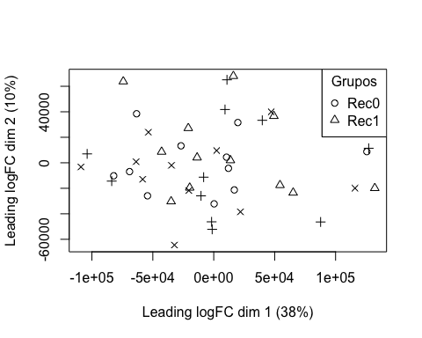

boxplot(targets$E, col = "royalblue", names = str_trunc(targets$targets$FileName, width = 10, side = "left"))

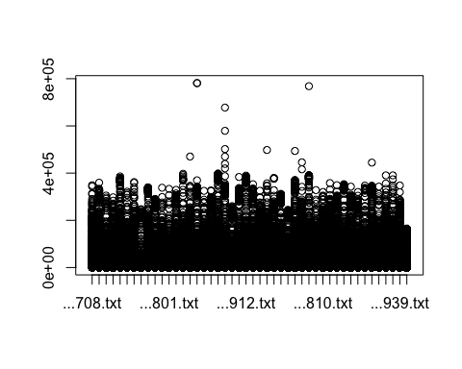

## 3. Preprocesado

### 3.1 Background

BK <- backgroundCorrect(targets, method ="normexp", printer=targets$printer, verbose=TRUE)

## Array 1 corrected  
## Array 2 corrected  
## Array 3 corrected  
## Array 4 corrected  
## Array 5 corrected  
## Array 6 corrected  
## Array 7 corrected  
## Array 8 corrected  
## Array 9 corrected  
## Array 10 corrected  
## Array 11 corrected  
## Array 12 corrected  
## Array 13 corrected  
## Array 14 corrected  
## Array 15 corrected  
## Array 16 corrected  
## Array 17 corrected  
## Array 18 corrected  
## Array 19 corrected  
## Array 20 corrected  
## Array 21 corrected  
## Array 22 corrected  
## Array 23 corrected  
## Array 24 corrected  
## Array 25 corrected  
## Array 26 corrected  
## Array 27 corrected  
## Array 28 corrected  
## Array 29 corrected  
## Array 30 corrected  
## Array 31 corrected  
## Array 32 corrected  
## Array 33 corrected  
## Array 34 corrected  
## Array 35 corrected  
## Array 36 corrected  
## Array 37 corrected  
## Array 38 corrected  
## Array 39 corrected  
## Array 40 corrected  
## Array 41 corrected  
## Array 42 corrected  
## Array 43 corrected  
## Array 44 corrected  
## Array 45 corrected  
## Array 46 corrected

### 3.2 Normalización

MA.p<-normalizeBetweenArrays(BK, method = 'quantile')  
transposed <- t(MA.p$E)  
df<-data.frame(value = transposed, group = as.character(Grupo))  
plotDensities(MA.p, legend = FALSE, type="1")

## Warning: In density.default(E[, a], n = npoint, na.rm = TRUE, ...) :  
## extra argument 'type' will be disregarded  
  
## Warning: In density.default(E[, a], n = npoint, na.rm = TRUE, ...) :  
## extra argument 'type' will be disregarded  
  
## Warning: In density.default(E[, a], n = npoint, na.rm = TRUE, ...) :  
## extra argument 'type' will be disregarded  
  
## Warning: In density.default(E[, a], n = npoint, na.rm = TRUE, ...) :  
## extra argument 'type' will be disregarded  
  
## Warning: In density.default(E[, a], n = npoint, na.rm = TRUE, ...) :  
## extra argument 'type' will be disregarded  
  
## Warning: In density.default(E[, a], n = npoint, na.rm = TRUE, ...) :  
## extra argument 'type' will be disregarded  
  
## Warning: In density.default(E[, a], n = npoint, na.rm = TRUE, ...) :  
## extra argument 'type' will be disregarded  
  
## Warning: In density.default(E[, a], n = npoint, na.rm = TRUE, ...) :  
## extra argument 'type' will be disregarded  
  
## Warning: In density.default(E[, a], n = npoint, na.rm = TRUE, ...) :  
## extra argument 'type' will be disregarded  
  
## Warning: In density.default(E[, a], n = npoint, na.rm = TRUE, ...) :  
## extra argument 'type' will be disregarded  
  
## Warning: In density.default(E[, a], n = npoint, na.rm = TRUE, ...) :  
## extra argument 'type' will be disregarded  
  
## Warning: In density.default(E[, a], n = npoint, na.rm = TRUE, ...) :  
## extra argument 'type' will be disregarded  
  
## Warning: In density.default(E[, a], n = npoint, na.rm = TRUE, ...) :  
## extra argument 'type' will be disregarded  
  
## Warning: In density.default(E[, a], n = npoint, na.rm = TRUE, ...) :  
## extra argument 'type' will be disregarded  
  
## Warning: In density.default(E[, a], n = npoint, na.rm = TRUE, ...) :  
## extra argument 'type' will be disregarded  
  
## Warning: In density.default(E[, a], n = npoint, na.rm = TRUE, ...) :  
## extra argument 'type' will be disregarded  
  
## Warning: In density.default(E[, a], n = npoint, na.rm = TRUE, ...) :  
## extra argument 'type' will be disregarded  
  
## Warning: In density.default(E[, a], n = npoint, na.rm = TRUE, ...) :  
## extra argument 'type' will be disregarded  
  
## Warning: In density.default(E[, a], n = npoint, na.rm = TRUE, ...) :  
## extra argument 'type' will be disregarded  
  
## Warning: In density.default(E[, a], n = npoint, na.rm = TRUE, ...) :  
## extra argument 'type' will be disregarded  
  
## Warning: In density.default(E[, a], n = npoint, na.rm = TRUE, ...) :  
## extra argument 'type' will be disregarded  
  
## Warning: In density.default(E[, a], n = npoint, na.rm = TRUE, ...) :  
## extra argument 'type' will be disregarded  
  
## Warning: In density.default(E[, a], n = npoint, na.rm = TRUE, ...) :  
## extra argument 'type' will be disregarded  
  
## Warning: In density.default(E[, a], n = npoint, na.rm = TRUE, ...) :  
## extra argument 'type' will be disregarded  
  
## Warning: In density.default(E[, a], n = npoint, na.rm = TRUE, ...) :  
## extra argument 'type' will be disregarded  
  
## Warning: In density.default(E[, a], n = npoint, na.rm = TRUE, ...) :  
## extra argument 'type' will be disregarded  
  
## Warning: In density.default(E[, a], n = npoint, na.rm = TRUE, ...) :  
## extra argument 'type' will be disregarded  
  
## Warning: In density.default(E[, a], n = npoint, na.rm = TRUE, ...) :  
## extra argument 'type' will be disregarded  
  
## Warning: In density.default(E[, a], n = npoint, na.rm = TRUE, ...) :  
## extra argument 'type' will be disregarded  
  
## Warning: In density.default(E[, a], n = npoint, na.rm = TRUE, ...) :  
## extra argument 'type' will be disregarded  
  
## Warning: In density.default(E[, a], n = npoint, na.rm = TRUE, ...) :  
## extra argument 'type' will be disregarded  
  
## Warning: In density.default(E[, a], n = npoint, na.rm = TRUE, ...) :  
## extra argument 'type' will be disregarded  
  
## Warning: In density.default(E[, a], n = npoint, na.rm = TRUE, ...) :  
## extra argument 'type' will be disregarded  
  
## Warning: In density.default(E[, a], n = npoint, na.rm = TRUE, ...) :  
## extra argument 'type' will be disregarded  
  
## Warning: In density.default(E[, a], n = npoint, na.rm = TRUE, ...) :  
## extra argument 'type' will be disregarded  
  
## Warning: In density.default(E[, a], n = npoint, na.rm = TRUE, ...) :  
## extra argument 'type' will be disregarded  
  
## Warning: In density.default(E[, a], n = npoint, na.rm = TRUE, ...) :  
## extra argument 'type' will be disregarded  
  
## Warning: In density.default(E[, a], n = npoint, na.rm = TRUE, ...) :  
## extra argument 'type' will be disregarded  
  
## Warning: In density.default(E[, a], n = npoint, na.rm = TRUE, ...) :  
## extra argument 'type' will be disregarded  
  
## Warning: In density.default(E[, a], n = npoint, na.rm = TRUE, ...) :  
## extra argument 'type' will be disregarded  
  
## Warning: In density.default(E[, a], n = npoint, na.rm = TRUE, ...) :  
## extra argument 'type' will be disregarded  
  
## Warning: In density.default(E[, a], n = npoint, na.rm = TRUE, ...) :  
## extra argument 'type' will be disregarded  
  
## Warning: In density.default(E[, a], n = npoint, na.rm = TRUE, ...) :  
## extra argument 'type' will be disregarded  
  
## Warning: In density.default(E[, a], n = npoint, na.rm = TRUE, ...) :  
## extra argument 'type' will be disregarded  
  
## Warning: In density.default(E[, a], n = npoint, na.rm = TRUE, ...) :  
## extra argument 'type' will be disregarded  
  
## Warning: In density.default(E[, a], n = npoint, na.rm = TRUE, ...) :  
## extra argument 'type' will be disregarded

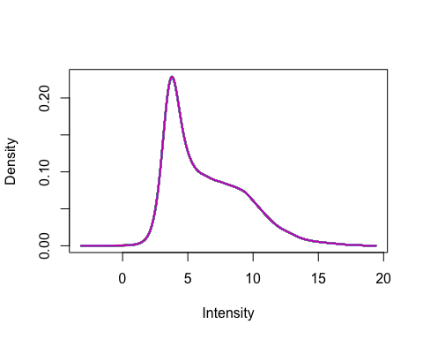

### 3.3 Anotación

MA.p$genes$EntrezID<- mapIds(HsAgilentDesign026652.db, MA.p$genes$ProbeName, keytype = "PROBEID", column = "ENTREZID")

## 'select()' returned 1:1 mapping between keys and columns

MA.p$genes$Symbol <- mapIds(HsAgilentDesign026652.db, MA.p$genes$ProbeName, keytype = "PROBEID", column = "SYMBOL")

## 'select()' returned 1:1 mapping between keys and columns

map=getGEO("GPL20844")

### 3.3 Filtering

control_1 =MA.p$genes$ControlType == 1  
control_b= MA.p$genes$ControlType == -1

NoSym = is.na(MA.p$genes$Symbol)  
NoEnID= is.na(MA.p$genes$EntrezID)  
table(NoEnID)

## NoEnID  
## FALSE TRUE   
## 36037 26939

yfilt = MA.p[!control_1& !control_b & !NoSym & !NoEnID,]

boxplot(yfilt$E, col = "royalblue", names = str_trunc(targets$targets$FileName, width = 10, side = "left"))

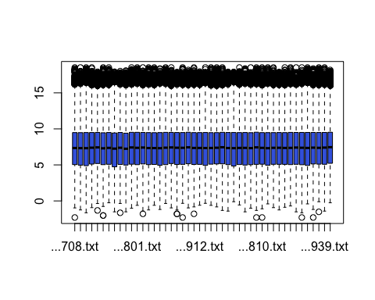

pcomp=prcomp(yfilt$E, scale. = TRUE)  
eso=summary(pcomp)  
eso

## Importance of components:  
## PC1 PC2 PC3 PC4 PC5 PC6 PC7  
## Standard deviation 6.5071 0.92585 0.54649 0.47827 0.47377 0.45669 0.35493  
## Proportion of Variance 0.9205 0.01863 0.00649 0.00497 0.00488 0.00453 0.00274  
## Cumulative Proportion 0.9205 0.93911 0.94561 0.95058 0.95546 0.95999 0.96273  
## PC8 PC9 PC10 PC11 PC12 PC13 PC14  
## Standard deviation 0.32985 0.32571 0.31129 0.29972 0.29730 0.28217 0.26379  
## Proportion of Variance 0.00237 0.00231 0.00211 0.00195 0.00192 0.00173 0.00151  
## Cumulative Proportion 0.96510 0.96740 0.96951 0.97146 0.97338 0.97511 0.97663  
## PC15 PC16 PC17 PC18 PC19 PC20 PC21  
## Standard deviation 0.26047 0.24819 0.24130 0.23602 0.2252 0.22088 0.21376  
## Proportion of Variance 0.00147 0.00134 0.00127 0.00121 0.0011 0.00106 0.00099  
## Cumulative Proportion 0.97810 0.97944 0.98071 0.98192 0.9830 0.98408 0.98507  
## PC22 PC23 PC24 PC25 PC26 PC27 PC28  
## Standard deviation 0.21149 0.20993 0.20580 0.19896 0.18778 0.18575 0.18195  
## Proportion of Variance 0.00097 0.00096 0.00092 0.00086 0.00077 0.00075 0.00072  
## Cumulative Proportion 0.98605 0.98700 0.98793 0.98879 0.98955 0.99030 0.99102  
## PC29 PC30 PC31 PC32 PC33 PC34 PC35  
## Standard deviation 0.17873 0.17700 0.17399 0.16827 0.16482 0.16282 0.15839  
## Proportion of Variance 0.00069 0.00068 0.00066 0.00062 0.00059 0.00058 0.00055  
## Cumulative Proportion 0.99172 0.99240 0.99306 0.99367 0.99426 0.99484 0.99538  
## PC36 PC37 PC38 PC39 PC40 PC41 PC42  
## Standard deviation 0.15660 0.15277 0.14789 0.14622 0.13827 0.13764 0.1361  
## Proportion of Variance 0.00053 0.00051 0.00048 0.00046 0.00042 0.00041 0.0004  
## Cumulative Proportion 0.99592 0.99642 0.99690 0.99736 0.99778 0.99819 0.9986  
## PC43 PC44 PC45 PC46  
## Standard deviation 0.13025 0.12902 0.12643 0.12266  
## Proportion of Variance 0.00037 0.00036 0.00035 0.00033  
## Cumulative Proportion 0.99896 0.99933 0.99967 1.00000

com=as.data.frame(pcomp$x)  
ggplot(com, aes(PC1, PC2)) + geom_point()+theme_bw(base_size=32)+xlab(paste("PC1:",eso$importance[2,1])) + ylab(paste("PC2:",eso$importance[2,2]))+theme(legend.position="top")

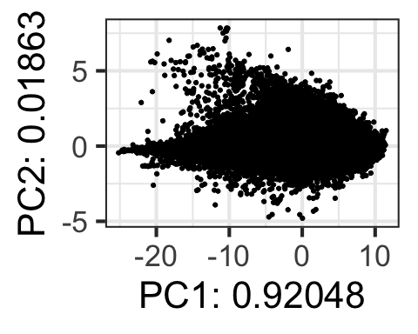

## 4. Expresión Diferencial

### 4.1 Modelización i Regresión

design <- model.matrix(~0+Grupo)  
colnames(design) = c(params$Rec0, params$Rec1)  
design

## Rec0 Rec1  
## 1 1 0  
## 2 1 0  
## 3 1 0  
## 4 1 0  
## 5 1 0  
## 6 1 0  
## 7 1 0  
## 8 1 0  
## 9 1 0  
## 10 1 0  
## 11 1 0  
## 12 1 0  
## 13 1 0  
## 14 1 0  
## 15 1 0  
## 16 1 0  
## 17 1 0  
## 18 1 0  
## 19 1 0  
## 20 1 0  
## 21 1 0  
## 22 1 0  
## 23 1 0  
## 24 1 0  
## 25 1 0  
## 26 1 0  
## 27 0 1  
## 28 0 1  
## 29 0 1  
## 30 0 1  
## 31 0 1  
## 32 0 1  
## 33 0 1  
## 34 0 1  
## 35 0 1  
## 36 0 1  
## 37 0 1  
## 38 0 1  
## 39 0 1  
## 40 0 1  
## 41 0 1  
## 42 0 1  
## 43 0 1  
## 44 0 1  
## 45 0 1  
## 46 0 1  
## attr(,"assign")  
## [1] 1 1  
## attr(,"contrasts")  
## attr(,"contrasts")$Grupo  
## [1] "contr.treatment"

fit = lmFit(yfilt, design)

parametre1 = params$Rec0  
parametre2 = params$Rec1  
  
  
contraste = makeContrasts(Rec0-Rec1, levels = design)  
fit2 = contrasts.fit(fit, contraste)  
fit2 = eBayes(fit2)

### 4.2 Resultados

topTable(fit2, adjust.method = "BH", n=30)

## Row Col ControlType ProbeName SystematicName EntrezID Symbol  
## 42906 262 102 0 A_33_P3258046 NM_170685 255061 TAC4  
## 17034 104 142 0 A_23_P218784 NM_006386 10521 DDX17  
## 54158 331 38 0 A_23_P139471 NM_001029 6231 RPS26  
## 60935 372 91 0 A_33_P3357337 BC026272 892 CCNC  
## 7377 45 161 0 A_23_P103720 NM_024758 79814 AGMAT  
## 20913 128 85 0 A_33_P3372699 NM_174977 284904 SEC14L4  
## 36400 222 156 0 A_23_P101342 NM_032885 84971 ATG4D  
## 37309 228 81 0 A_24_P323545 NM_001077186 79784 MYH14  
## 61783 377 119 0 A_23_P74928 NM_001531 3140 MR1  
## 624 4 132 0 A_33_P3288294 ENST00000520767 84750 FUT10  
## 21603 132 119 0 A_23_P401904 NM_001009936 26147 PHF19  
## 41759 255 103 0 A_23_P103720 NM_024758 79814 AGMAT  
## 6823 42 99 0 A_24_P687326 NR_024366 286333 FAM225A  
## 56833 347 89 0 A_23_P101342 NM_032885 84971 ATG4D  
## 41224 252 60 0 A_23_P101342 NM_032885 84971 ATG4D  
## 39953 244 101 0 A_32_P180971 ENST00000416103 728323 LINC01881  
## 33409 204 117 0 A_23_P99579 NM_032490 84520 GON7  
## 557 4 65 0 A_24_P62615 NM_006367 10487 CAP1  
## 14389 88 121 0 A_23_P312344 NM_016196 9904 RBM19  
## 30255 185 79 0 A_23_P410717 NM_144697 148523 CIART  
## 24323 149 51 0 A_23_P127394 NM_021117 1408 CRY2  
## 11556 71 76 0 A_23_P160869 NM_014813 9860 LRIG2  
## 14588 89 156 0 A_23_P338603 NM_001011667 79145 CHCHD7  
## 41052 251 52 0 A_33_P3766959 NM_018319 55775 TDP1  
## 50646 309 134 0 A_23_P306933 NM_139283 160760 PPTC7  
## 2167 14 35 0 A_23_P431939 NM_001531 3140 MR1  
## 25047 153 119 0 A_23_P103720 NM_024758 79814 AGMAT  
## 17688 108 140 0 A_23_P126735 NM_000572 3586 IL10  
## 45046 275 110 0 A_33_P3288904 NM_003899 8874 ARHGEF7  
## 36903 226 3 0 A_23_P101342 NM_032885 84971 ATG4D  
## logFC AveExpr t P.Value adj.P.Val B  
## 42906 -0.9051033 4.321763 -4.814407 1.508423e-05 0.1775709 2.5301620  
## 17034 0.6679744 12.454345 4.728584 2.013494e-05 0.1775709 2.2985938  
## 54158 -0.6769907 4.880552 -4.697392 2.235500e-05 0.1775709 2.2146833  
## 60935 0.6297617 6.794285 4.576363 3.347789e-05 0.1775709 1.8904948  
## 7377 -0.8496281 5.116920 -4.573255 3.382538e-05 0.1775709 1.8822012  
## 20913 0.6959933 7.943509 4.497480 4.347965e-05 0.1775709 1.6804886  
## 36400 0.5790588 7.047653 4.471126 4.743180e-05 0.1775709 1.6105725  
## 37309 0.6065054 8.161499 4.446690 5.140901e-05 0.1775709 1.5458543  
## 61783 -0.6369798 7.150501 -4.388386 6.226011e-05 0.1775709 1.3918981  
## 624 0.5808080 6.833402 4.381015 6.378190e-05 0.1775709 1.3724818  
## 21603 -0.9784151 10.010314 -4.371210 6.586264e-05 0.1775709 1.3466696  
## 41759 -0.8621528 5.408233 -4.355937 6.923636e-05 0.1775709 1.3065006  
## 6823 -0.9777022 5.376704 -4.326280 7.627519e-05 0.1775709 1.2286391  
## 56833 0.6166567 7.180665 4.302249 8.248623e-05 0.1775709 1.1656795  
## 41224 0.6079186 7.288082 4.280074 8.865317e-05 0.1775709 1.1076890  
## 39953 0.6190776 11.977187 4.258905 9.495764e-05 0.1775709 1.0524311  
## 33409 -0.6502352 6.495403 -4.258480 9.508854e-05 0.1775709 1.0513229  
## 557 -0.5514703 10.485557 -4.248809 9.811639e-05 0.1775709 1.0261090  
## 14389 -0.6294327 7.792508 -4.244068 9.963439e-05 0.1775709 1.0137592  
## 30255 1.2502891 7.399104 4.237828 1.016678e-04 0.1775709 0.9975077  
## 24323 0.7611654 10.718880 4.232378 1.034766e-04 0.1775709 0.9833219  
## 11556 0.5207998 8.476730 4.176468 1.239358e-04 0.2029936 0.8381867  
## 14588 -0.7683230 7.484456 -4.146923 1.362839e-04 0.2029936 0.7617810  
## 41052 -0.5711841 9.158777 -4.123389 1.469664e-04 0.2029936 0.7010720  
## 50646 0.3984409 9.781625 4.115763 1.505995e-04 0.2029936 0.6814267  
## 2167 -0.6571603 8.267612 -4.104806 1.559719e-04 0.2029936 0.6532286  
## 25047 -0.7814024 5.395551 -4.102323 1.572154e-04 0.2029936 0.6468405  
## 17688 -0.7638707 5.595516 -4.101317 1.577218e-04 0.2029936 0.6442535  
## 45046 0.5793626 8.082985 4.066316 1.763593e-04 0.2038271 0.5544034  
## 36903 0.5671656 7.009518 4.064266 1.775148e-04 0.2038271 0.5491503

tT=topTable(fit2, adjust.method = "BH", n=3000)  
  
results = decideTests(fit2, p.value = 0.05)  
summary(decideTests(fit2), p.value = 0.05)

## Rec0 - Rec1  
## Down 0  
## NotSig 36037  
## Up 0

EnhancedVolcano(tT, lab = tT$Symbol, x = "logFC", y = "adj.P.Val", pCutoff = 0.05, FCcutoff=2, labSize = 6.0, ylim=0.95)

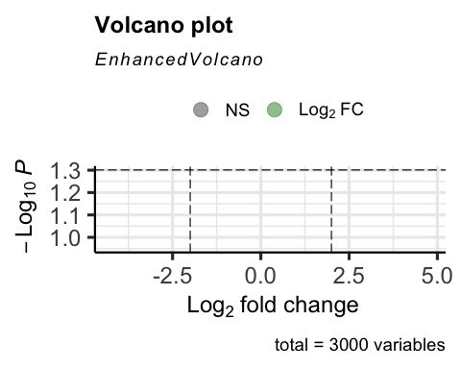

vennDiagram(results, include=c("both"), circle.col = "red", counts.col = "blue", names = c("CHD9-CTL"))

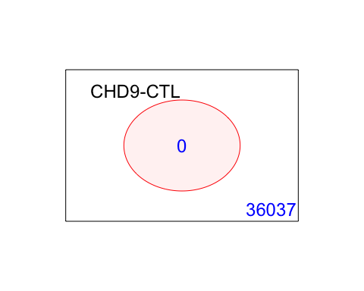

## 5. Gene Enrichment Analysis

### Gene Ontology

g = goana(fit2, species="Hs", geneid = fit2$genes$EntrezID, FDR = 0.05)

## No DE genes

topGO(g, n=20)

## data frame with 0 columns and 0 rows

### KEGG

k = kegga(fit2, species="Hs", geneid = fit2$genes$EntrezID, FDR = 0.05)

## No DE genes

topKEGG(k, number = 20)

## data frame with 0 columns and 0 rows