SubtipoSupVsNodRecod

Estefanía Gómez Guil

2023-06-11

Table of Contents

## 1. Importación de los datos

params <- list(  
 Sup="Sup",  
 Nod="Nod",  
 directorio= "/Users/estefaniagomezguil/Desktop/SubtiposRecod"  
)  
ruta_sup<- file.path(params$directorio, "Superficial")  
ruta_nod<- file.path(params$directorio, "Nodular")  
  
files_sup <- list.files(path = ruta_sup, pattern = ".txt", full.names = TRUE)  
files_nod <- list.files(path = ruta_nod, pattern = ".txt", full.names = TRUE)  
Grupo <- c (rep(params$Sup, length(files_sup)), rep(params$Nod, length(files_nod)))  
files <- c(files_sup, files_nod)  
print(files)

## [1] "/Users/estefaniagomezguil/Desktop/SubtiposRecod/Superficial/2708.txt"  
## [2] "/Users/estefaniagomezguil/Desktop/SubtiposRecod/Superficial/2710.txt"  
## [3] "/Users/estefaniagomezguil/Desktop/SubtiposRecod/Superficial/2711.txt"  
## [4] "/Users/estefaniagomezguil/Desktop/SubtiposRecod/Superficial/2724.txt"  
## [5] "/Users/estefaniagomezguil/Desktop/SubtiposRecod/Superficial/2727.txt"  
## [6] "/Users/estefaniagomezguil/Desktop/SubtiposRecod/Superficial/2729.txt"  
## [7] "/Users/estefaniagomezguil/Desktop/SubtiposRecod/Superficial/2730.txt"  
## [8] "/Users/estefaniagomezguil/Desktop/SubtiposRecod/Superficial/2748.txt"  
## [9] "/Users/estefaniagomezguil/Desktop/SubtiposRecod/Superficial/2749.txt"  
## [10] "/Users/estefaniagomezguil/Desktop/SubtiposRecod/Superficial/2777.txt"  
## [11] "/Users/estefaniagomezguil/Desktop/SubtiposRecod/Superficial/2790.txt"  
## [12] "/Users/estefaniagomezguil/Desktop/SubtiposRecod/Superficial/2801.txt"  
## [13] "/Users/estefaniagomezguil/Desktop/SubtiposRecod/Superficial/2807.txt"  
## [14] "/Users/estefaniagomezguil/Desktop/SubtiposRecod/Superficial/2810.txt"  
## [15] "/Users/estefaniagomezguil/Desktop/SubtiposRecod/Superficial/2858.txt"  
## [16] "/Users/estefaniagomezguil/Desktop/SubtiposRecod/Superficial/2880.txt"  
## [17] "/Users/estefaniagomezguil/Desktop/SubtiposRecod/Superficial/2881.txt"  
## [18] "/Users/estefaniagomezguil/Desktop/SubtiposRecod/Superficial/2890.txt"  
## [19] "/Users/estefaniagomezguil/Desktop/SubtiposRecod/Superficial/2891.txt"  
## [20] "/Users/estefaniagomezguil/Desktop/SubtiposRecod/Superficial/2892.txt"  
## [21] "/Users/estefaniagomezguil/Desktop/SubtiposRecod/Superficial/2893.txt"  
## [22] "/Users/estefaniagomezguil/Desktop/SubtiposRecod/Superficial/2894.txt"  
## [23] "/Users/estefaniagomezguil/Desktop/SubtiposRecod/Superficial/2895.txt"  
## [24] "/Users/estefaniagomezguil/Desktop/SubtiposRecod/Superficial/2898.txt"  
## [25] "/Users/estefaniagomezguil/Desktop/SubtiposRecod/Superficial/2899.txt"  
## [26] "/Users/estefaniagomezguil/Desktop/SubtiposRecod/Superficial/2907.txt"  
## [27] "/Users/estefaniagomezguil/Desktop/SubtiposRecod/Superficial/2912.txt"  
## [28] "/Users/estefaniagomezguil/Desktop/SubtiposRecod/Superficial/2933.txt"  
## [29] "/Users/estefaniagomezguil/Desktop/SubtiposRecod/Superficial/2934.txt"  
## [30] "/Users/estefaniagomezguil/Desktop/SubtiposRecod/Nodular/2740.txt"   
## [31] "/Users/estefaniagomezguil/Desktop/SubtiposRecod/Nodular/2750.txt"   
## [32] "/Users/estefaniagomezguil/Desktop/SubtiposRecod/Nodular/2769.txt"   
## [33] "/Users/estefaniagomezguil/Desktop/SubtiposRecod/Nodular/2911.txt"

targets = read.maimages(file=files, source="agilent", green.only=TRUE)

## Read /Users/estefaniagomezguil/Desktop/SubtiposRecod/Superficial/2708.txt   
## Read /Users/estefaniagomezguil/Desktop/SubtiposRecod/Superficial/2710.txt   
## Read /Users/estefaniagomezguil/Desktop/SubtiposRecod/Superficial/2711.txt   
## Read /Users/estefaniagomezguil/Desktop/SubtiposRecod/Superficial/2724.txt   
## Read /Users/estefaniagomezguil/Desktop/SubtiposRecod/Superficial/2727.txt   
## Read /Users/estefaniagomezguil/Desktop/SubtiposRecod/Superficial/2729.txt   
## Read /Users/estefaniagomezguil/Desktop/SubtiposRecod/Superficial/2730.txt   
## Read /Users/estefaniagomezguil/Desktop/SubtiposRecod/Superficial/2748.txt   
## Read /Users/estefaniagomezguil/Desktop/SubtiposRecod/Superficial/2749.txt   
## Read /Users/estefaniagomezguil/Desktop/SubtiposRecod/Superficial/2777.txt   
## Read /Users/estefaniagomezguil/Desktop/SubtiposRecod/Superficial/2790.txt   
## Read /Users/estefaniagomezguil/Desktop/SubtiposRecod/Superficial/2801.txt   
## Read /Users/estefaniagomezguil/Desktop/SubtiposRecod/Superficial/2807.txt   
## Read /Users/estefaniagomezguil/Desktop/SubtiposRecod/Superficial/2810.txt   
## Read /Users/estefaniagomezguil/Desktop/SubtiposRecod/Superficial/2858.txt   
## Read /Users/estefaniagomezguil/Desktop/SubtiposRecod/Superficial/2880.txt   
## Read /Users/estefaniagomezguil/Desktop/SubtiposRecod/Superficial/2881.txt   
## Read /Users/estefaniagomezguil/Desktop/SubtiposRecod/Superficial/2890.txt   
## Read /Users/estefaniagomezguil/Desktop/SubtiposRecod/Superficial/2891.txt   
## Read /Users/estefaniagomezguil/Desktop/SubtiposRecod/Superficial/2892.txt   
## Read /Users/estefaniagomezguil/Desktop/SubtiposRecod/Superficial/2893.txt   
## Read /Users/estefaniagomezguil/Desktop/SubtiposRecod/Superficial/2894.txt   
## Read /Users/estefaniagomezguil/Desktop/SubtiposRecod/Superficial/2895.txt   
## Read /Users/estefaniagomezguil/Desktop/SubtiposRecod/Superficial/2898.txt   
## Read /Users/estefaniagomezguil/Desktop/SubtiposRecod/Superficial/2899.txt   
## Read /Users/estefaniagomezguil/Desktop/SubtiposRecod/Superficial/2907.txt   
## Read /Users/estefaniagomezguil/Desktop/SubtiposRecod/Superficial/2912.txt   
## Read /Users/estefaniagomezguil/Desktop/SubtiposRecod/Superficial/2933.txt   
## Read /Users/estefaniagomezguil/Desktop/SubtiposRecod/Superficial/2934.txt   
## Read /Users/estefaniagomezguil/Desktop/SubtiposRecod/Nodular/2740.txt   
## Read /Users/estefaniagomezguil/Desktop/SubtiposRecod/Nodular/2750.txt   
## Read /Users/estefaniagomezguil/Desktop/SubtiposRecod/Nodular/2769.txt   
## Read /Users/estefaniagomezguil/Desktop/SubtiposRecod/Nodular/2911.txt

targets$targets$class <- Grupo  
files2<- str_remove_all(string=files, pattern= "US85003608_253949442215")  
files2<- str_remove_all(string=files2, patter= "_S01_GE1_107_Sep09")

## 2. Control de calidad

limma::plotMA3by2(targets, status = targets$genes$ControlType, prefix = "MA", device = "pdf")  
# Obtener los grupos únicos y sus correspondientes colores  
grupos_unicos <- unique(Grupo)  
  
colores <- 1:4  
Grupo2<-colores  
plotMDS(targets, top = 100, gene.selection = "pairwise", pch=colores, type="p", plot = TRUE)  
  
# Agregar la leyenda  
legend("topright", legend = grupos_unicos, pch = colores, title = "Grupos")  
legend("topright", legend = grupos_unicos, pch = colores, title = "Grupos")

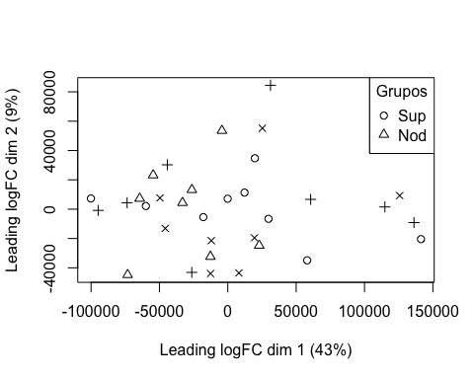

boxplot(targets$E, col = "royalblue", names = str_trunc(targets$targets$FileName, width = 10, side = "left"))

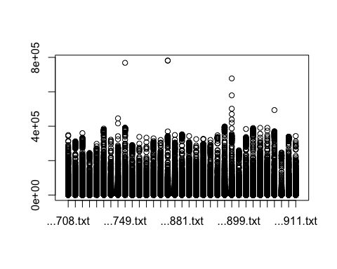

## 3. Preprocesado

### 3.1 Background

BK <- backgroundCorrect(targets, method ="normexp", printer=targets$printer, verbose=TRUE)

## Array 1 corrected  
## Array 2 corrected  
## Array 3 corrected  
## Array 4 corrected  
## Array 5 corrected  
## Array 6 corrected  
## Array 7 corrected  
## Array 8 corrected  
## Array 9 corrected  
## Array 10 corrected  
## Array 11 corrected  
## Array 12 corrected  
## Array 13 corrected  
## Array 14 corrected  
## Array 15 corrected  
## Array 16 corrected  
## Array 17 corrected  
## Array 18 corrected  
## Array 19 corrected  
## Array 20 corrected  
## Array 21 corrected  
## Array 22 corrected  
## Array 23 corrected  
## Array 24 corrected  
## Array 25 corrected  
## Array 26 corrected  
## Array 27 corrected  
## Array 28 corrected  
## Array 29 corrected  
## Array 30 corrected  
## Array 31 corrected  
## Array 32 corrected  
## Array 33 corrected

### 3.2 Normalización

MA.p<-normalizeBetweenArrays(BK, method = 'quantile')  
transposed <- t(MA.p$E)  
df<-data.frame(value = transposed, group = as.character(Grupo))  
plotDensities(MA.p, legend = FALSE, type="1")

## Warning: In density.default(E[, a], n = npoint, na.rm = TRUE, ...) :  
## extra argument 'type' will be disregarded  
  
## Warning: In density.default(E[, a], n = npoint, na.rm = TRUE, ...) :  
## extra argument 'type' will be disregarded  
  
## Warning: In density.default(E[, a], n = npoint, na.rm = TRUE, ...) :  
## extra argument 'type' will be disregarded  
  
## Warning: In density.default(E[, a], n = npoint, na.rm = TRUE, ...) :  
## extra argument 'type' will be disregarded  
  
## Warning: In density.default(E[, a], n = npoint, na.rm = TRUE, ...) :  
## extra argument 'type' will be disregarded  
  
## Warning: In density.default(E[, a], n = npoint, na.rm = TRUE, ...) :  
## extra argument 'type' will be disregarded  
  
## Warning: In density.default(E[, a], n = npoint, na.rm = TRUE, ...) :  
## extra argument 'type' will be disregarded  
  
## Warning: In density.default(E[, a], n = npoint, na.rm = TRUE, ...) :  
## extra argument 'type' will be disregarded  
  
## Warning: In density.default(E[, a], n = npoint, na.rm = TRUE, ...) :  
## extra argument 'type' will be disregarded  
  
## Warning: In density.default(E[, a], n = npoint, na.rm = TRUE, ...) :  
## extra argument 'type' will be disregarded  
  
## Warning: In density.default(E[, a], n = npoint, na.rm = TRUE, ...) :  
## extra argument 'type' will be disregarded  
  
## Warning: In density.default(E[, a], n = npoint, na.rm = TRUE, ...) :  
## extra argument 'type' will be disregarded  
  
## Warning: In density.default(E[, a], n = npoint, na.rm = TRUE, ...) :  
## extra argument 'type' will be disregarded  
  
## Warning: In density.default(E[, a], n = npoint, na.rm = TRUE, ...) :  
## extra argument 'type' will be disregarded  
  
## Warning: In density.default(E[, a], n = npoint, na.rm = TRUE, ...) :  
## extra argument 'type' will be disregarded  
  
## Warning: In density.default(E[, a], n = npoint, na.rm = TRUE, ...) :  
## extra argument 'type' will be disregarded  
  
## Warning: In density.default(E[, a], n = npoint, na.rm = TRUE, ...) :  
## extra argument 'type' will be disregarded  
  
## Warning: In density.default(E[, a], n = npoint, na.rm = TRUE, ...) :  
## extra argument 'type' will be disregarded  
  
## Warning: In density.default(E[, a], n = npoint, na.rm = TRUE, ...) :  
## extra argument 'type' will be disregarded  
  
## Warning: In density.default(E[, a], n = npoint, na.rm = TRUE, ...) :  
## extra argument 'type' will be disregarded  
  
## Warning: In density.default(E[, a], n = npoint, na.rm = TRUE, ...) :  
## extra argument 'type' will be disregarded  
  
## Warning: In density.default(E[, a], n = npoint, na.rm = TRUE, ...) :  
## extra argument 'type' will be disregarded  
  
## Warning: In density.default(E[, a], n = npoint, na.rm = TRUE, ...) :  
## extra argument 'type' will be disregarded  
  
## Warning: In density.default(E[, a], n = npoint, na.rm = TRUE, ...) :  
## extra argument 'type' will be disregarded  
  
## Warning: In density.default(E[, a], n = npoint, na.rm = TRUE, ...) :  
## extra argument 'type' will be disregarded  
  
## Warning: In density.default(E[, a], n = npoint, na.rm = TRUE, ...) :  
## extra argument 'type' will be disregarded  
  
## Warning: In density.default(E[, a], n = npoint, na.rm = TRUE, ...) :  
## extra argument 'type' will be disregarded  
  
## Warning: In density.default(E[, a], n = npoint, na.rm = TRUE, ...) :  
## extra argument 'type' will be disregarded  
  
## Warning: In density.default(E[, a], n = npoint, na.rm = TRUE, ...) :  
## extra argument 'type' will be disregarded  
  
## Warning: In density.default(E[, a], n = npoint, na.rm = TRUE, ...) :  
## extra argument 'type' will be disregarded  
  
## Warning: In density.default(E[, a], n = npoint, na.rm = TRUE, ...) :  
## extra argument 'type' will be disregarded  
  
## Warning: In density.default(E[, a], n = npoint, na.rm = TRUE, ...) :  
## extra argument 'type' will be disregarded  
  
## Warning: In density.default(E[, a], n = npoint, na.rm = TRUE, ...) :  
## extra argument 'type' will be disregarded

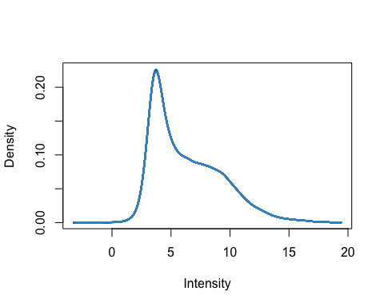

### 3.3 Anotación

MA.p$genes$EntrezID<- mapIds(HsAgilentDesign026652.db, MA.p$genes$ProbeName, keytype = "PROBEID", column = "ENTREZID")

## 'select()' returned 1:1 mapping between keys and columns

MA.p$genes$Symbol <- mapIds(HsAgilentDesign026652.db, MA.p$genes$ProbeName, keytype = "PROBEID", column = "SYMBOL")

## 'select()' returned 1:1 mapping between keys and columns

map=getGEO("GPL20844")

### 3.3 Filtrado

control_1 =MA.p$genes$ControlType == 1  
control_b= MA.p$genes$ControlType == -1

NoSym = is.na(MA.p$genes$Symbol)  
NoEnID= is.na(MA.p$genes$EntrezID)  
table(NoEnID)

## NoEnID  
## FALSE TRUE   
## 36037 26939

yfilt = MA.p[!control_1& !control_b & !NoSym & !NoEnID,]

boxplot(yfilt$E, col = "royalblue", names = str_trunc(targets$targets$FileName, width = 10, side = "left"))

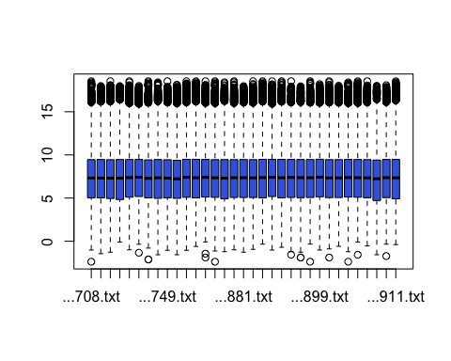

pcomp=prcomp(yfilt$E, scale. = TRUE)  
eso=summary(pcomp)  
eso

## Importance of components:  
## PC1 PC2 PC3 PC4 PC5 PC6 PC7  
## Standard deviation 5.534 0.7221 0.52525 0.45918 0.38295 0.35482 0.30486  
## Proportion of Variance 0.928 0.0158 0.00836 0.00639 0.00444 0.00382 0.00282  
## Cumulative Proportion 0.928 0.9438 0.95216 0.95854 0.96299 0.96680 0.96962  
## PC8 PC9 PC10 PC11 PC12 PC13 PC14  
## Standard deviation 0.28993 0.27035 0.25480 0.25000 0.24526 0.23244 0.22565  
## Proportion of Variance 0.00255 0.00221 0.00197 0.00189 0.00182 0.00164 0.00154  
## Cumulative Proportion 0.97217 0.97438 0.97635 0.97824 0.98007 0.98170 0.98325  
## PC15 PC16 PC17 PC18 PC19 PC20 PC21  
## Standard deviation 0.22145 0.21321 0.20870 0.20116 0.18806 0.18562 0.18119  
## Proportion of Variance 0.00149 0.00138 0.00132 0.00123 0.00107 0.00104 0.00099  
## Cumulative Proportion 0.98473 0.98611 0.98743 0.98866 0.98973 0.99077 0.99177  
## PC22 PC23 PC24 PC25 PC26 PC27 PC28  
## Standard deviation 0.17330 0.17181 0.16515 0.16129 0.15722 0.14695 0.14613  
## Proportion of Variance 0.00091 0.00089 0.00083 0.00079 0.00075 0.00065 0.00065  
## Cumulative Proportion 0.99268 0.99357 0.99440 0.99519 0.99594 0.99659 0.99724  
## PC29 PC30 PC31 PC32 PC33  
## Standard deviation 0.14217 0.13891 0.13635 0.13151 0.12562  
## Proportion of Variance 0.00061 0.00058 0.00056 0.00052 0.00048  
## Cumulative Proportion 0.99785 0.99843 0.99900 0.99952 1.00000

com=as.data.frame(pcomp$x)  
ggplot(com, aes(PC1, PC2)) + geom_point()+theme_bw(base_size=32)+xlab(paste("PC1:",eso$importance[2,1])) + ylab(paste("PC2:",eso$importance[2,2]))+theme(legend.position="top")

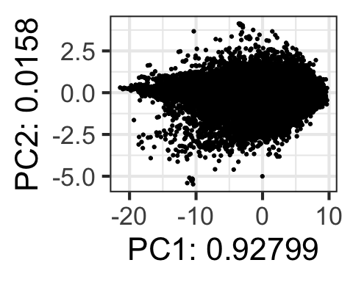

## 4. Expresión Diferencial

### 4.1 Modelización y Regresión

design <- model.matrix(~0+Grupo)  
colnames(design) = c(params$Sup, params$Nod)  
design

## Sup Nod  
## 1 0 1  
## 2 0 1  
## 3 0 1  
## 4 0 1  
## 5 0 1  
## 6 0 1  
## 7 0 1  
## 8 0 1  
## 9 0 1  
## 10 0 1  
## 11 0 1  
## 12 0 1  
## 13 0 1  
## 14 0 1  
## 15 0 1  
## 16 0 1  
## 17 0 1  
## 18 0 1  
## 19 0 1  
## 20 0 1  
## 21 0 1  
## 22 0 1  
## 23 0 1  
## 24 0 1  
## 25 0 1  
## 26 0 1  
## 27 0 1  
## 28 0 1  
## 29 0 1  
## 30 1 0  
## 31 1 0  
## 32 1 0  
## 33 1 0  
## attr(,"assign")  
## [1] 1 1  
## attr(,"contrasts")  
## attr(,"contrasts")$Grupo  
## [1] "contr.treatment"

fit = lmFit(yfilt, design)

parametre1 = params$Sup  
parametre2 = params$Nod  
  
contraste = makeContrasts(Sup-Nod, levels = design)  
fit2 = contrasts.fit(fit, contraste)  
fit2 = eBayes(fit2)

### 4.2 Resultados

topTable(fit2, adjust.method = "bonferroni", n=30)

## Row Col ControlType ProbeName SystematicName EntrezID Symbol  
## 44760 273 152 0 A_23_P82823 NM_017884 54984 PINX1  
## 56173 343 85 0 A_23_P109636 NM_015541 26018 LRIG1  
## 35100 215 4 0 A_23_P8240 NM_012135 26240 FAM50B  
## 29899 183 51 0 A_24_P125335 NM_005408 6357 CCL13  
## 60663 370 147 0 A_33_P3320548 NM_007342 11097 NUP42  
## 58444 357 60 0 A_23_P102172 NM_173077 130749 CPO  
## 19838 121 158 0 A_23_P54357 NM_033195 92483 LDHAL6B  
## 19665 120 149 0 A_23_P151059 NM_018088 55138 FAM90A1  
## 15427 95 11 0 A_23_P11995 NM_002574 5052 PRDX1  
## 48957 299 85 0 A_33_P3230254 NM_022346 64151 NCAPG  
## 885 6 65 0 A_23_P11995 NM_002574 5052 PRDX1  
## 42703 261 63 0 A_24_P110914 NR_024458 100190939 TPT1-AS1  
## 36014 220 98 0 A_23_P109636 NM_015541 26018 LRIG1  
## 35907 219 155 0 A_33_P3307253 NM_012093 26289 AK5  
## 45814 280 58 0 A_33_P3215113 NM_012317 23641 LDOC1  
## 54812 335 36 0 A_33_P3382324 NM_012217 23430 TPSD1  
## 54732 334 120 0 A_23_P37702 NM_003294 7177 TPSAB1  
## 15776 97 32 0 A_23_P11995 NM_002574 5052 PRDX1  
## 23485 144 33 0 A_23_P6413 NM_080430 140606 SELENOM  
## 45577 278 149 0 A_23_P109636 NM_015541 26018 LRIG1  
## 30635 187 131 0 A_23_P103765 NM_002001 2205 FCER1A  
## 46092 282 8 0 A_23_P103765 NM_002001 2205 FCER1A  
## 26192 160 116 0 A_23_P109636 NM_015541 26018 LRIG1  
## 61302 374 130 0 A_23_P11995 NM_002574 5052 PRDX1  
## 35289 216 29 0 A_23_P109636 NM_015541 26018 LRIG1  
## 20976 128 148 0 A_23_P109636 NM_015541 26018 LRIG1  
## 58072 355 16 0 A_23_P154037 NM_001159 316 AOX1  
## 4485 28 57 0 A_23_P11995 NM_002574 5052 PRDX1  
## 25721 157 137 0 A_23_P109636 NM_015541 26018 LRIG1  
## 60577 370 61 0 A_33_P3377151 NM_006274 6363 CCL19  
## logFC AveExpr t P.Value adj.P.Val B  
## 44760 1.169889 7.949530 5.124868 1.078126e-05 0.3885241 3.123360  
## 56173 -2.176304 9.571553 -4.875708 2.293792e-05 0.8266139 2.481230  
## 35100 -2.290073 7.770821 -4.844048 2.523962e-05 0.9095601 2.399783  
## 29899 -3.082497 8.566785 -4.787296 2.995237e-05 1.0000000 2.253912  
## 60663 1.342870 8.915579 4.768385 3.170879e-05 1.0000000 2.205340  
## 58444 -1.310724 4.075669 -4.741604 3.437171e-05 1.0000000 2.136594  
## 19838 1.240365 3.418849 4.734695 3.509382e-05 1.0000000 2.118867  
## 19665 1.695673 5.599000 4.719922 3.668879e-05 1.0000000 2.080968  
## 15427 -1.083659 13.149951 -4.672903 4.225747e-05 1.0000000 1.960447  
## 48957 1.401240 5.056368 4.621025 4.937409e-05 1.0000000 1.827655  
## 885 -1.107919 13.361742 -4.611229 5.084505e-05 1.0000000 1.802603  
## 42703 1.434180 11.771287 4.605228 5.176751e-05 1.0000000 1.787260  
## 36014 -2.070270 9.815964 -4.586288 5.478837e-05 1.0000000 1.738856  
## 35907 1.411873 5.654904 4.578158 5.613793e-05 1.0000000 1.718087  
## 45814 -2.565917 10.715563 -4.564609 5.846012e-05 1.0000000 1.683490  
## 54812 -3.451788 8.657516 -4.557844 5.965484e-05 1.0000000 1.666221  
## 54732 -3.409571 9.236536 -4.525686 6.567165e-05 1.0000000 1.584188  
## 15776 -1.063930 13.207664 -4.519062 6.698338e-05 1.0000000 1.567303  
## 23485 -1.529762 10.469473 -4.518332 6.712954e-05 1.0000000 1.565442  
## 45577 -2.053075 9.322207 -4.515489 6.770174e-05 1.0000000 1.558195  
## 30635 -3.002940 9.142317 -4.508773 6.907232e-05 1.0000000 1.541083  
## 46092 -3.018371 8.985715 -4.496970 7.154787e-05 1.0000000 1.511017  
## 26192 -1.924647 9.633202 -4.470668 7.738322e-05 1.0000000 1.444067  
## 61302 -1.055802 13.253755 -4.451014 8.204710e-05 1.0000000 1.394088  
## 35289 -2.059542 9.413799 -4.444099 8.375308e-05 1.0000000 1.376512  
## 20976 -2.031348 9.325796 -4.438779 8.508925e-05 1.0000000 1.362994  
## 58072 -2.534989 6.964982 -4.420462 8.985244e-05 1.0000000 1.316473  
## 4485 -1.043725 13.384738 -4.402392 9.480813e-05 1.0000000 1.270617  
## 25721 -1.997847 9.383262 -4.400157 9.543948e-05 1.0000000 1.264948  
## 60577 -3.582727 10.039101 -4.392530 9.762517e-05 1.0000000 1.245607

tT=topTable(fit2, adjust.method = "bonferroni", n=3000)  
  
results = decideTests(fit2, p.value = 0.1)  
summary(decideTests(fit2), p.value = 0.1)

## Sup - Nod  
## Down 0  
## NotSig 36037  
## Up 0

EnhancedVolcano(tT, lab = tT$Symbol, x = "logFC", y = "adj.P.Val", pCutoff = 0.05, FCcutoff=2, labSize = 6.0, ylim=0.95)

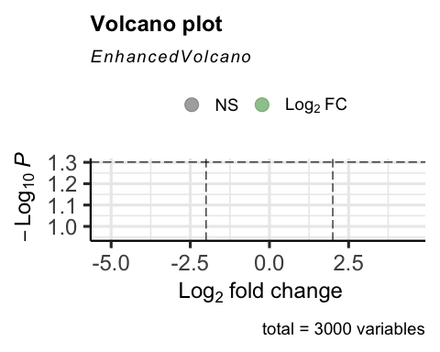

vennDiagram(results, include=c("both"), circle.col = "red", counts.col = "blue", names = c("CHD9-CTL"))

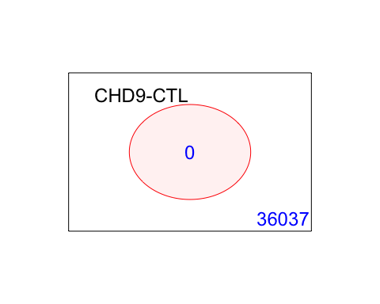

## 5. Gene Enrichment Analysis

### Gene Ontology

g = goana(fit2, species="Hs", geneid = fit2$genes$EntrezID, FDR = 0.05)

## No DE genes

topGO(g, n=20)

## data frame with 0 columns and 0 rows

### KEGG

k = kegga(fit2, species="Hs", geneid = fit2$genes$EntrezID, FDR = 0.05)

## No DE genes

topKEGG(k, number = 20)

## data frame with 0 columns and 0 rows