UlceracionRecod

Estefanía Gómez Guil

2023-06-11

Table of Contents

## Análisis previo: Chi cuadrado

#### Los datos se distribuyen de esta manera:

| Estadio | Ulceración presente | Ulceración ausente |
| --- | --- | --- |
| Estadio 1 | 0 | 10 |
| Estadio 2 | 3 | 4 |
| Estadio 3 | 9 | 5 |
| Estadio 4 | 10 | 12 |

tabla <- matrix(c(0, 10, 3, 4, 9, 5, 10, 12), nrow = 4, byrow = TRUE)  
  
rownames(tabla) <- c("Estadio 1", "Estadio 2", "Estadio 3", "Estadio 4")  
colnames(tabla) <- c("Ulceración presente", "Ulceración ausente")  
  
tabla

## Ulceración presente Ulceración ausente  
## Estadio 1 0 10  
## Estadio 2 3 4  
## Estadio 3 9 5  
## Estadio 4 10 12

resultado <- chisq.test(tabla)

## Warning in chisq.test(tabla): Chi-squared approximation may be incorrect

resultado

##   
## Pearson's Chi-squared test  
##   
## data: tabla  
## X-squared = 10.234, df = 3, p-value = 0.01668

## 1. Importación de los datos

params <- list(  
 ulcAus="ulcAus",  
 ulcPres="ulcPres",  
 directorio= "/Users/estefaniagomezguil/Desktop/UlceracionRecod"  
)  
ruta_ulcAus<- file.path(params$directorio, "Ausente")  
ruta_ulcPres<- file.path(params$directorio, "Presente")  
  
files_ulcAus <- list.files(path = ruta_ulcAus, pattern = ".txt", full.names = TRUE)  
files_ulcPres <- list.files(path = ruta_ulcPres, pattern = ".txt", full.names = TRUE)  
Grupo <- c (rep(params$ulcAus, length(files_ulcAus)), rep(params$ulcPres, length(files_ulcPres)))  
files <- c(files_ulcAus, files_ulcPres)  
print(files)

## [1] "/Users/estefaniagomezguil/Desktop/UlceracionRecod/Ausente/2708.txt"   
## [2] "/Users/estefaniagomezguil/Desktop/UlceracionRecod/Ausente/2727.txt"   
## [3] "/Users/estefaniagomezguil/Desktop/UlceracionRecod/Ausente/2729.txt"   
## [4] "/Users/estefaniagomezguil/Desktop/UlceracionRecod/Ausente/2730.txt"   
## [5] "/Users/estefaniagomezguil/Desktop/UlceracionRecod/Ausente/2736.txt"   
## [6] "/Users/estefaniagomezguil/Desktop/UlceracionRecod/Ausente/2777.txt"   
## [7] "/Users/estefaniagomezguil/Desktop/UlceracionRecod/Ausente/2790.txt"   
## [8] "/Users/estefaniagomezguil/Desktop/UlceracionRecod/Ausente/2799.txt"   
## [9] "/Users/estefaniagomezguil/Desktop/UlceracionRecod/Ausente/2801.txt"   
## [10] "/Users/estefaniagomezguil/Desktop/UlceracionRecod/Ausente/2807.txt"   
## [11] "/Users/estefaniagomezguil/Desktop/UlceracionRecod/Ausente/2810.txt"   
## [12] "/Users/estefaniagomezguil/Desktop/UlceracionRecod/Ausente/2823.txt"   
## [13] "/Users/estefaniagomezguil/Desktop/UlceracionRecod/Ausente/2824.txt"   
## [14] "/Users/estefaniagomezguil/Desktop/UlceracionRecod/Ausente/2858.txt"   
## [15] "/Users/estefaniagomezguil/Desktop/UlceracionRecod/Ausente/2880.txt"   
## [16] "/Users/estefaniagomezguil/Desktop/UlceracionRecod/Ausente/2881.txt"   
## [17] "/Users/estefaniagomezguil/Desktop/UlceracionRecod/Ausente/2891.txt"   
## [18] "/Users/estefaniagomezguil/Desktop/UlceracionRecod/Ausente/2892.txt"   
## [19] "/Users/estefaniagomezguil/Desktop/UlceracionRecod/Ausente/2893.txt"   
## [20] "/Users/estefaniagomezguil/Desktop/UlceracionRecod/Ausente/2894.txt"   
## [21] "/Users/estefaniagomezguil/Desktop/UlceracionRecod/Ausente/2895.txt"   
## [22] "/Users/estefaniagomezguil/Desktop/UlceracionRecod/Ausente/2898.txt"   
## [23] "/Users/estefaniagomezguil/Desktop/UlceracionRecod/Ausente/2899.txt"   
## [24] "/Users/estefaniagomezguil/Desktop/UlceracionRecod/Ausente/2907.txt"   
## [25] "/Users/estefaniagomezguil/Desktop/UlceracionRecod/Ausente/2912.txt"   
## [26] "/Users/estefaniagomezguil/Desktop/UlceracionRecod/Ausente/2929.txt"   
## [27] "/Users/estefaniagomezguil/Desktop/UlceracionRecod/Ausente/2948.txt"   
## [28] "/Users/estefaniagomezguil/Desktop/UlceracionRecod/Ausente/2949.txt"   
## [29] "/Users/estefaniagomezguil/Desktop/UlceracionRecod/Presente/2701.txt"  
## [30] "/Users/estefaniagomezguil/Desktop/UlceracionRecod/Presente/2710.txt"  
## [31] "/Users/estefaniagomezguil/Desktop/UlceracionRecod/Presente/2711.txt"  
## [32] "/Users/estefaniagomezguil/Desktop/UlceracionRecod/Presente/2712.txt"  
## [33] "/Users/estefaniagomezguil/Desktop/UlceracionRecod/Presente/2724.txt"  
## [34] "/Users/estefaniagomezguil/Desktop/UlceracionRecod/Presente/2740.txt"  
## [35] "/Users/estefaniagomezguil/Desktop/UlceracionRecod/Presente/2748.txt"  
## [36] "/Users/estefaniagomezguil/Desktop/UlceracionRecod/Presente/2749.txt"  
## [37] "/Users/estefaniagomezguil/Desktop/UlceracionRecod/Presente/2750.txt"  
## [38] "/Users/estefaniagomezguil/Desktop/UlceracionRecod/Presente/2769.txt"  
## [39] "/Users/estefaniagomezguil/Desktop/UlceracionRecod/Presente/2871.txt"  
## [40] "/Users/estefaniagomezguil/Desktop/UlceracionRecod/Presente/2890.txt"  
## [41] "/Users/estefaniagomezguil/Desktop/UlceracionRecod/Presente/2908.txt"  
## [42] "/Users/estefaniagomezguil/Desktop/UlceracionRecod/Presente/2911.txt"  
## [43] "/Users/estefaniagomezguil/Desktop/UlceracionRecod/Presente/2915.txt"  
## [44] "/Users/estefaniagomezguil/Desktop/UlceracionRecod/Presente/2933.txt"  
## [45] "/Users/estefaniagomezguil/Desktop/UlceracionRecod/Presente/2934.txt"  
## [46] "/Users/estefaniagomezguil/Desktop/UlceracionRecod/Presente/2939.txt"

targets = read.maimages(file=files, source="agilent", green.only=TRUE)

## Read /Users/estefaniagomezguil/Desktop/UlceracionRecod/Ausente/2708.txt   
## Read /Users/estefaniagomezguil/Desktop/UlceracionRecod/Ausente/2727.txt   
## Read /Users/estefaniagomezguil/Desktop/UlceracionRecod/Ausente/2729.txt   
## Read /Users/estefaniagomezguil/Desktop/UlceracionRecod/Ausente/2730.txt   
## Read /Users/estefaniagomezguil/Desktop/UlceracionRecod/Ausente/2736.txt   
## Read /Users/estefaniagomezguil/Desktop/UlceracionRecod/Ausente/2777.txt   
## Read /Users/estefaniagomezguil/Desktop/UlceracionRecod/Ausente/2790.txt   
## Read /Users/estefaniagomezguil/Desktop/UlceracionRecod/Ausente/2799.txt   
## Read /Users/estefaniagomezguil/Desktop/UlceracionRecod/Ausente/2801.txt   
## Read /Users/estefaniagomezguil/Desktop/UlceracionRecod/Ausente/2807.txt   
## Read /Users/estefaniagomezguil/Desktop/UlceracionRecod/Ausente/2810.txt   
## Read /Users/estefaniagomezguil/Desktop/UlceracionRecod/Ausente/2823.txt   
## Read /Users/estefaniagomezguil/Desktop/UlceracionRecod/Ausente/2824.txt   
## Read /Users/estefaniagomezguil/Desktop/UlceracionRecod/Ausente/2858.txt   
## Read /Users/estefaniagomezguil/Desktop/UlceracionRecod/Ausente/2880.txt   
## Read /Users/estefaniagomezguil/Desktop/UlceracionRecod/Ausente/2881.txt   
## Read /Users/estefaniagomezguil/Desktop/UlceracionRecod/Ausente/2891.txt   
## Read /Users/estefaniagomezguil/Desktop/UlceracionRecod/Ausente/2892.txt   
## Read /Users/estefaniagomezguil/Desktop/UlceracionRecod/Ausente/2893.txt   
## Read /Users/estefaniagomezguil/Desktop/UlceracionRecod/Ausente/2894.txt   
## Read /Users/estefaniagomezguil/Desktop/UlceracionRecod/Ausente/2895.txt   
## Read /Users/estefaniagomezguil/Desktop/UlceracionRecod/Ausente/2898.txt   
## Read /Users/estefaniagomezguil/Desktop/UlceracionRecod/Ausente/2899.txt   
## Read /Users/estefaniagomezguil/Desktop/UlceracionRecod/Ausente/2907.txt   
## Read /Users/estefaniagomezguil/Desktop/UlceracionRecod/Ausente/2912.txt   
## Read /Users/estefaniagomezguil/Desktop/UlceracionRecod/Ausente/2929.txt   
## Read /Users/estefaniagomezguil/Desktop/UlceracionRecod/Ausente/2948.txt   
## Read /Users/estefaniagomezguil/Desktop/UlceracionRecod/Ausente/2949.txt   
## Read /Users/estefaniagomezguil/Desktop/UlceracionRecod/Presente/2701.txt   
## Read /Users/estefaniagomezguil/Desktop/UlceracionRecod/Presente/2710.txt   
## Read /Users/estefaniagomezguil/Desktop/UlceracionRecod/Presente/2711.txt   
## Read /Users/estefaniagomezguil/Desktop/UlceracionRecod/Presente/2712.txt   
## Read /Users/estefaniagomezguil/Desktop/UlceracionRecod/Presente/2724.txt   
## Read /Users/estefaniagomezguil/Desktop/UlceracionRecod/Presente/2740.txt   
## Read /Users/estefaniagomezguil/Desktop/UlceracionRecod/Presente/2748.txt   
## Read /Users/estefaniagomezguil/Desktop/UlceracionRecod/Presente/2749.txt   
## Read /Users/estefaniagomezguil/Desktop/UlceracionRecod/Presente/2750.txt   
## Read /Users/estefaniagomezguil/Desktop/UlceracionRecod/Presente/2769.txt   
## Read /Users/estefaniagomezguil/Desktop/UlceracionRecod/Presente/2871.txt   
## Read /Users/estefaniagomezguil/Desktop/UlceracionRecod/Presente/2890.txt   
## Read /Users/estefaniagomezguil/Desktop/UlceracionRecod/Presente/2908.txt   
## Read /Users/estefaniagomezguil/Desktop/UlceracionRecod/Presente/2911.txt   
## Read /Users/estefaniagomezguil/Desktop/UlceracionRecod/Presente/2915.txt   
## Read /Users/estefaniagomezguil/Desktop/UlceracionRecod/Presente/2933.txt   
## Read /Users/estefaniagomezguil/Desktop/UlceracionRecod/Presente/2934.txt   
## Read /Users/estefaniagomezguil/Desktop/UlceracionRecod/Presente/2939.txt

targets$targets$class <- Grupo  
files2<- str_remove_all(string=files, pattern= "US85003608_253949442215")  
files2<- str_remove_all(string=files2, patter= "_S01_GE1_107_Sep09")

## 2. Control de calidad

limma::plotMA3by2(targets, status = targets$genes$ControlType, prefix = "MA", device = "pdf")  
# Obtener los grupos únicos y sus correspondientes colores  
grupos_unicos <- unique(Grupo)  
  
colores <- 1:4  
Grupo2<-colores  
plotMDS(targets, top = 100, gene.selection = "pairwise", pch=colores, type="p", plot = TRUE)  
  
# Agregar la leyenda  
legend("topright", legend = grupos_unicos, pch = colores, title = "Grupos")  
legend("topright", legend = grupos_unicos, pch = colores, title = "Grupos")

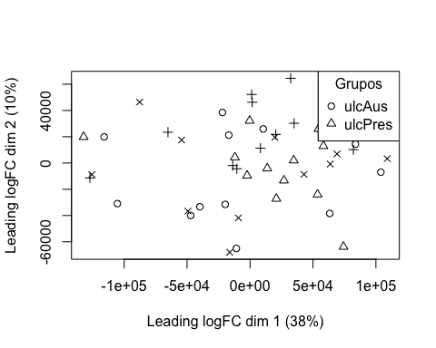

boxplot(targets$E, col = "royalblue", names = str_trunc(targets$targets$FileName, width = 10, side = "left"))

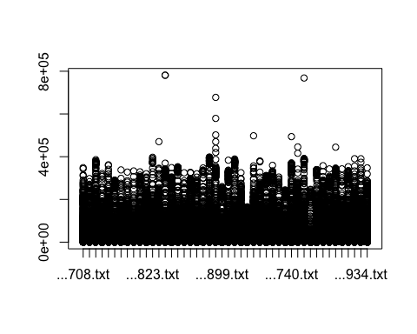

## 3. Preprocesado

### 3.1 Background

BK <- backgroundCorrect(targets, method ="normexp", printer=targets$printer, verbose=TRUE)

## Array 1 corrected  
## Array 2 corrected  
## Array 3 corrected  
## Array 4 corrected  
## Array 5 corrected  
## Array 6 corrected  
## Array 7 corrected  
## Array 8 corrected  
## Array 9 corrected  
## Array 10 corrected  
## Array 11 corrected  
## Array 12 corrected  
## Array 13 corrected  
## Array 14 corrected  
## Array 15 corrected  
## Array 16 corrected  
## Array 17 corrected  
## Array 18 corrected  
## Array 19 corrected  
## Array 20 corrected  
## Array 21 corrected  
## Array 22 corrected  
## Array 23 corrected  
## Array 24 corrected  
## Array 25 corrected  
## Array 26 corrected  
## Array 27 corrected  
## Array 28 corrected  
## Array 29 corrected  
## Array 30 corrected  
## Array 31 corrected  
## Array 32 corrected  
## Array 33 corrected  
## Array 34 corrected  
## Array 35 corrected  
## Array 36 corrected  
## Array 37 corrected  
## Array 38 corrected  
## Array 39 corrected  
## Array 40 corrected  
## Array 41 corrected  
## Array 42 corrected  
## Array 43 corrected  
## Array 44 corrected  
## Array 45 corrected  
## Array 46 corrected

### 3.2 Normalización

MA.p<-normalizeBetweenArrays(BK, method = 'quantile')  
transposed <- t(MA.p$E)  
df<-data.frame(value = transposed, group = as.character(Grupo))  
plotDensities(MA.p, legend = FALSE, type="1")

## Warning: In density.default(E[, a], n = npoint, na.rm = TRUE, ...) :  
## extra argument 'type' will be disregarded  
  
## Warning: In density.default(E[, a], n = npoint, na.rm = TRUE, ...) :  
## extra argument 'type' will be disregarded  
  
## Warning: In density.default(E[, a], n = npoint, na.rm = TRUE, ...) :  
## extra argument 'type' will be disregarded  
  
## Warning: In density.default(E[, a], n = npoint, na.rm = TRUE, ...) :  
## extra argument 'type' will be disregarded  
  
## Warning: In density.default(E[, a], n = npoint, na.rm = TRUE, ...) :  
## extra argument 'type' will be disregarded  
  
## Warning: In density.default(E[, a], n = npoint, na.rm = TRUE, ...) :  
## extra argument 'type' will be disregarded  
  
## Warning: In density.default(E[, a], n = npoint, na.rm = TRUE, ...) :  
## extra argument 'type' will be disregarded  
  
## Warning: In density.default(E[, a], n = npoint, na.rm = TRUE, ...) :  
## extra argument 'type' will be disregarded  
  
## Warning: In density.default(E[, a], n = npoint, na.rm = TRUE, ...) :  
## extra argument 'type' will be disregarded  
  
## Warning: In density.default(E[, a], n = npoint, na.rm = TRUE, ...) :  
## extra argument 'type' will be disregarded  
  
## Warning: In density.default(E[, a], n = npoint, na.rm = TRUE, ...) :  
## extra argument 'type' will be disregarded  
  
## Warning: In density.default(E[, a], n = npoint, na.rm = TRUE, ...) :  
## extra argument 'type' will be disregarded  
  
## Warning: In density.default(E[, a], n = npoint, na.rm = TRUE, ...) :  
## extra argument 'type' will be disregarded  
  
## Warning: In density.default(E[, a], n = npoint, na.rm = TRUE, ...) :  
## extra argument 'type' will be disregarded  
  
## Warning: In density.default(E[, a], n = npoint, na.rm = TRUE, ...) :  
## extra argument 'type' will be disregarded  
  
## Warning: In density.default(E[, a], n = npoint, na.rm = TRUE, ...) :  
## extra argument 'type' will be disregarded  
  
## Warning: In density.default(E[, a], n = npoint, na.rm = TRUE, ...) :  
## extra argument 'type' will be disregarded  
  
## Warning: In density.default(E[, a], n = npoint, na.rm = TRUE, ...) :  
## extra argument 'type' will be disregarded  
  
## Warning: In density.default(E[, a], n = npoint, na.rm = TRUE, ...) :  
## extra argument 'type' will be disregarded  
  
## Warning: In density.default(E[, a], n = npoint, na.rm = TRUE, ...) :  
## extra argument 'type' will be disregarded  
  
## Warning: In density.default(E[, a], n = npoint, na.rm = TRUE, ...) :  
## extra argument 'type' will be disregarded  
  
## Warning: In density.default(E[, a], n = npoint, na.rm = TRUE, ...) :  
## extra argument 'type' will be disregarded  
  
## Warning: In density.default(E[, a], n = npoint, na.rm = TRUE, ...) :  
## extra argument 'type' will be disregarded  
  
## Warning: In density.default(E[, a], n = npoint, na.rm = TRUE, ...) :  
## extra argument 'type' will be disregarded  
  
## Warning: In density.default(E[, a], n = npoint, na.rm = TRUE, ...) :  
## extra argument 'type' will be disregarded  
  
## Warning: In density.default(E[, a], n = npoint, na.rm = TRUE, ...) :  
## extra argument 'type' will be disregarded  
  
## Warning: In density.default(E[, a], n = npoint, na.rm = TRUE, ...) :  
## extra argument 'type' will be disregarded  
  
## Warning: In density.default(E[, a], n = npoint, na.rm = TRUE, ...) :  
## extra argument 'type' will be disregarded  
  
## Warning: In density.default(E[, a], n = npoint, na.rm = TRUE, ...) :  
## extra argument 'type' will be disregarded  
  
## Warning: In density.default(E[, a], n = npoint, na.rm = TRUE, ...) :  
## extra argument 'type' will be disregarded  
  
## Warning: In density.default(E[, a], n = npoint, na.rm = TRUE, ...) :  
## extra argument 'type' will be disregarded  
  
## Warning: In density.default(E[, a], n = npoint, na.rm = TRUE, ...) :  
## extra argument 'type' will be disregarded  
  
## Warning: In density.default(E[, a], n = npoint, na.rm = TRUE, ...) :  
## extra argument 'type' will be disregarded  
  
## Warning: In density.default(E[, a], n = npoint, na.rm = TRUE, ...) :  
## extra argument 'type' will be disregarded  
  
## Warning: In density.default(E[, a], n = npoint, na.rm = TRUE, ...) :  
## extra argument 'type' will be disregarded  
  
## Warning: In density.default(E[, a], n = npoint, na.rm = TRUE, ...) :  
## extra argument 'type' will be disregarded  
  
## Warning: In density.default(E[, a], n = npoint, na.rm = TRUE, ...) :  
## extra argument 'type' will be disregarded  
  
## Warning: In density.default(E[, a], n = npoint, na.rm = TRUE, ...) :  
## extra argument 'type' will be disregarded  
  
## Warning: In density.default(E[, a], n = npoint, na.rm = TRUE, ...) :  
## extra argument 'type' will be disregarded  
  
## Warning: In density.default(E[, a], n = npoint, na.rm = TRUE, ...) :  
## extra argument 'type' will be disregarded  
  
## Warning: In density.default(E[, a], n = npoint, na.rm = TRUE, ...) :  
## extra argument 'type' will be disregarded  
  
## Warning: In density.default(E[, a], n = npoint, na.rm = TRUE, ...) :  
## extra argument 'type' will be disregarded  
  
## Warning: In density.default(E[, a], n = npoint, na.rm = TRUE, ...) :  
## extra argument 'type' will be disregarded  
  
## Warning: In density.default(E[, a], n = npoint, na.rm = TRUE, ...) :  
## extra argument 'type' will be disregarded  
  
## Warning: In density.default(E[, a], n = npoint, na.rm = TRUE, ...) :  
## extra argument 'type' will be disregarded  
  
## Warning: In density.default(E[, a], n = npoint, na.rm = TRUE, ...) :  
## extra argument 'type' will be disregarded

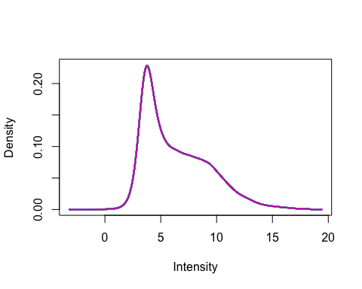

### 3.3 Anotación

MA.p$genes$EntrezID<- mapIds(HsAgilentDesign026652.db, MA.p$genes$ProbeName, keytype = "PROBEID", column = "ENTREZID")

## 'select()' returned 1:1 mapping between keys and columns

MA.p$genes$Symbol <- mapIds(HsAgilentDesign026652.db, MA.p$genes$ProbeName, keytype = "PROBEID", column = "SYMBOL")

## 'select()' returned 1:1 mapping between keys and columns

map=getGEO("GPL20844")

### 3.3 Filtrado

control_1 =MA.p$genes$ControlType == 1  
control_b= MA.p$genes$ControlType == -1

NoSym = is.na(MA.p$genes$Symbol)  
NoEnID= is.na(MA.p$genes$EntrezID)  
table(NoEnID)

## NoEnID  
## FALSE TRUE   
## 36037 26939

yfilt = MA.p[!control_1& !control_b & !NoSym & !NoEnID,]

boxplot(yfilt$E, col = "royalblue", names = str_trunc(targets$targets$FileName, width = 10, side = "left"))

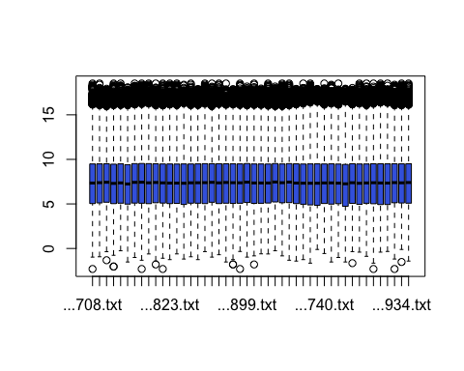

pcomp=prcomp(yfilt$E, scale. = TRUE)  
eso=summary(pcomp)  
eso

## Importance of components:  
## PC1 PC2 PC3 PC4 PC5 PC6 PC7  
## Standard deviation 6.5071 0.92585 0.54649 0.47827 0.47377 0.45669 0.35493  
## Proportion of Variance 0.9205 0.01863 0.00649 0.00497 0.00488 0.00453 0.00274  
## Cumulative Proportion 0.9205 0.93911 0.94561 0.95058 0.95546 0.95999 0.96273  
## PC8 PC9 PC10 PC11 PC12 PC13 PC14  
## Standard deviation 0.32985 0.32571 0.31129 0.29972 0.29730 0.28217 0.26379  
## Proportion of Variance 0.00237 0.00231 0.00211 0.00195 0.00192 0.00173 0.00151  
## Cumulative Proportion 0.96510 0.96740 0.96951 0.97146 0.97338 0.97511 0.97663  
## PC15 PC16 PC17 PC18 PC19 PC20 PC21  
## Standard deviation 0.26047 0.24819 0.24130 0.23602 0.2252 0.22088 0.21376  
## Proportion of Variance 0.00147 0.00134 0.00127 0.00121 0.0011 0.00106 0.00099  
## Cumulative Proportion 0.97810 0.97944 0.98071 0.98192 0.9830 0.98408 0.98507  
## PC22 PC23 PC24 PC25 PC26 PC27 PC28  
## Standard deviation 0.21149 0.20993 0.20580 0.19896 0.18778 0.18575 0.18195  
## Proportion of Variance 0.00097 0.00096 0.00092 0.00086 0.00077 0.00075 0.00072  
## Cumulative Proportion 0.98605 0.98700 0.98793 0.98879 0.98955 0.99030 0.99102  
## PC29 PC30 PC31 PC32 PC33 PC34 PC35  
## Standard deviation 0.17873 0.17700 0.17399 0.16827 0.16482 0.16282 0.15839  
## Proportion of Variance 0.00069 0.00068 0.00066 0.00062 0.00059 0.00058 0.00055  
## Cumulative Proportion 0.99172 0.99240 0.99306 0.99367 0.99426 0.99484 0.99538  
## PC36 PC37 PC38 PC39 PC40 PC41 PC42  
## Standard deviation 0.15660 0.15277 0.14789 0.14622 0.13827 0.13764 0.1361  
## Proportion of Variance 0.00053 0.00051 0.00048 0.00046 0.00042 0.00041 0.0004  
## Cumulative Proportion 0.99592 0.99642 0.99690 0.99736 0.99778 0.99819 0.9986  
## PC43 PC44 PC45 PC46  
## Standard deviation 0.13025 0.12902 0.12643 0.12266  
## Proportion of Variance 0.00037 0.00036 0.00035 0.00033  
## Cumulative Proportion 0.99896 0.99933 0.99967 1.00000

com=as.data.frame(pcomp$x)  
ggplot(com, aes(PC1, PC2)) + geom_point()+theme_bw(base_size=32)+xlab(paste("PC1:",eso$importance[2,1])) + ylab(paste("PC2:",eso$importance[2,2]))+theme(legend.position="top")

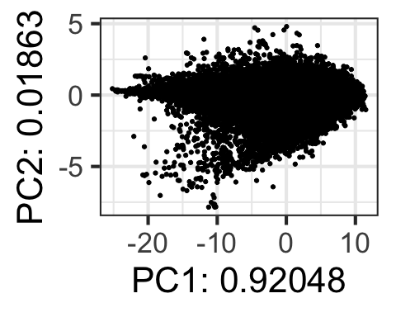

## 4. Expresión Diferencial

### 4.1 Modelización y Regresión

design <- model.matrix(~0+Grupo)  
colnames(design) = c(params$ulcAus, params$ulcPres)  
design

## ulcAus ulcPres  
## 1 1 0  
## 2 1 0  
## 3 1 0  
## 4 1 0  
## 5 1 0  
## 6 1 0  
## 7 1 0  
## 8 1 0  
## 9 1 0  
## 10 1 0  
## 11 1 0  
## 12 1 0  
## 13 1 0  
## 14 1 0  
## 15 1 0  
## 16 1 0  
## 17 1 0  
## 18 1 0  
## 19 1 0  
## 20 1 0  
## 21 1 0  
## 22 1 0  
## 23 1 0  
## 24 1 0  
## 25 1 0  
## 26 1 0  
## 27 1 0  
## 28 1 0  
## 29 0 1  
## 30 0 1  
## 31 0 1  
## 32 0 1  
## 33 0 1  
## 34 0 1  
## 35 0 1  
## 36 0 1  
## 37 0 1  
## 38 0 1  
## 39 0 1  
## 40 0 1  
## 41 0 1  
## 42 0 1  
## 43 0 1  
## 44 0 1  
## 45 0 1  
## 46 0 1  
## attr(,"assign")  
## [1] 1 1  
## attr(,"contrasts")  
## attr(,"contrasts")$Grupo  
## [1] "contr.treatment"

fit = lmFit(yfilt, design)

parametre1 = params$ulcAus  
parametre2 = params$ulcPres  
  
contraste = makeContrasts(ulcAus-ulcPres, levels = design)  
fit2 = contrasts.fit(fit, contraste)  
fit2 = eBayes(fit2)

### 4.2 Resultados

topTable(fit2, adjust.method = "bonferroni", n=30)

## Row Col ControlType ProbeName SystematicName EntrezID Symbol  
## 10920 67 96 0 A_23_P64161 NM_178127 253935 ANGPTL5  
## 24199 148 91 0 A_24_P397386 NM_002310 3977 LIFR  
## 38935 238 67 0 A_32_P309404 AK096980 6581 SLC22A3  
## 39430 241 70 0 A_23_P81158 NM_000669 126 ADH1C  
## 41342 253 14 0 A_23_P323272 NM_145260 130497 OSR1  
## 62676 383 28 0 A_23_P251132 NM_018968 54221 SNTG2  
## 13805 85 29 0 A_23_P103256 NM_021023 10878 CFHR3  
## 37510 229 118 0 A_23_P156708 NM_032470 7148 TNXB  
## 62816 384 4 0 A_23_P103256 NM_021023 10878 CFHR3  
## 55298 338 30 0 A_23_P103256 NM_021023 10878 CFHR3  
## 34433 210 157 0 A_33_P3381338 NM_019105 7148 TNXB  
## 40061 245 45 0 A_23_P103256 NM_021023 10878 CFHR3  
## 57813 353 85 0 A_23_P56578 NM_053276 5212 VIT  
## 48740 298 32 0 A_23_P103256 NM_021023 10878 CFHR3  
## 48422 296 42 0 A_23_P103256 NM_021023 10878 CFHR3  
## 53706 328 78 0 A_23_P103256 NM_021023 10878 CFHR3  
## 11351 70 35 0 A_23_P103256 NM_021023 10878 CFHR3  
## 25548 156 128 0 A_33_P3318288 NM_001014975 3075 CFH  
## 48826 298 118 0 A_23_P386942 NM_145173 148252 DIRAS1  
## 23034 141 74 0 A_24_P87036 NM_018043 55107 ANO1  
## 4083 25 147 0 A_23_P69497 NM_003278 7123 CLEC3B  
## 43341 265 45 0 A_33_P3315288 NM_175078 374454 KRT77  
## 24807 152 43 0 A_24_P146683 NM_002443 4477 MSMB  
## 34374 210 98 0 A_23_P119562 NM_001928 1675 CFD  
## 3267 20 151 0 A_23_P103256 NM_021023 10878 CFHR3  
## 35585 217 161 0 A_33_P3215640 NM_153370 221476 PI16  
## 15582 96 2 0 A_23_P103765 NM_002001 2205 FCER1A  
## 55181 337 77 0 A_23_P372834 NM_198098 358 AQP1  
## 25995 159 83 0 A_23_P103765 NM_002001 2205 FCER1A  
## 56703 346 123 0 A_33_P3390868 NM_133477 171024 SYNPO2  
## logFC AveExpr t P.Value adj.P.Val B  
## 10920 2.549956 5.495729 6.178705 1.314310e-07 0.004736381 7.255442  
## 24199 1.809618 6.343719 5.936980 3.082033e-07 0.011106722 6.485961  
## 38935 1.463296 4.496525 5.891695 3.614238e-07 0.013024628 6.342035  
## 39430 2.927456 7.605161 5.717792 6.654069e-07 0.023979268 5.790298  
## 41342 1.010887 3.540319 5.647023 8.524040e-07 0.030718082 5.566315  
## 62676 1.501331 6.160908 5.627298 9.132510e-07 0.032910827 5.503948  
## 13805 1.893350 9.007932 5.618680 9.411686e-07 0.033916893 5.476711  
## 37510 2.399308 11.755386 5.589409 1.042469e-06 0.037567440 5.384238  
## 62816 1.807538 8.968417 5.558297 1.162007e-06 0.041875261 5.286027  
## 55298 1.802454 9.070895 5.536159 1.255250e-06 0.045235439 5.216194  
## 34433 1.981274 9.792894 5.484170 1.504390e-06 0.054213693 5.052374  
## 40061 1.832876 9.175774 5.481025 1.520944e-06 0.054810256 5.042472  
## 57813 2.273645 7.087053 5.454819 1.666080e-06 0.060040520 4.959997  
## 48740 1.826195 9.048606 5.440029 1.753962e-06 0.063207536 4.913480  
## 48422 1.792540 9.133481 5.425971 1.841746e-06 0.066370991 4.869286  
## 53706 1.860247 9.243434 5.416364 1.904221e-06 0.068622430 4.839096  
## 11351 1.808187 9.071425 5.393604 2.060731e-06 0.074262545 4.767614  
## 25548 1.833898 10.758991 5.379303 2.165523e-06 0.078038956 4.722724  
## 48826 -1.639153 9.379475 -5.376143 2.189377e-06 0.078898577 4.712809  
## 23034 1.207657 7.971266 5.373157 2.212162e-06 0.079719667 4.703439  
## 4083 2.278325 11.968857 5.364078 2.282877e-06 0.082268042 4.674961  
## 43341 3.471566 9.272888 5.355474 2.351957e-06 0.084757488 4.647981  
## 24807 2.856642 8.469554 5.339308 2.487401e-06 0.089638480 4.597307  
## 34374 2.128128 13.908172 5.324171 2.621201e-06 0.094460227 4.549887  
## 3267 1.753331 8.995464 5.309047 2.761993e-06 0.099533946 4.502533  
## 35585 3.873431 10.822247 5.275694 3.099456e-06 0.111695104 4.398200  
## 15582 2.360135 8.624860 5.260135 3.270517e-06 0.117859604 4.349577  
## 55181 1.399767 14.220225 5.233875 3.580638e-06 0.129035452 4.267581  
## 25995 2.139296 9.312823 5.208000 3.914598e-06 0.141070361 4.186872  
## 56703 1.790208 7.631089 5.185315 4.232577e-06 0.152529390 4.116185

tT=topTable(fit2, adjust.method = "bonferroni", n=3000)  
  
results = decideTests(fit2, p.value = 0.1)  
summary(decideTests(fit2), p.value = 0.1)

## ulcAus - ulcPres  
## Down 605  
## NotSig 34278  
## Up 1154

EnhancedVolcano(tT, lab = tT$Symbol, x = "logFC", y = "adj.P.Val", pCutoff = 0.05, FCcutoff=2, labSize = 6.0, ylim=0.95)

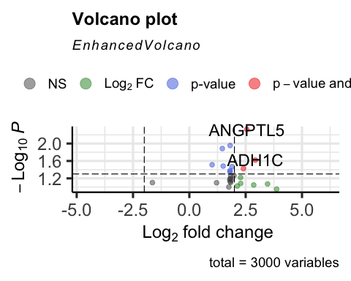

vennDiagram(results, include=c("both"), circle.col = "red", counts.col = "blue", names = c("CHD9-CTL"))

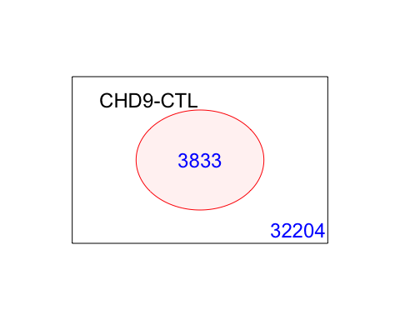

## 5. Gene Enrichment Analysis

### Gene Ontology

g = goana(fit2, species="Hs", geneid = fit2$genes$EntrezID, FDR = 0.05)  
topGO(g, n=20)

## Term Ont N Up Down  
## GO:0071944 cell periphery CC 5762 343 76  
## GO:0008544 epidermis development BP 371 60 5  
## GO:0009888 tissue development BP 1926 153 24  
## GO:0048513 animal organ development BP 3003 199 45  
## GO:0043588 skin development BP 305 48 3  
## GO:0005886 plasma membrane CC 5295 297 71  
## GO:0005576 extracellular region CC 3992 239 59  
## GO:0048856 anatomical structure development BP 5699 309 105  
## GO:0060429 epithelium development BP 1187 100 16  
## GO:0009653 anatomical structure morphogenesis BP 2608 169 49  
## GO:0030216 keratinocyte differentiation BP 171 32 0  
## GO:0009913 epidermal cell differentiation BP 236 37 2  
## GO:0032502 developmental process BP 6265 323 121  
## GO:0007155 cell adhesion BP 1478 110 14  
## GO:0031012 extracellular matrix CC 546 57 8  
## GO:0030312 external encapsulating structure CC 547 57 8  
## GO:0062023 collagen-containing extracellular matrix CC 409 47 7  
## GO:0005615 extracellular space CC 3138 184 49  
## GO:0030855 epithelial cell differentiation BP 699 64 5  
## GO:0003674 molecular_function MF 17308 692 372  
## P.Up P.Down  
## GO:0071944 3.902698e-26 0.99999968  
## GO:0008544 1.325041e-22 0.88538099  
## GO:0009888 5.278768e-21 0.99831072  
## GO:0048513 2.389439e-18 0.99446927  
## GO:0043588 8.317864e-18 0.95342853  
## GO:0005886 1.412820e-17 0.99999758  
## GO:0005576 7.722768e-17 0.99903141  
## GO:0048856 2.895069e-16 0.93104247  
## GO:0060429 2.384360e-15 0.97736750  
## GO:0009653 1.658847e-14 0.78888003  
## GO:0030216 1.887348e-14 1.00000000  
## GO:0009913 5.811234e-14 0.95784469  
## GO:0032502 5.927284e-14 0.83596134  
## GO:0007155 3.600532e-13 0.99982922  
## GO:0031012 8.539815e-13 0.88127666  
## GO:0030312 9.212149e-13 0.88245265  
## GO:0062023 3.201562e-12 0.74584816  
## GO:0005615 8.256757e-12 0.98958574  
## GO:0030855 1.137370e-11 0.99897857  
## GO:0003674 1.682104e-11 0.04117615

### KEGG

k = kegga(fit2, species="Hs", geneid = fit2$genes$EntrezID, FDR = 0.05)  
topKEGG(k, number = 20)

## Pathway N Up  
## hsa00980 Metabolism of xenobiotics by cytochrome P450 64 14  
## hsa00982 Drug metabolism - cytochrome P450 58 13  
## hsa04530 Tight junction 165 22  
## hsa04110 Cell cycle 157 0  
## hsa04061 Viral protein interaction with cytokine and cytokine receptor 97 15  
## hsa05204 Chemical carcinogenesis - DNA adducts 54 10  
## hsa05200 Pathways in cancer 525 39  
## hsa05202 Transcriptional misregulation in cancer 185 19  
## hsa05150 Staphylococcus aureus infection 88 12  
## hsa04060 Cytokine-cytokine receptor interaction 290 24  
## hsa00830 Retinol metabolism 57 9  
## hsa00140 Steroid hormone biosynthesis 51 8  
## hsa00600 Sphingolipid metabolism 53 8  
## hsa04914 Progesterone-mediated oocyte maturation 95 1  
## hsa04360 Axon guidance 181 16  
## hsa00340 Histidine metabolism 22 5  
## hsa02010 ABC transporters 45 7  
## hsa00590 Arachidonic acid metabolism 60 8  
## hsa01232 Nucleotide metabolism 83 2  
## hsa00350 Tyrosine metabolism 36 6  
## Down P.Up P.Down  
## hsa00980 0 5.559672e-08 1.000000e+00  
## hsa00982 0 1.221389e-07 1.000000e+00  
## hsa04530 1 1.488177e-07 9.687596e-01  
## hsa04110 16 1.000000e+00 1.775022e-07  
## hsa04061 2 2.165855e-06 5.997364e-01  
## hsa05204 0 2.140033e-05 1.000000e+00  
## hsa05200 10 2.162676e-05 6.500717e-01  
## hsa05202 3 4.718499e-05 7.403270e-01  
## hsa05150 2 7.989358e-05 5.467344e-01  
## hsa04060 4 1.658189e-04 8.538437e-01  
## hsa00830 0 1.995481e-04 1.000000e+00  
## hsa00140 0 4.698594e-04 1.000000e+00  
## hsa00600 1 6.135687e-04 6.705396e-01  
## hsa04914 8 9.706158e-01 7.995684e-04  
## hsa04360 3 9.716039e-04 7.268222e-01  
## hsa00340 0 9.870496e-04 1.000000e+00  
## hsa02010 0 1.112642e-03 1.000000e+00  
## hsa00590 1 1.417367e-03 7.155382e-01  
## hsa01232 7 8.096507e-01 1.668346e-03  
## hsa00350 3 1.737921e-03 3.801591e-02