# Hands-on using Cytoscape

## Preparation

Open Cytoscape v3.10.1

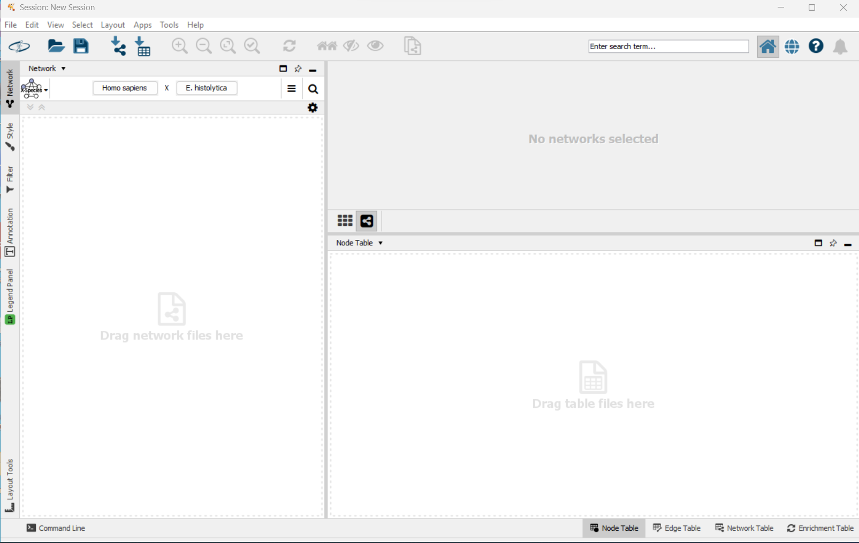

First install the stringApp

Go to Apps -> App Store -> Show App Store. Start with searching for stringApp

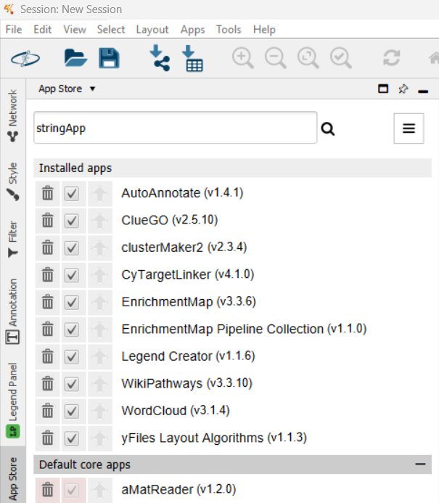

Now the Cytoscape app store is opened in your web browser

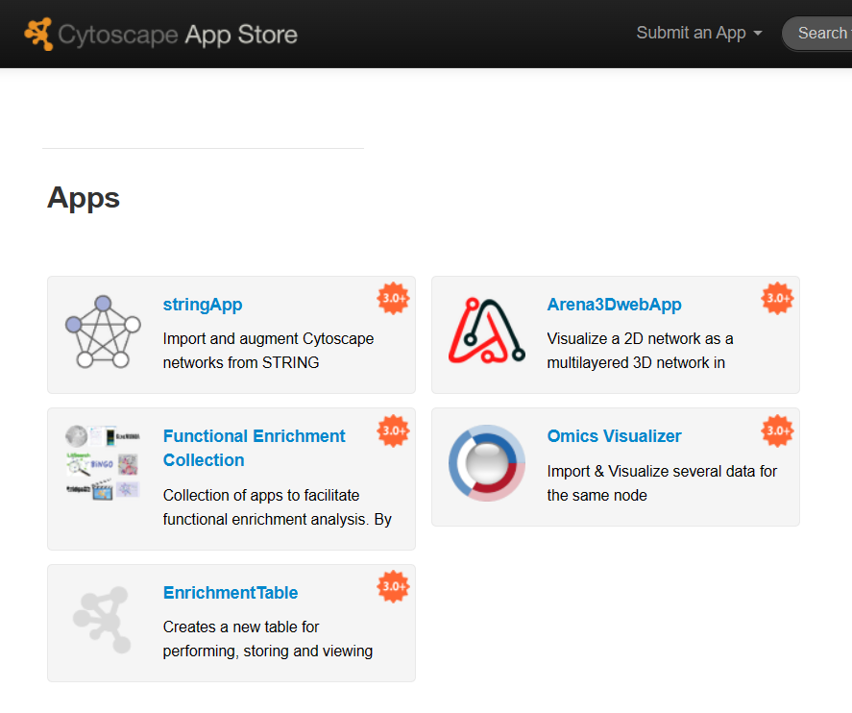

Click at the stringApp and, thereafter click at Install

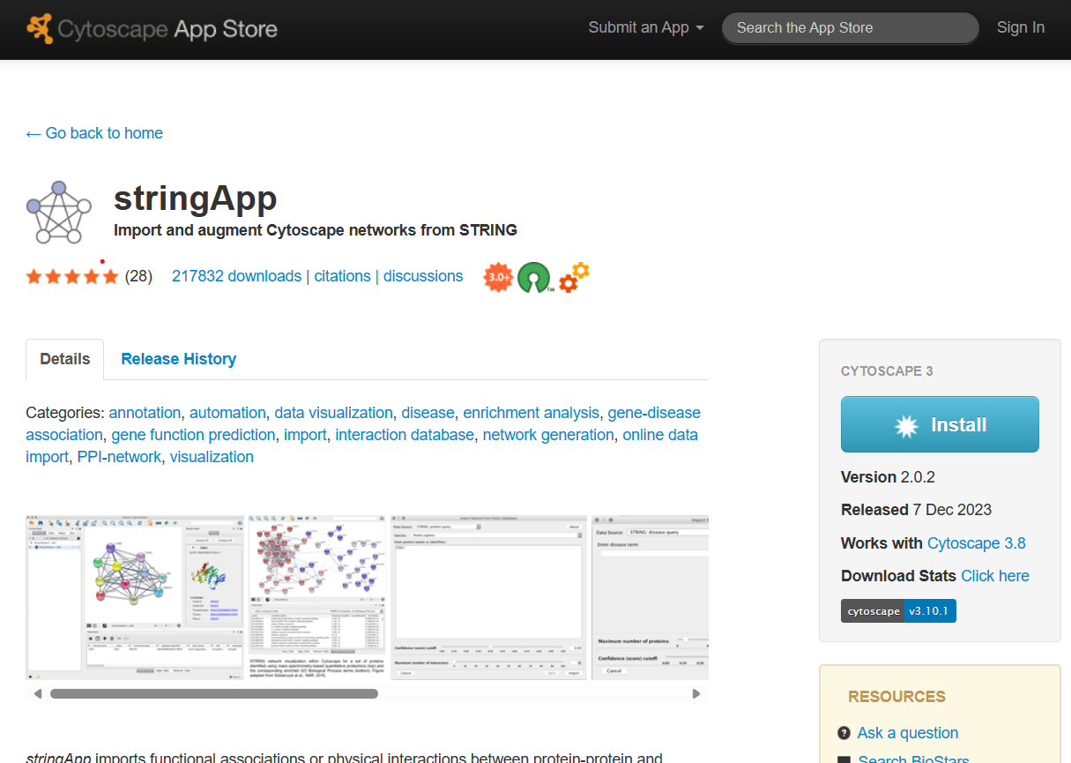

Now the stringApp is installed in Cytoscape.

## Assignment 1: Create a protein-protein network with de differentially upregulated genes

1. Download the spreadsheet with significantly upregulated genes, file: SigUP_F.csv
2. Copy the column with the Ensembl indentifiers (226 genes)
3. Open Cytoscape and click at Network on the left hands side
4. Go to the STRING: protein query

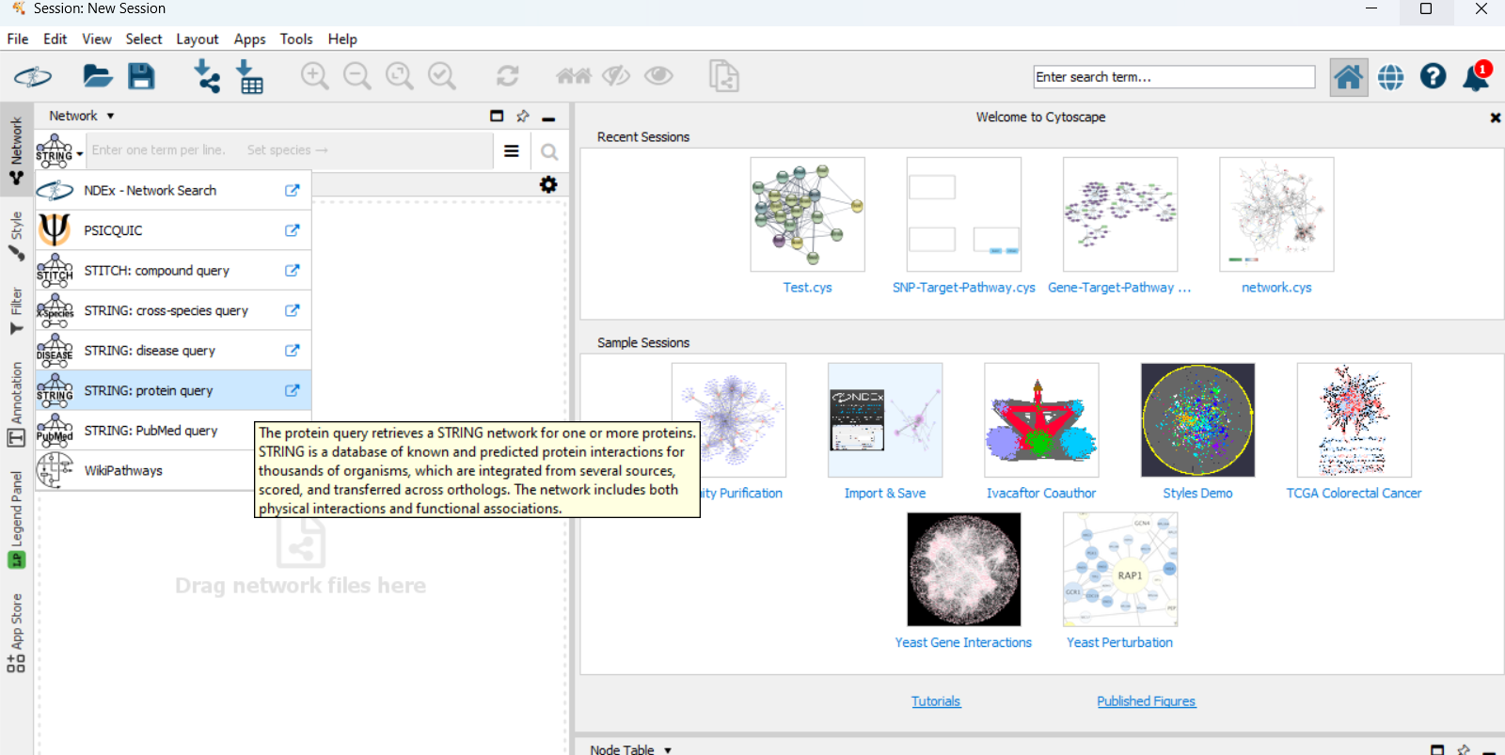

1. Paste the list of Ensembl Identifiers and click at the three lines next to the query

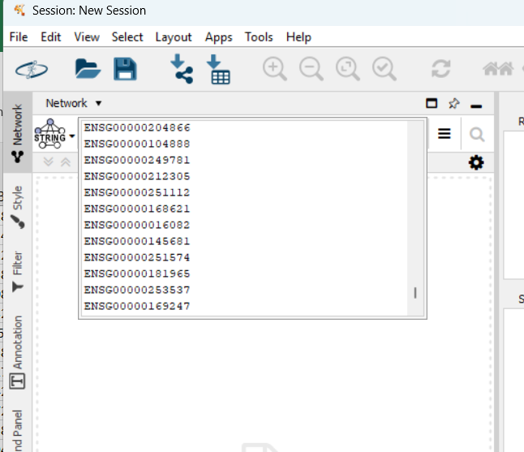

1. Start with setting the confidence score to 0.4 and make sure NO additional interactions are added to the network. Thereafter start with searching the network

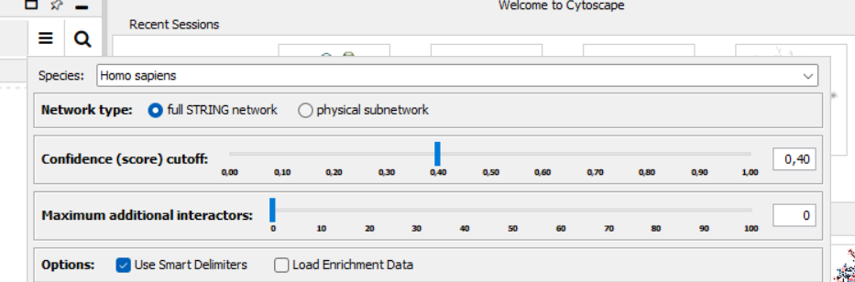

We will now explore the created protein-protein network together.

## Assignment 2: Analyze the PPI network

1. Go to Tools -> Analyze Network
2. It is not a directed network, so you don’t need select it.
3. At the right hand side, a legend “Analyze” is visible

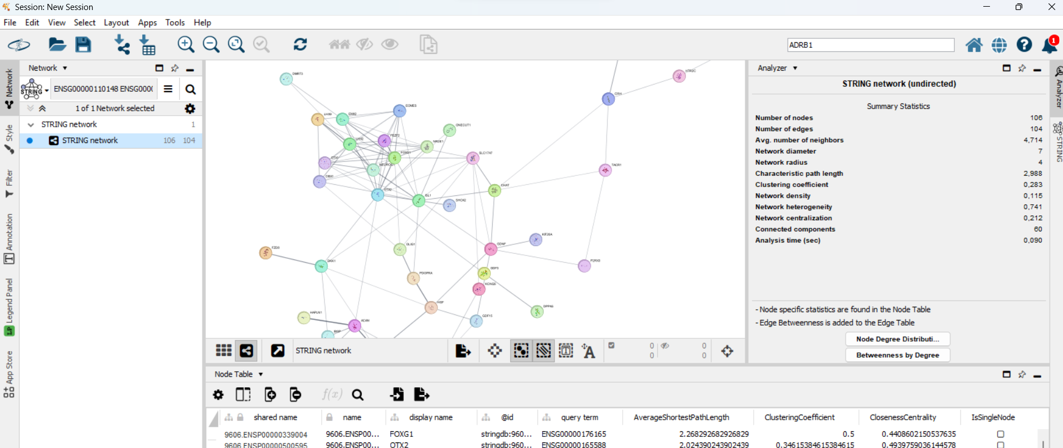

1. Click in the legend at “Node Degree Distribution” and explain the figure
2. In the node table which of the gene(s) have the highest degree?
3. What is the BetweennessCentrality of the gene(s)? What does this mean?

## Assignment 3: Open a PPI linked to schizophrenia

1. Go to the String Disease queary and search for Schizophrenia

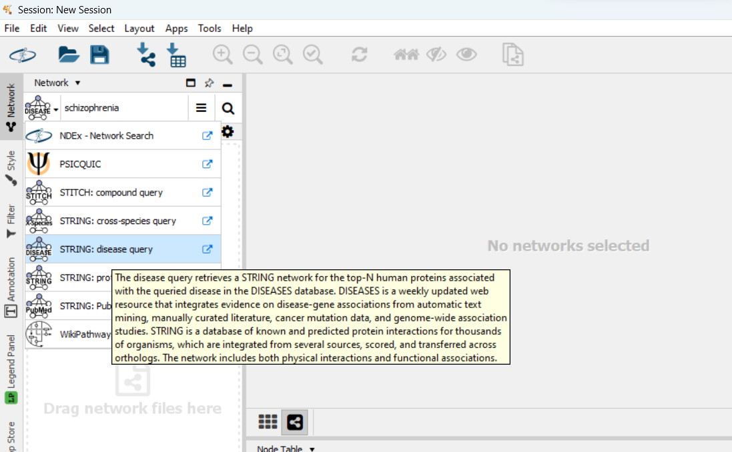

1. Select the first term in the list with a DOID: 5419

The confidence score cut-off should be 0.7 and the max number of proteins should be 100.

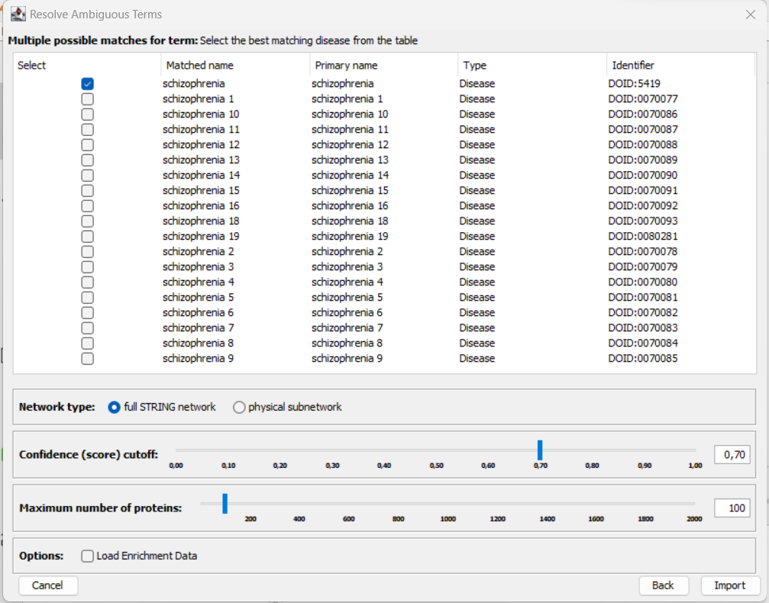

1. How many egdes (links) are between the proteins?

## Assignment 4: Open a WikiPathways pathway related to Copy Number Variations

1. Go to Network, select the WikiPathways query and search the pathway “Disruption of postsynaptic signaling by CNV” by using the WikiPathways identifier - WP4875 in Homo Sapiens.

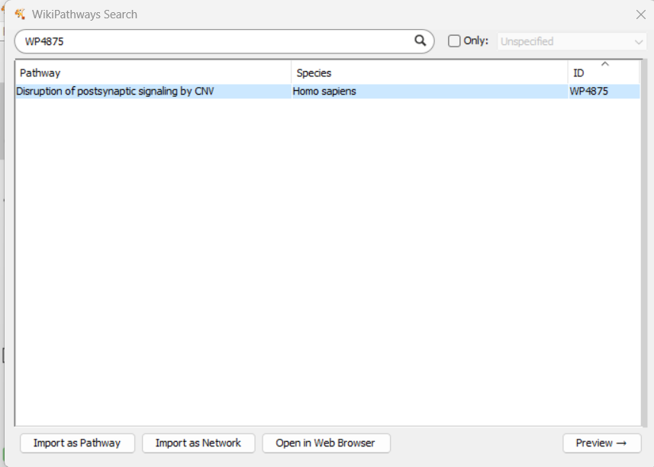

1. Now you can choose whether you want to import the pathway as pathway or as network. Try both and compare the two networks. What is different between the two?