Interactive Predictive Toxicology with Bioclipse - OpenTox

Egon Willighagen¹, Roman Affentranger², Roland Grafström^{1,3}, Barry Hardy², Nina Jeliazkova⁴, Ola Spjuth⁵.
1.Division of Molecular Toxicology, Institute of Environmental Medicine, Karolinska Institutet, SE-17177 Stockholm, Sweden
2.Douglas Connect, Baermeggenweg 14, 4314 Zeiningen, Switzerland
3.VTT Technical Research Center of Finland, Medical Biotechnology, FI-20521 Turku, Finland
4.Ideaconsult Ltd, A. Kanchev 4, Sofia 1000, Bulgaria
5.Department of Pharmaceutical Biosciences, Uppsala University, SE-75124 Uppsala, Sweden

Much is already known about the toxicity of small molecules, but yet it is a challenge to predict the toxicology of new compounds. At the same time, society demands insight in the toxicity of compounds, such as outlined by the REACH regulations in the European Union (EuropeainParliament & EuropeanCommision, 2006). Where and when experimental testing of toxicity is expensive or too cumbersome, experimental data may under certain conditions be complemented by alternative methods. Among these alternative methods are computational tools that predict a wide-variety of toxicological properties. Read-across and QSAR approaches are commonly used here, and a good coverage of predictions will many alternative models can help get a good feeling for the toxicity of the compound.

Such predictive toxicology draws knowledge from many independent sources which need to be integrated to provide a weight of evidence on the toxicity of untested chemical compounds. Typical sources include in vivo and in vitro experimental databases such as ToxCast (Knudsen et al., 2011) and SuperToxic (Schmidt et al., 2009), literature-derived databases, such as SIDER summarizing adverse reactions (M. Kuhn, Campillos, Letunic, Jensen, & Bork, 2010), but also computational resources based on toxicity data for other compounds including DSSTox (Williams-DeVane, Wolf, & Richard, 2009). And somehow, all this information should be aggregated and presented to the user in way that various, potentially contradiction, pieces of information results in a weighted decision on the toxicity of the compound.

Visualization of this information is, therefore, an important tool, and should preferable linked to the chemical structure of the compound itself. Further visualization that will be important is that of relevant life science data, such as gene, protein and biological pathway information (Huang, Sherman, & Lempicki, 2009) (Kelder et al., 2009) (Kanehisa & Goto, 2000) or metabolic reactions (Rydberg, Gloriam, & Olsen, 2010). Bioclipse was designed to provide such interactive data analysis for the life sciences, though the latter resources are not yet as tightly integrated as other sources.

Underlying this knowledge integration there must be a platform that allows you to use a multiple of prediction services. This is exactly what the Bioclipse-OpenTox platform is providing, which we recently introduced (E L Willighagen, N Jeliazkova, B Hardy, Grafström, & O Spjuth, 2011b). This chapter will describe how this platform can be used to interactively study the toxicity of chemical structures using computational toxicology tools. Its ability to interactively predict toxicity and the ability to dynamically discover computational services, allows the use to get the latest insights in toxicity predictions while while hiding technicalities. Other tools that provide similar functionality include the QSAR ToolBox (Diderichs, 2010) (“QSAR ToolBox,” n d) and ToxTree (Patlewicz, N Jeliazkova, Safford, Worth, & Aleksiev, 2008) (“ToxTree,” n d). Bioclipse, however, is not a platform targeted at toxicity alone, and has been used for other scientific fields too, taking advantage of the easy by which other functionality, both local and remote, can be integrated (Ola Spjuth et al., 2007) (Ola Spjuth, Alvarsson, Berg, Eklund, S. Kuhn, Mäsak, Torrance, Wagener, Egon L Willighagen, Steinbeck, & J. E. S. Wikberg, 2009a) (Ola Spjuth, Eklund, Ahlberg Helgee, Boyer, & Carlsson, 2011).

This chapter will not go into too much technical detail, and instead of a two example use cases of the platform. Detailed descriptions can be found the paper describing the OpenTox Application Programming Interface (API) (Barry Hardy et al., 2010), the AMBIT implementation of these APIs (Nina Jeliazkova & Jeliazkov, 2011), the second Bioclipse paper describing the scriptability (Ola Spjuth, Alvarsson, Berg, Eklund, S. Kuhn, Mäsak, Torrance, Wagener, Egon L Willighagen, Steinbeck, & J. E. S. Wikberg, 2009b)⁠, our recent paper that describes how we integrated these tools (E L Willighagen, N Jeliazkova, B Hardy, Grafström, & O Spjuth, 2011a), and the paper describing the technologies used to glue together the components (Egon L Willighagen, Alvarsson, Andersson, Eklund, Lampa, et al., 2011). For the user of the platform is suffices to know that all functionality of the Bioclipse-OpenTox interoperability is accessible both graphically as well as by means of scripting. Table 1 shows an overview of all functionality that is currently available.

Table 1: Bioclipse-OpenTox functionality from the Graphical User Interface is also available from the scripting environment. Scriptable command (left column) and description (right column) for various groups of functionality are provided in this table.

Authentication
login(accountname, password) | Authenticate the user with OpenSSO and login on the OpenTox network.
logout() | Logout from the OpenTox network.
getToken() | Returns a security token when Bioclipse is logged in on the OpenTox network.
Computation
calculateDescriptor(service, descriptor, molecules) | Calculates a descriptor value for a set of molecules.
calculateDescriptor(service, descriptor, molecule) | Calculates a descriptor value for a single molecule.
predictWithModel(service, model, molecules) | Predicts modeled properties for the given list of  molecules.
predictWithModel(service, model, molecule) | Predicts modeled properties for the given molecule.
Data exchange
createDataset(service) | Creates a new data set on an OpenTox server.
createDataset(service, molecules) | Creates a new data set on an OpenTox server and adds the given molecules.
createDataset(service, molecule) | Creates a new data set on an OpenTox server and adds a single molecule.
addMolecule(dataset, mol) | Adds a molecule to an existing data set.
addMolecules(dataset, molecules) | Adds a list of molecules to an existing data set.
deleteDataset(dataset) | Deletes a data set.
downloadCompoundAsMDLMolﬁle(service, dataset, molecule) | Downloads a molecule from a data set as a MDL molﬁle.
downloadDataSetAsMDLSDﬁle(service, dataset, ﬁlename) | Download a complete data set as MDL SD ﬁle and saves it to a local ﬁle in the Bioclipse workspace.
listCompounds(service, dataset) | Lists the molecules in a data set.
Querying
listModels(service) | Lists the predictive models available from the given service.
getFeatureInfo(ontologyServer, feature) | Returns information about a particular molecular feature (property).
getFeatureInfo(ontologyServer, features) | Returns information about a set of molecular features.
getModelInfo(ontologyServer, model) | Returns information for a computational model.
getModelInfo(ontologyServer, models) | Returns information for a list of computational models.
getAlgorithmInfo(ontologyServer, algorithm) | Returns information for a computational algorithm.
getAlgorithmInfo(ontologyServer, algorithms) | Returns information for a list of computational algorithms.
listAlgorithms(ontologyServer) | Returns a list of algorithms.
listDescriptors(ontologyServer) | Returns a list of descriptor algorithms.
listDataSets(service) | Returns the data sets available at the given OpenTox server.
searchDataSets(ontologyServer, query) | Returns matching data sets using a free text search.
search(service, inchi) | Returns matching structures based on the InChI given.
search(service, molecule) | Returns matching structures based on the molecule given.

This chapter will first outline a few basic tasks one can perform with the Bioclipse – OpenTox platform, including the calculation of molecular descriptors (which can also be used to calculate properties important to toxicology, including logP and pK_{a}), the sharing of data on toxins and toxicants online, and how Bioclipse supports the authorization and authentication on the OpenTox network. After that, two more elaborate use cases will be presented.

Basic Bioclipse – OpenTox interaction Examples
As introduction to the Bioclipse-OpenTox interoperability, this chapter will first introduce a few short examples. First, Figure 1 shows the Bioclipse QSAR environment for calculating molecular properties and theoretical descriptors (Ola Spjuth, Egon L Willighagen, Guha, Eklund, & J. E. E. Wikberg, 2010). This environment has been extended to discover OpenTox services on the internet. Using this approach, Bioclipse has access to the most recent descriptors relevant to toxicity predictions. The figure shows the equivalence of a number of descriptors provided by both local services (CDK and CDK REST, provided by the Chemistry Development Kit library (Steinbeck et al., 2006)) and OpenTox, as well as the Ionization Potential descriptor provided only via an OpenTox computational service. Practically, these online computational services are found by querying a registry of OpenTox services: this registry makes use of the OpenTox ontology (Barry Hardy et al., 2010) which Bioclipse queries, as outlined in (E L Willighagen, N Jeliazkova, B Hardy, Grafström, & O Spjuth, 2011a)⁠. The ability to compute descriptors using various local and remote provides, creates a flexible application for the integration of numerical input for statistical modeling of toxicologically relevant endpoints, as well as the comparison of various predictive models for a more balanced property analysis.

Figure 1 : Integration of online OpenTox descriptor calculation services in the Bioclipse QSAR environment. Molecular descriptors are much used in computational toxicology models. This screenshot from Bioclipse QSAR shows descriptors discovered on the Internet (providers: OpenTox and CDK REST) in combination with local software (provider: CDK).

A second basic example is the sharing of data on the OpenTox network, which we will also use to demonstrate how all Graphical User Interface (GUI) interaction in Bioclipse is using the BSL script extension for the OpenTox API. For example, Figure 2 shows the Bioclipse dialog for uploading a small data set with ten neurotoxin structures to an OpenTox server. This dialog asks to which OpenTox server the structures should be uploaded (the Ambit2 server is selected, http://apps.ideaconsult.net:8080/ambit2/), a title under which this data set will be available (“Ten neurotoxins found in Wikipedia”), and the data license under which the data will be available to others (the Creative Commons Zero license in this case (“CC0 1.0 Universal Public Domain Dedication,” n d)).

At a scripting level, this dialog makes use of the createDataSet(service, molecules), setDatasetLicense(datasetURI, licenseURI), and setDatasetTitle(datasetURI, title) commands, as listed in Table 1. The latter two methods use the data set's Universal Resource Identifier (URI) returned by the first method. Therefore, the matching BSL JavaScript would look like:
service = “http://apps.ideaconsult.net:8080/ambit2/”;
neurotoxins = cdk.loadMolecules("/OpenTox/neurotoxins.sdf");
datasetURI = opentox.createDataset(service, neurotoxins);
opentox.setDatasetLicense(
datasetURI,
“http://creativecommons.org/publicdomain/zero/1.0/”
);
opentox.setDatasetTitle(
datasetURI,
“Ten neurotoxins found in Wikipedia”
);
The dialog, however, opens the data set's web page in a browser window in Bioclipse (see Figure 3) when the upload has finished. This is currently not possible using the scripting language.

Most of the other Bioclipse-OpenTox integration takes advantage of the fact that Bioclipse has all graphical user interface (GUI) functionality matched by a scripted equivalent too. The use of the BSL directly, allows interaction with the OpenTox network to be automated, combined with other Bioclipse functionality into larger workflows, and makes it easier to share procedures with others, using social scientific sites like MyExperiment (Goble et al., 2010).
For example, a BSL script equivalent for the earlier descriptor calculation GUI would like like:

service = "http://apps.ideaconsult.net:8080/ambit2/";
serviceSPARQL = "http://apps.ideaconsult.net:8080/ontology/";
stringMat = opentox.listDescriptors(serviceSPARQL);
descriptor = stringMat.get(1,”algo”);
molecules = cdk.createMoleculeList();
molecules.add(
cdk.fromSMILES("CC(=O)C1=CC=C(C=C1)N")
);
molecules.add(
cdk.fromSMILES("C1=CC=C(C(=C1)CC(=O)O)NC2=C(C=CC=C2C1)C1")
);
js.say(
descriptor + " - " +
opentox.calculateDescriptor(service, descriptor, molecules)
);

This script combines functionality from the Chemistry Development Kit plugin for Bioclipse via the cdk BSL extension with the OpenTox functionality provided by the opentox extension.
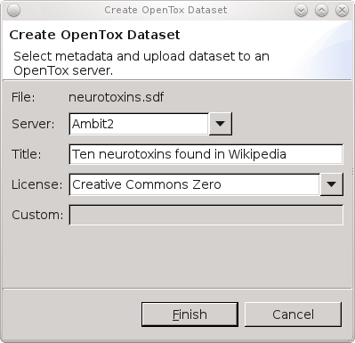
Figure 2 : The Bioclipse Graphical User Interface for uploading data to OpenTox. Sharing new toxicological data about molecular structures can be done by uploading the data to an OpenTox server. This Bioclipse dialog shows a selected MDL SD file with ten neurotoxins (neurotoxins.sdf) being shared on the Ambit2 server, the OpenTox server to upload to, providing a title for the data set, and the CC0 waiver (see main text). Clicking the Finish button will upload the structures and open a web browser window in Bioclipse with the resulting online data set (see Figure 3).

The third basic functionality of the Bioclipse-OpenTox interoperability we highlight here is the support for accessing protected resources within the OpenTox network. Despite preferences of the authors, we acknowledge that not all scientific data will be Open Data in the foreseeable future. As such, authentication and authorization (A&A) are important features of data access. OpenTox implements both aspects, and provides web services for A&A, allowing users to log in and out of OpenTox applications, accompanied by policy-based specification of OpenTox resource access permissions. Additionally, the same mechanism is used to restrict the access to calculation procedures, allowing to expose software with commercial licenses as protected OpenTox resources.

Bioclipse was extended to support the this authentication functionality, allowing the OpenTox servers to properly authorize the user access to particular web services and data sets. The OpenTox account information is registered with Bioclipse' keyring system, centralizing logging in and out onto remote services, providing the graphical user interface for adding a new OpenTox account and to log in and out. The corresponding script commands for the authentication are given in Authentication category in Table 1.

With these basics covered, we will now turn to two use cases much more interesting from a toxicology perspective. For these, we will use the Tres Cantos Medicines Development Campus of GlaxoSmithKline deposited in 2010 a collection of 13533 compounds – the Tres Cantos Antimalarial Compound Set, TCAMS – at the ChEMBL Neglected Tropical Disease Database (https://www.ebi.ac.uk/chemblntd) making the data publicly available (Gamo, Sanz, Vidal, de Cozar, Alvarez, Lavandera, Vanderwall, Green, Kumar, Hasan, Brown, Peishoff, Cardon, & Garcia-Bustos, 2010a). Each of the chemicals in the TCAMS inhibits growth of the 3D7 strain of Plasmodium falciparum – the malaria causing parasite – by at least 80% at a concentration of 2 µM. Many also show a similar effect against the multi-drug resistant P. falciparum strain DD2. Evidence for liver toxicity is provided by growth inhibition data against human hepatoma HepG2 cells.

Of all TCAMS compounds, 857 are annotated with a so-called “target hypothesis”. This target hypothesis had been obtained by comparing each compound with public and GSK-internal data of compound-target relationships, accepting a target hypothesis if a homologue to the identified target exists in P. falciparum and unless many compound-target relationships had been identified for a given chemical. And of this subset, 233 are annotated as potential Ser/Thr kinase inhibitors.

Figure 3 : OpenTox web page showing uploaded data. Screenshot of Bioclipse showing a web browser window with the neurotoxins data hosted on the Ambit2 OpenTox server after the upload, as shown in Figure 2 (see http://apps.ideaconsult.net:8080/ambit2/dataset/619517).

Use Case 1: Removing toxicity without interfering with pharmacology

From the TCAMS data set, we select the compound TCMDC-135308 (CN(C)c1ccc2nc(nc(Nc3ccncc3)c2c1)c4cccc(C)n4) for further investigation. TCMDC-135308 is similar (Tanimoto=0.915) to quinazoline 3d (Gellibert et al., 2009) (Cc1cccc(n1)c2nc(Nc3ccnc(C)c3)c4ccccc4n2), (THESE STRUCTURES, INCL SMILESES, WILL GO INTO A SEPARATE FIGURE) a potent human-TGF-β1 inhibitor (Transforming growth factor- β1). TCMDC-135308 inhibits growth of the P. falciparum strain 3D7 by 98% at a concentration of 2 µM (XC50=700 nm). It is also active against the multi-drug-resistant P. falciparum strain DD2, inhibiting its growth by 63% at at a concentration of 2 µM. The compound has not shown significant growth inhibition of human HepG2 cells (5% at a concentration of 10 µM).

We import the TCMDC-135308 using its SMILES to Bioclipse, log in to OpenTox and move to the Decision Support Perspective, where we run all models. It turns out TCMDC-135308 contains a CPDB Signature Alert for Carcinogenicity.

Figure 4: CPDB Signature Alert for Carcinogenicity for TCMDC-135308

The carcinogenicity prediction is confirmed by the positive predictions with the OpenTox models “IST Carcinogenicity (Canc)” and “ToxTree: Benigni/Bossa rules for carcinogenicity and mutagenicity” (structural alert for genotoxic carcinogenicity). Also, the OpenTox models “IST Salmonella Mutagenicity (SAL)” and “ToxTree: Structure Alerts for the in vivo micronucleus assay in rodents” are positive.

To identify the structural alerts, we click on the “Structural Alert for genotoxic carcinogenicity#explanation” line in the Decision Support window. In the property tab, the property “Name” lists the contents of the #explanation obtained from OpenTox. One can either scroll along the explanation in the value field of the “Name” property, or copy-paste its content to a text editor to identify which structural alert was fired. For our compound of interest, it is the presence of a dialkylamine, which overlaps with the CPDB Signature Alert for Carcinogenicity. The presence of a dialkylamine is also a structural alert for the “in vivo micronucleus assay in rodents” model.

Figure 5: Identification of the structural alert in the OpenTox Benigni/Bossa model for carcinogenicity and mutagenicity

Analyzing the crystal structure of the related to quinazoline 3d bound to human-TGF-β1 (PDB entry 3HMM (Gellibert et al., 2009)) we find that the dimethylamine is not deeply buried in the binding pocket, but rather exposed, without making crucial interactions. It might therefore be easily replaceable without affecting too much the activity of the compound.

Figure 6: Left: crystal structure of human TGF- β1 with the inhibitor quinazoline 3d bound (pdb-entry 3HMM). Right: the dimethylamino group of TCMDC-135308 points to the water-exposed side of the binding pocket. The image was generated from the 3HMM crystal structure, removing all water molecules and adding the dimethylamino group to quinazoline 3d, followed by a short relaxation using the “sculpting” mode of PyMol.

However, since we do not know the exact target protein in P. falciparum, we cannot exclude that the dimethylamino group is important for the activity or selectivity of the compound. Therefore, we try to replace it with a bioisosteric group, the simplest one being a methoxy group.

In the Bioclipse compound window, we modify the structure of TCMDC-135308 by renaming the nitrogen atom of the dimethyl amino group to oxygen, and deleting one of the methyl groups of the former dimethyl amino group.

Figure 7 : Replacing the dimethylamino group of TCMDC-135308 by a methoxy group.

Re-running all predictions, we find that there are no CPDP signature alerts anymore (5), and that the OpenTox Benigni/Bossa rules predict the modified compound to be negative for both genotoxic and non-genotoxic carcinogenicity (6). The OpenTox model for the in vivo micronucleus assay is still positive because of the presence of two hydrogen-bond acceptors that are three bonds apart. Also the two OpenTox IST models for carcinogenicity and mutagenicity are still positive. As expected, physico-chemical properties such as pK_{a} or XLogP are not, or only marginally, affected (no change to pK_{a}, XLogP changes from 0.845 to 0.551), and also, no new positive toxicity predictions are obtained due to the change.

Figure 8: Replacing the dimethyl amino group of TCMDC-135308 with a methoxy group resolves the CPDP signature alert.

Figure 9: Replacing the dimethyl amino group of TCMDC-135308 with a methoxy group resolves the OpenTox Benigni/Bossa Structure Alerts for carcinogenicity and mutagenicity.

Thus, our bioisosteric replacement of the dimethylamino group has resolved several toxicity predictions, while hopefully only marginally affecting the compound’s activity. As it turns out, the methoxy variant we constructed based on TCMDC-135308 exists in TCAMS, as well. It is TCMDC-134670. Its activity against P. falciparum 3D7 is almost identical to that of TCMDC-135308 (101% growth inhibition at 2 µM, XC50 = 670 nm), while its activity against P. falciparum DD2 is slightly decreased (from 63 to 42% growth inhibition at 2 µM). TCMDC-134670 is also slightly less active in the in vitro hepatotoxicity assay reported (-1% growth inhibition of human HepG2 cells at a concentration of 10 µM, compared to 5% obtained with TCMDC-135308).

Use Case 2: Importing a set of compounds, use DS for individual ones.

As a second, illustrative example, we look at the US FDA’s AERS (Adverse Events Reporting System) database (Gamo, Sanz, Vidal, de Cozar, Alvarez, Lavandera, Vanderwall, Green, Kumar, Hasan, Brown, Peishoff, Cardon, & Garcia-Bustos, 2010b). This database is a unique source of in vivo data on observations of the adverse outcomes of human toxicities of drugs. Pharmatrope (“Pharmatrope,” n d) has processed the AERS data according to statistical considerations, and created the Titanium Adverse Events Database and Models. For all compounds in the TCAMS we predicted association with groups of human adverse events related to the hepatobiliary tract and classified the compounds’ association with these adverse events.

All data on the annotated kinase inhibitors in TCAMS – namely the compounds’ identifiers and SMILES, the inhibition of P. falciparum 3D7 and DD2, of human HepG2 cells, and the degree of association with human adverse events – was combined into an SDF file and imported into Bioclipse. Double-clicking the imported file in the Bioclipse Navigator opens the table, allowing to re-arrange the columns.
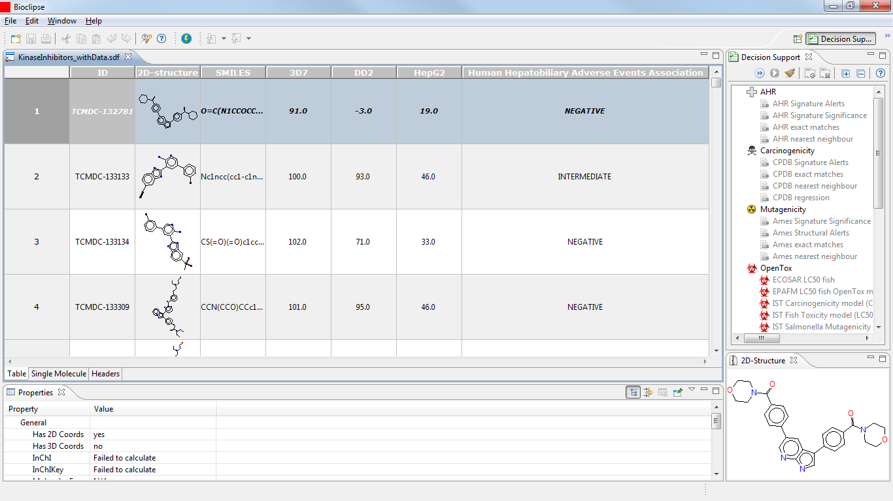

Figure 10: Annotated kinase inhibitors of the TCAMS, imported to Bioclipse as SDF together with data on the association with human adverse events.

We won’t be using the SMILES here, so we hide the column by right-clicking on its header and selecting “Hide Column”. Clicking again on a column header, all compounds are selected. Right-clicking and selecting “Decision Support” in the menu that opens gives the list of Bioclipse toxicity predictions that can be run on the compounds. We select the CPDB Signature Matches.

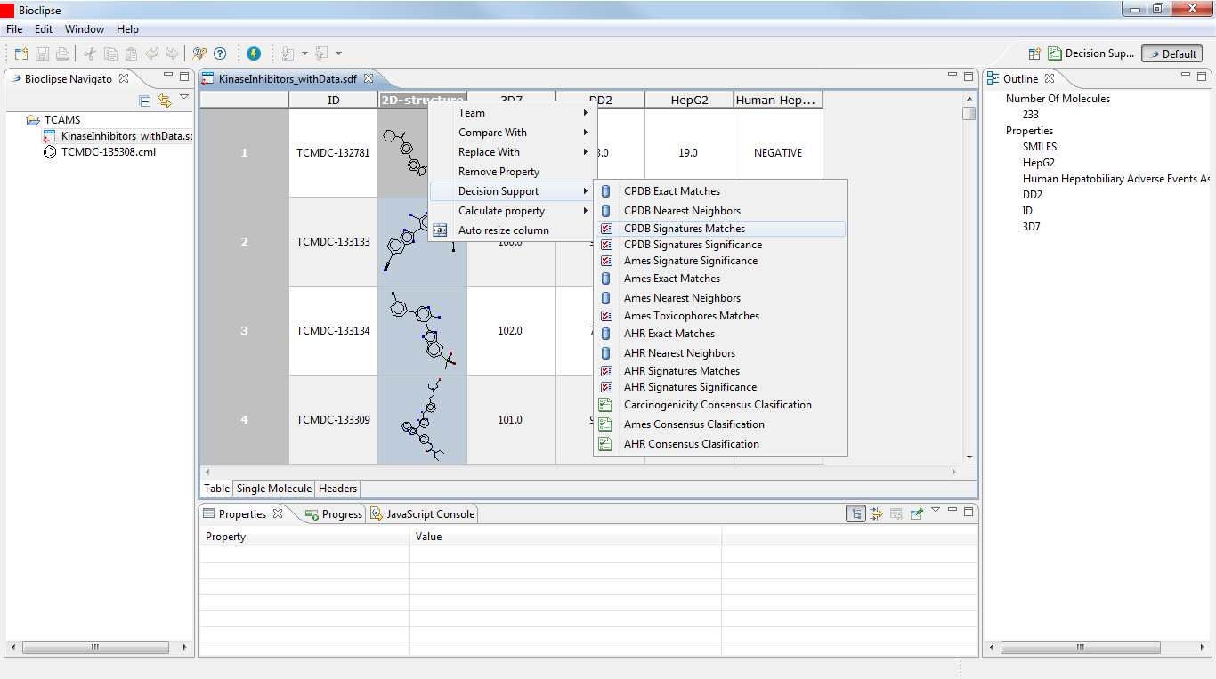
'
Figure 11: Applying toxicity models to sets of compounds from within the Bioclipse Molecule TableEditor.

While running the calculations, Bioclipse displays a progress bar.

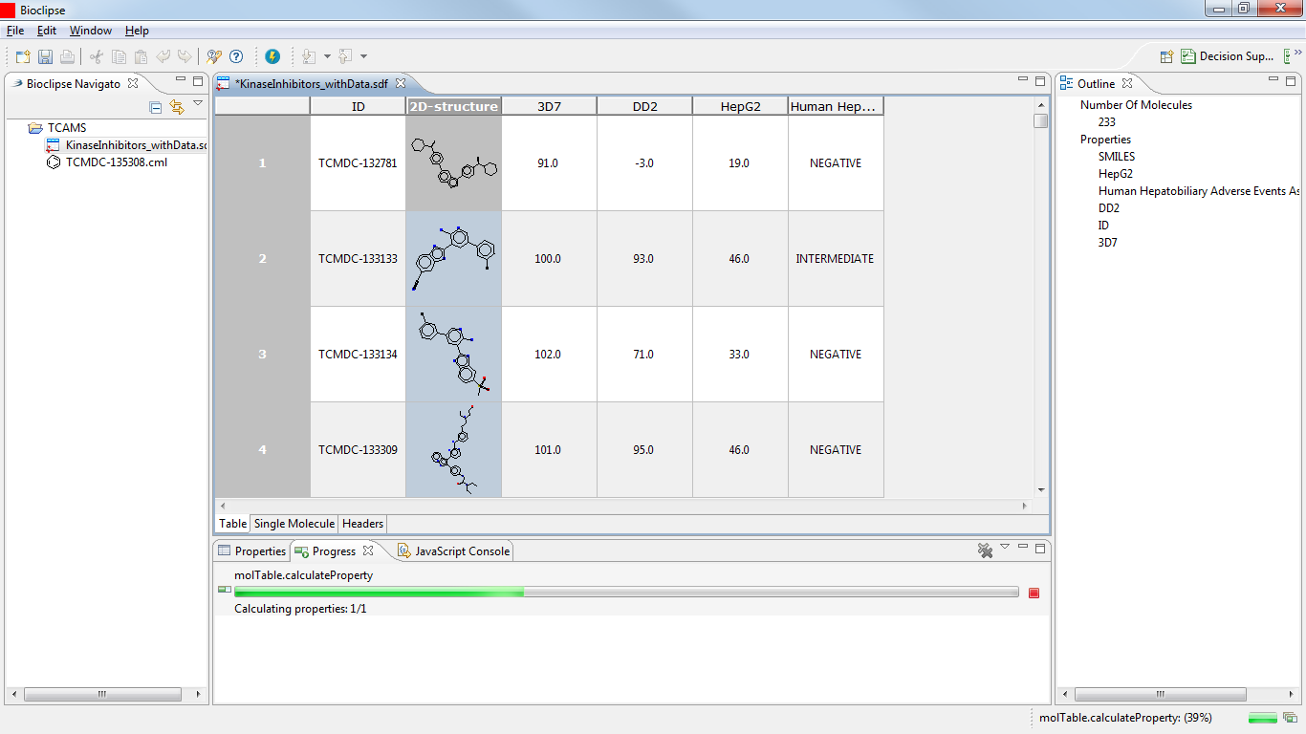

Figure 12: Display of the progress on calculations carried out on a set of compounds.

In a similar manner we calculate the Ames Toxicophore Matches and the AHR Signature Matches. Once the computations are completed, we save the table under a new name.
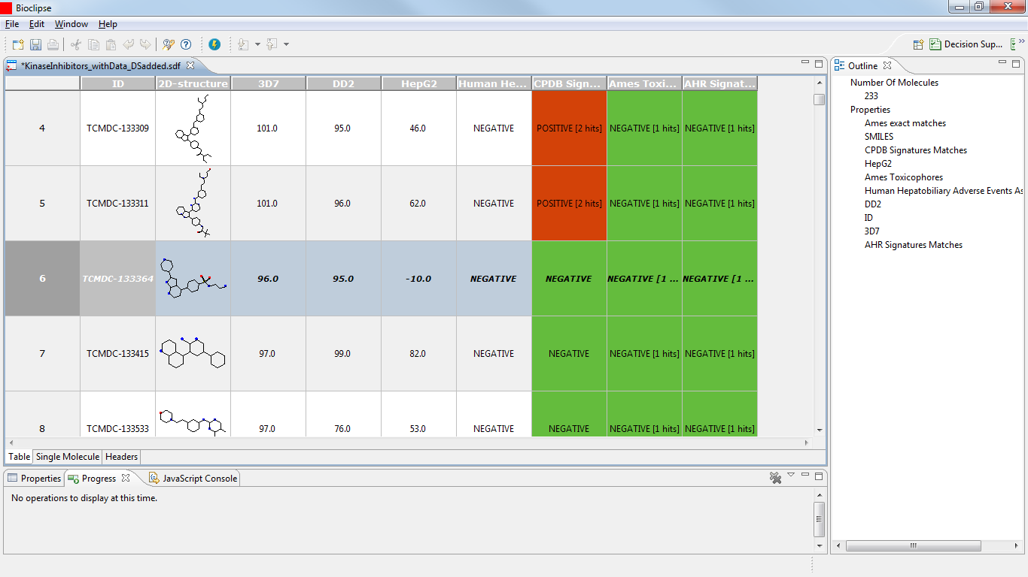

Figure 13: Adding Decision Support columns to the molecule table. The highlighted compound – TCMDC-133364 – is an interesting candidate as it is highly active against both strains of P. falciparum while being inactive against human HepG2 cells. Also, the compound is predicted negative for any of the toxicity models included.

Browsing the table, we can identify some interesting compounds: e.g., TCMDC-133364 is very active against both P. falciparum strains, without inhibiting the growth of the HepG2 cells. The compound’s association with human adverse events is negative, and the Bioclipse models are negative, as well. Double-clicking on the 2D-structure diagram of TCMDC-133364 opens the compound in the Single Molecule View. We can now change to the Decision Support Perspective and apply the OpenTox models on the selected compound.

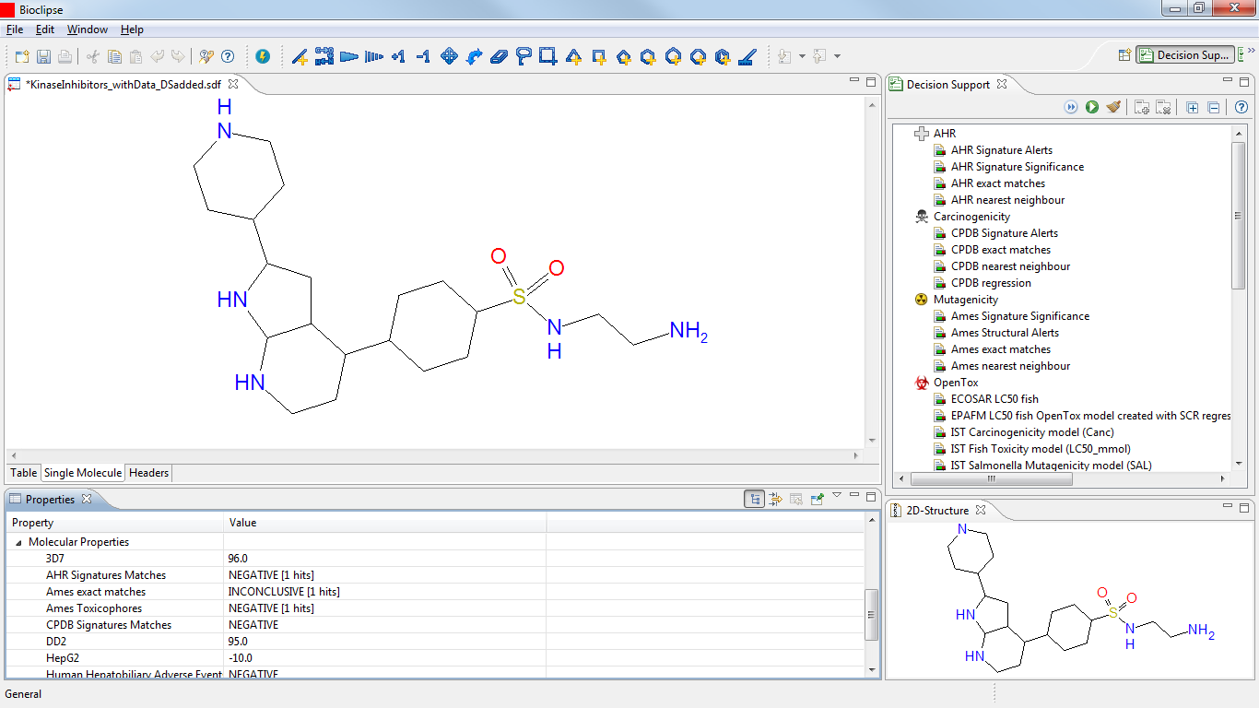

Figure 14: Opening a single compound from a table in the Decision Support Perspective.

The negative prediction for carcinogenicity by the CPDB model in Bioclipse is confirmed by the negative predictions of the OpenTox models “IST Carcinogenicity model (Canc)” and “ToxTree: Benigni/Bossa rules for carcinogenicity and mutagenicity”. For mutagenicity we have the negative prediction by Bioclipse’s Ames model, the negative prediction with the OpenTox Benigni/Bossa model as well as the “IST Salmonella Muatagenicity model (SAL)”. However, we obtain a positive prediction with the OpenTox “ToxTree: Structure Alerts for the in vivo micronucleus assay” model. Inspecting the details of that prediction we see that it is related to hydrogen-bond acceptors separated by three covalent bonds in the sulfonamide part of the molecule.

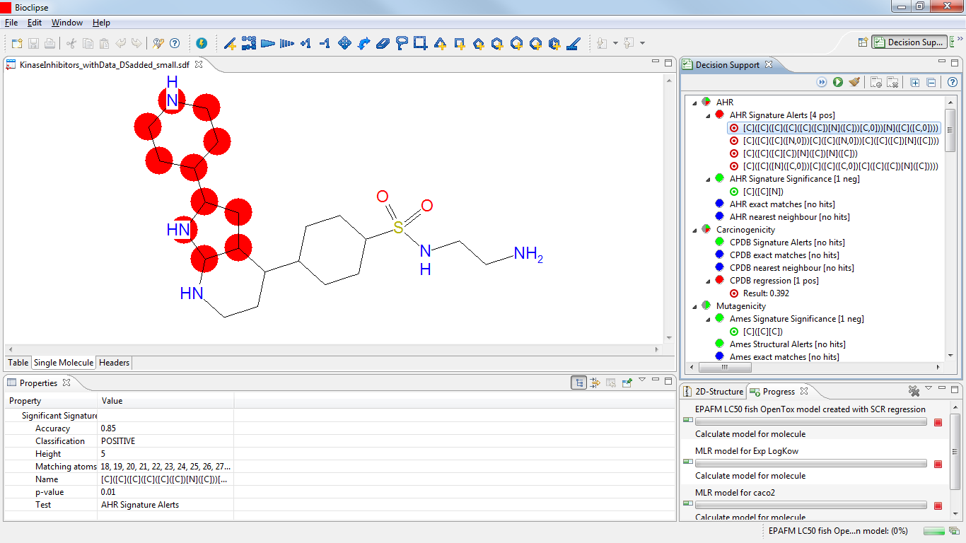

Figure 16: TCMDC-133364 exhibits AHR Structure Alerts.

[I don’t know how to interpret these AHR Signature Alerts here. In the table view, running the Decision Support -> AHR Signature Matches I got a negative prediction for this compound.]

CMDC-135174 is also very active against both P. falciparum strains, without inhibiting the growth of the HepG2 cells, and its association with human adverse events, as well as the Ames Toxicophore Match and the AHR Signature Match, are negative, as well. However, the Bioclipse CPDB Signature Match is positive.

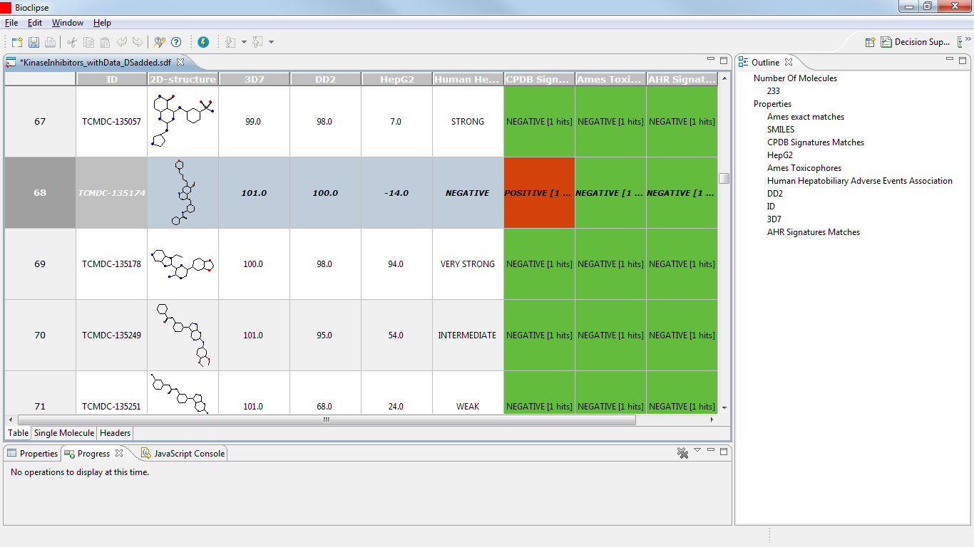

Figure 17 : Adding Decision Support columns to the molecule table. The highlighted compound – TCMDC-135174 – is an interesting candidate as it is highly active against both strains of P. falciparum while being inactive against human HepG2 cells. Also, the compound is predicted negative for three of the four toxicity models included. However, it triggered a CPDB Signature alert for carcinogenicity.

This positive carcinogenicity prediction is confirmed in the DS perspective with the OpenTox models “IST Carcinogenicity model (Canc)” (positive), however, the “ToxTree: Benigni/Bossa rules for carcinogenicity and mutagenicity” are negative. The DS view offers additional information, though: the “ToxTree: Structure Alerts for the in vivo micronucleus assay in rodents“ as well as the “IST Salmonella mutagenicity (SAL)” models are positive, and two “ToxTree: Skin sensitization alerts” are triggered. Combining these pieces of information, we might decide against selecting this compound as a drug development candidate.

In terms of its cytotoxic experimental data, also TCMDC-134695 is a promising candidate. In addition, all Bioclipse Decision Support models are negative. However, the compound has a weak association predicted with human adverse events related to the hepatobiliary tract.

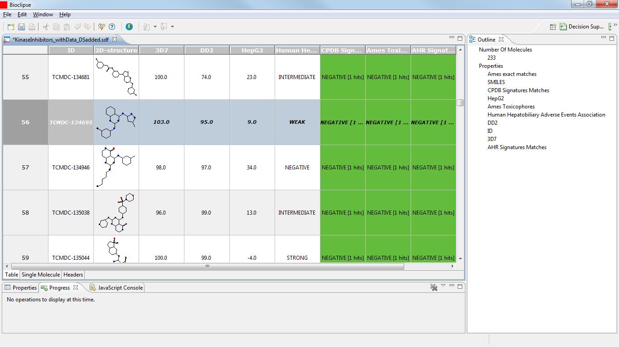

Figure 18: Molecule Table view of TCMDC-134695. The compound is promising for all its properties represented in the table. However, it is weakly associated with human adverse events.

Running the OpenTox models in the DS perspective on this compound confirms the concerns raised with the predicted association with human adverse events. The compound is predicted carcinogenic and mutagenic with the OpenTox models “ToxTree: Structure alerts for the in vivo micronucleus assay in rodents”, “IST Salmonella Mutagenicity model (SAL)”, “IST Carcinogenicity model (Canc)”, and the “ToxTree: Benigni/Bossa rules for carcinogenicity and mutagenicity”.

TCMDC-133807 appears to be a rather toxic compound, being predicted to be strongly associated with human adverse events and triggering a structure alert with Bioclipse’s CPDB carcinogenicity model.

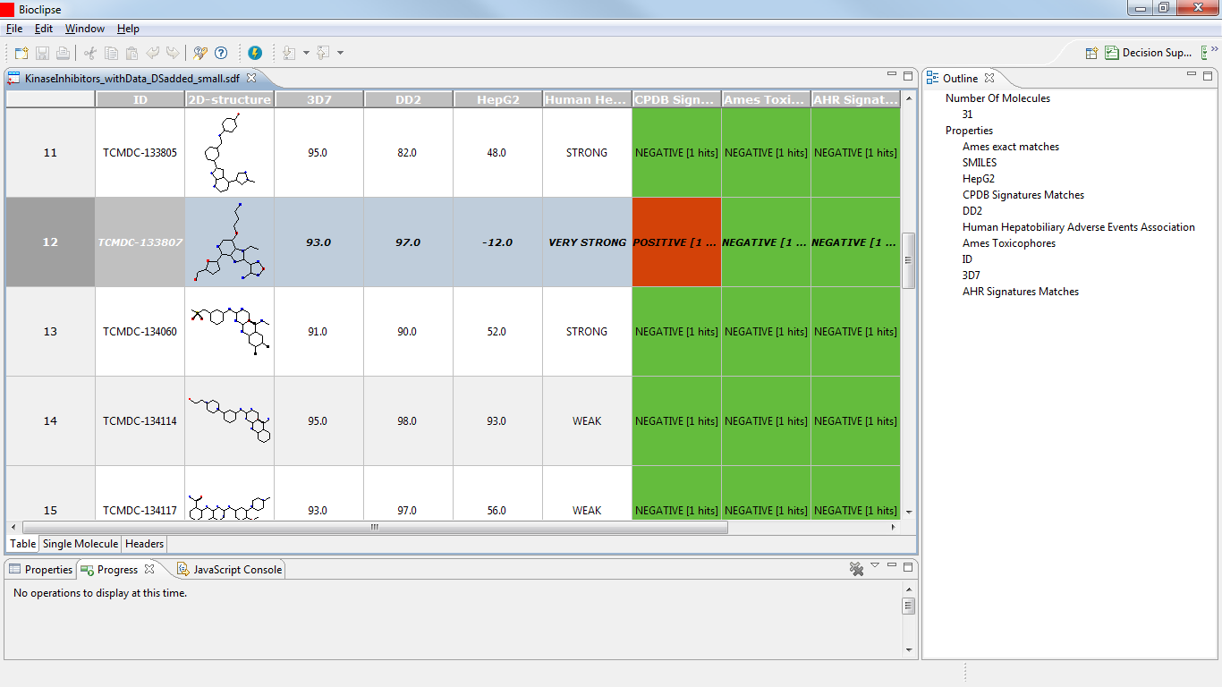

Figure 20: The compound TCMDC-133807 is predicted to be strongly associated with human adverse events, and yields a signature match with Bioclipse’s CPDB carcinogenicity model.

Indeed the compound turns out positive with the following OpenTox models:
- “ToxTree: Structure alerts for the in vivo micronucleus assay in rodents”,
- “IST Carcinogenicity model (Canc)”,
- “ToxTree: Skin sensitization”
However, the compound is negative with the following OpenTox models:
- “IST Salmonella Mutagenicity model (SAL)”
- “ToxTree: Benigni/Bossa rules for carcinogenicity and mutagenicity”

Discussion
These uses case show an interoperability advance, which enables toxicologists and people working in other life science fields to interactively explore and evaluate the toxicological properties of molecules.
The integration into Bioclipse makes various features of the OpenTox platform available to the user, both via the Graphical User Interface as well as via the Bioclipse Scripting Language, the latter focusing on reproducibility, the former on interactive exploration and optimization. This dual nature of the Bioclipse-OpenTox interoperability make it fairly unique. A solution which is capable of dynamically discovering new services, applying them while working interactively, makes the platform different from other software like ToxTree, ToxPredict (“OpenTox ToxPredict application,” n d), and the OECD QSAR ToolBox, or more general tools like Taverna (Oinn et al., 2004) and KNIME (http://knime.org).

A further difference to some of these alternative tools, is that the Bioclipse-OpenTox integration relies on semantic web technologies, which are seeing significant adoption in other areas of the life sciences too, including drug discovery, text mining, and neurosciences (Ruttenberg et al., 2007) (Splendiani, Burger, Paschke, Romano, & Marshall, 2011) (Egon L Willighagen & Brändle, 2011). The OpenTox platform demonstrated the provision of a simple but well-defined and consistent ontology for the interaction with their services, providing functionality for both service discovery and service invocation. The SADI framework is the only known semantic alternative (Chepelev & Dumontier, 2011), but does currently not provide the same level of computational toxicology services as OpenTox does.

The combination of these two unique features make it possible for Bioclipse-OpenTox to follow the evolution of computational toxicology closely and promptly. We are therefore delighted that this book chapter is available under a Creative Commons license, allowing us to update it for changes in the Bioclipse-OpenTox environment.

Bibliography

CC0 1.0 Universal Public Domain Dedication. (n.d.). . Retrieved from http://creativecommons.org/publicdomain/zero/1.0/
Chepelev, L. L., & Dumontier, M. (2011). Semantic Web integration of Cheminformatics resources with the SADI framework. Journal of cheminformatics, 3, 16. doi:10.1186/1758-2946-3-16
Diderichs, R. (2010). Tools for Category Formation and Read-Across: Overview of the OECD (Q)SAR Application Toolbox. In M. J. Cronin M. (Ed.), In Silico Toxicology (pp. 385-407). RSC Publishing. doi:10.1039/9781849732093-00385
EuropeainParliament, & EuropeanCommision. (2006). Regulation (EC) No. 1907/2006 of the European Parliament and of the Council. Official Journal of the European Union. Retrieved from http://www.reach-compliance.eu/irish/legislation/docs/launchers/launch-2006-1907-EC.html
Gamo, F.-J., Sanz, L. M., Vidal, J., de Cozar, C., Alvarez, E., Lavandera, J.-L., Vanderwall, D. E., Green, D. V. S., Kumar, V., Hasan, S., Brown, J. R., Peishoff, C. E., Cardon, L. R., & Garcia-Bustos, J. F. (2010a). Thousands of chemical starting points for antimalarial lead identification. Nature, 465(7296), 305-10. doi:10.1038/nature09107
Gamo, F.-J., Sanz, L. M., Vidal, J., de Cozar, C., Alvarez, E., Lavandera, J.-L., Vanderwall, D. E., Green, D. V. S., Kumar, V., Hasan, S., Brown, J. R., Peishoff, C. E., Cardon, L. R., & Garcia-Bustos, J. F. (2010b). Thousands of chemical starting points for antimalarial lead identification. Nature, 465(7296), 305-10. doi:10.1038/nature09107
Gellibert, F., Fouchet, M.-H., Nguyen, V.-L., Wang, R., Krysa, G., de Gouville, A.-C., Huet, S., et al. (2009). Design of novel quinazoline derivatives and related analogues as potent and selective ALK5 inhibitors. Bioorganic & medicinal chemistry letters, 19(8), 2277-81. doi:10.1016/j.bmcl.2009.02.087
Goble, C. A., Bhagat, J., Aleksejevs, S., Cruickshank, D., Michaelides, D., Newman, D., Borkum, M., et al. (2010). myExperiment: a repository and social network for the sharing of bioinformatics workflows. Nucleic Acids Research, 38(suppl 2), W677-W682. doi:10.1093/nar/gkq429
Hardy, Barry, Douglas, N., Helma, C., Rautenberg, M., Jeliazkova, Nina, Jeliazkov, V., Nikolova, I., et al. (2010). Collaborative Development of Predictive Toxicology Applications. Journal of cheminformatics, 2(1), 7. doi:10.1186/1758-2946-2-7
Huang, D. W., Sherman, B. T., & Lempicki, R. A. (2009). Systematic and integrative analysis of large gene lists using DAVID bioinformatics resources. Nature protocols, 4(1), 44-57. doi:10.1038/nprot.2008.211
Jeliazkova, Nina, & Jeliazkov, V. (2011). AMBIT RESTful web services: an implementation of the OpenTox application programming interface. Journal of cheminformatics, 3, 18. doi:10.1186/1758-2946-3-18
Kanehisa, M., & Goto, S. (2000). KEGG: Kyoto Encyclopedia of Genes and Genomes. Nucl. Acids Res., 28(1), 27-30. doi:10.1093/nar/28.1.27
Kelder, T., Pico, A. R., Hanspers, K., van Iersel, M. P., Evelo, C., & Conklin, B. R. (2009). Mining biological pathways using WikiPathways web services. PloS one, 4(7), e6447. doi:10.1371/journal.pone.0006447
Knudsen, T. B., Houck, K. A., Sipes, N. S., Singh, A. V., Judson, R. S., Martin, M. T., Weissman, A., et al. (2011). Activity profiles of 309 ToxCastTM chemicals evaluated across 292 biochemical targets. Toxicology, 282(1-2), 1-15. doi:10.1016/j.tox.2010.12.010
Kuhn, M., Campillos, M., Letunic, I., Jensen, L. J., & Bork, P. (2010). A side effect resource to capture phenotypic effects of drugs. Molecular systems biology, 6, 343. doi:10.1038/msb.2009.98
Oinn, T., Addis, M., Ferris, J., Marvin, D., Senger, M., Greenwood, M., Carver, T., et al. (2004). Taverna: a tool for the composition and enactment of bioinformatics workflows. Bioinformatics, 20(17), 3045-3054. doi:10.1093/bioinformatics/bth361
OpenTox ToxPredict application. (n.d.). . Retrieved from http://toxpredict.org
Patlewicz, G., Jeliazkova, N, Safford, R. J., Worth, A. P., & Aleksiev, B. (2008). An evaluation of the implementation of the Cramer classification scheme in the Toxtree software. SAR and QSAR in environmental research, 19(5-6), 495-524. doi:10.1080/10629360802083871
Pharmatrope. (n.d.). . Retrieved from http://pharmatrope.com/
QSAR ToolBox. (n.d.). . Retrieved from http://www.qsartoolbox.org
Ruttenberg, A., Clark, T., Bug, W., Samwald, M., Bodenreider, O., Chen, H., Doherty, D., et al. (2007). Advancing translational research with the Semantic Web. BMC Bioinformatics, 8(Suppl 3). doi:10.1186/1471-2105-8-S3-S2
Rydberg, P., Gloriam, D. E., & Olsen, L. (2010). The SMARTCyp cytochrome P450 metabolism prediction server. Bioinformatics, 26(23), 2988-2989. doi:10.1093/bioinformatics/btq584
Schmidt, U., Struck, S., Gruening, B., Hossbach, J., Jaeger, I. S., Parol, R., Lindequist, U., et al. (2009). SuperToxic: a comprehensive database of toxic compounds. Nucleic acids research, 37(Database issue), D295-9. doi:10.1093/nar/gkn850
Spjuth, Ola, Alvarsson, J., Berg, A., Eklund, M., Kuhn, S., Mäsak, C., Torrance, G., Wagener, J., Willighagen, Egon L, Steinbeck, C., & Wikberg, J. E. S. (2009a). Bioclipse 2: a scriptable integration platform for the life sciences. BMC Bioinformatics, 10(1), 397. doi:10.1186/1471-2105-10-397
Spjuth, Ola, Alvarsson, J., Berg, A., Eklund, M., Kuhn, S., Mäsak, C., Torrance, G., Wagener, J., Willighagen, Egon L, Steinbeck, C., & Wikberg, J. E. S. (2009b). Bioclipse 2: a scriptable integration platform for the life sciences. BMC Bioinformatics, 10(1), 397. doi:10.1186/1471-2105-10-397
Spjuth, Ola, Eklund, M., Ahlberg Helgee, E., Boyer, S., & Carlsson, L. (2011). Integrated decision support for assessing chemical liabilities. Journal of chemical information and modeling. doi:10.1021/ci200242c
Spjuth, Ola, Helmus, T., Willighagen, Egon L, Kuhn, S., Eklund, M., Wagener, J., Murray-Rust, P., et al. (2007). Bioclipse: an open source workbench for chemo- and bioinformatics. BMC Bioinformatics, 8(1), 59. Affymetrix. doi:10.1186/1471-2105-8-59
Spjuth, Ola, Willighagen, Egon L, Guha, R., Eklund, M., & Wikberg, J. E. E. (2010). Towards interoperable and reproducible QSAR analyses: Exchange of datasets. Journal of Cheminformatics, 2(1). doi:10.1186/1758-2946-2-5
Splendiani, A., Burger, A., Paschke, A., Romano, P., & Marshall, M. S. (2011). Biomedical semantics in the Semantic Web. Journal of biomedical semantics, 2 Suppl 1, S1. doi:10.1186/2041-1480-2-S1-S1
Steinbeck, C., Hoppe, C., Kuhn, S., Floris, M., Guha, R., & Willighagen, Egon L. (2006). Recent developments of the chemistry development kit (CDK) - an open-source java library for chemo- and bioinformatics. Current pharmaceutical design, 12(17), 2111-20. doi:10.2174/138161206777585274
ToxTree. (n.d.). . Retrieved from http://toxtree.sourceforge.net
Williams-DeVane, C. R., Wolf, M. A., & Richard, A. M. (2009). DSSTox chemical-index files for exposure-related experiments in ArrayExpress and Gene Expression Omnibus: enabling toxico-chemogenomics data linkages. Bioinformatics (Oxford, England), 25(5), 692-4. doi:10.1093/bioinformatics/btp042
Willighagen, E L, Jeliazkova, N, Hardy, B, Grafström, R. C., & Spjuth, O. (2011a). Computational toxicology using the OpenTox application programming interface and Bioclipse.
Willighagen, E L, Jeliazkova, N, Hardy, B, Grafström, R. C., & Spjuth, O. (2011b). Computational toxicology using the OpenTox application programming interface and Bioclipse.
Willighagen, Egon L, & Brändle, M. P. (2011). Resource description framework technologies in chemistry. Journal of Cheminformatics, 3(1), 15. doi:10.1186/1758-2946-3-15
Willighagen, Egon L, Alvarsson, J., Andersson, A., Eklund, M., Lampa, S., Lapins, M., Spjuth, Ola, et al. (2011). Linking the Resource Description Framework to cheminformatics and proteochemometrics. Journal of Biomedical Semantics, 2(Suppl 1), S6. BioMed Central Ltd. doi:10.1186/2041-1480-2-S1-S6

