Interactive Predictive Toxicology with Bioclipse - OpenTox

Egon Willighagen¹, Roman Affentranger², Roland Grafström^{1,3}, Barry Hardy², Nina Jeliazkova⁴, Ola Spjuth⁵.
1.Division of Molecular Toxicology, Institute of Environmental Medicine, Karolinska Institutet, SE-17177 Stockholm, Sweden
2.Douglas Connect, Baermeggenweg 14, 4314 Zeiningen, Switzerland
3.VTT Technical Research Center of Finland, Medical Biotechnology, FI-20521 Turku, Finland
4.Ideaconsult Ltd, A. Kanchev 4, Sofia 1000, Bulgaria
5.Department of Pharmaceutical Biosciences, Uppsala University, SE-75124 Uppsala, Sweden

Much is already known about the toxicity of small molecules, but yet it is a challenge to predict the toxicology of new compounds. At the same time, society demands insight in the toxicity of compounds, such as outlined by the REACH regulations in the European Union. Where and when experimental testing of toxicity is expensive or too cumbersome, experimental data may under certain conditions be complemented by alternative methods. Among these alternative methods are computational tools that predict a wide-variety of toxicological properties. Read-across and QSAR approaches are commonly used here, and a good coverage of predictions will many alternative models can help get a good feeling for the toxicity of the compound.
Therefore, a platform that allows you to use a multiple of prediction services is very benificial. This is exactly what the Bioclipse-OpenTox platform is providing, which we recently introduced [Willighagen2011c]. This chapter will describe how this platform can be used to interactively study the toxicity of chemical structures using computational toxicology tools. Its ability to interactively

XXXXXXXXXXXXXXXXX

that is able to dynamically discover computational services running the latest predictive algorithms and models, while hiding technicalities by reusing a graphics-oriented workbench for the life sciences. QSAR ToolBox [Diderichs2010, QSARToolBox] and ToxTree [Patlewicz2008, ToxTree] are existing softwares that aggregate computation toxicity models, but do not integrate with other functionality easily, such as online services. Bioclipse, however, is designed to integrate local and remote functionality [Spjuth2007,Spjuth2009,Spjuth2011].

In this paper we outline how we implemented a new platform, integrating the OpenTox Open Standards [Hardy2010] and the interactive, but scriptable Open Source workbench for the life sciences, Bioclipse. This approach makes it possible for anyone to make new computational toxicology models available to Bioclipse without the need to change the software source code.

Predictive toxicology is a field where knowledge from many sources needs to be integrated to provide a weight of evidence on the toxicity of untested chemical compounds. Typical sources of information include databases with in vivo and in vitro experimental data such as ToxCast and SuperToxic [Knudsen2011,Schmidt2011], literature databases summarizing adverse reactions like SIDER [Kuhn2010], and computational resources based on toxicity data for other compounds including DSSTox [WilliamsDeVane2009]. Importantly, this information should be visualized, preferably linked to the chemical structure of the compound, or by visualizing relevant life science data, such as gene, protein and biological pathway information [Huang2009,Ogata1999,Kelder2009] or metabolic reactions [Rydberg2010]. Bioclipse was designed to provide such interactive data analysis for the life sciences.

Moreover, predictive toxicology is an advancing science, aiming to develop new alternative testing methods, satisfying the demanding risk assessment requirements of the European REACH guidance [REACH]. The dynamic discovery of new toxicology-related data and computational methods is therefore of utmost scientific and practical importance. The EU FP7 OpenTox project recently developed a framework to enable the feasibility of semantic integration of such new resources [Hardy2010].

We describe here the subsequent technological interoperation of Bioclipse and the OpenTox platform, such as implemented by the AMBIT software [Jeliazkova2011]. This short report outlines what functionality the new combined platform provides to the toxicologist and what development is ongoing. At the core of the interoperation lies the use of the Resource Description Framework (RDF) [Carroll2004] and related Open Standards. OpenTox uses RDF as a primary exchange format and the RDF query language SPARQL [PrudHommeaux2008b] to discover data sets, algorithms and models. Bioclipse recently gained support for these standards [Willighagen2011], simplifying the interoperation task with OpenTox.

We outline three applications that exemplify how the various used technologies make this interoperability possible, starting with a computational toxicology example. Advantage is taken of three technologies that drive the interoperability. First, it uses the SPARQL RDF query language [PrudHommeaux2008] to discover functionality on the OpenTox network. Secondly, it uses the OpenTox web services for remote computation. Finally, all graphical user interfaces use a new Bioclipse Scripting Language (BSL) [Spjuth2009] extension to interact with OpenTox servers, allowing all interaction to be scripted and automated too.

Computational Toxicology

Figure 1 shows how the interoperability of Bioclipse with the OpenTox API is designed, and in particular how it was used to extend the molecular descriptor calculation functionality in Bioclipse described previously [Spjuth2010]. This functionality can be use to calculate properties such as logP and pK_{a}, important to various aspects of toxicity, including membrane transport and receptor binding. Knowledge about such properties can be used under the European REACH regulation. For example, predicted physical and chemical properties can, under certain conditions, complement toxicity testing using animal experiments, and as such, calculation of such descriptors is increasingly relevant.

Figure 1 : An overview of the Bioclipse QSAR and OpenTox integration. Toxicological properties of molecules can be calculated in Bioclipse using the online computational services within the OpenTox cloud, in parallel to local services. When the user calculates these properties, Bioclipse will rst query local and online service providers for available functionality. Example of services in the OpenTox cloud are the ToxTree toxicology prediction models. The OpenTox cloud is queried by Bioclipse internally using the SPARQL query language. Once the user has selected the toxicological properties of interest (see Figure 2), these will be calculated by Bioclipse. Here, REST technologies are used to perform this computation in the OpenTox cloud. The computed results will then be used in Bioclipse, as exemplied in Figure 5.

SPARQL is used by Bioclipse to dynamically discover descriptor algorithms exposed via the OpenTox servers, using the OpenTox ontology service's SPARQL endpoint. This way, when a new descriptor algorithm or model is registered on the OpenTox ontology service, it will automatically be picked up by Bioclipse.

Figure 2 shows several discovered OpenTox descriptor algorithms, along with algorithms from other local (CDK [Steinbeck2006]) and remote (CDK REST) providers. Using this approach, Bioclipse has access to the most recent descriptors relevant to toxicity predictions.

Figure 2 : Integration of OpenTox descriptors in Bioclipse QSAR. Molecular descriptors are much used in computational toxicology models. This screenshot from Bioclipse QSAR shows descriptors discovered on the Internet (providers: OpenTox and CDK REST) in combination with local software (provider: CDK).

OpenTox provides web services to calculate a descriptor value for a given molecule. Using the linked resources idea of the semantic web, the descriptors discovered via the ontology server can be invoked via Bioclipse directly. As such, OpenTox-provided descriptor calculations can be mixed with descriptor calculations local to Bioclipse, or from other remote computational services, as described before [Spjuth2010]. This creates a flexible application for the integration of numerical input for statistical modeling of toxicologically relevant end points, as well as the comparison of various predictive models for a more balanced property analysis.

All functionality for remote computing on the OpenTox network is also available as BSL scripting commands, allowing all OpenTox interoperation with the Bioclipse graphical user interface to be replicated using BSL scripts. Tables 1 shows the BSL commands for service and data discovery and the invocation of remote services, under the categories Querying and Computation, respectively.

Data Sharing

Using a second, data sharing use case we will explain how all graphical interoperation is using a BSL script extension. For example, Figure 3 shows the Bioclipse dialog for uploading a small data set with ten neurotoxins to an OpenTox server (see Additional file 1). This dialog asks which OpenTox server to upload to (the Ambit2 server is selected, http://apps.ideaconsult.net:8080/ambit2/), a title under which this data set will be available (currently showing a default value), and the data license under which the data will be available to others (the Creative Commons Zero license [CCZero] in this case).

Figure 3 : Graphical user interface for uploading data to OpenTox. Sharing new toxicological data about molecular structures can be done by uploading the data to an OpenTox server. This Bioclipse dialog shows a select MDL SD le with ten neurotoxins (neurotoxins.sdf ) being shared on the Ambit2 server, the OpenTox server to upload to, providing a title for the data set, and a license (see main text). Clicking the Finish button will upload the structures and open a web browser window in Bioclipse with the resulting online data set (see Figure 4).

Technically, the dialog makes use of the script commands createDataSet(service, molecules), setDatasetLicense(datasetURI, licenseURI), and setDatasetTitle(datasetURI, title) (see Table 1). The latter two methods use the data set Universal Resource Identifier (URI) returned by the first method. When the upload has finished, the resulting OpenTox web page is opened in a browser window in Bioclipse (see Figure 4).

Figure 4 : OpenTox web page showing uploaded data. Screenshot of Bioclipse showing a web browser window with the neurotoxins data hosted on the Ambit2 OpenTox server after the upload, as shown in Figure 3 (see http://apps.ideaconsult.net:8080/ambit2/dataset/619517).

This use case shows nicely how the Bioclipse-OpenTox integration takes advantage of the fact that Bioclipse has all graphical user interface (GUI) functionality matched by a scripted equivalent. The use of the BSL directly, allows interaction with the OpenTox network to be automated, combined with other Bioclipse functionality into larger workflows, and makes it easier to share procedures with others, using social scientific sites like MyExperiment [Goble:2010uq]. An example BSL script for calculating molecular descriptors is shown in Figure 5 and combines OpenTox functionality with cheminformatics functionality provided by the cdk script extensions (see Additional file 2). Table 1 shows an overview of the available BSL commands for uploading data to and downloading data from OpenTox servers under the heading Data exchange.

Authentication

The third demonstration of Bioclipse-OpenTox interoperability is the support for accessing protected resources within the OpenTox network. Despite preferences of the authors, we acknowledge that not all scientific data will be Open Data. As such, authentication and authorization (A&A) are important features of data access. OpenTox implements both aspects, and provides web services for A&A, allowing users to log in and out of OpenTox applications, accompanied by policy-based specification of OpenTox resource access permissions. Additionally, the same mechanism is used to restrict the access to calculation procedures, allowing to expose software with commercial licenses as protected OpenTox resources.

Bioclipse was extended to support the OpenTox authentication, allowing the OpenTox servers to properly authorize the user access to particular web services and data sets. The OpenTox account information is registered with Bioclipse' keyring system, centralizing logging in and out onto remote services, providing the graphical user interface for adding a new OpenTox account and to log in and out. The corresponding script commands for the authentication are given in Authentication category in Table 1.

Use Case 1: Removing toxicity without interfering with pharmacology

In 2010, the Tres Cantos Medicines Development Campus of GlaxoSmithKline deposited a collection of 13533 compounds – the Tres Cantos Antimalarial Compound Set, TCAMS – at the ChEMBL Neglected Tropical Disease Database (https://www.ebi.ac.uk/chemblntd) making the data publicly available [Game2010]. Each of the chemicals in the TCAMS inhibits growth of the 3D7 strain of Plasmodium falciparum – the malaria causing parasite – by at least 80% at a concentration of 2 µM. Many also show a similar effect against the multi-drug resistant P. falciparum strain DD2. Evidence for liver toxicity is provided by growth inhibition data against human hepatoma HepG2 cells.
857 compounds in the TCAMS are annotated with a so-called “target hypothesis”. This target hypothesis had been obtained by comparing each compound with public and GSK-internal data of compound-target relationships, accepting a target hypothesis if a homolog to the identified target exists in P. falciparum and unless many compound-target relationships had been identified for a given chemical. Of these 857 compounds, 233 are annotated as potential Ser/Thr kinase inhibitors.

We select the compound TCMDC-135308 (CN(C)c1ccc2nc(nc(Nc3ccncc3)c2c1)c4cccc(C)n4) for further investigation. TCMDC-135308 is similar (Tanimoto=0.915) to quinazoline 3d [Gillebert2009] (Cc1cccc(n1)c2nc(Nc3ccnc(C)c3)c4ccccc4n2), a potent human-TGF-β1 inhibitor (Transforming growth factor- β1). TCMDC-135308 inhibits growth of the P. falciparum strain 3D7 by 98% at a concentration of 2 µM (XC50=700 nm). It is also active against the multi-drug-resistant P. falciparum strain DD2, inhibiting its growth by 63% at at a concentration of 2 µM. The compound has not shown significant growth inhibition of human HepG2 cells (5% at a concentration of 10 µM).
We import the TCMDC-135308 using its SMILES to Bioclipse, log in to OpenTox and move to the Decision Support Perspective, where we run all models. It turns out TCMDC-135308 contains a CPDB Signature Alert for Carcinogenicity.

Figure : CPDB Signature Alert for Carcinogenicity for TCMDC-135308

The carcinogenicity prediction is confirmed by the positive predictions with the OpenTox models “IST Carcinogenicity (Canc)” and “ToxTree: Benigni/Bossa rules for carcinogenicity and mutagenicity” (structural alert for genotoxic carcinogenicity). Also, the OpenTox models “IST Salmonella Mutagenicity (SAL)” and “ToxTree: Structure Alerts for the in vivo micronucleus assay in rodents” are positive.

To identify the structural alerts, we click on the “Structural Alert for genotoxic carcinogenicity#explanation” line in the Decision Support window. In the property tab, the property “Name” lists the contents of the #explanation obtained from OpenTox. One can either scroll along the explanation in the value field of the “Name” property, or copy-paste its content to a text editor to identify which structural alert was fired. For our compound of interest, it is the presence of a dialkylamine, which overlaps with the CPDB Signature Alert for Carcinogenicity. The presence of a dialkylamine is also a structural alert for the “in vivo micronucleus assay in rodents” model.
Figure : Identification of the structural alert in the OpenTox Benigni/Bossa model for carcinogenicity and mutagenicity
Analyzing the crystal structure of the related to quinazoline 3d bound to human-TGF-β1 (pdb-entry 3HMM [Gillebert2009]) we find that the dimethylamine is not deeply buried in the binding pocket, but rather exposed, without making crucial interactions. It might therefore be easily replaceable without affecting too much the activity of the compound.

Figure : Left: crystal structure of human TGF- β1 with the inhibitor quinazoline 3d bound (pdb-entry 3HMM). Right: the dimethylamino group of TCMDC-135308 points to the water-exposed side of the binding pocket. The image was generated from the 3HMM crystal structure, removing all water molecules and adding the dimethylamino group to quinazoline 3d, followed by a short relaxation using the “sculpting” mode of PyMol.
However, since we do not know the exact target protein in P. falciparum, we cannot exclude that the dimethylamino group is important for the activity or selectivity of the compound. Therefore, we try to replace it with a bioisosteric group, the simplest one being a methoxy group.

In the Bioclipse compound window, we modify the structure of TCMDC-135308 by renaming the nitrogen atom of the dimethylamino group to oxygen, and deleting one of the methyl groups of the former dimethylamino group.

Figure : Replacing the dimethylamino group of TCMDC-135308 by a methoxy group.

Re-running all predictions, we find that there are no CPDP signature alerts anymore (5), and that the OpenTox Benigni/Bossa rules predict the modified compound to be negative for both genotoxic and non-genotoxic carcinogenicity (6). The OpenTox model for the in vivo micronucleus assay is still positive because of the presence of two hydrogen-bond acceptors that are three bonds apart. Also the two OpenTox IST models for carcinogenicity and mutagenicity are still positive. As expected, physico-chemical properties such as pKa or XLogP are not, or only marginally, affected (no change to pKa, XLogP changes from 0.845 to 0.551), and also, no new positive toxicity predictions are obtained due to the change.

Figure : Replacing the dimethylamino group of TCMDC-135308 with a methoxy group resolves the CPDP signature alert.
Figure : Replacing the dimethylamino group of TCMDC-135308 with a methoxy group resolves the OpenTox Benigni/Bossa Structure Alerts for carcinogenicity and mutagenicity.

Thus, our bioisosteric replacement of the dimethylamino group has resolved several toxicity predictions, while hopefully only marginally affecting the compound’s activity. As it turns out, the methoxy variant we constructed based on TCMDC-135308 exists in TCAMS, as well. It is TCMDC-134670. Its activity against P. falciparum 3D7 is almost identical to that of TCMDC-135308 (101% growth inhibition at 2 µM, XC50 = 670 nm), while its activity against P. falciparum DD2 is slightly decreased (from 63 to 42% growth inhibition at 2 µM). TCMDC-134670 is also slightly less active in the in vitro hepatotoxicity assay reported (-1% growth inhibition of human HepG2 cells at a concentration of 10 µM, compared to 5% obtained with TCMDC-135308).

Use Case 2: Importing a set of compounds, use DS for individual ones.
In 2010, the Tres Cantos Medicines Development Campus of GlaxoSmithKline deposited a collection of 13533 compounds – the Tres Cantos Antimalarial Compound Set, TCAMS – at the ChEMBL Neglected Tropical Disease Database (https://www.ebi.ac.uk/chemblntd) making the data publicly available. Each of the chemicals in the TCAMS inhibits growth of the 3D7 strain of Plasmodium falciparum – the malaria causing parasite – by at least 80% at a concentration of 2 µM. Many also show a similar effect against the multi-drug resistant P. falciparum strain DD2. Evidence for liver toxicity is provided by growth inhibition data against human hepatoma HepG2 cells.

857 compounds in the TCAMS are annotated with a so-called “target hypothesis”. This target hypothesis had been obtained by comparing each compound with public and GSK-internal data of compound-target relationships, accepting a target hypothesis if a homolog to the identified target exists in P. falciparum and unless many compound-target relationships had been identified for a given chemical. Of these 857 compounds, 233 are annotated as potential Ser/Thr kinase inhibitors.

The US FDA’s AERS (Adverse Events Reporting System) database is a unique source of in vivo data on observations of the adverse outcomes of human toxicities of drugs. Pharmatrope has processed the AERS data according to statistical considerations, and created the Titanium Adverse Events Database and Models. For all compounds in the TCAMS we predicted association with groups of human adverse events related to the hepatobiliary tract and classified the compounds’ association with these adverse events.

All data on the annotated kinase inhibitors in TCAMS – namely the compounds’ identifiers and SMILES, the inhibition of P. falciparum 3D7 and DD2, of human HepG2 cells, and the degree of association with human adverse events – was combined into an SDF file and imported into Bioclipse. Double-clicking the imported file in the Bioclipse Navigator opens the table, allowing to re-arrange the columns.
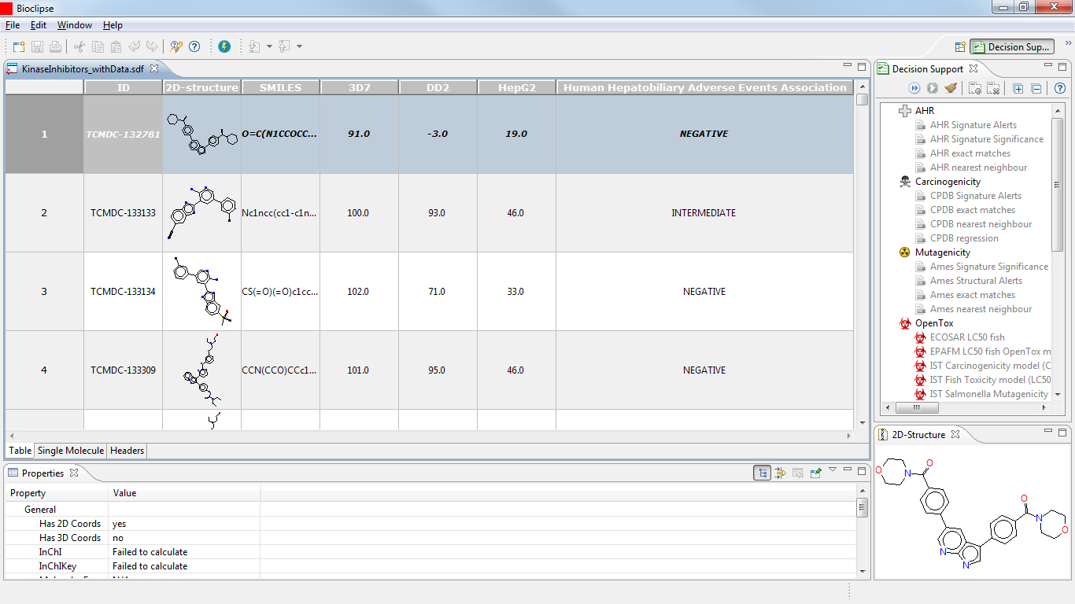
Figure : Annotated kinase inhibitors of the TCAMS, imported to Bioclipse as SDF together with data on the association with human adverse events.
We won’t be using the SMILES here, so we hide the column by right-clicking on its header and selecting “Hide Column”. Clicking again on a column header, all compounds are selected. Right-clicking and selecting “Decision Support” in the menu that opens gives the list of Bioclipse toxicity predictions that can be run on the compounds. We select the CPDB Signature Matches.
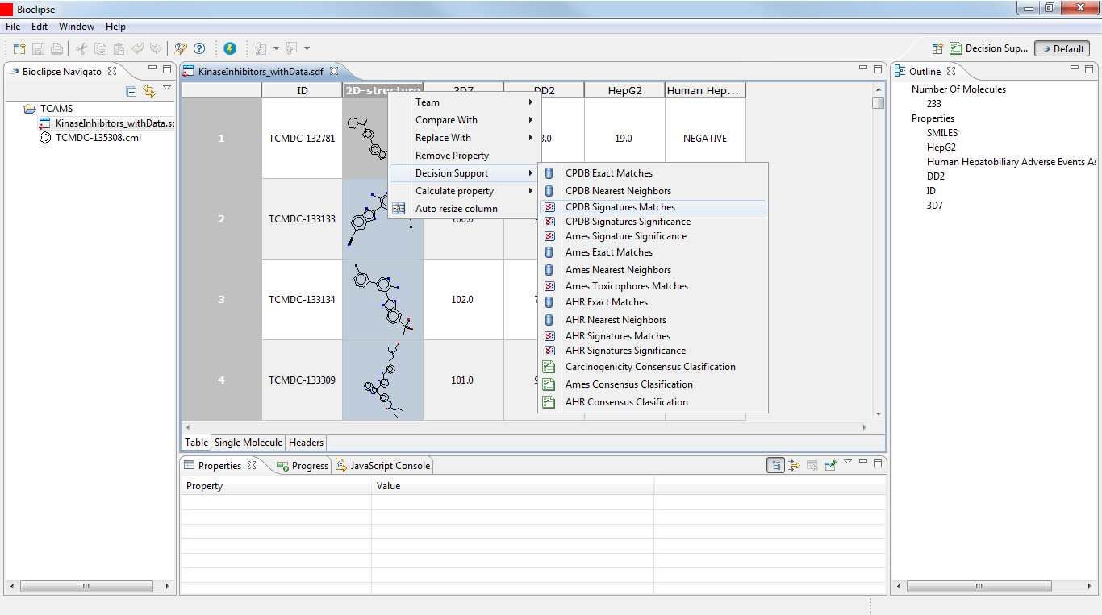
Figure : Applying toxicity models to sets of compounds from within the Bioclipse Molecule TableEditor.
While running the calculations, Bioclipse displays a progress bar.
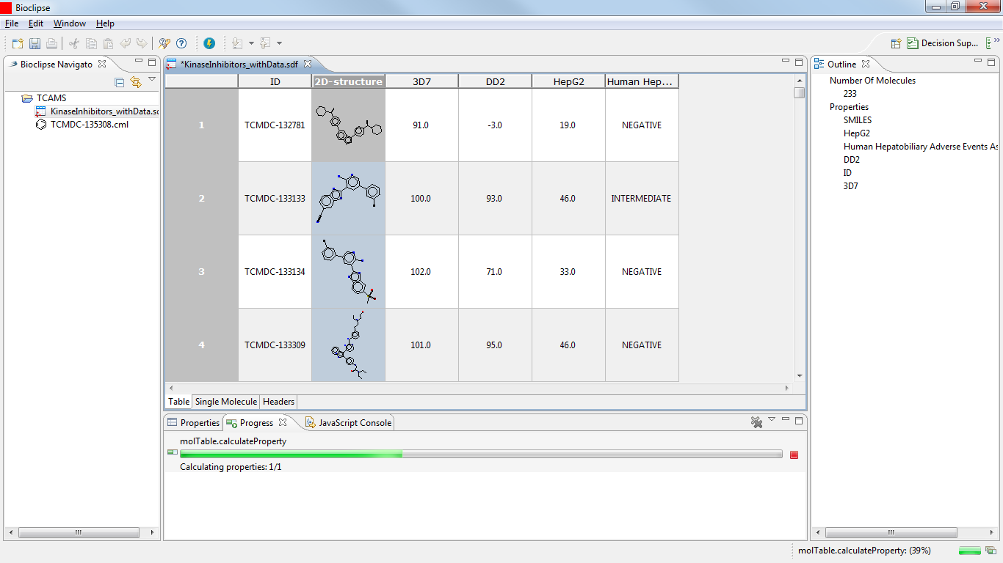
Figure : Display of the progress on calculations carried out on a set of compounds.
In a similar manner we calculate the Ames Toxicophore Matches and the AHR Signature Matches. Once the computations are completed, we save the table under a new name.
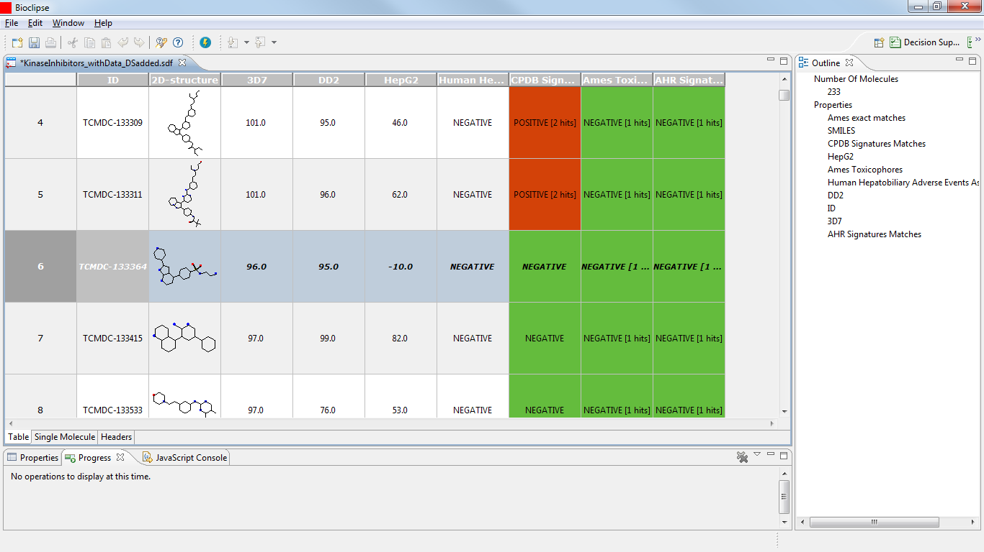
Figure : Adding Decision Support columns to the molecule table. The highlighted compound – TCMDC-133364 – is an interesting candidate as it is highly active against both strains of P. falciparum while being inactive against human HepG2 cells. Also, the compound is predicted negative for any of the toxicity models included.
Browsing the table, we can identify some interesting compounds: e.g., TCMDC-133364 is very active against both P. falciparum strains, without inhibiting the growth of the HepG2 cells. The compound’s association with human adverse events is negative, and the Bioclipse models are negative, as well. Double-clicking on the 2D-structure diagram of TCMDC-133364 opens the compound in the Single Molecule View. We can now change to the Decision Support Perspective and apply the OpenTox models on the selected compound.
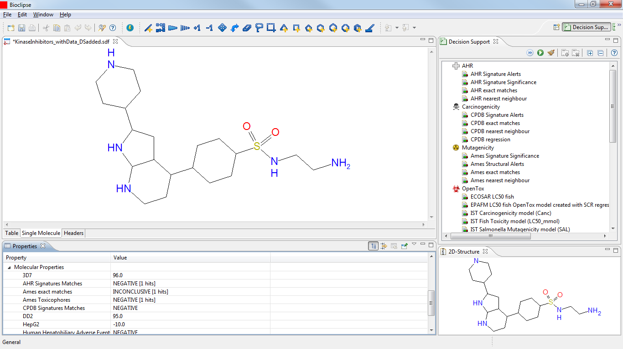
Figure : Opening a single compound from a table in the Decision Support Perspective.
The negative prediction for carcinogenicity by the CPDB model in Bioclipse is confirmed by the negative predictions of the OpenTox models “IST Carcinogenicity model (Canc)” and “ToxTree: Benigni/Bossa rules for carcinogenicity and mutagenicity”. For mutagenicity we have the negative prediction by Bioclipse’s Ames model, the negative prediction with the OpenTox Benigni/Bossa model as well as the “IST Salmonella Muatagenicity model (SAL)”. However, we obtain a positive prediction with the OpenTox “ToxTree: Structure Alerts for the in vivo micronucleus assay” model. Inspecting the details of that prediction we see that it is related to hydrogen-bond acceptors separated by three covalent bonds in the sulfonamide part of the molecule.
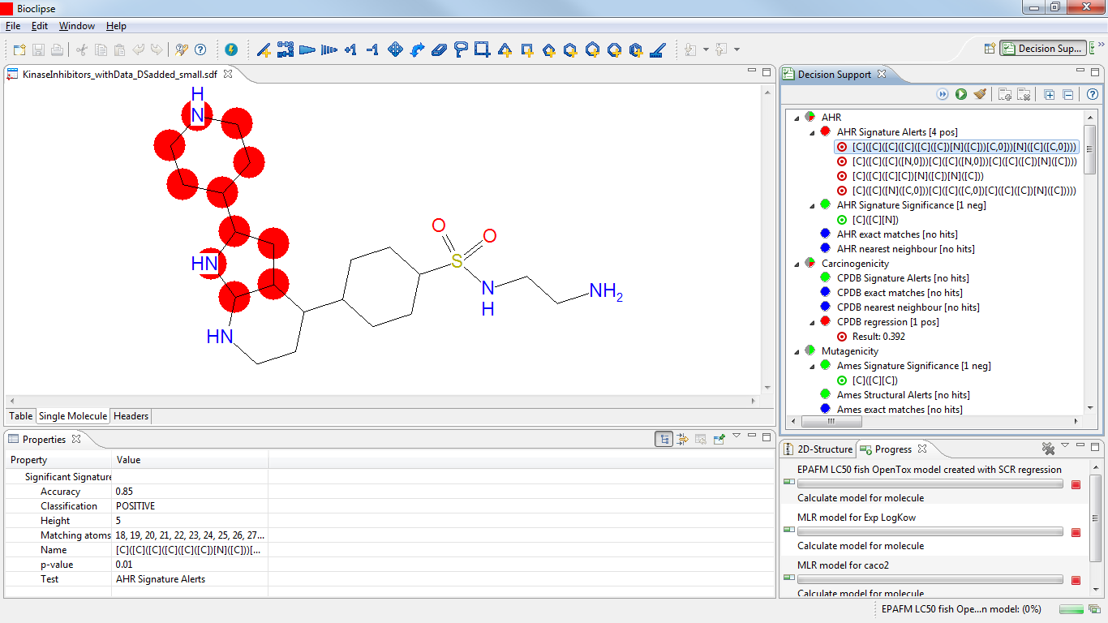
Figure : TCMDC-133364 exhibits AHR Structure Alerts
[I don’t know how to interpret these AHR Signature Alerts here. In the table view, running the Decision Support -> AHR Signature Matches I got a negative prediction for this compound.]

TCMDC-135174 is also very active against both P. falciparum strains, without inhibiting the growth of the HepG2 cells, and its association with human adverse events, as well as the Ames Toxicophore Match and the AHR Signature Match, are negative, as well. However, the Bioclipse CPDB Signature Match is positive.
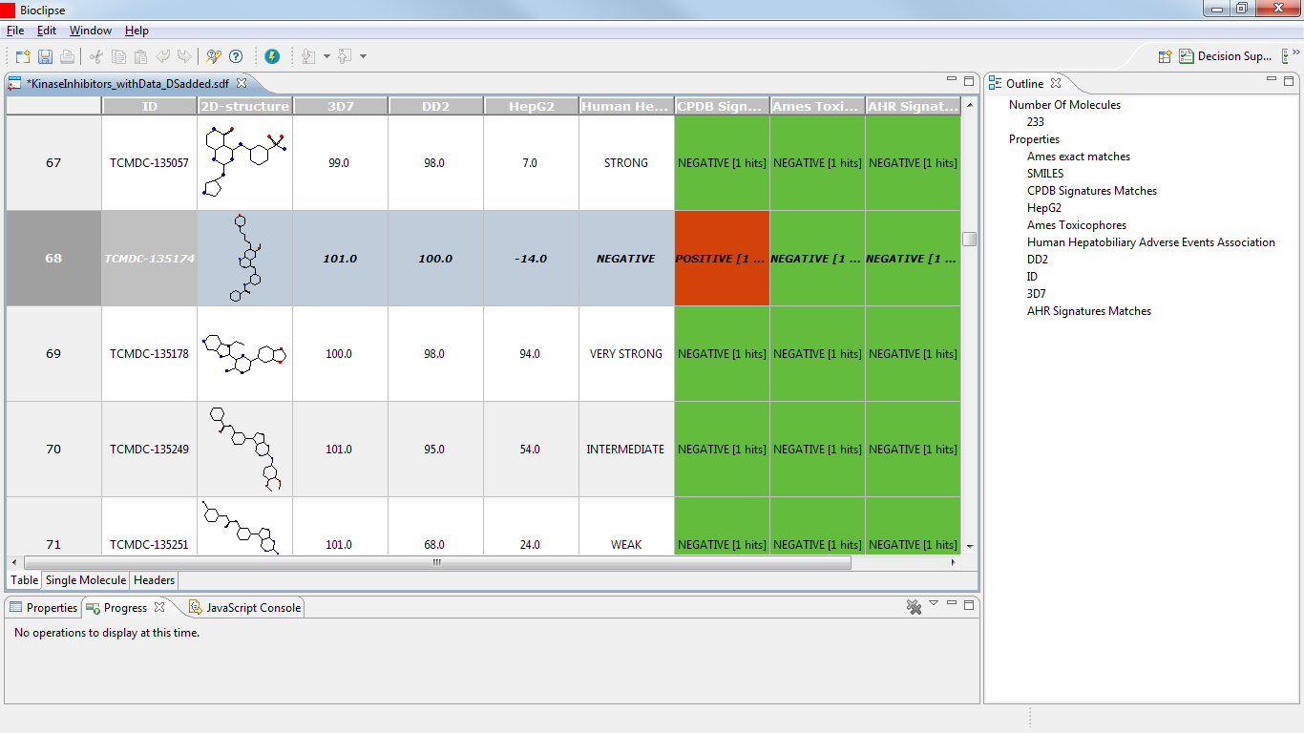
Figure : Adding Decision Support columns to the molecule table. The highlighted compound – TCMDC-135174 – is an interesting candidate as it is highly active against both strains of P. falciparum while being inactive against human HepG2 cells. Also, the compound is predicted negative for three of the four toxicity models included. However, it triggered a CPDB Signature alert for carcinogenicity.
This positive carcinogenicity prediction is confirmed in the DS perspective with the OpenTox models “IST Carcinogenicity model (Canc)” (positive), however, the “ToxTree: Benigni/Bossa rules for carcinogenicity and mutagenicity” are negative. The DS view offers additional information, though: the “ToxTree: Structure Alerts for the in vivo micronucleus assay in rodents“ as well as the “IST Salmonella mutagenicity (SAL)” models are positive, and two “ToxTree: Skin sensitization alerts” are triggered. Combining these pieces of information, we might decide against selecting this compound as a drug development candidate.

In terms of its cytotoxic experimental data, also TCMDC-134695 is a promising candidate. In addition, all Bioclipse Decision Support models are negative. However, the compound has a weak association predicted with human adverse events related to the hepatobiliary tract.
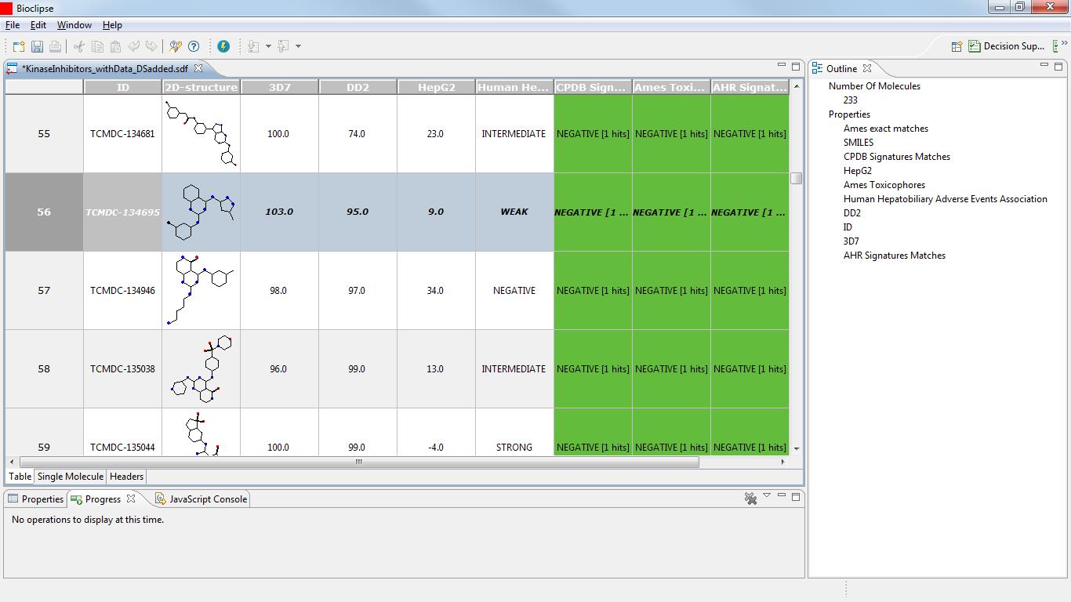
Figure : Molecule Table view of TCMDC-134695. The compound is promising for all its properties represented in the table. However, it is weakly associated with human adverse events.
Running the OpenTox models in the DS perspective on this compound confirms the concerns raised with the predicted association with human adverse events. The compound is predicted carcinogenic and mutagenic with the OpenTox models “ToxTree: Structure alerts for the in vivo micronucleus assay in rodents”, “IST Salmonella Mutagenicity model (SAL)”, “IST Carcinogenicity model (Canc)”, and the “ToxTree: Benigni/Bossa rules for carcinogenicity and mutagenicity”.

TCMDC-133807 appears to be a rather toxic compound, being predicted to be strongly associated with human adverse events and triggering a structure alert with Bioclipse’s CPDB carcinogenicity model.
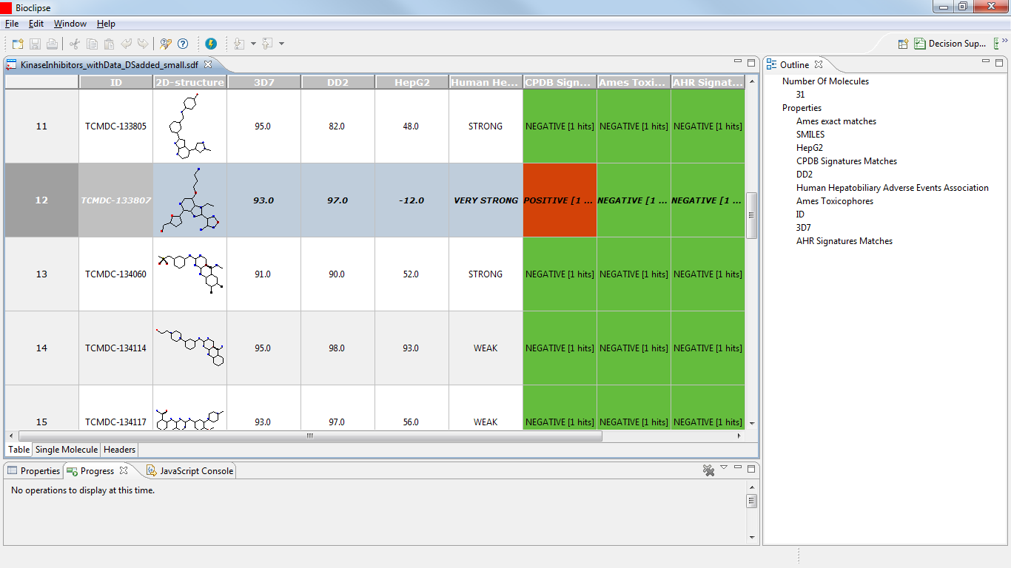
Figure : The compound TCMDC-133807 is predicted to be strongly associated with human adverse events, and yields a signature match with Bioclipse’s CPDB carcinogenicity model.

Indeed the compound turns out positive with the following OpenTox models:
- “ToxTree: Structure alerts for the in vivo micronucleus assay in rodents”,
- “IST Carcinogenicity model (Canc)”,
- “ToxTree: Skin sensitization”
However, the compound is negative with the following OpenTox models:
- “IST Salmonella Mutagenicity model (SAL)”
- “ToxTree: Benigni/Bossa rules for carcinogenicity and mutagenicity”

Discussion
We have described here an interoperability advance, enabling users to interactively explore and evaluate the toxicity properties of molecules based on a semantic web approach to toxicology resources. The integration into Bioclipse makes various components of the OpenTox platform available to the user, both via the graphical user interface as well as via the Bioclipse Scripting Language. The Bioclipse-OpenTox plugin makes it possible to upload data sets to and download them from any OpenTox server, calculate molecular descriptors, and apply predictive toxicology models on molecular structures. All functionality has support for user authentication using the OpenTox-adopted OpenSSO technology.

The presented aspects make this integration fairly unique; creating a solution which is capable of dynamically discovering new services in the OpenTox network when it starts, which differentiates the software from specialized software like ToxTree and the OECD QSAR ToolBox. These tools aggregate several predictive models, but need to be updated manually by the developers for each new model. However, it is noted that these tools too can be extended to support the OpenTox platform too.

An added value is that updates to computational modules are only done on the server side, so that the client software (Bioclipse) does not need to be updated; a feature in common with web-based solutions like ToxPredict [toxpredict]. The scripting functionality makes it easy to automate data workflows as do workflow applications such as Taverna [Oinn:2004fk] and KNIME (http://knime.org), but the combination with the rich Bioclipse user interface makes it possible at the same time to work with OpenTox interactively.

The calculation results are cached by the OpenTox dataset service, allowing to avoid time consuming processing if the same calculation on the same dataset is requested more than once. Users of the integrated Bioclipse-OpenTox environment do not, therefore, need to care about the performance on their own computer, though we are also exploring the options to have Bioclipse itself run an OpenTox server. The latter is technically possible, and would convert the integrated platform into a standalone application that does not require web access.

From a technological perspective, the Bioclipse-OpenTox integration relies on semantic web technologies, which are seeing significant adoption in other areas of the life sciences too, including drug discovery, text mining, and neurosciences [Ruttenberg2007,Splendiani2011, Willighagen2011b]. The OpenTox platform demonstrated the provision of a simple but well-defined and consistent ontology for the interaction with their services, providing functionality for both service discovery and service invocation. The SADI framework is the only known semantic alternative [Chepelev2011], but does currently not provide the same level of computational toxicology services as OpenTox does.

However, while the integration is greatly simplified and semantically defines what services are available and do, the used technologies do neither solve the problem of the chemical validity of the molecular structures that are sent around, nor does it semantically define and specify in detail how to interpret the computational results of toxicity predictions. The first problem refers to the problem that even with explicit meaning we can make incorrect claims. For example, we can always define a triple stating that :water :isToxicAtLowConcentrationsTo :human, by using ontologies for all aspects, but that would not make it true. Semantic technologies is not about correctness. Instead, they make it much easier to find inconsistencies between knowledge bases. The same argument applies to semantically marked up molecular structures and other data passed between Bioclipse and the OpenTox cloud.

An example of the second problem is that various services can indicate that a compound is carcinogenic, but express that statement in different ways. One service may return a binary yes/no answer, while another returns a more detailed answer, such as for which organism or for which cell line the prediction is made. Such semantic integration is currently outside the scope of this Bioclipse-OpenTox interoperability, but it is not a problem unique to our approach either.

To address these issues, the community needs to develop better capabilities to link automatically and reliably the various concepts in toxicology, such as links between chemical names and structures and links to toxicities based on current biological knowledge on effects, targets and pathways. The platform is ready for such semantic integration, but the community needs to develop a common language, which will be enabled through the creation of a public set of linked, harmonized and interoperable ontologies satisfying the predictive toxicology use cases of the future, supporting an integrated data analysis.

Gamo et al., Nature 465(7296), 305-10 (2010), doi:10.1038/nature09107
http://www.fda.gov/Drugs/GuidanceComplianceRegulatoryInformation/Surveillance/AdverseDrugEffects/default.htm
http://pharmatrope.com/

