# Introduction

Section 1 explains how the dose-response data for GSH, DCF, MMP, Supernatant lactate, and HMOX1 was modelled. The models selected in this section and the parameter estimates were then used in section 2 in order to determine relationships between Molecular Initiating Events (MIE) and Intermediate Events (IE) and between IE. The relationships of interest for the AOP are in section 1.2 and in the whole of section 2.

# Models of Molecular Initiating Events and Intermediate Events as functions of KBrO3 concentrations

## Dose-response models

Where sigmoidal dose-response relationships are observed or expected, the data was modelled with the 4-parameter log-logistic model using the R drc package. In some cases, the minimum response *c* was set to 0, resulting in a 3-parameter log-logistic model. Parameter *b* represents the slope factor, parameter *d* the maximum response level, and parameter *e* the logEC50.



## GSH -KBrO3

GSH, expressed as % control, was measured for 5 concentrations of KBrO3 ranging from 0.375mM to 6mM + control, at time point 1hr.

The data was modelled with the 3-parameter log-logistic, having checked that setting the high concentration asymptote to 0 was detrimental to model fit, with b=1.72, d=100, and e=-0.601.

 where x is the KBrO3 concentration (mM) (1)

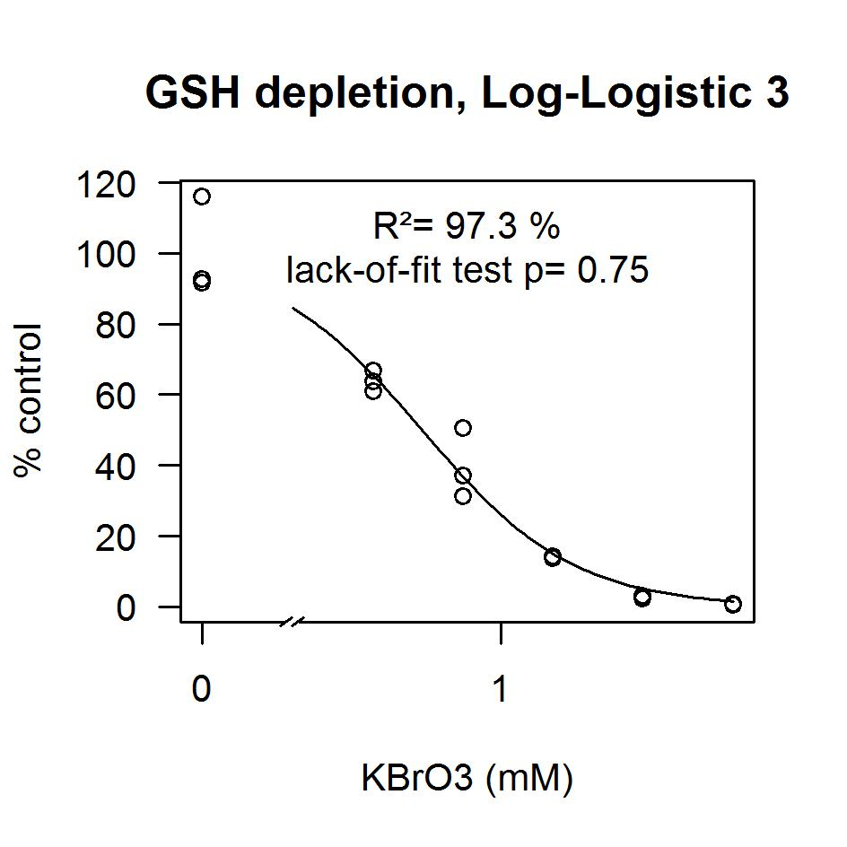

Figure 1 : Dose-response model and data for GSH as a function of KBrO3

## DCF – KbrO3

DCF was measured for KBrO3 ranging from 0.75mM to 6mM, with 8 replicates for 4 concentrations + control. Time-series data are available from time points 0.0167 to 25.5 hrs, every 15 min.

The data was normalized by subtracting the DCF value at the first time-point available for each well from each time-series. On average, the DCF value at the first time-point is equal to 2176. The logarithm of the normalized data was then modelled with the 4-parameter log-logistic model where some parameters vary as a function of time. Parameter *c* is a 4-parameter Log-logistic function of time, and parameter *e* (the logEC50) is a Brain-Cousens function of time.

 where x is the KBrO3 concentration (mM) (2)





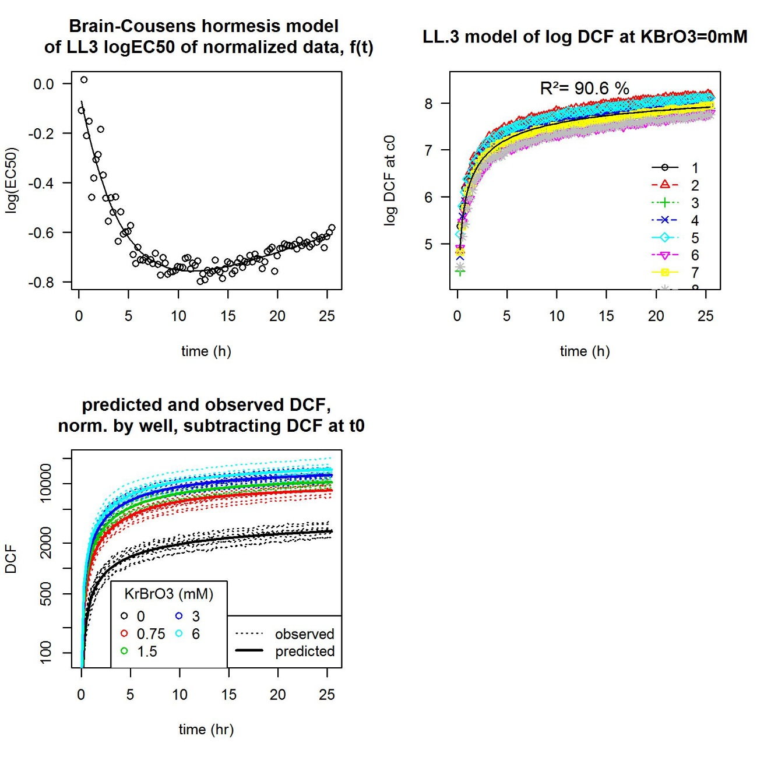

Figure 2 : Dose-response model and data for DCF as a function of KBrO3 and time

The residual variability between wells is not modelled. Knowing more about any time lag between wells could possibly help reduce that residual. The mean value for dose and time point is well predicted though, if one subtracts the value at the first time point (1min).

## MMP-KBrO3

MMP, expressed as % control (?), was measured for 1 concentration of KBrO3 (1mM) + control, at time point 1hr.

As there is only one concentration, one negative control and one positive control (AA?) the data was modelled with the 4-parameter log-logistic with only 2 estimated parameters. The slope was set to -1 and the asymptote for high concentrations was set to the mean value for AA (0.976).

 where x is the KBrO3 concentration (mM) (3)

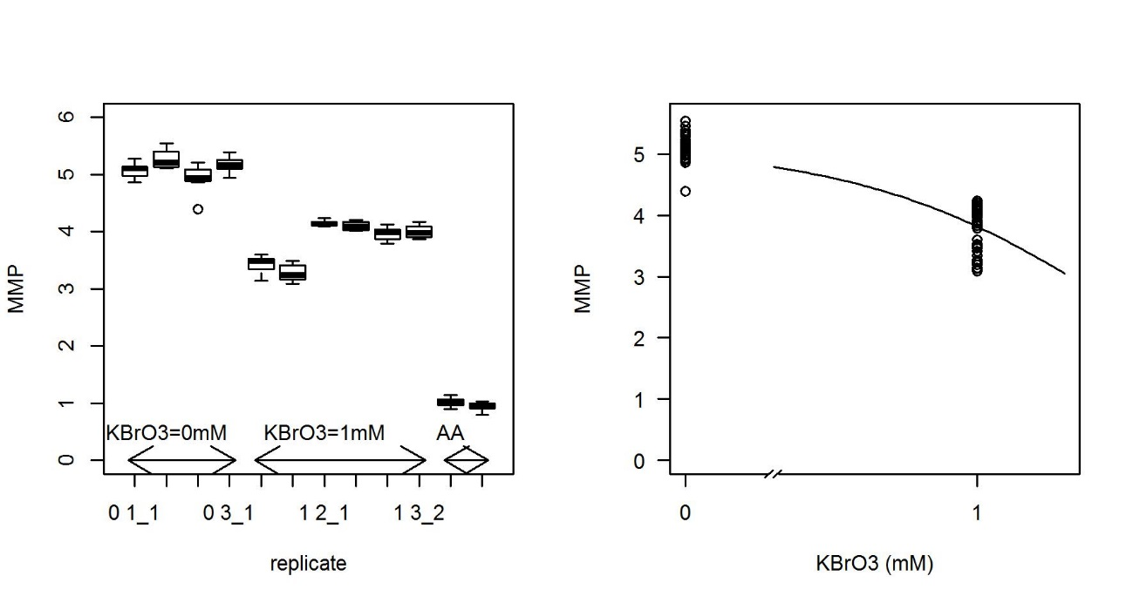

Figure 3 : Dose-response model and data for MMP as a function of KBrO3

There is only one concentration level of KBrO3. MMP levels smaller than about 4 (KBrO3 greater than 1mM) will be extrapolated. There is a considerable amount of uncertainty around the slope factor (set to -1) and therefore around the EC50 (e).

There also appears to be some unnamed structure in the data as some columns have lower MMP values than other columns.

Uncertainty could be reduced with extra concentrations of KBrO3.

## Supernatant lactate

Supernatant lactate (mM) was measured for 7 concentrations of KBrO3 ranging from 0.5mM to 6mM + control, at time point 72hr.

The data was modelled with a 4 parameter log-logistic model of log values (the logarithmic transformation reduced heteroscedasticity).

 where x is the KBrO3 concentration (mM) (4)

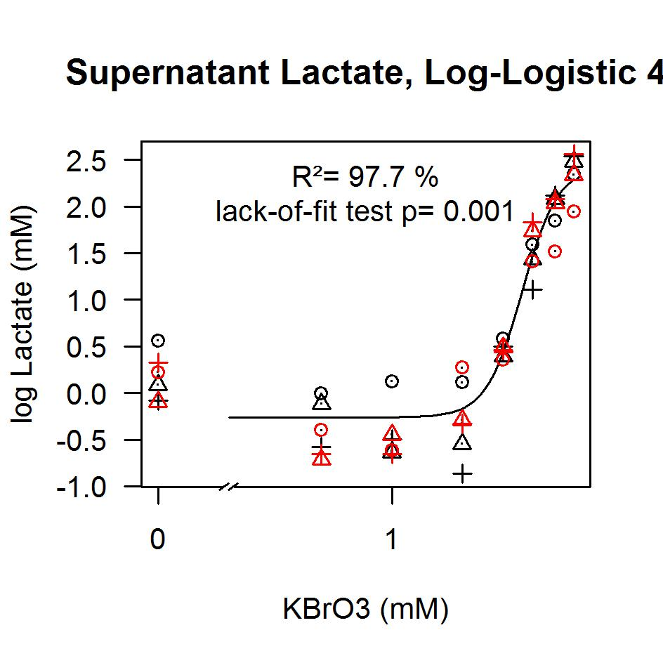

Figure 4 : Dose-response model and data for MMP as a function of KBrO3

There is a difference in lactate between control and low doses. The estimated response at low doses might be more accurate in a new dataset, but as there are several doses corresponding to the lowest response level, the control does not have a very large weight anyway.

## mRNA – KbrO3

mRNA, expressed as log2 fold induction, was measured for 4 concentrations of KBrO3 ranging from 0.1mM to 6mM, at time point 7hrs, and also for 1mMKBrO3, at 9 time points from 1 to 10hrs.

The two datasets are not coherent for KBrO3=1mM, time=7hrs. Only the concentration-dependent data was finally modelled.

The data was modelled with a 3-parameter log-logistic model:

 where x is the KBrO3 concentration (mM) (5)

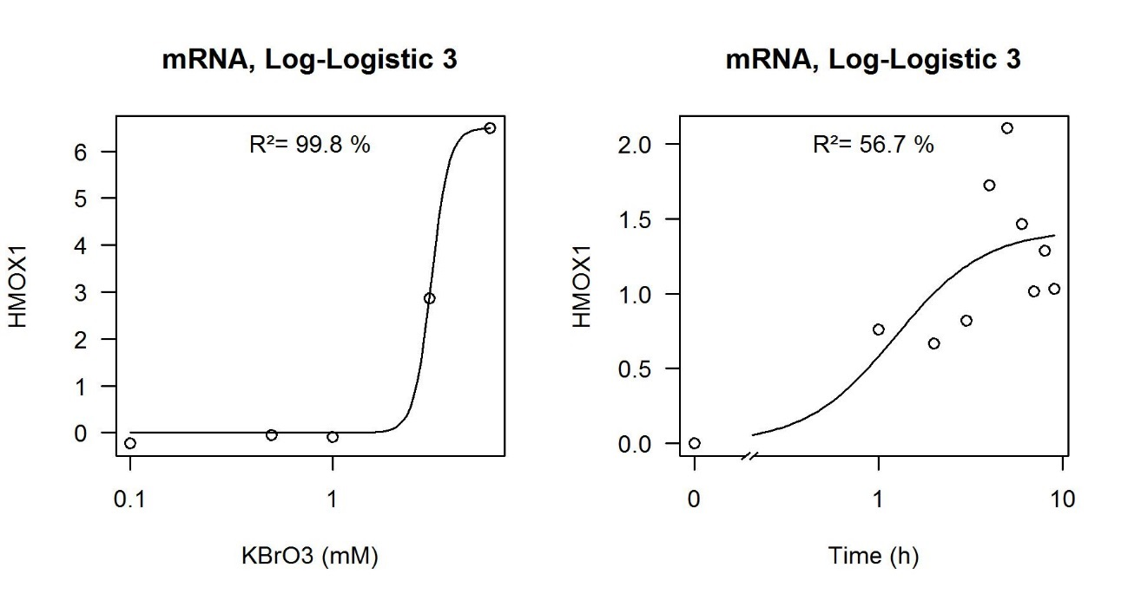

Figure 6 : Dose-response model and data for HMOX1 as a function of KBrO3 or time

The time-dependent data was not used in section 3 because the only point which could be compared with concentration-dependent data was not quite as expected.

If concentration-time-dependent data can be produced and is of interest, test each concentration at each time-point.

In the data that focusses on just one time-point, there are only 2 responses greater than the background level, and we cannot set the maximum response to a known level. Therefore, there is uncertainty on slope (its estimate is extremely high), maximum level (estimated to be approximately the highest observed) and on EC50, which could be higher than estimated. Intermediate concentrations of KBrO3 or higher concentrations of KBrO3 would help.

# Intermediate Events as functions of Molecular Initiating Events

## DCF -GSH

The first step is to express KBrO3 as a function of GSH at time point 1hr with equation 1. KrBrO3 (written as x) can then be substituted in equation 2 to calculate DCF normalized by first time-point:

 with  (6)





When using this relationship in the AOP, the implicit hypothesis is that the GSH-KBrO3 relationship is invariant over time.

The relationship can be plotted at any time point t:

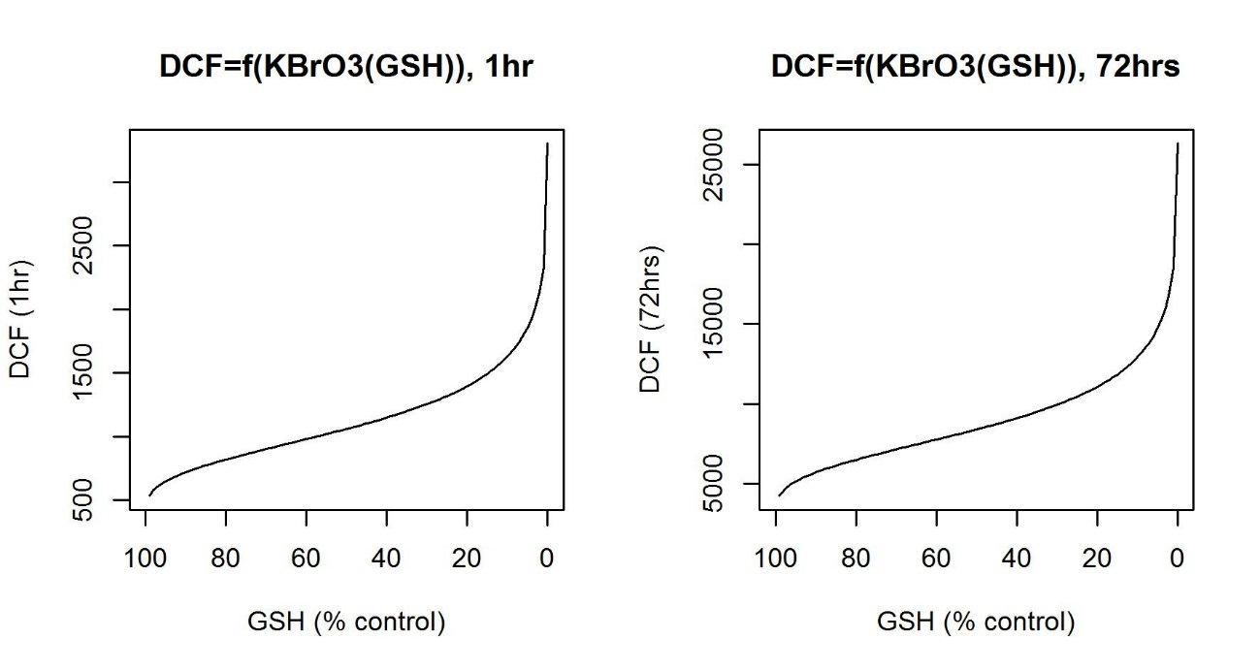

Figure 7 : DCF as a function of GSH, at 1hr and at 72hrs

## MMP-DCF

The first step is to express KBrO3 as a function of DCF at time point 1hr with equation 2. The estimation for parameter *c(t)* at 1hr is 6.10, and the estimation for parameter *e(t)* at 1hr is -0.206 (EC50=0.814mM). KrBrO3 (written as x) can then be substituted in equation 3 to express MMP at 1hr as a function of DCF normalized by first time-point.



with ,

As the prediction for MMP is not used later on in the AOP, the fact that this relationship is only valid at time point 1hr is not a problem.

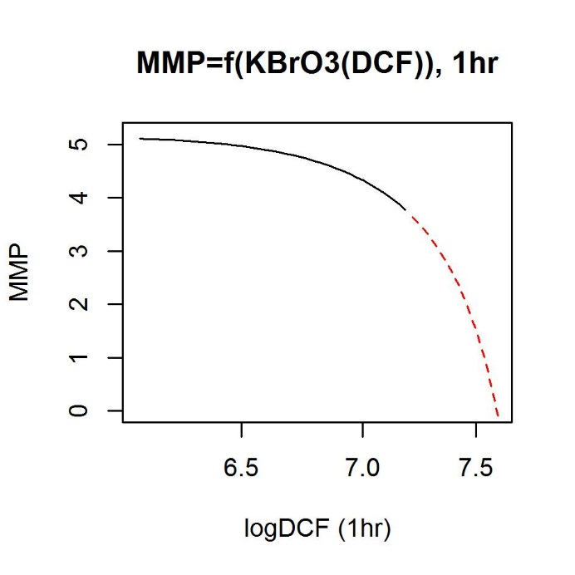

Figure 8 : MMP as a function of DCF, at 1hr. The red dashed line is the extrapolation of the MMP/KBrO3 relationship, calculated with KrBrO3 ranging from 0 mM to 6mM. It is extrapolated from KBrO3=1mM to 6mM.

Extra concentrations of KBrO3 in the MMP/KBrO3 experiment would reduce uncertainty due to extrapolation.

## Lactate – DCF

The first step is to express KBrO3 as a function of DCF with equation 2 at 72hrs (this is an extrapolation). The estimation for parameter *c(t)* at 72hrs is 8.18, and the estimation for parameter *e(t)* at 72hrs is -0.193 (EC50=0.824mM). KrBrO3 (written as x) can then be substituted in equation 4 to express Lactate as a function of DCF normalized by first time-point.



with ,

Supernatant lactate was measured at 72hrs whereas DCF was only measured up to 25hrs. These equations are extrapolations.

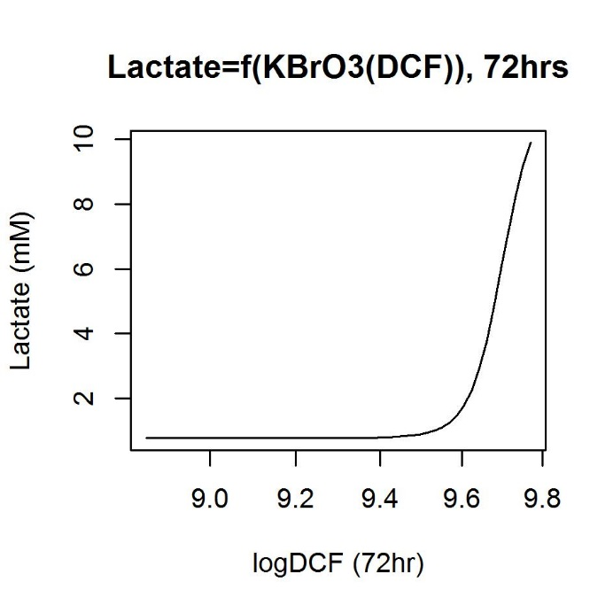

Figure 9 : Supernatant lactate concentration as a function of DCF, at 72hrs Calculated with KrBrO3 ranging from 0.3 mM to 6mM.

## HMOX1 – DCF

KBrO3 is again expressed as a function of DCF with equation 2 at 7hrs. The estimation for parameter *c(t)* at 7hrs is 7.40, and the estimation for parameter *e(t)* at 7hrs is -0.704 (EC50=0.495mM). KrBrO3 concentration (written x) can then be substituted in equation 5 to express HMOX1 as a function of DCF at 7hrs normalized by first time-point.

 with ,

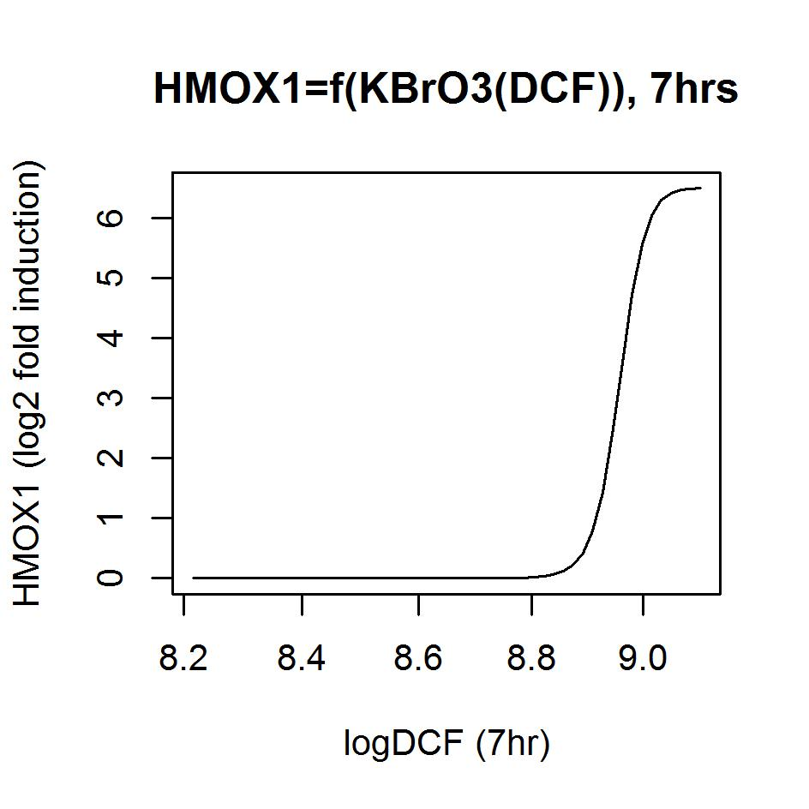

Figure 10 : HMOX1 as a function of DCF, at 7hrs. Calculated with KrBrO3 ranging from 0.3 mM to 6mM

# conclusions

The dose-response in particular for MMP / KBrO3 may need more data to avoid extrapolating too much.

In this analysis DCF is normalized by first time-point which accounted to a certain extent for variability between wells. Is this first time point level actually the same in all DCF experiments or should all DCF data always be normalized in that way?

GSH, which is at the beginning of the experiment, is only measured at 1 hour, so at the moment either the AOP until DCF is only valid for time-point 1 hour, or the GSH-KBrO3 relationship is invariant over time.