EGOOLA.COM
Database Migration Runbook
Step-by-Step: Legacy Schema → Redesigned Schema
How to run, verify, and cut over to the schema documented in Egoola_Database_Redesign_v5.docx
This is an operations runbook, not a schema reference — it assumes the redesigned schema itself (why each table is shaped the way it is) is already understood from the companion Database Redesign Proposal, and focuses entirely on the mechanics of actually moving data: what to back up, what order to run things in, how to verify each stage before trusting it, how to cut the live application over, and how to undo the cutover if something goes wrong. Every command below targets the migration tooling already committed to the repository — database/new_schema/new_schema.sql (the DDL) and app/Console/Commands/MigrateOldToNewDb.php (the data-migration Artisan command) — rather than introducing a second, parallel migration mechanism.
Prepared: September 2026
Document type: Operations Runbook — read fully before running anything against real data

Contents
This list updates automatically in Microsoft Word. If page numbers show as blank, right-click the list and choose “Update Field.”

1. Purpose & Audience
This document walks one person — whoever actually runs the cutover — through every step of moving Egoola's data from the 71-table legacy schema into the redesigned 35-table schema, in the order those steps need to happen, with a verification checkpoint after each one. It assumes familiarity with the command line, a MySQL/MariaDB client, and basic Laravel Artisan usage, but does not assume the reader has read the migration command's source code — every decision the tooling makes on your behalf is explained here in plain terms, with a pointer back to the exact method in app/Console/Commands/MigrateOldToNewDb.php if you need to verify it yourself.
Three things already exist in the repository and are treated here as fixed, reviewed inputs rather than something this runbook re-derives:
- database/new_schema/new_schema.sql — the complete DDL for all 35 new tables, generated from the same schema definition as the redesign proposal.
- app/Console/Commands/MigrateOldToNewDb.php — the data-migration Artisan command (php artisan db:migrate-to-new), covering all 16 migration steps referenced throughout this document.
- config/database.php and .env.example — already updated with a second new_mysql connection the migration command reads from/writes to alongside the existing mysql connection.
If any of these three are missing from your checkout, stop and pull the latest changes before continuing — the steps below assume they are present exactly as committed.

2. Safety Principles
Four rules govern every step below. They are what make it safe to attempt this more than once.
- The old database is never written to. Every migration step only ever reads from the legacy connection (mysql) and writes to the new connection (new_mysql). If anything goes wrong at any point, the old database is still exactly as it was — there is no rollback to perform on it because nothing on it ever changed.
- The new database is always disposable until cutover. --fresh drops and recreates every new-schema table from new_schema.sql before migrating. Until the application is actually pointed at it, the new database is not a system of record — it is safe to wipe and re-run as many times as needed.
- Every step is independently re-runnable. --only=<step> re-runs one migration step in isolation (see Section 5's table for the full list of step keys). Combined with the rule above, this means a mistake in one step never requires re-running the whole thing — drop the new DB, re-apply the schema, and re-run just the steps up to and including the one that needs fixing.
- Nothing is trusted until it is verified. Section 6 gives a row-count reconciliation query for every step. Do not proceed to the next step, and do not cut the application over, until the current step's numbers make sense — an unexplained shortfall is far cheaper to chase down before the next step builds on top of it.

3. Prerequisites
Confirm every item below before starting Step 1. None of these are optional — several of the later steps fail in confusing ways if a prerequisite is skipped rather than failing immediately with a clear error.
- ☐ A recent, verified backup of the live legacy database exists and has been test-restored at least once (a backup that has never been restored is not a backup).
- ☐ A separate MySQL/MariaDB server or schema is available for the new database — physically separate from the production old database, even if it's the same server instance under a different schema name.
- ☐ PHP CLI and Composer dependencies for this Laravel app are installed and working (php artisan list runs without error).
- ☐ You have credentials for both databases and have added NEW_DB_HOST/NEW_DB_PORT/NEW_DB_DATABASE/NEW_DB_USERNAME/NEW_DB_PASSWORD to your real .env file (not just .env.example).
- ☐ You have identified a maintenance window for the real cutover (Section 7) — even though the migration itself can run against a live-but-read-only old database, the actual cutover moment (switching the app's default connection) needs the application briefly unavailable.
- ☐ You know who to contact if a legacy column's meaning needs confirming — several migration steps make a documented best-effort assumption about an ambiguous legacy column (listed in Section 8) rather than guessing silently.
Do this on a copy first — always
Every step from here on should be run at least once against a restored copy of the backup, never directly against the production old database's live connection, until you have completed a full dry run and verified it end to end. The command itself never writes to the old connection, but pointing DB_* at production while you are still debugging step order or column assumptions adds real risk (load on a live database, credentials in more places than necessary) for no benefit — a restored copy behaves identically for every purpose this runbook cares about.

4. Pipeline Overview
The full journey from backup to cutover, at a glance. Each numbered stage below is expanded into its own detailed section further down this document.
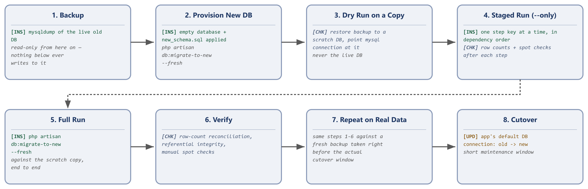
The same eight stages run twice in practice: once as a dry run against a restored copy (to catch problems for free), and once for real against a backup taken right before the actual cutover window.

5. Step-by-Step Procedure
1 | Back Up the Legacy Database
Take a fresh, complete dump of the live old database. This is your safety net for the entire rest of this process, and it is also the source you will restore into a scratch copy for the dry run in Step 3.
mysqldump -u <user> -p --single-transaction --routines --triggers \
egooxlkz_egoola > egoola_backup_$(date +%Y%m%d_%H%M).sql
--single-transaction avoids locking the live tables for the duration of the dump (assuming InnoDB, which the legacy schema mostly is — see Section 8 for the handful of MyISAM tables this doesn't apply to). Store the resulting file somewhere durable before continuing.
2 | Provision the New Database
Create an empty database for the new schema, then apply the DDL. The migration command can do this step for you automatically via --fresh, but doing it once by hand first lets you confirm the connection details in .env are actually correct before the Artisan command depends on them.
mysql -u <user> -p -e "CREATE DATABASE egoola_new CHARACTER SET utf8mb4 COLLATE utf8mb4_unicode_ci;"
mysql -u <user> -p egoola_new < database/new_schema/new_schema.sql
Verify all 35 tables were created:
mysql -u <user> -p egoola_new -e "SHOW TABLES;" | wc -l
# expect 36 (35 tables + the header line SHOW TABLES prints)
3 | Configure Both Connections
Confirm your real .env (not .env.example) has both connections fully populated: the existing DB_* variables pointing at the legacy database, and the NEW_DB_* variables pointing at the database you just created in Step 2. Then clear Laravel's cached config so the new connection is actually picked up.
php artisan config:clear
Two connections, two directions — don't mix them up
The migration command always reads from the connection named mysql and writes to the connection named new_mysql (see the $old / $new properties at the top of MigrateOldToNewDb.php). For the dry run in Step 4, this means DB_* in .env should point at your restored scratch copy of the backup, not at production — the command has no separate "dry run" flag; the dry run and the real run are the exact same command pointed at different databases via .env.
4 | Dry Run: Restore a Copy, Then Migrate It
Restore Step 1's backup into a separate scratch database, point DB_* at that scratch copy, and run the migration end to end against it. This is where you find and fix problems — there is no live-traffic pressure and nothing here can affect production.
mysql -u <user> -p -e "CREATE DATABASE egoola_old_scratch;"
mysql -u <user> -p egoola_old_scratch < egoola_backup_YYYYMMDD_HHMM.sql
# point DB_DATABASE=egoola_old_scratch in .env, then:
php artisan config:clear
Run the first few steps individually before attempting the full pipeline, since everything downstream depends on identity and geography resolving correctly:
php artisan db:migrate-to-new --fresh --only=geography
php artisan db:migrate-to-new --only=identity
Stop here and run the identity verification query from Section 6 before continuing — it is the single most important check in this entire process, because every other step depends on the admin/seller/user split having happened correctly. Once that checks out, run the remaining steps in the order given in Section 6's step reference table (or simply omit --only entirely to run everything left).
php artisan db:migrate-to-new
5 | Verify the Dry Run
Work through every row-count reconciliation query and every spot-check in Section 6 against the scratch copy. Do not proceed past this step on the assumption that "it didn't error out" — the command is written to skip rows it cannot confidently resolve (an orphaned foreign key, an unresolvable seller/category) rather than fail loudly, which is the safer default but means silence is not the same as completeness.
6 | Repeat Steps 1–5 Against Real Data
Once the dry run is fully verified, take a fresh backup (the one from Step 1 is now stale) and repeat Steps 1 through 5 for real, immediately before your planned cutover window. This second pass should be uneventful if the dry run already caught the real problems — treat any new discrepancy here as a signal that something changed in production between the two backups, not a tooling bug.
7 | Cut the Application Over
Detailed in full in Section 7. In short: put the application into maintenance mode, swap which connection Eloquent treats as default, smoke-test the application against the new database, then take it out of maintenance mode.
8 | Verify Post-Cutover, Then Decommission the Old Database (Later)
Keep the old database around, untouched and read-only, for a defined retention window (30 days is a reasonable starting point) after cutover — it costs almost nothing to retain and is the only path back if a gap surfaces that Sections 6 and 8 did not anticipate. Do not drop it on cutover day.

6. Verification, Reconciliation & Rollback
This section is the heart of the runbook: what "done" actually looks like for each step, and exactly what to do if it doesn't.
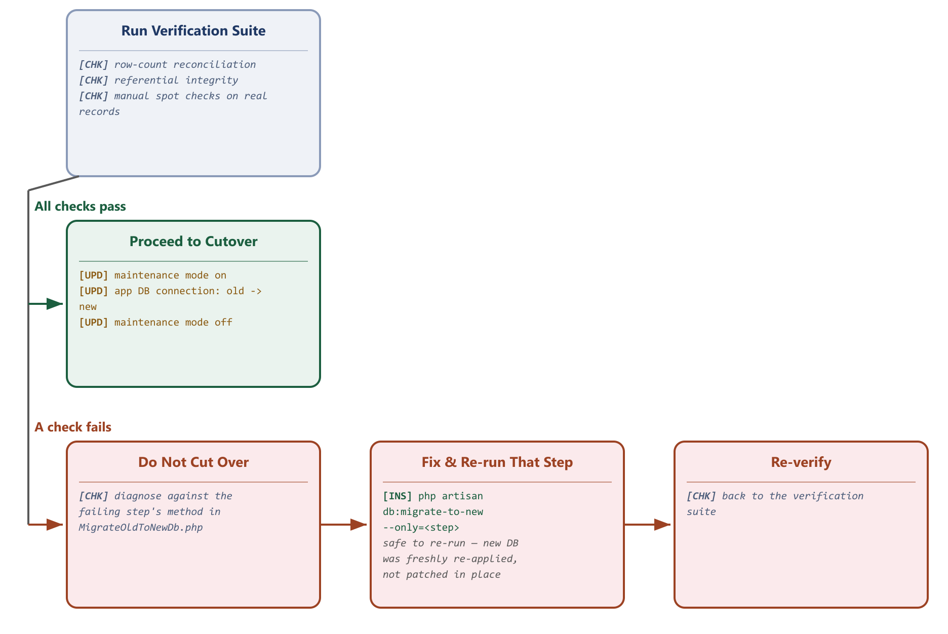
Every stage of the pipeline passes through this gate before the next stage begins.

6.1 The One Number That Must Match Exactly
Identity split reconciliation
SELECT COUNT(*) FROM egoola_old_scratch.users must equal the sum of COUNT(*) FROM egoola_new.admins + COUNT(*) FROM egoola_new.sellers + COUNT(*) FROM egoola_new.users. Every legacy users row lands in exactly one of the three new tables — migrateIdentity() has no code path that skips a row outright, only paths that leave its geography fields null if a country/state/city/thana can't be resolved. If this total doesn't match, stop immediately and do not proceed past Step 4 — every other step depends on the seller/user id maps built here.

6.2 Row-Count Reconciliation, Step by Step
For each step, run the legacy-side count and the new-side count and compare. "Expected relationship" tells you whether an exact match or a shortfall is normal, and why.
Step | Legacy query | New query | Expected relationship
geography | SELECT COUNT(*) FROM countries;  (repeat for states, cities) | SELECT COUNT(*) FROM countries;  (repeat for states, cities) | Should match exactly. A shortfall means a state/city referenced a country/state id that doesn't exist in the legacy data — worth a manual look, not expected in clean data.
geography (thanas) | SELECT COUNT(*) FROM unions; | SELECT COUNT(*) FROM thanas; | Should match exactly. upazilas is intentionally NOT counted here or migrated at all — it's the confirmed-dormant duplicate table, not a shortfall.
identity | SELECT COUNT(*) FROM users; | SELECT (SELECT COUNT(*) FROM admins)+(SELECT COUNT(*) FROM sellers)+(SELECT COUNT(*) FROM users); | Must match exactly — see 6.1 above.
sellerinfos | SELECT COUNT(*) FROM companies; | SELECT COUNT(*) FROM seller_infos; | Should match exactly if every companies.user_Id was correctly classified as a seller in the identity step. A shortfall means a company row belongs to a legacy user who didn't have user_infos.section = 1.
categories | SELECT (SELECT COUNT(*) FROM grand_categories)+(SELECT COUNT(*) FROM parent_categories)+(SELECT COUNT(*) FROM child_categories)+(SELECT COUNT(*) FROM service_grands)+(SELECT COUNT(*) FROM service_parents)+(SELECT COUNT(*) FROM service_children); | SELECT COUNT(*) FROM categories; | Should match exactly. A shortfall means a parent/child category referenced a parent id that was never inserted — usually a genuinely orphaned row in the legacy data.
measurements | SELECT COUNT(*) FROM measurements; | SELECT COUNT(*) FROM measurements; | Must match exactly — unconditional 1:1 copy, no skip logic at all.
listings | SELECT (SELECT COUNT(*) FROM products)+(SELECT COUNT(*) FROM used_malls)+(SELECT COUNT(*) FROM village_products)+(SELECT COUNT(*) FROM retail_shops)+(SELECT COUNT(*) FROM wholesales)+(SELECT COUNT(*) FROM brand_walls)+(SELECT COUNT(*) FROM services); | SELECT COUNT(*) FROM listings; | New total will typically be slightly lower. Every row here requires both its seller/buyer AND its category to already exist in the new DB — a listing whose owning user was never classified as a seller (data integrity issue upstream, not a tooling bug) is skipped, not force-inserted with a broken FK.
listingmedia | SELECT (SELECT COUNT(*) FROM product_images)+(SELECT COUNT(*) FROM service_images)+(SELECT COUNT(*) FROM documents); | SELECT COUNT(*) FROM listing_media; | Lower by however many rows the listings step itself skipped (a photo can't be migrated for a listing that doesn't exist in the new DB).
bids | SELECT COUNT(*) FROM bid_for_services; | SELECT COUNT(*) FROM bids; | Should be close to exact; a shortfall means the bid's service_id or saler_id didn't resolve.
carts | SELECT COUNT(*) FROM carts; | SELECT COUNT(*) FROM cart_items; | Row-for-row on the line-item side; separately, SELECT COUNT(DISTINCT buyer_id) FROM (legacy carts) should be close to SELECT COUNT(*) FROM (new) carts (the header table).
orders (product path) | SELECT COUNT(*) FROM orders; | SELECT COUNT(*) FROM orders WHERE order_type='product' AND EXISTS (matching legacy row); | Every legacy orders row requires its sale_id to resolve to a real sales row — an orders row with a dangling sale_id is skipped entirely, not partially migrated.
orders (service+job path) | SELECT (SELECT COUNT(*) FROM service_orders)+(SELECT COUNT(*) FROM hireds); | SELECT COUNT(*) FROM orders WHERE order_type IN ('service','job'); | Should be close to exact; shortfalls trace to an unresolvable listing/buyer/seller on that specific row.
quotes | SELECT COUNT(*) FROM simple_reqs; | SELECT COUNT(*) FROM quote_requests; | Should be close to exact; a shortfall means the legacy product_id didn't resolve to a migrated listing.
messaging | SELECT COUNT(*) FROM chats;  SELECT COUNT(*) FROM messages; | SELECT COUNT(*) FROM conversations;  SELECT COUNT(*) FROM messages; | conversations should be close to chats; messages should be close to messages minus any whose parent chat was itself skipped.
reviews / favourites | SELECT COUNT(*) FROM reviews;  SELECT COUNT(*) FROM favourits; | SELECT COUNT(*) FROM reviews;  SELECT COUNT(*) FROM favourites; | reviews will typically show the largest shortfall of any step: the new schema requires a matching completed order, which legacy reviews were never required to have. See Section 8 — this is expected, not a bug.
notifications | SELECT COUNT(*) FROM notifications; | SELECT COUNT(*) FROM notifications; | Must match exactly — unconditional straight copy, same primary keys preserved.
cms | SELECT (SELECT COUNT(*) FROM banners)+(SELECT COUNT(*) FROM sidebar_banners);  SELECT COUNT(*) FROM email_contents;  SELECT COUNT(*) FROM others; | SELECT COUNT(*) FROM banners;  SELECT COUNT(*) FROM email_templates;  SELECT COUNT(*) FROM settings; | banners should match exactly. email_templates/settings may be lower than the raw legacy row count if two legacy rows produced the same slugified key — insertOrIgnore silently keeps the first and drops the rest; worth a manual diff if the counts don't match, since it means two distinct settings collided into one key.

6.3 Referential Integrity & Spot Checks
Row counts alone can hide a systemic mis-mapping (e.g. every seller_id pointing at the wrong seller but still resolving to a valid row). Run these after the counts look right:
-- Orphan check: every FK column should return 0 rows here, for every table that has one
SELECT COUNT(*) FROM listings l LEFT JOIN sellers s ON l.seller_id = s.id
WHERE l.seller_id IS NOT NULL AND s.id IS NULL;

-- Every listing has exactly one owner (seller_id) or the other (buyer_id), never both, never neither
SELECT COUNT(*) FROM listings WHERE (seller_id IS NULL) = (buyer_id IS NULL);
-- expect 0
Then pick 5-10 real accounts you recognize (an active seller, a buyer with several past orders, an admin) and manually compare their full profile, listings, and order history side by side between the old and new databases. Automated counts catch missing rows; only a manual look catches a field that migrated to the wrong place but still "counted" correctly.

6.4 If Verification Fails
Because the new database is disposable until cutover (Section 2), the fix is almost always: diagnose against the specific migrateXxx() method named in Section 5's step reference table, fix it, then re-run — never patch rows by hand in the new database, since that fix wouldn't survive the next --fresh run and would leave the command's own logic still wrong for the real run.
# Re-run just the failing step after fixing the code:
php artisan db:migrate-to-new --only=<step>
Rollback, in this design, mostly means "don't proceed"
Because nothing has touched the old database and the new database isn't live yet, there is no data to roll back before cutover — rollback here means: stop, fix the migration command, wipe the new database with --fresh, and re-run from the top (or from --only=<step> if only downstream steps are affected). The rollback that matters operationally is the one after cutover, covered in Section 7.4.

7. Application Cutover
Cutover is the one moment in this whole process that touches the live application. Everything before this point can be rehearsed indefinitely with zero risk; this step should be short, scripted, and rehearsed at least once against a staging environment before doing it against production.

7.1 Immediately Before the Window
- Confirm the "real data" run (Step 6 of Section 5) has been fully verified per Section 6.
- Confirm the backup taken for that run is the most recent one available — if any writes happened to the live old database after that backup was taken, they will not be in the new database.
- Notify anyone who needs to know about the maintenance window.

7.2 During the Window
php artisan down --render="errors::503"
# swap which connection is the application's default — see note below
php artisan config:clear
php artisan up
How "swap the default connection" actually happens depends on how models currently specify their connection
If every Eloquent model in this codebase relies on Laravel's default DB_CONNECTION (the common case, and the one config/database.php's existing structure supports), swapping over is as simple as changing DB_CONNECTION=mysql to point at what is currently the new_mysql connection's credentials (or renaming connections in config/database.php so new_mysql becomes mysql and the old one becomes legacy_mysql) — then a single config:clear takes effect application-wide. If any model hardcodes ->setConnection('mysql') or uses $connection = 'mysql' explicitly, grep for those first; each one needs updating individually and won't pick up an .env change alone.

7.3 Smoke Test Before Reopening
- Log in as an admin, a seller, and a buyer (real accounts from the migrated data, not fixtures).
- Load a listing page, place a test action through checkout as far as is safe without a real charge, and open an existing conversation thread.
- Confirm the admin panel's dashboard counts look reasonable (not zero, not wildly different from what the old admin panel showed before the window started).

7.4 Rollback, If Something Is Wrong After Reopening
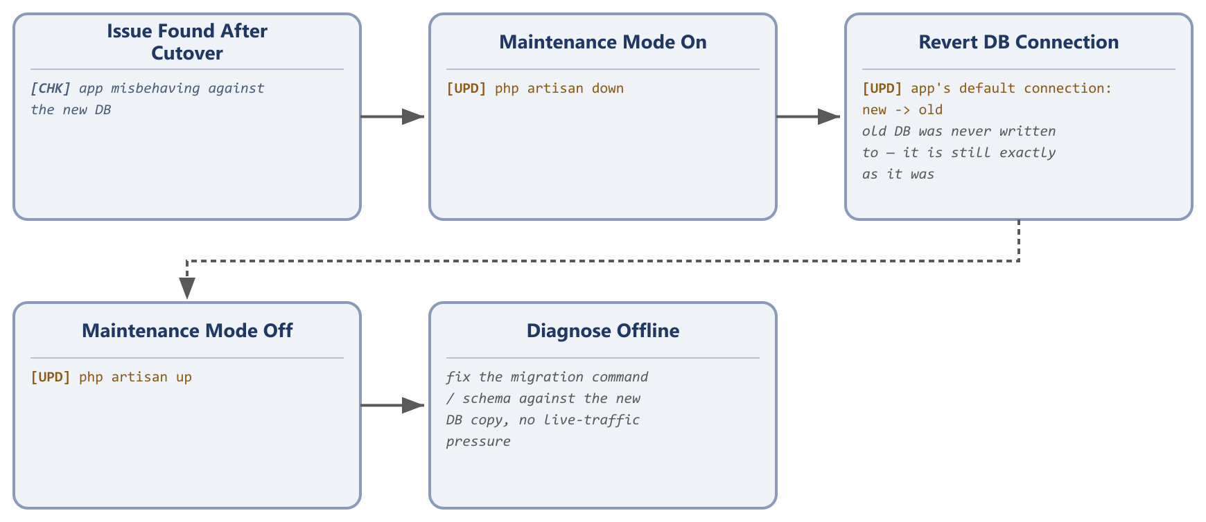
The old database was never written to during any of this — reverting the connection is enough; there is no data to restore.
If a serious problem surfaces after traffic resumes, the fastest safe recovery is to point the application back at the untouched old database, exactly as it was before the window started, rather than attempting a live fix under pressure. Diagnose the actual issue afterward against the new database copy, with no time pressure, then repeat the cutover once it's fixed.

8. Known Limitations & Manual Follow-Ups
These are not bugs in the migration tooling — they are places where the legacy data genuinely doesn't contain enough information to migrate automatically, confirmed against the actual legacy migration files and controllers rather than assumed. Each is called out in a comment at the relevant point in MigrateOldToNewDb.php as well.

Product-order (Stripe) checkout payments are not migrated into payments — confirmed, not an oversight
Verified against the actual checkout code
The legacy payments table (amount, is_done, paymentID, trxID) is only ever linked to an order through the order_pays and hire_pays join tables, which exist solely for the service and job order paths. The physical-goods checkout path (sales/orders/billings/shippings) has no such join table anywhere in the migration history, and PaymentController.php — the controller that actually takes a Stripe charge for a product order — confirms why: it checks sales.transaction != 0 as a simple "already paid" flag and never creates a payments row at all. There is nothing in the database for MigrateOldToNewDb.php to migrate here; the real transaction detail, if it exists anywhere, lives only in Stripe's own dashboard. If financial reconciliation of historical product orders is needed, that data has to come from Stripe's records, not this database. Until then, expect SELECT COUNT(*) FROM payments WHERE purpose='checkout_payment' to under-represent product-order revenue — this is a legacy data gap, not a migration bug.

Three parallel withdrawal systems, kept distinguishable rather than merged
balances, payment_requests, and seller_payments all represent a seller withdrawing money, apparently introduced at different times without the earlier ones being retired. Rather than silently merging them (and losing the ability to tell which legacy system a given historical payout came from), each migrated row's payments.meta.legacySource records which one it came from. Do not assume these three sources are mutually exclusive for a given seller — check for duplicate payouts on the same seller/amount/date if a seller ever appears to have two withdrawal systems recorded around the same time.

OTP codes, password-reset tokens, and “remember me” tokens are not migrated — by design
Per your own decision to move OTP verification to Redis, verify_phone/otps/otp_logs/forget_otps/password_resets/verifies are intentionally skipped. Every migrated seller/user account starts in the new system with no pending OTP or reset token — this is the correct behavior, not a gap to fix.

Reviews require a completed order the legacy data was never required to have
The new reviews.orderId is NOT NULL by design (Section 3.10 of the redesign proposal fixes exactly this gap). A legacy review with no matching completed order between that buyer and that listing is skipped rather than force-inserted with a fabricated order reference. Expect a meaningful percentage of legacy reviews to be dropped for this reason — quantify it during Section 6 verification and decide whether it's acceptable, rather than being surprised by it on cutover day.

Ambiguous legacy columns given a documented best-effort interpretation
- banners.statusS / sidebar_banners.type,what — collapsed to a single active/inactive status, per the same open question flagged in the redesign proposal's Section 3.11.
- services.saler_post — inferred from the column name to mean "1 = seller-posted offer, 0 = buyer-posted job request," not confirmed against a live data sample.
- payment_requests.status / seller_payments.payment_status — the exact meaning of each legacy status code/string is a best-effort guess (1 = completed, else pending); confirm against the admin panel before treating historical payout status as authoritative.

IDs are not preserved
Check for hardcoded ID references before cutover
Because several legacy tables collapse into one new table (six listing-format tables into listings, six category tables into categories, and so on), a new row's id is never guaranteed to equal its old row's id — the migration command builds an in-memory old-id → new-id map for exactly this reason. If any hardcoded links exist outside the database itself — a saved report, an external system, a printed document, a marketing email with a direct listing URL containing an old numeric id — those links will point at the wrong row (or nothing) after cutover. Audit for this before cutover, not after.

9. Migration Step Reference
The --only=<key> value for every step, in the exact order the command itself runs them, why that order is required, and where to look in the source if you need to change one step's behavior.
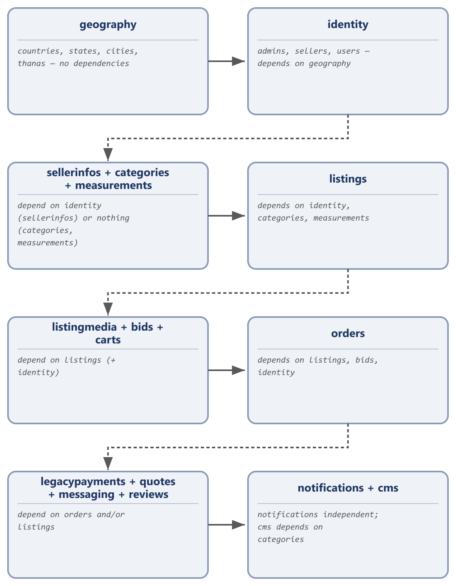
# | --only key | Reads (legacy) | Writes (new) | Depends on
1 | geography | countries, states, cities, unions | countries, states, cities, thanas | nothing
2 | identity | users, user_infos (+ skills/interests/edcations/experiences) | admins, sellers, users | geography
3 | sellerinfos | companies, contacts, company_files, certificats | seller_infos, seller_media | identity
4 | categories | grand/parent/child_categories, service_grands/parents/children | categories | nothing (but should run before listings/cms)
5 | measurements | measurements | measurements | nothing (but should run before listings)
6 | listings | products, used_malls, village_products, retail_shops, wholesales, brand_walls, services | listings, listing_price_tiers | identity, categories, measurements, geography
7 | listingmedia | product_images, service_images, documents | listing_media | listings
8 | bids | bid_for_services (+ hireds, read-only, for outcome) | bids | listings, identity
9 | carts | carts | carts, cart_items | identity, listings
10 | orders | sales, orders, shippings, billings, service_orders, hireds, order_pays, hire_pays | orders, order_items, addresses, payments (service/job checkout only) | identity, listings, bids
11 | legacypayments | balances, payment_requests, seller_payments, commission_payments, commissions, refund_histories | payments | identity, orders
12 | quotes | simple_reqs | quote_requests | listings, identity
13 | messaging | chats, messages | conversations, messages | identity, listings
14 | reviews | reviews, favourits | reviews, favourites | orders, identity, listings
15 | notifications | notifications | notifications | nothing
16 | cms | banners, sidebar_banners, email_contents, others | banners, email_templates, settings | categories
Rerunning a single step
php artisan db:migrate-to-new --only=listings re-runs just that step. Because every step INSERTs rather than UPSERTs, re-running a step without first wiping the new database (--fresh) produces duplicate rows — always pair a targeted re-run either with --fresh beforehand, or with manually truncating that step's target table(s) first.

10. Command Reference
Flag | Effect
--fresh | Drops and recreates every table in the new_mysql database from database/new_schema/new_schema.sql before running any migration step. Always safe pre-cutover; never run against a database the application is already live on.
--only=<key> (repeatable) | Runs only the listed step(s), by the keys in Section 9's table, in their normal relative order. Omit entirely to run all 16 steps.
--chunk=<n> | Rows read from the old database per chunk (default 500). Lower it if a single legacy table is large enough to cause memory pressure; raising it slightly speeds up very large tables at the cost of more memory per chunk.
# Full fresh run
php artisan db:migrate-to-new --fresh

# Fresh run, but only through categories (useful while debugging the early steps)
php artisan db:migrate-to-new --fresh --only=geography --only=identity --only=sellerinfos --only=categories

# Re-run one step after fixing it, without touching anything else
# (truncate its target table(s) first, or wipe everything with --fresh)
php artisan db:migrate-to-new --only=bids

11. Cutover-Day Checklist
A condensed, printable version of everything above, for the day itself.
- ☐ Fresh backup of the live old database taken and stored durably.
- ☐ New database provisioned, new_schema.sql applied, --fresh migration run against a restored copy of that exact backup.
- ☐ Identity reconciliation (6.1) confirmed exact.
- ☐ Every row-count reconciliation in 6.2 reviewed; every shortfall explained by an item in Section 8, not a surprise.
- ☐ Referential integrity queries (6.3) return zero orphans.
- ☐ 5-10 real accounts manually spot-checked side by side.
- ☐ Hardcoded old-id references audited (Section 8) — none found, or all accounted for.
- ☐ Maintenance window scheduled and communicated.
- ☐ Rollback procedure (7.4) reviewed by whoever is running the window, not just written down.
- ☐ Post-cutover smoke test (7.3) plan agreed before starting, not improvised during the window.
- ☐ Old database retention window decided and scheduled — not dropped on cutover day.

