DIR DIVING — MAIN Branch Complete Readiness Audit
Date: 2026-05-20 · Branch: main · HEAD: db72dce6b88aa45f9fa694ad33dde4d4aa8b2589 (working tree has uncommitted changes)
Audit-only (no code changes). Scope: Apple Watch MAIN + iOS Companion MAIN. Benchmarks: Docs/ReferenceUI/Watch_LIVE_reference.png and iOS_Companion_reference.png.

A. Branch & Build
- Branch main @ db72dce6b88aa45f9fa694ad33dde4d4aa8b2589.
- xcodegen + Watch + iOS builds: SUCCEEDED (audit run 2026-05-20).
- project.yml excludes experimental sources from MAIN targets.
- Bundle IDs: iOS com.egopfe.dirdiving.ios; Watch com.egopfe.dirdiving.ios.watch.
- Entitlements: iCloud KVS + CloudKit; Watch adds water submersion.
- 1 non-blocking AppIntents metadata warning on iOS build.
- Uncommitted WIP on disk: PlannerSafetyAcknowledgment, CloudSyncStore decode UI, iOS localization.

B. Executive Summary
Dimension | db72dce (committed) | With local WIP
Overall | ~91% | ~94%
Compile | 100% | 100%
Apple Watch MAIN | ~93% | ~93%
iOS Companion MAIN | ~90% | ~93%
UX completeness | ~93% | ~95%
Safety | ~88% | ~88%
UI vs reference | ~88% | ~90%

C. Feature Inventory (highlights)
Platform | Feature | Complete | Notes
Watch | Live dive + ascent gauge | Y | Matches neon reference
Watch | Auto depth / submersion | P | Ultra + entitlement required
Watch | 7 App Shortcuts | Y | Side button via Shortcuts only
Watch | Audio tones | N | Informational settings row
iOS | Logbook + detail + CSV | Y | No list thumbnails vs mock
iOS | Planner + Bühlmann | P | Indicative; not certified DC
iOS | Watch sync + conflicts | Y | More UI for conflicts
iOS | iCloud KVS | P | Decode error silent until WIP committed
iOS | GPX/KML/.ssrf | N | CSV only in MAIN

D. Navigation
- Watch: Live → BUSSOLA → Settings → [Images] → Dive Log → Detail.
- iOS: Planner → Logbook → Analysis → Equipment → More (reference mock: Logbook first).
- No critical dead ends; legal gates intentional.

E. UI Consistency vs Reference
Platform | Match | Gap | Severity
Watch | Strong | Some EN labels (RunTime) | LOW
iOS | Strong theme | Tab order; no logbook photos | LOW
iOS | Cards/charts | Planner/Equipment IT literals | LOW
Marketing | — | .ssrf in mock; app ships CSV | LOW

F–H. Settings / Haptics / Hardware
- Watch: units, alarms, ascent, haptics persisted and applied; tones N/A.
- iOS: units + demo + cloud + WC sync; planner ack session-only @ db72dce (WIP fixes).
- Haptics: comprehensive on Watch; iOS text-only feedback.
- Crown: vertical paging; side button not mapped; Action Button via App Intents.

I–J. Sync & Export
- Watch ↔ iPhone: signed dive payloads, tombstones, units, photos, offline queue.
- iCloud: KVS merge; decode failures need WIP UI before App Store.
- Export: Subsurface CSV both platforms; ShareLink; GPX/KML not in MAIN.

K–L. Safety & Empty States
- Strong disclaimers; planner not certified decompression guidance.
- Depth 35/38/40 m fixed; ascent banner inline.
- Empty states on logbook/analysis; sync/export errors mostly visible.
- Blocker: physical Ultra depth QA (R1).

M. Bugs To Fix
ID | Severity | Issue | Status
R1 | HIGH | Physical depth/submersion QA on Ultra | Open
R2 | MED | Planner safety ack not persisted | WIP on disk
R3 | MED | iCloud decode errors silent | WIP on disk
R4 | LOW | Mixed IT/EN on iOS main screens | WIP partial
R5 | LOW | Tab order vs reference mock | Open
R6 | LOW | Logbook thumbnails vs mock | Open

N. Priority Roadmap
- Before compile/use: none (builds succeed).
- Before TestFlight: R1 device QA; commit R2–R4 WIP.
- Before App Store: R1 + legal/metadata + iCloud error visibility shipped.
- Post-release: full i18n, GPX, iOS notifications, UI polish vs reference.

O. Final Verdict
Question | db72dce | After WIP commit
Ready to compile? | YES | YES
Ready for internal test? | YES | YES
Ready for average user? | MOSTLY (~91%) | MOSTLY (~94%)
Ready for TestFlight? | YES after R1 | YES after R1
Ready for App Store? | CONDITIONAL | CONDITIONAL
Blocks 100% | R1 hardware QA, store review, R2–R4 on remote | Primarily R1 + metadata

Prior fixes on main
- 876bcd2: manual edit, merge fields, planner mock row, disclaimer persist, sync fixes.
- db72dce: ascent gauge imperial, 7 App Shortcuts, shortcut help, detail refresh.

Reference UI
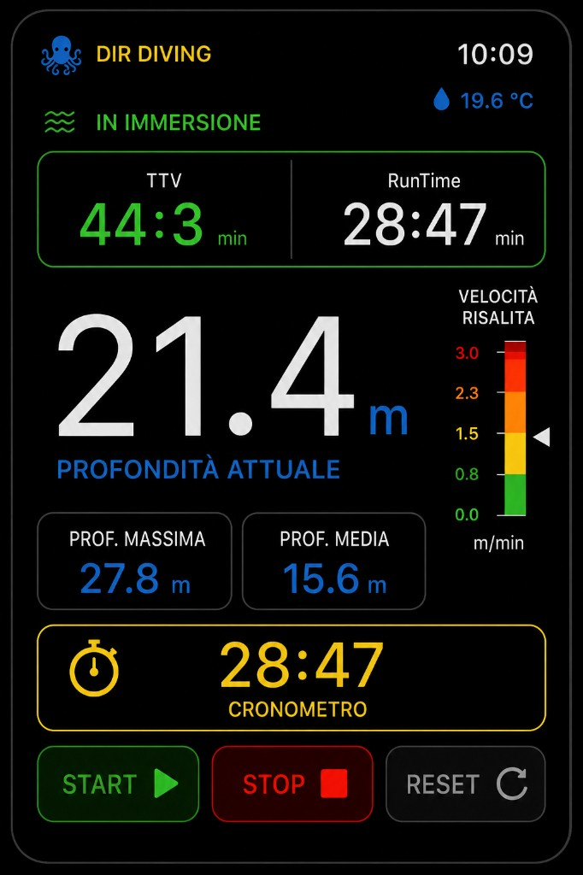
Watch LIVE reference
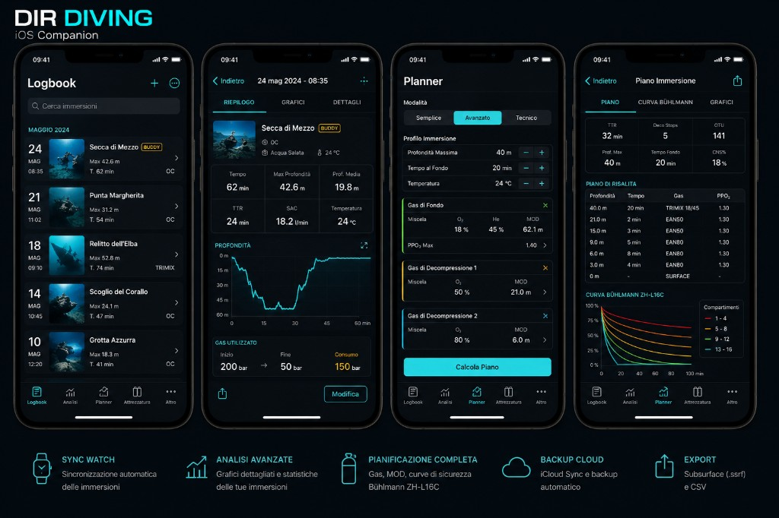
iOS Companion reference
Full markdown: MAIN_BRANCH_COMPLETE_READINESS_AUDIT_20260520.md

